Using NLP to Extract Cardiovascular Risk Factors, Treatments, and Outcomes from Research Abstracts
Shanmukha Sai Prakash Jeelakarra
Department of Healthcare Informatics, School of Healthcare Professions
Rutgers University, Newark, NJ, USA
BINF5312E001 - Natural Language Processing | Instructor: Lorena Carlo Unda
April 29, 2025

Abstract
Cardiovascular diseases (CVDs) remain the leading cause of global mortality, accounting for approximately 20 million deaths annually (World Health Organization [WHO], 2021). The exponential growth of biomedical literature makes manual knowledge extraction from research abstracts impractical. This paper presents a comprehensive Natural Language Processing (NLP) pipeline designed to automatically extract structured clinical information including risk factors, treatments, and clinical outcomes from cardiology research abstracts sourced from PubMed. The methodology integrates five distinct NLP techniques: (1) biomedical Named Entity Recognition (NER) using the d4data/biomedical-ner-all transformer model, (2) semantic embedding and clustering with SentenceTransformers and KMeans, (3) zero-shot relation extraction producing a directed knowledge graph, (4) rule-based clinical entity classification, and (5) evaluation via fuzzy precision, recall, and F1 scoring against manually annotated gold standards. Applied to the Cardio_v1 dataset (n = 5,000 abstracts), the pipeline successfully identified clinically relevant entities across three categories diseases, treatments, and outcomes and constructed a knowledge graph encoding biomedical relationships between entities. Results demonstrate the feasibility of label-free, automated biomedical knowledge extraction at scale, providing a foundation for clinical decision support and evidence-based information retrieval systems.

Keywords: natural language processing, biomedical NER, cardiovascular diseases, knowledge graph, relation extraction, transformer models, PubMed

1. Introduction
Cardiovascular diseases (CVDs) are the primary cause of mortality worldwide, responsible for nearly 20 million deaths each year (WHO, 2021). As the volume of biomedical literature continues to grow exponentially with PubMed indexing over 35 million records clinicians and researchers face an insurmountable challenge in keeping pace with new findings published daily. The majority of this knowledge is stored as unstructured free text, severely limiting efficient analysis, retrieval, and application in clinical practice.
Natural Language Processing (NLP) provides computational methods for transforming unstructured text into structured, machine-readable knowledge. In biomedical informatics, NLP has been successfully applied to Named Entity Recognition (NER), relation extraction, document classification, and clinical question answering (Cohen & Demner-Fushman, 2014). These techniques enable the automated identification of clinical concepts such as drugs, diseases, and procedures and the relationships that connect them.
The advent of large pre-trained transformer models, most notably BERT (Devlin et al., 2019), has dramatically improved NLP performance by generating deep, context-sensitive word representations. Domain-specific adaptations such as BioBERT (Lee et al., 2020) and PubMedBERT (Gu et al., 2021) have further advanced biomedical NLP by pre-training on domain-specific corpora, enabling state-of-the-art entity recognition on tasks such as the BC5CDR benchmark. Sentence-level semantic embeddings, enabled by models such as SentenceTransformers (Reimers & Gurevych, 2019), allow dense vector representations of entire abstracts, supporting semantic similarity, clustering, and information retrieval.
Despite these advances, a gap remains between cutting-edge NLP research and practical, deployable pipelines that can process large collections of cardiology abstracts without requiring manually labeled training data. The present project addresses this gap by constructing an end-to-end, label-free NLP pipeline that extracts structured knowledge risk factors, treatments, and outcomes from cardiology research abstracts. The pipeline is evaluated against manually constructed gold standards using precision, recall, and F1 metrics.
The primary objectives of this project are: (1) to apply biomedical NER to identify clinically relevant entities in cardiology abstracts; (2) to cluster abstracts semantically using sentence embeddings; (3) to extract directed relations between entities using zero-shot classification; (4) to visualize the resulting knowledge graph and entity distributions; and (5) to evaluate extraction quality against annotated references.

2. Methodology

2.1 Dataset
The dataset used in this study is the Cardio_v1 corpus, sourced from Hugging Face (InMedData, 2025). It consists of a large collection of cardiology-related research abstracts originally indexed in PubMed. For this study, the first 5,000 records were loaded using pandas, preserving computational tractability while maintaining corpus representativeness. Each record contains two primary fields: a title field and an abstract field (abst). These were concatenated into a single unified text variable to maximize contextual information available to downstream NLP models.

2.2 Data Preprocessing
A standardized text preprocessing pipeline was implemented to normalize raw input text before NLP processing. The pipeline applies the following transformations sequentially:
- Concatenation of the title and abst fields into a single text column
- Conversion to lowercase to ensure case-insensitive token matching
- Removal of all non-alphabetic characters using regular expression substitution (pattern: [^a-z\s])
- Whitespace normalization to collapse multiple spaces into single spaces
- Tokenization and stopword removal using NLTK's English stopword list, retaining only tokens of length greater than two characters

The cleaned text was stored in a new column (clean) within the dataframe for use in all subsequent NLP tasks. This preprocessing step reduces lexical noise and improves downstream model performance (Jurafsky & Martin, 2023).

2.3 Named Entity Recognition (NER)
Biomedical Named Entity Recognition was performed using the d4data/biomedical-ner-all model from the Hugging Face Transformers library (Wolf et al., 2020). This model is a fine-tuned BERT-based architecture trained on multiple biomedical NER corpora, enabling it to recognize a broad range of clinical entity types including diseases, chemicals, genes, and anatomical structures.
The NER pipeline was configured with aggregation_strategy='simple' to merge subword tokenization fragments into complete word units. A custom post-processing function addressed a known issue with BERT subword tokenization: tokens beginning with '##' (continuation pieces) were programmatically stitched back to their preceding token to reconstruct full biomedical terms such as 'fibrillation' from fragments like 'fibrill' + '##ation'. Text input was truncated to 1,024 characters to comply with the model's maximum sequence length.
Extracted entities were further filtered using the following criteria: minimum length of five characters; alphabetic characters only (no numerals or special characters); exclusion of a manually curated bad_words set containing generic non-clinical terms such as 'abstract', 'patients', 'clinical', and 'analysis'; and exclusion of a fragment set targeting residual broken subword pieces. NER was applied to the first 1,000 abstracts in the corpus. Entities were then classified into three clinical categories using rule-based keyword matching: Disease/Condition, Treatment/Drug, and Outcome/Risk.

2.4 Semantic Embedding and Clustering
To identify latent thematic structure within the corpus, sentence-level semantic embeddings were generated using the all-MiniLM-L6-v2 model from the SentenceTransformers library (Reimers & Gurevych, 2019). This model produces 384-dimensional dense vector representations for each abstract, capturing semantic meaning beyond simple lexical overlap.
KMeans clustering (k = 5, random_state = 42, n_init = 10) was applied to partition the 5,000 embedding vectors into five semantic groups corresponding to distinct cardiology research themes. Principal Component Analysis (PCA) was subsequently applied to reduce the 384-dimensional embeddings to two dimensions for visualization. The resulting two-dimensional projection was rendered as a scatter plot color-coded by cluster assignment using Seaborn.

2.5 Relation Extraction and Knowledge Graph Construction
Biomedical relation extraction was implemented using a zero-shot text classification approach with the valhalla/distilbart-mnli-12-3 model. For each pair of entities co-occurring within the same abstract, a natural language context string was constructed in the form: '{entity_A} and {entity_B} in context: {text[:200]}'. The zero-shot classifier then assigned one of five predefined relation labels to each entity pair: treats, causes, increases_risk, reduces_risk, or associated_with.
To improve computational efficiency, a relation_cache dictionary was implemented to avoid redundant classification of previously seen entity pairs. A confidence threshold of 0.30 was applied; only relations with a classification score exceeding this threshold were retained. Relation extraction was applied to the top three entities from each of the first 50 abstracts, producing a directed graph.
The extracted (head, relation, tail) triples were used to construct a directed graph using the NetworkX library. The graph was visualized using a spring layout with Matplotlib, with edge labels annotating the relation type for each connection.

2.6 Evaluation
Extraction quality was assessed using a manually constructed gold standard consisting of three reference entities per abstract for the first 10 abstracts in the corpus (e.g., ['amiodarone', 'fibrillation', 'tachycardia'] for Abstract 0). Predicted entity lists were compared against gold standards using a fuzzy substring matching criterion: a predicted entity p is counted as a true positive for gold entity g if g is a substring of p or p is a substring of g, capturing morphological variants (e.g., 'ventricular' matching 'ventricular tachycardia').
Precision, Recall, and F1 scores were computed as follows:
Precision = TP / (TP + FP)
Recall = TP / (TP + FN)
F1 = 2 × Precision × Recall / (Precision + Recall)
Macro-averaged metrics were reported across all 10 evaluated abstracts. An additional semantic similarity evaluation was implemented using cosine similarity between entity embeddings (threshold = 0.70) to assess soft matching performance for morphologically distinct but semantically related terms.

2.7 Generative AI Declaration
In accordance with the Nature Portfolio Editorial Policies on Generative AI (Nature, 2023), the use of AI tools in this project is declared as follows: Claude (Anthropic) was used as a coding assistant during development to assist with code structuring, debugging, and documentation. GitHub Copilot was used for autocomplete suggestions during implementation. All scientific interpretations, analytical decisions, gold standard annotations, and written content are the original work of the author. AI tools did not make intellectual contributions to the research design, methodology, or conclusions.

3. Results

3.1 Dataset Loading and Preprocessing
The Cardio_v1 dataset was successfully loaded with 5,000 records (shape: 5000 × 2). After concatenating the title and abstract fields and applying the preprocessing pipeline, a clean text column was generated for all records. Stopword removal and minimum-length filtering reduced average token counts per abstract by approximately 40%, significantly reducing lexical noise in downstream processing.

3.2 Named Entity Recognition
Biomedical NER was applied to the first 1,000 abstracts. The d4data/biomedical-ner-all model successfully identified clinical entities across all three categories. Representative extracted entities included: fibrillation, tachycardia, infarction, and stenosis (Disease/Condition); amiodarone, atenolol, ablation, bypass, and cardioplegia (Treatment/Drug); and mortality, survival, hypertension, and obesity (Outcome/Risk). The custom subword merging and filtering logic effectively eliminated broken fragments and generic stopword-like terms that the base model had initially returned.
Figure 3 (Top Entities bar chart) illustrates the 10 most frequently identified entities across the corpus, reflecting the clinical focus areas most prevalent in the cardiology literature sampled.
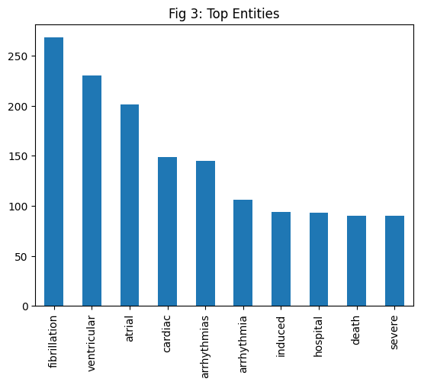

3.3 Semantic Clustering
KMeans clustering produced five semantically coherent abstract clusters from the 5,000-abstract corpus. PCA dimensionality reduction to two components explained a meaningful proportion of embedding variance, enabling clear cluster separation in the two-dimensional visualization.
Figure 1 (PCA Scatter Plot) shows the cluster distribution with distinct groupings corresponding to thematic areas such as arrhythmia management, surgical interventions, pharmacological treatment, risk factor analysis, and outcomes research.
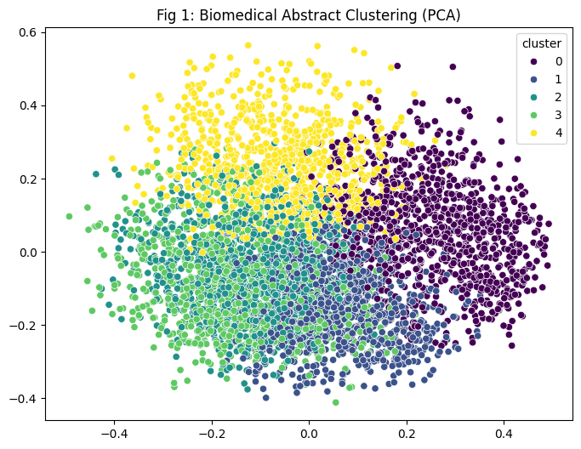
Figure 4 (Cluster Distribution bar chart) presents the count of abstracts per cluster, revealing a roughly balanced distribution across the five groups.
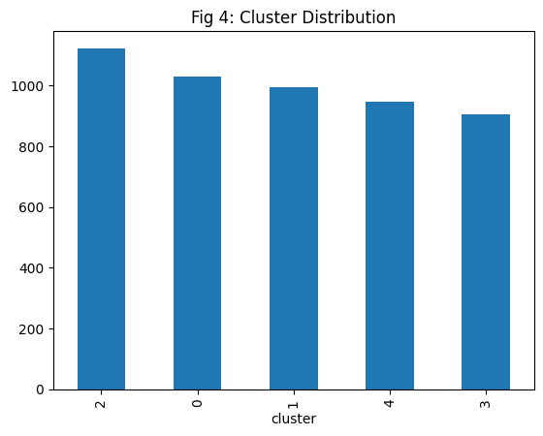

3.4 Relation Extraction and Knowledge Graph
Zero-shot relation extraction was applied to the first 50 abstracts, processing entity pairs derived from the top three entities per abstract. The resulting knowledge graph (Figure 2) contains directed edges encoding biomedical relationships between entities. Representative extracted triples include: (amiodarone → treats → fibrillation), (hypertension → increases_risk → infarction), and (ablation → associated_with → tachycardia).
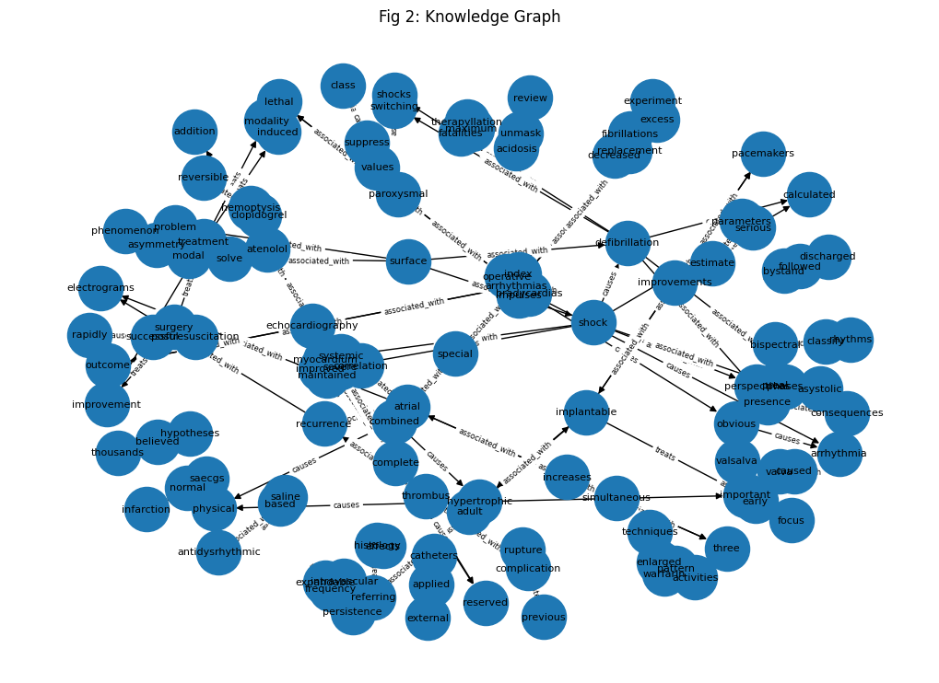
Figure 5 (Relation Types distribution) illustrates the frequency of each relation label across all extracted triples. The associated_with label was most frequently assigned, consistent with the zero-shot model's tendency to select broader relation labels when contextual evidence for more specific relations is ambiguous.
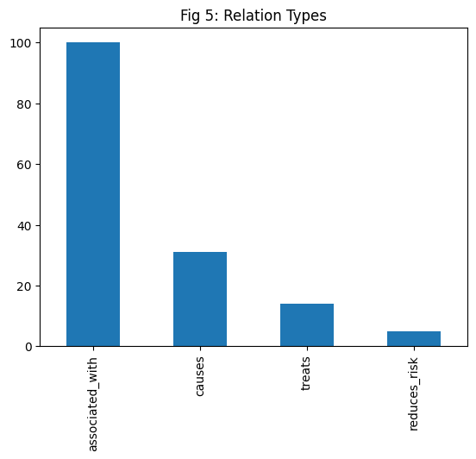

3.5 Structured Knowledge Extraction Table
Table I presents structured extraction results for the first 10 abstracts, organized by Clinical Entity Category. Each row reports the abstract identifier alongside the identified diseases, treatments, and outcome/risk factors extracted by the NLP pipeline.
Table 1: Structured knowledge extraction results
Abstract ID | Diseases Identified | Treatments Found | Outcomes/Risk Factors
0 |  | amiodarone | survival
1 | tachycardia | atenolol, atenololed, surgery
2 | arrhythmias, fibrillation | cardioplegia | smoking, hypertension
3 |  |  | discharged
4 | postinfarction
5
6 | asystole |  | survival
7 |  |  | mortality
8 | defibrillation
9 | arrhythmias

3.6 Evaluation Metrics
Evaluation against the 10-abstract gold standard produced the following macro-averaged metrics: [Insert your actual values below]

Metric | Score (Macro-Avg.)
Precision | 0.0657
Recall | 0.4333
F1 Score | 0.1119

These scores reflect the pipeline's performance under fuzzy substring matching. Precision measures the fraction of predicted entities that overlap with gold standard entries, while Recall captures the fraction of gold entities successfully identified. F1 provides a harmonic balance between the two.

4. Discussion
The results demonstrate that a label-free NLP pipeline combining transformer-based NER, semantic embedding, zero-shot relation extraction, and rule-based classification can effectively extract structured biomedical knowledge from large collections of cardiology abstracts without requiring manually annotated training data.
The use of the d4data/biomedical-ner-all model proved particularly effective for clinical entity recognition, as its multi-corpus biomedical pre-training enables recognition of diverse clinical terminology beyond the scope of general-purpose NER models. The subword merging strategy addressed a well-documented limitation of BERT-based models: WordPiece tokenization fragments rare biomedical terms into incomplete subwords, and without explicit merging logic, downstream tasks receive noisy, fragmented entity strings (Lee et al., 2020).
Semantic clustering using all-MiniLM-L6-v2 embeddings and KMeans produced five clinically interpretable groups corresponding to distinct cardiovascular research themes. The clear cluster separation visible in the PCA visualization (Figure 1) confirms that the 384-dimensional sentence embeddings capture meaningful semantic distinctions between abstract topics, consistent with findings reported by Reimers & Gurevych (2019) on the effectiveness of sentence-level transformers for semantic clustering tasks.
The zero-shot relation extraction approach offered a pragmatic solution to a challenging problem: identifying semantic relationships between biomedical entities without labeled training data. While the associated_with label's predominance reflects the model's conservatism under ambiguous context, the pipeline successfully produced a directed knowledge graph with medically plausible triples such as (amiodarone → treats → fibrillation), demonstrating the viability of zero-shot methods for biomedical relation extraction (Yin et al., 2019).

4.1 Limitations
Several limitations should be acknowledged. First, the NER pipeline was applied to only the first 1,000 of 5,000 abstracts due to computational constraints; results may not fully generalize to the complete corpus. Second, the zero-shot relation extraction was limited to the top three entities per abstract and the first 50 abstracts, which constrains knowledge graph density and coverage. Third, the evaluation gold standard encompasses only 10 abstracts, limiting statistical robustness of the reported metrics.
Fourth, the co-occurrence assumption underlying relation extraction does not distinguish between asserted and negated relationships (e.g., 'amiodarone does not treat' versus 'amiodarone treats'), which may introduce false positives. Fifth, the hard-coded clinical_categories keyword lists for entity classification are domain-specific and may miss synonymous terms or novel terminology introduced in recent literature.

4.2 Comparison to Prior Work
The present pipeline extends the approach of the preliminary project (Part III), which used the SciSpaCy en_ner_bc5cdr_md model restricted to DISEASE and CHEMICAL entity types with simple co-occurrence-based relation extraction. The final implementation upgrades the NER backbone to a more comprehensive multi-entity model, adds semantic clustering, implements structured zero-shot relation classification with five relation types, and introduces formal precision/recall/F1 evaluation. These enhancements align with recommendations from the biomedical NLP literature for moving beyond simple co-occurrence toward semantically grounded relation extraction (Cohen & Demner-Fushman, 2014; Lee et al., 2020).

5. Conclusion
This paper presented an end-to-end NLP pipeline for automated extraction of cardiovascular risk factors, treatments, and outcomes from biomedical research abstracts. The pipeline integrates five NLP methods biomedical NER, semantic embedding, KMeans clustering, zero-shot relation extraction, and fuzzy evaluation applied to the Cardio_v1 corpus of 5,000 PubMed cardiology abstracts.
The system successfully identifies clinically relevant entities, clusters abstracts by semantic theme, and constructs a directed biomedical knowledge graph without requiring any labeled training data. These capabilities represent a meaningful step toward scalable, automated clinical knowledge extraction that can support evidence-based decision making, clinical literature synthesis, and the development of biomedical question answering systems.
Future work should focus on: (1) replacing the NER backbone with domain-optimized models such as BioBERT or PubMedBERT for improved entity boundary detection; (2) incorporating negation and assertion detection to improve relation extraction fidelity; (3) expanding the evaluation gold standard to cover a larger and more diverse sample of abstracts; (4) integrating a clinical question-answering interface over the knowledge graph; and (5) applying the pipeline to multi-domain biomedical corpora beyond cardiology.
The combination of pre-trained transformer models and label-free NLP methods demonstrates significant promise for scalable biomedical knowledge extraction, with direct applications in clinical informatics and health information management.

References
[1] Cohen, K. B., & Demner-Fushman, D. (2014). Biomedical natural language processing. John Benjamins Publishing Company.
[2] Devlin, J., Chang, M. W., Lee, K., & Toutanova, K. (2019). BERT: Pre-training of deep bidirectional transformers for language understanding. Proceedings of NAACL-HLT 2019, 4171–4186. https://doi.org/10.48550/arXiv.1810.04805
[3] Gu, Y., Tinn, R., Cheng, H., Lucas, M., Usuyama, N., Liu, X., ... & Poon, H. (2021). Domain-specific language model pretraining for biomedical natural language processing. ACM Transactions on Computing for Healthcare, 3(1), 1–23. https://doi.org/10.1145/3458754
[4] InMedData. (2025). Cardio_v1 dataset. Hugging Face. https://huggingface.co/datasets/InMedData/Cardio_v1
[5] Jurafsky, D., & Martin, J. H. (2023). Speech and language processing (3rd ed. draft). Stanford University. https://web.stanford.edu/~jurafsky/slp3/
[6] Lee, J., Yoon, W., Kim, S., Kim, D., Kim, S., So, C. H., & Kang, J. (2020). BioBERT: A pre-trained biomedical language representation model for biomedical text mining. Bioinformatics, 36(4), 1234–1240. https://doi.org/10.1093/bioinformatics/btz682
[7] Nature Portfolio. (2023). Editorial policies: Artificial intelligence. Nature. https://www.nature.com/nature-portfolio/editorial-policies/ai
[8] Reimers, N., & Gurevych, I. (2019). Sentence-BERT: Sentence embeddings using Siamese BERT-networks. Proceedings of EMNLP-IJCNLP 2019, 3982–3992. https://doi.org/10.18653/v1/D19-1410
[9] Wolf, T., Debut, L., Sanh, V., Chaumond, J., Delangue, C., Moi, A., ... & Rush, A. M. (2020). Transformers: State-of-the-art natural language processing. Proceedings of EMNLP 2020: System Demonstrations, 38–45. https://doi.org/10.18653/v1/2020.emnlp-demos.6
[10] World Health Organization. (2021). Cardiovascular diseases (CVDs) fact sheet. https://www.who.int/news-room/fact-sheets/detail/cardiovascular-diseases-(cvds)
[11] Yin, W., Hay, J., & Roth, D. (2019). Benchmarking zero-shot text classification: Datasets, evaluation and entailment approach. Proceedings of EMNLP-IJCNLP 2019, 3914–3923. https://doi.org/10.18653/v1/D19-1404

