The DWR subprocess is located at Construction > Contract. It is a collection of Daily Work Report (DWR) records reflecting the Inspector or Project Manager’s (PM) daily record of construction activity on a specific contract for a specific day. An Inspector will submit one DWR per day to the PM. The PM will indicate if the record is authorized for inclusion in the Diary, or return to the Inspector for modifications and resubmission.
- Requires Work Group = Contracts
- Created by Inspector or PM
- Inspectors will only see the DWRs they created. PMs will only see DWRs that are in a Draft or Pending status. PMs will have the ability to review DWR detail for their inspectors in the Diary process.
- Primary Pm can Deny a Draft or pending DWR if the Creator is not assigned to the Contract.
- If DWR Remark is rejected by PM then DWR status will display Draft.

When Accepted For Maintenance
- Draft DWRs may be Added by Inspector or PMs
- Draft DWRs may be Deleted by creator
- Draft DWRs may be Submitted by creator; status = Pending
- Draft/Pending DWRs may be Approved from Primary PM’s DWR Summary
  - On Approve, DWR status = Approved on creator’s window; detail remains if PM is creator, else cleared from PM’s DWR Summary
- Draft/Pending DWRs may be Denied from Primary PM’s DWR Summary
  - If Denied, detail row is removed from PM DWR Summary
  - Once Denied the Inspectors denied DWR will Remain on Inspectors Summary Screen with Status of Denied

When Final Estimate Paid Key Date exists
- No additional DWRs may be created

DWR Summary
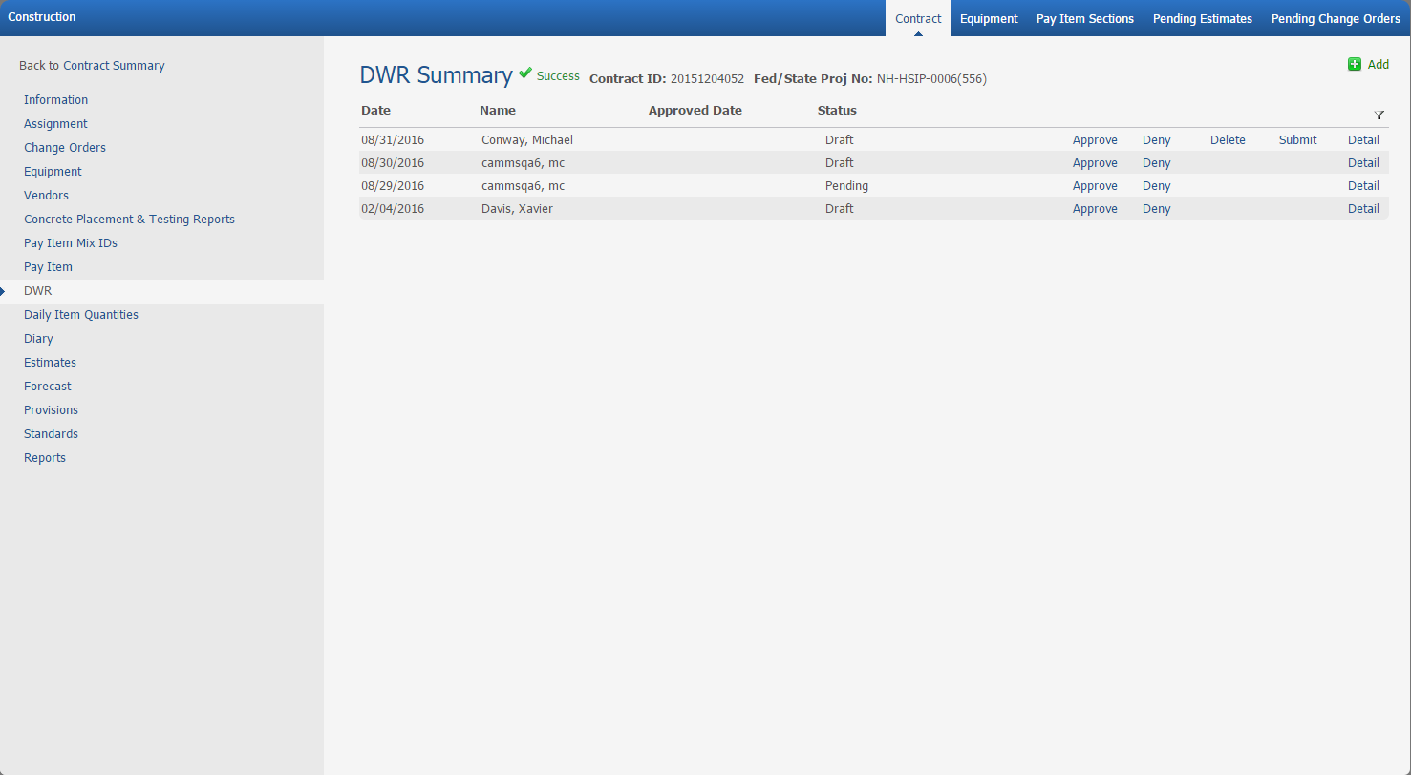

Label, * = req’d | Type, Format | Description, Calculation, Etc.
Header | Standard | Contract ID, Fed/State Proj No
Add | Link | Function that navigates user to DWR Add window.
Date | DD/MM/YYYY | Date selected by Inspector or PM for which the DWR is to be created.
Name | CHAR(??) | Name of Inspector or PM that created the DWR.
Approved Date | DD/MM/YYYY | Date the DWR was authorized on the Diary.
Status |  | - Draft = DWR in progress and not submitted for PM review/use on Diary. Converted, unauthorized legacy enter in Draft and will only be visible to creator.  - On initial Draft status, Inspector may delete DWR.  - Additional edits while in Draft status do not require additional reasons.  - Pending = Submitted for PM review/use on Diary.  - Approved = PM marked content at Diary as Include (all DWR detail included, and Remarks included) or Exclude (all DWR detail included, but Remarks excluded.)  - Estimate generated that retrieved this Authorized DWR.  - Once approved, if DWR is modified, deletion is not allowed, regardless of status.  - If Inspector edits an Approved DWR, Status updates to Draft, Change Remark Titled “Change Reason” is required, and re-submission resumes. Change Remark will display under associated Diary > DWR Info, but will not display on PDF. On DWR approval, Change Remark box will be suppressed.  - Amended = Remark is added after DWR is Approved and date is included in Estimate.  - If Inspector Edits a Locked DWR (in use at DIQ) by Add of new Remark only, then Remark Status updates to Amended.  If user is PM and Primary Assignment to Contract Or if User is in Chain of Command then they will be able to see the following Status: their own Approved, Pending, and Draft DWR’s.
Submit | Link | Function allows worker to indicate that DWR edits are complete, and submits DWR for PM review/use on Diary.
Deny | Link | Only displays for PM when a DWR is in Draft and Pending.
Approve | Link | Only displays for Primary PM if contract has been Accepted for Maintenance.
Detail | Link | Function that navigates user to DWR Detail window. User will land on Details Tab.  NOTE: Link returns user to last occupied tab, i.e., if user last worked on Remarks tab, then link navigates to that position.
Delete | Link | Delete DWR allowed prior to initial submission to PM; deletion disallowed from that point on.
Other |  | - Column headers contain standard sort and filter.  - Subprocess is visible with Add privileges to any worker with a contract assignment.  - DWR Summary content ordered Date DESC, Name ASC.  - When Accepted for Maintenance date is entered and there are DWR’s in Draft and Pending the Primary PM can either Approve or Deny the entry.

DWR Add
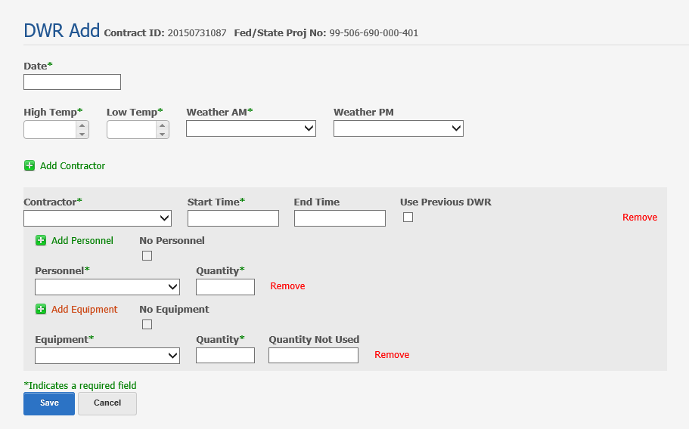

Label, * = req’d | Type, Format | Description, Calculation, Etc.
Header | Standard | Contract ID, Fed/State Proj No
Date* | DD/MM/YYYY | Date the daily work report was created to specify work occurred on the contract.  User enterable or select from calendar.  Allow historical entry.
High Temp* | ### | Highest temp recorded for the day.  User enterable or use arrows; three-digit temp requires manual entry.  Max entry is 125  Min entry is -40  Recorded as Fahrenheit, regardless of contract’s Unit System.
Low Temp* | ### | Lowest temp recorded for the day.  User enterable or use arrows; three-digit temp requires manual entry.  Max entry is 125  Min entry is -40  Disallow low temp greater than high temp.  Recorded as Fahrenheit, regardless of contract’s Unit System.
Weather AM* | Defined list | AM Weather recorded by DWR creator:  Clear  Partly Cloudy  Overcast  Rain  Foggy  Sleet  Hail  Snow
Weather PM | Defined list | PM Weather recorded by DWR creator:  Clear  Partly Cloudy  Overcast  Rain  Foggy  Sleet  Hail  Snow
Add Contractor | Link | Inserts data box to collect details.  Contractor is optional
Contractor* | Defined list | Contractor is auto-inserted when the DIQ Pay Item Contractor is selected, if not already on the day’s DWR.  Edit checks to ensure that DWR inserted contractor exists on the associated DIQ.  Onsite Prime or Subcontractor vendors recorded by DWR creator.  Prime vendor name will be prepended with “Prime – Vendor Name” in picklist and on display.  Prime will display first, then Subcontractors case insensitive.
Start Time* | HH:MM TT | Time work for the day started on the contract.  User enterable or select from sliders.  Start Time must precede End Time.  Time may be entered in 12 or 24-hour formats, but will be converted to 12-hour display.
End Time | HH:MM TT | Time work for the day ended on the contract.  User enterable or select from sliders.  Time may be entered in 12 or 24-hour formats, but will be converted to 12-hour display.  End time may precede Begin Time to accommodate overnight jobs.  End Time becomes required in order to approve a DWR.
Use Previous DWR | Checkbox | Contractor-specific checkbox that will copy the previous day’s DWR detail for Personnel and Equipment for that Contractor.
Remove |  | Allows associated data to be removed.  If selected at the Contractor level, also removes added Personnel and Equipment.
Add Personnel | Link | Inserts data box to collect details.
No Personnel | Check Box | Check box if no personnel onsite.
Personnel* | Defined list | - FOREMAN, LABORERS - Skilled, LABORERS - Unskilled, OPERATORS, OTHERS (requires Remark.)  - List will include SUPERINTENDENT if selected Contractor is Prime and a Superintendent is assigned to the contract.  - If a worker is assigned to the contract as Superintendent, worker name will be prepended with “Supt – Worker Name.”  - Converted legacy workers assigned as Supervisor/Foreman and/or Superintendents will be created, if necessary, but Assignments and Worker Status will be set to Inactive.
Quantity* | ## | Numeric field indicating count of Personnel.  Max entry is 99.  If Personnel = Superintendent, Quantity set to 1.
Remove | Link | Allows associated data to be removed.
Add Equipment | Link | Inserts data box to collect details.
Equipment* | Defined list | Select from defined list of contract-assigned equipment.
Quantity* (total pieces available) | ## | Numeric count of total equipment pieces onsite.  Min entry is 0, Max entry is 99.
Quantity Not Used | ## | Count of equipment pieces onsite but not used.  May not exceed Quantity (total pieces available.)  Quantity may not be negative.
Remove |  | Allows associated data to be removed.
Save |  | Function that stores user entry.  Writes a record to the DWR Summary window.
Cancel |  | Function that clears any user updates, if executed before Save.
Other |  | CONST P&P: If Equipment is not used and relevant work performed, annotate at Remark > Remark Type = Contractor Activities.
 |  | Legacy DWR Paid, DWR Locked indicators, and Staff Members detail was not converted.

DWR Detail > Detail Tab
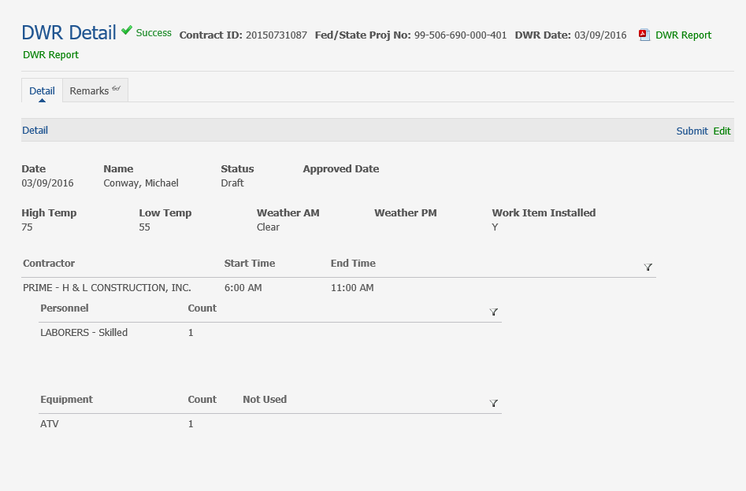

Label, * = req’d | Type, Format | Description, Calculation, Etc.
Header | Standard | Contract ID, Fed/State Proj No, DWR Date
DWR Report | PDF | Generates an Unofficial PDF Screen Capture Report
DWR Report | Link | Generates DWR Report.
DWR Summary | Link | Navigates user to DWR Summary window.
Submit | Link | Submits finished DWR report to PM for review/inclusion on Diary.  DWR Status updates to Pending.
Edit | Link | Navigates user to DWR Edit window.  Link suppressed if DWR is Approved on Diary.
Date | MM/DD/YYYY | Date the daily work report was created to specify work occurred on the contract.
Name |  | Inspector or PM that created the DWR.
Status |  | Reflects the status of the DWR.  - Draft = Default status until DWR is submitted to PM.  - Pending = DWR submitted to PM.  - Approved = PM approved DWR for inclusion on Diary.
Approved Date |  | Date the DWR was approved on the Diary.
High Temp | ### | Displays Temp that was entered on DWR Add.
Low Temp | ### | Displays Temp that was entered on DWR Add.
Weather AM |  | Displays Weather that was selected on DWR Add.
Weather PM |  | Displays Weather that was selected on DWR Add.
Work Item Installed |  | Indicates whether work items were installed in that’s day’s Field Book entry.  Y = work Items installed  N = no work items installed
Contractor |  | Displays Contractor that was selected on DWR Add
Start Time | HH:MM TT | If converted from legacy, the DWR Start Time will apply to all legacy Contractors. If converted legacy was null, value was defaulted to 12:00 AM and General Remark “No Data to Convert” was inserted.
End Time | HH:MM TT | If converted from legacy, the DWR End Time will apply to all legacy Contractors. If converted legacy was null, value was defaulted to 12:00 AM and General Remark “No Data to Convert” was inserted.
Personnel |  | If converted from legacy, contractor Supervisor/Foreman will only display as Superintendent if their Contractor is Prime.
Count | Number Field | Reflects Quantity of Personnel.
Equipment |  | Note: Legacy Storage Trailer was changed to Roadbed Processor at some point in time.
Count | Number Field | Reflects Quantity of Equipment.
Not Used | Number Field | Count of Equipment pieces onsite, but not used.
Other |  | Conversion was coded to exclude legacy DWR Daily Staff detail.

DWR Edit
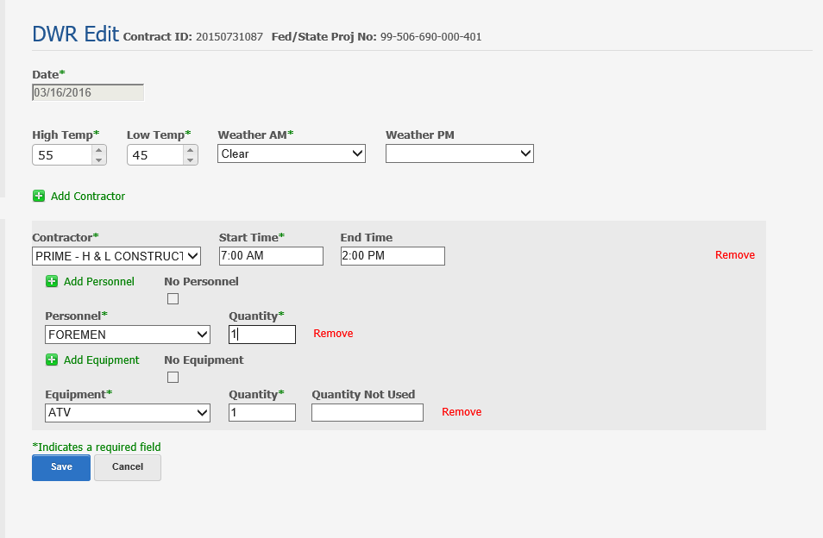

Label, * = req’d | Type, Format | Description, Calculation, Etc.
Header | Standard | Contract ID, Fed/State Proj No
Date* | DD/MM/YYYY | Date the daily work report was created to specify work occurred on the contract.  User enterable or select from calendar.  Allow historical entry.
High Temp* | ### | Highest temp recorded for the day.  User enterable or use arrows; three-digit temp requires manual entry.  Max entry is 125  Min entry is -40  Recorded as Fahrenheit, regardless of contract’s Unit System.
Low Temp* | ### | Lowest temp recorded for the day.  User enterable or use arrows; three-digit temp requires manual entry.  Max entry is 125  Min entry is -40  Disallow low temp greater than high temp.  Recorded as Fahrenheit, regardless of contract’s Unit System.
Weather AM* | Defined list | AM Weather recorded by DWR creator:  Clear  Partly Cloudy  Overcast  Rain  Foggy  Sleet  Hail  Snow
Weather PM | Defined list | PM Weather recorded by DWR creator:  Clear  Partly Cloudy  Overcast  Rain  Foggy  Sleet  Hail  Snow
Add Contractor | Link | Inserts data box to collect details.  Contractor is optional
Contractor* | Defined list | Contractor is auto-inserted when the DIQ Pay Item Contractor is selected, if not already on the day’s DWR.  Edit checks to ensure that DWR inserted contractor exists on the associated DIQ.  Onsite Prime or Subcontractor vendors recorded by DWR creator.  Prime vendor name will be prepended with “Prime – Vendor Name” in picklist and on display.  Prime will display first, then Subcontractors case insensitive.
Start Time* | HH:MM TT | Time work for the day started on the contract.  User enterable or select from sliders.  Start Time must precede End Time.  Time may be entered in 12 or 24-hour formats, but will be converted to 12-hour display.
End Time | HH:MM TT | Time work for the day ended on the contract.  User enterable or select from sliders.  Time may be entered in 12 or 24-hour formats, but will be converted to 12-hour display.  End time may precede Begin Time to accommodate overnight jobs.  End Time becomes required in order to approve a DWR.
Use Previous DWR | Checkbox | Contractor-specific checkbox that will copy the previous day’s DWR detail for Personnel and Equipment for that Contractor.
Remove |  | Allows associated data to be removed.  If selected at the Contractor level, also removes added Personnel and Equipment.
Add Personnel | Link | Inserts data box to collect details.
No Personnel | Check Box | Check box if no personnel onsite.
Personnel* | Defined list | - FOREMAN, LABORERS - Skilled, LABORERS - Unskilled, OPERATORS, OTHERS (requires Remark.)  - List will include SUPERINTENDENT if selected Contractor is Prime and a Superintendent is assigned to the contract.  - If a worker is assigned to the contract as Superintendent, worker name will be prepended with “Supt – Worker Name.”  - Converted legacy workers assigned as Supervisor/Foreman and/or Superintendents will be created, if necessary, but Assignments and Worker Status will be set to Inactive.
Quantity* | ## | Numeric field indicating count of Personnel.  Max entry is 99.  If Personnel = Superintendent, Quantity set to 1.
Remove | Link | Allows associated data to be removed.
Add Equipment | Link | Inserts data box to collect details.
Equipment* | Defined list | Select from defined list of contract-assigned equipment.
Quantity* (total pieces available) | ## | Numeric count of total equipment pieces onsite.  Min entry is 0, Max entry is 99.
Quantity Not Used | ## | Count of equipment pieces onsite but not used.  May not exceed Quantity (total pieces available.)  Quantity may not be negative.
Remove |  | Allows associated data to be removed.
Save |  | Function that stores user entry.  Writes a record to the DWR Summary window.
Cancel |  | Function that clears any user updates, if executed before Save.
Other |  | CONST P&P: If Equipment is not used and relevant work performed, annotate at Remark > Remark Type = Contractor Activities.
 |  | Legacy DWR Paid, DWR Locked indicators, and Staff Members detail was not converted.

DWR Edit of Approved DWR
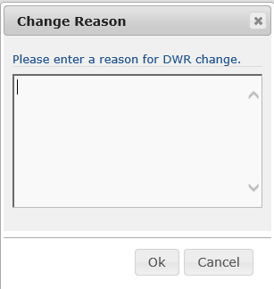

Label, * = req’d | Type, Format | Description, Calculation, Etc.
Change Reason |  | This field will display if Inspector Edits Approved DWR
Reason For DWR Change | Clob | Enter Reason for Editing Approved DWR
Ok | Button | Button will Save Change Reason To DWR Remarks Tab
Cancel | Button | Button will Redirect Inspector to DWR Edit

DWR Detail > Remarks Tab
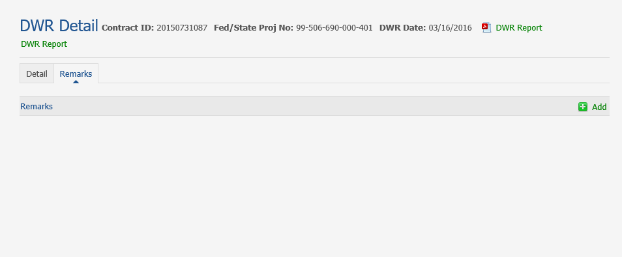
Label, * = req’d | Type, Format | Description, Calculation, Etc.
Header | Standard | Contract ID, Fed/State Proj No, DWR Date
Remarks |  | Navigates user to Remarks tab to view added DWR Remarks.  Converted legacy will display the text preceded by legacy ‘Vendor ID – Equipment/Personnel IDs’.
Add | Link | Function navigates user to DWR Add in order to insert Remarks associated with the DWR.  Link is not suppressed if DWR is approved.  Defaulted status for converted legacy records is Pending.
Remark Type | Defined list | Type of remark selected at Remark Add or Edit window.
Remark |  | Remark text entered at Remark Add or Edit window.
Status |  | - Pending = at Diary for review, but not yet included on PM’s Diary, or record is converted legacy detail.  - Include = PM included on Diary; remark not editable.  - Reject = PM desires the Inspector’s remark to be edited before including on Diary.  - Exclude = PM accepts Inspector’s remarks, but will exclude from Diary; remark not editable.
Edit | Link | Function navigates user to DWR Edit in order to modify Remark Type or text.
Delete | Link | Function allows deletion of Remark if Remark Status is Pending or Reject.  If Remark Status = Include or Exclude, deletion not allowed.

DWR Remark Add
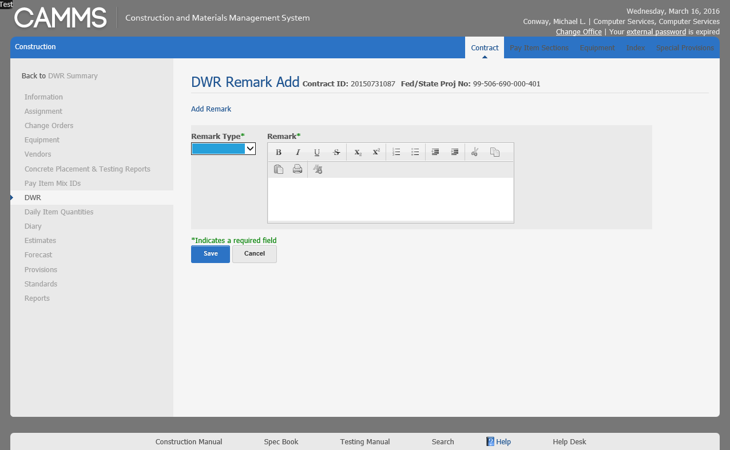
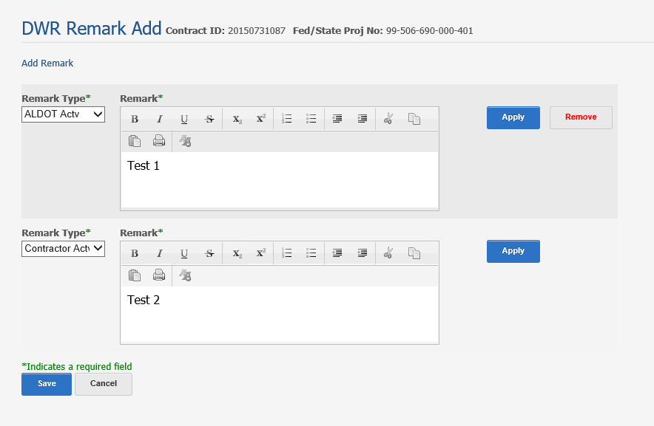

Label, * = req’d | Type, Format | Description, Calculation, Etc.
Header | Standard | Contract ID, Fed/State Proj No
Add Remark | Link | Allow inspector to enter Multiple Remarks.
Remark Type* | Defined list | Type of remark selected at Remark Add or Edit window.
Remark* |  | Remark text entered at Remark Add or Edit window.
Apply | Link | Will be visible once Remark field has information entered  - This will allow the inspector to enter multiple remarks without having to save all at once. User will select apply and the remark will be saved from that point.
Remove | Link | Will be visible once the Add Remark has been selected to add multiple remarks. However the Original Remark type and Remark fields will not display a Remove Link.
Save |  | Function that stores user entry; writes a record to the DWR Summary window.
Cancel |  | Function that clears any user updates, if executed before Save.
Other |  | Each Remark Type may only be used once per DWR.

Remark Type | Definition
ALDOT Activities | Document work by Project Inspection staff and decisions made.
Contractor Activities | Document work by the Contractor and its subcontractors.
Crashes | Document basic info for crash (aka accident) such as location, time and impact on traffic or contractor’s work, if applicable. Do not include info on those involved, cause or any details included in Crash Report.
DBE/EEO | Can track issues like DBE Interviews and non-performance.
NOI/Claims | Should be tracking things like NOI filed, weekly meeting held, issues concerning the claim, when it is over, claim submitted, etc.
Railroad | Should be tracking RR flagmen here.
Stormwater | Most records should be in SWTS. However, should include comments for upset events, ADEM inspections, and NOVs as well as inspections for any non-permit project.
Traffic Control | Document when C-25 inspections were done daily, traffic shifts, and TC changes.
Utilities | Remarks for non-contract relocation work, utility location spotting, and comments about conflicts.
Visitors
Weather | Document when you need to elaborate on weather conditions.

DWR Remark Edit
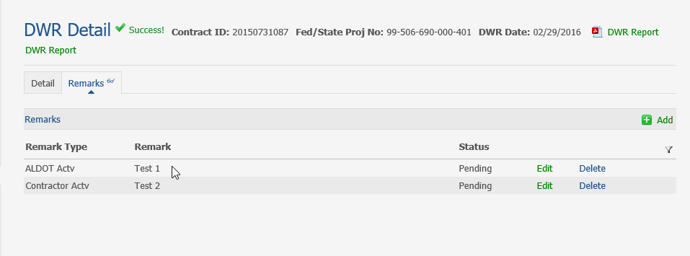
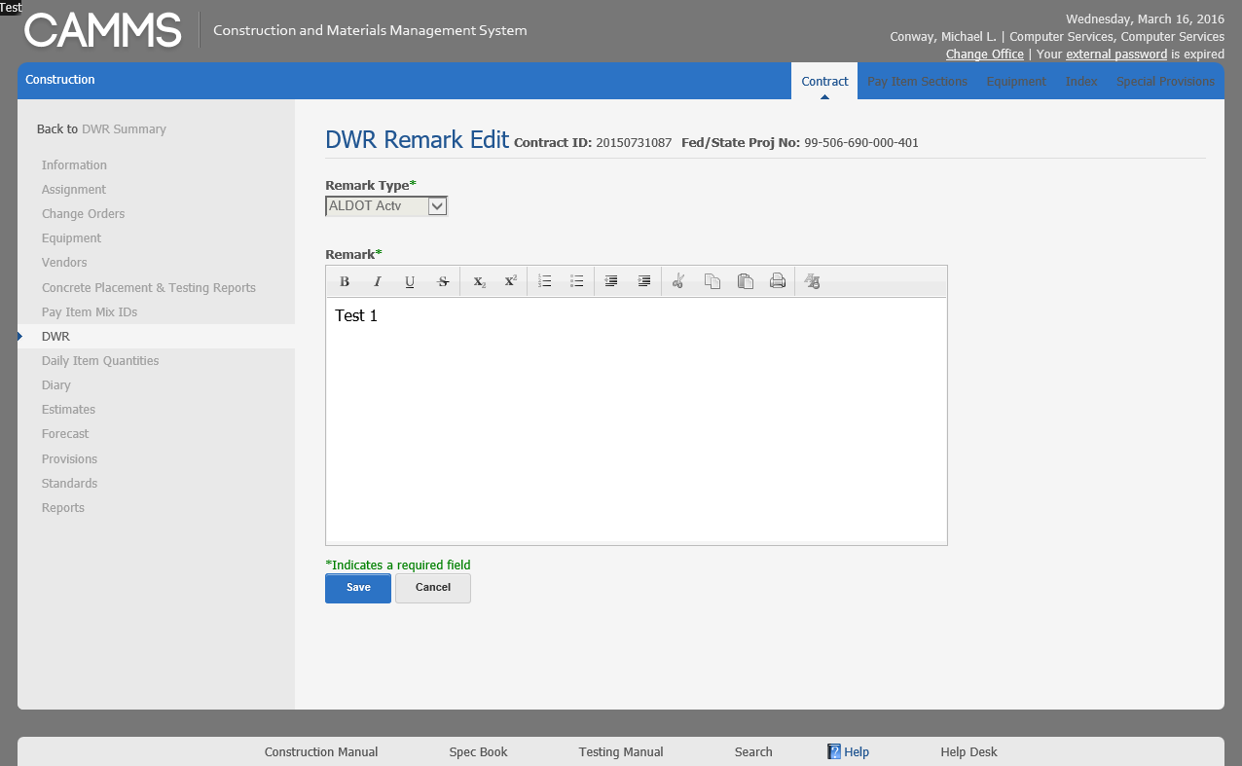

Label, * = req’d | Type, Format | Description, Calculation, Etc.
Header | Standard | Contract ID, Fed/State Proj No
Remark Type | Defined list | Remark Type is disabled on Edit.
Remark* |  | Remark text entered at Remark Add or Edit window.
Save |  | Function that stores user entry; writes a record to the DWR Summary window.
Cancel |  | Function that clears any user updates, if executed before Save.

