**Figure 1**

**Left Panel**: A scatter plots of records with both High FICO score High Interest Rate which is one of the created subsets containing records that are inconsistent (counter-intuitive) with the expected relationship between FICO scores and interest rates. The color of the dots (Light Blue = 60 month loan length, Dark Blue = 36 month loan length) illustrates the influence that loan length has on interest rates. The majority of the dots are light blue, meaning a 60 month loan length is related to the High FICO score High Interest Rate subset.

**Right Panel**: A scatter plots of records with Low FICO score High Interest Rate which is one of the created subsets contained records that are consistent with the expected relationship between FICO scores and interest rates. The color of the dots (Light Blue = 60 month loan length, Dark Blue = 36 month loan length) illustrates the influence that loan length has on interest rates. The majority of the dots in the lower quadrants are dark blue, meaning a 36 month loan length is related to the lower interests rates portion of the Low FICO score High Interest Rate subset, while the majority of the dots in the upper quadrants are light blue, meaning a 60 month loan length is related to the higher interests rates portion.

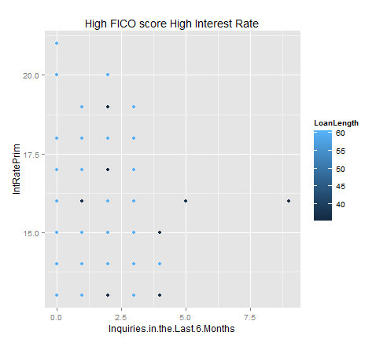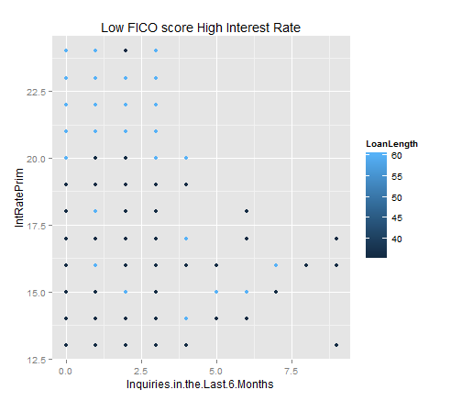

Light Blue = 60 month loan length, Dark Blue = 36 month loan length