**Figure 1**

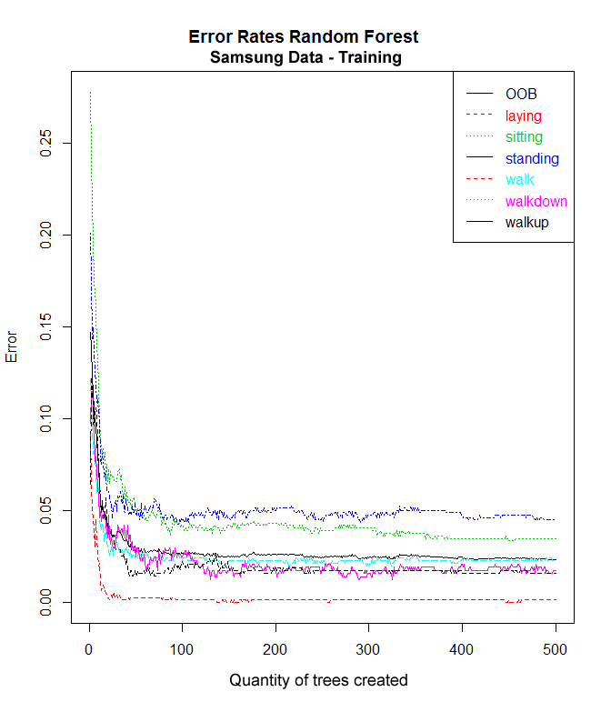A random forest model is typically made up of hundreds of decision trees. The graph below shows the decreasing model error as the quantity of trees increase. The activities that this model had the most difficulty estimating were *standing* and *sitting*. Note how the error rate for the activity ***standing*** (colored in **royal blue**) hovers near 5% and varies little after only a few dozen decision trees are grown, while the error rate for the activity ***sitting*** (colored in **green**) continues to improve even after 300+ decision trees are grown but never falls as low as the other activities (laying, walking, walking up and walking down). Out-of-bag (OOB) data are used to get an unbiased estimate of the classification error as trees are added to the forest. The **OOB** estimate of error rate for this random forest was: 2.34%