Assessing the DevOps Landscape:A Focus on Quality Metrics

Kyathi Rama Indu Mythri Vitta  
*Dept. of Computer Science and Engineering*   
*Koneru Lakshmaiah Education Foundation,Green Fields, Vaddeswaram,Guntur,*522302,Andhra Pradesh,India.  
[induvitta@gmail.com](mailto:induvitta@gmail.com)

Uma Venkat Mamidala  
*Dept. of Computer Science and Engineering*   
*Koneru Lakshmaiah Education Foundation,Green Fields, Vaddeswaram,Guntur,*522302,Andhra Pradesh,India.  
[umavenkatmamidala@gmail.com](mailto:umavenkatmamidala@gmail.com) Shanmukh Ikkurthi  
*Dept. of Computer Science and Engineering*   
*Koneru Lakshmaiah Education Foundation,Green Fields, Vaddeswaram,Guntur,*522302,Andhra Pradesh,India.  
[shanmukhikkurthi9@gmail.com](mailto:shanmukhikkurthi9@gmail.com)

Siva Nageswara Rao G  
*Dept. of Computer Science and Engineering*   
*Koneru Lakshmaiah Education Foundation,Green Fields, Vaddeswaram,Guntur,*522302,Andhra Pradesh,India.  
[sivnags@kluniversity.in](mailto:sivnags@kluniversity.in) Yamini Naganjali Sivarathri  
*Dept. of Computer Science and Engineering*   
*Koneru Lakshmaiah Education Foundation,Green Fields, Vaddeswaram,Guntur,*522302,Andhra Pradesh,India.  
[yaminisivarathri19@gmail.com](mailto:yaminisivarathri19@gmail.com)

*Abstract*— A new model called DevOps breaks down the old divisions between the development and operations teams, allowing for quick software delivery and agile reactions to changing requirements. Considerable progress has been made in recent years to better align DevOps phases with tools and processes in order to improve software quality and optimize the delivery pipeline. There is still a noticeable lack of consistency in the research community's efforts to explore themes related to DevOps, and there is a dearth of thorough surveys that cover quality engineering features. In order to close this gap, a thorough analysis of recent DevOps research projects is conducted in this study. The emphasis is on classifying these initiatives according to the main contributions they provide to the various phases of the DevOps lifecycle. By combining the body of current knowledge The study explores many facets of DevOps, including as its theoretical foundations, real-world applications, and related difficulties. The relationship between development and operations is explored, with a focus on how DevOps approaches enable software delivery that is continuous and allows for quick response to changing requirements. This paper examines the current suite of tools and methodologies used in different DevOps stages and clarifies how well they work to enhance software quality and the delivery process as a whole. The study attempts to drive future research paths by categorizing research activities according to their main areas and contributions, enabling a more comprehensive and integrated knowledge of quality engineering concepts within the developing DevOps paradigm. Researchers, practitioners, and businesses looking to improve software quality and delivery efficiency while navigating the complicated DevOps landscape should find value in the study's findings

Keywords— DevOps, Quality Metrics, Software Development, Continuous Integration, Automation

# Introduction

Organizations are progressively implementing DevOps principles in the rapidly changing field of software development in order to improve teamwork, automate procedures, and accelerate the delivery of high-caliber software. Combining development and operations, DevOps emphasizes continuous integration, continuous delivery, and continuous improvement. It is a cultural transformation. When companies begin their DevOps journey, it is critical to do a thorough landscape assessment, paying special attention to the quality indicators that support the effectiveness of these techniques. Assessing the DevOps environment is important because it can provide information about how successful, dependable, and efficient the software development lifecycle is as a whole. This study examines the complex relationship between quality measures and DevOps approaches, emphasizing that speed and agility shouldn't come at the expense of quality. With a focus on the metrics that act as gauges for software quality, this article attempts to explore the many facets of evaluating the DevOps environment. By doing this, we hope to offer a thorough grasp of the condition of DevOps techniques at the moment, point out problems, and suggest solutions. This research aims to provide insightful analysis of quality measures in the context of DevOps, which will add to the continuing conversation on how to optimize software development processes in a time of rapid technical advancement and elevated user expectations.

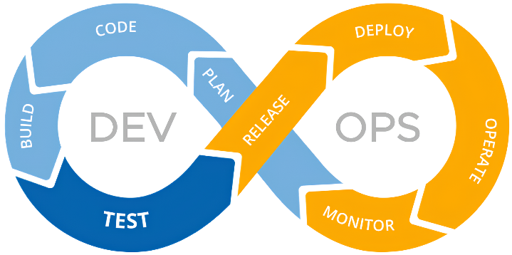

Fig1.Overview of Devops

## 1.1.The DevOps Cycle:

The DevOps cycle is an iterative, continuous process that unifies operations and development to improve teamwork, streamline processes, and release software more quickly. The cycle usually consists of multiple important phases, all of which help to accomplish the ultimate objective of having a smooth and effective pipeline for software development and delivery. The core phases of the DevOps cycle are as follows:

1.1.1.Organizing:

Goal: Clearly state the objectives, parameters, and needs of the software development project.

Activities: Work together to efficiently schedule sprints, establish priorities, and distribute resources across the development and operations teams.

1.1.2.Coding:

Goal: Create and create the code in accordance with the specifications of the project.

Activities: While maintaining version control and teamwork, developers write, test, and validate code.

1.1.3.Construction:

Goal: Creating executable artifacts from the source code is the goal.

Activities: Manage dependencies, compile code, and create executable files or packages using build automation tools. 1.1.4.Testing:

Goal: Confirm that the code satisfies quality requirements and performs as planned.

Activities: In order to find and address defects early in the development process, activities include automated testing, unit testing, integration testing, and user acceptance testing. 1.1.5.Combination:

Goal: Consolidate code modifications from several authors into a common repository.

Activities: To guarantee that the product continues to function as new features are added, Continuous Integration (CI) technologies automatically merge and test code updates. 1.1.6.Implementation:

Goal: Launch the application into the operational setting. Activities: By automating the deployment process, Continuous Deployment (CD) lowers the possibility of failures during deployment and increases its reliability. 1.1.7.Observing:

Goal: Monitor and assess the application's behavior and performance in real time.

Activities: Gather and examine data on system performance, user interactions, and application health using monitoring tools.

1.1.8.Comments and Enhancement:

Goal: The goal is to get input from operations and users in order to enhance upcoming development cycles.

Activities: Gather user input, keep an eye on system performance, and refine the development process to maximize effectiveness and fix any problems. The iterative process of planning, coding, creating, testing, integrating, deploying, monitoring, and optimizing software results in an approach to software development and delivery that is more agile and responsive for enterprises.

## 1.2. Continous Integration:

Software engineers that use continuous integration (CI) routinely merge their code changes into a shared repository, typically multiple times a day. An automated build process that includes code compilation, automated testing, and other quality checks verifies each integration. The main objective of continuous integration (CI) is to identify and fix integration faults as soon as feasible, which enhances software quality overall and expedites the development process.

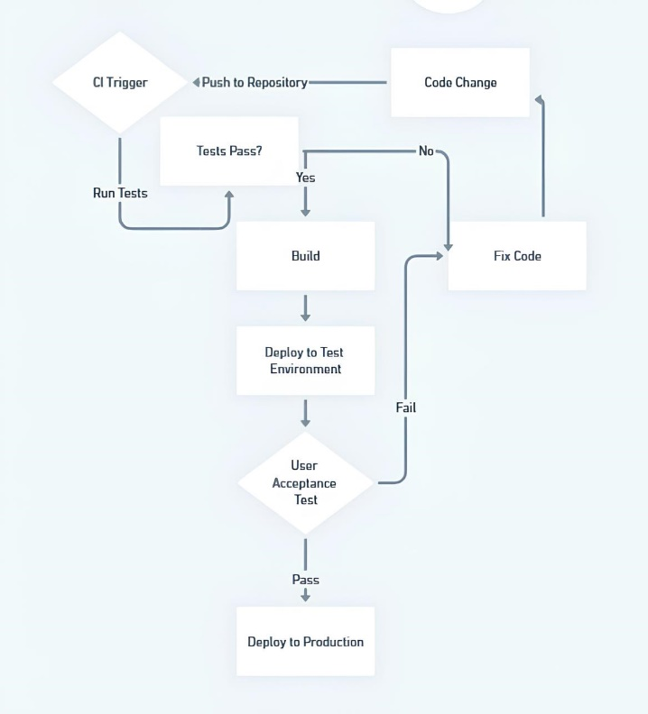

Fig2.Continuous Integration Workflow

# Literature Review

The author's research on evaluating DevOps with an emphasis on quality measures may have several goals, some of which could be as follows: Filling in a Knowledge Gap: By examining a topic that hasn't received much attention or where a thorough understanding is lacking, the author may hope to add to the corpus of current knowledge. Application in Practice: By keeping an eye on quality, the author hopes to offer businesses and practitioners useful advice and insights for implementing or enhancing DevOps processes. Resolving Real-World Issues: The author may try to address particular problems or obstacles that companies encounter while implementing DevOps techniques and offer suggestions or answers based on factual data. Advancing the topic: By suggesting fresh frameworks, procedures, or techniques for gauging quality measures and determining how successful DevOps practices are, the author may want to further the topic of DevOps. Contributing to Academic Discourse: By providing fresh viewpoints, approaches, or insights into the evaluation of DevOps quality measures, the author may hope to promote academic discussion and future research. The purpose of evaluating and assuring the efficacy, efficiency, and dependability of DevOps methods in producing high-quality software products is the emphasis of a quality metrics-based assessment of DevOps. Organizations may improve overall software quality, pinpoint areas for improvement, and streamline their DevOps procedures by methodically measuring different quality indicators. Insights regarding the effectiveness of DevOps projects are sought after by this evaluation, which will help companies make informed decisions, reduce risks, and enhance their software delivery pipelines over time. In the end, successful DevOps principles execution under strict quality standards should lead to faster time-to-market, increased customer happiness, and greater corporate value.

# Methodology

## Choosing the Right Quality Metrics:

Determine pertinent quality indicators using industry best practices and standards as a guide.Sort data according to several parameters, including lead time, incident response, code quality, and deployment frequency.

## Information Gathering:

Identify the sources of the data, such as incident management systems, monitoring tools, CI/CD pipelines, and version control systems.Use automated procedures for gathering data to guarantee consistency and accuracy.

## Design of a Case Study or Survey:

## Choose between gathering information through a survey of several firms or performing a case study inside a particular organization.Create an interview guide or questionnaire to get in-depth information on DevOps procedures.

## Analysis of Data:

## To examine quality measures, apply statistical methodologies and data visualization approaches.To find trends and patterns, correlate measurements.

## Evaluation Framework:

Provide a methodology for using quality metrics to evaluate the DevOps environment as a whole. Establish criteria or benchmarks for every indicator in order to assess performance.

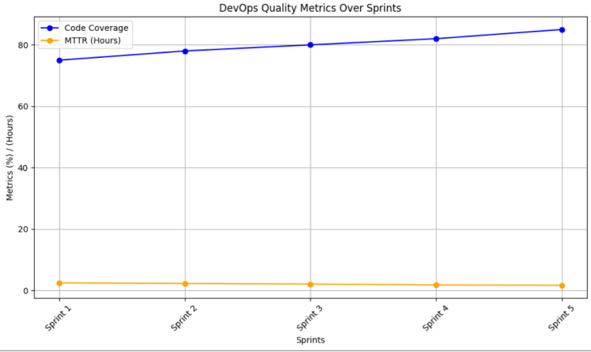

Fig3.Devops Quality Over Sprints

# Model Based DevOps

Using models or representations to explain, simulate, and automate different parts of the software development and operations lifecycle is commonly referred to as "model-based DevOps." When evaluating the DevOps environment with an emphasis on quality metrics, a model-based approach could take the following factors into account:

*A. Process Modelling:*

Use graphical models to explain the software development and delivery process. Workflow diagrams, swim lane diagrams, and other visual aids that show the interactions between various phases of the DevOps pipeline may be used to demonstrate this.

*B. Modelling Quality Metrics:*

Create models for quality metrics that are pertinent to the DevOps workflow. Models for code quality, test coverage, deployment success rates, and other software quality-related key performance indicators (KPIs) may fall under this category. Examine the possibilities for modelling automation in the context of the DevOps lifecycle. In order to demonstrate how automation helps to maintain and improve software quality, this could entail developing models for the processes of continuous integration, continuous deployment, and automated testing. Models can be used to simulate various situations and forecast how they would affect quality indicators. In the DevOps process, simulations can be used to find possible bottlenecks, hazards, and areas for improvement

*C. Integration of Quality measurements:*

Talk about the ways in which the DevOps process as a whole incorporates quality measurements. This entails gathering, examining, and applying high-quality data at different phases to promote ongoing development. Describe the approaches for feedback loops and monitoring that offer in-themoment insights into the functionality and caliber of the software. These models might cover how development and operations processes incorporate feedback from production settings.

# Quality Metrics

In the context of research, "quality metrics" refers to a range of quantitative and qualitative measures that are used to evaluate the importance, influence, and quality of scholarly work. The rigor, dependability, and usefulness of research output are assessed by academics, institutions, funding agencies, and other stakeholders with the aid of these indicators. The following is a summary of the main points about quality metrics in scholarly research:

## Analysis of Citations:

Impact Factor: A measure of a journal's significance determined by the typical number of citations each paper receives. Citation Indices: Citation counts for specific papers, authors, and journals are provided by resources such as Web of Science, Scopus, and Google Scholar. H-Index: Takes into account a researcher's total number of publications and citation counts to assess the productivity as well as the impact of their work. Tools for Citation Analysis: Programs and websites that examine citation trends and offer perceptions into the significance and impact of research.

## Review by peers:

Gold Standard: Prior to publication, peer review is regarded as the gold standard for assessing the caliber of research. Blind review reduces prejudice by having reviewers evaluate articles without knowing who the authors are. Open Peer Review: A more open method in which authors and occasionally the public are given access to the names and feedback of reviewers. Following Publication Peer review is a post-publication review procedure that facilitates continuous assessment and input.

## Replicability:

Reproducibility Crisis: Anxieties over numerous scientific studies' failure to reproduce their conclusions. Transparent Reporting: Increasing the repeatability and transparency of research is the goal of initiatives such as the Transparency and Openness Promotion (TOP) Guidelines. Registered Reports: To increase openness and lessen publication bias, peer-reviewed methods for research investigations are examined prior to data collection.

## Alternative metrics:

Alternative Metrics: Track research impact and reach using metrics other than typical citation counts, such as views, downloads, and mentions on social media. Online Attention: Alternative impact metrics are provided by Altmetric.com and other platforms that monitor mentions of study findings in a variety of online venues. Public Engagement: Metrics used to evaluate how research affects society and is used outside of academia

## Difficulties and Debates:

Gaming and Manipulation: Publishers and researchers may manipulate metrics to exaggerate the apparent significance of their work. Over-reliance on Quantitative Indicators: According to critics, a study's qualitative components may be neglected if only quantitative measurements are used. Equity and Diversity: Metrics may unintentionally reinforce prejudices against particular research areas, approaches, or marginalized populations.

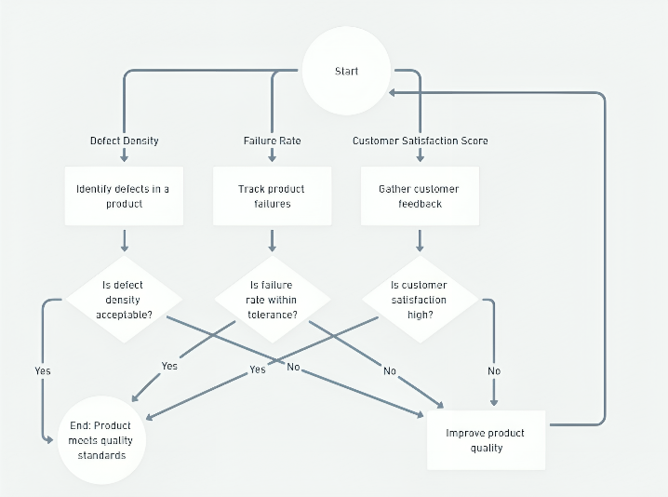

Fig4.Overview of Quality Metrics

# Results

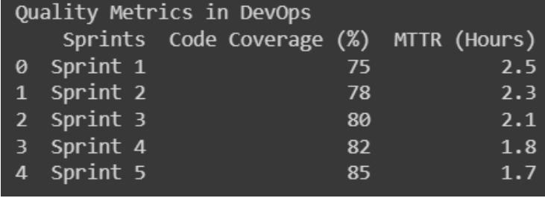

Fig5.Results for quality metrics

## Coverage of Code:

Over the course of the sprints, the code coverage rises steadily, from 75% in Sprint 1 to 85% in Sprint 5. This shows that over time, the fraction of the codebase covered by automated tests has improved.

## Mean Time to Recovery, or MTTR:

As the sprints go on, the mean recovery time gets shorter; it went from 2.5 hours in Sprint 1 to 1.7 hours in Sprint 5. This may indicate that the team is getting better at handling errors or occurrences, which will result in less downtime. All things considered, these findings offer insightful information about the caliber of the software development process under the DevOps setting. Delivering high-quality software products effectively requires ongoing improvement, which is demonstrated by the increased code coverage and reducing MTTR.

# Conclusion

To sum up, the literature research has shed light on how DevOps should be evaluated using quality measures. With its emphasis on cooperation, automation, and continuous improvement, DevOps has emerged as a key component of contemporary software development methodologies. When assessing the efficacy and efficiency of DevOps implementations, quality metrics are essential since they give firms practical insights into how to improve their software delivery procedures. Lead time and deployment frequency are two examples of efficiency indicators that help businesses assess the speed and agility of their DevOps pipelines. Metrics for reliability, such as mean time to failure and mean time to recovery, provide insight into the resilience and stability of software releases. Organizations may evaluate the capacity and performance of their DevOps infrastructure with the help of scalability metrics, which guarantee smooth scalability as demand increases. Security metrics emphasize how critical it is to measure security-related risks and vulnerabilities and include security into DevOps operations. The use of quality metrics in DevOps evaluation has advantages, but there are drawbacks as well, such as complicated tooling, difficult to interpret measurements, and corporate reluctance to change. Nonetheless, case studies and best practices show that businesses may get past these obstacles if they choose, apply, and evaluate metrics in a methodical manner. Future research and innovation opportunities are available to further develop the state-of-the-art in quality metrics-based DevOps assessment. New developments in machine learning, predictive analytics, and automated decision-making could improve the measuring and assessment capabilities of DevOps. To sum up, the literature analysis emphasizes how crucial it is to evaluate DevOps using quality measures in order to promote innovation and ongoing development in software delivery processes. Organizations may improve their DevOps activities, provide high-quality software more quickly, and maintain their competitiveness in the ever-changing market landscape of today by properly utilizing quality metrics.

##### References

1. M. Virmani, ‘‘Understanding DevOps & bridging the gap from continuous integration to continuous delivery,’’ in Proc. INTECH, May 2015, Available: http://ieeexplore.ieee.org/document/ 7173368/
2. J. Wettinger, U. Breitenbücher, and F. Leymann, ‘‘Devopslang-bridging the gap between development and operations,’’ in Proc. Eur. Conf. Service-Oriented Cloud Comput. Berlin, Germany: Springer, Sep. 2014, pp. 108–122.
3. A. Balalaie, A. Heydarnoori, and P. Jamshidi, ‘‘Microservices architecture enables DevOps: Migration to a cloud-native architecture,’’ IEEE Softw., vol. 33, no. 3, pp. 42–52, May 2016.
4. T. Schneider, ‘‘Achieving cloud scalability with microservices and DevOps in the connected car domain,’’ in Proc. Soft. Eng. CEUR, 2016, pp. 138–141.
5. A. Brunnert et al., ‘‘Performance-oriented DevOps: A research agenda,’’ 2015, arXiv:1508.04752. [Online]. Available: https://arxiv.org/ abs/1508.04752.
6. M. Miglierina and D. A. Tamburri, ‘‘Towards omnia: A monitoring factory for quality-aware DevOps,’’ in Proc. ICPE ACM/SPEC, 2017, pp. 145–150.
7. Y. Zhao, A. Serebrenik, Y. Zhou, V. Filkov, and B. Vasilescu, ‘‘The impact of continuous integration on other software development practices: A large-scale empirical study,’’ in Proc. ASE. Urbana, IL, USA: IEEE, Oct. 2017, pp. 60–71. [Online]. Available: http://ieeexplore. ieee.org/document/8115619/
8. L. J. Bass, I. M. Weber, and L. Zhu, DevOps—A Software Architect’s Perspective (SEI Series in Software Engineering). Reading, MA, USA: Addison-Wesley, 2015. [Online]. Available: http://bookshop.pearson. de/devops.html?productid=208463
9. D. Perez-Palacin, Y. Ridene, and J. Merseguer, ‘‘Quality assessment in DevOps: Automated analysis of a tax fraud detection system,’’ in Proc. 8th ACM/SPEC ICPE, 2017, pp. 133–138
10. T. Suk, J. Hwang, M. F. Bulut, and Z. Zeng, ‘‘Failure-aware application placement modeling and optimization in high turnover DevOps environment,’’ in Proc. CLOUD, 2019, pp. 115–123.