Agent-Based Modelling: Understanding Complex Systems Through Simulation

Ethan Park, Shanofi Somani, Simran Dhal, Tisha Maria Mendes, Vinuson Ryan Suntharesan
Department of Psychology, University of Waterloo
Psychology 420: Introduction to Computational Neuroscience Methods
Dr. Britt Anderson

April 22, 2026

Introduction to Agent-Based Modeling (ABM)

Traditionally, there have been two approaches to studying complicated social systems: top-down mathematical aggregation and qualitative sociological observation. But a strong computational paradigm that emphasizes a "bottom-up" (p. 58). Employee involvement in decision-making is valued by the bottom-up management approach. By including those who are actively involved in operations, it fosters creativity and engagement by utilizing insights from all organizational levels) generative approach to social inquiry has emerged with the introduction of Agent-Based Modeling (ABM) (Touro University Worldwide, n.d.; McCown, 2021). Fundamentally, an ABM is a decentralized simulation made up of independent, rule-abiding entities (referred to as agents) that interact in a common environment to generate group results (Wilensky, 1999).
The Three Components of Agent-Based Modeling
There are three major components that make up an Agent-Based Model. First, there are the agents themselves. Usually, these actors are the main focus of the model with specific properties and relationships with other agents that dictate their actions (Lyon, 2019). These actions are then recorded and observed, making up the purpose of the model. The next major component is the environment, which is the space where agents live and interact. The environment can be interactive, which influences what the agents choose to do, but the environment does not always have to be more than the space where agents are allowed to be. The size of the environment itself can be an important factor that influences the results of the model. For example, when simulating the spread of a disease, the environment space dictates where the agents are allowed to run, and the distance between those infected and those not infected can change the end result of the model. The last major component is the rules, which dictate the options the agents have and what the environment is able to do. This can range from the directions they’re allowed to move to what they do when interacting with certain objects (Lyon, 2019).

How Did ABMs Develop?

Enrico Fermi
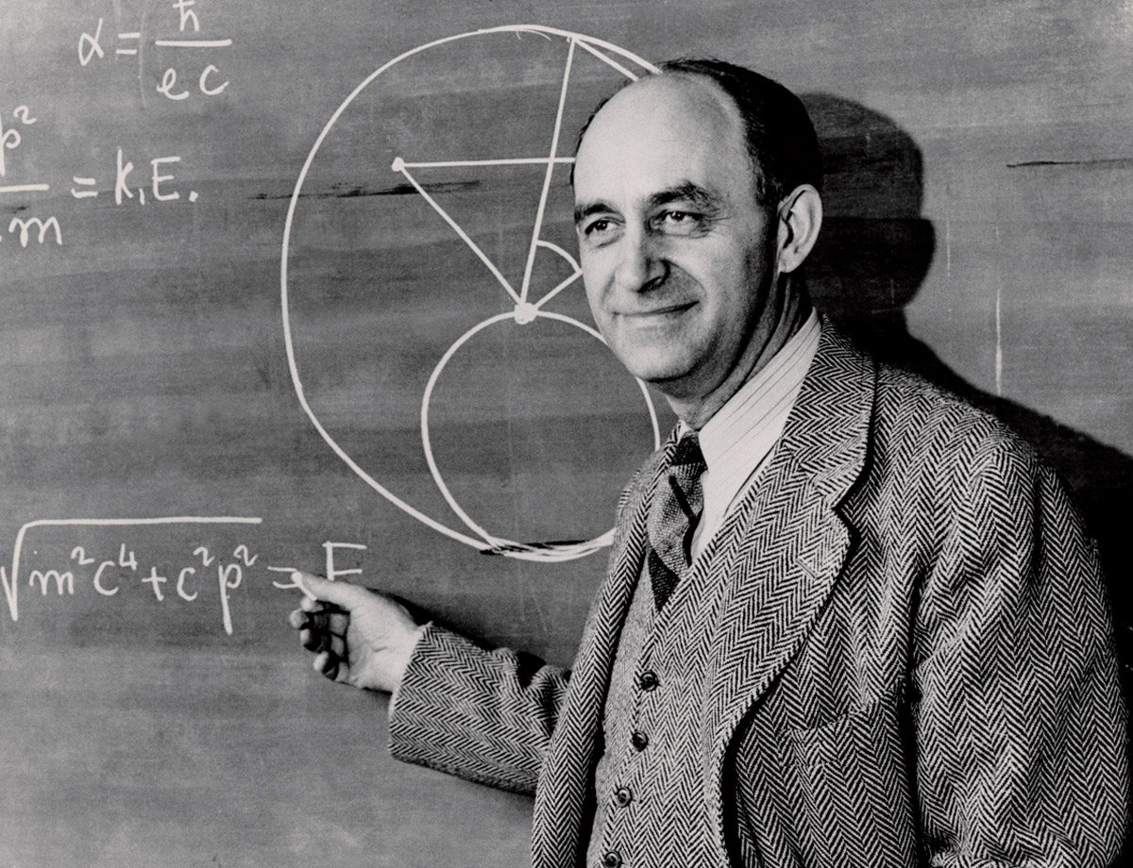
Figure 1: Enrico Fermi (2002)
Note. From Enrico Fermi, by Atomic Heritage Foundation (2002), Atomic Heritage Foundation (https://ahf.nuclearmuseum.org/ahf/profile/enrico-fermi/).
Agent-based modelling emerged due to the
The work of Enrico Fermi, a Nobel prize-winning Italian physicist. His biggest achievement was the development of the first nuclear reactor through the Manhattan Project. He emigrated to the United States and held positions at Columbia University and the Nuclear Institute of Chicago till his death (The Nobel Prize, 2018). He was studying the random movements of neurons through matter, which made it a struggle to calculate the behaviour of millions of neurons at one time. Instead of trying to do it all at once, he treated each neuron as a separate agent. He utilised a hand-cranked mechanical adding machine and random numbers to indicate probabilities. By individually simulating the movement of neurons, he provided himself with an accurate visual of how they behaved in reality. His techniques were adapted for use in research on nuclear power and weapons (Decision Lab 2017).
Thomas Schelling
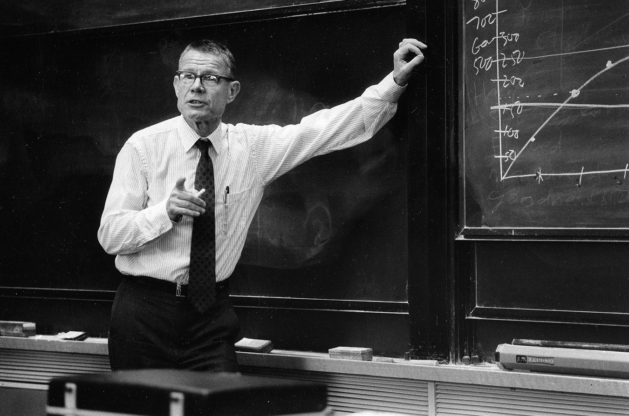

Figure 2: Thomas Schelling (2016)
Note. From A clearest mind: Remembering Tom Schelling, by Harvard Kennedy School (n.d.), Harvard Kennedy School (https://www.hks.harvard.edu/announcements/clearest-mind-remembering-tom-schelling).

What further strengthened the growth of ABM was Thomas Schelling's innovative
breakthrough. He was an American economist and a Nobel Laureate from the University of Maryland. He became famous for his application of game theory to conflict in the context of nuclear strategy and bargaining. (Alfred Nobel, 2005) He wished to understand how agents' micro-level preferences for where they lived caused macro-level patterns in the population. He used agents on a checkerboard grid to represent households. His book Micromotives and Macrobehaviours showed that even when individual agents had a minimal preference, neighbourhoods still became segregated. (Schelling, 1978) This proved that aggregated results are not reflective of individual desire. A basic urge for minimal segregation leading to high levels of segregation does not mean a specific individual desires complete segregation (Schelling, 1978). His model of ABM highlighted a core element of ABM called Emergence. It is when simple rules come together to create complex patterns or behaviours that were not planned or obvious (Decision Lab, 2017).
Human Intuition Correction: The Schelling Legacy
Thomas Schelling's groundbreaking research on residential segregation may be the greatest example of how ABM may be used as a tool to repair faulty human intuition (Hilbert, nd). Schelling (1971) demonstrated that relatively fewer individual preferences might lead to enormous macro-level segregation using a manual simulation akin to a board game. He showed that the overall outcome was a "tipping point" (p. 143) that resulted in a completely segregated map, even if agents were extremely tolerant, preferring merely that a tiny proportion of their neighbors had their own qualities (Schelling, 1971).
The Emergence Mechanism
ABM's main theoretical advantage is its capacity to mimic emergence, a phenomenon in which widespread social patterns arise that aren't specifically encoded into the individual agents (McCown, 2021). This calls into question conventional top-down (A hierarchical decision-making process is essential to the success of the top-down management approach. Under this structure, plans, policies, and goals are created by senior executives and leaders and then distributed across the company. It is motivated by visionary leadership to promote harmony and make sure that everyone travels on the same path, which frequently depends on the notion of a "representative agent" (p. 11) or population averages (Touro University Worldwide, n.d.). ABM, on the other hand, thrives on heterogeneity, enabling researchers to create agents with a variety of physical locations, interaction rules, and preferences. By doing this, the modeler may see how local interactions combine to form global structures, which frequently shows that a social system's ‘whole’ differs qualitatively from the sum of its constituent parts (Hilbert, n.d.).
The Methodological Imperative
Unlike traditional statistical paradigms that prioritize the identification of correlations between isolated variables, Agent-Based Modeling (ABM) facilitates a mechanistic explanation of social phenomena. By delineating the fundamental mechanics of a system—encompassing specific movement protocols, satisfaction thresholds, and environmental constraints—researchers are empowered to detect critical phase transitions where subtle behavioral shifts catalyze non-linear transformations within the broader social fabric (McCown, 2021). Consequently, ABM has solidified its position as an indispensable analytical instrument across a diverse array of disciplines, including economics, epidemiology, and cognitive science, providing a rigorous framework to decipher how localized ‘rules’ we abide by coalesce into the multifaceted complexity of the macroscopic world.
Examining the Mathematical Models of ABMs:
Understanding ABMs and their emergent properties requires examining the mathematical conceptualization of how the individual components of this model interact with each other to create a larger simulation. Suppose you have a model of $N$agents, and the status of an agent $(i)$ at a given time $(t)$ is denoted by $s_{i}(t$). An agent’s status is not necessarily a single integer value, but rather a set of information regarding its properties - they may be static or dynamic, and are very dependent on the simulation. For instance, status properties could be an agent’s sex and age, and dynamic properties could be its position in the simulation (Chopra et al., 2024).
As the simulation progresses over time (e.g., seconds, time steps), the agent’s status changes as it interacts with its environment, [$e(t)]$; as well as its neighbourhood $[N_{i}(t)]$ that can be defined by certain metrics like proximity factors, or a graph. The agent interacts with neighbouring agents $(j)$ , and these interactions or messages are denoted by $m_{ij}(t)$. These status changes, in addition to any fixed constants or parameters (𝛳), can be combined to create the following agent status update rule:
$s_{i}(t+1) = f[s_{i}(t), ∪_{i ϵ N(i)}{}m_{ij}(t), e(t), θ]$
Where an agent’s status update at the next time step is the function ($f$) of its current status, the union of messages from its set of neighbouring agents, the current environment, and any fixed parameters (Chopra et al., 2024).
A unique feature of ABMs is that they allow for modeling a dynamic environment that can be time-evolving. This is represented as follows:
$e(t+1) = g[s(t),e(t), θ]$
Where the environment’s status update at the next time step is the function ($g$) of the states of all agents in the environment $[s(t$)], the current environment, and any fixed parameters (Chopra et al., 2024).
Consider the following simulation of two people (i.e., agents A and B) trying to find the door to escape a house fire, which has a constant growth rate of 2 sq feet every 3 time steps (i.e., $θ$). Initially, agents A and B are at positions (2,3) and (3,3) respectively; and start with 100% health, are moving at a velocity of 2km/hr, and have 20% feelings of panic. As time progresses, agent A gets more and more panicked, which causes agent B to also panic. As the panic increases, they hyperventilate, causing available oxygen to deplete, making them move more slowly (i.e., velocity decreases). Simultaneously, the environment is changing due to the growing fire, which is emitting more carbon monoxide, which decreases the agents’ health, causing further panic. And as the agents panic, they hyperventilate more, which further depletes available oxygen in the environment, causing them to move even slower. This example of environmental changes impacting agent status, which then changes environment status, demonstrates how ABMs are a coupled dynamic system. Hence, simulating ABMs requires viewing the larger picture of these local dynamics.
Simulating ABMs
While microscopic-level information is valuable, the aforementioned coupled dynamic system is crucial as the main interest of ABMs is to view the macro-level results of micro-level interactions. Hence, ABM simulations are primarily interested in the aggregate outcomes over agent states, which is typically over a multivariate time series. Chopra and colleagues (2024) illustrate ABM calibration as:
$x = F[θ, s(0), e(0)]$
Where F represents the iterative composition of the update rules $f$ and $g$ over time $[F=(f,g)∘...∘(f,g)]$. That is, at each time step, the agent states, and the environment is updated by recursively applying equations (1) and (2), and this process is repeated $T$ times. The output $x$ represents aggregate or observable quantities derived from the simulation, such as average panic levels or evacuation times, providing macro-level results compared to the micro-level information provided by equations 1 and 2 individually (Chopra et al,2024).
Importantly, this formulation emphasizes that an ABM is inherently a stochastic simulator. Even when the inputs $[θ, s(0), e(0)]$ are fixed, repeated runs may produce different outputs (Chopra et al., 2024; Bonabeau, 2002). Thus, $F$ it is more appropriately described as generating a distribution over possible outcomes, rather than a single deterministic result (Bonabeau,2002).
Understanding Stochasticity in ABMs:
In many agent-based models, functions $f$ and $g$ include stochastic components to represent uncertainty in the model and bounded rationality in agent decision-making, where agents act under incomplete information or with inherent variability (Macal & North, 2010; Bonabeau, 2002). To illustrate this, reconsider the example of two agents escaping a house fire. Suppose agent A is initially located at position $(2,3)$, and the model specifies that agents may move one grid space per time step in one of four directions: up, down, left, or right. The agent's position is updated deterministically based on the chosen direction, such that:
- If the agent moves up, then update the position to $(x, y +1)$
- If the agent moves down, then update the position to $(x, y -1)$
- If the agent moves left, then update the position to $(x-1, y)$
- If the agent moves right, then update the position to $(x+1, y)$
At each time step, however, the agent selects its direction according to a decision rule that may include a stochastic component. This randomness can be interpreted as reflecting uncertainty or bounded rationality in the agent's behavior, rather than purely arbitrary choice (Bonabeau, 2002). As a result, even under identical initial conditions, the agent may follow different paths across different realizations of the model (Bonabeau, 2002).
Additionally, the possible trajectories an agent may follow are vast. At time step 0, the agent has four possible actions; then at time step 1, it again has four possible actions, regardless of the action taken in the previous step. Consequently, over two time steps, there are $4 × 4 = 4^{2}$ possible movement sequences. More generally, over $T$ time steps, the agent's trajectory can be described as an ordered sequence of actions, yielding$4^{T}$ possible sequences. This exponential growth reflects the number of distinct paths the agent may take through the grid and highlights the stochastic nature of the update function $f$.
However, this combinatorial representation is a simplification of agent behaviour; in a complete ABM, actions and state transitions are typically interdependent and influenced by past states. Each agent's state may include additional variables, such as health or panic level, which evolve through interactions with neighboring agents and the environment (Chopra et al, 2024). This introduces dependencies and feedback mechanisms that influence how the system evolves.
As a result, the overall system must account for the joint evolution of all agent states and their interactions, leading to a rapidly expanding space of possible system trajectories (Epstein & Axtell, 1996).
Importantly, emergence does not arise solely from the large number of possible trajectories. Rather, it emerges from the way in which interactions between agents and their environment structure and constrain these possibilities, giving rise to coherent macro-level patterns that are not immediately apparent from the individual rules (Epstein & Axtell, 1996; Macal & North, 2010). This interplay between stochasticity, interaction, and system structure underlies the usefulness of agent-based models in studying complex systems.
Calibrating ABMs:
The key advantage of ABM simulations is when they are calibrated, which is “the process of finding a set of structural parameters, or a probability distribution over$θ$, such that $F[θ, s(0), e(0)]$ produces an output that is consistent with real-world data $(y)$” (Chopra et al., 2024, p. 2). This can be achieved by using techniques such as approximate Bayesian computation, where an ABM is simulated repeatedly with different parameter values and the simulated outputs are compared to real-world data (Platt, 2020). After which, sensitivity analyses can be conducted on ABMs to examine retroactive events, explore alternative scenarios, and consider prospective policy interventions (Chopra et al., 2024).

The Schelling Segregation Model: The Historical Origin of Schelling’s Thinking
Before the computational revolution, Thomas Schelling derived his seminal theory via a remarkably analog and tactile methodology. During a flight in the late 1960s, he initiated experiments utilizing zinc and copper coins (pennies and nickels) positioned upon a checkered paper grid (Schelling, 1971).
Schelling was motivated by a persistent sociopolitical paradox: the enduring nature of residential segregation in American urban centers despite the dismantling of legal impediments to integration. He posited that this phenomenon did not necessitate organized or extremist prejudice, but rather could emerge from the intersection of individual incentives and collective results (Schelling, 1971). Through the manipulation of coins according to a localized protocol—wherein each entity mandates that at least one-third of its neighbors possess identical attributes—he observed the spontaneous reorganization of an integrated environment into dense, segregated clusters.
The Evolution of the Theory: From Coins to Computation
Schelling’s inquiry was transformative, as it deviated from the top-down sociological paradigms that attributed segregation exclusively to institutional mandates or macroeconomic forces. Instead, he conceptualized the role of micromotives—the discrete, local preferences of individual actors.
As delineated by Smaldino (2017), this manual simulation served as a nascent "logical engine" (p. 316), demonstrating several critical principles:
- The Disparity Between Preference and Outcome: Populations expressing a desire for integration may nonetheless be driven toward segregated states due to specific satisfaction thresholds.
- The "Tipping Point" (p. 181) Mechanism: A singular behavioral shift can render a localized environment uncomfortable for others, catalyzing a non-linear chain reaction of departures (Schelling, 1971).
Example of a Segregated City: Chicago
Chicago provides a primary empirical illustration of the macroscopic patterns described by Schelling. Frequently characterized as one of the most segregated urban centers in the United States, its spatial organization reflects the clustered grid formations seen in the model.
- Macro-Level Patterning: The city exhibits a stark geographic division between the predominantly White Northern Side and the predominantly Black and Latino Southern and Western Sides.
- Empirical Evidence of Tipping: In testing Schelling’s framework, Clark (1991) identified that while residents frequently value multi-ethnic environments, their mobility is governed by a specific threshold. When minority representation reached approximately 20% to 30%, White flight occurred at accelerated rates.
- The Structural Dimension: Contemporary research by Trounstine (2026) suggests that institutional factors, such as economic zoning and property tax structures, function as physical constraints that solidify these micromotive patterns into permanent macroscopic structures.

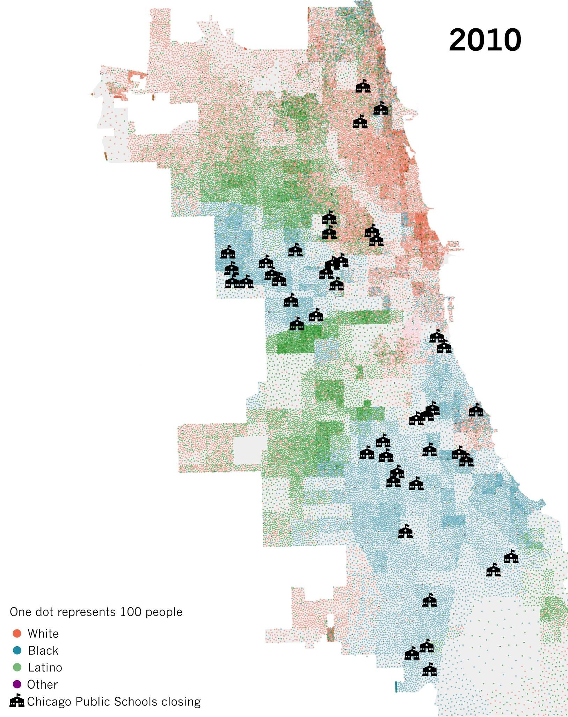

Figure 3 shows Chicago's racial geography using data from the 2010 Census. This map illustrates Chicago's extreme segregation, with Black and Latino people predominating on the South and West sides and white people predominating on the North Side. From How Did Chicago Get So Segregated? By Inventing Modern Segregation, WTTW, n.d. (https://www.wttw.com/firsthand/segregation/how-did-Chicago-become-so-segregated-by-inventing-modern-segregation)

Benefits of ABM
There are several benefits to using Agent-Based Modeling over other models. The first of these benefits is heterogeneity, which means that Agent-Based Modeling makes it easy to explore the direct benefits and consequences of agents being different. On a blog describing the uses of Agent-Based Modeling, it’s stated that “As individual agents are modeled, it becomes possible to explore the consequences of the heterogeneity of the agents; that is, agents being different in some way” (Lyon, 2019). The importance of exploring these consequences is the fact that people in real life are different from each other and will make different decisions, making Agent-Based Modeling ideal for understanding people. With this in mind, the realism of Agent-Based Modeling itself is a benefit for population-based studies and observing how a group of people may react to certain circumstances. Unlike other models, which may not be able to depict a population as accurately, ABMs have been cited as useful for real-world applications. Citizen evacuation is a big example where they use an ABM to simulate an emergency in an enclosed area (Crowdlogo, 2023). Another benefit of Agent-Based Modeling comes from its flexibility, where it’s easy to add more dimensions and more agents to see the results of different factors. While adding too many elements can be detrimental as it makes the model unnecessarily complex, overall, it’s helpful to have the tools and ability to change the model easily in order to observe theoretically if taking certain actions would be better or worse for the population.
Emergent phenomena are another benefit of Agent-Based Modeling that makes it worth using. It’s the idea that Agent-Based Modeling captures details about behaviours and aspects of agents that occur from interactions with other agents that can’t happen, or be observed, if the agent is viewed independently. Given instructions from the model, agents will eventually form patterns that simulate the idea of “learning” in the sense that they will understand to take the best course of action in accordance with their goals based on what they have interacted with (Wilcher, 2021). An example of this can come from traffic accidents in a number of different ways. First, someone speeding down an intersection can cause other drivers to react and crash, causing an accident. While the one speeding isn’t directly involved with the accident and is now far from it, they are still the ones responsible, which cannot be observed in an independent vacuum. Second, from this accident, other drivers will avoid going to that intersection if their goal is to make it somewhere in the shortest time possible. While complex, this is the sort of pattern that emerges from an Agent-Based Model and can prove useful when detailing and observing behaviour.

Limitations and Resistance
Limitations of ABMs:
High Computational Costs
ABM, like most technological models, has some drawbacks. One of the major issues with ABM is that it is computationally expensive. It takes immense technological effort to calculate the behaviour of the agents and their actions. Besides this, a large amount of storage is required to store all the data we receive from ABM models. (Explorer, 2018)
Challenging to Calibrate ABMs to Data
It is also very challenging to calibrate ABMs to data (Mathématiques, 2021). One of the major challenges arises because the majority of these models have too many parameters, which develops large search spaces and creates more dimensionality, making the process complex and expensive. (Avegliano & Sichman, 2023) Some of these parameter sets produce the same outcomes, making it difficult to recognise accurate parameter sets. Most ABMs have a nonlinear relationship, so minor inputs can create huge and unexpected changes in outputs, which makes the system hard to tune. The stochastic nature of ABM models means that simulations using similar parameters can generate different results, which causes more uncertainty (Avegliano & Sichman, 2023). Data from the real world is quite heavy or complex, which requires large samples and complex methods of estimation. This makes reliable parameter calibration extremely difficult.
Too Many Parameters
ABMs are renowned for their high level of flexibility, which also creates high levels of complexity because it includes many types of agents, interactions, and rules (Bodine et al., 2020). Developing such models also involves nuanced choices about interaction, data, and behaviour; it makes such models overcomplicated. These models are overly complex, and adding more details to these models increases complexity exponentially. (Sun et al., 2016) These complexities distract researchers from the core drivers of behaviours and make interpreting results more challenging. (Explorer, 2018)
Reproducibility Issues
It is very difficult to replicate ABM models because of the high flexibility of models, the complexity of rules, and the stochasticity does not follow a fixed pattern. One way in which ABMs can be replicated more effectively is by the establishment of protocols for standardised design and analysis of ABM’s (Bodine et al., 2020)
Confirmation Bias
ABM models are susceptible to confirmation biases as they can be tuned by researchers to match outcomes that support the researchers' outcomes (Bodine et al., 2020). To reduce the impact of biases, researchers are developing methods of model reduction that focus on the core features of models and eliminate unnecessary details that do not contribute directly to the topic of interest. For example, agents portraying humans do not require details about age, sex, and race unless they are part of the process or decision. (Auchincloss & Garcia, 2015). Paradoxically, eliminating unnecessary details removes the real mechanisms that make these models feel more accurate, but extremely constrained within parameters. This leads to oversimplification of the model, which introduces deeper-rooted biases because the model is so restructured that it produces only certain types of outcomes. (Windrum, 2007)
Resistance to ABMs
Requirement of Great Levels of Knowledge
There is a great hesitancy to engage in the use of ABM’s because it requires a great level of individualised knowledge. This is exacerbated due to the lack of education resources on complex systems, which makes people realise they do not understand how these systems work. Thus, they do not feel that using agent-based modelling is necessary to understand complex systems. Another issue is that people lack the skills to use tools like Netlogo and Mesa, which can help them solve complex problems (Explorer, 2018). Without such individualised education and knowledge about agent-based modelling and the tools involved, people might find interpreting the billions of data sets generated by agent models challenging to analyse and interpret.
People Prefer Easily Accessible Information
People tend to look for things where they can find them easily, like the drunkard looking for his keys on the brightly lit sidewalk instead of the park where he actually lost his keys. Also, people resort to information they can find easily while bypassing complex resources where they can find something more enriching on ABM models (Explorer, 2018). Humans require Central Leaders, Orderly Movements, and Certainty
As humans, we have all been wired into systems with a central leader. This influences people's perspective of complex systems, leaving them uncomfortable using a system that lacks a central leader. It is also challenging for us humans to accept that sometimes random movement can give rise to orderly patterns or emergent patterns. Finally, as humans, we believe everything happens for a reason, and hence we negate the possibility of chance (Explorer, 2018).

The Evolution of ABMs
ABMs and Large Language Models (LLMs)
In the modern world, ABM models are evolving at a rapid pace. The emergence of large language models is changing what agents can look like. Researchers have been working on enabling them to reason and converse with large language models as if they were their brains. LLM empowered agents can enhance simulations by allowing agents to grasp and comprehend environments via natural language and enabling both direct and indirect interactions while encouraging interaction between agents and more humanistic analysis of situations, context, and emotions. (Gao et al., 2024 )
LLMs improve reasoning and executive functioning by enabling agents to assess situations more smartly and make context-related choices with a level of independence via random action selection, adjustable strategies, and planning. (Gao et al., 2023 ) Such models enhance adaptable learning and growth through the updation of behaviours based on changing information and environments, which reflect real-world perspectives. They support rigorous heterogeneity and personalization by highlighting various agent traits, behaviours, and judgement styles via prompting or fine-tuning, which reduces oversimplification present in traditional models (Gao et al, 2023 ). On the whole, LLM empowered agents are highly flexible, realistic, and competent to handle complex, powerful systems rather than rigid rule-based systems or equation-based systems.
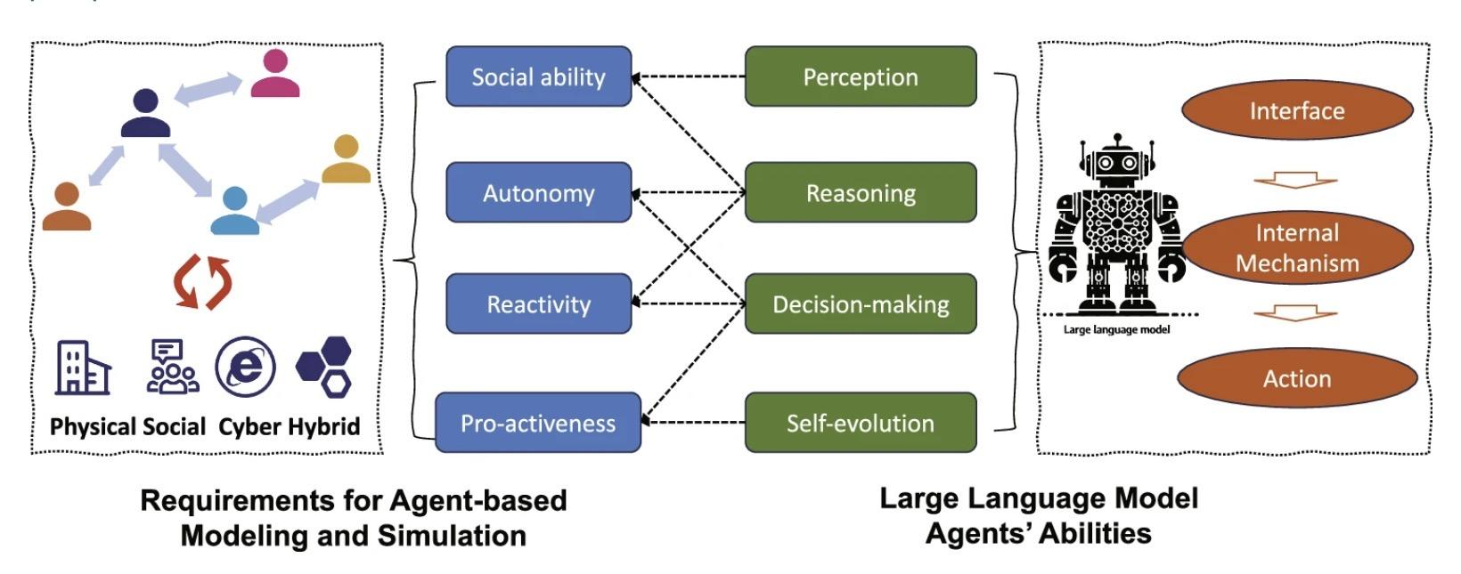
Figure 4: How large language model agents meet the requirements of agent-based modeling and simulation. Large language models empowered agent-based modeling and simulation: A survey and perspectives, by C. Gao et al., 2023, Humanities and Social Sciences Communications, 11, Article 1259 (https://www.nature.com/articles/s41599-024-03611-3). Copyright 2024 by the authors.

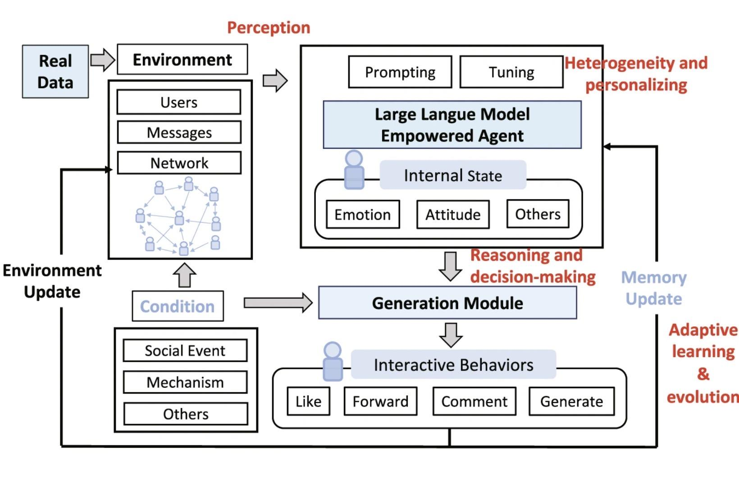
Illustration 2 : how large language model-empowered agents work based on four aspects of critical abilities (figure edited from S3 Gao et al, 2023): perception, heterogeneity and personalizing, reasoning and decision-making, adaptive learning, and evolution. Large language models empowered agent-based modeling and simulation: A survey and perspectives, by C. Gao et al., 2024, Humanities and Social Sciences Communications, 11, Article 1259 (https://www.nature.com/articles/s41599-024-03611-3). Copyright 2024 by the authors.

Generative Agents
At Stanford University (Decision Lab, 2017), experiments have developed generative agents that do not follow pre-programmed rules or explicit instructions but generate behaviours in the moment, which create life-like simulations. It offers new ways of understanding everything from social behaviour to public health, climate resilience, and artificial societies (Decision Lab, 2017).
AI and LLMs enhance agent-based modeling.
Agent-based models (ABM) and Artificial Intelligence (AI), particularly large language models (LLMs), are two separate approaches to understanding complex systems that can be used in a highly cooperative fashion. While ABM uses interactions between individual agents to observe emergent behaviors at the system level, AI introduces adaptive data-driven intelligence that enhances how those agents act within their respective simulation environment (Gao et al., 2024).
Traditional ABMs rely on predefined rule-based systems where agents follow set rules. LLMs allow agents to move past rigid decision-making through the enablement of reasoning, interpretation, and context-awareness. This creates a shift from static agents to adaptable agents that can respond dynamically to the surroundings of their environment (Gao et al., 2023). As such, the incorporation of LLMs into ABM allows for real-world human behavior where decisions rarely occur due solely to simple rules.
One key way these approaches supplement each other is through decision-making complexity. In standard ABMs, an agent may follow a simple rule, such as moving if they do not meet satisfaction thresholds. However, when LLMs are incorporated into an ABM, that same agent can evaluate multiple contextual factors, including past interactions, changes in the environment, or social reasoning, before making a decision (Gao et al., 2024). This significantly increases the simulation's realism.
Another important contribution of AI is learning and adaptation over time. In Traditional ABMs, agents do not change unless programmed to do so. When AI is incorporated into an ABM, agents can update strategies based on prior outcomes and learn from experience. This addition of feedback loops more accurately reflects real-world systems where individuals adapt instead of behaving statically (Gao et al., 2023).
Additionally, LLMs improve communication among agents. Many classical ABMs limit interaction to numerical exchanges or binary states. LLM-powered agents can, however, simulate more complex forms of interaction such as negotiation, persuasion, or cooperation. This is especially beneficial in modeling social systems where communication plays a central role in shaping results (Gao et al., 2024).
Though there are advantages to incorporating both ABM and AI into simulations, it must also be acknowledged that using both methods will produce greater computational complexity and create new challenges, such as interpretability and control of agent behavior (Gao et al., 2024). Yet, the incorporation of these two disciplines provides a major advancement in computational modeling.
Overall, ABM provides a structural framework for simulating systems, while AI enhances the intelligence of individual agents within that framework. Collectively, they allow for simulations capable of creating realistic, flexible, and powerful representations of both micro-level decision making and macro-level emergent patterns.

References
Agent-Based Modeling - The Decision Lab. (2017). The Decision Lab. https://thedecisionlab.com/reference-guide/computer-science/agent-based-modeling
Atomic Heritage Foundation. (2002). Enrico Fermi - Nuclear Museum. Https://Ahf.nuclearmuseum.org/. https://ahf.nuclearmuseum.org/ahf/profile/enrico-fermi/
Auchincloss, A. H., & Garcia, L. M. T. (2015). Brief introductory guide to agent-based modeling and an illustration from urban health research. Cadernos de Saúde Pública, 31(suppl 1), 65–78. https://doi.org/10.1590/0102-311x00051615
Avegliano, P., & Sichman, J. S. (2023). Equation-Based Versus Agent-Based Models: Why Not Embrace Both for an Efficient Parameter Calibration? Journal of Artificial Societies and Social Simulation, 26(4). https://doi.org/10.18564/jasss.5183
Bodine, E. N., Panoff, R. M., Voit, E. O., & Weisstein, A. E. (2020). Agent-Based Modeling and Simulation in Mathematics and Biology Education. Bulletin of Mathematical Biology, 82(8). https://doi.org/10.1007/s11538-020-00778-z
Bonabeau, E. (2021). Agent-based modeling: Methods and techniques for simulating human systems. Proceedings of the National Academy of Sciences, 99(Supplement 3), 7280–7287. https://doi.org/10.1073/pnas.082080899
Chopra, A., Kumar, S., Giray-Kuru, N., Raskar, R., & Quera-Bofarull, A. (2024). On the limits of agency in agent-based models. ArXiv.org. https://arxiv.org/abs/2409.10568v3
‌Clark, W. A. V. (1991). "Residential Preferences and Neighborhood Racial Segregation: A Test of the Schelling Segregation Model." Demography, 28(1), 1–19. https://doi.org/10.2307/2061333
Dignum, E., Boterman, W., Flache, A., & Lees, M. (2025). "Empirically Estimating an Agent-Based Model of School Choice on Household-Level Register Data." Journal of Artificial Societies and Social Simulation, 28(4). https://www.jasss.org/28/4/8.html
Epstein, J., & Axtell, R. (1996). Growing Artificial Societies. The MIT Press. https://doi.org/10.7551/mitpress/3374.001.0001
Explorer, C. (2018, June 28). Agent Based Modelling: Limitations and Resistance (P. B. Rand, Ed.) [Review of Agent Based Modelling: Limitations and Resistance ]. Santa Fe Institute, New Mexico. https://www.youtube.com/watch?v=vZ9cOvU6GDw&list=PLF0b3ThojznRKYcrw8moYMUUJK2Ra8Hwl&index=24&t=2s
Gao, C., Lan, X., Li, N., Yuan, Y., Ding, J., Zhou, Z., Xu, F., & Li, Y. (2024). Large language models empowered agent-based modeling and simulation: a survey and perspectives. Humanities and Social Sciences Communications, 11(1). https://doi.org/10.1057/s41599-024-03611-3
Helbing, D. (2012). Agent-Based Modeling. In: Helbing, D. (eds) Social Self-Organization. Understanding Complex Systems. Springer, Berlin, Heidelberg. https://doi.org/10.1007/978-3-642-24004-1_2
Hilbert, M. (n.d.). Computational social science: Agent-based modeling and the Schelling model [Video lecture]. YouTube. https://youtu.be/AZlWOykGzYg
Iozzi, Fabrizio. (2008). A simple implementation of Schelling's segregation model in NetLogo. "Carlo F. Dondena" Centre for Research on Social Dynamics (DONDENA), Universit� Commerciale Luigi Bocconi, Working Papers.
Lyon, J. (2019). Why are agent-based models so useful? - Simudyne. Simudyne. https://simudyne.com/resources/why-are-agent-based-models-so-useful/
Macal, C. M., & North, M. J. (2005). Tutorial on agent-based modeling and simulation. Proceedings of the Winter Simulation Conference, 2005. https://doi.org/10.1109/wsc.2005.1574234
McCown, F. (2014). Schelling’s model of segregation. Nifty Assignments. https://nifty.stanford.edu/2014/mccown-schelling-model-segregation/
Mathématiques, C. de R. (2021, septembre 8). Data fitting in Informing Cancer Modelling and Treatment (A. L. Jenner, Ed.) [Review of Data fitting in Informing Cancer Modelling and Treatment]. University of Queensland, Australia. https://www.youtube.com/watch?v=S5qVXED9nHY
Platt, D. (2020). A comparison of economic agent-based model calibration methods. Journal of Economic Dynamics and Control, 113(103859), 103859. https://doi.org/10.1016/j.jedc.2020.103859
Sun, Z., Lorscheid, I., Millington, J. D., Lauf, S., Magliocca, N. R., Groeneveld, J., Balbi, S., Nolzen, H., Müller, B., Schulze, J., & Buchmann, C. M. (2016). Simple or complicated agent-based models? A complicated issue. Environmental Modelling & Software, 86, 56–67. https://doi.org/10.1016/j.envsoft.2016.09.006
Schelling, T. C. (1978). Micromotives and Macrobehaviour. W.W, Norton and Company.
The Sveriges Riksbank Prize in Economic Sciences in Memory of Alfred Nobel(2005). NobelPrize.org. https://www.nobelprize.org/prizes/economic-sciences/2005/schelling/biographical/
Schelling, T. C. (1971). Dynamic models of segregation†. The Journal of Mathematical Sociology, 1(2), 143–186. https://doi.org/10.1080/0022250X.1971.9989794
The Nobel Prize. (2018). The Nobel Prize in Physics 1938. NobelPrize.org. https://www.nobelprize.org/prizes/physics/1938/fermi/biographical/
Touro University Worldwide. (n.d.). Top-down vs. bottom-up management: Which is better? https://www.tuw.edu/business/top-down-bottom-up-management/
Trounstine, J. (2026). "When Restrictive Economic Zoning Leads to Racial Segregation." Political Science Research and Methods. Cambridge University Press. https://doi.org/10.1017/psrm.2026.10089
The Clearest Mind: Remembering Tom Schelling. (2016a, December 13). Harvard.edu. https://www.hks.harvard.edu/announcements/clearest-mind-remembering-tom-schelling
Wilcher, D. (2021). Agent-Based Modeling Helps in Studying Emergent Phenomena. Design News. https://www.designnews.com/electronics/agent-based-modeling-helps-in-studying-emergent-phenomena
Wilensky, U. (1997). NetLogo Segregation model. http://ccl.northwestern.edu/netlogo/models/Segregation. Center for Connected Learning and Computer-Based Modeling, Northwestern University, Evanston, IL.
Wilensky, U., & Rand, W. (2015). An Introduction to Agent-Based Modeling: Modeling Natural, Social, and Engineered Complex Systems with NetLogo. MIT Press.
Windrum, P. (2007). Empirical Validation of Agent-Based Models: Alternatives and Prospects. Journal of Artificial Societies and Social Simulation, 10(2), 1–8. https://ideas.repec.org/a/jas/jasssj/2006-40-2.html

Appendix
Appendix A: Computational Representation of the Schelling Segregation Model
This computational representation follows the principles outlined by Schelling's (1971) segregation model and has been created in Python as an example of how agent-level preferences are used to create emergent segregation. This representation uses a two-dimensional matrix with each cell representing an agent who will move or stay at their current location depending on the characteristics of their surrounding neighborhood.
A.1 System Parameters and Setup
Several parameters have been defined in this simulation that influence the way the system behaves:

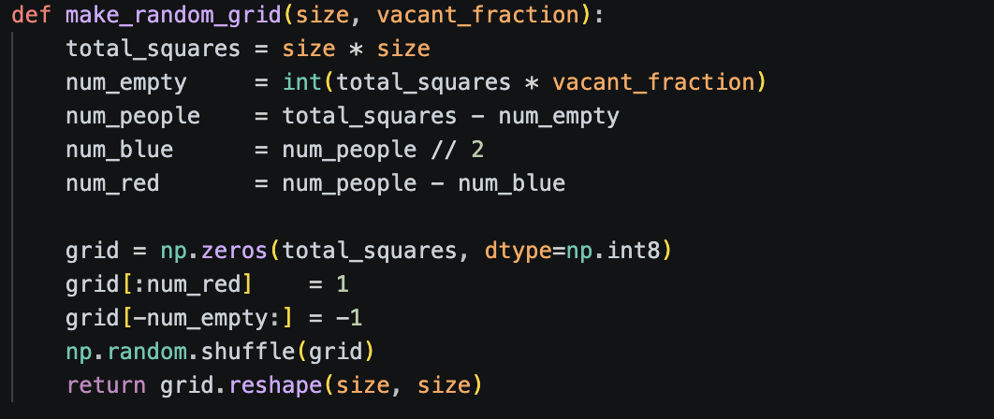
Parameters controlling the spatial scale of the grid, the number of neighbors an agent is satisfied with, and the number of empty cells on the grid define the system. Agents are distributed randomly across the grid space, along with random placement of "empty" cells to establish the initial environment:

This ensures that there is no bias in the conditions with which an agent begins, therefore providing a natural process for segregation to arise from interaction among agents.

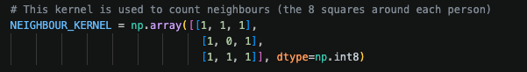
A.2 Neighborhood Assessment
Agents assess their neighborhood through convolution to count neighboring agents:

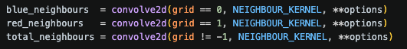

The current implementation provides a mechanism by which each agent can view the eight surrounding cells, representing local rules of interaction as commonly found within the body of literature related to agent-based modeling.
A.3 Agent Satisfaction and Motion
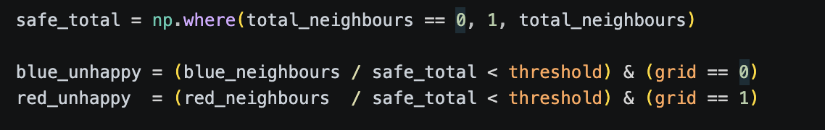
Agents make decisions about their degree of satisfaction based on the number of neighboring agents who have similar characteristics to the agent:

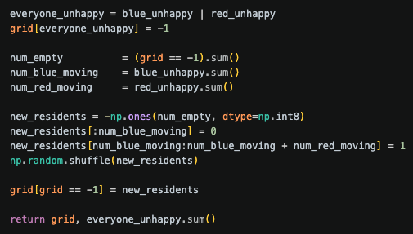
Unhappiness leads to an agent being eliminated and assigned a random position as follows:

This also illustrates that agents will not attempt to maximize their own movement, so the emergence of large-scale structures results from simple local mechanisms, not rational decisions made by agents.
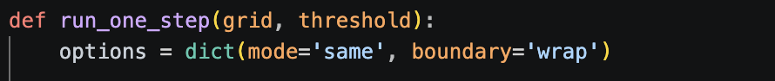
A.4 The Evolution of the Simulation
The evolution occurs at each time step in discrete units of time; the process of each agent evaluating its current situation and then changing its position (or not) is repeated many times:
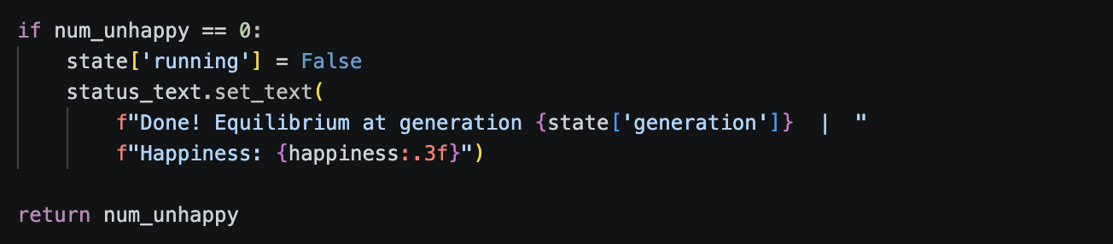
The simulation ends once the system reaches equilibrium:

At this stage, every agent is satisfied with their environment.
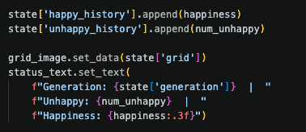
A.5 Agent Tracker: Agent Behavior
To assess the behavior of the tracking system during a run of the simulation, we collect data on two primary aspects:

- How happy agents were (on average) at each time step in the simulation
- The number of unhappy agents present at each time
These data will enable us to analyze whether or not the simulation has reached convergence and if it is stable as a system.
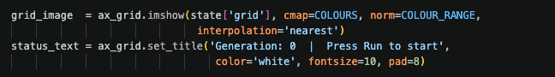
A.6 Model Visualizer and Interactive Model Parameters
Matplotlib allows visualization of the model during a run of the simulation:

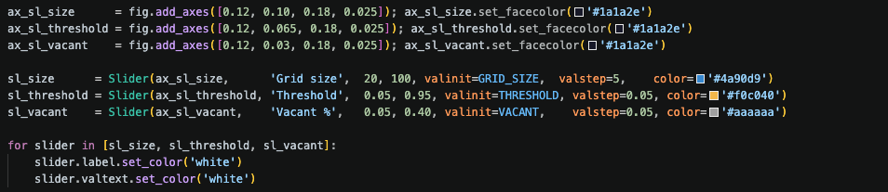
Slider controls that enable user interaction with parameters such that users can vary the value of a particular parameter "live" while running a simulation:

User interaction provides an opportunity for users to experimentally explore how changes in the input parameters affect emergent patterns and behaviors.
A.7 Results from Simulations
Across several simulations, the same segregated pattern emerged across space regardless of a moderate or low satisfaction threshold. Agents formed increasingly large stable clusters as thresholds rose. Higher vacancy rates resulted in free relocation of agents, allowing faster convergence towards an equilibrium state.
Agents experienced a significant increase in their average happiness within the first few generations, but eventually reached a plateau where no additional unhappy agents existed. The observed results illustrate that simple decisions made by each agent may result in complex long-term behaviors or structures at the population level and provide examples of emergent properties based on the interaction of many individuals (Schelling, 1971).
A.8 Agent-Based Modeling Software and Development Decisions
This model was created using Python. This programming language used NumPy for performing mathematical operations, Matplotlib for creating visualizations, and SciPy for efficiently calculating which neighbors are to be evaluated. By utilizing convolution (convolve2d), all agent neighborhoods could be evaluated simultaneously, increasing performance.
Python was chosen because it is flexible and easy to read, while also providing access to an enormous range of other analytical and visualization capabilities. Although both NetLogo and Python can be used to create agent-based models, Python provides much greater ability to customize the model and incorporate additional analytical/visualization techniques compared to NetLogo.
A.9 Conceptual Basis
This computational model translates Schelling's conceptual work into a specific set of rules for decision-making by each agent. The resulting simulation shows how localized interactions among agents lead to the emergence of global patterns, thus demonstrating key concepts of agent-based modeling.

