About the project

Smart route is a web interface focused on informing drivers on an impending traffic on the road and directing to them to a different road to be taken.

Background information

Waking up very early to beat the huge traffic jam has been the life style of inhabitants in the urban areas. Not only is this stressful rather a major contribution to pollution in the urban areas when there is a heap of cars on the road. Stuck on the road, smoke coming from these vehicles contain gases that contribute to global warming in the urban areas when vehicles are stuck over a place for a long period of time.

The project is about how to eliminate traffic congestion on the road. Traffic congestion has been a challenge facing people in the urban areas in our current world today. This as a result causes delay in one’s schedule, triggers road rage, speed up fuel consumption and again causes pollution to our surrounding.

Taking all these into consideration, our group teamed up to coin a creative idea to curb this challenge. This brought to birth the initiative of smart route web interface. The web interface will focus on informing and drivers on an impending traffic on a particular route and direct them to the nearest free and possible route to take

Impact

The web interface will help to regulate and reduce the huge traffic jams in the urban areas. Aid drivers have easy and convenient driving in the urban areas and also reduce global warming caused by smoke from slow moving vehicles in the urban areas.

How does it work

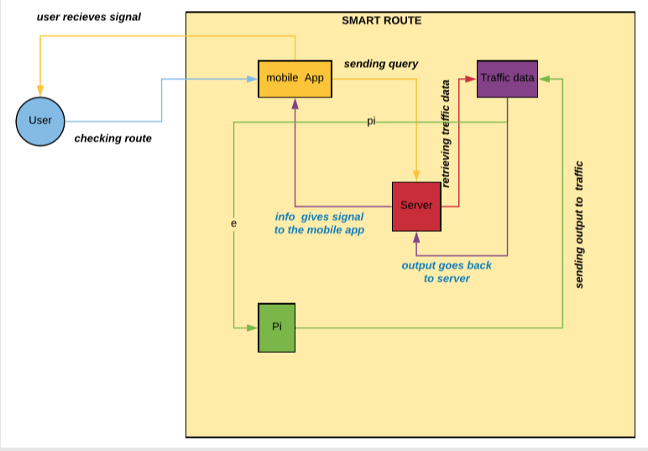

The user first request for the interface on a webpage and clicks on a button that also request for the status of a traffic system, the system also takes the status from the traffic light and produce a the status of the traffic light in the form of an image which is the same as the traffic light on the web page.

Technology

* Raspberry pi
* Led
* Flask
* Bootstraps

Languages

* Python
* JavaScript
* Html
* CSS