Project 2

Design Write-Up
For the beta version of the Persona Orchestrator, I expanded the starter project into a system that can create and store personas, retrieve existing personas, generate conversations between multiple agents , and route natural-language commands .
The project separates its functionality across persona.py, orchestrator.py, conversation.py, agent.py,and llm.py. I kept these responsibilities different so that each area of the applications could be tested and modified independently.
One vital improvement was the persona system itself . Personas were stored as Markdown files including information such as the persona's assigned name, role, description and summary . This makes personas consistent rather than recreating them every time the program starts . The persona function also supports finding personas by their slug, name, or role.
I also improved the orchestrator so that users can communicate with the system using natural-language commands. The orchestrator determines what the current user is seeking and routes the request to the functionality accordingly . It can handle persona selection, persona creation,missing information, ambiguous participants, conversations, multiple actions, and adjustable conversation lengths.
The agent system was designed so each persona's depiction becomes a part of the model's system prompt. Conversation history is then translated into messages that the language model can comprehend. This allows each participant to respond appropriately to its assigned persona while still responding to what was said previously by participants .The conversation system handles the interactions between agents. This action requires at least two participants, keeps a transcript of the conversation, alternates between speakers, and supports an adjustable number of turns. Transcripts can also be downloaded so that the generated conversations can be later reviewed.
Another essential design decision was dividing the language-model access through llm.py. The project contains an offline model application that does not require a live API key as well as being a support for a real Claude model. This makes it possible to test and develop the application without being billed for API calls every test run.
Finally, I added limited conversation history so that the orchestrator does not continue collecting unlimited context. This helps with controlling the amount of information passed through the system and suppresses the risk of prompts that are excessively large .

Saved Transcript and Commentary
I tested the system with a conversation called "MRI results" between David Chen and Doctor Edward. David inquires for a clear explanation of his MRI results and continues with questions about physical therapy, NSAIDs , pain, and flare-ups. Edward answers these questions and adjusts his answers as David provides him with more information.
The transcript displays that the agents contain different roles and continues the same discussion across numerous turns. David acts like a concerned patient asking detailed questions, while Edward focuses on responding to David's concerns and explaining his results. Responses later in the conversation also reference information introduced earlier, displaying that the conversation`s information is being maintained .One issue that occurred during this project was the arrival of stage directions such as "taps pen,""leans forward," and "glances at watch." Although the system`s prompt is created to prevent narration, the model did not always follow that instruction.
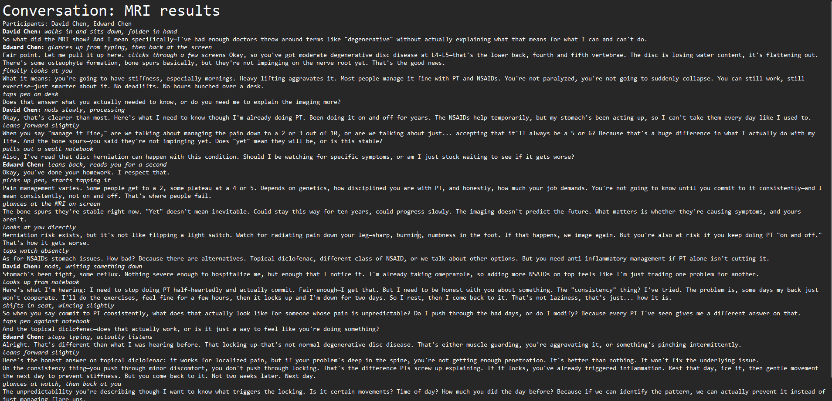

Honest Failure Analysis
One limitation is formatting drift and character creation . Agents may implement narrations or behavior unnecessarily . The MRI Result transcript demonstrates this through the stage directions, displaying that acceptable prompting does not guarantee a perfect model compliance .
Lengthy conversations can also result in agents losing important context. Limited conversation history prevents prompts from becoming excessively large but deleting older messages can cause agents to forget context discussed earlier.
Another limitation is the cost because each conversation turn requires an API request. Lengthy conversations and added agents will therefore increase the model`s usage. The offline LLM suppresses this problem during the testing phase but cannot entirely reproduce real model behavior.
Natural-language routing can also fail when the commands are unusual or vague . The orchestrator manages several obscure situations but it cannot prepare for every possible request. The quality of generated conversations also varies on how thorough and correct the given persona descriptions are.

Test Coverage
I tested the project's primary components using pytest. All 45 of the tests in the entire test suite passed in 0.16 seconds. The agent, dialog, orchestrator, LLM, and persona components were all tested. Prompt construction,turn counts, speaker alternation, discussion themes, transcript production, persona formation, participant resolution, and error handling are all confirmed by the agent and conversation tests. Scripted answers, offline operation, persona creation, dialog creation, and Claude LLM construction are all validated by the LLM tests.
Natural-language routing, multiple actions, missing information, ambiguous participants, adjustable turns, and bounded history are all covered in the orchestrator tests. All six of the orchestrator tests passed in 0.06 seconds when I ran them independently.
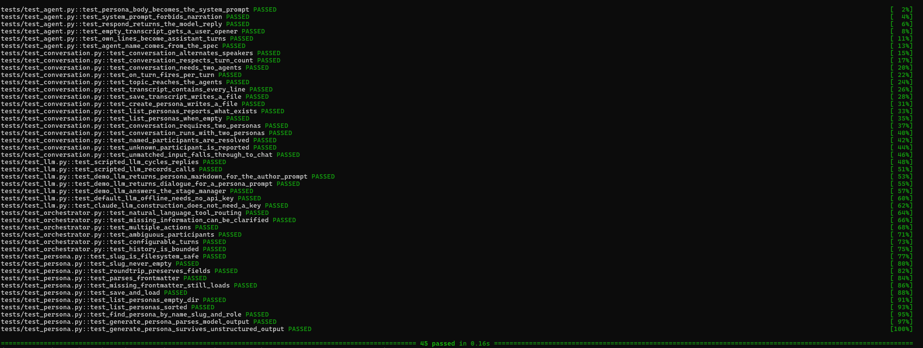
The persona tests confirm saving and loading personas, safe filenames, parsing frontmatter, persona searching, sorted persona listings, and handling generated persona output. These results display that the main components I created are working correctly and covered by automated testing.

Conclusion
The beta version effectively organizes multi-agent discussions, builds durable personas, routes commands in natural language, preserves transcripts, and supports both offline/real language models. The MRI transcript reveals flaws like unwelcome narration while also showing that agents may maintain several roles and conversation context.
All 45 automated tests are currently passing, and the beta version generally satisfies the main project objectives. Stronger character control, better long-term context management, better routing, and lower model costs should be the main areas of future development.

References

- Ebringer, L. (2022, September 13). Moesif. What You Need to Know About API Pricing in 2026 | Moesif Blog. https://www.moesif.com/blog/api-monetization/api-pricing/

https://huggingface.co/spaces/GQuellTS/personaforge

