Project 1

Introduction
The goal of this project was to enhance an automated system that approximates the credibility of web sources. The initial system used a rule-based algorithm to analyze characteristics such as the domain, top-level domain, HTTPS usage, DOI presence and URL path. It also contained an optional large language model (LLM) layer utilizing Claude to provide an alternative credibility judgment.
Although the initial system gave a useful baseline, it had numerous weaknesses. It mainly analyzed the URL instead of the webpage itself, rewarded .edu domains with high credibility regardless of the type of page,it did not clearly decipher preprints from peer-reviewed research, provided weak explanations, and did not analyze if whether its numerical scores were well calibrated. My improvements concentrated on these weaknesses while keeping the required score_url() output format.

Literature Review
Discoveries on web credibility suggest that credibility should be evaluated using several signals rather than just one characteristic. The Stanford Web Credibility Project suggests that making information legitimate through references and citations , clearly recognizing who is responsible for keeping information current and content . These discoveries support examining references,authorship, publication information, and publisher reputation when evaluating a webpage.
Fogg et al also discovered that website credibility relies on multiple characteristics, including trustworthiness, expertise,and organizational legitimacy. This defends using a combination of findings instead of assuming that an entire domain has similar credibility.
The W3C Credible Web Community Group similarly illustrates automated credibility assessment as a complicated problem involving provenance, evidence,context, and reputation. Scholarly metadata can deliver additional evidence. For example,Crossref provides publication metadata and information about retractions and corrections. These approaches swayed my decision to combine URL information, scholarly-publication status, webpage evidence, and an LLM judgment.

Improved Algorithm
The improved algorithm uses several types of credibility proof . First, the initial URL-based rules remained in place. Known publishers acquire reputation-based scores, while unknown websites utilize weaker top-level-domain information. DOI patterns,HTTPS, and suspicious URL paths are also weighed .
The .edu rule was adjusted because a university domain does not impulsively make every single page authoritative. The base credibility allotted to .edu was reduced, and personal or student-page patterns can be given additional caution. This enables the system to distinguish more precisely between institutional and personally handled educational content.
The hugest improvement was adding a page-level inspection portion . The program aspires to recover the webpage and look for an identifiable publication date,author, references or bibliography, peer-review indicators, corrections information,and possible retraction cautions . These features give more suggestive evidence because they concern the true webpage rather than only its address. If the webpage cannot be accessed , the program cautiously falls back to the other available signals.
The algorithm also handles preprints more cautiously . Sources hosted on known preprint repositories are known as material that should not impulsively assume to have completed peer review. This is handled as a warning rather than evidence that the research is inevitably unreliable.
Another improvement was that the scores explanation. Instead of simply listing rules that were activated , the system clarifies why each indicator is important . For example, a known author improves accountability, references enables readers to explore supporting evidence, and HTTPS defends the connection but does not establish that the content is accurate.
Finally, the system uses Claude as a second layer to access the Anthropic API key . The LLM weighs publisher reputation, self-publication,peer-review status, editorial standards,and other characteristics. Its judgment is shared with the rule-based score. This is specifically helpful for reputable publishers that are not included in the manually created domain table.

Quantitative Evaluation
The improved system was evaluated using the provided evaluate.py program on 24 different URLs. I compared rules-only performance with performance when the LLM layer was enabled. The LLM-enabled system achieved better values on all three measures. Mean absolute error decreased from 0.143 to 0.091,which is approximately a 36.4% reduction. This implies that the predicted credibility scores were closer to the expected scores.
The Band accuracy improved from 62.5% to 83.3%, an improvement of 20.8 percentage points. The worst individual error also dropped from 0.410 to 0.230. These outcomes show that merging the rule-based algorithm with the LLM produced predictions that more closely matched the provided labels on this evaluation set.
To understand this comparison further , a calibration plot was generated . The calibration plot showed that the credibility scorer is calibrated well overall, although some score ranges differ from the perfect-calibration line. In the lower and middle ranges, the predicted credibility scores seemed to be slightly higher than the expected scores, suggesting some overestimation of credibility. For example, predictions averaging 0.520 were compared to an expected average of 0.400. At the higher credibility levels, the expected and predicted scores are closer together. Overall, the plot suggests that the scorer performs well at deciphering credibility levels but could benefit from further calibration, specifically for low and medium credibility sources.
Evaluation | MAE | Band Accuracy | Worst Error
Rules only | 0.143 | 62.5% | 0.410
Rules + LLM | 0.091 | 83.3% | 0.230
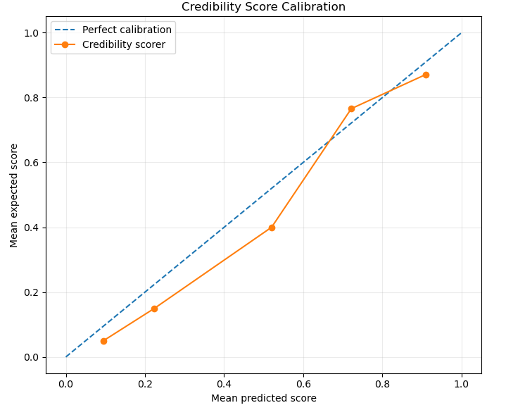

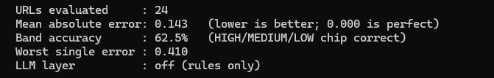

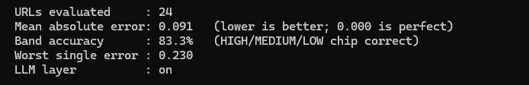

Limitations
Numerous weaknesses still remain. Firstly , some websites block automated inquiries , use paywalls, require JavaScript,or provide content as PDFs. Therefore, the page-reading element cannot always contain publication, reference, authorship,or correction information.
Secondly , the presence of credibility indicators does not guarantee that information is true . A low-quality website can still provide a date, author, and references. The current algorithm mainly discovers if whether these indicators exist instead of determining whether the references themselves are trustworthy .
The preprint classifications also remain imperfect. A preprint is not impulsively unreliable, and some preprints will later become peer-reviewed publications. A future version could utilize Crossref or similar scholarly metadata to decipher whether a published version is available and whether an article has been retracted.
The LLM layer can also make incorrect assumptions . Although it enhanced the evaluation results, it should not be weighed as a source of ground truth. Its performance can rely on the prompt, model,and familiarity with a specific publisher.
Finally, the evaluation included only 24 URLs, which is a fairly small sample. The expected credibility scores are also human estimates rather than the absolute truth. Therefore, the results display improvement on the provided evaluation set but do not establish that the system will perform equivalently well across the whole web.

Conclusion
This project enhanced the credibility scorer by merging URL-based rules with webpage evidence, preprint identification,better .edu handling, calibration analysis,clearer explanations, and an optional LLM judgment. The goal was to use numerous pieces of proof instead of predicting that publisher reputation determines credibility by itself .
The quantitative evaluation displayed meaningful improvement. With the LLM available , MAE dropped from 0.143 to 0.091, the band accuracy improved from 62.5% to 83.3%, and the worst error dropped from 0.410 to 0.230.
Despite these changes , credibility cannot be decided perfectly by an automated score. The system is better viewed as a tool that assists readers with evaluating sources instead of a specific determination of whether information is true or false. Future improvements could utilize bigger datasets, retraction databases,structured scholarly metadata, and learned scoring weights to make the system better calibrated and more accurate.

References
- Crossref. Metadata Retrieval and Retraction Watch. Crossref Documentation.
- Fogg, B. J. (2002). Stanford Guidelines for Web Credibility. Stanford Persuasive Technology Lab.
- Fogg, B. J., et al. (2001). What Makes a Web Site Credible? A Report on a Large Quantitative Study. Proceedings of the SIGCHI Conference on Human Factors in Computing Systems.
- W3C Credible Web Community Group. (2018). Technological Approaches to Improving Credibility Assessment on the Web. World Wide Web Consortium.

