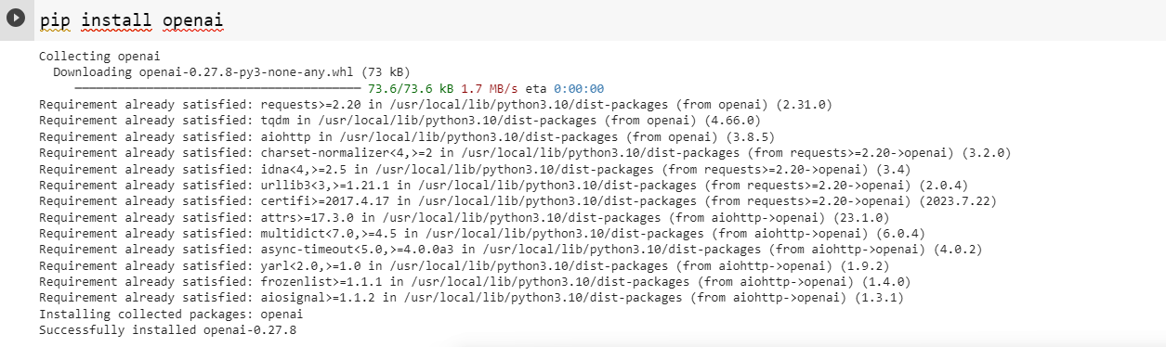

**Answers:**

