**Kubernetes Three-Tier Application**

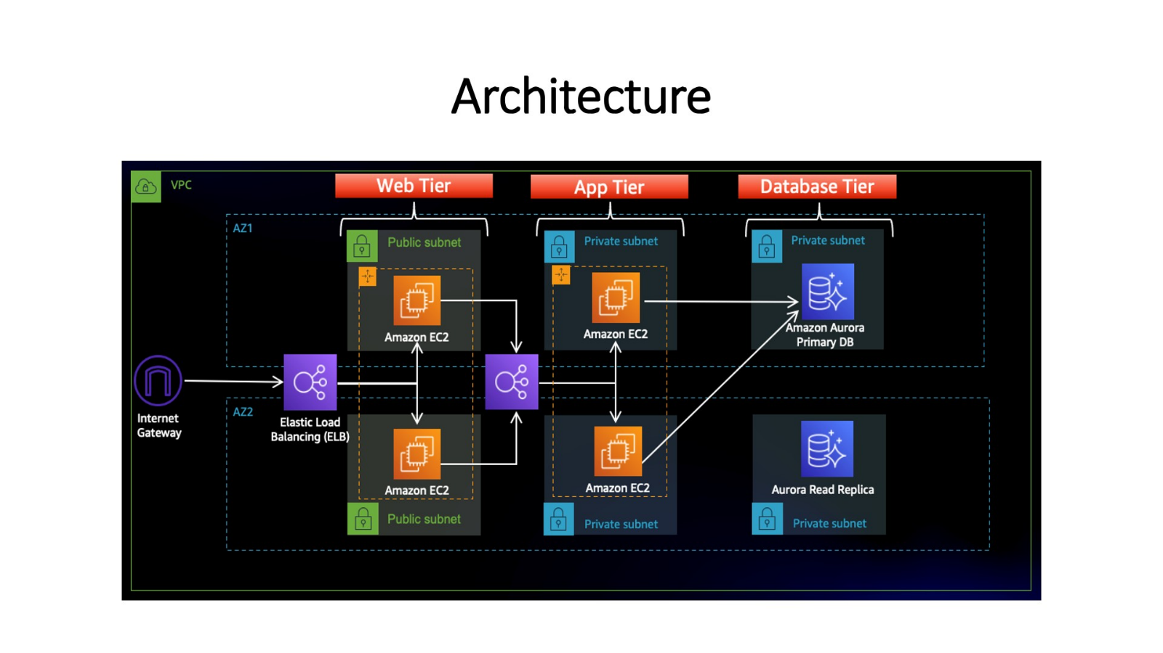

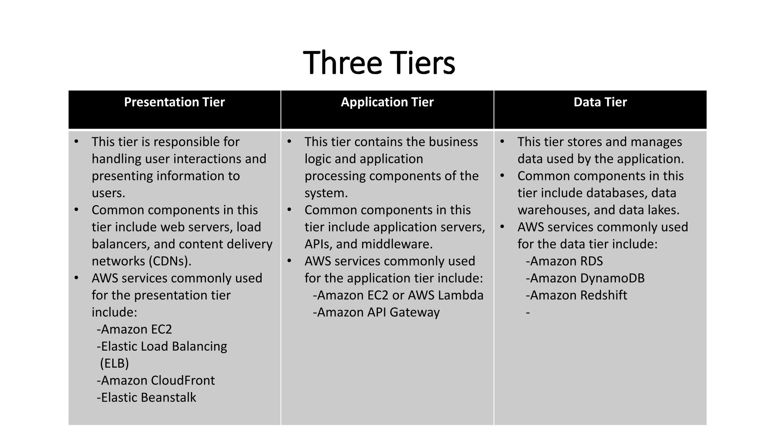

**1] Now we create Backend Directory in which we create Dockerfile, deployment.yaml, service.yaml & init.sql**

**Backend:-**

**Dockerfile:**

FROM mysql

ENV MYSQL_ROOT_PASSWORD="1234"

ENV MYSQL_DATABASE="studentapp"

COPY init.sql /docker-entrypoint-initdb.d/

**deployment.yaml:**

apiVersion: apps/v1

kind: Deployment

metadata:

name: backend-app

spec:

replicas: 1

selector:

matchLabels:

app: backend-app

strategy:

type: RollingUpdate

template:

metadata:

labels:

app: backend-app

spec:

containers:

- name: backend-app

image: shan20000/k8s_3teir_project:backend

ports:

- name: java

containerPort: 8080

protocol: TCP

**init.sql:**

CREATE DATABASE IF NOT EXISTS studentapp;

USE studentapp;

CREATE TABLE IF NOT EXISTS students (

student_id INT NOT NULL AUTO_INCREMENT,

student_name VARCHAR(100) NOT NULL,

student_addr VARCHAR(100) NOT NULL,

student_age VARCHAR(3) NOT NULL,

student_qual VARCHAR(20) NOT NULL,

student_percent VARCHAR(10) NOT NULL,

student_year_passed VARCHAR(10) NOT NULL,

PRIMARY KEY (student_id)

);

**service.yaml:**

apiVersion: v1

kind: Service

metadata:

name: backend-service

spec:

selector:

app: backend-app

ports:

- name: http

targetPort: 3306

port: 3306

type: ClusterIP

**2] Here we create Frontend Directory in which we create Dockerfile, deployment.yaml, service.yaml & config**

**Frontend:-**

**Dockerfile:**

FROM tomcat:9.0-slim

WORKDIR /opt

ENV APP_HOME=/usr/local/tomcat

ENV PORT=8080

ADD https://s3-us-west-2.amazonaws.com/studentapi-cit/student.war $APP_HOME/webapps/

ADD https://s3-us-west-2.amazonaws.com/studentapi-cit/mysql-connector.jar $APP_HOME/lib

COPY config /opt

RUN sed -i '20r /opt/config' /usr/local/tomcat/conf/context.xml

EXPOSE $PORT

CMD ["catalina.sh", "run"]

**Service.yaml:**

apiVersion: v1

kind: Service

metadata:

name: frontend-service

spec:

selector:

app: frontend-app

ports:

- name: http

targetPort: 8080

port: 80

type: LoadBalancer

**config:**

<Resource name="jdbc/TestDB" auth="Container" type="javax.sql.DataSource"

maxTotal="100" maxIdle="30" maxWaitMillis="10000" username="root"

password="1234" driverClassName="com.mysql.jdbc.Driver"

url="jdbc:mysql://backend-service:3306/studentapp"/>

**deployment.yaml:**

**apiVersion: apps/v1**

**kind: Deployment**

**metadata:**

**name: backend-app**

**spec:**

**replicas: 1**

**selector:**

**matchLabels:**

**app: backend-app**

**strategy:**

**type: RollingUpdate**

**template:**

**metadata:**

**labels:**

**app: backend-app**

**spec:**

**containers:**

**- name: backend-app**

**image: shan20000/k8s_3teir_project:backend**

**ports:**

**- name: java**

**containerPort: 8080**

**protocol: TCPapiVersion: apps/v1**

**kind: Deployment**

**metadata:**

**name: frontend-app**

**spec:**

**replicas: 1**

**selector:**

**matchLabels:**

**app: frontend-app**

**strategy:**

**type: RollingUpdate**

**template:**

**metadata:**

**labels:**

**app: frontend-app**

**spec:**

**containers:**

**- name: frontend-app**

**image: shan20000/k8s_3teir_project:frontend**

**ports:**

**- name: tomcat**

**containerPort: 8080**

**protocol: TCP**

**3] Here we create Frontend Directory in which we create Dockerfile, deployment.yaml, service.yaml & nginx.conf**

**Proxy:-**

**Dokerfile:**

FROM nginx:latest

# Copy the custom configuration file to the NGINX directory

COPY nginx.conf /etc/nginx/nginx.conf

# Remove the default.conf file

RUN rm /etc/nginx/conf.d/default.conf

# Expose the necessary port (e.g., 80 for HTTP)

EXPOSE 80

**service.yaml:**

apiVersion: v1

kind: Service

metadata:

name: proxy-service

spec:

selector:

app: proxy-app

ports:

- name: http

targetPort: 80

port: 80

type: LoadBalancer

**nginx.config:**

user nginx;

worker_processes 1;

error_log /var/log/nginx/error.log warn;

pid /var/run/nginx.pid;

events {

worker_connections 1024;

}

http {

include /etc/nginx/mime.types;

default_type application/octet-stream;

log_format main '$remote_addr - $remote_user [$time_local] "$request" '

'$status $body_bytes_sent "$http_referer" '

'"$http_user_agent" "$http_x_forwarded_for"';

access_log /var/log/nginx/access.log main;

sendfile on;

tcp_nopush on;

tcp_nodelay on;

keepalive_timeout 65;

types_hash_max_size 2048;

include /etc/nginx/conf.d/*.conf;

server {

listen 80;

server_name localhost;

location / {

proxy_pass http://frontend-service/student/;

}

}

}

**deployment.yaml**:

apiVersion: apps/v1

kind: Deployment

metadata:

name: proxy-app

spec:

replicas: 1

selector:

matchLabels:

app: proxy-app

strategy:

type: RollingUpdate

template:

metadata:

labels:

app: proxy-app

spec:

containers:

- name: proxy-app

image: shan20000/k8s_3teir_project:proxy

ports:

- name: proxy

containerPort: 80

protocol: TCP

**step 1:-**

Clone dockerfile of frontend, backend and proxy and Build it. [give your dockerhub repository name]

git init

git clone https://github.com/shantanu20000/k8s.git

cd k8s/

cd backend/

docker build -t shan20000/k8s_3teir_project:backend .

cd ../frontend

docker build -t shan20000/k8s_3teir_project:frontend .

cd ../proxy

docker build -t shan20000/k8s_3teir_project:proxy .

docker login

Give login and tocken of github

Push images to dockerhub [ give your dockerhub repository path ]

docker push shan20000/k8s_3teir_project:backend

docker push shan20000/k8s_3teir_project:frontend

docker push shan20000/k8s_3teir_project:proxy

**step 2:**

Apply deployment.yml and service.yaml file on Cloud Shell. go in every directory [backend, frontend, proxy]

kubectl apply -f deployment.yaml

kubeclt apply -f service.yaml

**step 3:**

View all services copy proxy loadbalancer DNS and paste it on url bar of Crome

kubeclt get svc

You will see Student form fill up It and check data is store or not .

