Activity 1:1. 1. Create new repository in github as demo-day12. 2. Login into VM and open the Git Bash3. 3. Create new folder as my-github-code4. 4. cd my-github-code5. 5. git clone URLofRepository6. 6. cd demo-day17. 7. echo "hello" > abc.txt8. 8. git status9. 9. git add .10. 10. git commit -m "My first file added as abc.txt"11. 11. git push12. 12. Enter User name and password as per your details.

Solution:-

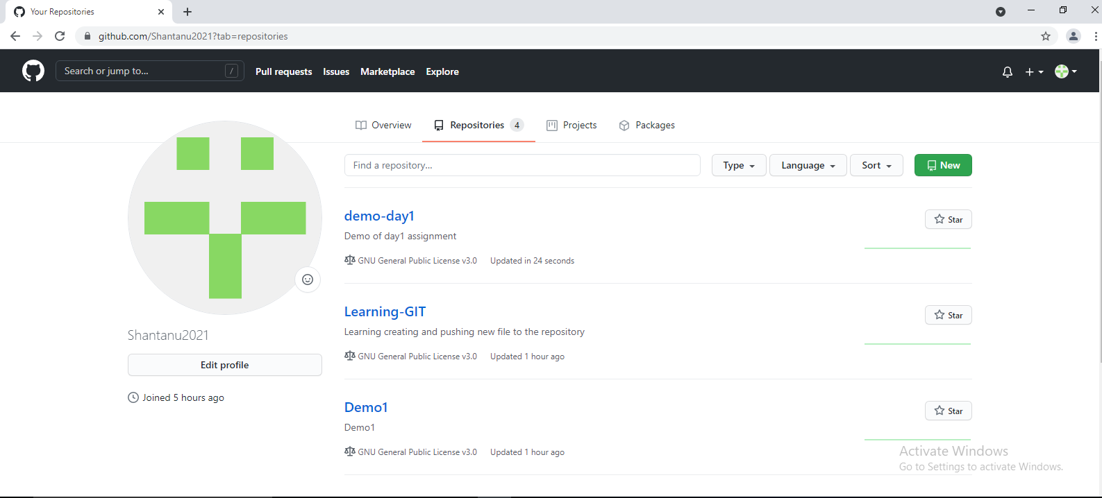

ustdocker27@ustdkr07 MINGW64 ~

$ pwd

/c/Users/ustdocker27

ustdocker27@ustdkr07 MINGW64 ~

$ mkdir my-github-code

ustdocker27@ustdkr07 MINGW64 ~

$ cd my-github-code/

ustdocker27@ustdkr07 MINGW64 ~/my-github-code

$ git clone https://github.com/Shantanu2021/demo-day1.git

Cloning into 'demo-day1'...

remote: Enumerating objects: 5, done.

remote: Counting objects: 100% (5/5), done.

remote: Compressing objects: 100% (4/4), done.

remote: Total 5 (delta 0), reused 0 (delta 0), pack-reused 0

Unpacking objects: 100% (5/5), 12.71 KiB | 255.00 KiB/s, done.

ustdocker27@ustdkr07 MINGW64 ~/my-github-code

$ ls -ltr

total 4

drwxr-xr-x 1 ustdocker27 1049089 0 May 31 17:54 demo-day1/

ustdocker27@ustdkr07 MINGW64 ~/my-github-code

$ cd demo-day1/

ustdocker27@ustdkr07 MINGW64 ~/my-github-code/demo-day1 (main)

$ echo "Hello" > abc.txt

ustdocker27@ustdkr07 MINGW64 ~/my-github-code/demo-day1 (main)

$ git status

On branch main

Your branch is up to date with 'origin/main'.

Untracked files:

(use "git add <file>..." to include in what will be committed)

abc.txt

nothing added to commit but untracked files present (use "git add" to track)

ustdocker27@ustdkr07 MINGW64 ~/my-github-code/demo-day1 (main)

$ git add .

warning: LF will be replaced by CRLF in abc.txt.

The file will have its original line endings in your working directory

ustdocker27@ustdkr07 MINGW64 ~/my-github-code/demo-day1 (main)

$ ls -ltr

total 38

-rw-r--r-- 1 ustdocker27 1049089 35823 May 31 17:54 LICENSE

-rw-r--r-- 1 ustdocker27 1049089 38 May 31 17:54 README.md

-rw-r--r-- 1 ustdocker27 1049089 6 May 31 17:56 abc.txt

ustdocker27@ustdkr07 MINGW64 ~/my-github-code/demo-day1 (main)

$ git commit -m "Added my first file as abc.txt in the demo-day1 repository"

[main dc7b678] Added my first file as abc.txt in the demo-day1 repository

Committer: unknown <ustdocker27@iiht.tech>

Your name and email address were configured automatically based

on your username and hostname. Please check that they are accurate.

You can suppress this message by setting them explicitly. Run the

following command and follow the instructions in your editor to edit

your configuration file:

git config --global --edit

After doing this, you may fix the identity used for this commit with:

git commit --amend --reset-author

1 file changed, 1 insertion(+)

create mode 100644 abc.txt

ustdocker27@ustdkr07 MINGW64 ~/my-github-code/demo-day1 (main)

$ git push

Logon failed, use ctrl+c to cancel basic credential prompt.

Enumerating objects: 4, done.

Counting objects: 100% (4/4), done.

Delta compression using up to 4 threads

Compressing objects: 100% (2/2), done.

Writing objects: 100% (3/3), 302 bytes | 302.00 KiB/s, done.

Total 3 (delta 1), reused 0 (delta 0), pack-reused 0

remote: Resolving deltas: 100% (1/1), completed with 1 local object.

To https://github.com/Shantanu2021/demo-day1.git

105cd1a..dc7b678 main -> main

ustdocker27@ustdkr07 MINGW64 ~/my-github-code/demo-day1 (main)

$

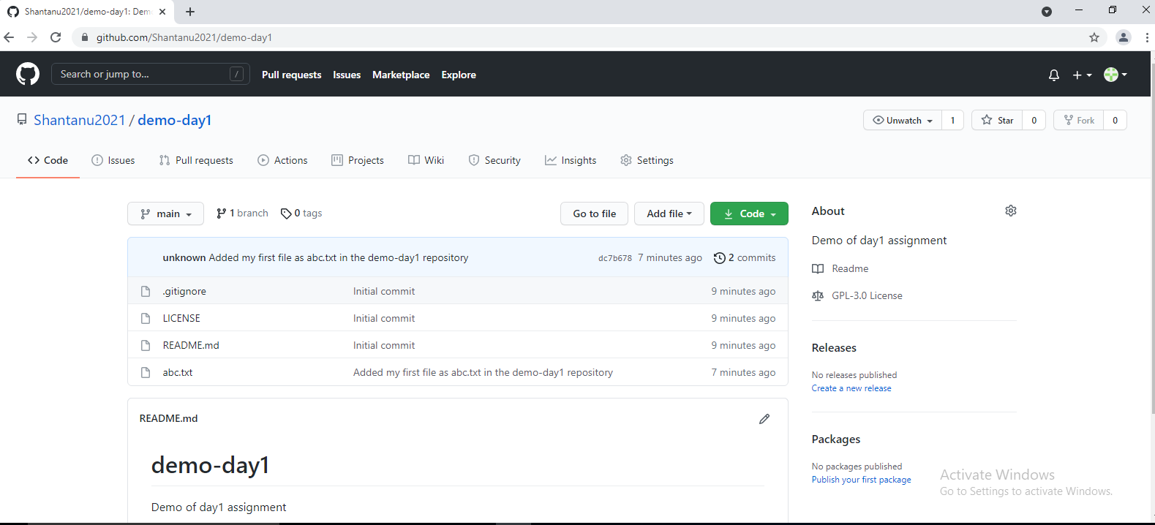

Activity 2:1. Login into VM and clone the above project demo-day12. Go to the GUI and edit README.md file and commit it.

3. Go to the VM and change the directory where your code there

4. git pull

5. Note: you will see some file got pulled form remote and it will be display into screen

Solution:-

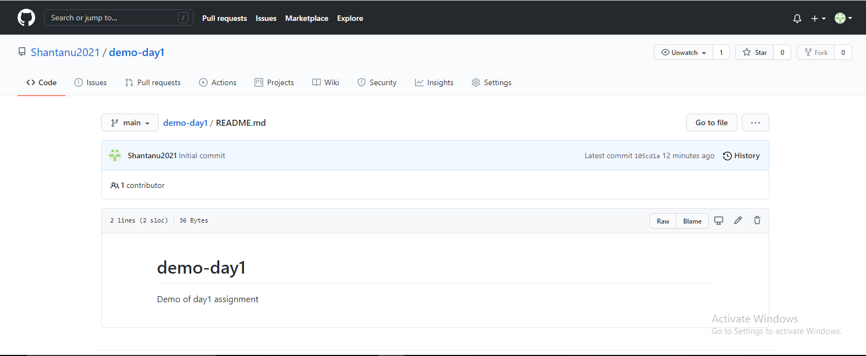

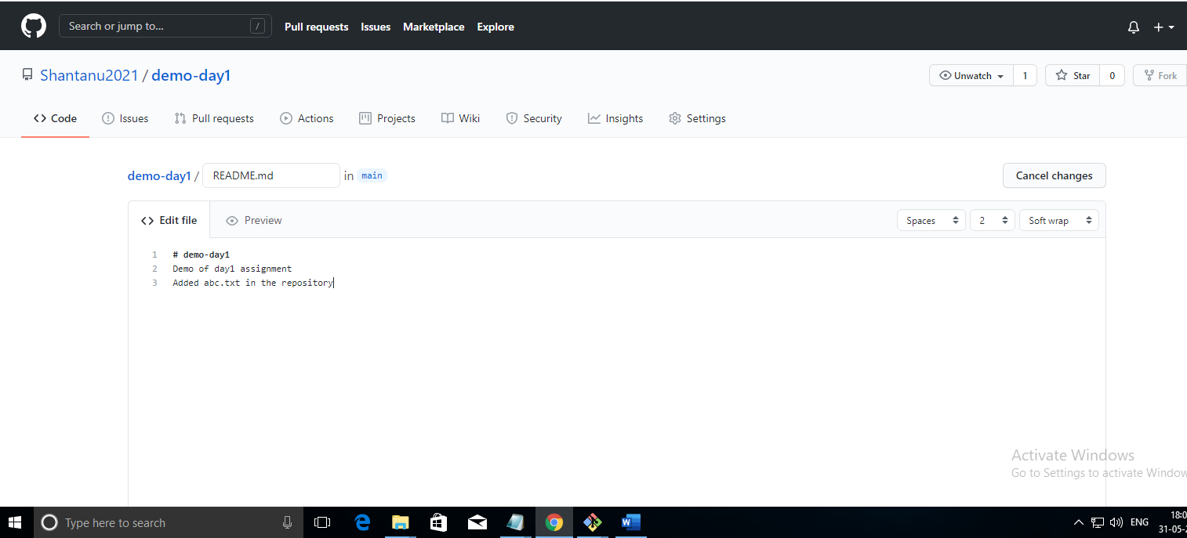

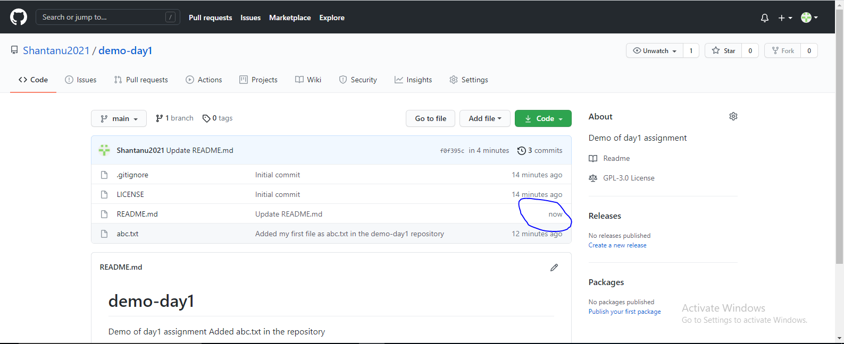

ustdocker27@ustdkr07 MINGW64 ~

$ pwd

/c/Users/ustdocker27

ustdocker27@ustdkr07 MINGW64 ~

$ mkdir my-github-code

ustdocker27@ustdkr07 MINGW64 ~

$ cd my-github-code/

ustdocker27@ustdkr07 MINGW64 ~/my-github-code

$ git clone https://github.com/Shantanu2021/demo-day1.git

Cloning into 'demo-day1'...

remote: Enumerating objects: 5, done.

remote: Counting objects: 100% (5/5), done.

remote: Compressing objects: 100% (4/4), done.

remote: Total 5 (delta 0), reused 0 (delta 0), pack-reused 0

Unpacking objects: 100% (5/5), 12.71 KiB | 255.00 KiB/s, done.

ustdocker27@ustdkr07 MINGW64 ~/my-github-code

$ ls -ltr

total 4

drwxr-xr-x 1 ustdocker27 1049089 0 May 31 17:54 demo-day1/

ustdocker27@ustdkr07 MINGW64 ~/my-github-code

$ cd demo-day1/

ustdocker27@ustdkr07 MINGW64 ~/my-github-code/demo-day1 (main)

$ echo "Hello" > abc.txt

ustdocker27@ustdkr07 MINGW64 ~/my-github-code/demo-day1 (main)

$ git status

On branch main

Your branch is up to date with 'origin/main'.

Untracked files:

(use "git add <file>..." to include in what will be committed)

abc.txt

nothing added to commit but untracked files present (use "git add" to track)

ustdocker27@ustdkr07 MINGW64 ~/my-github-code/demo-day1 (main)

$ git add .

warning: LF will be replaced by CRLF in abc.txt.

The file will have its original line endings in your working directory

ustdocker27@ustdkr07 MINGW64 ~/my-github-code/demo-day1 (main)

$ ls -ltr

total 38

-rw-r--r-- 1 ustdocker27 1049089 35823 May 31 17:54 LICENSE

-rw-r--r-- 1 ustdocker27 1049089 38 May 31 17:54 README.md

-rw-r--r-- 1 ustdocker27 1049089 6 May 31 17:56 abc.txt

ustdocker27@ustdkr07 MINGW64 ~/my-github-code/demo-day1 (main)

$ git commit -m "Added my first file as abc.txt in the demo-day1 repository"

[main dc7b678] Added my first file as abc.txt in the demo-day1 repository

Committer: unknown <ustdocker27@iiht.tech>

Your name and email address were configured automatically based

on your username and hostname. Please check that they are accurate.

You can suppress this message by setting them explicitly. Run the

following command and follow the instructions in your editor to edit

your configuration file:

git config --global --edit

After doing this, you may fix the identity used for this commit with:

git commit --amend --reset-author

1 file changed, 1 insertion(+)

create mode 100644 abc.txt

ustdocker27@ustdkr07 MINGW64 ~/my-github-code/demo-day1 (main)

$ git push

Logon failed, use ctrl+c to cancel basic credential prompt.

Enumerating objects: 4, done.

Counting objects: 100% (4/4), done.

Delta compression using up to 4 threads

Compressing objects: 100% (2/2), done.

Writing objects: 100% (3/3), 302 bytes | 302.00 KiB/s, done.

Total 3 (delta 1), reused 0 (delta 0), pack-reused 0

remote: Resolving deltas: 100% (1/1), completed with 1 local object.

To https://github.com/Shantanu2021/demo-day1.git

105cd1a..dc7b678 main -> main

ustdocker27@ustdkr07 MINGW64 ~/my-github-code/demo-day1 (main)

$ ls -ltr

total 38

-rw-r--r-- 1 ustdocker27 1049089 35823 May 31 17:54 LICENSE

-rw-r--r-- 1 ustdocker27 1049089 38 May 31 17:54 README.md

-rw-r--r-- 1 ustdocker27 1049089 6 May 31 17:56 abc.txt

ustdocker27@ustdkr07 MINGW64 ~/my-github-code/demo-day1 (main)

$ git pull

remote: Enumerating objects: 5, done.

remote: Counting objects: 100% (5/5), done.

remote: Compressing objects: 100% (3/3), done.

remote: Total 3 (delta 1), reused 0 (delta 0), pack-reused 0

Unpacking objects: 100% (3/3), 698 bytes | 12.00 KiB/s, done.

From https://github.com/Shantanu2021/demo-day1

dc7b678..f0f395c main -> origin/main

Updating dc7b678..f0f395c

Fast-forward

README.md | 1 +

1 file changed, 1 insertion(+)

ustdocker27@ustdkr07 MINGW64 ~/my-github-code/demo-day1 (main)

$ ls -ltr

total 38

-rw-r--r-- 1 ustdocker27 1049089 35823 May 31 17:54 LICENSE

-rw-r--r-- 1 ustdocker27 1049089 6 May 31 17:56 abc.txt

-rw-r--r-- 1 ustdocker27 1049089 71 May 31 18:12 README.md

ustdocker27@ustdkr07 MINGW64 ~/my-github-code/demo-day1 (main)

$