Name:-Shantanu More

Roll no.:-2213547

Class:-CSF-2(A)

# Assignment 2

Title:- To study the steps for hiding and extract any text file behind an image file/ Audio file using Command Prompt.

Screenshot:-

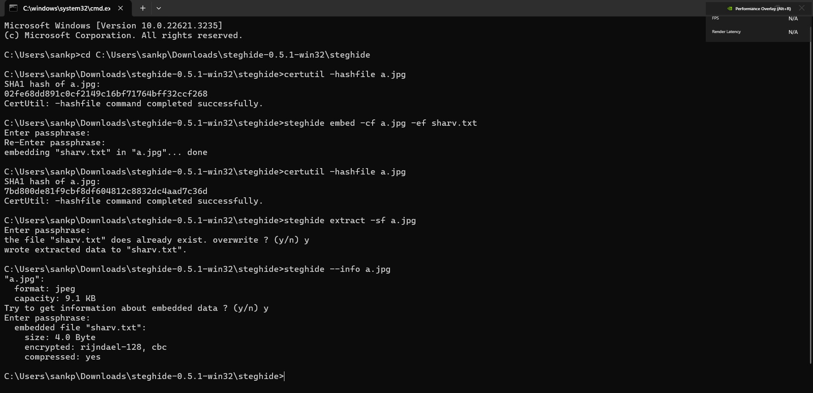

# Assignment 3

Title:- Introduction of FTK (Forensics Toolkit) Imager and Installation Screenshot:-

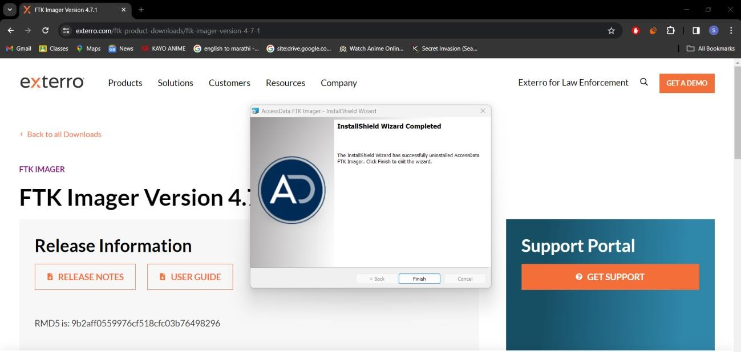

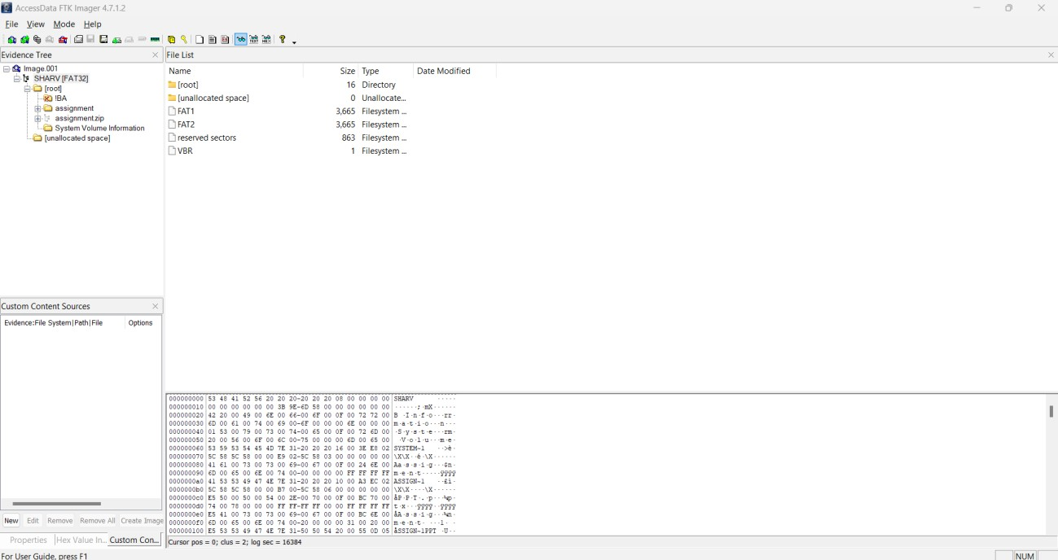

# Assignment 4

Title:- Creating a Forensic Image using FTK Imager/Encase Imager : -

* Creating Forensic Image
* Check Integrity of Data
* Analyze Forensic Image.

Screenshot:-

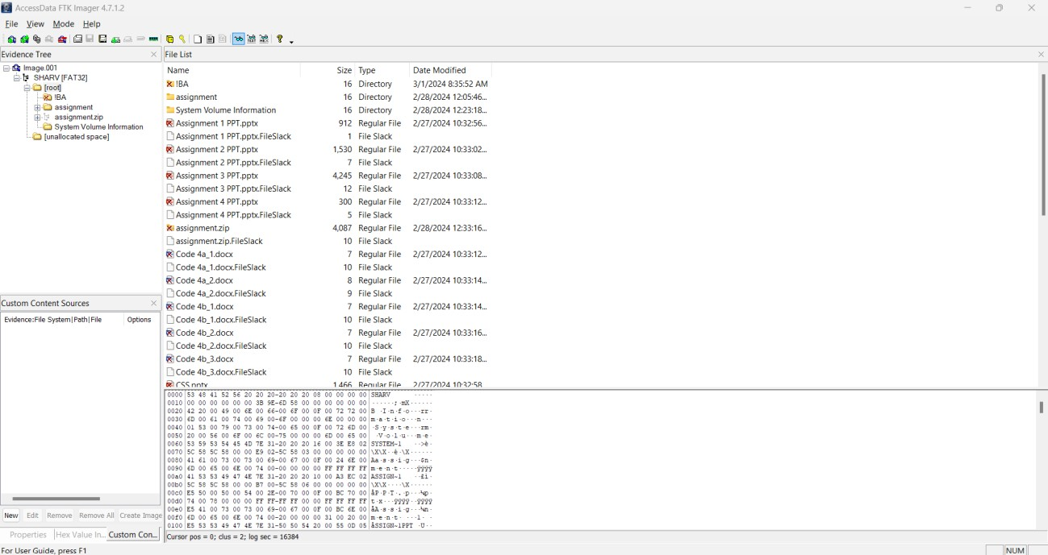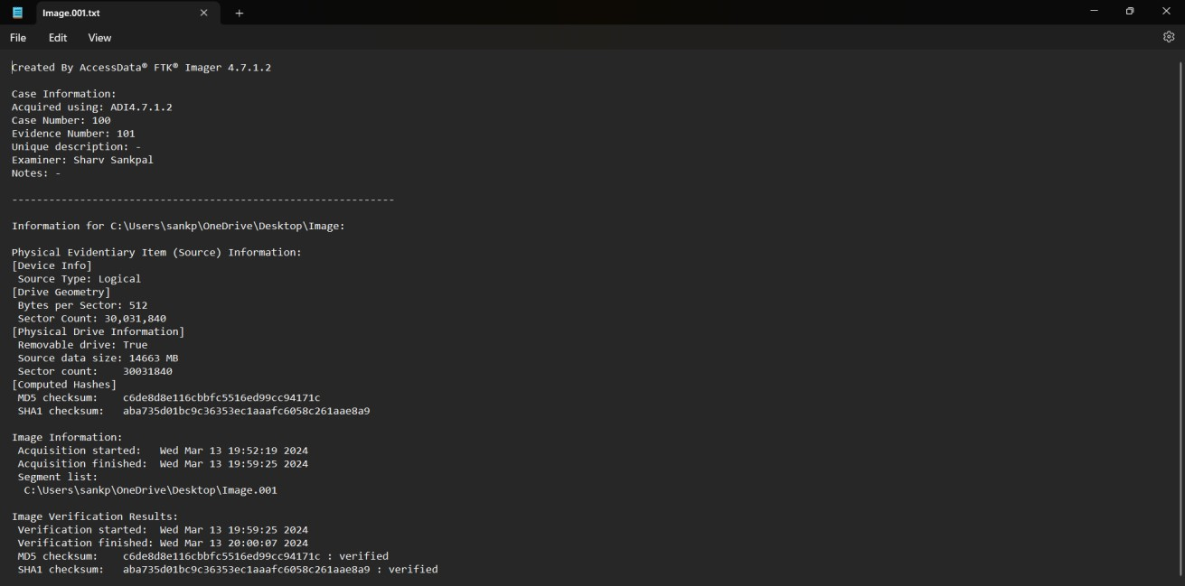

# Assignment 8

Title:- Introduction to Wireshark Network Analyzer & Installation of Wireshark

Screenshot:-

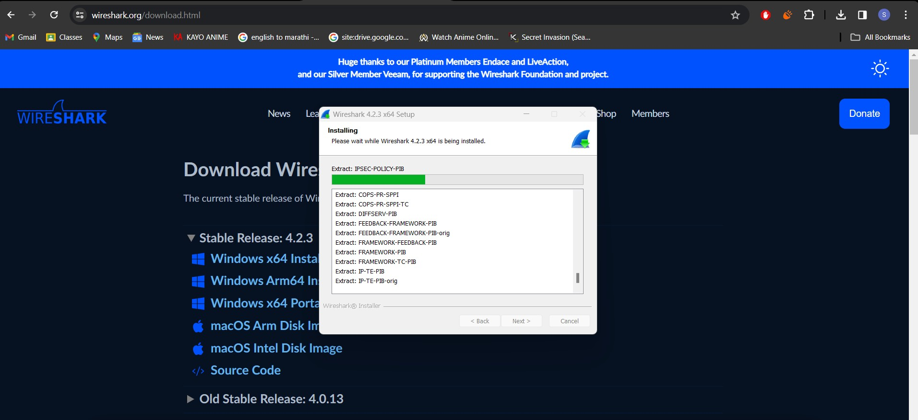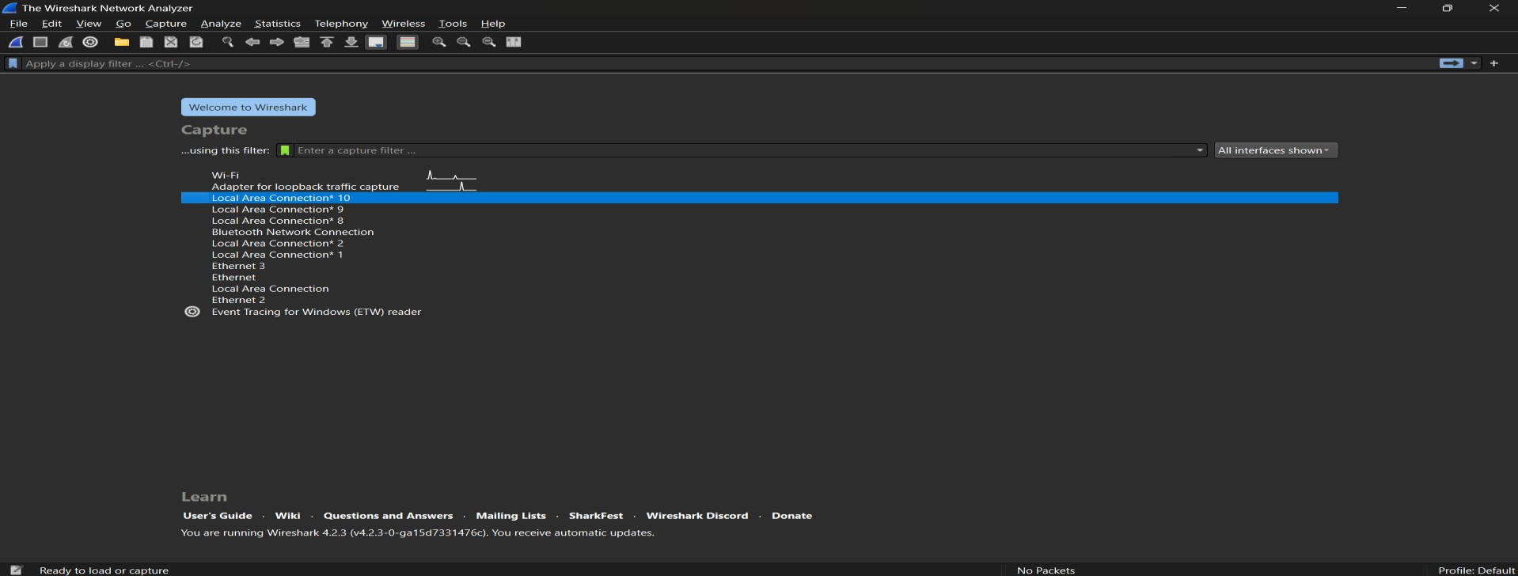

# Assignment 9

Title:- Capturing and analyzing network packets using Wireshark (Fundamentals) : -

Identification the live network - Capture Packets - Analyze the captured packets.

Screenshot:-

