**Name:: Shantanu More**

**Roll no. :: 2213547**

Lab Experiment:-12

HTML Code:-

<!DOCTYPE html>

<html lang="en">

<head>

    <meta charset="UTF-8">

    <title>Popup on Mouseover</title>

    <style>

        /* Style for the popup */

        .popup {

            display: none;

            position: absolute;

            padding: 20px;

            background: #fff;

            border: 1px solid #ccc;

            z-index: 1;

        }

    </style>

</head>

<body>

<p>Hover over this <a href="#" id="link">link</a> to see the popup.</p>

<div id="popup" class="popup">

    <input type="text" id="textBox1" placeholder="Textbox 1">

    <br><br>

    <input type="text" id="textBox2" placeholder="Textbox 2">

    <br><br>

    <button id="submitButton">Submit</button>

</div>

<script>

    // Get the link and popup elements

    const link = document.getElementById('link');

    const popup = document.getElementById('popup');

    // Show the popup on mouseover

    link.addEventListener('mouseover', function() {

        popup.style.display = 'block';

    });

    // Hide the popup on mouseout

    link.addEventListener('mouseout', function() {

        popup.style.display = 'none';

    });

</script>

</body>

</html>

Output:- 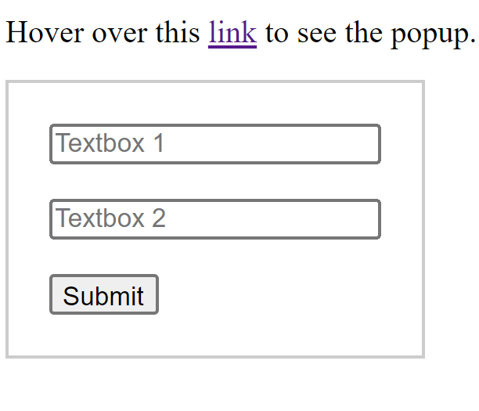

Explanation:- This code creates a simple webpage with a link that, when hovered over, displays a popup. The popup contains two text boxes and a button.

- HTML defines the structure of the page, including the link and the hidden popup section.

- CSS provides basic styling for the popup, making it initially hidden and defining its appearance.

- JavaScript handles the interactivity by showing the popup when the link is hovered over and hiding it when the cursor moves away from the link.

The JavaScript code uses event listeners to trigger the display and hiding of the popup based on the mouseover and mouseout events on the link element.