EDA

1. SALES TREND ANALYSIS BUSINESS QUESTION
“How are sales behaving over time?”
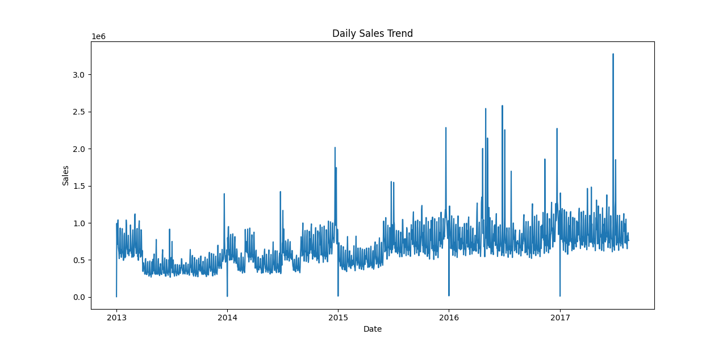

2. PRODUCT FAMILY ANALYSIS BUSINESS QUESTION
“Which product categories drive revenue?”
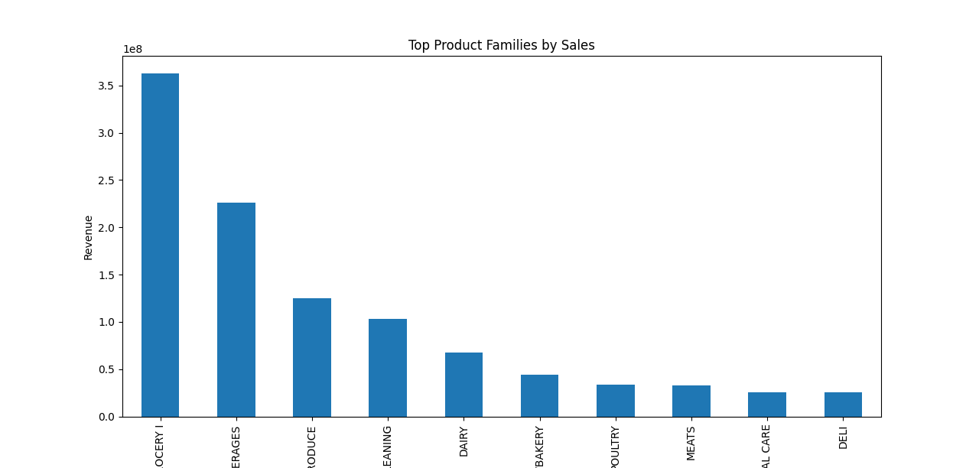

3. PROMOTION EFFECTIVENESS ANALYSIS BUSINESS QUESTION
“Do promotions actually increase sales?”
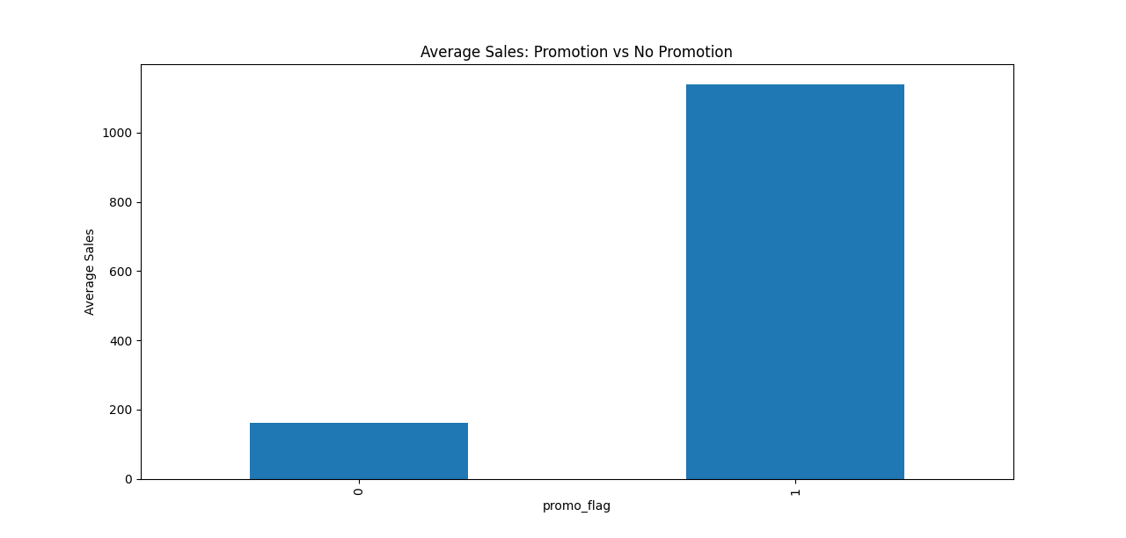

4. SEASONALITY ANALYSIS BUSINESS QUESTION
“Do certain months perform better?”
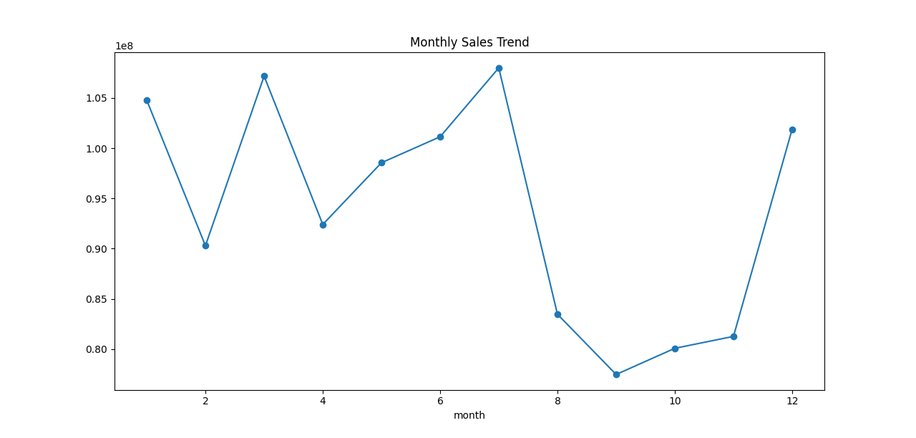

5. STORE / REGIONAL ANALYSIS BUSINESS QUESTION
“Which regions perform best?”
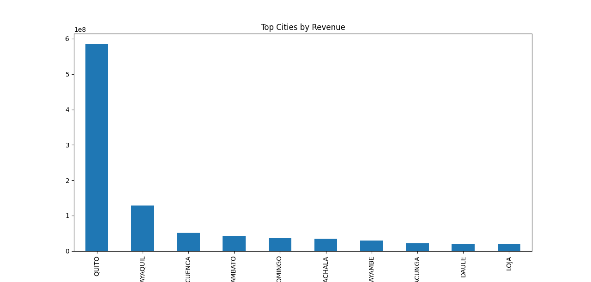

6. HOLIDAY IMPACT ANALYSIS BUSINESS QUESTION
“Do holidays affect sales?”
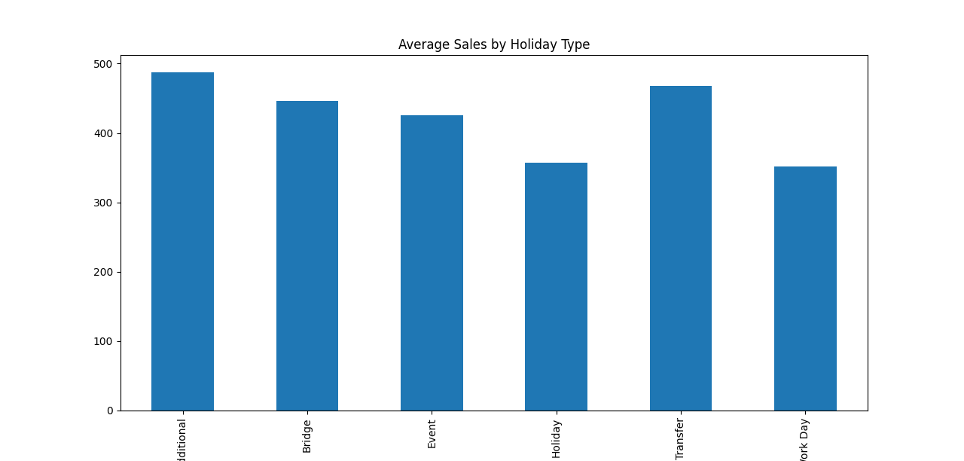

7. TRANSACTION VS SALES ANALYSIS BUSINESS QUESTION
“Does higher footfall increase sales?”
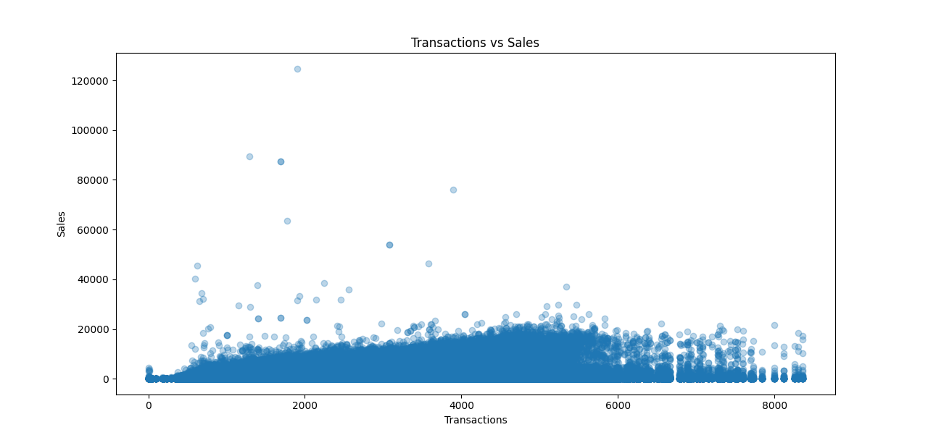

8. Correlation Matrix
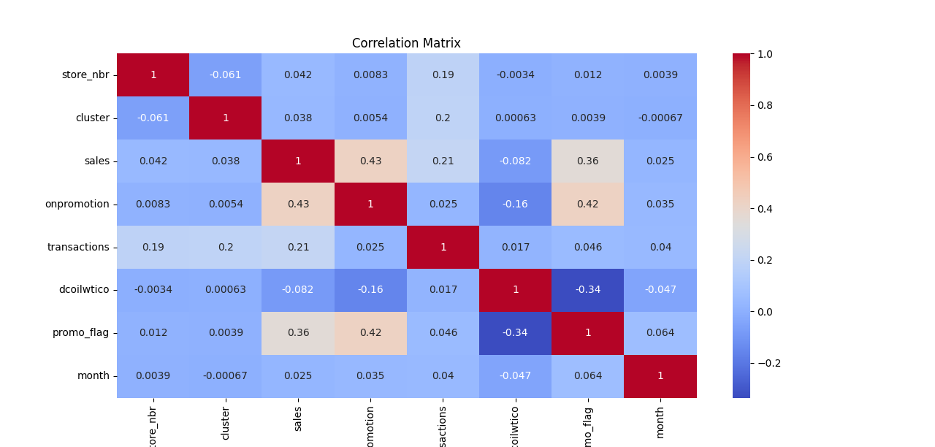

9. OUTLIER ANALYSIS
