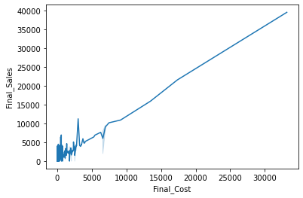

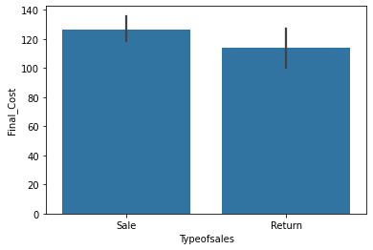

We can understand typesofsales vs average final_cost

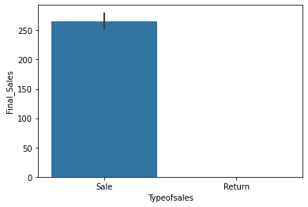

After comparing final sales and final cost with types of sales (sale and return)-

Cost of final sales of return sale types becomes zero.

Histogram=

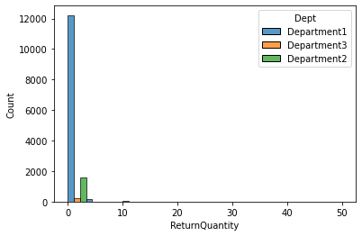

Return quantity is very high in dept 1

Return qty -dept1>dept2>dept3

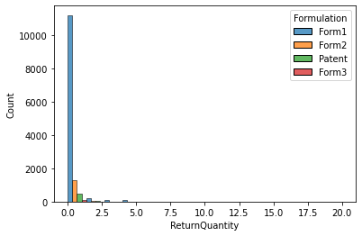

Count of rtn qty=form1>form2>patent>form3

Scatter plot-

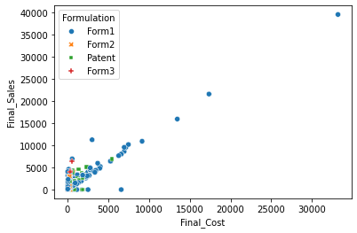

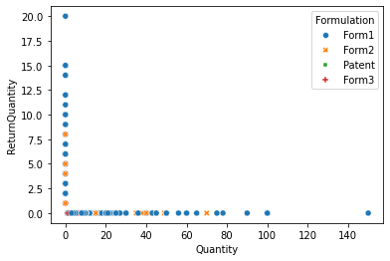

Form 1>form2 in returning qty

