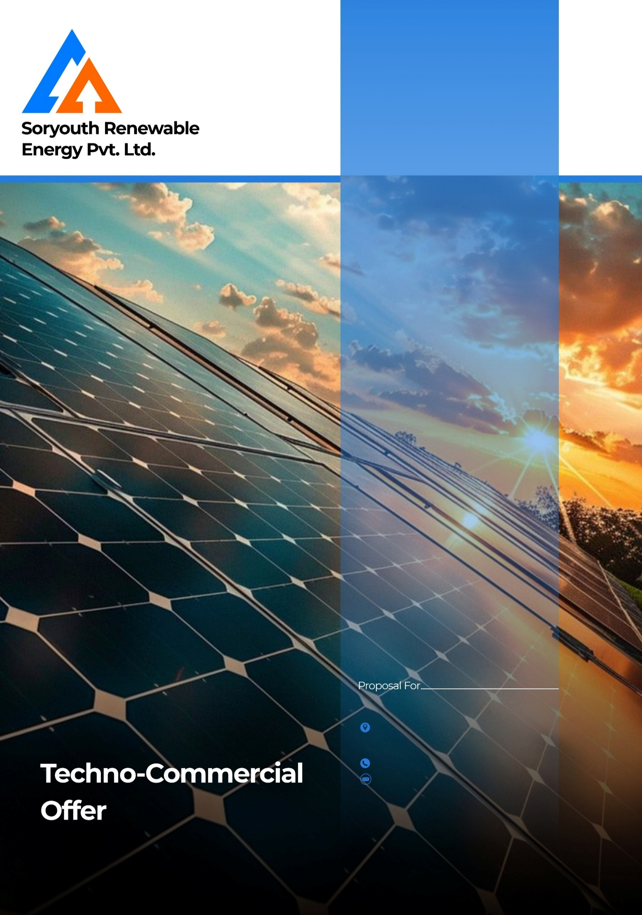

Date: {{date_today}}

Proposal No: {{proposal_number}}

{{contact_person}}
{{city_area}}
{{capacity}} kW

{{phone}}
{{contact_person}}
Created By: {{created_by}}

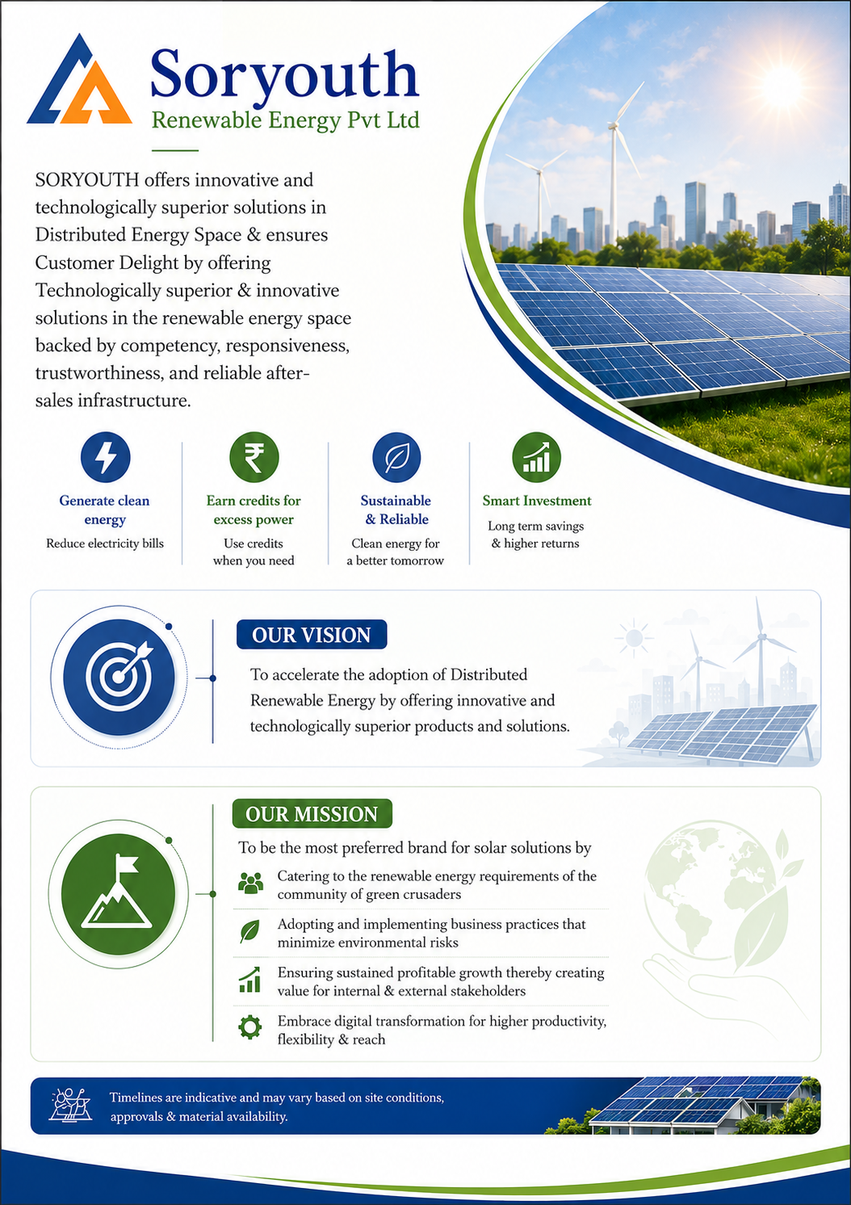

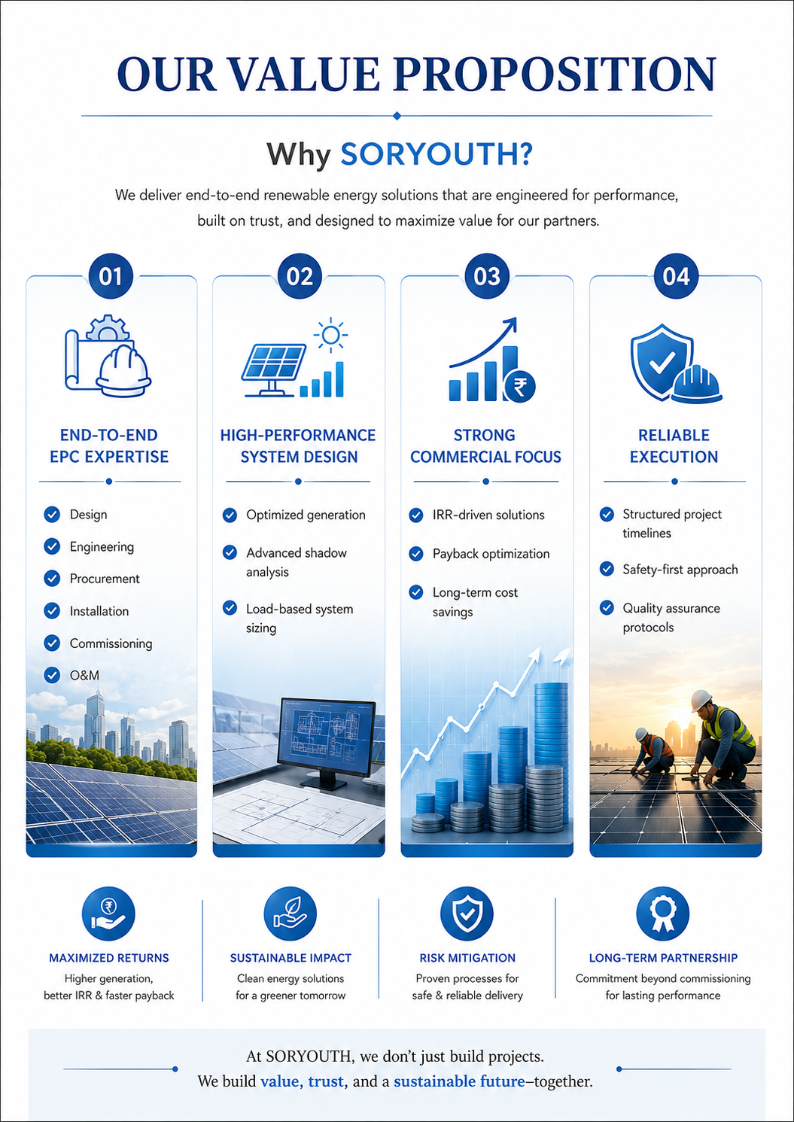

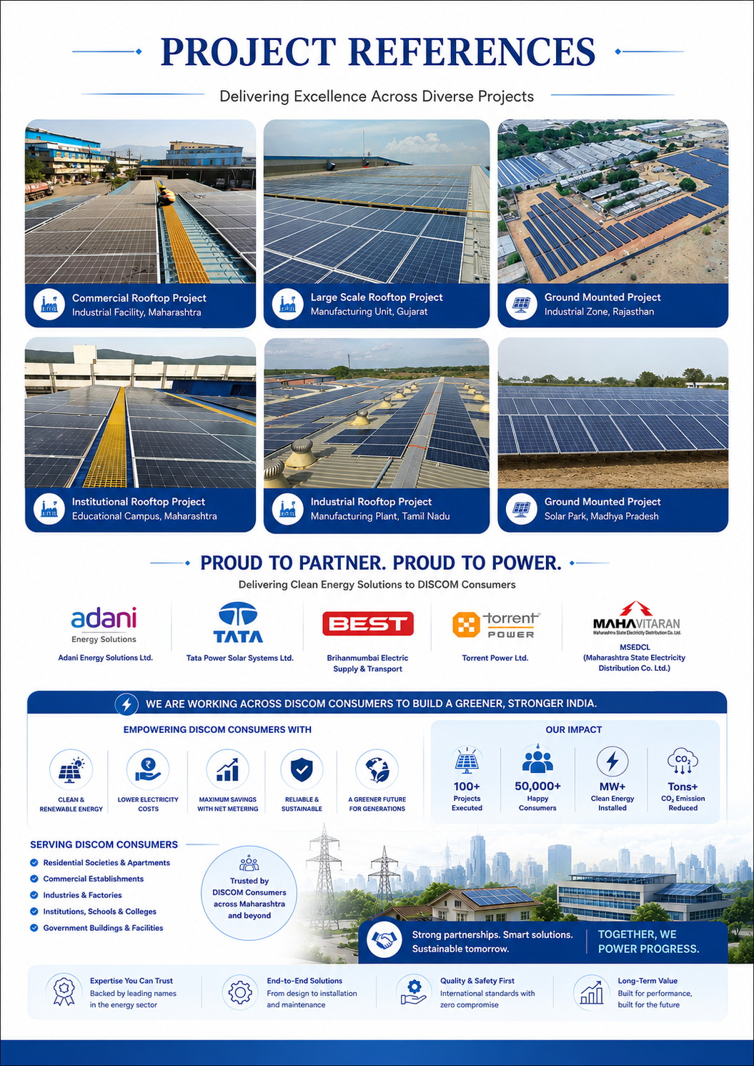

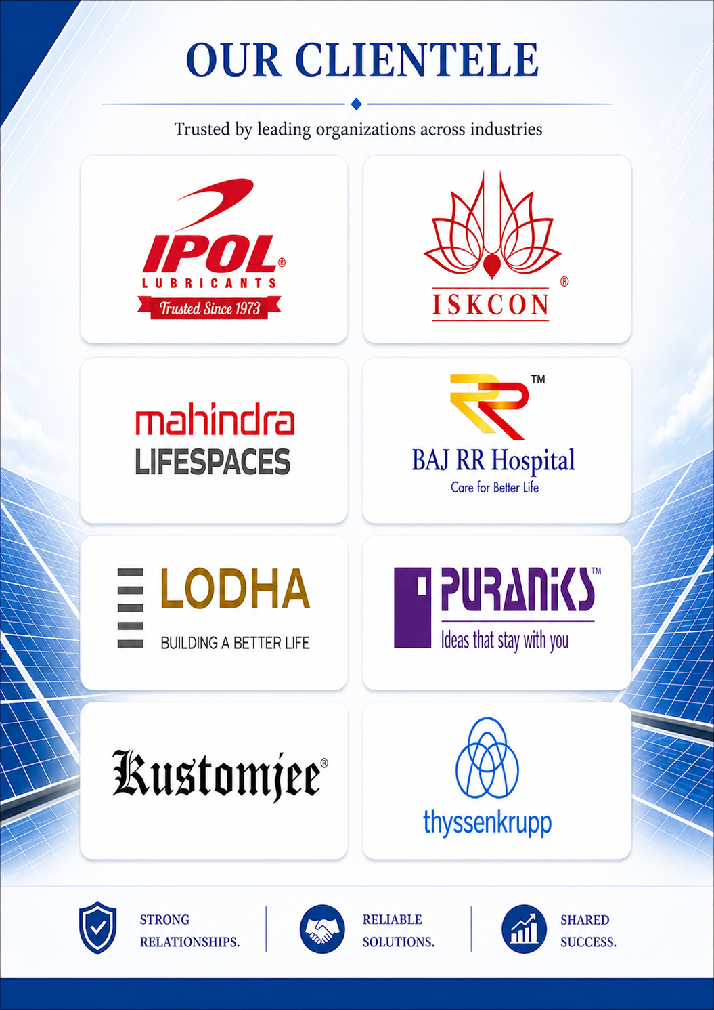

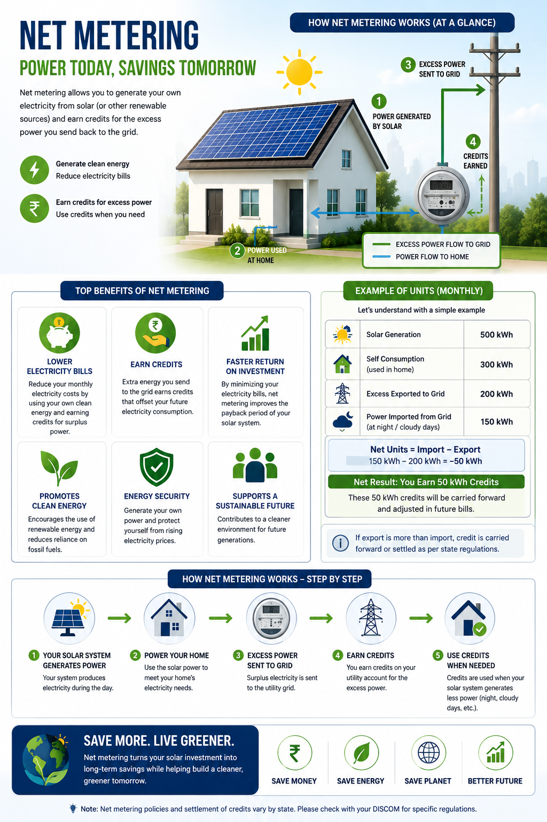

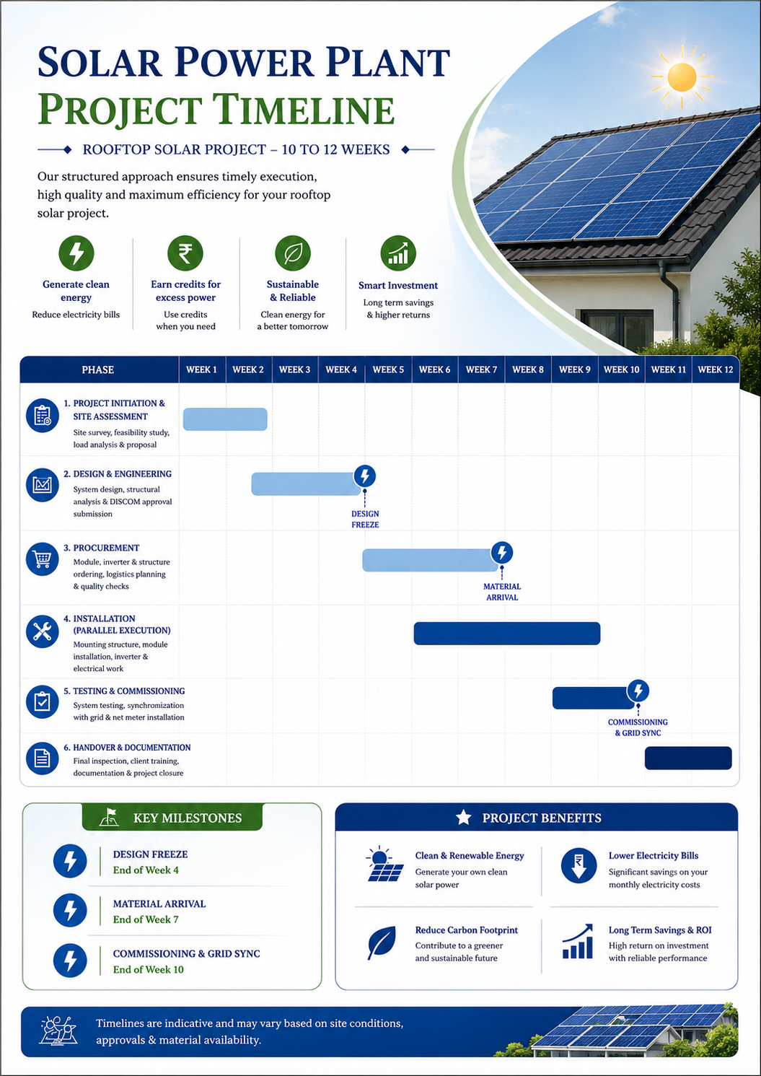

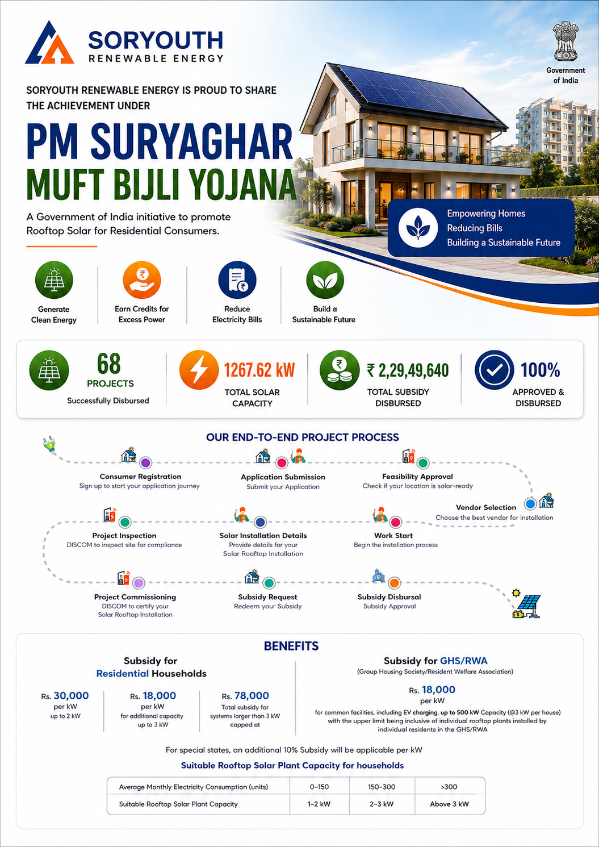
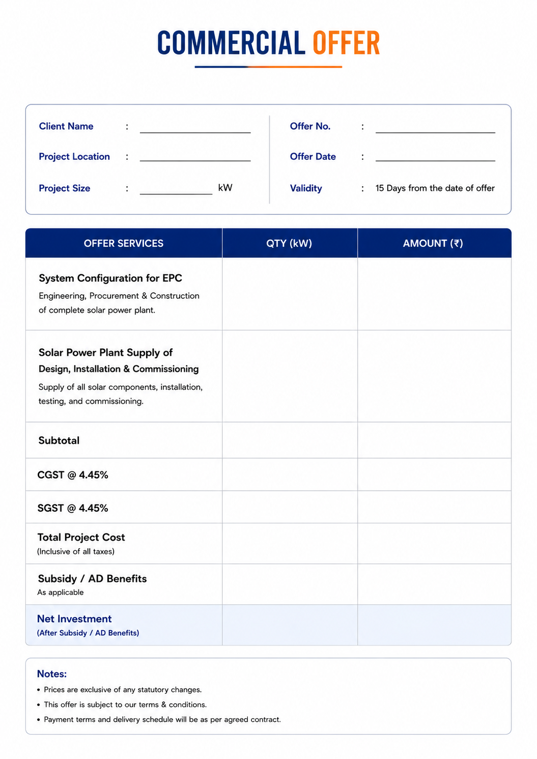

{{proposal_number}}
{{name}}
₹ {{subsidy_amount}}

₹ {{base_amount}}

{{capacity}}
{{date_today}}
{{city_area}}
{{capacity}} kW
₹ {{netInvestment}}

₹ {{final_amount}}

₹ {{base_amount}}

₹ {{cgst_amount}}

₹ {{sgst_amount}}

Included
Included

Balance Of System
Component | Details | Qty | Specifications
Solar Modules | Premier Energies Topcon Half Cut | {{module_qty}} | {{module_spec}}
Inverter | String Inverter with MPPT | {{inverter_qty}} | {{inverter_spec}}
Mounting Structure | {{mounting_structure}} | 1 Lot | HDGI Square Pipe 1.7-2 mm with 80-120 micron Zinc Coating
DC Cable | 4 sq.mm | As per design | Polycab 1.1 kV Standard EN 50618 / IEC 62930 UV Resistant - Yes
AC Cable | As per Design | As per design | XLPE Aluminium Armoured Cable as per IEC Standard
DCDB | As per design | {{dcdb_qty_nos}} | DC Isolator, DC SPD Type-II, String Fuses Enclosure - IP65 Weatherproof
ACDB | As per design | {{acdb_qty_nos}} | MCCB/MCB, AC SPD Type-II Enclosure - IP65 Weatherproof
Earthing Kit | Chemical Earthing | {{earthing_kit_qty_nos}} | Electrode Size - 17.2 mm Copper Bonded / GI Electrode Earth Resistance less than 5 Ohms Compliance IS 3043
Lightning Arrester | Standard | 1 Nos | IS/IEC Standards
Connectors | MC4 compatible | As required | 1500 V DC  Protection Class - IP68
Monitoring | RMS App-based | 1 Set | Real-Time Generation, Fault Alerts, Historical Data Analysis
Tags | Aluminum Engraved | 1 Set | Aluminum Engraved Identification Tags
Fire Extinguishers | As per compliance | 1 Set | As per MNRE / Electrical Compliance Requirements
{{capex_evaluation_sheet}}
{{combined_charts_page}}

Project's Scope

Sr. No. | Category | Scope Item | Soryouth's | Client's
1 | Supply of Items | PV Solar components as per BOM & BOQ | Yes | -
 |  | Roof / Superstructure / Elevated Structure | Yes | -
 |  | Data Logger | Yes | -
2 | Freight | Transportation | Yes | -
 |  | Packing & Handling | Yes | -
3 | Material Handling at Site | Safe unloading of material from vehicle | Yes | -
 |  | Lifting & shifting of materials at site | Yes | -
 |  | Parking space / permission for vehicles | - | Yes
4 | Material Storage | Safe & secure storage space at site | - | Yes
5 | Roof | Waterproofing | - | Yes
 |  | NOC / Permission for Roof Usage | - | Yes
 |  | Safe Access to Installation Site | - | Yes
 |  | Clearance of Installation Area | - | Yes
6 | Liaisoning | Net Metering Liaisoning with Utility | Yes | -
7 | Installation & Commissioning (I&C) | Design & Engineering of Solar PV System | Yes | -
 |  | Tools, Tackles & Installation Consumables | Yes | -
 |  | Solar PV system installation services | Yes | -
 |  | Lightning Arrestor (LA) | Yes | -
 |  | Earthing & system safety | Yes | -
 |  | Civil works for installation | Yes | -
 |  | Testing & Commissioning | Yes | -
8 | Statutory Approvals | Additional utility permissions | - | Yes
 |  | Load Enhancement / Sanctioned Load Changes / Name Change | - | Yes
 |  | Modifications in Existing Control Panel | - | Yes
9 | Discom Metering | Permissions & Documentation | Yes | -
 |  | Testing of Meters & Accessories | Yes | -
10 | Internet Facility | Wi-Fi / SIM / LAN availability at site | - | Yes
11 | AMC | Annual Maintenance Contract | Optional | -
12 | Others | Training / Maintenance Guidelines | Yes | -
 |  | Soft water for module cleaning | - | Yes
 |  | Tree Trimming / Shadow Removal | - | Yes
 |  | Electricity & Water During Construction | - | Yes
 |  | Design Approvals (if applicable) | - | Yes
13 | Warranty | Warranty Certificates & Documentation | Yes | -

Term's & Conditions

Sr. No. | Section | Details
1 | Pricing & Validity | Proposal valid for 15 days. Price subject to change if scope, specifications, or statutory requirements change. Excludes permits, panel upgrades, roof repairs, trenching unless specified.
2 | Taxes | GST shall be charged extra at actuals as per applicable rates.
3 | Freight & Logistics | Inclusive of transportation, packing, forwarding, and unloading at site.
4 | Technical Site Assessment | Site verification post-LOI/PO. Any variation may impact cost. No warranty on roof or electrical panel condition.
5 | Delivery & Timeline | Delivery within 8 weeks from advance payment and PO confirmation. Subject to extension due to delays, approvals, force majeure, or client-side dependencies.
6 | Approvals & Documentation | Seller will assist as agent for approvals. Timelines depend on authorities; delays not attributable to Seller.
7 | Proposal & IP | All documents remain Seller’s IP. Cannot be reused without consent. Financial estimates are indicative only.
8 | Insurance | Seller responsible till commissioning. Post-delivery and post-commissioning insurance responsibility lies with Purchaser.
9 | Warranty (General) | Equipment and services warranted against defects as per defined terms.
10 | Warranty (Equipment) | Modules: 12 yrs product + 30 yrs performance. Inverter: 5 yrs. BOS: 2 yrs
11 | Warranty Exclusions | Excludes wear & tear, misuse, unauthorized changes, environmental damage, theft, force majeure.
12 | Pre-Warranty Damages | Damages due to negligence or external factors before warranty start shall be repaired at Purchaser’s cost.
13 | Excluded Costs | Transport, reinstallation, customs, and related costs not covered under warranty. Replacement does not reset warranty.
14 | Change in Law | Any cost or timeline impact due to regulatory changes shall be borne by Purchaser.
15 | Client Obligations | Timely payment, site access, utilities, approvals, and material support to be ensured by Purchaser.
16 | Payment Delay Remedies | Seller may charge 12% interest, suspend work, terminate contract, and recover losses.
17 | Suspension | Costs due to suspension borne by Purchaser unless caused by Seller.
18 | Termination | Either party may terminate for breach with 30-day cure period. Purchaser liable for completed work and associated costs.
19 | Intellectual Property Rights | Seller IP to be used only for plant operation. Misuse subject to indemnity.
20 | Limitation of Liability | Seller liability limited to 3% of contract value.
21 | Consequential Damages | Neither party liable for indirect or consequential losses (profit, revenue, generation).
22 | Indemnity | Both parties indemnify each other against contractual breaches.
23 | Force Majeure | Covers uncontrollable events (natural disasters, war, etc.). Financial inability excluded.
24 | Dispute Resolution | Amicable → Management → Arbitration (MCIA, Mumbai, single arbitrator).
25 | Jurisdiction | Mumbai courts shall have exclusive jurisdiction.
26 | Payment Terms | 40% Advance, 50% On 1st Lot Material Delivery (DC Cable, Inverter,  Earthing), 10% Net Metering (Meter Installation)
27 | Advance Payment / Token Amount (Non-Refundable) | The advance payment or token amount paid by the Purchaser is non-refundable and non-transferable. In the event of cancellation, suspension, or delay attributable to the Purchaser, the Seller shall have the right to forfeit the entire advance without any obligation to refund. This amount represents committed engineering, procurement, and administrative costs incurred by the Seller.

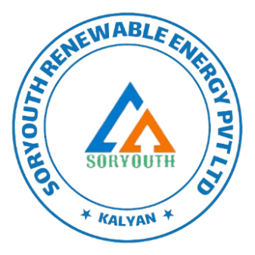
Yours truly,
Thank You for Choosing Soryouth

303, Seasons Business Center,
Ch. Shivaji Maharaj Chow, Kalyan West -421301.
Ph: +91 8591920448
Email: enquiry@soryouth.com

