# Memory Management

* To provide a detailed description of various ways of organizing memory hardware
* To discuss various memory-management techniques, including paging and segmentation
* To provide a detailed description of the Intel Pentium, which supports both pure segmentation and segmentation with paging
* Program must be brought (from disk) into memory and placed within a process for it to be run
* Main memory and registers are only storage CPU can access directly
* Register access in one CPU clock (or less)
* Main memory can take many cycles
* **Cache** sits between main memory and CPU registers
* Protection of memory required to ensure correct operation

**Base and Limit Registers**

A pair of **base** and **limit** registers define the logical address space

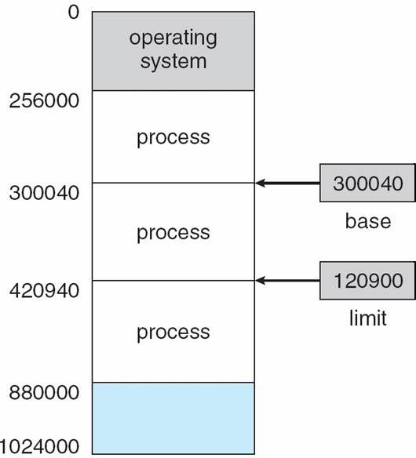

**Binding of Instructions and Data to Memory**

* Address binding of instructions and data to memory addresses can happen at three different stages
* **Compile time**: If memory location known a priori, **absolute code** can be generated; must recompile code if starting location changes
* **Load time**: Must generate **relocatable code** if memory location is not known at compile time
* **Execution time**: Binding delayed until run time if the process can be moved during its execution from one memory segment to another. Need hardware support for address maps (e.g., base and limitregisters)

## Multistep Processing of a User Program

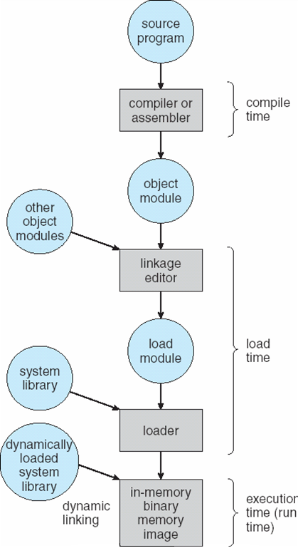

**Logical vs. Physical Address Space**

* The concept of a logical address space that is bound to a separate **physical address space** is central to proper memory management
* **Logical address** – generated by the CPU; also referred to as **virtual address**
* **Physical address** – address seen by the memory unit
* Logical and physical addresses are the same in compile-time and load-time address-binding schemes; logical (virtual) and physical addresses differ in execution-time address-binding scheme

**Memory-Management Unit (MMU)**

* Hardware device that maps virtual to physical address
* In MMU scheme, the value in the relocation register is added to every address generated by a user process at the time it is sent to memory
* The user program deals with *logical* addresses; it never sees the *real* physical addresses

**Dynamic relocation using a relocation register**

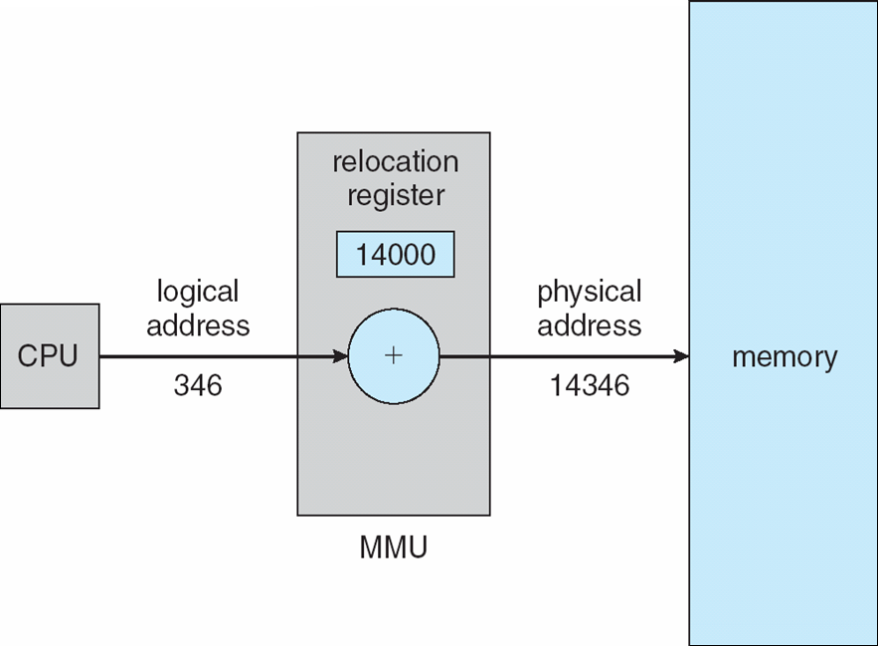

**Dynamic Loading**

* Routine is not loaded until it is called
* Better memory-space utilization; unused routine is never loaded
* Useful when large amounts of code are needed to handle infrequently occurring cases
* No special support from the operating system is required implemented through program design

**Dynamic Linking**

* Linking postponed until execution time
* Small piece of code, *stub*, used to locate the appropriate memory-resident library routine
* Stub replaces itself with the address of the routine, and executes the routine
* Operating system needed to check if routine is in processes’ memory address
* Dynamic linking is particularly useful for libraries
* System also known as **shared libraries**

**Swapping**

A process can be swapped temporarily out of memory to a backing store, and then brought back into memory for continued execution

n**Backing store** – fast disk large enough to accommodate copies of all memory images for all users; must provide direct access to these memory images

n**Roll out, roll in** – swapping variant used for priority-based scheduling algorithms; lower-priority process is swapped out so higher-priority process can be loaded and executed

nMajor part of swap time is transfer time; total transfer time is directly proportional to the amount of memory swapped

nModified versions of swapping are found on many systems (i.e., UNIX, Linux, and Windows)

System maintains a **ready queue** of ready-to-run processes which have memory images on disk

**Schematic View of Swapping**

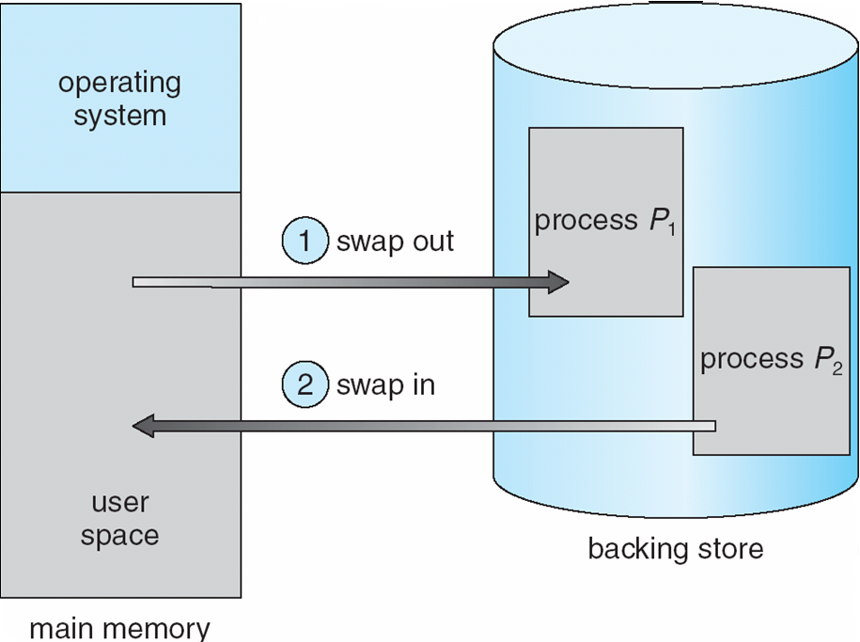

**Contiguous Allocation**

* Main memory usually into two partitions:
* Resident operating system, usually held in low memory with interrupt vector
* User processes then held in high memory
* nRelocation registers used to protect user processes from each other, and from changing operating-system code and data
* Base register contains value of smallest physical address
* Limit register contains range of logical addresses – each logical address must be less than the limit register
* MMU maps logical address *dynamically*

**Hardware Support for Relocation and Limit Registers**

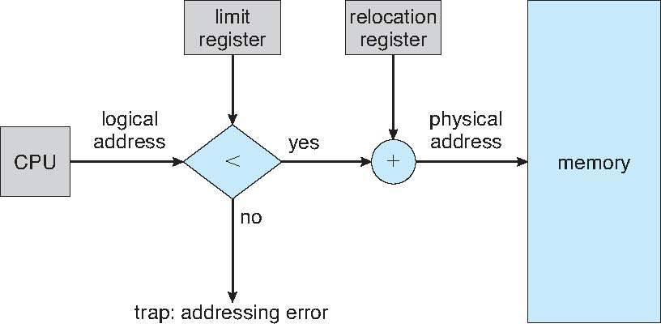

* Multiple-partition allocation
* Hole – block of available memory; holes of various size are scattered throughout memory
* When a process arrives, it is allocated memory from a hole large enough to accommodate it
* Operating system maintains information about:
* a) allocated partitions b) free partitions (hole)

OS

process 5

process 8

process 2

OS

process 5

process 2

process 9

OS

process 5

process 9

process 2

process 10

OS

process 5

process 2

**Dynamic Storage-Allocation Problem**

* **First-fit**: Allocate the *first* hole that is big enough
* **Best-fit**: Allocate the *smallest* hole that is big enough; must search entire list, unless ordered by size Produces the smallest leftover hole
* **Worst-fit**: Allocate the *largest* hole; must also search entire list
* Produces the largest leftover hole
* First-fit and best-fit better than worst-fit in terms of speed and storage utilization

**Fragmentation**

* **External Fragmentation** – total memory space exists to satisfy a request, but it is not contiguous
* **Internal Fragmentation** – allocated memory may be slightly larger than requested memory; this size difference is memory internal to a partition, but not being used
* Reduce external fragmentation by **compaction**
* Shuffle memory contents to place all free memory together in one large block
* Compaction is possible *only* if relocation is dynamic, and is done at execution time.
* I/O problem

Latch job in memory while it is involved in I/O

Do I/O only into OS buffers

**Paging**

* Logical address space of a process can be noncontiguous; process is allocated physical memory whenever the latter is available
* Divide physical memory into fixed-sized blocks called **frames** (size is power of 2, between 512 bytes and 8,192 bytes)
* Divide logical memory into blocks of same size called **pages**
* nKeep track of all free frames
* To run a program of size ***n*** pages, need to find *n* free frames and load program
* Set up a page table to translate logical to physical addresses
* Internal fragmentation

## Address Translation Scheme

* Address generated by CPU is divided into
* **Page number (*p*)** – used as an index into a *page* *table* which contains base address of each page in physical memory
* **Page offset (d)** – combined with base address to define the physical memory address that is sent to the memory unit

page number

page offset

*p*

*d*

*m - n*

*n*

* For given logical address space 2*m and page size 2*n

**Paging Hardware**

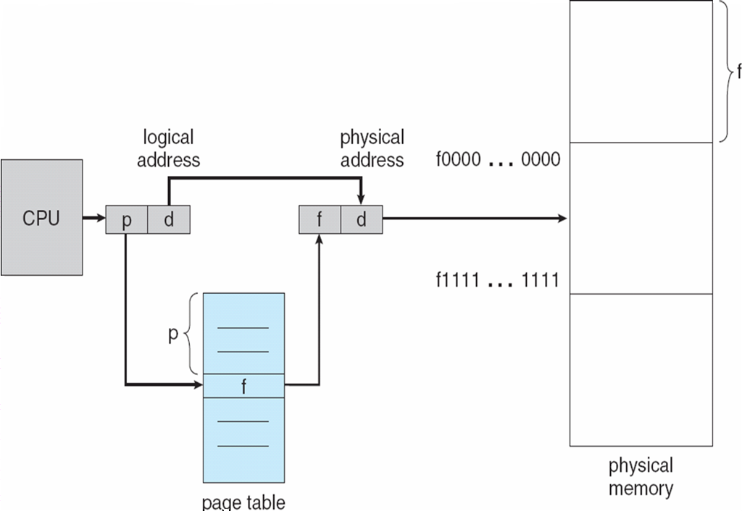

**Paging Model of Logical and Physical Memory**

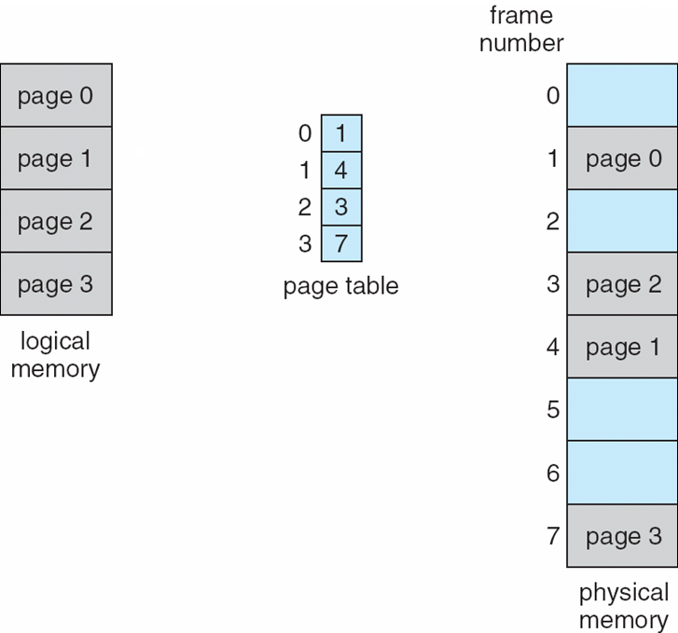

**Paging Example**

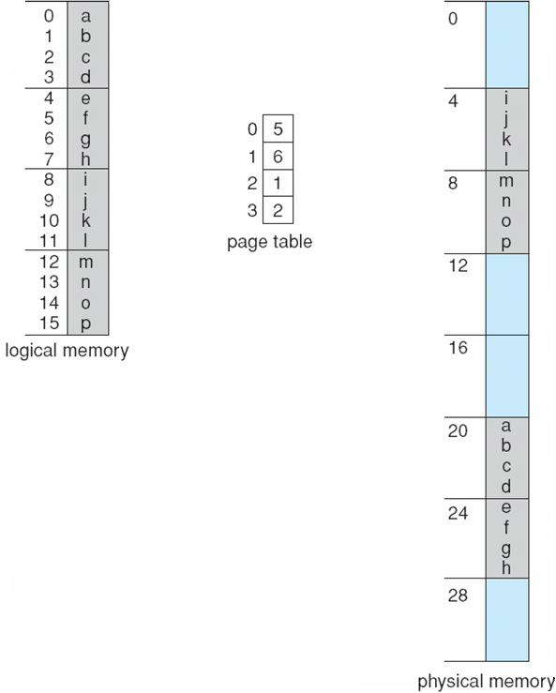

32-byte memory and 4-byte pages

**Free Frames**

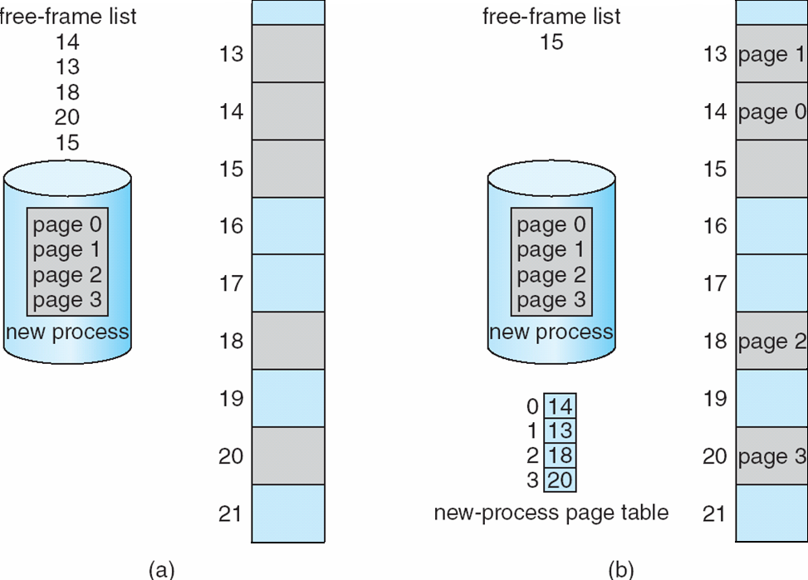

**Implementation of Page Table**

* Page table is kept in main memory
* **Page-table base register (PTBR)** points to the page table
* **Page-table length register (PRLR)** indicates size of the page table
* In this scheme every data/instruction access requires two memory accesses. One for the page table and one for the data/instruction.
* The two memory access problem can be solved by the use of a special fast-lookup hardware cache called **associative memory** or **translation look-aside buffers (TLBs)**
* Some TLBs store **address-space identifiers (ASIDs)** in each TLB entry – uniquely identifies each process to provide address-space protection for that process

**Associative Memory**

* Associative memory – parallel search
* Address translation (p, d)
* If p is in associative register, get frame # out
* Otherwise get frame # from page table in memory

Frame #

Page #

**Paging Hardware With TLB**

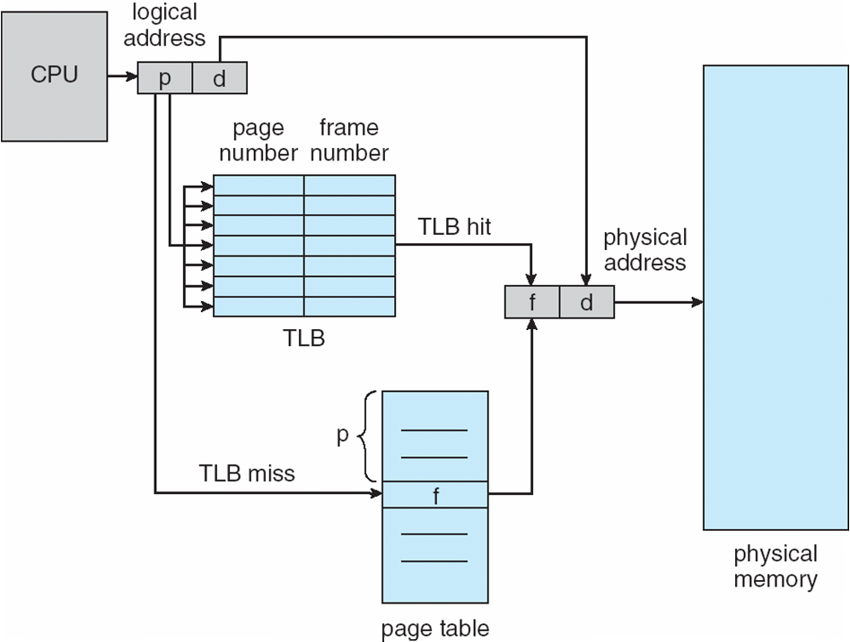

**Effective Access Time**

* Associative Lookup = time unit
* Assume memory cycle time is 1 microsecond
* Hit ratio – percentage of times that a page number is found in the associative registers; ratio related to number of associative registers
* Hit ratio =

n **Effective Access Time** (EAT)

EAT = (1 + ) + (2 + )(1 – )

= 2 + –

**Memory Protection**

* Memory protection implemented by associating protection bit with each frame
* **Valid-invalid** bit attached to each entry in the page table:
* “valid” indicates that the associated page is in the process’ logical address space, and is thus a legal page
* “invalid” indicates that the page is not in the process’ logical address space
* **Valid (v) or Invalid (i) Bit In A Page Table**

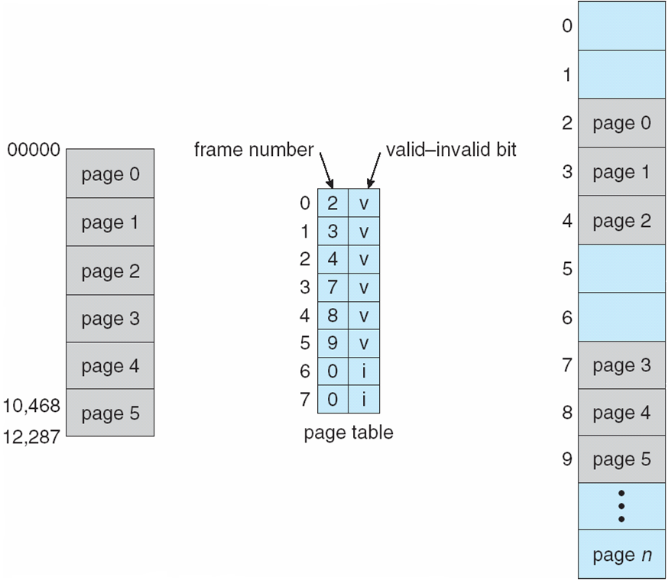

**Shared Pages**

**Shared code**

* One copy of read-only (reentrant) code shared among processes (i.e., text editors, compilers, window systems).
* Shared code must appear in same location in the logical address space of all processes

**Private code and data**

* Each process keeps a separate copy of the code and data
* The pages for the private code and data can appear anywhere in the logical address space

## Shared Pages Example

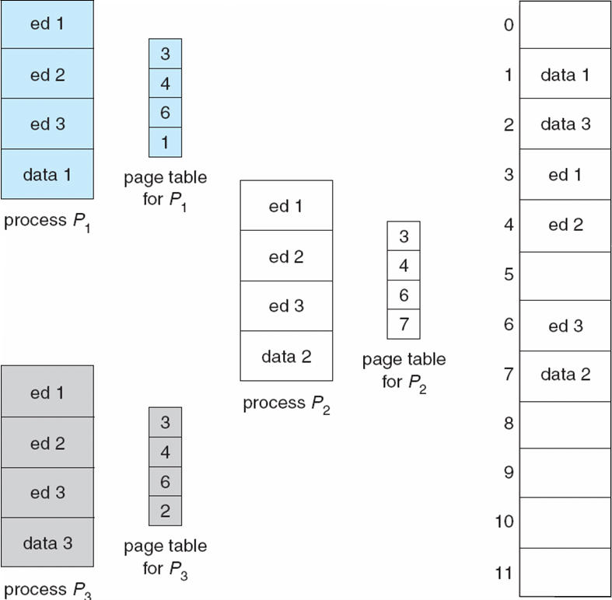

**Structure of the Page Table**

* Hierarchical Paging
* Hashed Page Tables
* Inverted Page Tables

**Hierarchical Page Tables**

* Break up the logical address space into multiple page tables
* A simple technique is a two-level page table

**Two-Level Page-Table Scheme**

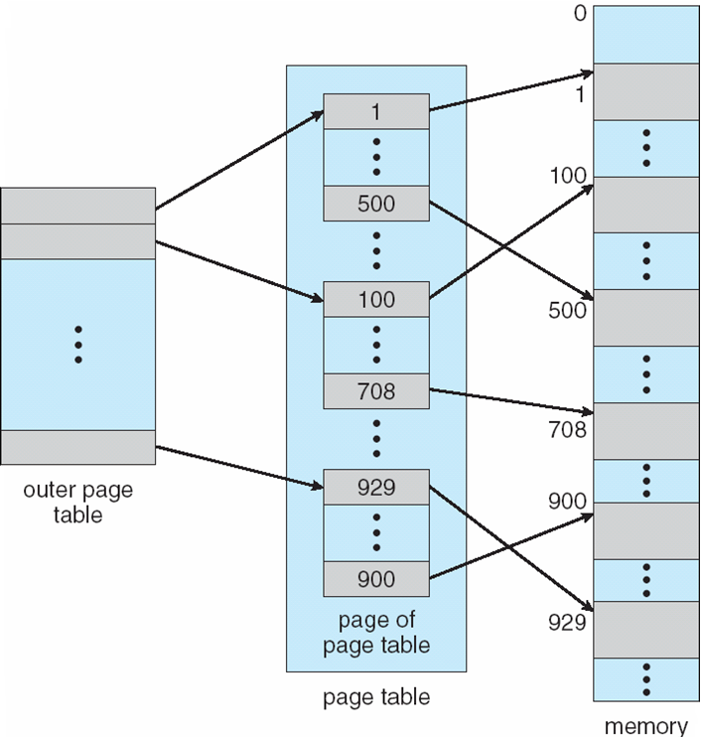

**Two-Level Paging Example**

* A logical address (on 32-bit machine with 1K page size) is divided into:
* a page number consisting of 22 bits
* a page offset consisting of 10 bits
* Since the page table is paged, the page number is further divided into:
* a 12-bit page number
* a 10-bit page offset
* Thus, a logical address is as follows:  
    
  where *pi* is an index into the outer page table, and *p2* is the displacement within the page of the outer page table

page number

page offset

*p*i

*p*2

*d*

10

10

12

**Address-Translation Scheme**

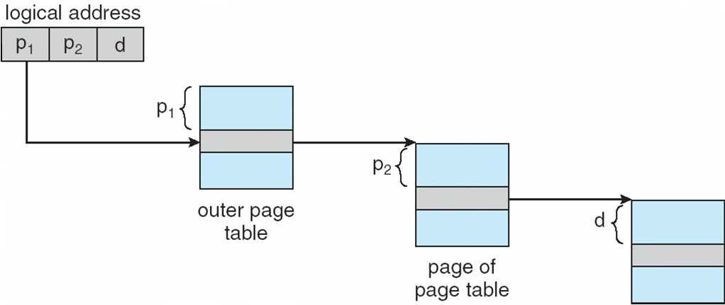

**Three-level Paging Scheme**

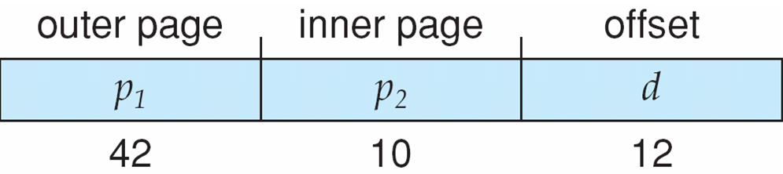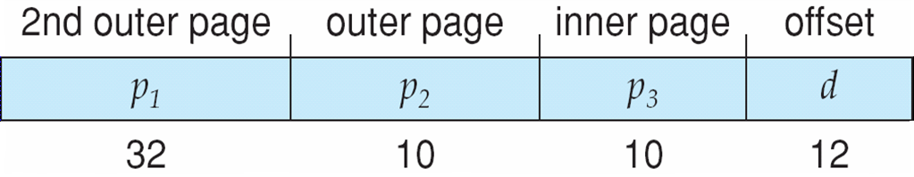

**Hashed Page Tables**

* Common in address spaces > 32 bits
* The virtual page number is hashed into a page table
* This page table contains a chain of elements hashing to the same location
* Virtual page numbers are compared in this chain searching for a match
* If a match is found, the corresponding physical frame is extracted

**Hashed Page Table**

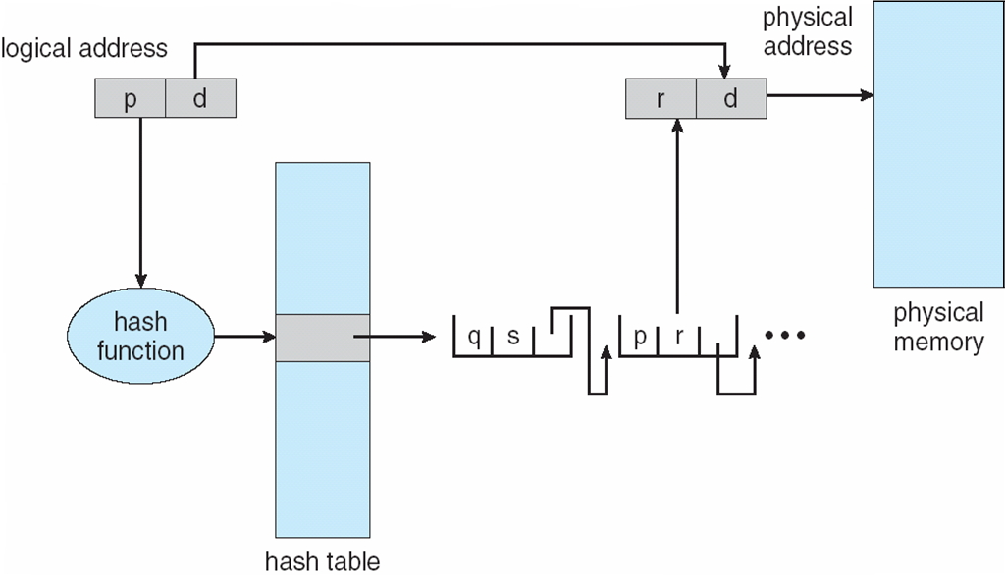

## Inverted Page Table

* One entry for each real page of memory
* Entry consists of the virtual address of the page stored in that real memory location, with information about the process that owns that page
* Decreases memory needed to store each page table, but increases time needed to search the table when a page reference occurs
* Use hash table to limit the search to one — or at most a few — page-table entries

**Inverted Page Table Architecture**

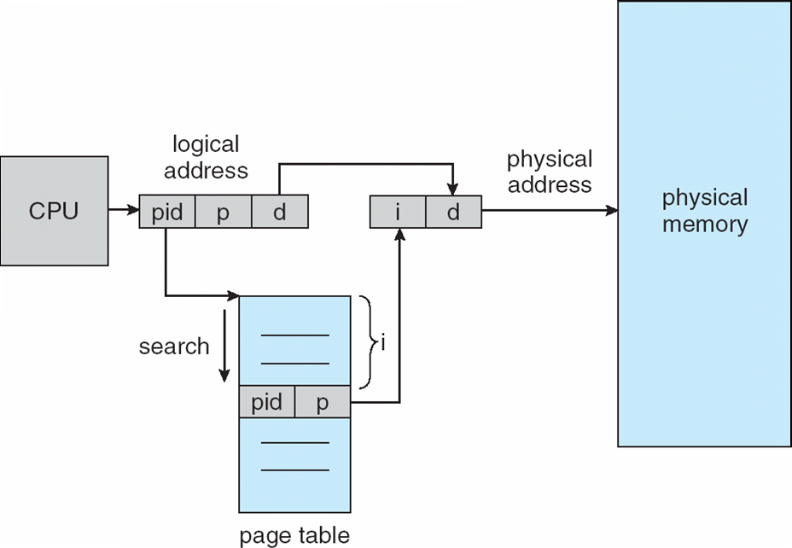

**Segmentation**

Memory-management scheme that supports user view of memory

* A program is a collection of segments
* A segment is a logical unit such as:
* main program
* procedure
* function
* method
* 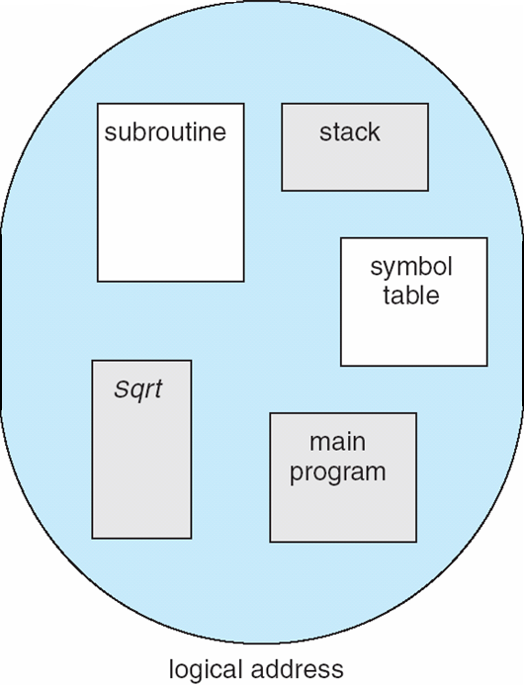object
* local variables, global variables
* common block
* stack
* symbol table
* arrays

**User’s View of a Program**

**Logical View of Segmentation**

user space

1

4

2

3

4

2

3

1

physical memory space

**Segmentation Architecture**

* Logical address consists of a two tuple:
  + - * + <segment-number, offset>,
* **Segment table** – maps two-dimensional physical addresses; each table entry has:
* **base** – contains the starting physical address where the segments reside in memory
* **limit** – specifies the length of the segment
* **Segment-table base register (STBR)** points to the segment table’s location in memory
* **Segment-table length register (STLR)** indicates number of segments used by a program;

segment number ***s*** is legal if ***s*** < **STLR**

* Protection
* With each entry in segment table associate:
* validation bit = 0 illegal segment
* read/write/execute privileges
* Protection bits associated with segments; code sharing occurs at segment level
* Since segments vary in length, memory allocation is a dynamic storage-allocation problem
* A segmentation example is shown in the following diagram

**Segmentation Hardware**

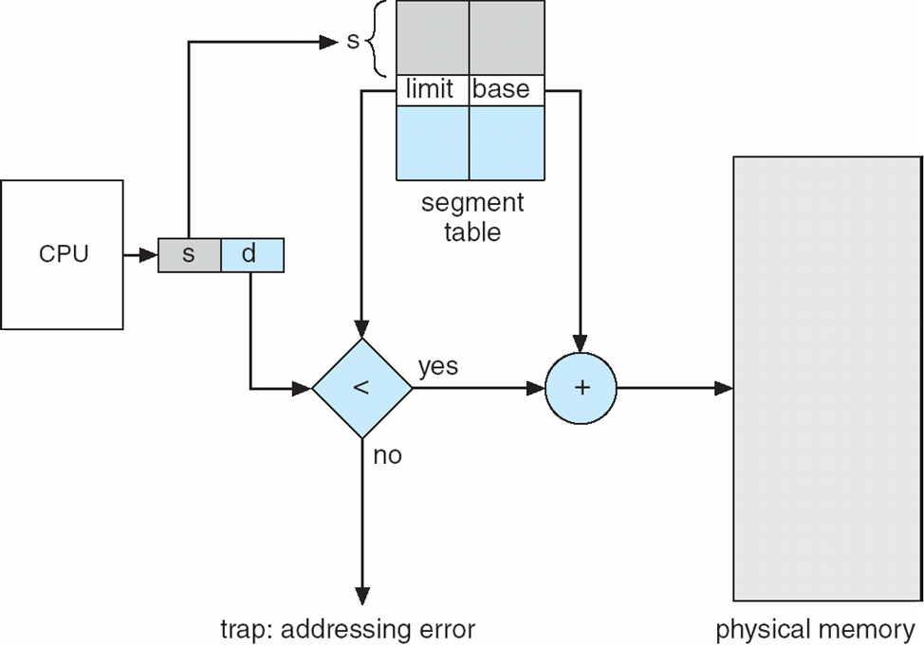

**Example of Segmentation**

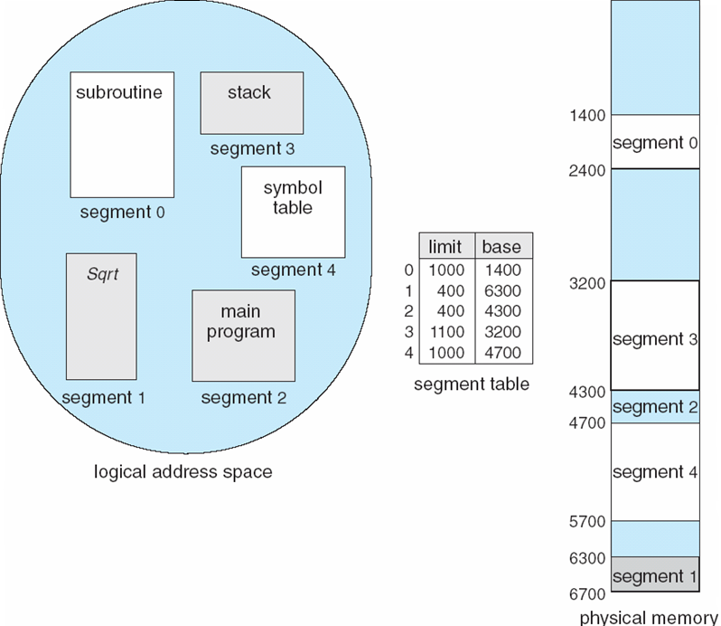

**Example: The Intel Pentium**

* Supports both segmentation and segmentation with paging
* CPU generates logical address
* Given to segmentation unit

Which produces linear addresses

* Linear address given to paging unit

Which generates physical address in main memory

Paging units form equivalent of MMU

**Logical to Physical Address Translation in Pentium**

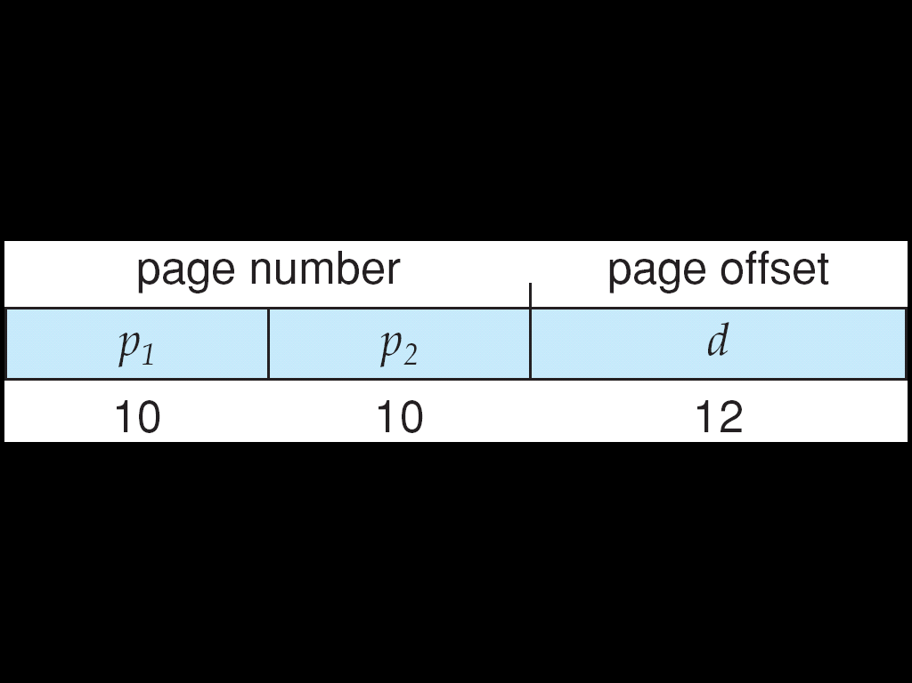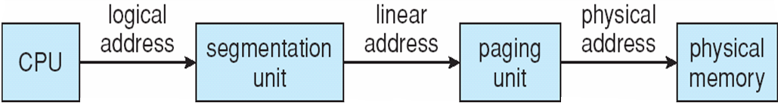

**Intel Pentium Segmentation**

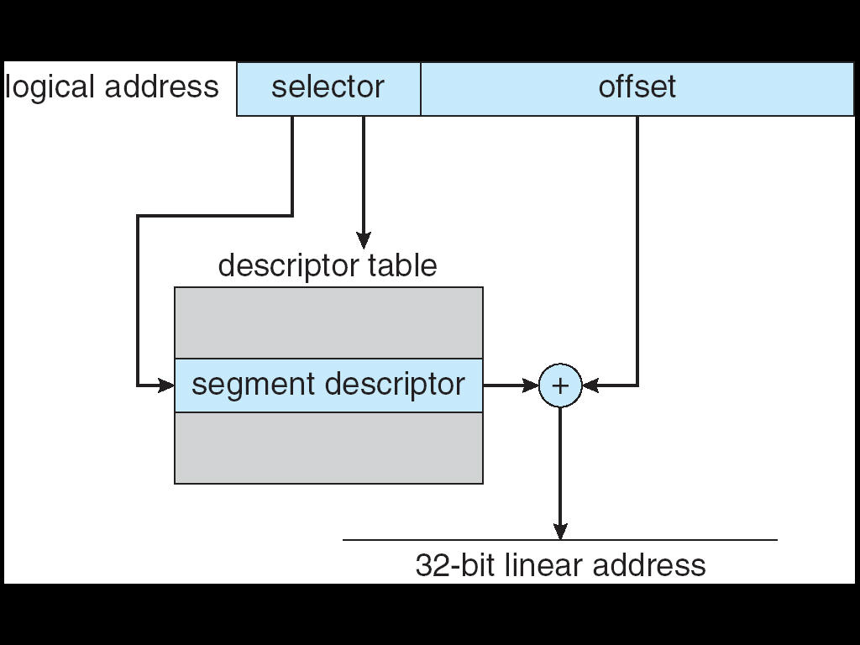

**Pentium Paging Architecture**

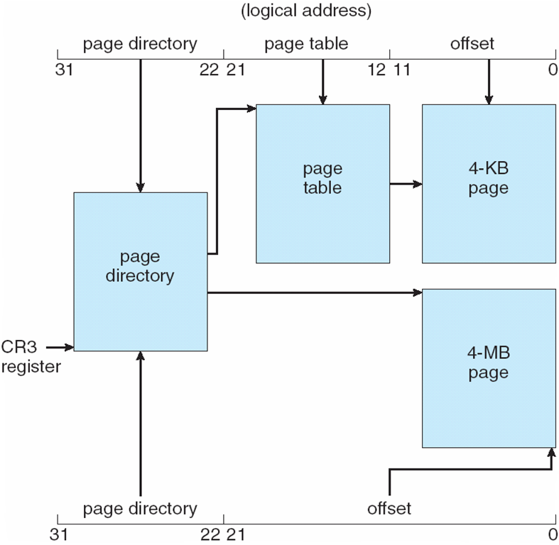

## Linear Address in Linux



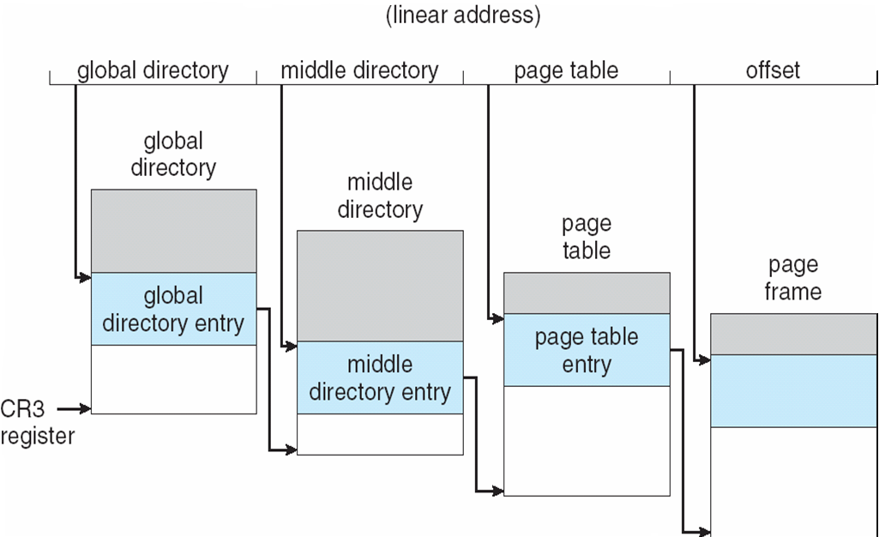**Three-level Paging in Linux**