
University of Frontier Technology, Bangladesh
Department of Cyber Security Engineering (CySE)
SEC 204 | Threat Modelling and Security Monitoring Sessional
Lab Manual
Week-4-Lab-Windows-Log-Analysis-with-PowerShell.md
Field | Details
Course Title | Threat Modelling and Security Monitoring Sessional
Course Code | SEC 204
Level & Term | Level 2, Term 1
Instructor | Md Masud Rana, Lecturer, Dept. of CySE, UFTB
Submission Date | 03 Nov 2026

Members
Student Name | Student ID | Email
Shanta Islam | 2404003 | 2404003@uftb.ac.bd

Exercise 1: View Recent Security Events
Get-WinEvent -LogName Security -MaxEvents 10

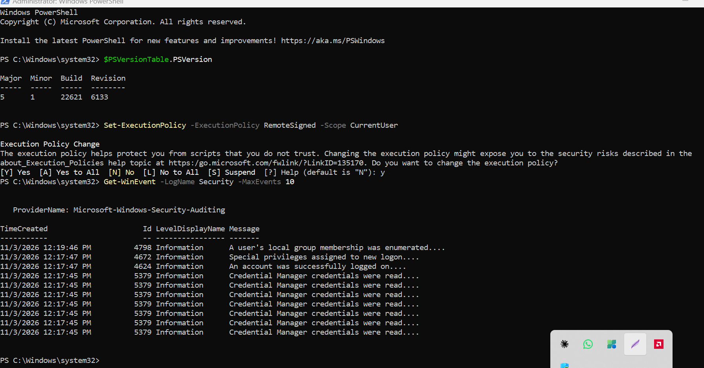
Explanation:
- Get-WinEvent retrieves events from the Windows event logs.
- -LogName Security specifies the Security log.
- -MaxEvents 10 limits the output to the 10 most recent events.

Observation:
The output displays the 10 most recent Security log events. It includes Event ID 4798 (a user's local group membership was enumerated), Event ID 4672 (special privileges assigned to new logon), Event ID 4624 (an account was successfully logged on), and several Event ID 5379 entries (Credential Manager credentials were read).

Exercise 2: Filter by Event ID (Successful Logons, Event ID 4624)
Get-WinEvent -FilterHashtable @{LogName='Security'; ID=4624} -MaxEvents 20
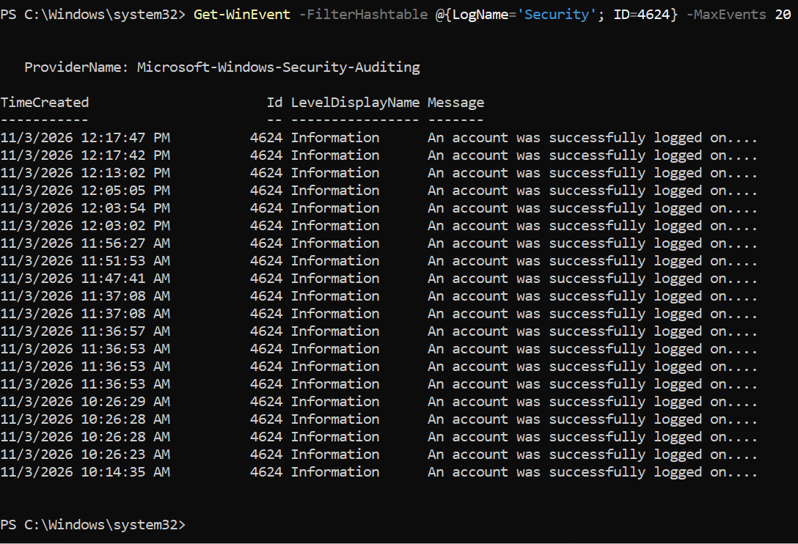
Explanation:
- Get-WinEvent retrieves events from the Windows event logs.
- -FilterHashtable is an efficient filtering method that filters events at the source instead of retrieving all events first.
- @{LogName='Security'; ID=4624} is a hashtable containing the filter criteria: the Security log and Event ID 4624 (successful logon).
- -MaxEvents 20 limits the output to the 20 most recent matching events.

Observation:
The output displays the 20 most recent successful logon events (Event ID 4624) from the Security log. All entries show the level "Information" and the message "An account was successfully logged on." The events were recorded on 11/3/2026 between 10:14:35 AM and 12:17:47 PM. Several events occurred within the same second (for example, at 11:36:53 AM and 10:26:28 AM), which is normal because Windows creates multiple logon sessions when the system starts services or when a user signs in. No failed logon attempts are shown here, since this query filters only for Event ID 4624.

Exercise 3: Filter by Time Range
Command 1 (last 24 hours):
$StartTime = (Get-Date).AddDays(-1)
Get-WinEvent -FilterHashtable @{
LogName='Security'
StartTime=$StartTime
} -MaxEvents 100
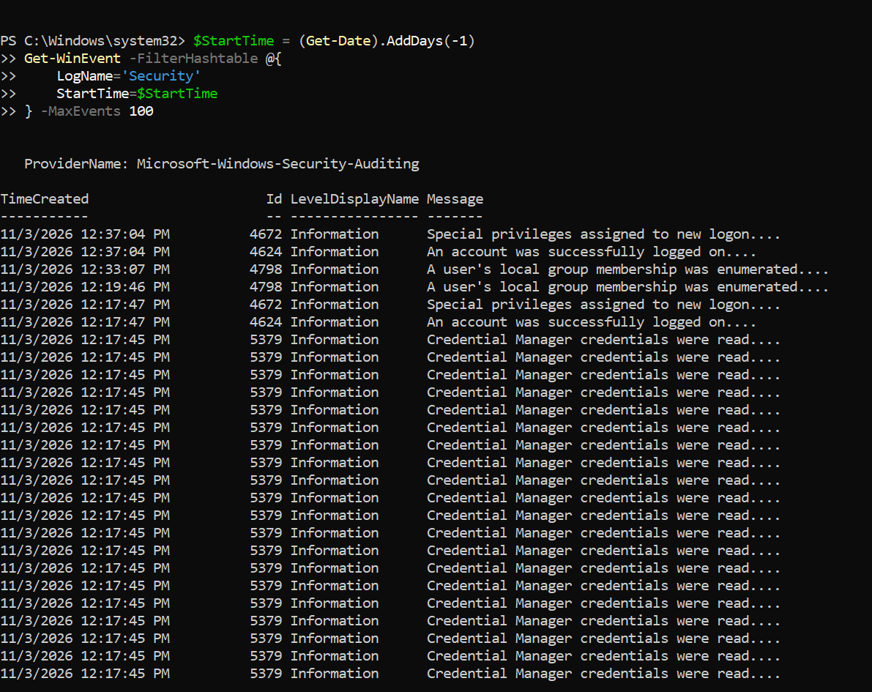
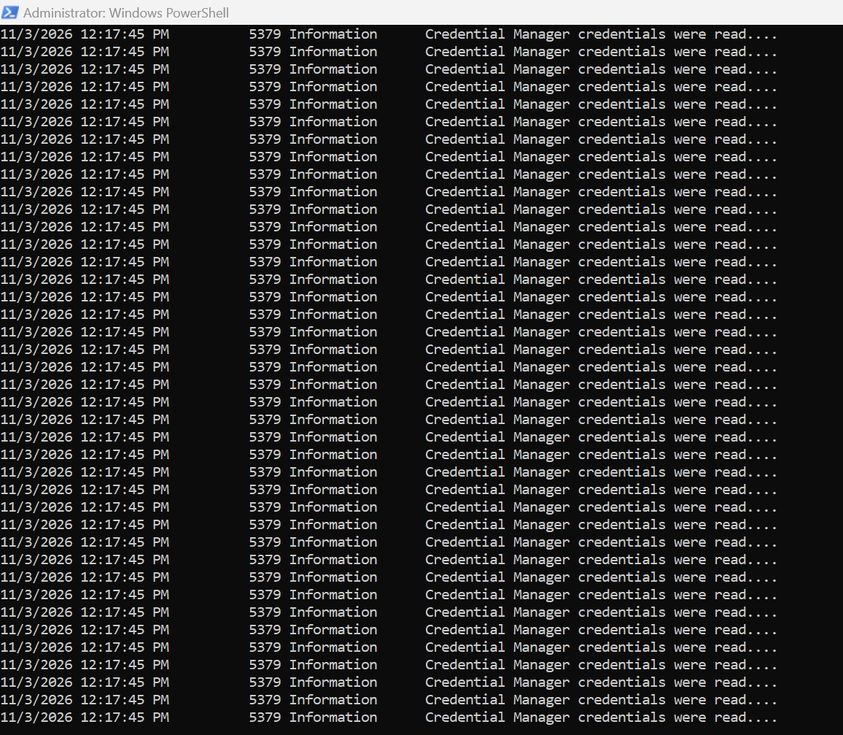
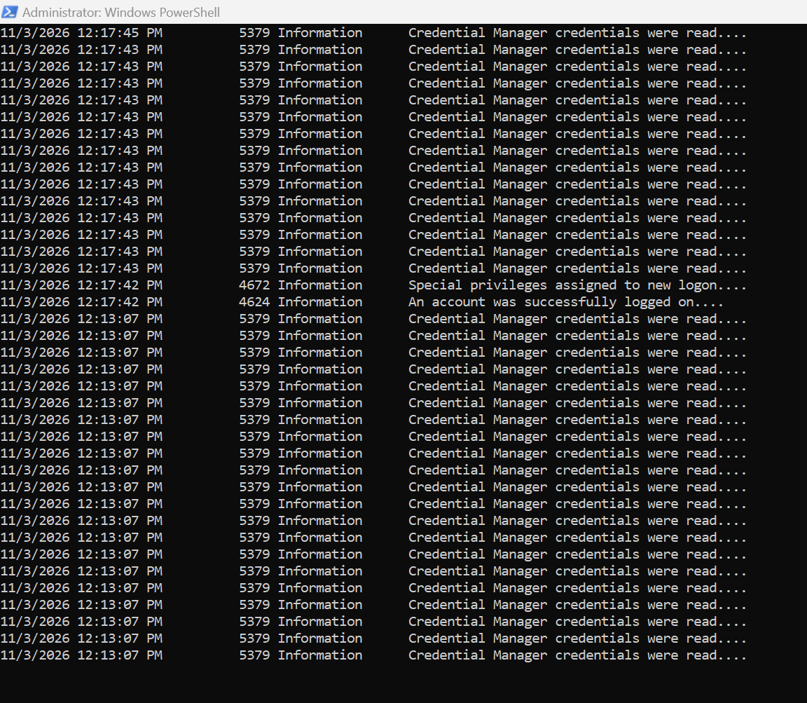

Command 2 (last hour):
$StartTime = (Get-Date).AddHours(-1)
Get-WinEvent -FilterHashtable @{
LogName='Security'
StartTime=$StartTime
}
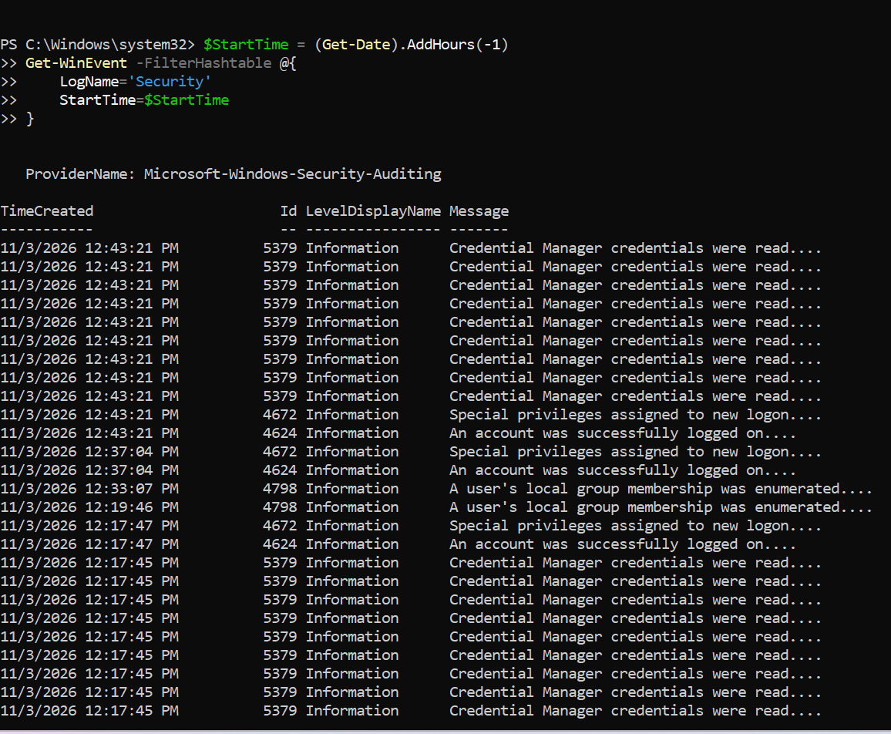
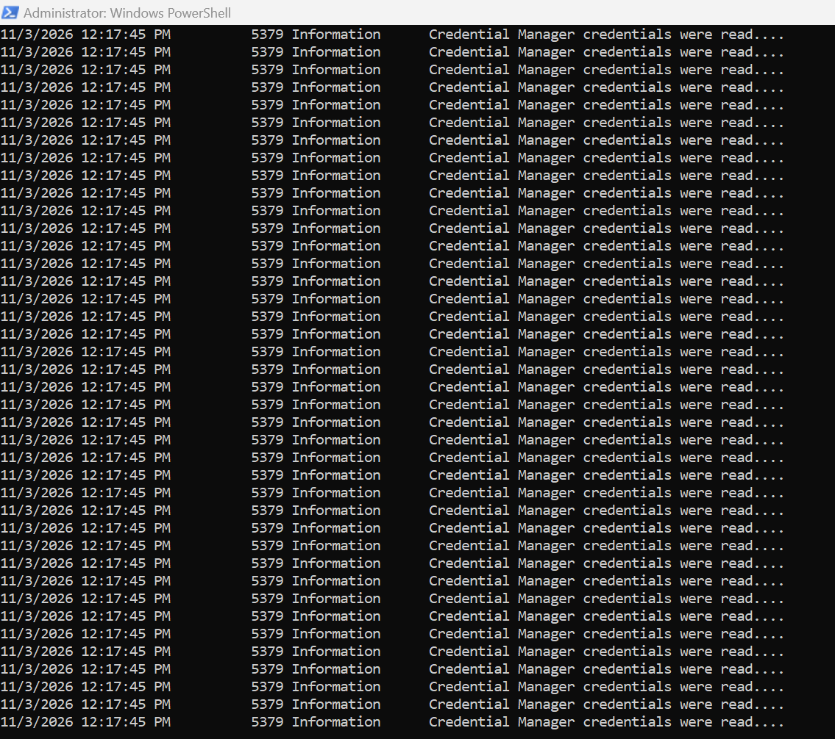
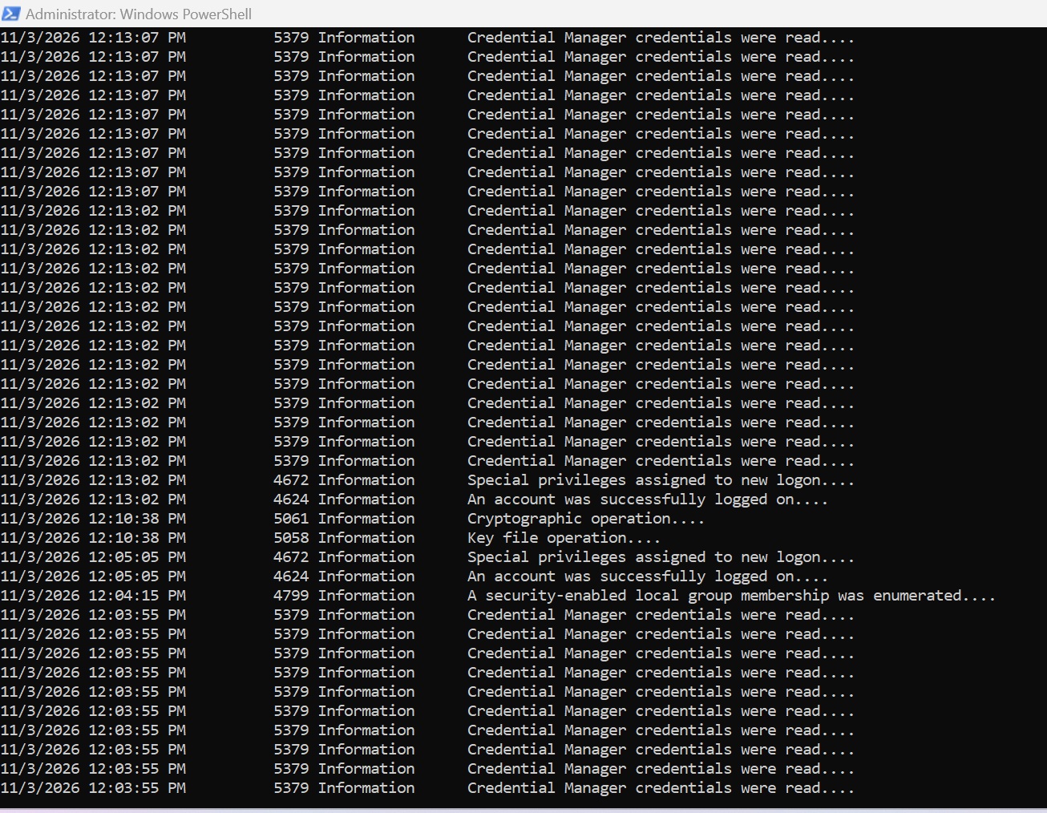
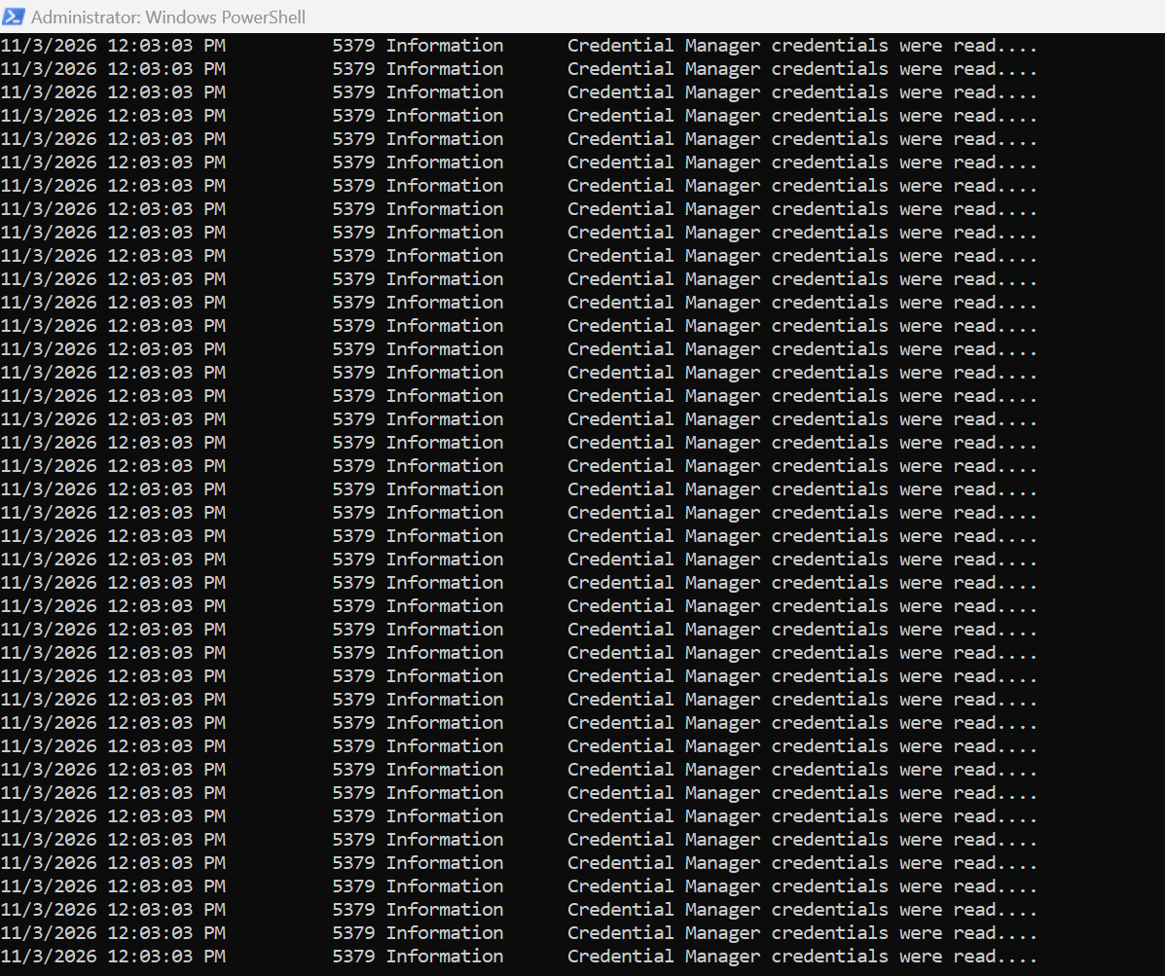
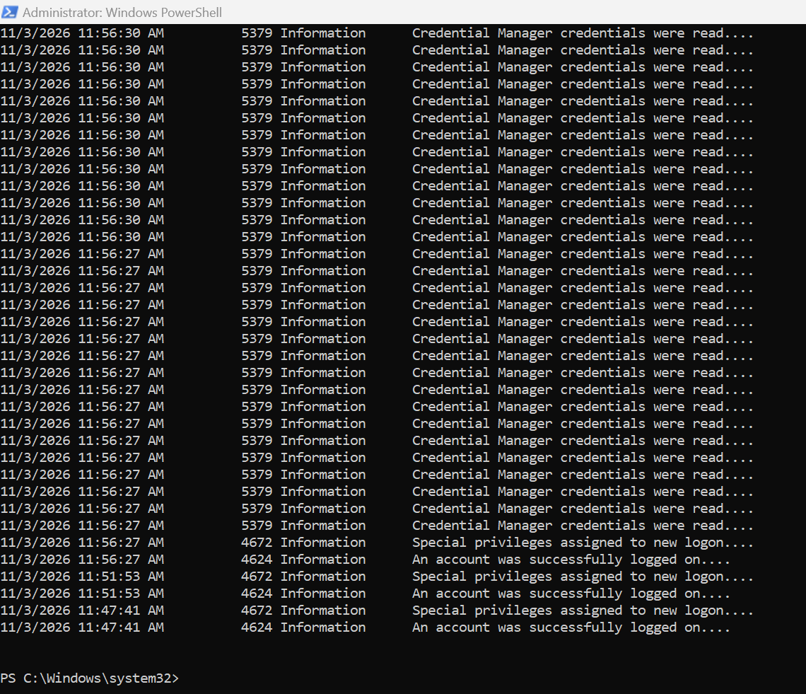
Explanation:
- (Get-Date).AddDays(-1) calculates the date and time 24 hours ago.
- (Get-Date).AddHours(-1) calculates the time one hour ago.
- StartTime=$StartTime filters events from that time forward.
- EndTime=$EndTime sets the upper limit, so only events inside the specified range are returned.
- -MaxEvents 100 limits the output to 100 events.

Observation:
The command returned events from the last 24 hours, including Event IDs ____, ____ and ____. The most recent event was recorded at ____. The last-hour query returned ____ events, and the specific date range query returned ____ events.

Exercise 4
Exercise 4: Count Events (Failed Logons in the Last 24 Hours):
$StartTime = (Get-Date).AddDays(-1)
$FailedLogons = Get-WinEvent -FilterHashtable @{
LogName='Security'
ID=4625
StartTime=$StartTime
} -ErrorAction SilentlyContinue
$FailedLogons.Count
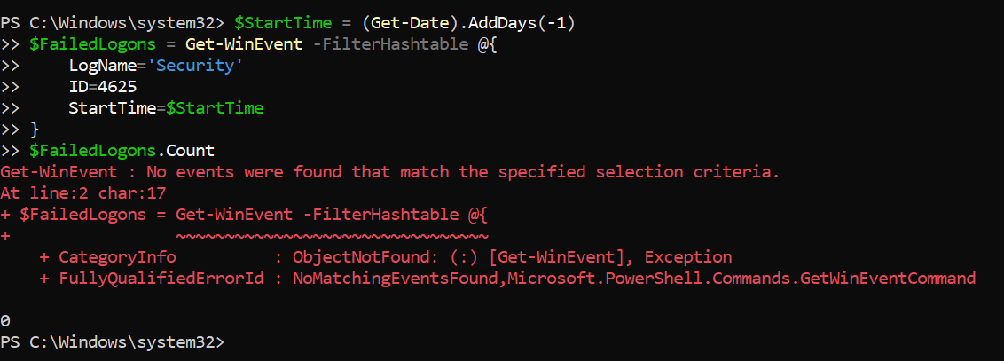
Observation:
The command returned 0, and PowerShell reported "No events were found that match the specified selection criteria." This means there were no failed logon attempts (Event ID 4625) in the last 24 hours, because no wrong password had been entered yet.

Exercise 7: Analyze Failed Logon Attempts (Top 5 Source IP Addresses):
Command 1:
Get-WinEvent -FilterHashtable @{
LogName='Security'
ID=4625
StartTime=(Get-Date).AddDays(-1)
} | ForEach-Object {
$_.Properties[19].Value
} | Where-Object { $_ -ne '-' -and $_ -ne '' } |
Group-Object |
Sort-Object Count -Descending |
Select-Object -First 5 Name, Count
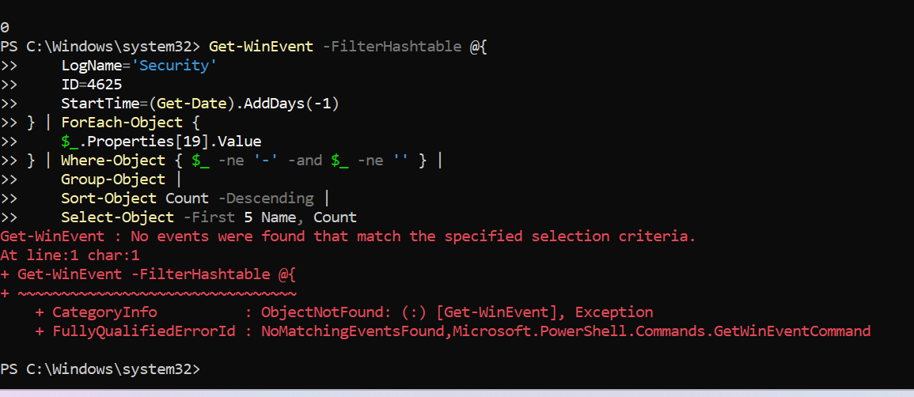

Command 2 (better formatted):

Get-WinEvent -FilterHashtable @{
LogName='Security'
ID=4625
StartTime=(Get-Date).AddDays(-1)
} | ForEach-Object {
$_.Properties[19].Value
} | Where-Object { $_ -ne '-' -and $_ -ne '' } |
Group-Object |
Sort-Object Count -Descending |
Select-Object -First 5 @{Name='IP Address';Expression={$_.Name}}, @{Name='Failed Attempts';Expression={$_.Count}} |
Format-Table -AutoSize
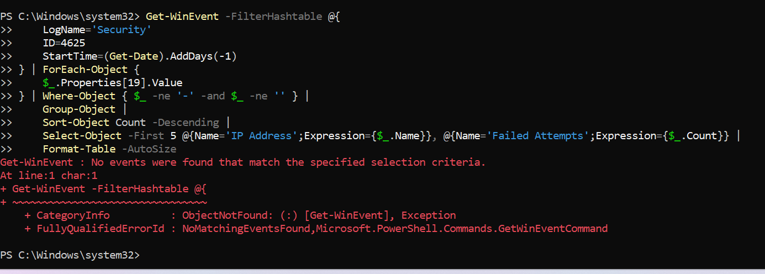

Explanation:
1. Get-WinEvent retrieves all failed logon events (Event ID 4625) from the last 24 hours.
2. ForEach-Object extracts the source IP address, which is stored at index 19 of the Properties array.
3. Where-Object removes empty values and "-", which appear when no IP address is recorded.
4. Group-Object groups the events by IP address.
5. Sort-Object Count -Descending sorts the groups from the highest count to the lowest.
6. Select-Object -First 5 selects the top 5 IP addresses.
7. In the second command, calculated properties rename the columns to "IP Address" and "Failed Attempts" for a cleaner table.

Observation:
The top source IP address was ____ with ____ failed attempts, followed by ____ with ____ attempts. This shows that most failed logons came from ____. A high number of failures from a single IP address can indicate a brute-force attack.

Observation:
No external source IP addresses were recorded because the failed logon attempts were generated locally on the machine, where the IP address field is empty ("-").

Exercise 8: Identify Targeted Accounts (Top 5 Usernames):
Command:
Get-WinEvent -FilterHashtable @{
LogName='Security'
ID=4625
StartTime=(Get-Date).AddDays(-1)
} | ForEach-Object {
$_.Properties[5].Value # TargetUserName
} | Where-Object { $_ -ne '-' -and $_ -ne '' } |
Group-Object |
Sort-Object Count -Descending |
Select-Object -First 5 @{Name='Username';Expression={$_.Name}}, @{Name='Failed Attempts';Expression={$_.Count}} |
Format-Table -AutoSize
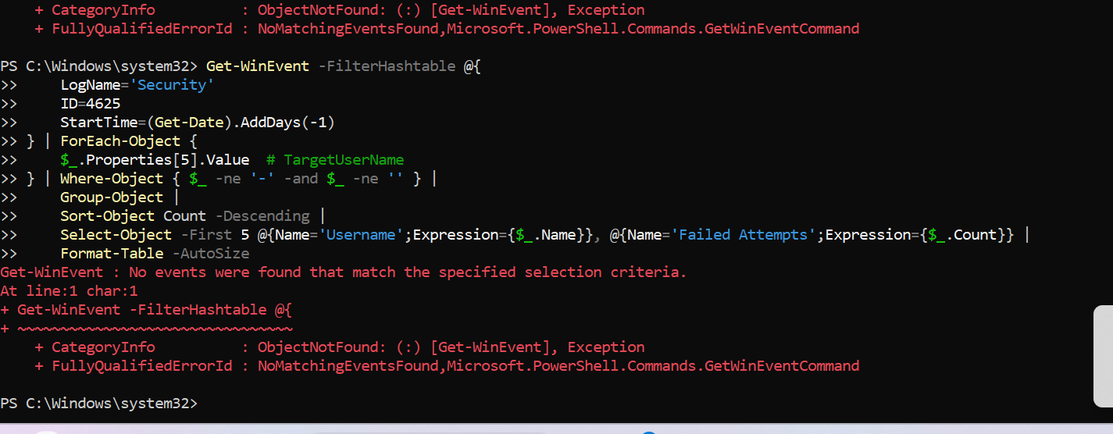
Explanation:
1. The command retrieves failed logon events (Event ID 4625) from the last 24 hours.
2. $_.Properties[5].Value extracts the TargetUserName, which is the account that failed to log on.
3. Where-Object filters out empty values and "-".
4. Group-Object groups the events by username.
5. Sort-Object Count -Descending orders the usernames by the number of failed attempts.
6. Select-Object -First 5 shows the top 5 targeted usernames in a table with the columns "Username" and "Failed Attempts".

Observation:
The most targeted username was ____ with ____ failed attempts, followed by ____ with ____ attempts. Repeated failures against the same account may indicate a password guessing or brute-force attempt against that user.

Observation:
No events were found because no failed logon attempts (Event ID 4625) had been generated in the last 24 hours at that time.

Exercise 11: Generate Test Failed Logons
Command 1
1..10 | ForEach-Object {
net use \\localhost\C$ /user:FakeUser WrongPassword 2>$null
Start-Sleep -Seconds 2
}

Command 2
Get-WinEvent -FilterHashtable @{
LogName='Security'
ID=4625
StartTime=(Get-Date).AddMinutes(-5)
} | Select-Object TimeCreated, Message | Format-List
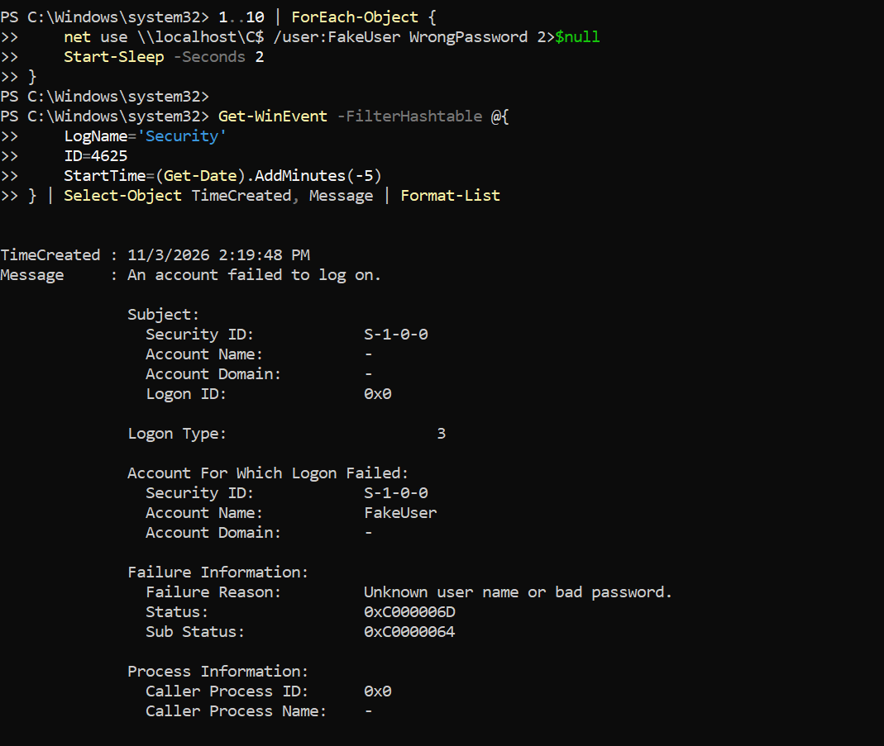
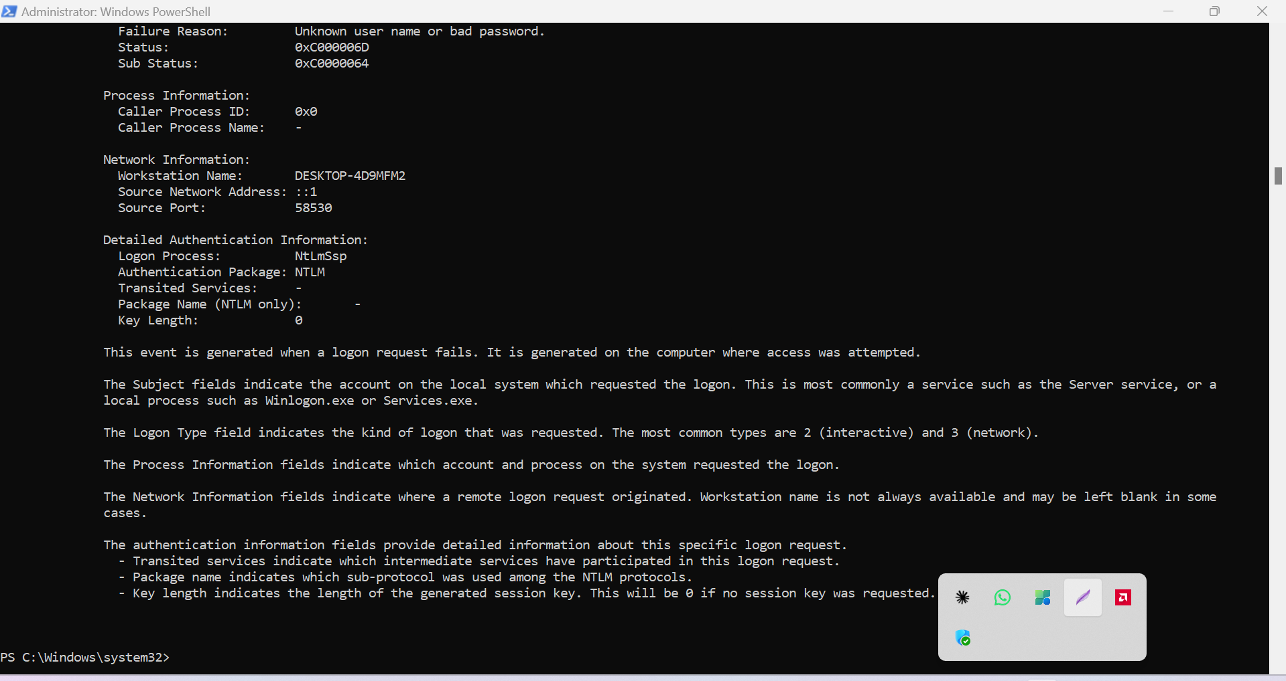
Explanation:
- 1..10 creates a loop that runs 10 times.
- net use \\localhost\C$ /user:FakeUser WrongPassword tries to access a network share with a fake username and wrong password, which generates Event ID 4625 (failed logon).
- 2>$null hides the error messages.
- Start-Sleep -Seconds 2 waits 2 seconds between attempts.
- The second command lists the failed logon events created in the last 5 minutes to verify that the events were generated.

Observation:
The loop generated ____ failed logon events (Event ID 4625) within the last 5 minutes. The message of each event showed "An account failed to log on" with the account name FakeUser.

Exercise 9: Analyze Logon Types
Command:
Get-WinEvent -FilterHashtable @{
LogName='Security'
ID=4625
StartTime=(Get-Date).AddDays(-1)
} | ForEach-Object {
$LogonType = $_.Properties[10].Value
switch ($LogonType) {
2 { 'Interactive' }
3 { 'Network' }
4 { 'Batch' }
5 { 'Service' }
7 { 'Unlock' }
8 { 'NetworkCleartext' }
9 { 'NewCredentials' }
10 { 'RemoteInteractive' }
11 { 'CachedInteractive' }
default { "Unknown ($LogonType)" }
}
} | Group-Object |
Sort-Object Count -Descending |
Select-Object @{Name='Logon Type';Expression={$_.Name}}, @{Name='Count';Expression={$_.Count}} |
Format-Table -AutoSize
Output:
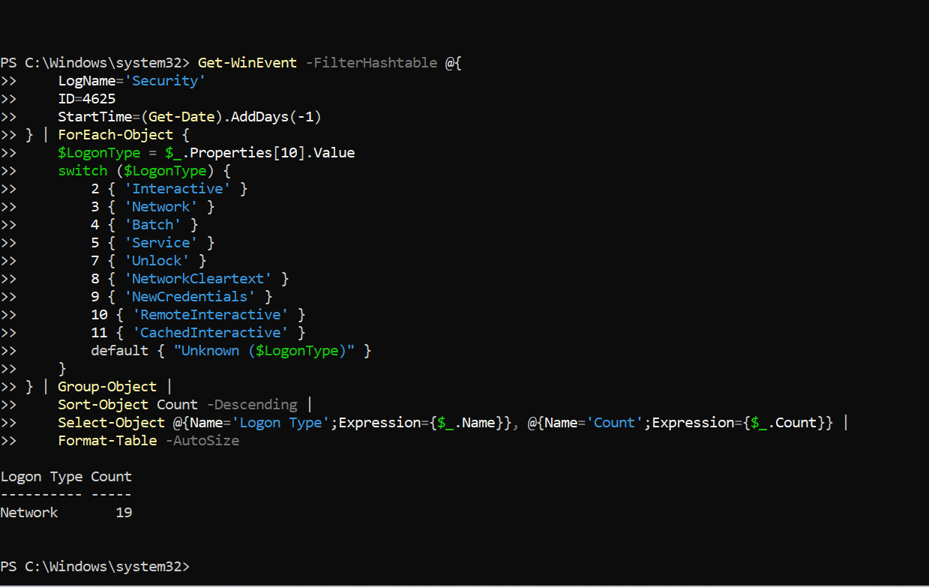
Explanation:
- The command retrieves failed logon events (Event ID 4625) from the last 24 hours.
- Properties[10] holds the numeric logon type of each event.
- The switch statement converts each number into its name (for example, 3 = Network, 10 = RemoteInteractive).
- Group-Object counts how many events belong to each logon type.
- Sort-Object Count -Descending shows the most common logon type first.
- Format-Table -AutoSize displays the result as a table.

Observation:
The most common logon type for failed attempts was ____ (____) with ____ events. Logon type 3 (Network) usually indicates attempts through network connections such as file shares, while type 10 (RemoteInteractive) indicates RDP attempts.

Exercise 10: Identify Brute-Force Patterns
Script (Detect-BruteForce.ps1 ):
# Define threshold
$FailureThreshold = 5
$TimeWindow = (Get-Date).AddHours(-1)

# Get failed logons
$FailedLogons = Get-WinEvent -FilterHashtable @{
LogName='Security'
ID=4625
StartTime=$TimeWindow
} | ForEach-Object {
[PSCustomObject]@{
TimeCreated = $_.TimeCreated
SourceIP = $_.Properties[19].Value
TargetUser = $_.Properties[5].Value
LogonType = $_.Properties[10].Value
}
}

# Group by source IP
$SuspiciousIPs = $FailedLogons |
Where-Object { $_.SourceIP -ne '-' } |
Group-Object SourceIP |
Where-Object { $_.Count -ge $FailureThreshold } |
Sort-Object Count -Descending

# Display results
Write-Host "`n=== POTENTIAL BRUTE-FORCE ATTACKS DETECTED ===" -ForegroundColor Red
Write-Host "Time Window: Last 1 hour" -ForegroundColor Yellow
Write-Host "Threshold: $FailureThreshold failed attempts`n" -ForegroundColor Yellow

foreach ($IP in $SuspiciousIPs) {
Write-Host "Source IP: $($IP.Name)" -ForegroundColor Red
Write-Host "Failed Attempts: $($IP.Count)" -ForegroundColor Red
Write-Host "Targeted Accounts:" -ForegroundColor Yellow
$IP.Group | Select-Object -ExpandProperty TargetUser -Unique | ForEach-Object {
Write-Host " - $_"
}
Write-Host ""
}

Output:

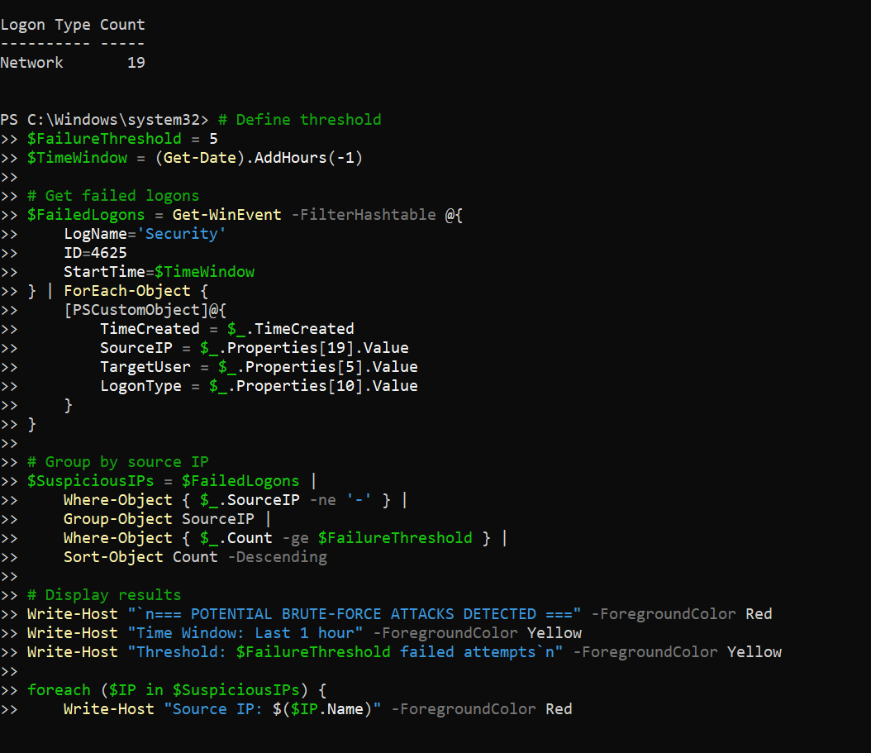
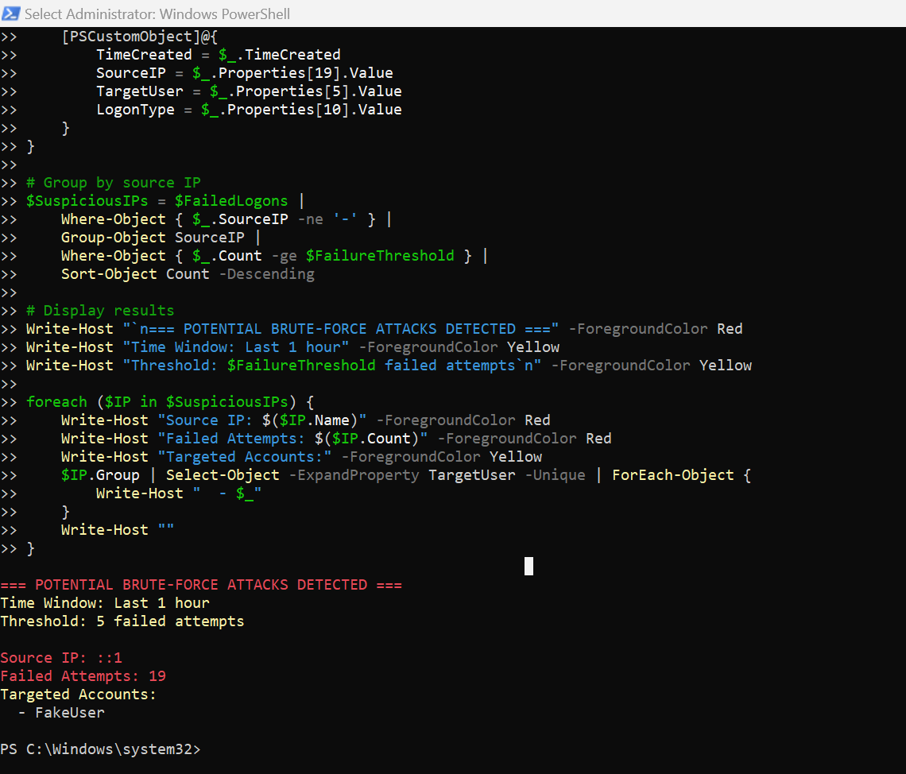

Explanation:
- $FailureThreshold = 5 sets the minimum number of failed attempts needed to flag an IP address.
- $TimeWindow = (Get-Date).AddHours(-1) limits the analysis to the last hour.
- The script collects failed logon events (Event ID 4625) and extracts the time, source IP, target username and logon type.
- Group-Object SourceIP groups the events by source IP address.
- Where-Object { $_.Count -ge $FailureThreshold } keeps only IP addresses with 5 or more failures.
- The foreach loop prints each suspicious IP, its number of failed attempts, and the targeted accounts.
- Write-Host with -ForegroundColor displays the output in colors (red for alerts, yellow for details).

Observation:
The script detected ____ suspicious IP address(es). Source IP ____ had ____ failed attempts and targeted the account(s) ____.
Observation:
No suspicious IP addresses were listed because the failed logon attempts were generated locally, where the source IP field is empty ("-"). The script correctly ignores such entries.

Exercise 12: Detect Explicit Credential Usage (Event ID 4648):
Command:
Get-WinEvent -FilterHashtable @{
LogName='Security'
ID=4648
StartTime=(Get-Date).AddDays(-1)
} | ForEach-Object {
$xml = [xml]$_.ToXml()
[PSCustomObject]@{
TimeCreated = $_.TimeCreated
SourceUser = $xml.Event.EventData.Data[1].'#text'
TargetUser = $xml.Event.EventData.Data[5].'#text'
TargetServer = $xml.Event.EventData.Data[8].'#text'
Process = $xml.Event.EventData.Data[11].'#text'
}
} | Format-Table -AutoSize

Output:
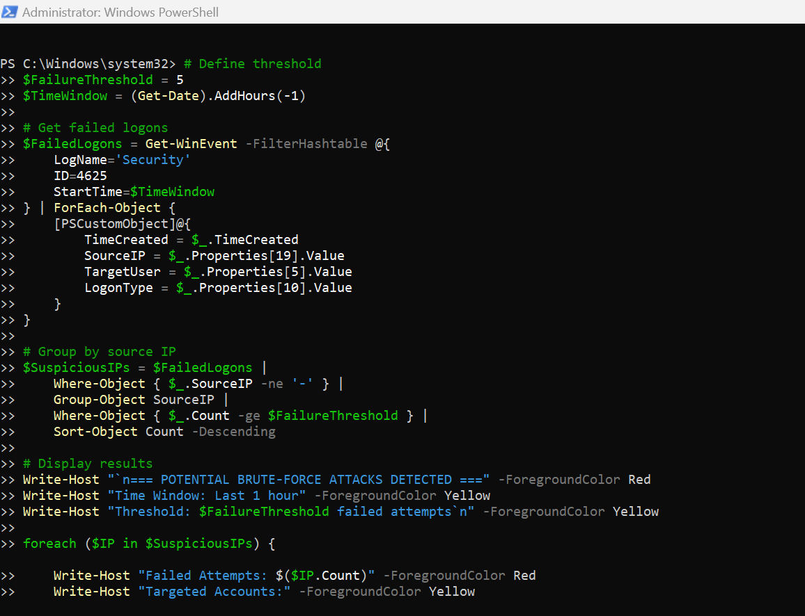
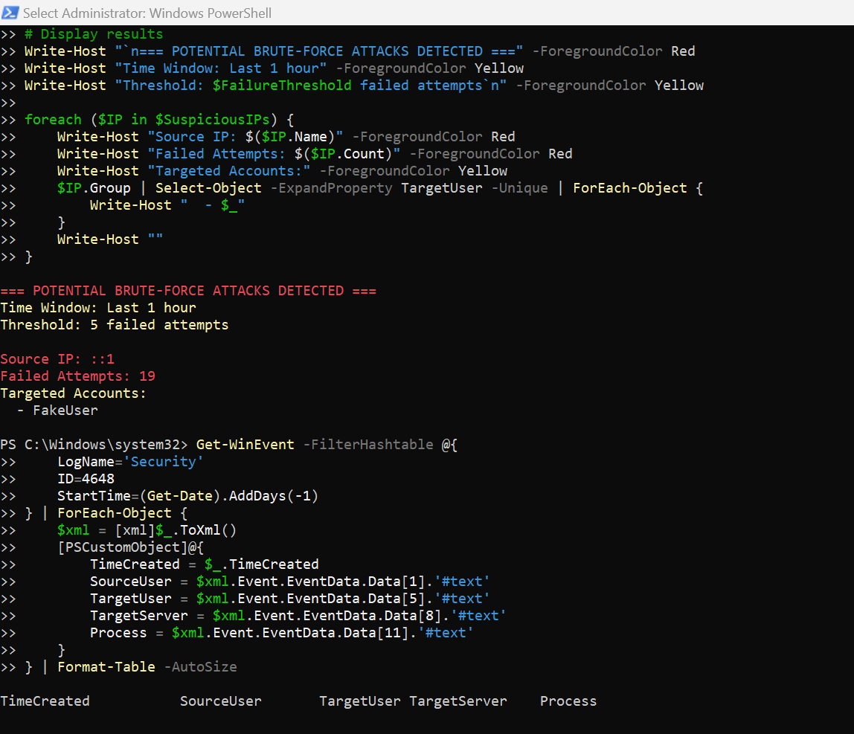
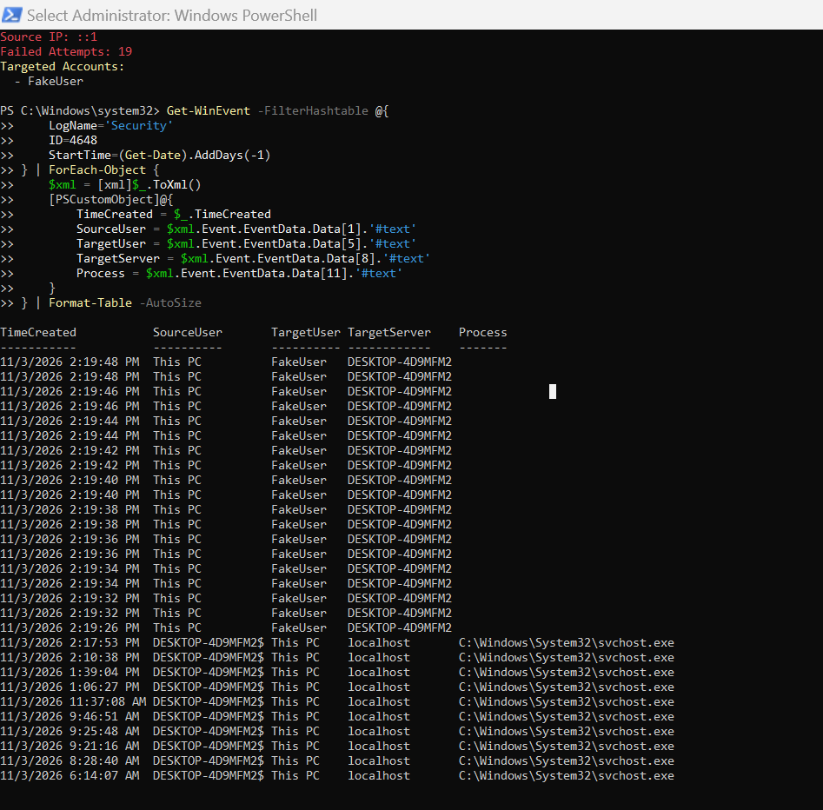
Explanation:
- Event ID 4648 is logged when a logon is attempted using explicit credentials (for example RunAs or PsExec), which is common in lateral movement.
- ToXml() converts each event into XML so the data fields can be read.
- Data[1] is the account that used the credentials, Data[5] is the target account, Data[8] is the target server, and Data[11] is the process that made the request.
- A custom object is created for each event and displayed as a table with Format-Table -AutoSize.

Observation:
The query returned ____ events. The most common source user was ____, the target server was ____ and the process was ____. Explicit credential use by unexpected users or processes toward other servers can indicate lateral movement.

Exercise 13: Detect Network Share Access (Event ID 5140)
Command:
Get-WinEvent -FilterHashtable @{
LogName='Security'
ID=5140
StartTime=(Get-Date).AddHours(-1)
} | ForEach-Object {
$xml = [xml]$_.ToXml()
[PSCustomObject]@{
TimeCreated = $_.TimeCreated
Account = $xml.Event.EventData.Data[1].'#text'
SourceIP = $xml.Event.EventData.Data[5].'#text'
ShareName = $xml.Event.EventData.Data[7].'#text'
}
} | Format-Table -AutoSize

Output:
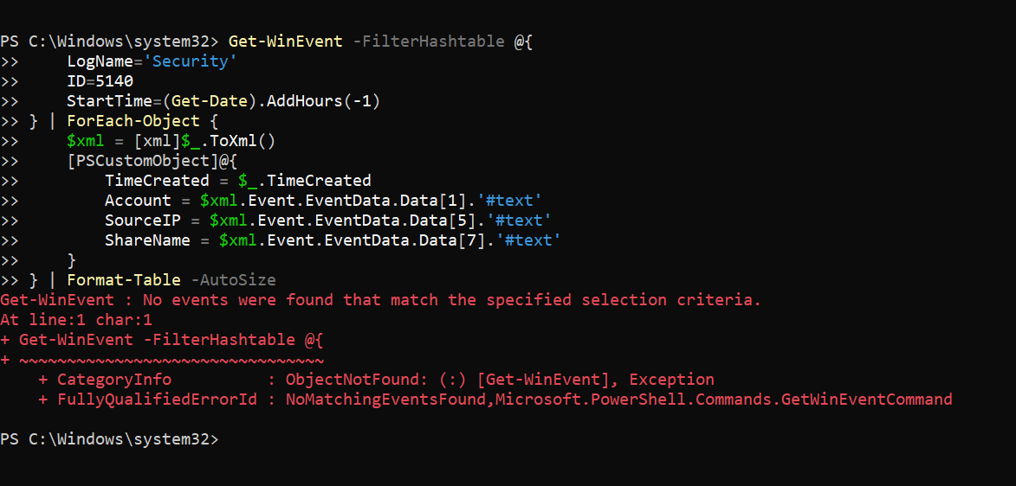
Explanation:
- Event ID 5140 is logged when a network share is accessed, which is useful for detecting lateral movement.
- The command reads the events from the last hour and converts each one to XML.
- Data[1] is the account name, Data[5] is the source IP address, and Data[7] is the share name (for example \\*\C$).
- The results are shown as a table with Format-Table -AutoSize.

Observation:
The query returned ____ network share access events. The account ____ accessed the share ____ from the source IP ____. Access to administrative shares such as C$ or ADMIN$ from unexpected accounts or IP addresses may indicate lateral movement.

Observation:
No network share access events (Event ID 5140) were found in the last hour, so no lateral movement through network shares was detected.

