PROGRAMMING 2B
PROG6212
SHANTELL MALATJIE
ST10475153

RACEDAY NOVA
PART 1 – SYSTEM PLANNING AND DATABASE

Table of Contents
- 1. Project Overview
- 2. Part 1 Objectives
- 3. User Roles and Functional Scope
- 4. Database Planning
- 5. Entity Relationship Design
- 6. REST API Endpoint Plan
- 7. SQL Database Script
- 8. GitHub and CI/CD
- 9. Submission Evidence
- 10. Twenty Meaningful Commits
- 11. Video Presentation
- 12. Rubric Traceability
- 13. Part 2 Continuity

1. Project Overview
RaceDay Nova is a web-based event management system for the South African road-running, walking and cycling community. It supports event organisers and participants. Organisers manage events, categories, enrolments and results, while participants create accounts, browse events, enter categories and track their own performance.
Part 1 is the assessed planning and database foundation. The database model and REST API contract are designed before application implementation so that later C# development can follow a stable specification.

2. Part 1 Objectives
- Produce a complete ERD with entities, attributes, primary keys, foreign keys and cardinalities.
- Produce a structured REST API endpoint plan covering all required functional areas.
- Create a SQL Server script that creates and populates the complete relational schema.
- Apply appropriate NOT NULL, UNIQUE, DEFAULT and CHECK constraints.
- Seed realistic sample data: at least two organisers, two participants, three events, categories for each event and sample enrolments/results.
- Place all planning documents and the SQL script in /docs.
- Configure GitHub Actions to validate the repository structure.
- Maintain at least 20 meaningful commits and prepare evidence for the README and video.

3. User Roles and Functional Scope
Role | Permissions | Key functions
Organiser | Create/edit/delete events; manage categories; capture results; view event enrolments. | Event and result administration
Participant | Create account; browse events; select a category; view own enrolments; track personal results. | Registration and performance tracking

4. Database Planning
The seven planned entities are:
- Users – account, login and role information.
- Events – race/event information and organiser ownership.
- Categories – reusable category definitions.
- EventCategories – event-specific categories and the bridge between Events and Categories.
- Enrolments – participant entries into event categories.
- Results – performance records linked to enrolments.
- EventWeatherSnapshots – weather conditions associated with an event.
EventCategories resolves the many-to-many relationship between Events and Categories. Enrolments then reference a specific EventCategory, ensuring that a participant enters a real category belonging to a particular event. Results reference the enrolment, preserving clear ownership and avoiding duplicate participant/result relationships.

5. Entity Relationship Design
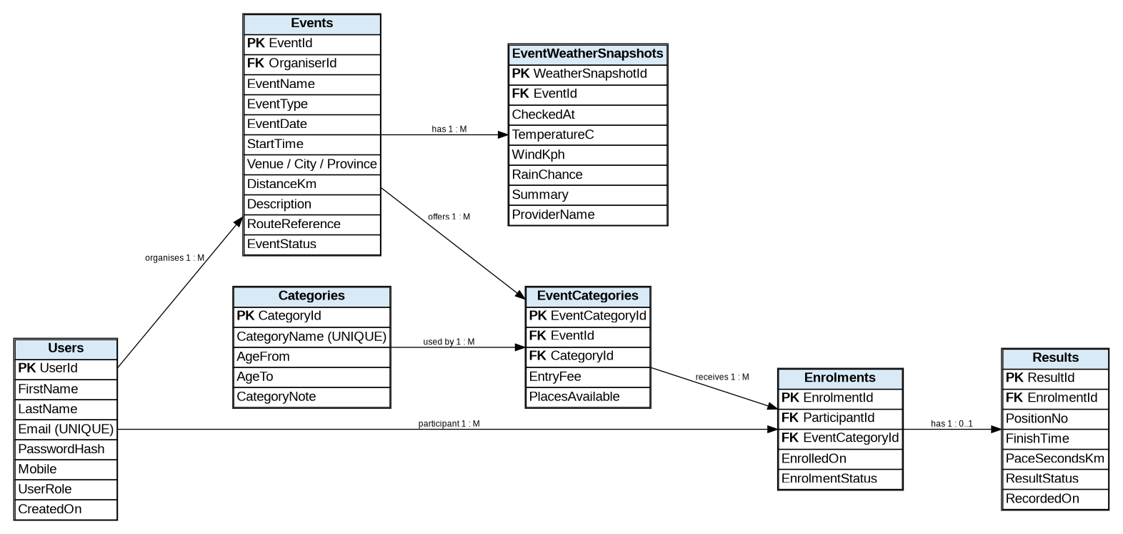
The submitted ERD must match the SQL script exactly. Primary keys, foreign keys and cardinalities must be visible.
- One organiser can create many events; an event belongs to one organiser.
- Events and categories form a many-to-many relationship through EventCategories.
- A participant can have many enrolments; each enrolment belongs to one participant.
- An EventCategory can have many enrolments.
- An enrolment can have zero or one result.
- An event can have multiple weather snapshots.

6. REST API Endpoint Plan
Every endpoint uses the /api/ prefix. The endpoint specification is the contract for Part 2 and records the method, route, description, role, request body and expected response.
Method | Route | Description | Role | Request body | Expected response
POST | /api/auth/register | Register account | Public | name, email, password, role | 201 Created
POST | /api/auth/login | Authenticate user | Public | email, password | 200 OK + token
GET | /api/users/{id} | View profile | Owner/Organiser | None | 200 OK
GET | /api/events | Browse events | Public | Optional filters | 200 OK
POST | /api/events | Create event | Organiser | Event details | 201 Created
PUT | /api/events/{id} | Update event | Organiser | Event details | 200 OK
DELETE | /api/events/{id} | Delete event | Organiser | None | 204 No Content
GET | /api/categories | List categories | Public | None | 200 OK
POST | /api/events/{eventId}/categories | Add event category | Organiser | Category details | 201 Created
POST | /api/eventcategories/{id}/enrolments | Enter category | Participant | Entry details | 201 Created
GET | /api/users/{id}/enrolments | Own enrolments | Participant | None | 200 OK
GET | /api/events/{id}/enrolments | Event enrolments | Organiser | None | 200 OK
POST | /api/enrolments/{id}/result | Capture result | Organiser | Position/time | 201 Created
GET | /api/users/{id}/results | Own results | Participant | None | 200 OK
GET | /api/events/{id}/results | Event results | Organiser | None | 200 OK

7. SQL Database Script
- Create the complete SQL Server schema in dependency order.
- Define primary keys and foreign keys matching the ERD.
- Use NOT NULL for mandatory business data.
- Use UNIQUE constraints for values that must not be duplicated, such as email.
- Use DEFAULT values for suitable status/date fields.
- Use CHECK constraints for valid roles, positive values and permitted statuses.
- Seed at least two organisers, two participants and three events.
- Seed categories for every event and realistic enrolments/results.
- Test the script on a clean SQL Server instance in SSMS.
- Run verify_part1.sql and capture successful evidence where required.
The SQL file supplied with this package is RaceDay_Nova_Database.sql and the verification file is verify_part1.sql.

8. GitHub and CI/CD
- Use the lecturer-provided GitHub repository/submission link for the final ARC submission.
- Store the ERD, endpoint plan, SQL script and supporting planning documents inside /docs.
- Use .github/workflows/ for the GitHub Actions workflow.
- Make at least 20 meaningful commits using the student's own GitHub account.
- Ensure commits represent genuine progress, not repeated cosmetic changes.
- Run GitHub Actions and verify the workflow produces a green check.
- Include a screenshot of the successful green build in the README.
- Do not submit a ZIP instead of the required GitHub repository link if the POE specifically requires the repository link.

9. Submission Evidence
Requirement | Package evidence | Student must still provide
ERD | RaceDay_Nova_ERD.png | Confirm image is the final ERD used by SQL.
API plan | RaceDay_Nova_API_Endpoint_Plan.md | Confirm any lecturer-required deviations.
SQL script | RaceDay_Nova_Database.sql | Run in SSMS and capture evidence.
CI/CD | part1-validation.yml | Push to own GitHub and show green result.
Commit history | 20_Meaningful_Commits_Plan.md | Actually make 20 meaningful commits.
README | README.md | Add actual repository and video links/screenshots.
Video | Part1_Video_Script.md | Record with own voice; submit unlisted YouTube link.

10. Twenty Meaningful Commits
- 01. Initial RaceDay Nova repository structure
- 02. Add Part 1 README
- 03. Plan database entities
- 04. Add Users and role constraints
- 05. Add Events and organiser relationship
- 06. Add Categories
- 07. Add EventCategories bridge
- 08. Add Enrolments
- 09. Add Results
- 10. Add weather snapshots
- 11. Create ERD source
- 12. Render final ERD
- 13. Plan authentication endpoints
- 14. Plan event/category endpoints
- 15. Plan enrolment/result endpoints
- 16. Create SQL schema
- 17. Add constraints and indexes
- 18. Add seed data
- 19. Add verification queries
- 20. Add CI workflow and final documentation

11. Video Presentation
The Part 1 video should demonstrate and explain the work. The assignment instructions state that every part requires a video presentation and that AI-generated voices are not permitted.
- Introduce RaceDay Nova and its purpose.
- Explain the Organiser and Participant roles.
- Show the ERD and explain the seven entities and relationships.
- Explain the many-to-many Event/Category relationship and EventCategories bridge.
- Show the API endpoint plan and explain representative endpoints.
- Open the SQL script in SSMS and explain tables, constraints and seed data.
- Run the SQL/verification script and show successful output.
- Show the GitHub repository structure and successful green Actions check.
- Conclude by explaining how Part 1 prepares the system for the C# REST API in Part 2.

12. Rubric Traceability
Rubric area | Top-band preparation | Final evidence
Submission – 5 | README, /docs, ERD, API plan, SQL, CI/CD and video plan supplied. | Own GitHub link, green build screenshot and video link.
ERD – 25 | Complete seven-entity model with PK/FK/cardinality planning. | Final ERD must exactly match SQL.
API Endpoint Plan – 25 | Structured table includes method, route, description, role, request and response and required functional areas. | Final implementation in Part 2 must closely follow the plan.
SQL Database Script – 20 | Schema, constraints and realistic seed data prepared. | Successful clean SQL Server execution.
GitHub and CI/CD – 15 | Workflow and 20-commit plan supplied. | Actual meaningful Git history and green workflow.
Video – 10 | Complete human-voice presentation plan supplied. | Actual unlisted YouTube presentation.

13. Part 2 Continuity
The POE instructions shown require Part 2 to build the RESTful API in C#, connect it to the database and write unit tests with GitHub CI/CD. This planning document therefore treats the ERD and endpoint plan as the source of truth for the later C# implementation. Exact Part 2 features should be added only after the complete Part 2 specification/rubric is available, so that no requirement is guessed or omitted.
Final pre-submission check: replace student placeholders, use the student's own GitHub account, create the required meaningful commits, run the SQL in SSMS, obtain the green CI/CD result, record the required human-voice video, and insert the real links/evidence into the README.

