SEM-3-DBMS LAB

TOPIC : EVENT MANAGEMENT SYSTEM

***DATABASE USED :*** POSTGRESQL

***list of tables:***

1)events:

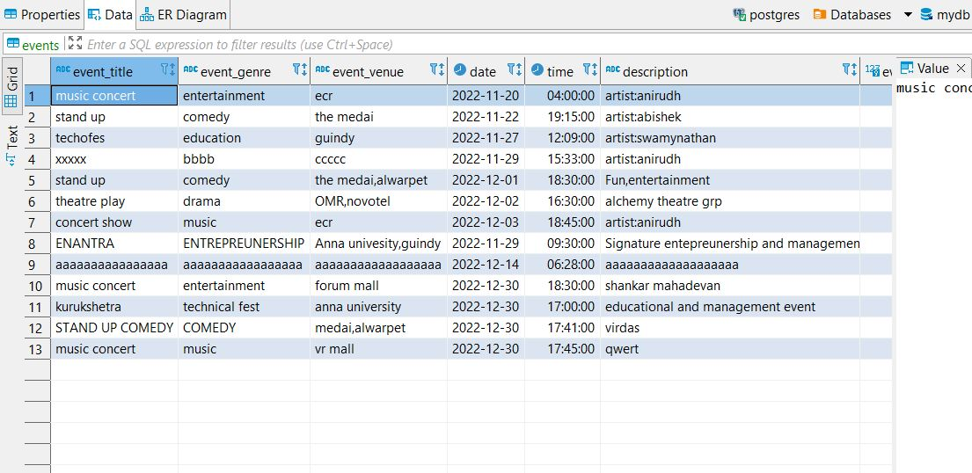

2)registered:

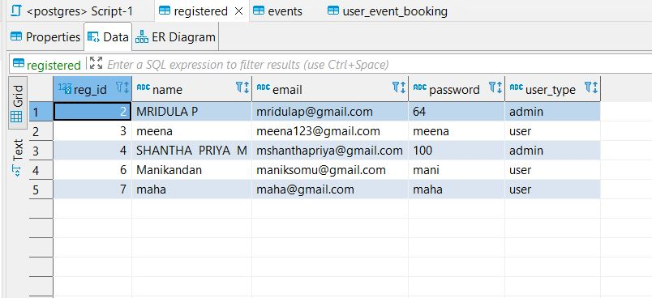

3)user_event_booking:

