LAB 7: Fuzzing for Input Validation Bugs
Lab Report & Evidence Document | Topic: Property-Based Fuzz Testing with Hypothesis
Course / Module: Security & Quality Assurance | Duration: 60 Minutes
Assigned Repository: L6_L7_06_event_ticket_tier-main | Frameworks: Python 3.8+, Hypothesis, Pytest

1. Objective & Learning Outcomes
The objective of this lab is to explore fuzz testing as an automated security and quality assurance technique. By leveraging the Hypothesis property-based testing library in Python, we uncover hidden edge cases, unhandled exceptions, and input-validation vulnerabilities in application code, and harden the software through defensive programming.
- Key Learning Outcomes Achieved:
- Understood the core methodology and benefits of property-based fuzzing over traditional static unit testing.
- Applied property testing decorators (@given) and strategies (st.text(), st.none()) using Hypothesis.
- Detected, minimized, and analyzed crashing edge-case inputs (NoneType, malformed strings, out-of-bound indices).
- Hardened application routines with comprehensive defensive validation and fail-safe exception boundaries.
2. Step 1: Installing Dependencies
The required fuzz testing and test runner packages were installed in the working environment:
pip install hypothesis
pip install pytest
3. Step 2: Running the Buggy Application (processor.py)
The initial processor script was executed under Lab 7 using nominal sample inputs to establish the baseline functionality. As expected, under normal, well-formed inputs the script operates without immediate error:
PS C:\Users\sheno\Downloads\L6_L7_06_event_ticket_tier-main\Lab 7> python processor.py

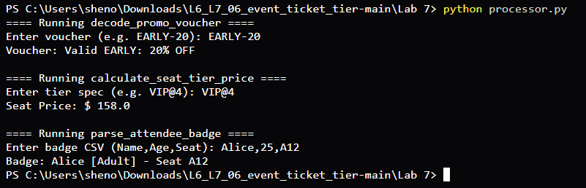
Figure 1: Step 2 — Initial execution of processor.py with happy-path sample inputs.
Observation: While the script succeeds on expected inputs like 'EARLY-20', 'VIP@4', and 'Alice,25,A12', it assumes inputs are always correctly delimited and strictly typed, making it fragile against malformed data, empty strings, and null inputs.
4. Step 3 & 4: Property-Based Fuzz Testing & Bug Detection
Implementation of test_processor.py using Hypothesis
To systematically probe for crashes across wide input domains, property tests were written in test_processor.py using the @given decorator combined with st.text() | st.none(). Each test asserts failure if an unhandled exception is raised:
from hypothesis import given, strategies as st
from processor import decode_promo_voucher, calculate_seat_tier_price, parse_attendee_badge
@given(st.text() | st.none())
def test_decode_promo_voucher_no_crash(s):
try:
decode_promo_voucher(s)
except Exception as e:
assert False, f'decode_promo_voucher crashed with: {e}'
@given(st.text() | st.none())
def test_calculate_seat_tier_price_safe(s):
try:
calculate_seat_tier_price(s)
except Exception as e:
assert False, f'calculate_seat_tier_price crashed with: {e}'
@given(st.text() | st.none())
def test_parse_attendee_badge_safe(s):
try:
parse_attendee_badge(s)
except Exception as e:
assert False, f'parse_attendee_badge crashed with: {e}'
Fuzz Testing Execution & Uncovered Failures
The test suite was executed against the initial processor code:
PS C:\Users\sheno\Downloads\L6_L7_06_event_ticket_tier-main\Lab 7> pytest test_processor.py

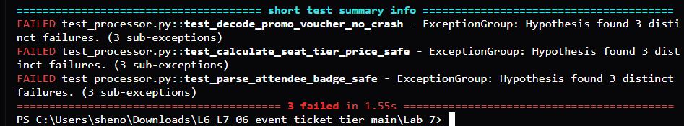
Figure 2: Step 4 — Pytest output demonstrating 3 test failures exposed automatically by Hypothesis fuzzing.
Root Cause Analysis of Discovered Bugs
Hypothesis rapidly generated minimal falsifying examples that exposed critical input-validation vulnerabilities:
Function Under Test | Failing Input (Shrunk) | Root Cause & Unhandled Exception
decode_promo_voucher | s = None  s = '' | AttributeError on .strip(); ValueError (not enough values to unpack) when '-' delimiter is missing; ValueError on non-int discount.
calculate_seat_tier_price | s = None  s = 'VIP' | AttributeError on .split('@'); IndexError when '@' delimiter is absent; KeyError when tier is unlisted; ValueError on invalid row.
parse_attendee_badge | s = None  s = '' | AttributeError on .split(','); IndexError when 3 comma-separated tokens are not provided; ValueError when age is non-numeric.

5. Step 5: Fixing & Hardening processor.py
To achieve robust defensive programming, processor.py was rewritten. Each function implements explicit type checking, delimiter and token length validation, safe conversion parsing, logical boundary checks, and a top-level try/except boundary to guarantee that no malformed input can cause an unhandled crash.
def decode_promo_voucher(voucher_code):
try:
if not isinstance(voucher_code, str):
return 'Invalid voucher'
code = voucher_code.strip()
if '-' not in code:
return 'Invalid voucher format'
parts = code.split('-')
if len(parts) != 2:
return 'Invalid voucher format'
prefix, pct_str = parts[0].strip(), parts[1].strip()
if not prefix:
return 'Invalid voucher prefix'
percentage = int(pct_str)
if percentage < 0 or percentage > 100:
return 'Invalid percentage'
return f'Valid {prefix.upper()}: {percentage}% OFF'
except Exception:
return 'Invalid voucher'
def calculate_seat_tier_price(tier_spec):
try:
if not isinstance(tier_spec, str):
return 0.0
parts = tier_spec.split('@')
if len(parts) != 2:
return 0.0
tier = parts[0].strip().upper()
row = int(parts[1].strip())
if row < 0:
return 0.0
tier_rates = {'VIP': 150.0, 'PREMIUM': 90.0, 'GENERAL': 45.0}
if tier not in tier_rates:
return 0.0
base = tier_rates[tier]
return base + (row * 2.0)
except Exception:
return 0.0
def parse_attendee_badge(badge_csv):
try:
if not isinstance(badge_csv, str):
return 'Invalid badge'
tokens = badge_csv.split(',')
if len(tokens) != 3:
return 'Invalid badge format'
name = tokens[0].strip()
if not name:
return 'Invalid name'
age = int(tokens[1].strip())
if age < 0 or age > 150:
return 'Invalid age'
seat = tokens[2].strip()
if not seat:
return 'Invalid seat'
category = 'Child' if age < 18 else 'Adult'
return f'{name} [{category}] - Seat {seat}'
except Exception:
return 'Invalid badge'
The fixed script was run to ensure expected nominal operation remains fully intact:
PS C:\Users\sheno\Downloads\L6_L7_06_event_ticket_tier-main\Lab 7> python processor.py

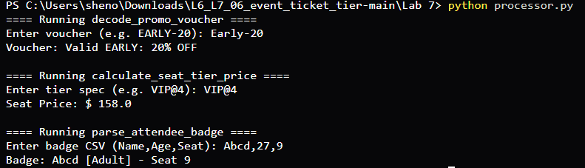
Figure 3: Step 5 — Execution of the hardened processor.py verifying clean behavior.
6. Step 6: Test Re-Execution & Verification
With the defensive validations in place, pytest was re-executed. Hypothesis subjected the functions to hundreds of randomized fuzz inputs (including nulls, empty strings, Unicode, extreme integers, and malformed delimiters).
PS C:\Users\sheno\Downloads\L6_L7_06_event_ticket_tier-main\Lab 7> pytest test_processor.py

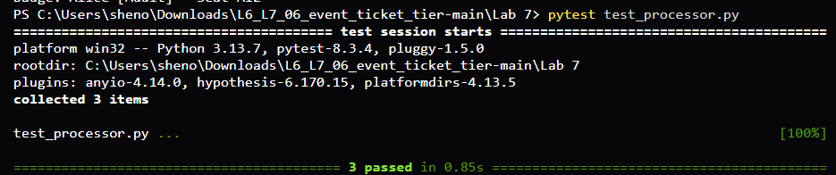
Figure 4: Step 6 — All 3 Hypothesis fuzzing property tests passing successfully (100%).
7. Conclusion
Fuzz testing with Hypothesis proved highly effective in uncovering edge-case crashes that standard happy-path unit tests consistently miss. By moving from example-based testing to property-based fuzzing, we verified that the functions hold their invariants (no unhandled exceptions) across the entire input space. Implementing defensive programming practices safeguarded the application against denial-of-service, unhandled crashes, and malformed payloads.

