COMPUTER NETWORKS
Host Discovery Service :
Automatically detect and maintain a list of hosts in the SDN network.
"Detect host join events; Maintain host database; Display host details;
Update dynamically
SCREENSHOTS:
1. Controller Setup Screenshot:
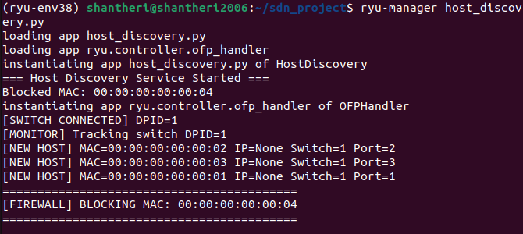
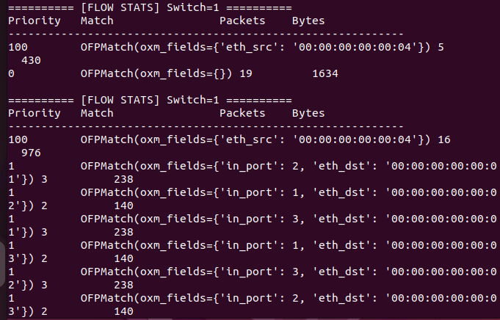

2. Mininet Topology Screenshot:
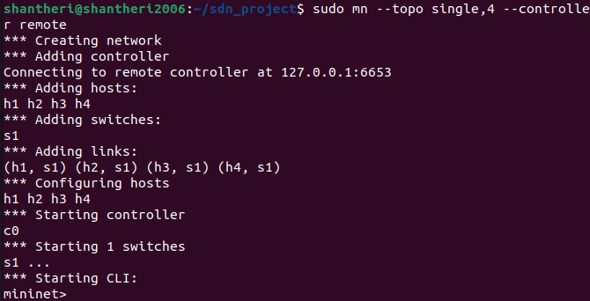

3. Host Discovery Output:
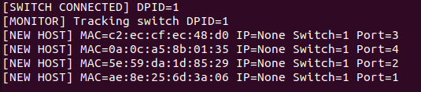

4. Normal Communication (Allowed):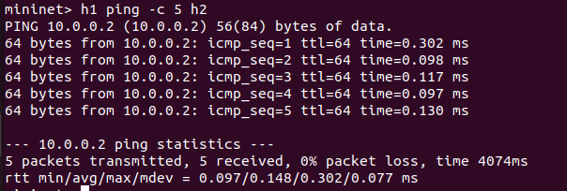

5. Firewall Rule Installed:
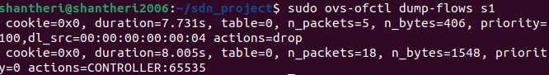

6. Blocked Communication:
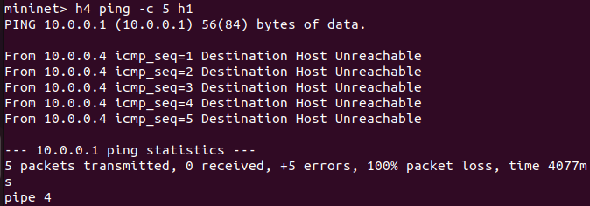

7. Flow Statistics:
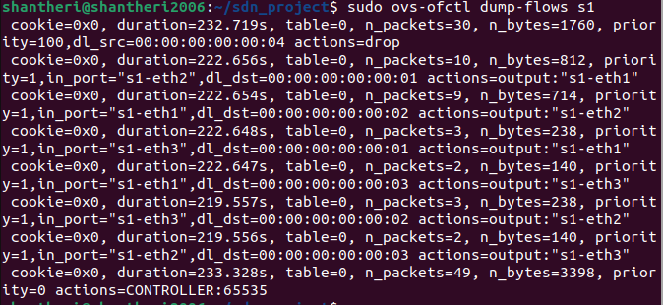

8. Performance Test:
