**A Major Project Report**

**on**

**FEATURE BASED OPINION MININGUSING ONTOLOGY ANALYSIS**

**Submitted to the Dept. of Information Technology, SNIST**

**in the partial fulfillment of the academic requirements for the award of**

**B.Tech (IT) under JNTU**

**By**

**A.Baby Shanthi(15311A1201)**

**N.Harini(15311A1217)**

**S.Pravalika(15311A1222)**

**S.Harika(16315A1202)**

**Under the guidance of**

**Dr.D.Teja Santosh**

**Associate Professor**

**Internal Guide**



**Department of Information Technology**

**School of Computer Science and Informatics**

**Sreenidhi Institute of Science and Technology**

**Yamnampet, Ghatkesar Mandal, R. R. Dist., Hyderabad – 501301**

**Affiliated to**

**Jawaharlal Nehru Technological University**

**Hyderabad – 500 085**

**2019**

**Department of Information Technology**

**School of Computer Science and Informatics**

**Sreenidhi Institute of Science and Technology(Autonomous)**



**Certificate**

This is to certify that the Project report on “**Feature Based Opinion Mining Using Ontology**” is a bonafide work carried out by **A.Baby Shanthi(15311A1201), N.Harini(15311A1217), S.Pravalika(15311A1222)**, **S.Harika(16315A1202)**in the partial fulfillment for the award of B.Tech degree in Information Technology, **Sreenidhi Institute of Science and Technology**,Hyderabad, affiliated to Jawaharlal Nehru Technological University, Hyderabad under our guidance and supervision.

The results embodied in the project work have not been submitted to any other University or Institute for the award of any degree or diploma.

**Internal guide Head of the Department**

**Dr.D.Teja Santosh Dr.V.V.S.S.S.Balaram**

**Project coordinators**

1. **Dr. Sunil Bhutada**
2. **Dr. V. Saravana Kumar**

**ACKNOWLEDGEMENTS**

We would like to express our immense gratitude and sincere thanks to **Dr.D.Teja Santosh**, Associate Professor, for his guidance, valuable suggestions and encouragement in completing the group work within the stipulated time.

We would like to express our sincere thanks to **Dr. P. Narasimha Reddy**, Executive Director, **Dr. T. Ch. Siva Reddy**, Principal, **Dr. V.V.S.S.S. Balaram**, Head of the Department of Information Technology, **Dr.SunilBhutada**, Project Work Coordinator, **Dr.V.SaravanaKumar**,Project Work Coordinator, **Sreenidhi Institute of Science and Technology**,Hyderabad, for permitting us to our project work at **Sreenidhi Institute of Science and Technology**,Hyderabad.

Finally, we would also like to thank the people who have directly or indirectly helped us and parents and friends for their cooperation in completing the project work.

**A.Baby Shanthi(15311A1201)**

**N.Harini(15311A1217)**

**S.Pravalika(15311A1222)**

**S.Harika(16315A1202)**

**ABSTRACT**

The ideology of the web has altered and many changes took place in this so called Internet called social web. Each and every user is aware of technologies and the social web, people are totally sticking in online using internet and now-a-days shopping is done on online websites where the orders come home without risk, When ordering online by seeing images is difficult so, there are reviews where the customers give the rating when a product is bought under that product. People are more interested in rating and reviews than believing the pictures where opinion ming comes into the picture. In opinion mining, the unorganized data is organized and put it in a good order and find polarity so that customers feel easy shopping, but in opinion mining there are missing semantic relations and less features extraction so as we get into the ontology which helps to get more hidden aspects and features with the semantic relations in an order.

**Table of Contents**

**1** **Introduction** 1

**1.1** **Purpose** 1

**1.2** **Scope** 2

**1.3** **Aim of the Project** 2

**2** **Literature survey** 3

**3** **Proposed System** 3

**3.1** **Collection of dataset** 4

**3.2** **Preprocessing using nltk** 5

**3.3** **Reviews Tokenization** 5

**3.4** **Stop words Removal** 6

**3.5** **POS Tagging** 7

**3.6** **Finding Linguistic Patterns** 7

**3.7** **Product Aspect Extraction** 7

**4** **Software Requirements Specification** 8

**4.1** **Introduction** 8

**4.1.1** **Jupyter Notebook** 8

**4.1.2** **Python** 8

**4.1.3** **Protégé** 8

**4.1.4** **Fluent Editor** 8

**4.2** **Software Requirements** 9

**5** **DESIGN** 10

**5.1** **Use Case Diagram** 10

**5.2** **Class Diagram** 11

**5.3** **State Chart Diagram** 12

**5.4** **Building Ontology** 13

**6** **Implementation** 14

**6.1** **Introduction** 14

**6.2** **Object Recognition** 14

**6.2.1** **Object** 14

**6.2.2** **Dataset** 15

**6.3** **Implementation of modules** 16

**6.3.1** **Collection of reviews** 16

**6.3.2** **Pre-processing using NLTK** 17

**5.3.3** 18

**5.3.4** 18

**5.3.5** 19

**5.3.6** 20

**5.3.7** 29

**7** **Conclusion** 32

# **Introduction**

Opinion mining requires deeper expertise of language function and textual context. In the beyond few years, many researchers studied the problem. Most of the present works are based on product evaluations due to the fact a overview generally makes a speciality of a selected product and contains little inappropriate records. The predominant responsibilities are to discover functions that have been commented on and to determine whether or not the evaluations are negative or positive.

An ontology is a proper description of information as a fixed of concepts inside a domain and the relationships that maintain between them. To permit this sort of description, we need to formally specify components inclusive of people (times of objects), training, attributes and family members in addition to restrictions, rules and axioms. The end result, ontologies do not only introduce a sharable and reusable know-how illustration but can also add new information about the area.

There are, of course, other strategies that use formal specifications for knowledge representation along with vocabularies, taxonomies, thesauri, subject matter maps and logical models. However, not like taxonomies or relational database schemas, as an instance, ontologies express relationships and enable customers to hyperlink more than one principles to different standards in a ramification of approaches.

## **Purpose**

Opinion mining is a rather lively studies area that incorporates natural language processing, computational linguistics and text analysis techniques with the aim of extracting various kinds of delivered-value and informational factors from customers critiques. However, present day opinion mining procedures are hampered by a number of drawbacks along with the absence of semantic relations between concepts in characteristic search techniques or the shortage of superior mathematical strategies in sentiment analysis techniques. We suggest an innovative opinion mining technique that takes gain of new semantic web-guided solutions to decoratethe outcomes received with conventional herbal language processing strategies and sentiment analysis procedures.

## **Scope**

Ontologies have numerous applications and that they represent the conceptual spine of the Semantic Web. Scope’s pre-built and custom designed ontology may be used in automatic text mining and semantic processing applications for offering a search and retrieval platform, greater advanced than the key-word based search functions.

Current net-primarily based expertise representations languages inclusive of OWL and RDF(S) lack the wealthy linguistic grounding this is required for language-mediated get entry to to ontologies. OWL and RDF(S) rely upon a belongings rdfs:label to seize the relation between a vocabulary element and its (desired) lexicalization in a given language.

## **Aim of the Project**

The main goals of the proposed methodology are:

(1) to provide feature-based opinion mining by using ontologies at feature selection stage.

(2) to provide aspect and opinion pairs from ontology.

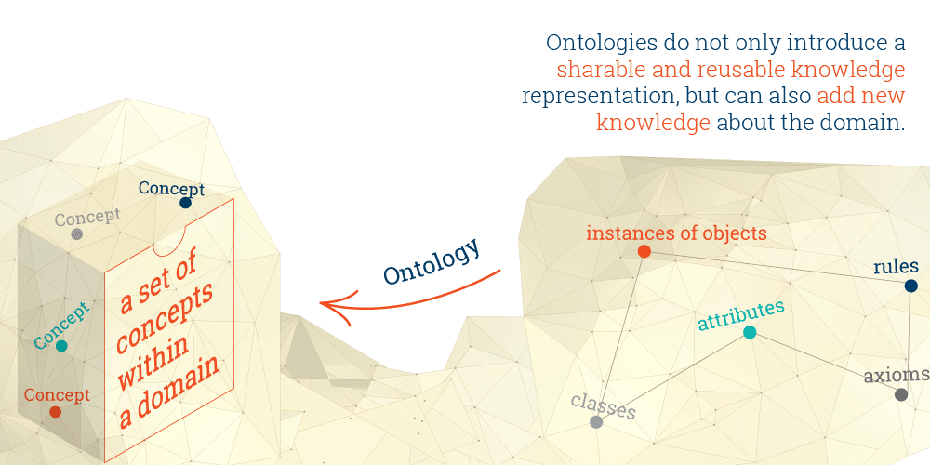

Fig.1.1 Ontology overview

# **Proposed System**

The principal objectives of the approach proposed in this manuscript are to improve feature-based opinion mining by employing ontologies in the selection of features and to provide a new method for sentiment analysis based on vector analysis. In order to achieve these goals, we present a framework composed of four main modules namely, the Collection of Dataset module, pre-processingusing NLTK(Natural Language Tool Kit) module(Reviews Tokenization, Stop words removal, POS Tagging),the finding linguistic patterns module, Product Aspect Extraction module,the ontology-based feature identification module, the polarity identification module and the opinion mining module.

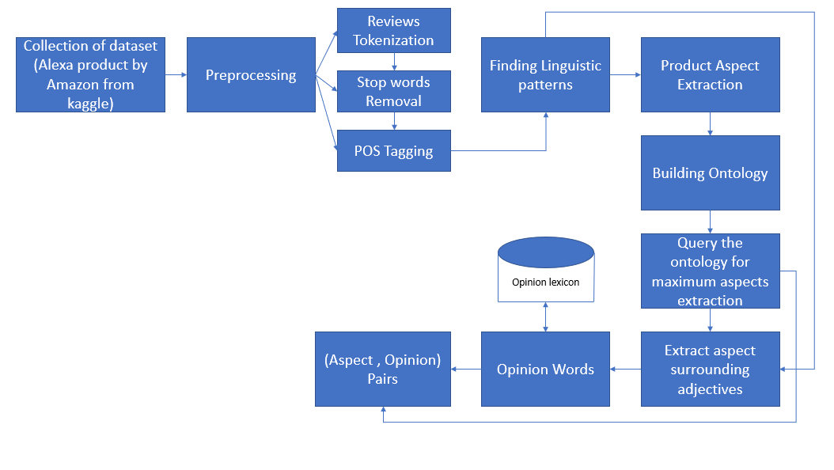

Fig. 2.1 Proposed system architecture

## **Collection of dataset**

**Data collection** is the process of gathering the data from the different sources of information. We can collect reviews from various e-commerce sites of particular product.

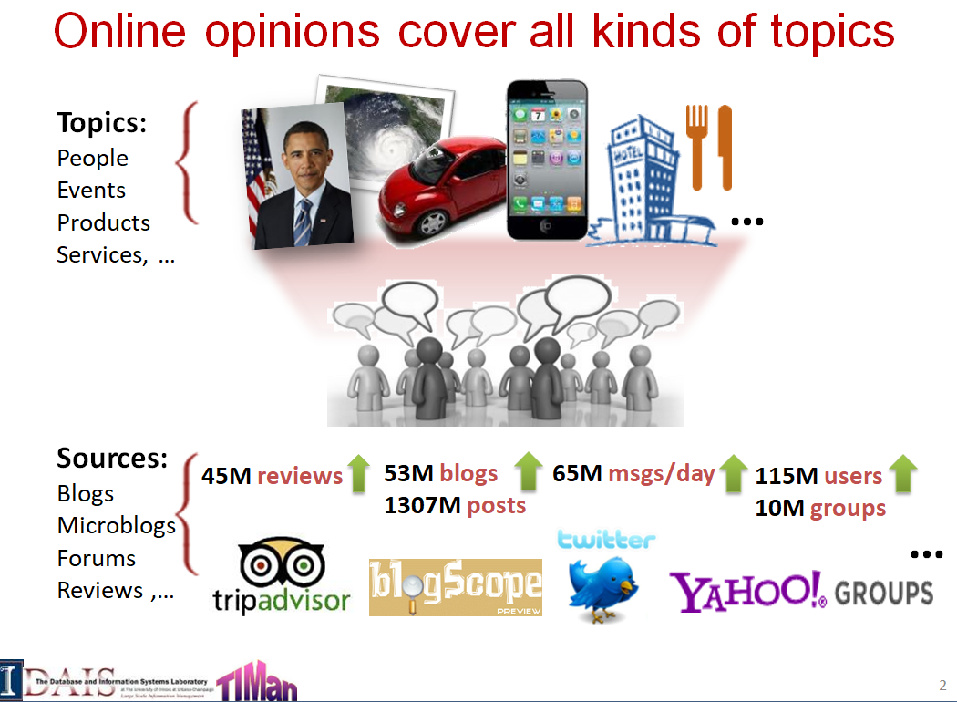

Fig No:2.1.1. collection of data from various sources

## **Preprocessing using nltk**

**NLTK(Natural Language ToolKit)**is a platform for building Python programs to work with human language data. It provides best suitable libraries pf of text processing for classification, tokenization, tagging, and semantic reasoning,.

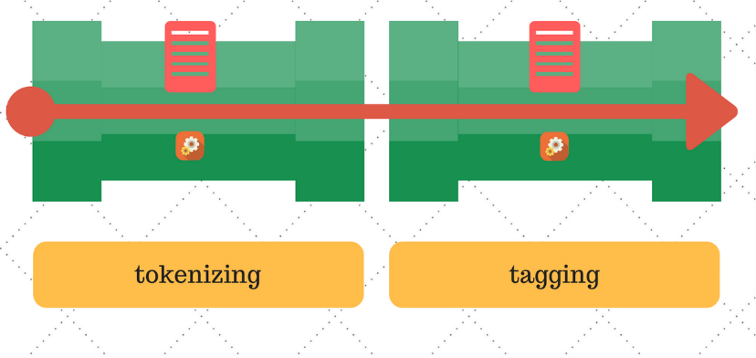

Fig No:- 2.2.1 pre-processing using nltk

[Natural Language ToolKit with Python](http://nltk.org/book) provides a practical introduction to programming for language processing. Written by the creators of NLTK, it guides the reader through the fundamentals of writing Python programs, categorizing text, analyzing linguistic structure.

## **Reviews Tokenization**

Tokenization is the process by which big quantity of text is divided into smaller parts called **tokens.** Natural language processing is used for Text classification.. It becomes vital to understand the pattern in the text to achieve the above-stated purpose. **These tokens are very useful for finding such patterns as well as is considered as a base step.**

Natural Language toolkit has Tokenization concept which deals with the tokenization of either sentences into words or sentence wise tokenization. It involves two types of Tokenization:

1. word tokenize
2. sentence tokenize

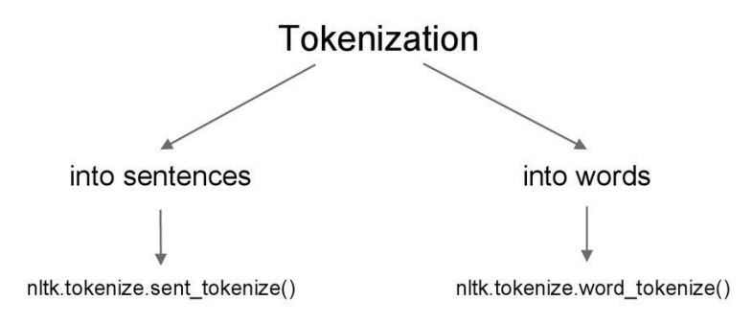

Fig No :- 2.2.1.1 Tokenization Categories

The output of word tokenization can be passed to input of other phases for better text understanding in machine learning applications. It can also be provided as input for further text cleaning steps such as punctuation removal, numeric character removal for pos tagging.

## **Stop words Removal**

A stop word is a commonly used word (such as “the”, “a”, “an”, “in”) that is commonly used to join or combine the sentences. They do not have any special meaning and have no need of them in doing the projects that are related to data science, artificial intelligence, machine learning. So these words are to be removed either manually or through the use of inbuilt stop words available. Python has inbuilt package nltk which has predefined list of stop words.

We manually picked up the stop words as the stop words are different from one project to another project. By removing the stop words we can decrease the storage space and can increase the time of execution

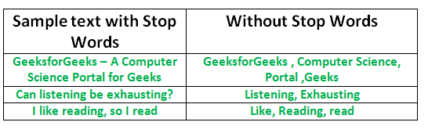

Fig No:- 2.2.2.1 Stop words removal usage

## **POS Tagging**

POS tagging is the processes of giving each word with its corresponding parts of speech tag.It is useful to identify the features or aspects of the object during the extraction of aspects.It is also useful to identify the linguistic patterns in the sentences.

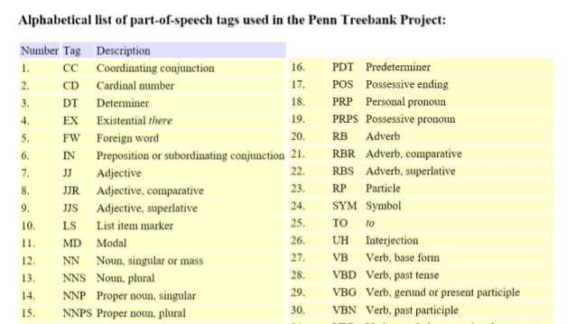

Fig No:- 2.2.3.1 Pos tags reference table

## **Finding Linguistic Patterns**

Linguistic patterns are the frequent occurrences of the sentences that can be found in one of the steps above which is POS tagging where noun or adjective that is part of the sentence that which we get output from the POS tag and to be given input to the code for finding the frequent sentences and also give the attached outputs of the parts of speech.

There are three dependencies before giving input to the linguistic patterns where these dependencies can be undergone through these three steps where each one gives the other as input and process the flow in order and give it to Linguistic patterns.

## **Product Aspect Extraction**

Aspect extraction is to extract as many aspects as possible that matches the in built aspects that are extracted through the linguistic patterns, for product Alexa there are camera , screen etc., but there is no hidden aspects that can be extracted and only through the manufacture details that are given by the amazon and the aspects or features are extracted but that are not related to the are not involved at the time of extraction.

# **Software Requirements Specification**

## **Introduction**

### **Jupyter Notebook**

Jupyter is web tool which can combine software code, computational output, explanatory text in single document. Users can write the code, execute the code, can visualize the output in the single document. It is an effective tool for the users who work on the projects related to data science, artificial intelligence, machine learning using Python Language.

### **Python**

Python is an interpreted language which have many inbuilt packages, libraries that are used for data scientists. It also have packages that are used for tokenization, POS Tagging, and packages related to data visualization. As it has inbuilt packages it makes the code much easier, lesser in size, reduce the errors.

### **Protégé**

Protégé tool is user to construct domain-based models with Ontologies. As it is an Ontology developed environment we can easily create, upload, modify and share ontologies. It generates the hierarchical tree structure of the model to know the detailed structure of model. It generates OWL file which will be given as input to fluent editor for querying the models.

### **Fluent Editor**

Fluent editor is an Ontology Editor, used for editing and manipulating Ontologies that uses Controlled Natural Language). Controlled natural language means the natural language with restricted grammar and vocabulary. we can also query the model by using fluent editor.

## **Software Requirements**

* Operating System : Windows 7/8.1/10
* User Interface :Jupyter Notebook
* Programming Languages : Python , Java
* Tools :
  + NLTK
  + Jupyter Notebook
  + Protégé (3.5 version)
  + Fluent Editor

# **DESIGN**

## **Use Case Diagram**

Use Case Diagram consists of Usecases and Actors. Usecases represents the set of actions and Actors represents the set of users involved. The use cases identified in this project are gives reviews,collect reviews, pre-processing, finding linguistic patterns, aspect extraction, building ontology, deploy the project. The Actors identified are Consumer, Analyst, End User. The first is Consumer gives the reviews next the Analyst collect the reviews and perform the actions like pre-processing the reviews, finding linguistic patterns, aspect extraction from the patterns, and building Ontology to extract the aspects and finally deploy the project.

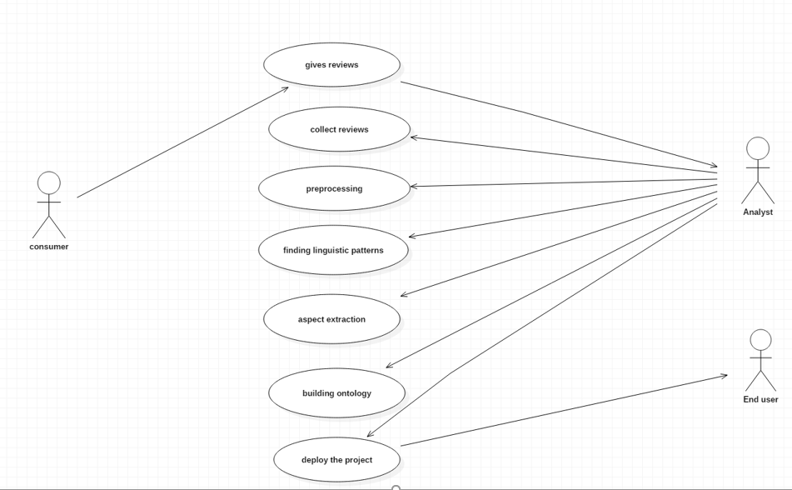

FigNo:- 4.1.1 Usecasediagram on the feature based opinion mining of reviews using Ontology

## **Class Diagram**

Class Diagram represents the set of classes, attributes, and methods. This Diagram shows the class diagram of Ontology of product reviews. The classes identified are Object, Aspect, (Subaspect), Thing, Review, Fact, Polarity, Opinion, Postag (Adjective, Adverb, Noun, Verb). The relationships identified are expressAspect, hasPolarity, isKindOf, isPartOf, isPartAspect, isexpressionOn, signifies, portray. And we also create the instances for each class.

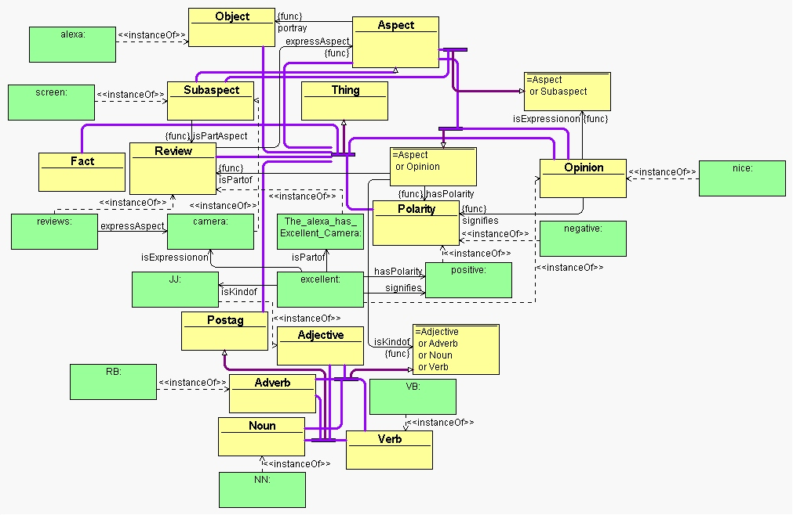

Fig No:- 4.2.1. Class diagram on feature based opinion mining using Ontology

## **State Chart Diagram**

State chart diagram represents the different states that the object undergoes during its lifetime. It starts with Initial state and ends with Dead state.The different states identified areGives reviews, Collect reviews, Pre-processing, Finding linguistic patterns, Aspect extraction, Building ontology, Deploying project.

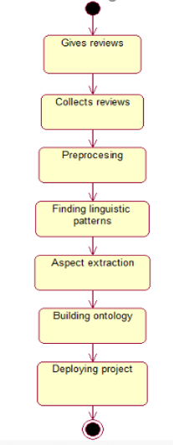

Fig No:- State chart diagram on feature based opinion mining through Ontology

## **Building Ontology**

Building Ontology involves the representation of the set of classes and relationship between the classes

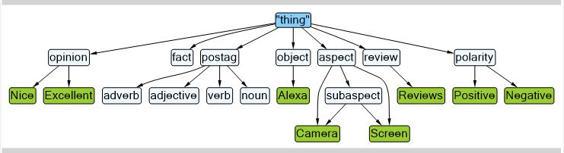

Fig No:- 4.4.1 Hierarchical tree structure of ontology

Protege software program is used to build the ontology version. Class, item and object assets areidentified as entity, character, and object property within the ontology version respectively.The members of the family among lessons, items and object properties were derived manually as consistent withthe human expertise of a sentence.

The Protege software is used to retrieve statistics from the ontology version. The formerly constructed ontology version on consumer’s evaluations is used for querying andidentifying the hassle vicinity. The opinions with thenegative sentiments are used to do sentiment analysis and to discover the hassle locationrelated to the customer problems.

# **Implementation**

## **Introduction**

It is the actual phase of building the project where we implement the code and execute the code for the required outcome of the product.Every software is composed of many modules and the software is said to be successfully implemented when each and every module is build and executed separately.

Themodules involved in the implementation phase are

1.Collection of Reviews

2.Preprocessing using NLTK

3.Finding Linguistic Patterns

4.Product Aspect Extraction

5.Building Ontology

6.Querying the model

## **Object Recognition**

### **Object**

Object in this project refers to an entity that the people commented on. In this project our object is Alexa product which is launched by Amazon. Object represents either the person or thing. It has properties refererred as Aspects.

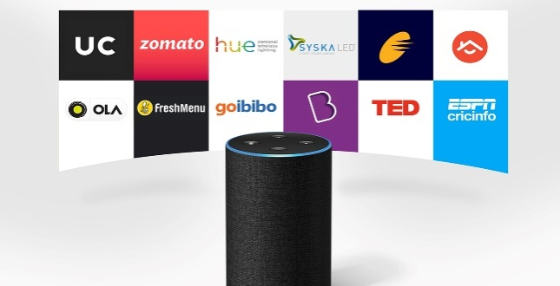

Fig No 5.2.1.1:- Amazon-Alexa

### 

### **Dataset**

First step of the project starts with the collection of best suitable dataset for the project. Data set is collection of the data. Dataset may be in the form of table or file (.csv, .txt,).The Data set that is used for this project is dataset-amazon-alexa-reviews collected from Kaggle website. Kaggle is the best site where we find the datasets used for the project implementation.

Dataset Name :- Dataset-amazon-alexa-reviews

Dataset Size :- 3150 reviews

Staring and ending date of commented reviews :- 16-05-2018 to 31-07-2018

Dataset Source:- Kaggle website

Reviews Source:- Extracted from Amazon website

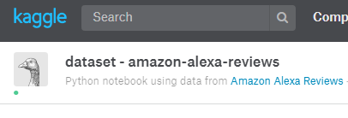

Fig No:- 5.2.1.1 Data set name and source

## **Implementation of modules**

### **Collection of reviews**

Collection of reviews starts with the selection of best suitable dataset from the best source. We selected the dataset Amazon -Alexa reviews from the Kaggle website. The dataset consists of 400 reviews that are given by the consumers of Amazon-Alexa product. The data set is in the form of .csv file which is opened in the Microsoft Excel which is used to view, manipulate the .csv file. The images that are needed for the project are collected from the Amazon website to know the properties of Alexa.

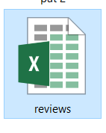

Fig No:- 5.3.1.1 .csv file of reviews

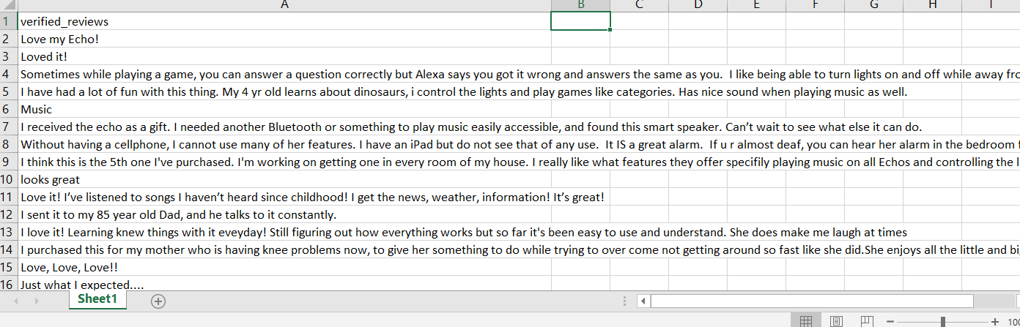

Fig No:- 5.3.1.2 collection of reviews

Next read the collect file using open method available in python which takes path name and encoding as arguments and store it in the variable

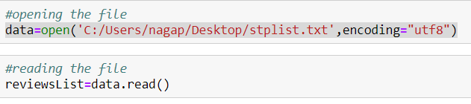

Fig No:5.3.1.1 opening and reading file of reviews

### **Pre-processing using NLTK**

#### **Tokenization**

After the collection of datasetthe data should be pre-processed using nltk. The software used is jupyter notebook where the project is built with the help of python language. Python language has many inbuilt packages among them nltk is the best suitable package that is used to work on data science projects.

First import the nltk using command

import nltk

Next tokenize the given sentences using either **word_tokenize()** or **sent_tokenize()** method available in the nltk package

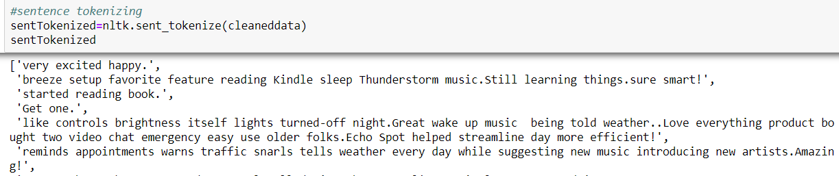

Fig No:-5.3.2.1 sentence tokenization of reviews

sent_tokenize() method takes one argument of the variable in which the data is stored. It divides the reviews into sentences and each sentences is separated by comma.

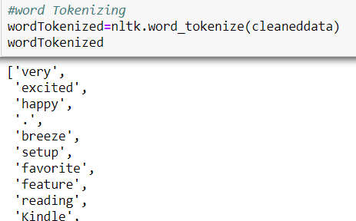

Fig No:-5.3.2.2 word tokenization using nltk

**5.3.3 POS tagging**

After tokenizing the sentences we should word tokenize the tokenized sentences and tag the obtained words with parts of speech. The method **pos_tag()** is used for parts of speech tagging of the words.This method takes one argument of the variable which stores the tokenized words.

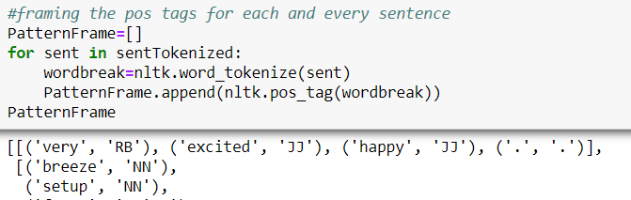

Fig No:- POS Tagging of the tokenized words

**5.3.4 Finding Linguistic Patterns**

After tagging the words with parts of speech for each and every sentence we have to find the linguistic patterns from them. Linguistic Patterns are the patterns that are repeated in th sentences with same sequence odpos tag.

**Counter()** method is used to count the repeated patterns in the given sentences which is available in the **Collections** package of python languages. It takes one argument of variable which has the pos tagged sentences.

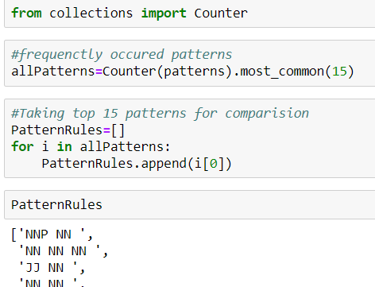

Fig No:- 5.3.4.1 Finding Linguistic Patterns from pos tagged sentences

In order to view the sentences that are matched with the given patterns we have to use the **zip()** method to map the given pattern with the sentences.



Fig No:- 5.3.4.2 mapping the patterns with the sentences

**5.3.5 Product Aspect Extraction**

Product aspects are the properties of the object Alexa. In order to extract the aspects from the sentences that are matched with the patterns extract the nouns and noun phrases from the matched sentences.Therefore compare the patterns with the noun and noun phrases and extract matched word from them.

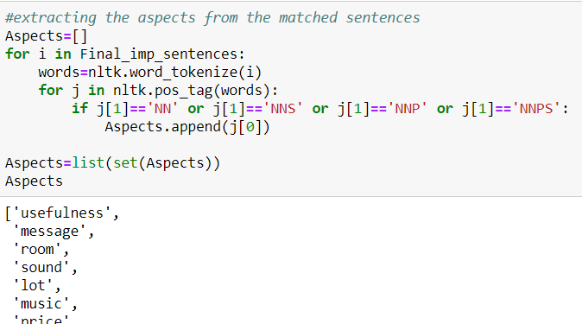

Fig No:- 5.3.5.1 Extracting aspects from matched sentences

After extracting the aspects compare the obtained aspects with the actual properties of Alexa In order to know the aspects of alexa that are extracted by this method. By knowing the count of aspects we can decide whether to build the ontology or not.

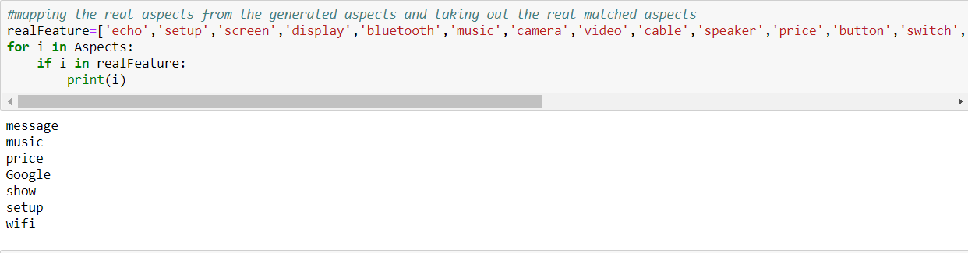

Take the aspects of Alexa in the list and compare the obtained aspects with the list then the actual aspects are obtained.

**5.3.6 Building Ontology**

For building ontology protege software must be installed and there are different divisions in the software where each expresses the set of aspects and reviews, in this software there are classes,individuals,properties where in classes we give aspects and subaspects as inputand we give the relationship between the classes in the properties and we add the instances for each and every class in the individuals.

The first step is to identify the classes and classes identified are fact,aspect,object,opinion,polarity,pos tag. In the classes that is given as inputaspect has subaspect and pos tag has its subclasses as noun,adjective,adverb which can be provided as an input.

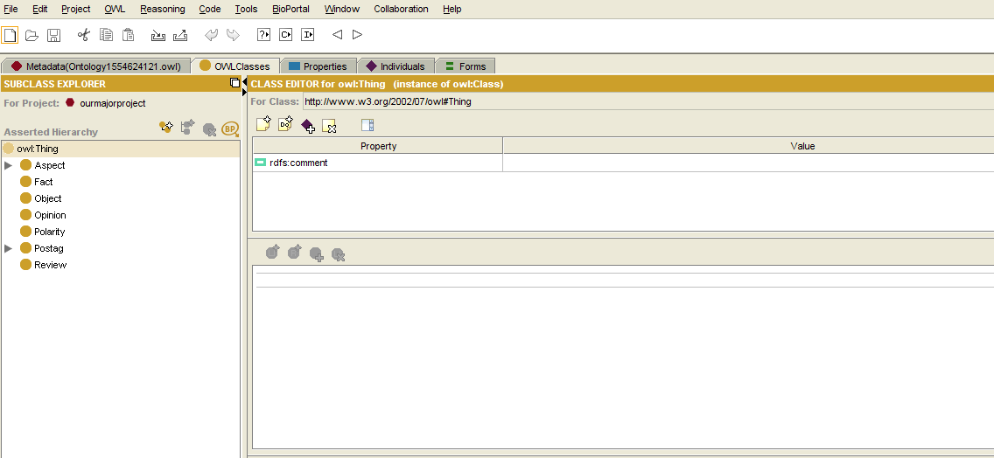

Fig No :- 5.3.6.1 Classes identified from the model

The second step is to identify the properties and the properties identified are expressAspect,hasPolarity,isKindof,isPartof,isPartAspect,isexpressionOn, signifies,polarity.

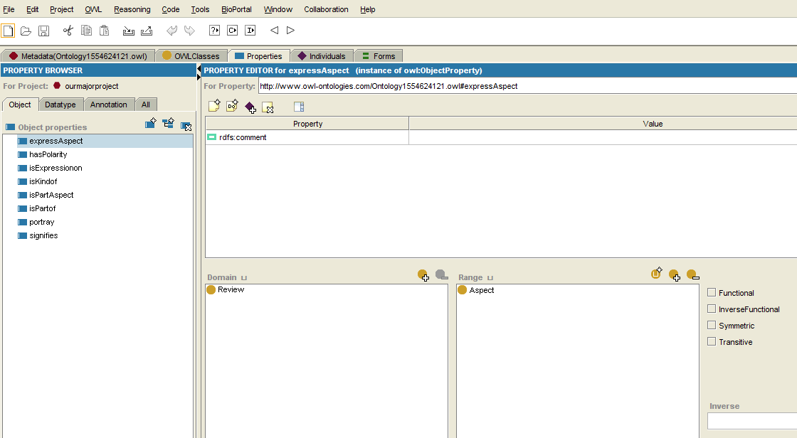

Fig No:-5.3.6.2 Properties identified from the model

The third step is to identify the individuals and the individuals are the instances of classes. For the class Object the instances identified is Alexa,For the class Opinion the instances identified are excellent,nice,for the class Polarity the instances identified are positive,negative,for the class aspect the instances identified are camera,screen, the instances for review can be taken as any two reviews that consists of the camera and screen as aspect.

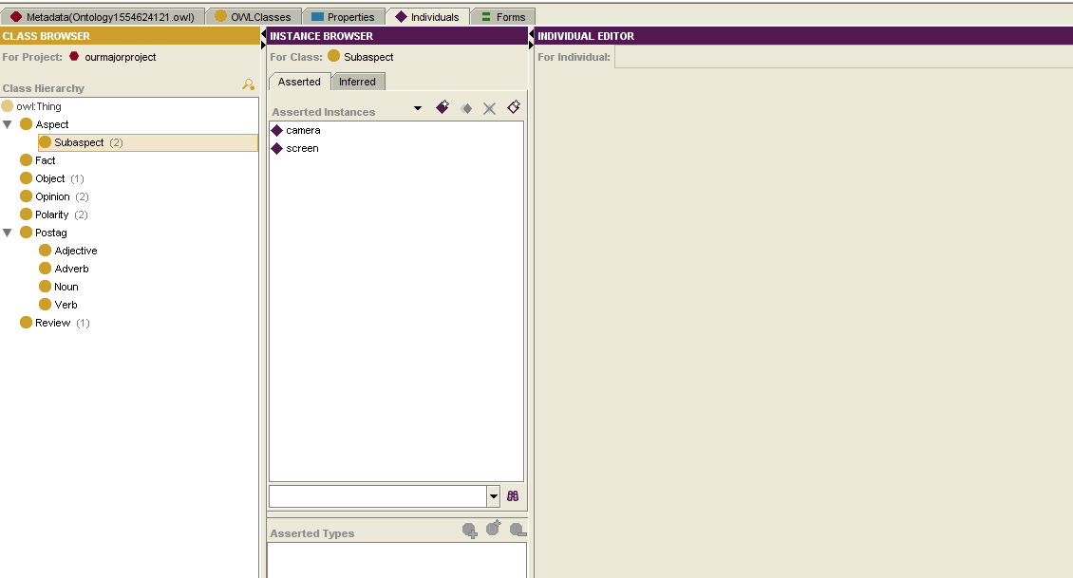

Fig No:-5.3.6.3 Instance creation for the Aspect Class

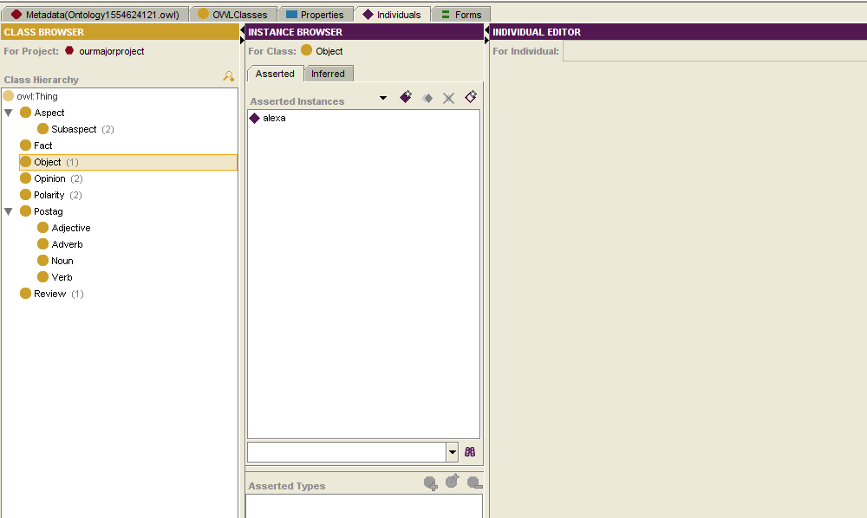

Fig No:- 5.6.3.4 Instance creation for the Object class

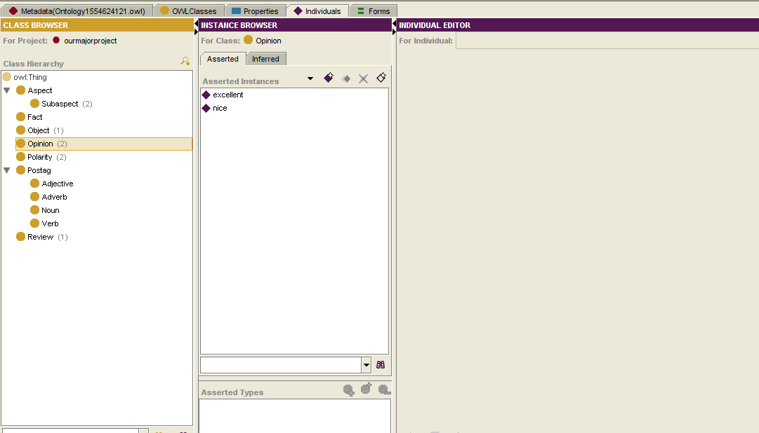

Fig No:- 5.6.3.5 Instance creation for the Opinion class

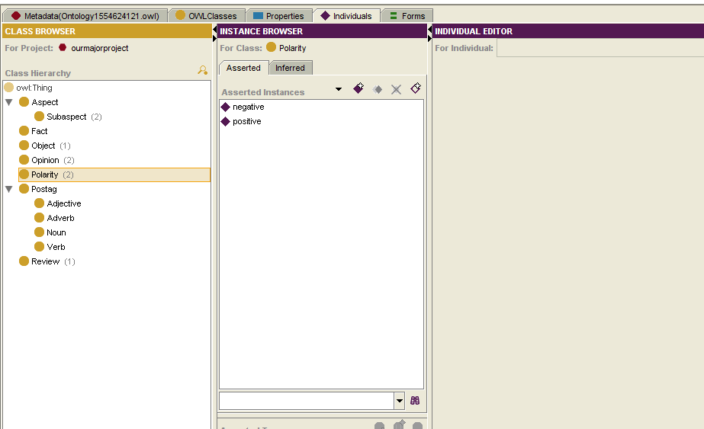

Fig No:5.3.6.6 Instance creation for the Polarity class

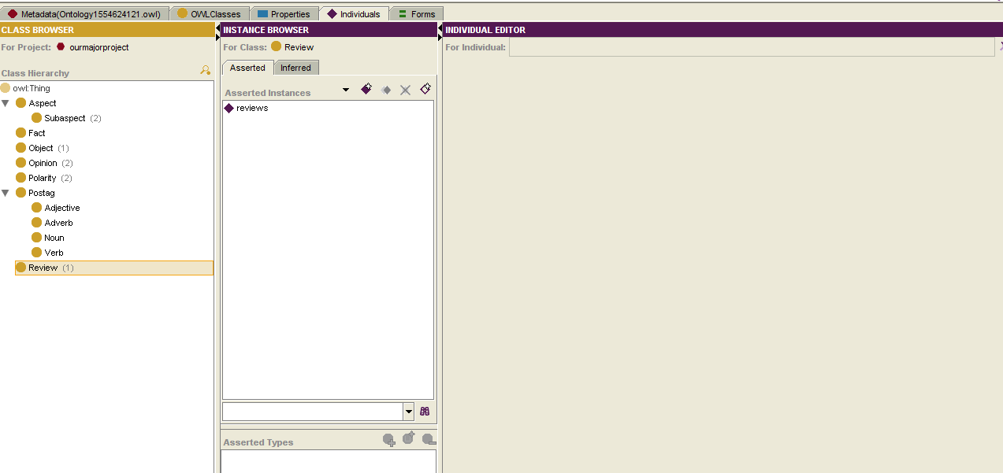

Fig No:5.3.6.7 Instance creation for the Review class

In the fourth step, is to form the domain set of classes and range set of classes and form the relationship between the classes through instances as expressAspect from review to the aspect, hasPolarity from opinion to polarity, isKindof from Aspect to noun, isKindof from opinion to adjective, isKindof from opinion to adverb, isKindof from opinion to verb, isPartof from aspect to review, isPartAspectof from subaspect to review, isPartof from opinion to review, isexpressionon from opinion to aspect, signifies from opinion to polarity, isExpressionon from opinion to subaspect, hasPolarity from aspect to object, haspolarity from aspect to polarity.



Fig No:-5.3.6.8 expressing the expressAspect relation between Review and Aspect

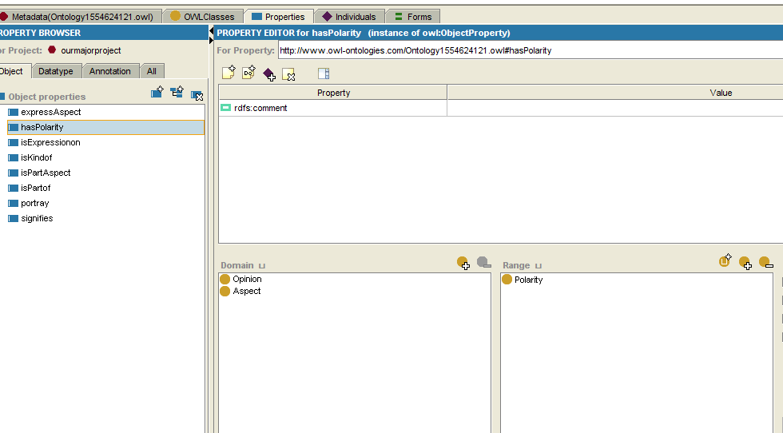

Fig No:- 5.3.6.9 Expressing the relation between opinion and polarity, aspect and polarity

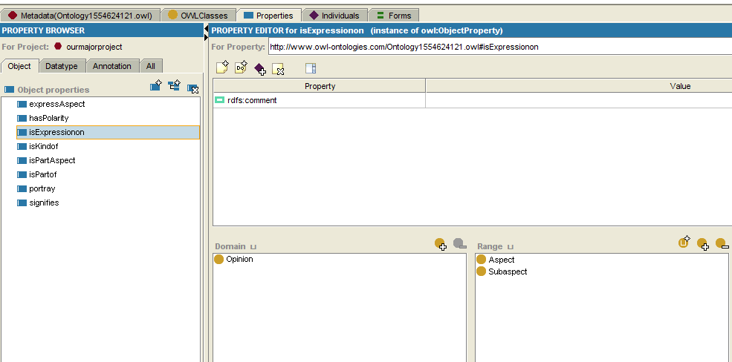

Fig No:-5.6.3.10 Expressing the relation between the opinion and aspect, opinion and subaspect

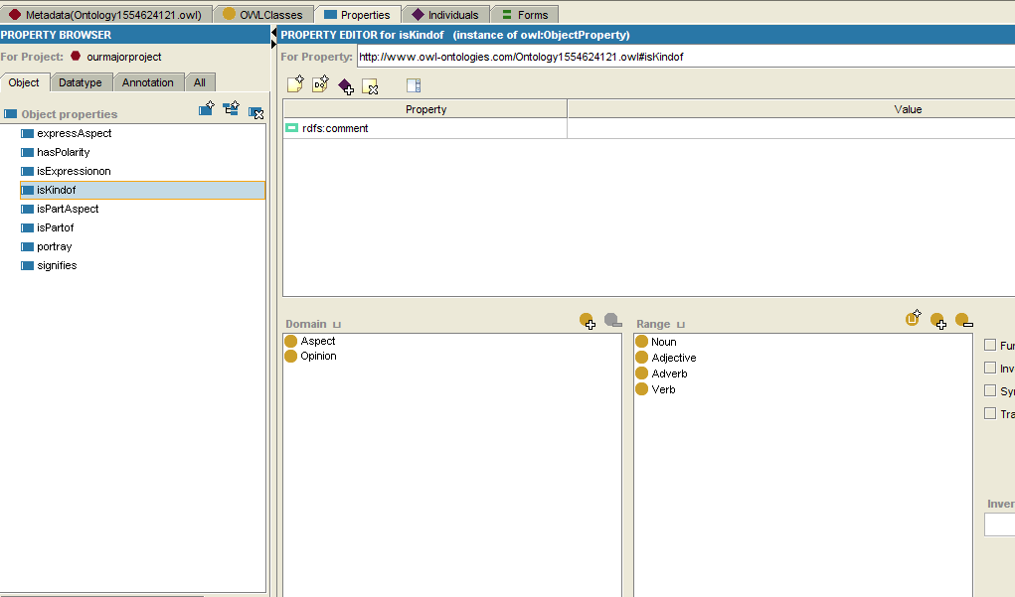

Fig No:-5.6.3.11Expressing the relation between Aspect,opinion and Noun,Adjective,Adverb

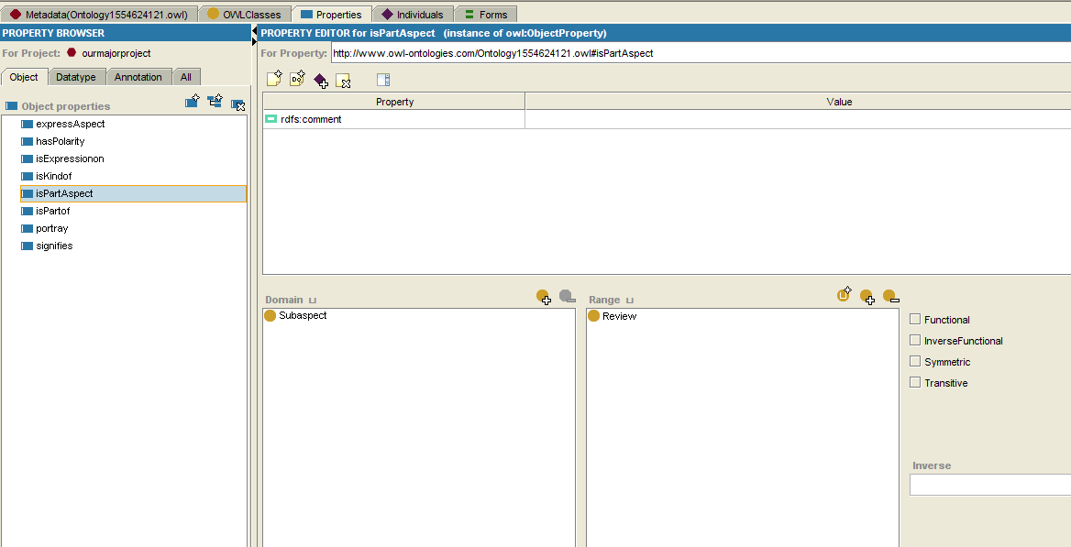

Fig No:- 5.6.3.12 Expressing the relationship between Subaspect and Review

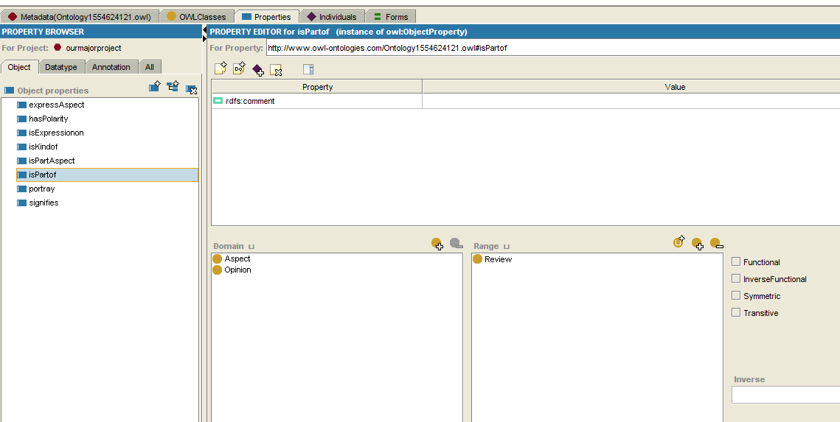

Fig No:-5.6.3.13 Expressing the relationship between Aspect,Opinion and Review

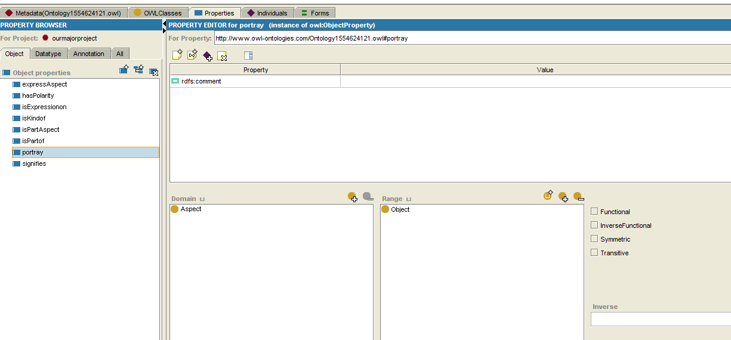

Fig No:-5.6.3.14Expressing the relation between the aspect and object

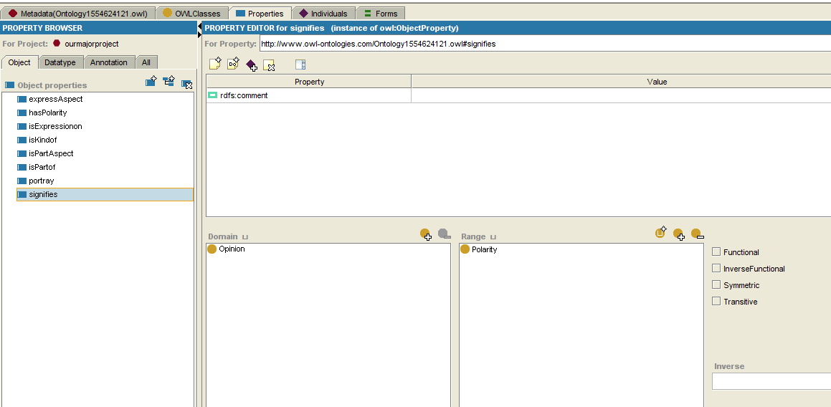

Fig No:- 5.6.3.15 Expressing the relation between the Opinion And Polarity

**5.3.7 Querying the model**

Fluent editor is an Ontology Editor, used for editing and manipulating Ontologies that uses Controlled Natural Language). Controlled natural language means the natural language with restricted grammar and vocabulary. we can also query the model by using fluent editor.

The first step is to import the owl file which is the ontology file that takes inputs in classes,individuals,properties when the software is opened we browse the file and import it into fluent editor. Then we get list of sentences that are understandable and readable by humans and in a known language, there is querying done on the imported ontology file which is to query or ask aspects and features related to the product and can extract hidden aspects of the product.

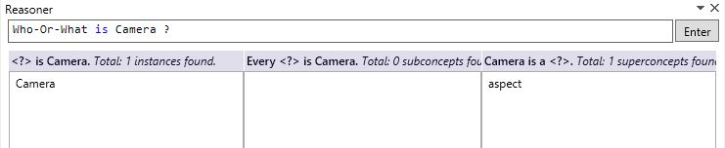

Fig 5.3.7.1 Query to find class of instance camera

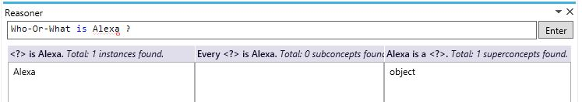

Fig No:- 5.3.7.2 Query to find class of the Alexa

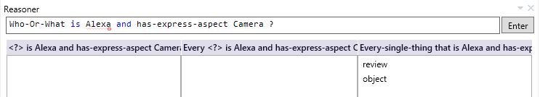

Fig No:-5.3.7.3 Query to find to what alexa is and what aspect it has

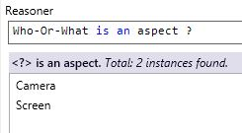

Fig No:- 5.3.7.4 Query to find what aspects we have

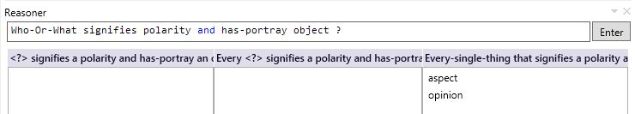

Fig No:- 5.3.7.5 Query to find the objects polarity

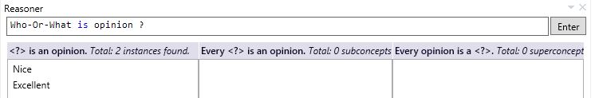

Fig No:- 5.3.7.6 Query to find the opinions

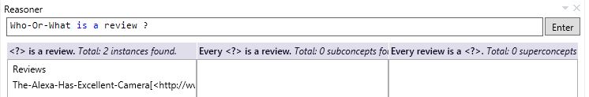

Fig No:- 5.3.7.7 Query to find the reviews



Fig No:-5.3.7.8 Query to find opinion of Alexa

The opinion- lexicon tool is used to find the opinion on aspect. After downloading the opinion-lexicon tool it has two inbuilt files in which one file consists of list of positive opinion words and another file consists of list of negative opinion words. Now after implementing the java code it compares the given word with the two lists and provides whether the given word has positive opinion or negative opinion.

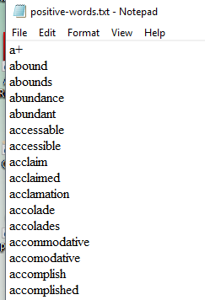

Fig No:-5.3.7.9 List of positive words

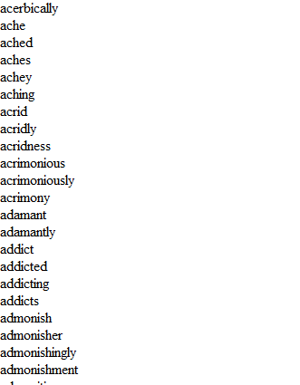

Fig No:-5.3.7.10 List of negative words

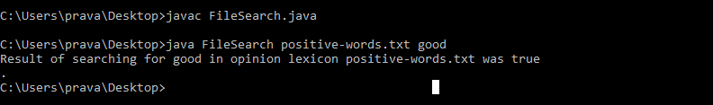

Fig No:-5.3.7.11 Checking the presence of good in positive list

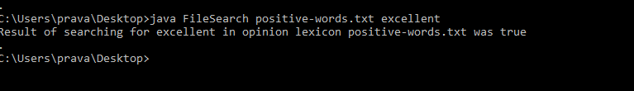

Fig No:- 5.3.7.12 Checking the presence of excellent in positive words list

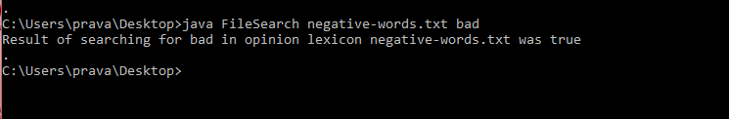

Fig No:-5.3.7.13 Checking the presence of bad in negative words list

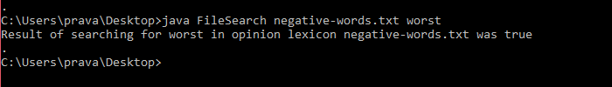

Fig No:-5.3.7.14 Checking the presence of worst opinion in negative words list

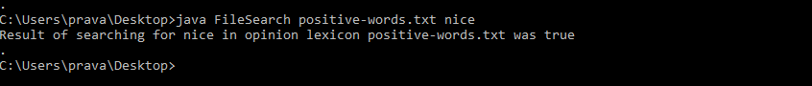

Fig No:-5.3.7.15 Checking the presence of nice in positive words list

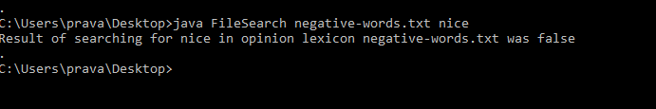

Fig No:- 5.3.7.16 Checking the presence of nice in negative words list

# **Conclusion**

So as the steps involved in getting the final output are through ontology, the main use of building through ontology is to extract hidden aspects and provide accurate review to the customer in addition to know what all aspects are possible for a product. In opinion mining there will be opinion words extracted for respective aspects but few aspects which are unknown cannot be identified and there can be inaccurate results so as ontology is built for getting more aspect and opinion pairs on undergoing many steps that are discussed above. In conclusion, it helps customers take good decisions about a product with good understanding.

**8.Scope And Future Enhancement**

Extending sentiment mining to other domain names may additionally lead to interesting new results. Future opinion-mining structures need broader and deeper common and common-sense information bases. This will lead to a better expertise of natural language evaluations and could extra efficiently bridge the space between multimodal facts and machine processable statistics. Blending scientific theories of emotion with the practical engineering goals of analyzing sentiments in natural language text will lead to more bio-inspired procedures to the layout of intelligent opinion-mining systems.

**9.References**

<http://www.inass.org/>

[www.elsevier.com/locate/eswa](http://www.elsevier.com/locate/eswa)

[https://www.researchgate.net/publication/262113904_Feature based_opinion_mining_through_ontologies](https://www.researchgate.net/publication/262113904_Feature%20based_opinion_mining_through_ontologies)