Linear Regression :

With learning rate=0.0005,epoch=100
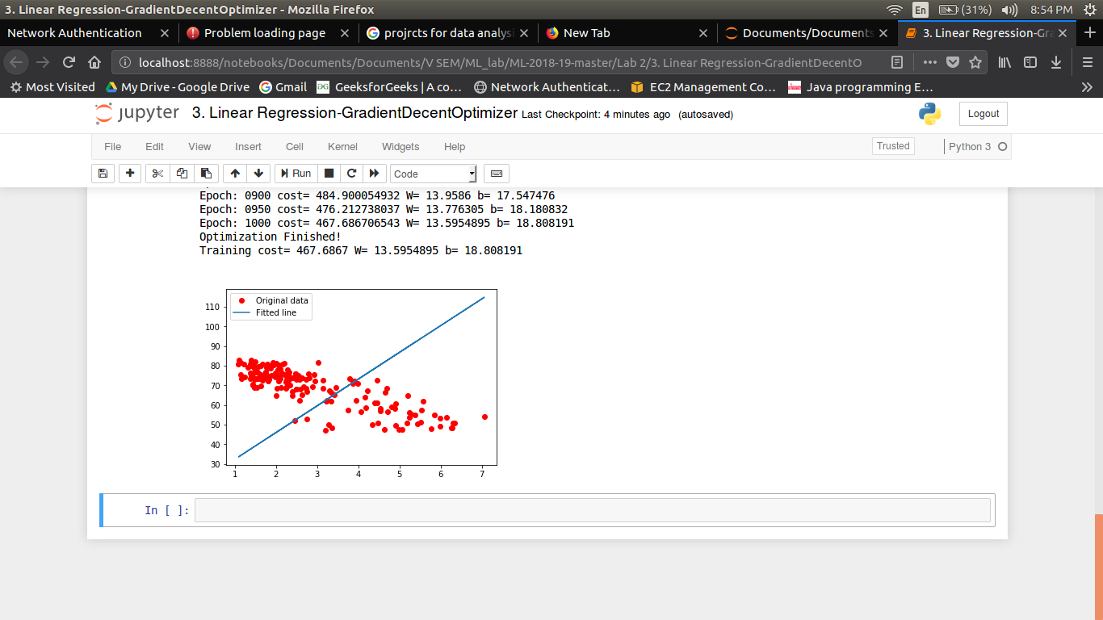

With learning rate=0.0005,epoch=1000
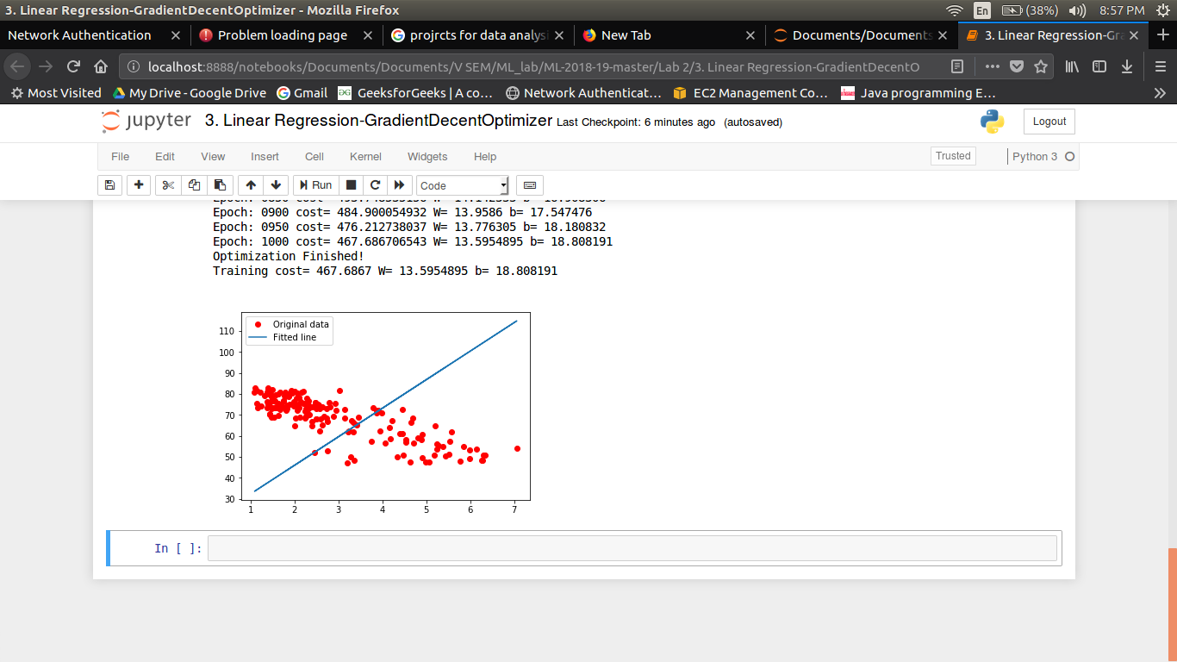

With learning rate=0.0005,epoch=1000
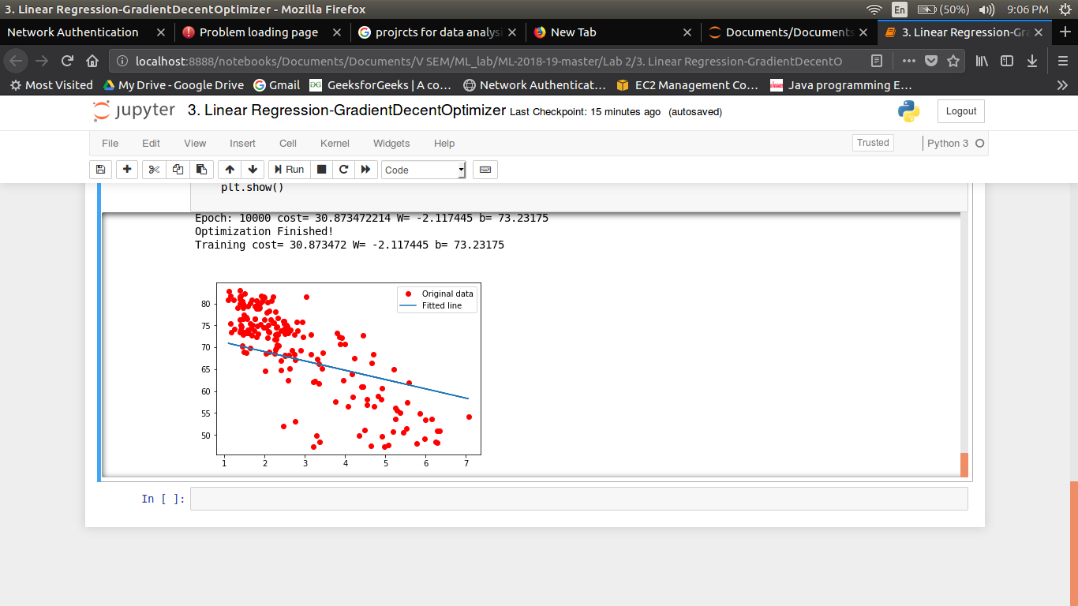

With learning rate=0.01,epochs =10000
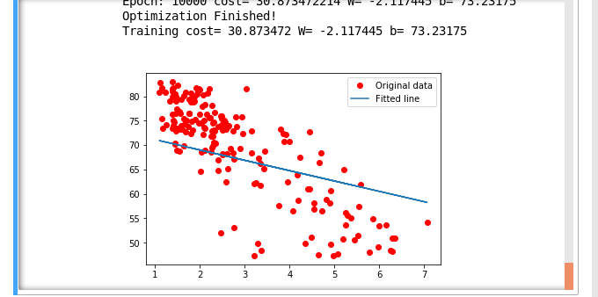

PART 2:

Time complexity:
For a given data set, time consumed by Batch gradient decent is 3m 35s
with learning rate of 0.001 and no.of epochs=10000

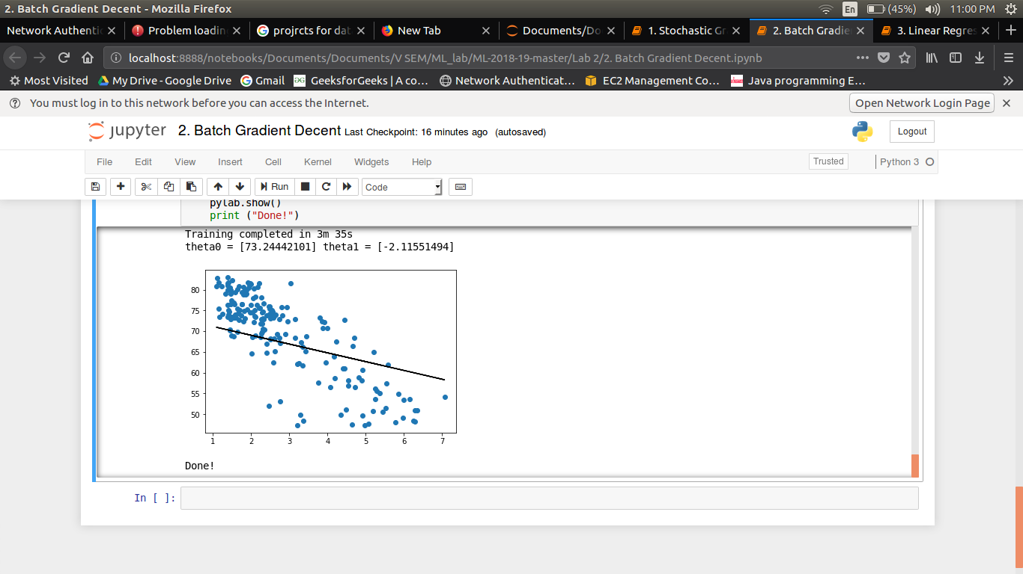

Conclusion:

1. The convergence time decreses with decrease in the value of learning rate.

2. A better fit for the data is achieved with the increased number of epochs.

PART 3:

1.Optimisation :
Optimisation can be increased by increasing the number of epochs and also by decreasing the value of learning rate.

2.Cost function:
Cross entropy cost is another cost function used in machine learning.
CCE(W,B,Sr,Er)=−∑j[Erj ln aLj+(1−Erj) ln (1−aLj)]

