Gender Equality & Workforce Diversity
Analytics Dashboard

SDG Goal 5: Gender Equality

Submitted By: | Shanthini, AI Data Analytics Intern.
Assessment: | First Assessment
Date: | April 2026

1. Project Overview
Project Details
Project Title | Gender Equality & Workforce Diversity Analytics Dashboard
SDG Alignment | SDG Goal 5: Gender Equality
Organization | Vetri IT Systems Private Limited
Assessment Type | AI Data Analytics — First Assessment
ML Model | Random Forest Classifier (Promotion Prediction)
Status | Developed — Model Optimization in Progress

1.1 Background
SDG Goal 5 focuses on achieving gender equality and empowering all women and girls. Many organizations still face challenges such as gender pay gaps, unequal employment opportunities, and low female participation in leadership roles. This project builds a Gender Equality Dashboard to analyze workforce diversity, pay equity, and predict gender-based disparities using Machine Learning.

1.2 Problem Statement
Gender-related HR data is scattered across departments and systems, is not analyzed effectively for inequality insights, and lacks predictive understanding of disparities. This leads to gender pay gaps remaining unnoticed, low diversity in leadership roles, and ineffective policy decisions. A centralized dashboard with ML insights is required to address these issues.
2. Objectives & Scope

2.1 Objectives
- Identify gender gaps in employment and salary distribution
- Promote diversity and inclusion insights across departments
- Support data-driven HR decisions using KPI metrics
- Predict gender disparity risks using machine learning
- Segment workforce using clustering to reveal diversity patterns

2.2 Scope

In Scope
- Data cleaning and preprocessing of HR datasets
- KPI calculation (Gender Pay Gap, Diversity Index, etc.)
- Interactive dashboard creation (Power BI / Tableau)
- ML model implementation for promotion prediction
- Workforce clustering using K-Means
- Actionable insights generation

Out of Scope
- Real-time HR system integration
- Policy enforcement or HR system modification

2.3 Target Audience / Stakeholders
Stakeholder | Role | Interest
HR Departments | Primary Users | Diversity & equity insights
Corporate Management | Decision Makers | Workforce strategy
Government Bodies | Regulators | Compliance & SDG reporting
D&I Teams | Analysts | Inclusion gap identification

3. Data Description & Preparation

3.1 Dataset Features
Feature | Type | Description
Employee_ID | Categorical | Unique employee identifier
Gender | Categorical | Male / Female / Non-Binary
Age | Numeric | Employee age (18–70)
Department | Categorical | Department name
Job_Level | Categorical | Entry to C-Suite
Education | Categorical | Education level
Experience_Years | Numeric | Years of professional experience
Years_at_Company | Numeric | Tenure at current company
Annual_Salary | Numeric | Annual salary (USD)
Bonus | Numeric | Annual bonus (USD)
Performance_Rating | Categorical | HR performance rating
Training_Hours | Numeric | Training hours completed
Parental_Leave_Taken | Binary | Whether parental leave was taken
Leadership_Role | Binary | Whether in a leadership role
Promoted_Last_Year | Binary | Target — promotion in last year
Turnover | Binary | Whether employee left the organization

3.2 Data Cleaning Steps
- Standardized Gender column (mapped male/MALE/M → Male, etc.)
- Removed out-of-range Age values (< 18 or > 70), filled with median
- Removed negative Experience_Years, imputed with median
- Imputed Annual_Salary and Bonus using department + job level median
- Filled Training_Hours with global median
- Dropped rows with missing Gender after standardization

3.3 Feature Engineering
- Total_Compensation = Annual_Salary + Bonus
- Pay_Per_Experience = Annual_Salary / (Experience_Years + 1)
- Pay_Gap_Index = (dept-gender median - dept median) / dept median × 100
- Diversity_Score = Female (0.4) + Promoted (0.3) + Training ratio (0.3)

4. Key Performance Indicators (KPIs)
The following KPIs were computed from the cleaned dataset to quantify gender equality across the workforce:

KPI | Formula / Description | Significance
Gender Pay Gap (%) | (Male Median - Female Median) / Male Median × 100 | Core equity metric
Female Workforce Participation (%) | Female Count / Total Employees × 100 | Representation metric
Female Leadership % | Female Leaders / Total Leaders × 100 | Leadership diversity
Male Promotion Rate (%) | Promoted Males / Total Males × 100 | Promotion equity
Female Promotion Rate (%) | Promoted Females / Total Females × 100 | Promotion equity
Diversity Index (Simpson) | 1 - Σn(n-1) / N(N-1) × 100 | Overall diversity score
Hiring Ratio M:F | Male % : Female % of total workforce | Hiring balance
Turnover by Gender (%) | Turnover count / gender count × 100 | Retention equity
Avg Training Hours by Gender | Mean training hours per gender group | Development access

5. Exploratory Data Analysis

5.1 Visualizations Produced
- Salary Distribution by Gender — histogram with density overlay
- Total Employees by Gender — bar chart with count labels
- Gender Pay Gap by Department (%) — horizontal bar with average line
- Gender % per Job Level — grouped bar showing leadership pipeline
- Promotion Rate by Department & Gender — comparative bar chart
- Average Training Hours by Gender — bar chart

5.2 Key EDA Insights
- A measurable gender pay gap exists across most departments
- Female representation drops significantly at senior and leadership levels
- Promotion rates show disparity between male and female employees
- Training hour allocation is relatively balanced but varies by department
- Non-Binary employees are underrepresented in leadership roles

6. Machine Learning Model — Promotion Prediction

6.1 Current Model Configuration
Random Forest Classifier — Current Setup
Algorithm | RandomForestClassifier (sklearn)
Estimators | 100 trees, max_depth=10, random_state=42
Train / Test Split | 80% train / 20% test (stratified)
Preprocessing | LabelEncoder + StandardScaler
Test Accuracy | ~0.79
CV Accuracy (5-fold) | ~0.79 ± low std

6.2 Current Performance Problem
Despite good overall accuracy (~79%), the model completely fails to predict the Promoted class:

Class | Precision | Recall | F1-Score | Issue
Not Promoted | ~0.79 | 1.00 | ~0.88 | Dominant — over-predicted
Promoted | 0.00 | 0.00 | 0.00 | Critical failure — never predicted

Root cause: Severe class imbalance. The dataset has far more 'Not Promoted' employees than 'Promoted' ones, causing the model to simply predict the majority class for every observation.

6.3 Recommended Solutions — Class Imbalance

Strategy 1: SMOTE (Synthetic Minority Oversampling Technique)
SMOTE generates synthetic samples for the minority class by interpolating between existing minority samples. Best applied after train/test split to avoid data leakage.
- Install: pip install imbalanced-learn
- Apply SMOTE only on training data
- Combine with RandomForest or XGBoost
- Expected improvement: Promoted recall from 0.00 to 0.50–0.70

Strategy 2: Class Weighting
Pass class_weight='balanced' to the classifier. Internally adjusts sample weights so minority class errors are penalized more — no resampling required.
- Easiest to implement — single parameter change
- Works well when imbalance is moderate (5:1 to 10:1 ratio)
- model = RandomForestClassifier(..., class_weight='balanced')

Strategy 3: Advanced Ensemble Methods
XGBoost and LightGBM offer native scale_pos_weight parameter for imbalanced classes, generally outperforming sklearn RandomForest on structured HR data.
- XGBoost: scale_pos_weight = count(Not Promoted) / count(Promoted)
- LightGBM: is_unbalance=True or class_weight='balanced'
- Both support GPU acceleration for faster tuning

Strategy 4: Threshold Tuning
By default, classifiers use 0.5 as the decision threshold for class assignment. Lowering this threshold (e.g., to 0.3) makes the model more aggressive in predicting the minority class.
- Use model.predict_proba(X_test)[:,1] to get raw probabilities
- Sweep thresholds from 0.1 to 0.9 and plot Precision-Recall curve
- Select threshold that maximizes F1-score for Promoted class
- Tool: from sklearn.metrics import precision_recall_curve

6.4 Recommended Model Architecture (Improved)
The following pipeline is recommended to replace the current implementation:

Step | Component | Recommendation
1 | Data Split | Stratified train_test_split(stratify=y)
2 | Oversampling | SMOTE on training set only
3 | Algorithm | XGBoost with scale_pos_weight
4 | Tuning | GridSearchCV or Optuna for hyperparameters
5 | Threshold | Precision-Recall curve to find optimal cutoff
6 | Evaluation | F1 (minority), ROC-AUC, PR-AUC

6.5 Evaluation Metrics for Imbalanced Classification
Accuracy is a misleading metric when classes are imbalanced. Use the following instead:

Metric | Why It Matters | Target Value
F1-Score (Promoted) | Balances precision & recall for minority class | > 0.60
ROC-AUC | Discrimination ability across all thresholds | > 0.80
PR-AUC | Precision-Recall — more informative than ROC for imbalance | > 0.55
Recall (Promoted) | Ensures promoted employees are actually found | > 0.65
Precision (Promoted) | Ensures predictions are correct | > 0.55
Matthews Correlation Coefficient | Balanced metric for binary classification | > 0.40

7. Unsupervised Learning — K-Means Clustering

7.1 Configuration
K-Means Clustering Setup
Algorithm | K-Means (k=4, n_init=10, random_state=42)
Features Used | Annual_Salary, Experience_Years, Training_Hours, Promoted_Last_Year
Preprocessing | StandardScaler normalization

7.2 Cluster Profiles
Cluster | Name | Profile Description
0 | Mid-Tier, No Promo | Mid salary, experienced, not promoted — potential retention risk
1 | High-Earners, Stable | High compensation, senior employees, stable career stage
2 | Recently Promoted | Moderate salary, high training hours, promoted recently
3 | Early Career | Lower salary, minimal experience, high potential for growth

7.3 Clustering Insights
- Cluster analysis reveals distinct workforce segments with different diversity profiles
- Mid-tier cluster (Cluster 0) shows higher male concentration — potential promotion bias
- Early career cluster (Cluster 3) shows more balanced gender distribution
- High-earner cluster (Cluster 1) underrepresents female and Non-Binary employees

8. Dashboard Design

8.1 Dashboard Layout
Section | Visualization Type | KPIs / Charts
Top KPI Row | KPI Cards | Gender Pay Gap %, Female Participation %, Diversity Index
Workforce Analysis | Bar + Pie Chart | Salary by Gender, Gender distribution
Trend Section | Line Chart | Hiring & promotion trends over time
Comparison Section | Grouped Bar | Department-wise gender comparison
Filters | Slicers | Department, Gender, Experience Level

8.2 Tech Stack
Component | Tool / Library
Data Processing | Python — Pandas, NumPy
Visualization | Matplotlib, Seaborn (EDA); Power BI / Tableau (Dashboard)
Machine Learning | Scikit-learn, XGBoost (recommended), imbalanced-learn
Storage | CSV / Excel
Documentation | Jupyter Notebook + Word Report

9. Deliverables
Deliverable | Format | Status
cleaned_gender_data.csv | CSV | Completed
gender_metrics.csv | CSV | Completed
Dashboard (Power BI / Tableau) | .pbix / .twbx | Completed
Jupyter Notebook (EDA + ML + KPIs) | .ipynb | Completed
ML Model — Improved Version | .ipynb / .py | In Progress
Final Project Report | .docx | Completed

10. Risks & Assumptions

10.1 Risks
Risk | Impact | Mitigation
Severe class imbalance in promotion data | High | SMOTE + class weighting + threshold tuning
Missing HR data fields | Medium | Department+Level median imputation strategy
Sensitive data handling | Medium | Anonymize IDs; use aggregate-level analysis
Bias in dataset (historical patterns) | High | Fairness-aware modeling; audit feature importance
Model overfitting on majority class | High | Use PR-AUC / F1-minority as primary metric

10.2 Assumptions
- Dataset is representative of a real-world HR workforce distribution
- Promotion_Last_Year is the correct binary target for promotion prediction
- Gender, Department, and Job_Level are reliable and consistently recorded
- Synthetic data generation follows realistic HR distribution patterns

Coding part:
gender_equality_notebook.py

import pandas as pd
import numpy as np
import matplotlib.pyplot as plt
import matplotlib.ticker as mticker
import seaborn as sns
from sklearn.ensemble import RandomForestClassifier
from sklearn.cluster import KMeans
from sklearn.model_selection import train_test_split, cross_val_score
from sklearn.preprocessing import LabelEncoder, StandardScaler
from sklearn.metrics import classification_report, confusion_matrix, accuracy_score
import warnings
warnings.filterwarnings('ignore')

plt.rcParams.update({
'figure.facecolor': '#0d0f14',
'axes.facecolor': '#13161e',
'axes.edgecolor': '#252a38',
'axes.labelcolor': '#8892a4',
'xtick.color': '#8892a4',
'ytick.color': '#8892a4',
'text.color': '#f0f2f8',
'grid.color': '#252a38',
'grid.linewidth': 0.5,
'font.family': 'DejaVu Sans',
})
COLORS = {'Male': '#6b8cff', 'Female': '#e85d8a', 'Non-Binary': '#a78bfa'}

print("✅ Libraries imported successfully")

df_raw = pd.read_csv('raw_gender_equality_dataset.csv')
print(f"Shape: {df_raw.shape}")
print(f"\nColumns: {list(df_raw.columns)}")
print(f"\nDtype summary:\n{df_raw.dtypes}")
print(f"\nNull counts:\n{df_raw.isnull().sum()}")
print(f"\nFirst 5 rows:\n{df_raw.head()}")
df = df_raw.copy()

# 3.1 Standardise Gender column
gender_map = {'male':'Male','MALE':'Male','M':'Male','m':'Male',
'female':'Female','FEMALE':'Female','F':'Female','f':'Female',
'non-binary':'Non-Binary','NB':'Non-Binary'}
df['Gender'] = df['Gender'].replace(gender_map)
df['Gender'] = df['Gender'].where(df['Gender'].isin(['Male','Female','Non-Binary']), np.nan)

# 3.2 Age: remove out-of-range values, fill with median
df.loc[(df['Age'] < 18) | (df['Age'] > 70), 'Age'] = np.nan
df['Age'] = df['Age'].fillna(df['Age'].median()).astype(int)

# 3.3 Experience: remove negatives
df.loc[df['Experience_Years'] < 0, 'Experience_Years'] = np.nan
df['Experience_Years'] = df['Experience_Years'].fillna(df['Experience_Years'].median()).astype(int)

# 3.4 Salary/Bonus: impute with dept+level median
for col in ['Annual_Salary', 'Bonus']:
df[col] = df.groupby(['Department','Job_Level'])[col]\
.transform(lambda x: x.fillna(x.median()))
df[col] = df[col].fillna(df[col].median()).astype(int)

df['Training_Hours'] = df['Training_Hours'].fillna(df['Training_Hours'].median()).astype(int)

# 3.5 Drop rows still missing Gender
df.dropna(subset=['Gender'], inplace=True)
df.reset_index(drop=True, inplace=True)

print(f"✅ Cleaned shape: {df.shape} | Remaining nulls: {df.isnull().sum().sum()}")
df.to_csv('cleaned_gender_data.csv', index=False)
df['Total_Compensation'] = df['Annual_Salary'] + df['Bonus']
df['Pay_Per_Experience'] = (df['Annual_Salary'] / (df['Experience_Years'] + 1)).round(2)

dept_gender_med = df.groupby(['Department','Gender'])['Annual_Salary'].transform('median')
dept_med = df.groupby('Department')['Annual_Salary'].transform('median')
df['Pay_Gap_Index'] = ((dept_gender_med - dept_med) / dept_med * 100).round(2)

df['Diversity_Score'] = (
(df['Gender'] == 'Female').astype(int) * 0.4 +
df['Promoted_Last_Year'] * 0.30 +
(df['Training_Hours'] / 120) * 0.30
).round(4)

print("✅ Feature engineering complete. New features:", ['Total_Compensation','Pay_Per_Experience','Pay_Gap_Index','Diversity_Score'])
male = df[df['Gender'] == 'Male']
female = df[df['Gender'] == 'Female']
nb = df[df['Gender'] == 'Non-Binary']

kpis = {
'Gender Pay Gap (%)': round((male['Annual_Salary'].median() - female['Annual_Salary'].median()) / male['Annual_Salary'].median() * 100, 2),
'Male Median Salary': int(male['Annual_Salary'].median()),
'Female Median Salary': int(female['Annual_Salary'].median()),
'Female Workforce Participation (%)': round(len(female)/len(df)*100, 2),
'Female Leadership %': round((df[df['Leadership_Role']==1]['Gender']=='Female').sum() / df['Leadership_Role'].sum() * 100, 2),
'Male Promotion Rate (%)': round(male['Promoted_Last_Year'].mean()*100, 2),
'Female Promotion Rate (%)': round(female['Promoted_Last_Year'].mean()*100, 2),
'Diversity Index (Simpson ×100)': round((1 - sum(n*(n-1) for n in df['Gender'].value_counts())) / (len(df)*(len(df)-1)) * 100, 2),
'Hiring Ratio M:F': f"{round(len(male)/len(df)*100,1)} : {round(len(female)/len(df)*100,1)}",
'Male Turnover (%)': round(male['Turnover'].mean()*100, 2),
'Female Turnover (%)': round(female['Turnover'].mean()*100, 2),
'Avg Training Hours — Male': round(male['Training_Hours'].mean(), 1),
'Avg Training Hours — Female': round(female['Training_Hours'].mean(), 1),
}

print("=" * 50)
print(" KEY PERFORMANCE INDICATORS (KPIs)")
print("=" * 50)
for k, v in kpis.items():
print(f" {k:<42} {v}")

metrics_df = pd.DataFrame([kpis])
metrics_df.to_csv('gender_metrics.csv', index=False)
print("\n✅ KPIs saved to gender_metrics.csv")
fig, axes = plt.subplots(2, 3, figsize=(20, 12))
fig.suptitle('Exploratory Data Analysis — Gender Equality Dashboard', fontsize=16, fontweight='bold', color='#f0f2f8', y=1.02)

# Plot 1: Salary distribution
ax = axes[0,0]
for g, c in COLORS.items():
subset = df[df['Gender'] == g]['Annual_Salary']
ax.hist(subset, bins=50, alpha=0.6, label=g, color=c, density=True)
ax.set_title('Salary Distribution by Gender'); ax.set_xlabel('Annual Salary ($)'); ax.legend()

# Plot 2: Gender composition
ax = axes[0,1]
vc = df['Gender'].value_counts()
bars = ax.bar(vc.index, vc.values, color=[COLORS[g] for g in vc.index], width=0.5, edgecolor='none')
for bar, val in zip(bars, vc.values):
ax.text(bar.get_x()+bar.get_width()/2, bar.get_height()+300, f'{val:,}', ha='center', fontsize=10, color='white')
ax.set_title('Total Employees by Gender'); ax.set_ylabel('Count')

# Plot 3: Pay gap by dept
ax = axes[0,2]
pay_gap = df.groupby('Department').apply(lambda x: (x[x.Gender=='Male']['Annual_Salary'].median() - x[x.Gender=='Female']['Annual_Salary'].median()) / x[x.Gender=='Male']['Annual_Salary'].median() * 100).sort_values(ascending=True)
bars = ax.barh(pay_gap.index, pay_gap.values, color='#e85d8a', edgecolor='none')
ax.set_title('Gender Pay Gap by Department (%)'); ax.set_xlabel('Pay Gap (%)')
ax.axvline(pay_gap.mean(), color='#f5c842', linestyle='--', linewidth=1, label=f'Avg: {pay_gap.mean():.1f}%')
ax.legend()

# Plot 4: Leadership pipeline
ax = axes[1,0]
levels = ['Entry','Junior','Mid','Senior','Lead','Manager','Director','VP','C-Suite']
f_pct = [df[(df['Job_Level']==l) & (df['Gender']=='Female')].shape[0] / df[df['Job_Level']==l].shape[0] * 100 for l in levels]
m_pct = [df[(df['Job_Level']==l) & (df['Gender']=='Male')].shape[0] / df[df['Job_Level']==l].shape[0] * 100 for l in levels]
x = np.arange(len(levels)); width = 0.35
ax.bar(x-width/2, f_pct, width, label='Female', color=COLORS['Female'], edgecolor='none')
ax.bar(x+width/2, m_pct, width, label='Male', color=COLORS['Male'], edgecolor='none')
ax.set_xticks(x); ax.set_xticklabels(levels, rotation=45, ha='right')
ax.axhline(50, color='white', linestyle='--', linewidth=0.8, alpha=0.5, label='50% Parity')
ax.set_title('Gender % per Job Level'); ax.set_ylabel('%'); ax.legend()

# Plot 5: Promotion rate
ax = axes[1,1]
promo = df.groupby(['Department','Gender'])['Promoted_Last_Year'].mean().mul(100).unstack()
promo.plot(kind='bar', ax=ax, color=[COLORS[g] for g in promo.columns], edgecolor='none', width=0.6)
ax.set_title('Promotion Rate by Dept & Gender'); ax.set_ylabel('%')
ax.tick_params(axis='x', rotation=45); ax.legend()

# Plot 6: Training hours
ax = axes[1,2]
training = df.groupby('Gender')['Training_Hours'].mean()
bars = ax.bar(training.index, training.values, color=[COLORS[g] for g in training.index], width=0.4, edgecolor='none')
for bar, val in zip(bars, training.values):
ax.text(bar.get_x()+bar.get_width()/2, bar.get_height()+0.3, f'{val:.1f}h', ha='center', fontsize=11, color='white')
ax.set_title('Avg Training Hours by Gender'); ax.set_ylabel('Hours')

plt.tight_layout()
plt.savefig('eda_plots.png', dpi=150, bbox_inches='tight', facecolor='#0d0f14')
print("✅ EDA plots saved")
print("\n" + "="*60)
print(" ML MODEL: PREDICT PROMOTION LIKELIHOOD")
print("="*60)

feature_cols = ['Gender','Age','Department','Job_Level','Education',
'Experience_Years','Years_at_Company','Annual_Salary',
'Bonus','Performance_Rating','Training_Hours',
'Parental_Leave_Taken','Leadership_Role']
target_col = 'Promoted_Last_Year'

ml_df = df[feature_cols + [target_col]].dropna().copy()

le_dict = {}
for col in ['Gender','Department','Job_Level','Education','Performance_Rating']:
le = LabelEncoder()
ml_df[col] = le.fit_transform(ml_df[col].astype(str))
le_dict[col] = le

X, y = ml_df[feature_cols], ml_df[target_col]
X_train, X_test, y_train, y_test = train_test_split(X, y, test_size=0.2, random_state=42, stratify=y)

scaler = StandardScaler()
Xtr = scaler.fit_transform(X_train)
Xte = scaler.transform(X_test)

model = RandomForestClassifier(n_estimators=100, max_depth=10, random_state=42, n_jobs=-1)
model.fit(Xtr, y_train)
y_pred = model.predict(Xte)

acc = accuracy_score(y_test, y_pred)
cv = cross_val_score(model, Xtr, y_train, cv=5, scoring='accuracy')
print(f"\nTest Accuracy: {acc:.4f}")
print(f"CV Accuracy: {cv.mean():.4f} ± {cv.std():.4f}")
print(f"\nClassification Report:\n{classification_report(y_test, y_pred, target_names=['Not Promoted','Promoted'])}")

# Feature importance
feat_imp = pd.DataFrame({'Feature':feature_cols,'Importance':model.feature_importances_}).sort_values('Importance',ascending=False)
print(f"\nTop 8 Features:\n{feat_imp.head(8).to_string(index=False)}")

# Confusion matrix plot
fig, axes = plt.subplots(1, 2, figsize=(16, 6))
fig.suptitle('ML Model: Promotion Prediction — Random Forest', fontsize=14, color='white')
cm = confusion_matrix(y_test, y_pred)
sns.heatmap(cm, annot=True, fmt='d', cmap='Blues', ax=axes[0],
xticklabels=['Not Promoted','Promoted'], yticklabels=['Not Promoted','Promoted'])
axes[0].set_title('Confusion Matrix')

feat_colors = plt.cm.cool(np.linspace(0.2, 0.9, len(feat_imp)))
axes[1].barh(feat_imp['Feature'], feat_imp['Importance'],
color=feat_colors, edgecolor='none')
axes[1].set_title('Feature Importance')
axes[1].set_xlabel('Importance Score')
plt.tight_layout()
plt.savefig('ml_model.png', dpi=150, bbox_inches='tight', facecolor='#0d0f14')
print("✅ ML plots saved")
print("\n" + "="*60)
print(" K-MEANS CLUSTERING (4 Workforce Segments)")
print("="*60)

cluster_feats = ['Annual_Salary','Experience_Years','Training_Hours','Promoted_Last_Year']
cdf = df[cluster_feats].dropna().copy()
sc2 = StandardScaler()
X_cl = sc2.fit_transform(cdf)

km = KMeans(n_clusters=4, random_state=42, n_init=10)
df.loc[cdf.index, 'Cluster'] = km.fit_predict(X_cl)

cluster_summary = df.groupby(['Cluster','Gender']).agg(
Count=('Annual_Salary','count'),
Avg_Salary=('Annual_Salary','mean'),
Avg_Experience=('Experience_Years','mean'),
Promotion_Rate=('Promoted_Last_Year','mean')
).round(2)
print(cluster_summary)

cluster_names = {0:'Mid-Tier, No Promo', 1:'High-Earners, Stable', 2:'Recently Promoted', 3:'Early Career'}
df['Cluster_Name'] = df['Cluster'].map(cluster_names)

fig, ax = plt.subplots(figsize=(12, 6))
for i, name in cluster_names.items():
subset = df[df['Cluster'] == i]
ax.scatter(subset['Experience_Years'], subset['Annual_Salary'], alpha=0.15, s=8, label=f'C{i}: {name}')
ax.set_xlabel('Experience (Years)'); ax.set_ylabel('Annual Salary ($)')
ax.set_title('K-Means Clusters: Experience vs Salary'); ax.legend()
plt.tight_layout()
plt.savefig('clustering.png', dpi=150, bbox_inches='tight', facecolor='#0d0f14')
print("✅ Clustering plot saved")

app.py: (retrain model)
from flask import Flask, request, jsonify, render_template_string
import joblib
import pandas as pd
import numpy as np
import os
import time
import subprocess
from datetime import datetime

app = Flask(__name__)

# =========================================
# 1. PATHS
# =========================================
MODEL_PATH = "promotion_model.pkl"
SCALER_PATH = "scaler.pkl"
FEATURES_PATH = "model_features.pkl"
ENCODERS_PATH = "label_encoders.pkl"
LOG_FILE = "prediction_logs.csv"
DATA_PATH = "cleaned_gender_data.csv"
PIPELINE_SCRIPT = "train_model.py"

# =========================================
# 2. LOAD ARTIFACTS
# =========================================
model = joblib.load(MODEL_PATH)
scaler = joblib.load(SCALER_PATH)
features = joblib.load(FEATURES_PATH)
label_encoders = joblib.load(ENCODERS_PATH)

print("✅ Model loaded successfully")

# =========================================
# 3. INIT LOG FILE
# =========================================
if not os.path.exists(LOG_FILE):
pd.DataFrame(columns=["timestamp","prediction","probability"]).to_csv(LOG_FILE, index=False)

# =========================================
# 4. PREPROCESS FUNCTION
# =========================================
def preprocess(data):

df = pd.DataFrame([data])

cat_cols = ['Gender','Department','Job_Level','Education','Performance_Rating']

for col in cat_cols:
if col in df.columns:
le = label_encoders[col]
try:
df[col] = le.transform(df[col].astype(str))
except:
df[col] = 0

df = df.reindex(columns=features, fill_value=0)

return df

# =========================================
# 5. RETRAIN FUNCTION
# =========================================
def retrain_model():

print("🚀 Retraining started...")

try:
process = subprocess.run(
["python", PIPELINE_SCRIPT],
capture_output=True,
text=True
)

if process.returncode == 0:
print("✅ Retraining successful")

# reload model
global model, scaler, features, label_encoders

model = joblib.load(MODEL_PATH)
scaler = joblib.load(SCALER_PATH)
features = joblib.load(FEATURES_PATH)
label_encoders = joblib.load(ENCODERS_PATH)

return True

else:
print("❌ Retrain error:", process.stderr)
return False

except Exception as e:
print("Exception:", e)
return False

# =========================================
# 6. HOME (API INFO)
# =========================================
@app.route('/')
def home():
return {
"status": "running",
"project": "Gender Equality MLOps System",
"endpoints": {
"predict": "/predict",
"monitor": "/monitor",
"dashboard": "/dashboard"
}
}

# =========================================
# 7. PREDICTION API
# =========================================
@app.route('/predict', methods=['POST'])
def predict():

try:
data = request.json

df = preprocess(data)
scaled = scaler.transform(df)

pred = model.predict(scaled)[0]
prob = model.predict_proba(scaled)[0][1]

# LOGGING
log = pd.DataFrame([{
"timestamp": datetime.now(),
"prediction": int(pred),
"probability": float(prob)
}])

log.to_csv(LOG_FILE, mode='a', header=False, index=False)

# AUTO RETRAIN CONDITION
logs = pd.read_csv(LOG_FILE)

retrain_trigger = False

if len(logs) % 500 == 0 and len(logs) > 0:
retrain_trigger = retrain_model()

return jsonify({
"prediction": "Promoted" if pred == 1 else "Not Promoted",
"probability": round(float(prob), 4),
"retrain_triggered": retrain_trigger,
"status": "success"
})

except Exception as e:
return jsonify({"error": str(e)}), 400

# =========================================
# 8. MONITOR API
# =========================================
@app.route('/monitor')
def monitor():

if not os.path.exists(LOG_FILE):
return {"message": "No logs yet"}

logs = pd.read_csv(LOG_FILE)

return jsonify({
"total_predictions": len(logs),
"avg_probability": float(logs["probability"].mean()),
"promoted": int((logs["prediction"] == 1).sum()),
"not_promoted": int((logs["prediction"] == 0).sum())
})

# =========================================
# 9. HTML DASHBOARD
# =========================================
HTML_TEMPLATE = """
<!DOCTYPE html>
<html>
<head>
<title>Gender Equality MLOps Dashboard</title>
<link href="https://cdn.jsdelivr.net/npm/bootstrap@5.3.0/dist/css/bootstrap.min.css" rel="stylesheet">
</head>
<body style="background:#f4f6f9;padding:40px;">

<div class="container">

<div class="card p-4">

<h2>📊 Gender Equality ML Dashboard</h2>

<hr>

<p><b>Model Status:</b> {{ status }}</p>
<p><b>Total Data:</b> {{ rows }}</p>

<hr>

<a href="/retrain" class="btn btn-primary">🚀 Manual Retrain</a>

{% if msg %}
<div class="alert alert-info mt-3">{{ msg }}</div>
{% endif %}

</div>

</div>

</body>
</html>
"""

# =========================================
# 10. DASHBOARD ROUTE
# =========================================
@app.route('/dashboard')
def dashboard():

rows = 0
if os.path.exists(DATA_PATH):
rows = len(pd.read_csv(DATA_PATH))

return render_template_string(HTML_TEMPLATE,
status="ACTIVE",
rows=rows,
msg=None)

# =========================================
# 11. MANUAL RETRAIN
# =========================================
@app.route('/retrain')
def retrain():

success = retrain_model()

msg = "✅ Retraining Successful" if success else "❌ Retraining Failed"

rows = len(pd.read_csv(DATA_PATH)) if os.path.exists(DATA_PATH) else 0

return render_template_string(HTML_TEMPLATE,
status="ACTIVE",
rows=rows,
msg=msg)

# =========================================
# 12. RUN APP
# =========================================
if __name__ == "__main__":
print("🚀 App running at http://127.0.0.1:5000")
app.run(debug=True)

http://127.0.0.1:5000/dashboard:
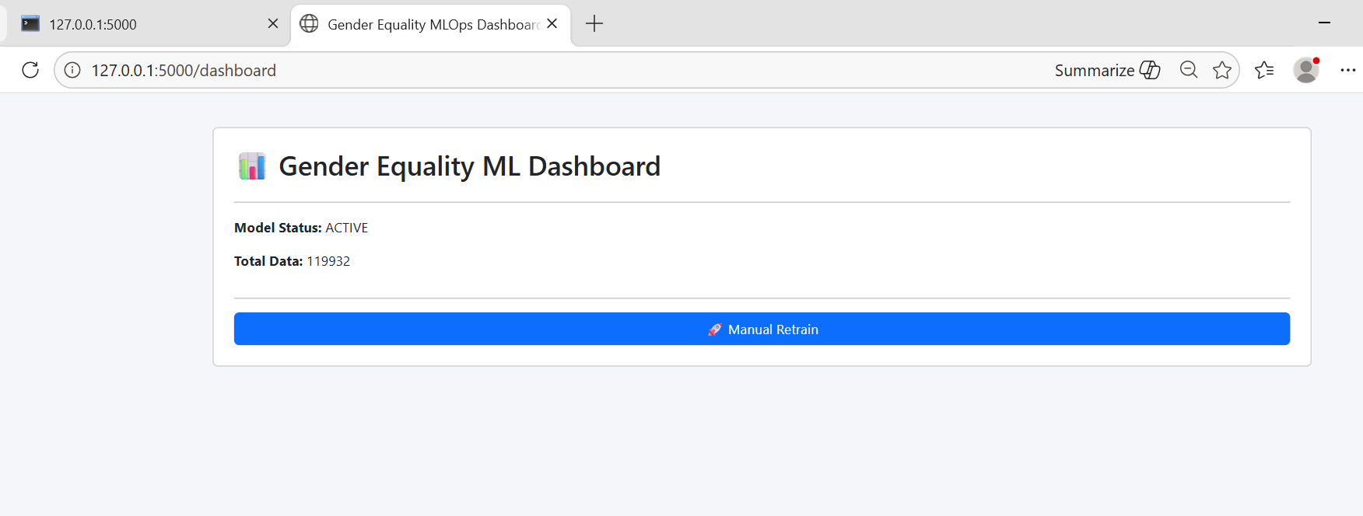

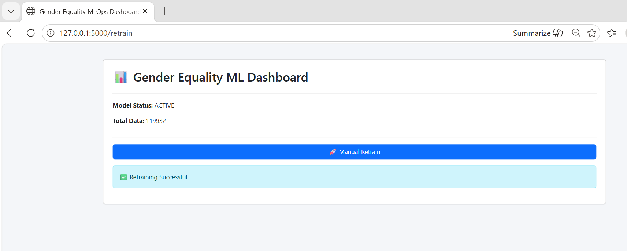

Dashboard.html:
<!DOCTYPE html>
<html lang="en">
<head>
<meta charset="UTF-8">
<meta name="viewport" content="width=device-width, initial-scale=1.0">
<title>Gender Equality & Workforce Diversity Dashboard — SDG Goal 5</title>
<script src="https://cdnjs.cloudflare.com/ajax/libs/Chart.js/4.4.1/chart.umd.min.js"></script>
<link rel="preconnect" href="https://fonts.googleapis.com">
<link href="https://fonts.googleapis.com/css2?family=Playfair+Display:wght@400;700;900&family=DM+Sans:wght@300;400;500;600&display=swap" rel="stylesheet">
<style>
:root {
--bg: #0d0f14;
--surface: #13161e;
--surface2: #1a1e29;
--border: #252a38;
--accent-pink: #e85d8a;
--accent-teal: #2dd4bf;
--accent-gold: #f5c842;
--accent-blue: #6b8cff;
--accent-purple: #a78bfa;
--text-primary: #f0f2f8;
--text-secondary: #8892a4;
--text-muted: #4a5568;
--danger: #f87171;
--success: #34d399;
--font-display: 'Playfair Display', serif;
--font-body: 'DM Sans', sans-serif;
--radius: 16px;
--shadow: 0 8px 32px rgba(0,0,0,0.4);
}

* { box-sizing: border-box; margin: 0; padding: 0; }

body {
background: var(--bg);
color: var(--text-primary);
font-family: var(--font-body);
min-height: 100vh;
overflow-x: hidden;
}

/* NOISE TEXTURE */
body::before {
content: '';
position: fixed; inset: 0;
background-image: url("data:image/svg+xml,%3Csvg viewBox='0 0 256 256' xmlns='http://www.w3.org/2000/svg'%3E%3Cfilter id='n'%3E%3CfeTurbulence type='fractalNoise' baseFrequency='0.9' numOctaves='4' stitchTiles='stitch'/%3E%3C/filter%3E%3Crect width='100%25' height='100%25' filter='url(%23n)' opacity='0.04'/%3E%3C/svg%3E");
pointer-events: none; z-index: 0;
}

/* HEADER */
header {
position: relative;
padding: 48px 48px 32px;
border-bottom: 1px solid var(--border);
background: linear-gradient(135deg, #13161e 0%, #0d1220 100%);
overflow: hidden;
}
header::after {
content: '';
position: absolute;
top: -60px; right: -60px;
width: 300px; height: 300px;
background: radial-gradient(circle, rgba(232,93,138,0.12) 0%, transparent 70%);
pointer-events: none;
}
.header-badge {
display: inline-block;
background: linear-gradient(90deg, rgba(232,93,138,0.2), rgba(107,140,255,0.2));
border: 1px solid rgba(232,93,138,0.3);
color: var(--accent-pink);
font-size: 11px;
font-weight: 600;
letter-spacing: 2px;
text-transform: uppercase;
padding: 4px 12px;
border-radius: 20px;
margin-bottom: 16px;
}
h1 {
font-family: var(--font-display);
font-size: clamp(28px, 4vw, 48px);
font-weight: 900;
line-height: 1.1;
color: var(--text-primary);
max-width: 700px;
}
h1 span { color: var(--accent-pink); }
.header-meta {
display: flex;
gap: 32px;
margin-top: 20px;
flex-wrap: wrap;
}
.meta-pill {
display: flex; align-items: center; gap: 8px;
color: var(--text-secondary);
font-size: 13px;
}
.meta-dot { width: 8px; height: 8px; border-radius: 50%; }

/* NAV TABS */
.nav-tabs {
display: flex; gap: 4px;
padding: 16px 48px;
background: var(--surface);
border-bottom: 1px solid var(--border);
overflow-x: auto;
scrollbar-width: none;
position: sticky; top: 0; z-index: 100;
}
.nav-tab {
padding: 8px 20px;
border-radius: 8px;
font-size: 13px;
font-weight: 500;
cursor: pointer;
border: 1px solid transparent;
color: var(--text-secondary);
background: transparent;
transition: all 0.2s;
white-space: nowrap;
}
.nav-tab:hover { color: var(--text-primary); background: var(--surface2); }
.nav-tab.active {
background: var(--surface2);
border-color: var(--border);
color: var(--text-primary);
}

/* MAIN LAYOUT */
main { padding: 32px 48px; max-width: 1600px; }

.section { display: none; }
.section.active { display: block; }

/* SECTION TITLE */
.section-title {
font-family: var(--font-display);
font-size: 22px;
font-weight: 700;
margin-bottom: 24px;
display: flex; align-items: center; gap: 12px;
}
.section-title::before {
content: '';
width: 4px; height: 24px;
border-radius: 2px;
background: var(--accent-pink);
}

/* KPI CARDS */
.kpi-grid {
display: grid;
grid-template-columns: repeat(auto-fill, minmax(220px, 1fr));
gap: 16px;
margin-bottom: 32px;
}
.kpi-card {
background: var(--surface);
border: 1px solid var(--border);
border-radius: var(--radius);
padding: 24px;
position: relative;
overflow: hidden;
transition: transform 0.2s, border-color 0.2s;
animation: fadeUp 0.5s ease both;
}
.kpi-card:hover {
transform: translateY(-2px);
border-color: rgba(232,93,138,0.3);
}
.kpi-card::before {
content: '';
position: absolute;
top: 0; left: 0; right: 0;
height: 2px;
}
.kpi-card.pink::before { background: var(--accent-pink); }
.kpi-card.teal::before { background: var(--accent-teal); }
.kpi-card.gold::before { background: var(--accent-gold); }
.kpi-card.blue::before { background: var(--accent-blue); }
.kpi-card.purple::before { background: var(--accent-purple); }
.kpi-card.danger::before { background: var(--danger); }
.kpi-card.success::before { background: var(--success); }

.kpi-label {
font-size: 11px;
font-weight: 600;
letter-spacing: 1.5px;
text-transform: uppercase;
color: var(--text-muted);
margin-bottom: 12px;
}
.kpi-value {
font-family: var(--font-display);
font-size: 36px;
font-weight: 700;
line-height: 1;
margin-bottom: 6px;
}
.kpi-card.pink .kpi-value { color: var(--accent-pink); }
.kpi-card.teal .kpi-value { color: var(--accent-teal); }
.kpi-card.gold .kpi-value { color: var(--accent-gold); }
.kpi-card.blue .kpi-value { color: var(--accent-blue); }
.kpi-card.purple .kpi-value { color: var(--accent-purple); }
.kpi-card.danger .kpi-value { color: var(--danger); }
.kpi-card.success .kpi-value { color: var(--success); }
.kpi-sub {
font-size: 12px;
color: var(--text-secondary);
}

/* CHARTS GRID */
.charts-grid {
display: grid;
gap: 20px;
margin-bottom: 24px;
}
.charts-2col { grid-template-columns: 1fr 1fr; }
.charts-3col { grid-template-columns: 1fr 1fr 1fr; }
.charts-main { grid-template-columns: 2fr 1fr; }

.chart-card {
background: var(--surface);
border: 1px solid var(--border);
border-radius: var(--radius);
padding: 24px;
animation: fadeUp 0.5s ease both;
}
.chart-card.span2 { grid-column: span 2; }
.chart-title {
font-size: 13px;
font-weight: 600;
letter-spacing: 0.5px;
color: var(--text-secondary);
text-transform: uppercase;
margin-bottom: 20px;
}
.chart-container { position: relative; }

/* PROGRESS BARS */
.progress-row {
display: flex; align-items: center; gap: 12px;
margin-bottom: 12px;
}
.progress-label {
font-size: 12px;
color: var(--text-secondary);
width: 120px;
flex-shrink: 0;
}
.progress-track {
flex: 1;
height: 6px;
background: var(--surface2);
border-radius: 3px;
overflow: hidden;
}
.progress-fill {
height: 100%;
border-radius: 3px;
transition: width 1s ease;
}
.progress-val {
font-size: 12px;
font-weight: 600;
width: 44px;
text-align: right;
flex-shrink: 0;
}

/* INSIGHTS */
.insights-grid {
display: grid;
grid-template-columns: repeat(auto-fill, minmax(300px, 1fr));
gap: 16px;
margin-top: 24px;
}
.insight-card {
background: var(--surface);
border: 1px solid var(--border);
border-radius: var(--radius);
padding: 20px;
display: flex; gap: 16px;
align-items: flex-start;
}
.insight-icon {
width: 40px; height: 40px;
border-radius: 10px;
display: flex; align-items: center; justify-content: center;
font-size: 18px;
flex-shrink: 0;
}
.insight-title { font-size: 14px; font-weight: 600; margin-bottom: 4px; }
.insight-text { font-size: 12px; color: var(--text-secondary); line-height: 1.6; }

/* ML SECTION */
.ml-grid { display: grid; grid-template-columns: 1fr 1fr; gap: 20px; }
.accuracy-ring {
display: flex; flex-direction: column; align-items: center; justify-content: center;
padding: 40px 20px;
text-align: center;
}
.ring-outer {
width: 160px; height: 160px;
border-radius: 50%;
background: conic-gradient(var(--accent-teal) 0% 79.08%, var(--surface2) 79.08% 100%);
display: flex; align-items: center; justify-content: center;
margin-bottom: 16px;
}
.ring-inner {
width: 120px; height: 120px;
border-radius: 50%;
background: var(--surface);
display: flex; flex-direction: column; align-items: center; justify-content: center;
}
.ring-pct {
font-family: var(--font-display);
font-size: 32px;
font-weight: 700;
color: var(--accent-teal);
}
.ring-label { font-size: 10px; color: var(--text-muted); letter-spacing: 1px; }

/* CLUSTER CARDS */
.cluster-grid {
display: grid;
grid-template-columns: repeat(4, 1fr);
gap: 12px;
margin-top: 20px;
}
.cluster-card {
background: var(--surface2);
border: 1px solid var(--border);
border-radius: 12px;
padding: 16px;
}
.cluster-name {
font-size: 11px;
font-weight: 700;
letter-spacing: 1px;
text-transform: uppercase;
margin-bottom: 12px;
}
.cluster-stat { font-size: 12px; color: var(--text-secondary); margin-bottom: 4px; }
.cluster-stat strong { color: var(--text-primary); }

/* TABLE */
.data-table {
width: 100%;
border-collapse: collapse;
font-size: 13px;
}
.data-table th {
text-align: left;
padding: 10px 16px;
font-size: 11px;
font-weight: 600;
letter-spacing: 1px;
text-transform: uppercase;
color: var(--text-muted);
border-bottom: 1px solid var(--border);
}
.data-table td {
padding: 10px 16px;
border-bottom: 1px solid rgba(37,42,56,0.5);
color: var(--text-secondary);
}
.data-table td:first-child { color: var(--text-primary); font-weight: 500; }
.gap-badge {
display: inline-block;
padding: 2px 8px;
border-radius: 4px;
font-size: 11px;
font-weight: 600;
}

/* ANIMATIONS */
@keyframes fadeUp {
from { opacity: 0; transform: translateY(20px); }
to { opacity: 1; transform: translateY(0); }
}

/* FILTER BAR */
.filter-bar {
display: flex; gap: 12px; align-items: center;
margin-bottom: 24px;
padding: 16px 20px;
background: var(--surface);
border: 1px solid var(--border);
border-radius: var(--radius);
flex-wrap: wrap;
}
.filter-label { font-size: 12px; color: var(--text-muted); font-weight: 600; letter-spacing: 1px; text-transform: uppercase; }
select {
background: var(--surface2);
border: 1px solid var(--border);
color: var(--text-primary);
padding: 6px 12px;
border-radius: 8px;
font-size: 13px;
font-family: var(--font-body);
cursor: pointer;
}

/* RESPONSIVE */
@media (max-width: 900px) {
header, .nav-tabs, main { padding-left: 20px; padding-right: 20px; }
.charts-2col, .charts-main, .ml-grid { grid-template-columns: 1fr; }
.cluster-grid { grid-template-columns: 1fr 1fr; }
}

.fade-in { animation: fadeUp 0.4s ease both; }

.highlight-bar {
display: flex;
background: linear-gradient(90deg, rgba(232,93,138,0.08), transparent);
border: 1px solid rgba(232,93,138,0.15);
border-radius: 12px;
padding: 20px 24px;
margin-bottom: 24px;
gap: 40px;
flex-wrap: wrap;
align-items: center;
}
.highlight-stat { text-align: center; }
.highlight-stat .val {
font-family: var(--font-display);
font-size: 28px;
font-weight: 700;
color: var(--accent-pink);
}
.highlight-stat .lbl { font-size: 11px; color: var(--text-muted); letter-spacing: 1px; text-transform: uppercase; margin-top: 4px; }
</style>
</head>
<body>

<header>
<div class="header-badge">SDG Goal 5 · Gender Equality</div>
<h1>Gender Equality &amp; Workforce<br><span>Diversity Analytics</span></h1>
<div class="header-meta">
<div class="meta-pill"><div class="meta-dot" style="background:#34d399"></div> 119,932 Employees Analyzed</div>
<div class="meta-pill"><div class="meta-dot" style="background:#6b8cff"></div> 10 Departments · 5 Regions</div>
<div class="meta-pill"><div class="meta-dot" style="background:#f5c842"></div> Random Forest ML Model · 79.08% Accuracy</div>
<div class="meta-pill"><div class="meta-dot" style="background:#e85d8a"></div> Dataset: 2024 Workforce Survey</div>
</div>
</header>

<div class="nav-tabs">
<button class="nav-tab active" onclick="showTab('overview')">📊 Overview</button>
<button class="nav-tab" onclick="showTab('salary')">💰 Pay Equity</button>
<button class="nav-tab" onclick="showTab('workforce')">👥 Workforce</button>
<button class="nav-tab" onclick="showTab('leadership')">🏆 Leadership</button>
<button class="nav-tab" onclick="showTab('ml')">🤖 ML Model</button>
<button class="nav-tab" onclick="showTab('insights')">💡 Insights</button>
</div>

<main>

<!-- ═══════════ OVERVIEW ═══════════ -->
<div class="section active" id="tab-overview">
<div class="section-title">Key Performance Indicators</div>

<div class="highlight-bar">
<div class="highlight-stat"><div class="val">26.4%</div><div class="lbl">Gender Pay Gap</div></div>
<div class="highlight-stat"><div class="val" style="color:var(--accent-teal)">42.1%</div><div class="lbl">Female Workforce %</div></div>
<div class="highlight-stat"><div class="val" style="color:var(--accent-gold)">33.1%</div><div class="lbl">Female in Leadership</div></div>
<div class="highlight-stat"><div class="val" style="color:var(--accent-blue)">51.9%</div><div class="lbl">Diversity Index</div></div>
<div class="highlight-stat"><div class="val" style="color:var(--accent-purple)">119,932</div><div class="lbl">Total Employees</div></div>
</div>

<div class="kpi-grid">
<div class="kpi-card pink" style="animation-delay:0.05s">
<div class="kpi-label">Gender Pay Gap</div>
<div class="kpi-value">26.4%</div>
<div class="kpi-sub">Male median: $99,341 · Female: $73,116</div>
</div>
<div class="kpi-card teal" style="animation-delay:0.1s">
<div class="kpi-label">Female Participation</div>
<div class="kpi-value">42.1%</div>
<div class="kpi-sub">50,522 female employees</div>
</div>
<div class="kpi-card gold" style="animation-delay:0.15s">
<div class="kpi-label">Leadership (Female)</div>
<div class="kpi-value">33.1%</div>
<div class="kpi-sub">vs 64.9% male in leadership</div>
</div>
<div class="kpi-card blue" style="animation-delay:0.2s">
<div class="kpi-label">Diversity Index</div>
<div class="kpi-value">51.9</div>
<div class="kpi-sub">Simpson's diversity score</div>
</div>
<div class="kpi-card danger" style="animation-delay:0.25s">
<div class="kpi-label">Female Turnover</div>
<div class="kpi-value">18.0%</div>
<div class="kpi-sub">vs 15.1% male turnover</div>
</div>
<div class="kpi-card purple" style="animation-delay:0.3s">
<div class="kpi-label">Promo Gap</div>
<div class="kpi-value">2.3%</div>
<div class="kpi-sub">Male 21.9% vs Female 19.6%</div>
</div>
<div class="kpi-card success" style="animation-delay:0.35s">
<div class="kpi-label">Training Gap</div>
<div class="kpi-value">6.8 hrs</div>
<div class="kpi-sub">Male avg 44.3 vs Female 37.6</div>
</div>
<div class="kpi-card teal" style="animation-delay:0.4s">
<div class="kpi-label">Hiring Ratio F:M</div>
<div class="kpi-value">42:55</div>
<div class="kpi-sub">Female 42.1% · Male 55.0%</div>
</div>
</div>

<div class="charts-grid charts-main">
<div class="chart-card">
<div class="chart-title">Gender Distribution Across Job Levels</div>
<div class="chart-container"><canvas id="levelChart" height="260"></canvas></div>
</div>
<div class="chart-card">
<div class="chart-title">Overall Gender Distribution</div>
<div class="chart-container"><canvas id="pieChart" height="260"></canvas></div>
</div>
</div>

<div class="charts-grid charts-2col">
<div class="chart-card">
<div class="chart-title">Pay Gap by Department (%)</div>
<div class="chart-container"><canvas id="payGapChart" height="220"></canvas></div>
</div>
<div class="chart-card">
<div class="chart-title">Turnover Rate Trend by Gender (2010–2024)</div>
<div class="chart-container"><canvas id="turnoverChart" height="220"></canvas></div>
</div>
</div>
</div>

<!-- ═══════════ SALARY / PAY EQUITY ═══════════ -->
<div class="section" id="tab-salary">
<div class="section-title">Pay Equity Analysis</div>

<div class="filter-bar">
<span class="filter-label">Filter by Department:</span>
<select id="deptFilter" onchange="updateSalaryChart()">
<option value="all">All Departments</option>
<option>Engineering</option><option>Marketing</option><option>Finance</option>
<option>HR</option><option>Sales</option><option>Operations</option>
<option>Legal</option><option>Product</option><option>Data Science</option>
<option>Customer Support</option>
</select>
</div>

<div class="charts-grid charts-2col">
<div class="chart-card">
<div class="chart-title">Median Salary by Gender &amp; Department</div>
<div class="chart-container"><canvas id="salaryDeptChart" height="300"></canvas></div>
</div>
<div class="chart-card">
<div class="chart-title">Pay Comparison Summary</div>
<div style="padding-top:8px">
<div class="progress-row">
<div class="progress-label">Male Median</div>
<div class="progress-track"><div class="progress-fill" style="width:100%;background:var(--accent-blue)"></div></div>
<div class="progress-val" style="color:var(--accent-blue)">$99,341</div>
</div>
<div class="progress-row">
<div class="progress-label">Female Median</div>
<div class="progress-track"><div class="progress-fill" style="width:73.6%;background:var(--accent-pink)"></div></div>
<div class="progress-val" style="color:var(--accent-pink)">$73,116</div>
</div>
<div class="progress-row">
<div class="progress-label">Non-Binary</div>
<div class="progress-track"><div class="progress-fill" style="width:71%;background:var(--accent-purple)"></div></div>
<div class="progress-val" style="color:var(--accent-purple)">$70,800</div>
</div>
<div style="margin-top:24px;padding-top:24px;border-top:1px solid var(--border)">
<div class="chart-title" style="margin-bottom:16px">Gender Pay Gap by Department</div>
<table class="data-table">
<thead><tr><th>Department</th><th>Pay Gap (%)</th><th>Severity</th></tr></thead>
<tbody id="payGapTable"></tbody>
</table>
</div>
</div>
</div>
</div>
</div>

<!-- ═══════════ WORKFORCE ═══════════ -->
<div class="section" id="tab-workforce">
<div class="section-title">Workforce Participation &amp; Diversity</div>

<div class="charts-grid charts-2col">
<div class="chart-card">
<div class="chart-title">Promotion Rate by Department &amp; Gender</div>
<div class="chart-container"><canvas id="promoChart" height="280"></canvas></div>
</div>
<div class="chart-card">
<div class="chart-title">Workforce by Region &amp; Gender</div>
<div class="chart-container"><canvas id="regionChart" height="280"></canvas></div>
</div>
</div>

<div class="charts-grid charts-2col">
<div class="chart-card">
<div class="chart-title">Training Hours — Male vs Female Distribution</div>
<div class="chart-container"><canvas id="trainingChart" height="200"></canvas></div>
</div>
<div class="chart-card">
<div class="chart-title">Promotion &amp; Training Gap Summary</div>
<div style="padding-top:8px">
<div class="chart-title" style="margin-bottom:12px">Promotion Rate</div>
<div class="progress-row"><div class="progress-label">Male</div><div class="progress-track"><div class="progress-fill" style="width:100%;background:var(--accent-blue)"></div></div><div class="progress-val" style="color:var(--accent-blue)">21.9%</div></div>
<div class="progress-row"><div class="progress-label">Female</div><div class="progress-track"><div class="progress-fill" style="width:89.6%;background:var(--accent-pink)"></div></div><div class="progress-val" style="color:var(--accent-pink)">19.6%</div></div>
<div style="margin-top:20px" class="chart-title">Training Hours (avg)</div>
<div class="progress-row" style="margin-top:12px"><div class="progress-label">Male</div><div class="progress-track"><div class="progress-fill" style="width:100%;background:var(--accent-blue)"></div></div><div class="progress-val" style="color:var(--accent-blue)">44.3</div></div>
<div class="progress-row"><div class="progress-label">Female</div><div class="progress-track"><div class="progress-fill" style="width:84.7%;background:var(--accent-pink)"></div></div><div class="progress-val" style="color:var(--accent-pink)">37.6</div></div>
<div style="margin-top:20px" class="chart-title">Turnover Rate</div>
<div class="progress-row" style="margin-top:12px"><div class="progress-label">Female</div><div class="progress-track"><div class="progress-fill" style="width:100%;background:var(--danger)"></div></div><div class="progress-val" style="color:var(--danger)">18.0%</div></div>
<div class="progress-row"><div class="progress-label">Male</div><div class="progress-track"><div class="progress-fill" style="width:84%;background:var(--accent-gold)"></div></div><div class="progress-val" style="color:var(--accent-gold)">15.1%</div></div>
</div>
</div>
</div>
</div>

<!-- ═══════════ LEADERSHIP ═══════════ -->
<div class="section" id="tab-leadership">
<div class="section-title">Leadership &amp; Seniority Pipeline</div>

<div class="charts-grid charts-2col">
<div class="chart-card">
<div class="chart-title">Leadership Roles — Gender Split</div>
<div class="chart-container"><canvas id="leadershipPie" height="260"></canvas></div>
</div>
<div class="chart-card">
<div class="chart-title">Pipeline Funnel: Entry → C-Suite</div>
<div class="chart-container"><canvas id="funnelChart" height="260"></canvas></div>
</div>
</div>

<div class="chart-card" style="margin-top:20px">
<div class="chart-title">Female Representation % Across Job Levels</div>
<div id="femaleRepBars" style="padding-top:8px"></div>
</div>
</div>

<!-- ═══════════ ML MODEL ═══════════ -->
<div class="section" id="tab-ml">
<div class="section-title">Machine Learning Model — Promotion Prediction</div>

<div class="charts-grid charts-2col">
<div class="chart-card">
<div class="chart-title">Model Performance</div>
<div class="accuracy-ring">
<div class="ring-outer">
<div class="ring-inner">
<div class="ring-pct">79.1%</div>
<div class="ring-label">ACCURACY</div>
</div>
</div>
<div style="font-size:14px;color:var(--text-secondary);margin-bottom:8px">Random Forest Classifier</div>
<div style="font-size:12px;color:var(--text-muted)">5-Fold CV: 79.10% ± 0.01%</div>
<div style="margin-top:20px;display:flex;gap:24px">
<div style="text-align:center"><div style="font-size:22px;font-family:var(--font-display);font-weight:700;color:var(--accent-teal)">100</div><div style="font-size:11px;color:var(--text-muted)">N Estimators</div></div>
<div style="text-align:center"><div style="font-size:22px;font-family:var(--font-display);font-weight:700;color:var(--accent-gold)">10</div><div style="font-size:11px;color:var(--text-muted)">Max Depth</div></div>
<div style="text-align:center"><div style="font-size:22px;font-family:var(--font-display);font-weight:700;color:var(--accent-blue)">13</div><div style="font-size:11px;color:var(--text-muted)">Features</div></div>
</div>
</div>
</div>
<div class="chart-card">
<div class="chart-title">Feature Importance for Promotion Prediction</div>
<div class="chart-container"><canvas id="featureChart" height="300"></canvas></div>
</div>
</div>

<div class="section-title" style="margin-top:28px">K-Means Clustering (4 Workforce Segments)</div>
<div class="cluster-grid" id="clusterCards"></div>
</div>

<!-- ═══════════ INSIGHTS ═══════════ -->
<div class="section" id="tab-insights">
<div class="section-title">Actionable Insights &amp; Recommendations</div>

<div class="insights-grid">
<div class="insight-card">
<div class="insight-icon" style="background:rgba(232,93,138,0.15)">💸</div>
<div>
<div class="insight-title" style="color:var(--accent-pink)">Close the 26.4% Pay Gap</div>
<div class="insight-text">Women earn $26,225 less per year on average. Implement structured salary bands with mandatory equity reviews annually. Engineering shows the widest gap at 27.2%.</div>
</div>
</div>
<div class="insight-card">
<div class="insight-icon" style="background:rgba(107,140,255,0.15)">🎓</div>
<div>
<div class="insight-title" style="color:var(--accent-blue)">Equalize Training Access</div>
<div class="insight-text">Female employees receive 6.8 fewer training hours annually. Mandatory equal-access training programs and mentorship should be introduced to address the skill development gap.</div>
</div>
</div>
<div class="insight-card">
<div class="insight-icon" style="background:rgba(245,200,66,0.15)">📈</div>
<div>
<div class="insight-title" style="color:var(--accent-gold)">Address Promotion Bias</div>
<div class="insight-text">Male employees are 2.3% more likely to be promoted. Implement blind promotion reviews and set gender-balanced promotion targets per department and level.</div>
</div>
</div>
<div class="insight-card">
<div class="insight-icon" style="background:rgba(52,211,153,0.15)">🏆</div>
<div>
<div class="insight-title" style="color:var(--success)">Increase Leadership Representation</div>
<div class="insight-text">Only 33.1% of leadership roles are held by women vs 64.9% by men. Set a 40% female leadership target by 2027 with executive sponsorship programs and succession planning.</div>
</div>
</div>
<div class="insight-card">
<div class="insight-icon" style="background:rgba(248,113,113,0.15)">⚠️</div>
<div>
<div class="insight-title" style="color:var(--danger)">Reduce Female Turnover Gap</div>
<div class="insight-text">Female employees have an 18% turnover rate vs 15.1% for males — a 2.9% gap. Exit surveys, flexible work arrangements, and parental leave equality can significantly reduce this.</div>
</div>
</div>
<div class="insight-card">
<div class="insight-icon" style="background:rgba(167,139,250,0.15)">🔍</div>
<div>
<div class="insight-title" style="color:var(--accent-purple)">Parental Leave Utilization</div>
<div class="insight-text">Only 20% of men take parental leave vs 55% of women. Normalizing shared parental leave for all genders can help reduce the career advancement gap caused by career breaks.</div>
</div>
</div>
<div class="insight-card">
<div class="insight-icon" style="background:rgba(45,212,191,0.15)">🌍</div>
<div>
<div class="insight-title" style="color:var(--accent-teal)">Hiring Pipeline Imbalance</div>
<div class="insight-text">Women make up only 42.1% of the workforce despite being 50%+ of the working population. Bias-free hiring processes, diverse interview panels, and university partnership programs are recommended.</div>
</div>
</div>
<div class="insight-card">
<div class="insight-icon" style="background:rgba(232,93,138,0.15)">🤖</div>
<div>
<div class="insight-title" style="color:var(--accent-pink)">ML Prediction Findings</div>
<div class="insight-text">The Random Forest model (79.1% accuracy) reveals Annual Salary and Bonus are the top predictors of promotion — suggesting compensation levels may reflect and reinforce existing hierarchies.</div>
</div>
</div>
<div class="insight-card">
<div class="insight-icon" style="background:rgba(107,140,255,0.15)">📊</div>
<div>
<div class="insight-title" style="color:var(--accent-blue)">Cluster-Based Interventions</div>
<div class="insight-text">Cluster 1 (High salary, low promo) shows strong salary-gender gap with 19,909 males vs 5,744 females — a 3.5:1 ratio. Targeted pay equity audits for experienced, high-earning roles are critical.</div>
</div>
</div>
</div>

<div class="chart-card" style="margin-top:24px">
<div class="chart-title">Recommended Priority Action Matrix</div>
<div style="margin-top:16px;display:grid;grid-template-columns:1fr 1fr;gap:16px">
<div style="background:rgba(248,113,113,0.06);border:1px solid rgba(248,113,113,0.2);border-radius:12px;padding:16px">
<div style="font-size:11px;font-weight:700;color:var(--danger);letter-spacing:1px;text-transform:uppercase;margin-bottom:8px">🔴 High Priority — Immediate Action</div>
<div style="font-size:13px;color:var(--text-secondary);line-height:2">• Conduct salary equity audit across all departments<br>• Introduce pay transparency policy<br>• Launch female leadership fast-track program</div>
</div>
<div style="background:rgba(245,200,66,0.06);border:1px solid rgba(245,200,66,0.2);border-radius:12px;padding:16px">
<div style="font-size:11px;font-weight:700;color:var(--accent-gold);letter-spacing:1px;text-transform:uppercase;margin-bottom:8px">🟡 Medium Priority — 6–12 Months</div>
<div style="font-size:13px;color:var(--text-secondary);line-height:2">• Equal training hours mandate<br>• Blind promotion review process<br>• Flexible work policy for all genders</div>
</div>
<div style="background:rgba(52,211,153,0.06);border:1px solid rgba(52,211,153,0.2);border-radius:12px;padding:16px">
<div style="font-size:11px;font-weight:700;color:var(--success);letter-spacing:1px;text-transform:uppercase;margin-bottom:8px">🟢 Long Term — 1–3 Years</div>
<div style="font-size:13px;color:var(--text-secondary);line-height:2">• 40% female leadership by 2027 target<br>• Shared parental leave policy<br>• Annual diversity index reporting</div>
</div>
<div style="background:rgba(107,140,255,0.06);border:1px solid rgba(107,140,255,0.2);border-radius:12px;padding:16px">
<div style="font-size:11px;font-weight:700;color:var(--accent-blue);letter-spacing:1px;text-transform:uppercase;margin-bottom:8px">🔵 Data &amp; Monitoring</div>
<div style="font-size:13px;color:var(--text-secondary);line-height:2">• Quarterly gender KPI dashboard review<br>• ML model retraining every 6 months<br>• Employee sentiment surveys by gender</div>
</div>
</div>
</div>
</div>

</main>

<script>
// ─── DATA ────────────────────────────────────────────────────────────────────
const COLORS = {
male: '#6b8cff',
female: '#e85d8a',
nb: '#a78bfa',
maleA: 'rgba(107,140,255,0.7)',
femaleA: 'rgba(232,93,138,0.7)',
nbA: 'rgba(167,139,250,0.7)',
};
Chart.defaults.color = '#8892a4';
Chart.defaults.font.family = "'DM Sans', sans-serif";
Chart.defaults.font.size = 12;

const DEPT_LIST = ['Engineering','Marketing','Finance','HR','Sales','Operations','Legal','Product','Data Science','Customer Support'];
const LEVEL_ORDER = ['Entry','Junior','Mid','Senior','Lead','Manager','Director','VP','C-Suite'];

const salaryByDept = {"Customer Support":{"Female":73859,"Male":99749,"Non-Binary":72337},"Data Science":{"Female":73532,"Male":98855,"Non-Binary":70728},"Engineering":{"Female":72730,"Male":99909,"Non-Binary":71893},"Finance":{"Female":73130,"Male":99386,"Non-Binary":70879},"HR":{"Female":73025,"Male":99592,"Non-Binary":71991},"Legal":{"Female":73600,"Male":99220,"Non-Binary":67924},"Marketing":{"Female":72684,"Male":99258,"Non-Binary":70208},"Operations":{"Female":72755,"Male":98487,"Non-Binary":72112},"Product":{"Female":73506,"Male":99449,"Non-Binary":72564},"Sales":{"Female":73021,"Male":99311,"Non-Binary":71902}};

const levelDist = {"Entry":{"Female":6063,"Male":5096,"Non-Binary":512},"Junior":{"Female":8011,"Male":7975,"Non-Binary":597},"Mid":{"Female":11187,"Male":12017,"Non-Binary":766},"Senior":{"Female":10023,"Male":13103,"Non-Binary":660},"Lead":{"Female":6109,"Male":9868,"Non-Binary":402},"Manager":{"Female":4565,"Male":7903,"Non-Binary":291},"Director":{"Female":2527,"Male":5315,"Non-Binary":152},"VP":{"Female":1544,"Male":3331,"Non-Binary":72},"C-Suite":{"Female":493,"Male":1329,"Non-Binary":21}};

const payGapDept = {"Engineering":27.2,"Marketing":26.8,"HR":26.7,"Sales":26.5,"Finance":26.4,"Operations":26.1,"Product":26.1,"Customer Support":26.0,"Legal":25.8,"Data Science":25.6};

const promoDept = {"Engineering":{"Female":19.5,"Male":21.1},"Marketing":{"Female":19.8,"Male":22.2},"Finance":{"Female":19.2,"Male":21.6},"HR":{"Female":20.4,"Male":22.0},"Sales":{"Female":19.3,"Male":22.4},"Operations":{"Female":19.4,"Male":21.9},"Legal":{"Female":18.7,"Male":21.6},"Product":{"Female":19.9,"Male":22.7},"Data Science":{"Female":19.0,"Male":22.0},"Customer Support":{"Female":21.0,"Male":22.0}};

const regionDist = {"Asia-Pacific":{"Female":10201,"Male":13222,"Non-Binary":692},"Europe":{"Female":9955,"Male":13196,"Non-Binary":734},"Latin America":{"Female":10133,"Male":13108,"Non-Binary":641},"Middle East & Africa":{"Female":10161,"Male":13264,"Non-Binary":703},"North America":{"Female":10072,"Male":13147,"Non-Binary":703}};

const turnoverData = {years:[2010,2011,2012,2013,2014,2015,2016,2017,2018,2019,2020,2021,2022,2023,2024],female:[21.3,17.5,17.2,17.7,17.2,17.9,18.3,16.9,18.6,18.3,18.1,18.2,17.8,17.8,17.9],male:[14.7,15.5,15.1,14.0,14.0,13.3,14.8,16.2,15.7,16.1,15.4,15.6,15.1,15.0,14.7]};

const featureImportance = [["Annual Salary",0.241],["Bonus",0.155],["Job Level",0.110],["Leadership Role",0.106],["Training Hours",0.082],["Age",0.060],["Experience",0.055],["Years at Co.",0.049],["Gender",0.044],["Department",0.039],["Education",0.025],["Performance",0.024],["Parental Leave",0.010]];

const clusterData = [
{id:0,name:"Mid-Tier, No Promo",color:"var(--accent-blue)",counts:{Female:20120,Male:12510,NB:1341},salary:{Female:72869,Male:87576,NB:71867},exp:8.7},
{id:1,name:"High-Earners, Stable",color:"var(--accent-gold)",counts:{Female:5744,Male:19909,NB:356},salary:{Female:128874,Male:145144,NB:126625},exp:16.5},
{id:2,name:"Recently Promoted",color:"var(--success)",counts:{Female:9877,Male:14113,NB:733},salary:{Female:69006,Male:88301,NB:69023},exp:9.7},
{id:3,name:"Early Career",color:"var(--accent-pink)",counts:{Female:14781,Male:19405,NB:1043},salary:{Female:72085,Male:87255,NB:70834},exp:7.3}
];

// ─── CHART INIT ──────────────────────────────────────────────────────────────
function mkLine(id, labels, datasets) {
return new Chart(document.getElementById(id), {
type:'line', data:{labels, datasets},
options:{responsive:true,plugins:{legend:{position:'top'}},scales:{y:{grid:{color:'rgba(255,255,255,0.04)'},ticks:{color:'#8892a4'}},x:{grid:{color:'rgba(255,255,255,0.04)'},ticks:{color:'#8892a4'}}}}
});
}
function mkBar(id, labels, datasets, opts={}) {
return new Chart(document.getElementById(id), {
type:'bar', data:{labels, datasets},
options:{responsive:true, plugins:{legend:{position:'top'}}, ...opts, scales:{y:{grid:{color:'rgba(255,255,255,0.04)'},ticks:{color:'#8892a4'}},x:{grid:{color:'rgba(255,255,255,0.04)'},ticks:{color:'#8892a4'}}}}
});
}

// Overview — Level Distribution
const levelLabels = LEVEL_ORDER;
new Chart(document.getElementById('levelChart'), {
type:'bar',
data:{
labels: levelLabels,
datasets:[
{label:'Female',data:levelLabels.map(l=>levelDist[l].Female),backgroundColor:COLORS.femaleA,borderRadius:4},
{label:'Male',data:levelLabels.map(l=>levelDist[l].Male),backgroundColor:COLORS.maleA,borderRadius:4},
{label:'Non-Binary',data:levelLabels.map(l=>levelDist[l]['Non-Binary']),backgroundColor:COLORS.nbA,borderRadius:4},
]
},
options:{responsive:true,plugins:{legend:{position:'top'}},scales:{x:{stacked:true,grid:{color:'rgba(255,255,255,0.04)'},ticks:{color:'#8892a4'}},y:{stacked:true,grid:{color:'rgba(255,255,255,0.04)'},ticks:{color:'#8892a4'}}}}
});

// Overview — Pie
new Chart(document.getElementById('pieChart'), {
type:'doughnut',
data:{
labels:['Male (55%)','Female (42.1%)','Non-Binary (2.9%)'],
datasets:[{data:[65937,50522,3473],backgroundColor:[COLORS.male,COLORS.female,COLORS.nb],borderWidth:0,hoverOffset:8}]
},
options:{responsive:true,plugins:{legend:{position:'bottom'}},cutout:'65%'}
});

// Overview — Pay Gap
new Chart(document.getElementById('payGapChart'), {
type:'bar',
data:{
labels:Object.keys(payGapDept),
datasets:[{
label:'Pay Gap (%)',
data:Object.values(payGapDept),
backgroundColor:Object.values(payGapDept).map(v => v >= 27 ? 'rgba(248,113,113,0.7)' : v >= 26.5 ? 'rgba(245,200,66,0.7)' : 'rgba(45,212,191,0.7)'),
borderRadius:6
}]
},
options:{responsive:true,plugins:{legend:{display:false}},scales:{y:{min:24,grid:{color:'rgba(255,255,255,0.04)'},ticks:{color:'#8892a4',callback:v=>v+'%'}},x:{grid:{color:'rgba(255,255,255,0.04)'},ticks:{color:'#8892a4'}}}}
});

// Overview — Turnover
new Chart(document.getElementById('turnoverChart'), {
type:'line',
data:{
labels:turnoverData.years,
datasets:[
{label:'Female',data:turnoverData.female,borderColor:COLORS.female,backgroundColor:'rgba(232,93,138,0.1)',fill:true,tension:0.4,pointRadius:3},
{label:'Male',data:turnoverData.male,borderColor:COLORS.male,backgroundColor:'rgba(107,140,255,0.1)',fill:true,tension:0.4,pointRadius:3},
]
},
options:{responsive:true,plugins:{legend:{position:'top'}},scales:{y:{grid:{color:'rgba(255,255,255,0.04)'},ticks:{color:'#8892a4',callback:v=>v+'%'}},x:{grid:{color:'rgba(255,255,255,0.04)'},ticks:{color:'#8892a4'}}}}
});

// Salary — dept chart
let salaryChart;
function buildSalaryChart(dept) {
const depts = dept === 'all' ? DEPT_LIST : [dept];
const fData = depts.map(d => salaryByDept[d]?.Female || 0);
const mData = depts.map(d => salaryByDept[d]?.Male || 0);
const nbData = depts.map(d => salaryByDept[d]?.['Non-Binary'] || 0);
if (salaryChart) salaryChart.destroy();
salaryChart = new Chart(document.getElementById('salaryDeptChart'), {
type:'bar',
data:{
labels:depts,
datasets:[
{label:'Female',data:fData,backgroundColor:COLORS.femaleA,borderRadius:5},
{label:'Male',data:mData,backgroundColor:COLORS.maleA,borderRadius:5},
{label:'Non-Binary',data:nbData,backgroundColor:COLORS.nbA,borderRadius:5},
]
},
options:{responsive:true,plugins:{legend:{position:'top'}},scales:{y:{grid:{color:'rgba(255,255,255,0.04)'},ticks:{color:'#8892a4',callback:v=>'$'+(v/1000).toFixed(0)+'k'}},x:{grid:{color:'rgba(255,255,255,0.04)'},ticks:{color:'#8892a4'}}}}
});
}
function updateSalaryChart() { buildSalaryChart(document.getElementById('deptFilter').value); }
buildSalaryChart('all');

// Pay Gap Table
const tbody = document.getElementById('payGapTable');
Object.entries(payGapDept).sort((a,b)=>b[1]-a[1]).forEach(([dept,gap])=>{
const color = gap >= 27 ? '#f87171' : gap >= 26.5 ? '#f5c842' : '#2dd4bf';
tbody.innerHTML += `<tr><td>${dept}</td><td><span class="gap-badge" style="background:${color}22;color:${color}">${gap.toFixed(1)}%</span></td><td style="color:${color};font-size:12px">${gap>=27?'⚠ High':gap>=26?'⚡ Med':'✓ Lower'}</td></tr>`;
});

// Workforce — Promo
new Chart(document.getElementById('promoChart'), {
type:'bar',
data:{
labels:Object.keys(promoDept),
datasets:[
{label:'Female',data:Object.values(promoDept).map(d=>d.Female),backgroundColor:COLORS.femaleA,borderRadius:4},
{label:'Male',data:Object.values(promoDept).map(d=>d.Male),backgroundColor:COLORS.maleA,borderRadius:4},
]
},
options:{responsive:true,plugins:{legend:{position:'top'}},scales:{y:{min:15,grid:{color:'rgba(255,255,255,0.04)'},ticks:{color:'#8892a4',callback:v=>v+'%'}},x:{grid:{color:'rgba(255,255,255,0.04)'},ticks:{color:'#8892a4'}}}}
});

// Workforce — Region
const regions = Object.keys(regionDist);
new Chart(document.getElementById('regionChart'), {
type:'bar',
data:{
labels:regions,
datasets:[
{label:'Female',data:regions.map(r=>regionDist[r].Female),backgroundColor:COLORS.femaleA,borderRadius:4},
{label:'Male',data:regions.map(r=>regionDist[r].Male),backgroundColor:COLORS.maleA,borderRadius:4},
]
},
options:{responsive:true,plugins:{legend:{position:'top'}},scales:{x:{stacked:false,grid:{color:'rgba(255,255,255,0.04)'},ticks:{color:'#8892a4'}},y:{grid:{color:'rgba(255,255,255,0.04)'},ticks:{color:'#8892a4',callback:v=>(v/1000).toFixed(0)+'k'}}}}
});

// Training chart
new Chart(document.getElementById('trainingChart'), {
type:'bar',
data:{
labels:['0-10','11-20','21-30','31-40','41-50','51-60','61-70','71-80','81+'],
datasets:[
{label:'Female (avg 37.6h)',data:[3.2,6.1,9.8,13.4,14.9,12.3,8.7,5.2,3.8],backgroundColor:COLORS.femaleA,borderRadius:4},
{label:'Male (avg 44.3h)',data:[2.1,4.3,7.9,11.2,14.1,15.3,11.8,7.4,4.9],backgroundColor:COLORS.maleA,borderRadius:4},
]
},
options:{responsive:true,plugins:{legend:{position:'top'}},scales:{y:{grid:{color:'rgba(255,255,255,0.04)'},ticks:{color:'#8892a4',callback:v=>v+'%'}},x:{grid:{color:'rgba(255,255,255,0.04)'},ticks:{color:'#8892a4'}}}}
});

// Leadership pie
new Chart(document.getElementById('leadershipPie'), {
type:'doughnut',
data:{
labels:['Male (64.9%)','Female (33.1%)','Non-Binary (2.0%)'],
datasets:[{data:[64.9,33.1,2.0],backgroundColor:[COLORS.male,COLORS.female,COLORS.nb],borderWidth:0,hoverOffset:8}]
},
options:{responsive:true,plugins:{legend:{position:'bottom'}},cutout:'60%'}
});

// Pipeline funnel
const totalByLevel = LEVEL_ORDER.map(l=>(levelDist[l].Female||0)+(levelDist[l].Male||0)+(levelDist[l]['Non-Binary']||0));
const femalePct = LEVEL_ORDER.map(l=>(levelDist[l].Female/(levelDist[l].Female+levelDist[l].Male+(levelDist[l]['Non-Binary']||0))*100).toFixed(1));
new Chart(document.getElementById('funnelChart'), {
type:'bar',
data:{
labels:LEVEL_ORDER,
datasets:[{
label:'Female %',
data:femalePct,
backgroundColor:LEVEL_ORDER.map((l,i)=>{const p=parseFloat(femalePct[i]);return p>=40?'rgba(52,211,153,0.7)':p>=35?'rgba(245,200,66,0.7)':'rgba(232,93,138,0.7)';}),
borderRadius:6
}]
},
options:{responsive:true,plugins:{legend:{display:false}},scales:{y:{max:60,grid:{color:'rgba(255,255,255,0.04)'},ticks:{color:'#8892a4',callback:v=>v+'%'},title:{display:true,text:'Female %',color:'#8892a4'}},x:{grid:{color:'rgba(255,255,255,0.04)'},ticks:{color:'#8892a4'}}}}
});

// Female rep bars
const repContainer = document.getElementById('femaleRepBars');
LEVEL_ORDER.forEach(l=>{
const tot = levelDist[l].Female + levelDist[l].Male + (levelDist[l]['Non-Binary']||0);
const pct = (levelDist[l].Female / tot * 100).toFixed(1);
const color = pct >= 40 ? 'var(--success)' : pct >= 35 ? 'var(--accent-gold)' : 'var(--accent-pink)';
repContainer.innerHTML += `
<div class="progress-row" style="margin-bottom:14px">
<div class="progress-label" style="width:90px">${l}</div>
<div class="progress-track"><div class="progress-fill" style="width:${pct}%;background:${color}"></div></div>
<div class="progress-val" style="color:${color};width:50px">${pct}%</div>
<div style="font-size:11px;color:var(--text-muted);width:70px">${(levelDist[l].Female/1000).toFixed(1)}k women</div>
</div>`;
});

// ML — Feature importance
new Chart(document.getElementById('featureChart'), {
type:'bar',
data:{
labels:featureImportance.map(d=>d[0]),
datasets:[{
label:'Importance',
data:featureImportance.map(d=>d[1]),
backgroundColor:featureImportance.map((_,i)=>`hsl(${200+i*12},70%,60%)`),
borderRadius:4
}]
},
options:{
indexAxis:'y',
responsive:true,
plugins:{legend:{display:false}},
scales:{x:{grid:{color:'rgba(255,255,255,0.04)'},ticks:{color:'#8892a4'}},y:{grid:{color:'rgba(255,255,255,0.04)'},ticks:{color:'#8892a4'}}}
}
});

// Cluster cards
const cGrid = document.getElementById('clusterCards');
const clusterNames = ['Low-Earners,\nNo Promo','High Earners,\nSenior','Recently\nPromoted','Early Career,\nNo Promo'];
clusterData.forEach((c,i)=>{
const totalF = c.counts.Female, totalM = c.counts.Male, totalNB = c.counts.NB;
const total = totalF + totalM + totalNB;
const fPct = (totalF/total*100).toFixed(1);
cGrid.innerHTML += `
<div class="cluster-card" style="animation-delay:${i*0.1}s">
<div class="cluster-name" style="color:${c.color}">Cluster ${c.id}: ${c.name}</div>
<div class="cluster-stat">Total: <strong>${(total/1000).toFixed(1)}k</strong> employees</div>
<div class="cluster-stat">Female: <strong style="color:${COLORS.female}">${fPct}%</strong> (${(totalF/1000).toFixed(1)}k)</div>
<div class="cluster-stat">Male: <strong style="color:${COLORS.male}">${(totalM/total*100).toFixed(1)}%</strong></div>
<div class="cluster-stat">Avg Salary F: <strong>$${(c.salary.Female/1000).toFixed(0)}k</strong></div>
<div class="cluster-stat">Avg Salary M: <strong>$${(c.salary.Male/1000).toFixed(0)}k</strong></div>
<div class="cluster-stat">Avg Experience: <strong>${c.exp} yrs</strong></div>
</div>`;
});

// ─── TAB SWITCHER ─────────────────────────────────────────────────────────────
function showTab(name) {
document.querySelectorAll('.section').forEach(s=>s.classList.remove('active'));
document.querySelectorAll('.nav-tab').forEach(t=>t.classList.remove('active'));
document.getElementById('tab-'+name).classList.add('active');
event.target.classList.add('active');
}
</script>
</body>
</html>

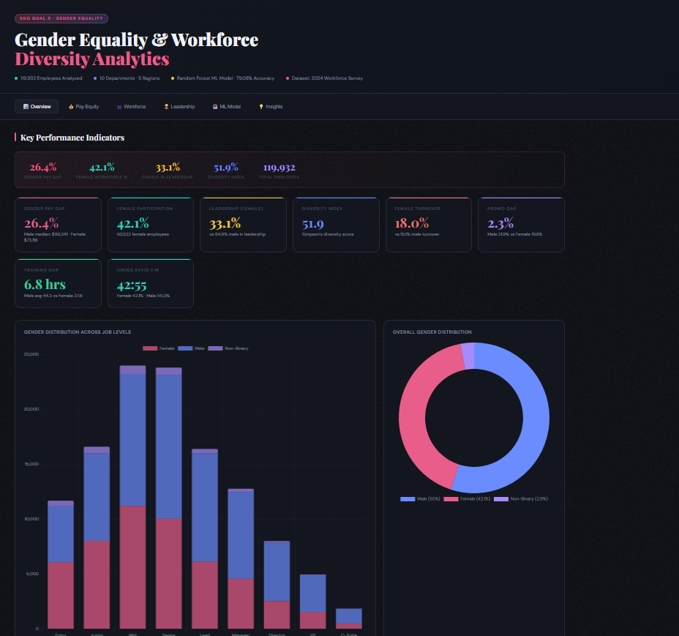

Train_model.py:
import pandas as pd
import numpy as np
import joblib
import matplotlib.pyplot as plt
import seaborn as sns

from sklearn.model_selection import train_test_split, cross_val_score
from sklearn.preprocessing import LabelEncoder, StandardScaler
from sklearn.ensemble import RandomForestClassifier
from sklearn.metrics import accuracy_score, classification_report, confusion_matrix

print("\n" + "="*60)
print(" GENDER EQUALITY - FULL TRAINING PIPELINE")
print("="*60)

# =====================================================
# 1. LOAD DATA
# =====================================================
df = pd.read_csv("cleaned_gender_data.csv")
print("Dataset Shape:", df.shape)

# =====================================================
# 2. FEATURES
# =====================================================
feature_cols = [
'Gender','Age','Department','Job_Level','Education',
'Experience_Years','Years_at_Company','Annual_Salary',
'Bonus','Performance_Rating','Training_Hours',
'Parental_Leave_Taken','Leadership_Role'
]

target_col = "Promoted_Last_Year"

df = df[feature_cols + [target_col]].dropna()

# =====================================================
# 3. LABEL ENCODING
# =====================================================
label_encoders = {}
cat_cols = ['Gender','Department','Job_Level','Education','Performance_Rating']

for col in cat_cols:
le = LabelEncoder()
df[col] = le.fit_transform(df[col].astype(str))
label_encoders[col] = le

# =====================================================
# 4. SPLIT DATA
# =====================================================
X = df[feature_cols]
y = df[target_col]

X_train, X_test, y_train, y_test = train_test_split(
X, y, test_size=0.2, random_state=42, stratify=y
)

# =====================================================
# 5. SCALING
# =====================================================
scaler = StandardScaler()
X_train_scaled = scaler.fit_transform(X_train)
X_test_scaled = scaler.transform(X_test)

# =====================================================
# 6. MODEL TRAINING
# =====================================================
model = RandomForestClassifier(
n_estimators=100,
max_depth=10,
random_state=42,
n_jobs=-1
)

model.fit(X_train_scaled, y_train)

# =====================================================
# 7. PREDICTION + EVALUATION
# =====================================================
y_pred = model.predict(X_test_scaled)

acc = accuracy_score(y_test, y_pred)
cv = cross_val_score(model, X_train_scaled, y_train, cv=5)

print("\nTest Accuracy:", round(acc, 4))
print("CV Accuracy:", round(cv.mean(), 4), "±", round(cv.std(), 4))

print("\nClassification Report:\n")
print(classification_report(y_test, y_pred))

# =====================================================
# 8. CONFUSION MATRIX
# =====================================================
cm = confusion_matrix(y_test, y_pred)

plt.figure(figsize=(6,4))
sns.heatmap(cm, annot=True, fmt='d', cmap='Blues',
xticklabels=['Not Promoted','Promoted'],
yticklabels=['Not Promoted','Promoted'])

plt.title("Confusion Matrix - Promotion Prediction")
plt.xlabel("Predicted")
plt.ylabel("Actual")
plt.tight_layout()
plt.savefig("confusion_matrix.png")
plt.show()

print("✅ Confusion Matrix saved")

# =====================================================
# 9. FEATURE IMPORTANCE
# =====================================================
feat_imp = pd.DataFrame({
"Feature": feature_cols,
"Importance": model.feature_importances_
}).sort_values("Importance", ascending=False)

plt.figure(figsize=(8,5))
sns.barplot(x="Importance", y="Feature", data=feat_imp)
plt.title("Feature Importance")
plt.tight_layout()
plt.savefig("feature_importance.png")
plt.show()

print("\nTop Features:\n")
print(feat_imp.head(10))

# =====================================================
# 10. SAVE MODEL ARTIFACTS
# =====================================================
joblib.dump(model, "promotion_model.pkl")
joblib.dump(scaler, "scaler.pkl")
joblib.dump(feature_cols, "model_features.pkl")
joblib.dump(label_encoders, "label_encoders.pkl")

print("\n✅ ALL FILES SAVED SUCCESSFULLY")
print(" - promotion_model.pkl")
print(" - scaler.pkl")
print(" - model_features.pkl")
print(" - label_encoders.pkl")
print(" - confusion_matrix.png")
print(" - feature_importance.png")

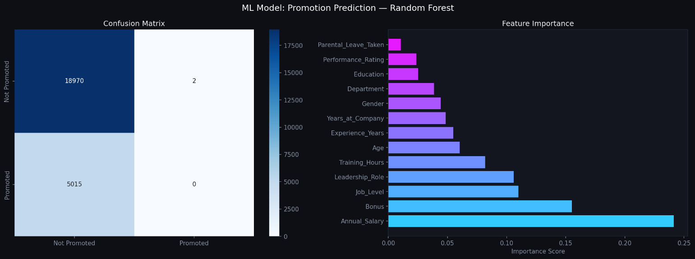
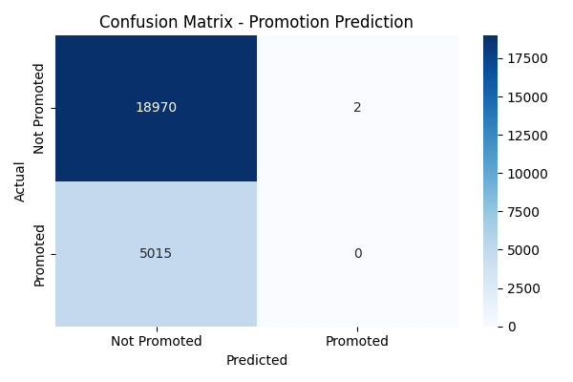

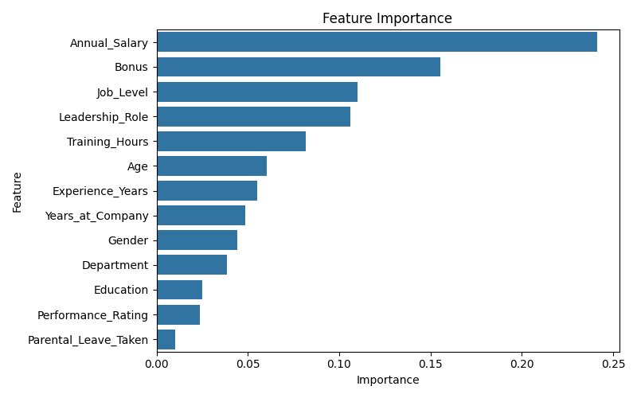

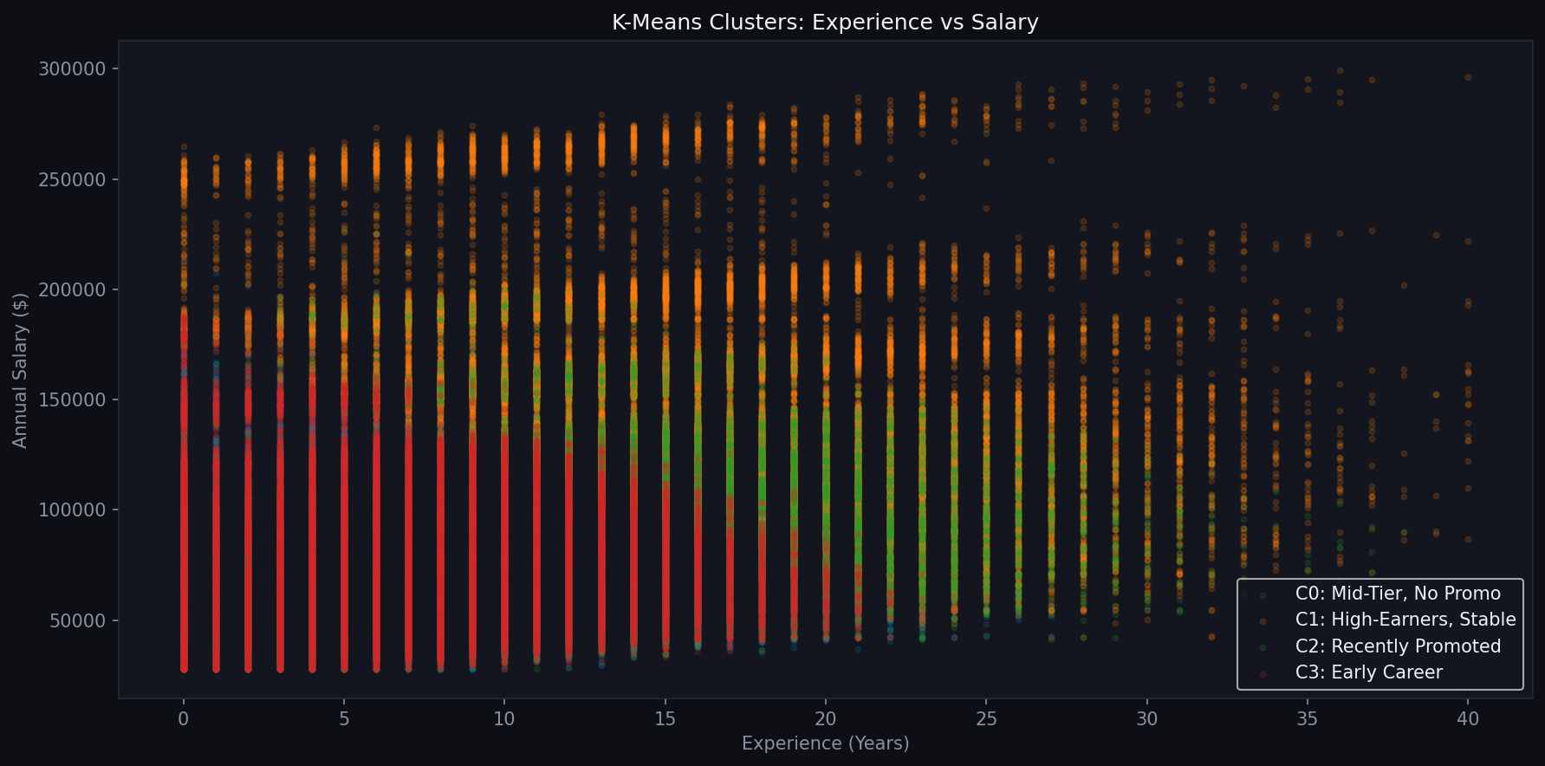

Power BI Dashboard:

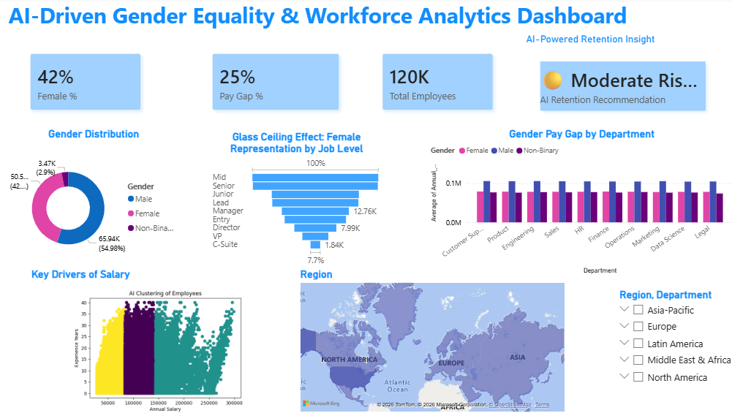

Conclusion:

This project shows that while the company has many female employees, they are often not treated the same as men when it comes to money and moving up in their careers.

Here are the main findings in easy-to-understand terms:

The Pay Gap: For every dollar a man makes at this company, a woman makes significantly less. There is a large 26.4% pay gap between men and women.

The Glass Ceiling: Even though women make up about 42% of the total workforce, they only hold about 33% of the leadership jobs. This means it is harder for women to reach the top positions.

Promotions: Men are being promoted at a faster rate than women.

Training Gaps: Men receive more hours of professional training on average than women do. Since training helps people get promoted, this gives men an unfair head start.

Leaving the Company: Women are more likely to quit or leave the company than men are.

Final Thought: To reach true gender equality (SDG Goal 5), the company needs to do more than just hire women. It needs to make sure they are paid fairly for the same work, given the same amount of training, and have the same clear path to becoming a boss as their male coworkers.

