This document contains Deployment and monitoring Instructions

**Deployment Instructions:**

**Prerequisites:**

1. Create a Virtual Machine on Microsoft Azure Cloud

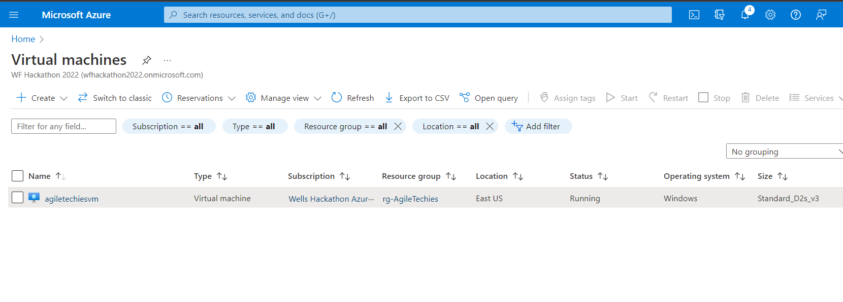

1. Download / clone the application code from the git hub repository available at below link to VM and put into the application run directory.

<https://github.com/Vid11/Hackathon2022_AgileTechies>

1. Run the databasesetup.sql file added in application code on yugabyte database cluster on Azure.

**Deployment Process:**

1. Open the CMD
2. Go to the python solution folder into the application run directory
3. Install the python modules from requirements.txt using command

Python install –r requirements.txt

If the above command faces issues, please install the below modules with below commands in the terminal/command prompt:

pip install requests

pip install psycopg2

pip install bs4

pip install configparser

pip install nltk

1. Go to the node app folder into the application run directory
2. Start the npm server using command

npm start

1. Go to the browser and run the application at <http://localhost:3000> (Note: (http://<Public IP of Virtual machine>:3000 )Site can be accessed also on public IP address of azure virtual machine)