**User Stories Document**

Team – Agile Techies

______________________________________________

Project Name: WFT Hackathon 2022

Problem Statement: Identify Diversely Owned/Led Business

Agile Techies Contributors

|  |  |  |
| --- | --- | --- |
| **Name** | **Designation** | **Work Effort Role** |
| Nishu Rani | Senior Information Security Engineer | Solution Architect |
| Utsahi Deshpande | Senior Information Security Engineer | Solution Architect |
| Vidyashree R | Senior Technology Operations Analyst | Frontend Developer |
| Gopinath Selvam | Lead Technology Operations Analyst | Database Engineer |
| Vijay Chandras | Lead Technology Operations Analyst | Product Owner/Scrum Master |
| Debasis Dash | Senior Software Engineer | Consultant |

1. **Assumptions**

|  |  |
| --- | --- |
| **ID** | **Assumption** |
| A.1 | The Solution is a prototype for the Hackathon problem statement and doesn’t cover all the use cases (the cases not covered currently are planned in the future scope) |
| A.2 | The solution expects as input the DUNS URL, which would form part of the tool’s database |
| A.3 | Availability of the tools and resources listed in the Technology Stack |

1. **Architecture Diagram**

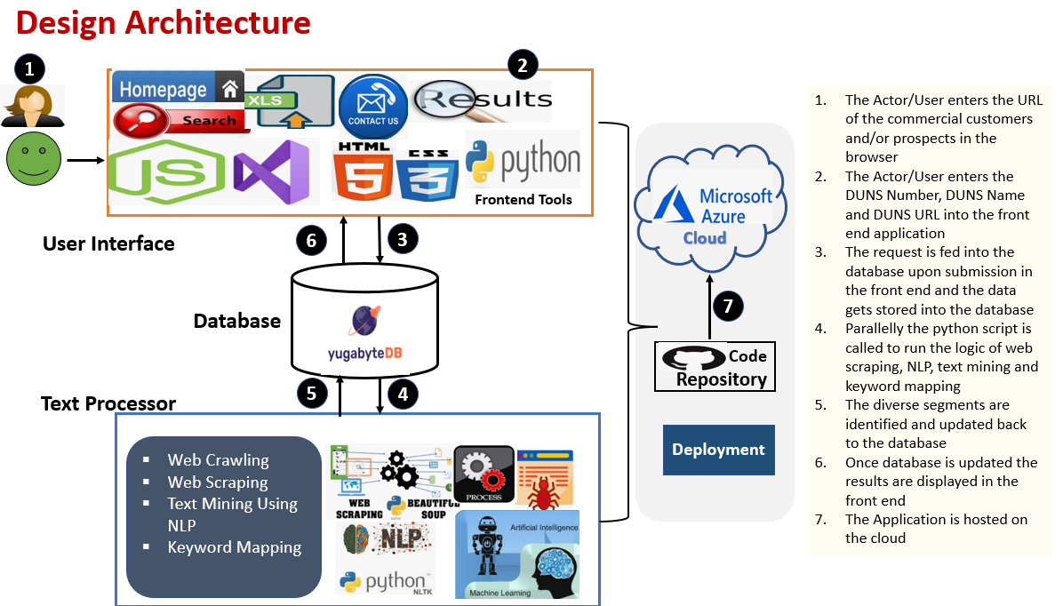

1. **Technology stack.**
2. Python
3. NLTK/NLP
4. Beautiful Soup
5. Yugabyte
6. Node JS
7. Microsoft Azure
8. Git
9. HTML
10. CSS
11. **User Stories**

**General Stories-**

|  |  |  |
| --- | --- | --- |
| **User Story Number** | **User Story Description.** | **Priority** |
| US-22-101 | As a general user of Diversity Led Business Identification Tool, I want to identify a diverse business from the public domain through an automated search to find the diverse businesses possibly relevant to commercial banking interest. | High |
| US-22-102 | As a general user of Diversity Led Business Identification Tool, should attempt to identify whether the company is women or diverse owned. | High |
| US-22-103 | The tool should have an ability to write to the IsWomenOwned Column of the Database Table when the company is identified as women based. | High |
| US-22-104 | The tool should have an ability to write to the column MinorityOwnedDesc of the database table when the company is identified anything Minority based. | High |
| US-22-105 | As a general user of the tool, I want to search the company website to identify whether the company has. Women or diverse senior leadership. | High |

**Front End Stories-**

|  |  |  |
| --- | --- | --- |
| **User Story Number** | **User Story Description** | **Priority** |
| US-22-201 | An Actor/User should be navigated to the Home page and a welcome message needs to be displayed “Welcome to the Diversity Led Business Identification Tool” | Medium |
| US-22-202 | An Actor/User should be navigated to the Search page and the below fields should be available in the UI:   1. Enter your DUNS Number 2. Enter your DUNS Name 3. Enter your DUNS url | High |
| US-22-203 | An Actor/User should have an ability to click on the Submit button which should be below the Enter DUNS Url | High |
| US-22-204 | An Actor/User should have an ability to click on the Contact Us page. | Low |
| US-22-205 | An actor/User Should have an ability to navigate to the results page, which should display the results with the decision of IsWomenOwned and MinorityOwned Description | High |

**Database Requirements:**

|  |  |  |
| --- | --- | --- |
| **User Story Number** | **User Story Description** | **Priority** |
| US-22-301 | The Actor/Developer should have an ability to create a Database in Yugabyte Cluster for the use of the Diversity Led Business Identification Tool. | High |
| US-22-302 | The Actor/Developer should have an ability to create a duns Table in the Database with the below columns:   * Autogenerated id * dunsnum * dunsname * dunsurl * County * StreetAddress * City * State * Zip * Phone * ExecutiveContact1 * ExecutiveContact2 * Iswomenowned * Minorityowneddesc | High |
| US-22-303 | The Actor/Developer should have an ability to create a diversitydimension Table in the Database with the below columns:   * diversitydimensionid * diversitydimensionname | High |
| US-22-304 | The Actor/Developer should have an ability to create a keywordmapping Table in the Database with the below columns:   * diversitydimensionid * keywordmapid * keywords | High |
| US-22-305 | The Actor/Developer should have an ability to create a Temporary webdata Table while processing the scribed data from the url in the Database with the below columns:   * Autogenerated id * dunsnum * weburl * webdatatext | High |
| US-22-306 | The Actor/Developer should have an ability to insert/update/delete on the Tables created in the Database. | High |

**Middleware Requirements:**

|  |  |  |
| --- | --- | --- |
| **User Story Number** | **User Story Description** | **Priority** |
| US-22-401 | The Actor/Developer should have an ability to fetch the DUNS url from the duns Table for processing in Python Script | High |
| US-22-402 | The Actor/Developer should have an ability to process the url to fetch data from Web Scraping using Beautiful Soup | High |
| US-22-403 | The Actor/Developer should have an ability to clean the Web Scraped data to have useful words only | High |
| US-22-404 | The Actor/Developer should have an ability to use cleaned data for removing the unnecessary characters, using NLTK. | High |
| US-22-405 | The Actor/Developer should have an ability to perform Text Mining from the NLTK data | High |
| US-22-406 | The Actor/Developer should have an ability to decide IswomenOwned based on Keyword Mapping | High |
| US-22-407 | The Actor/Developer should have an ability to decide MinorityOwnedDesc based on Keyword Mapping | High |

**Security Requirements:**

|  |  |  |
| --- | --- | --- |
| **User Story Number** | **User Story Description** | **Priority** |
| US-22-501 | The Actor/Developer has an ability to implement the Helmet that helps in mitigating cross-site scripting attacks, misused SSL certificates | Critical |
| US-22-502 | The Actor/Developer has an ability to implement the Express-rate-limit to prevent the DoS attack | Critical |

**5. Backlog (Future Scope)**

The following Use Cases/ Stories to be considered for the Future scope:

* Bulk Upload with multi-processing to be enabled for better efficiency along with effort and cost savings
* Additional security aspects to be incorporated which would address Authentication, Authorization, Encryption, Logging, Monitoring and Application security testing
* Creation of the dashboard in the results page for graphical representation of diversity dimensions of the ownership and/or the leadership of the commercial customers and/or prospects.
* In absence of information from the DUNS URL, extraction of information from LinkedIn
* Extraction of information from websites with popup design for diversity decision

**6. Code and Other Artifacts**

|  |  |
| --- | --- |
| **Link** | **Description** |
| <https://github.com/Vid11/Hackathon2022_AgileTechies> | GitHub Link with the code and other documents |