

Network Programming (IE2102)
2nd Year, 2nd Semester

Assignment
Design and Implementation of a Secure Multiprocessor TCP Application
Server with Custom Protocol and Session Management
Submitted to
Sri Lanka Institute of Information Technology

<IT24101727 >
<Shanthoshika. S >

In partial fulfillment of the requirements for the
Bachelor of Science Special Honors Degree in Information Technology

<<11/04/2026>>
Declaration
I certify that this report does not incorporate without acknowledgement, any material previously submitted for a degree or diploma in any university, and to the best of my knowledge and belief it does not contain any material previously published or written by another person, except where due reference is made in text.

- This screenshot shows the system hostname configured on the Ubuntu environment. The hostname includes the student registration number (IT24101727), ensuring proper identification of the host machine as required.
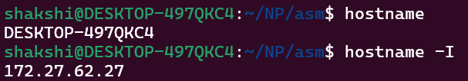
Figure:1.1 Hostname configuration

- This screenshot displays the network configuration of the system using commands such as ip a. It shows the IP address assigned to the host, confirming correct network setup for TCP communication.
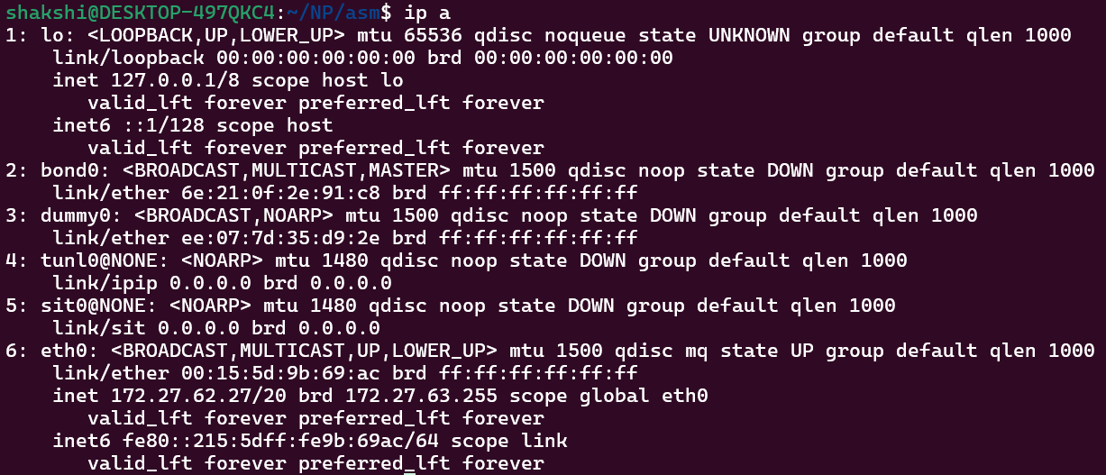
Figure:1.2 Network configuration

- this screenshot shows the server actively listening on port 50727 using ss -ltnp. It confirms that the TCP server is successfully running and bound to the specified port.
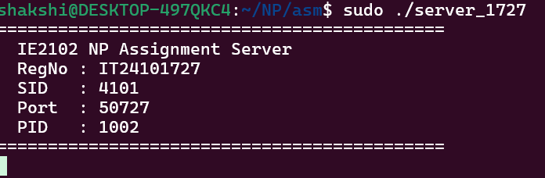
Figure:1.3 Server running

- This screenshot demonstrates successful execution of the REGISTER and LOGIN commands from the client. The server authenticates the user and returns a session token, confirming correct implementation of the authentication system.
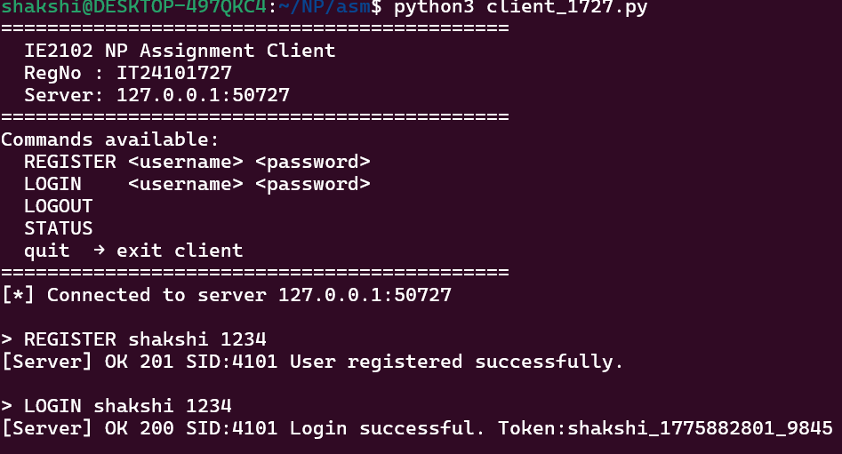
Figure:1.4 Successful REGISTER and LOGIN

- This screenshot shows multiple failed login attempts using incorrect credentials. After exceeding the allowed attempts, the server temporarily locks the account, demonstrating brute-force protection.
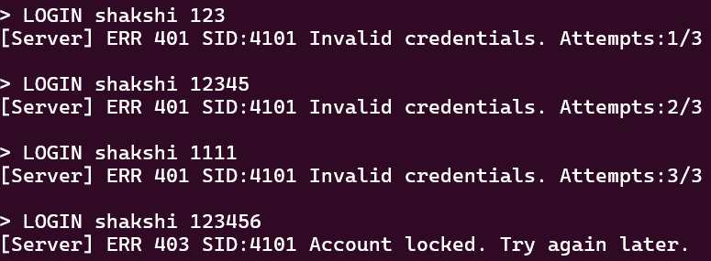
Figure:1.5 Failed login + lockout proof

- This screenshot displays multiple server processes using the ps command. Each client connection is handled by a separate child process created using fork(), confirming concurrent client handling.
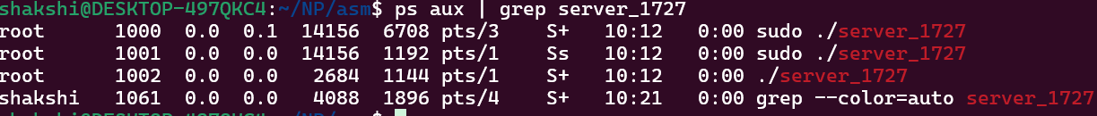
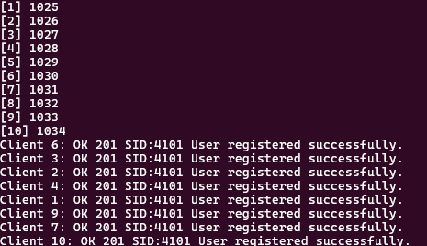
Figure:1.6 Multiple forked processes

- This screenshot shows entries from the server log file. Each log includes timestamp, client IP address, process ID, username, executed command, and result, verifying proper logging functionality.
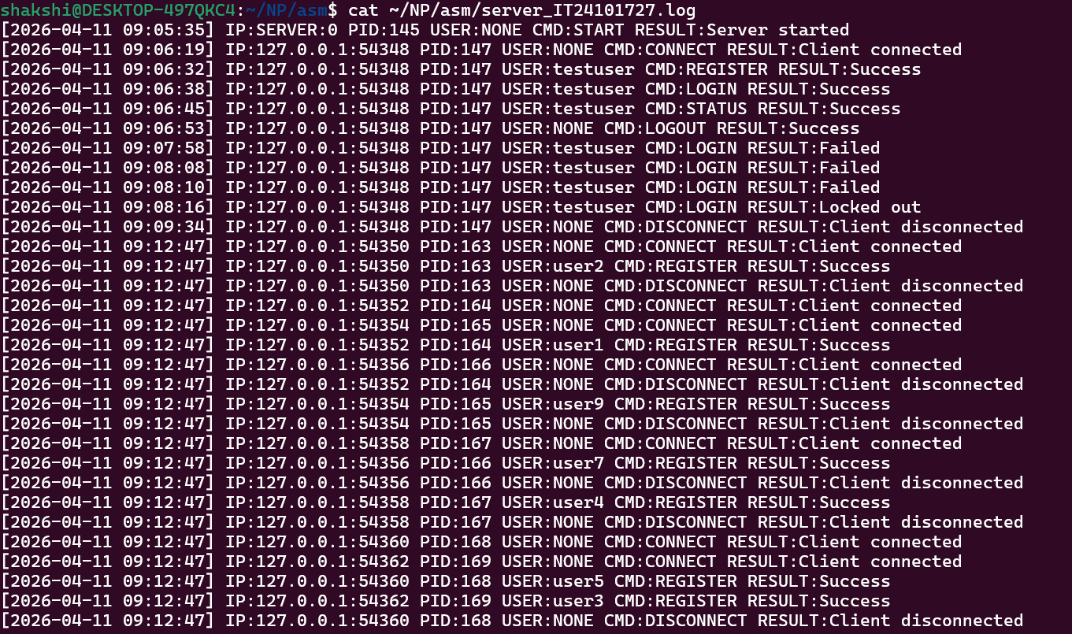
Figure:1.7 Log file entries

- This screenshot shows process status using the ps command. No zombie processes (defunct) are present, confirming correct handling of child processes using SIGCHLD.
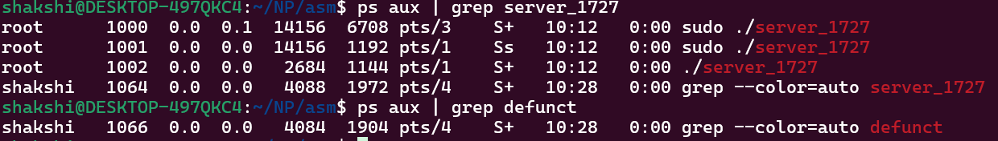
Figure:1.8 Proper child cleanup

