Project 3: Exploring Keyword Co-occurrence Networks in Scientific Publications
- Aims and Objective

The main objective of this project is to analyze the dataset of scientific publication and transform keyword details into a structured co-occurrence network. Here, different scientific publications datasets were studied forming a structured network from the lists of keywords. With the calculated network metrics like Degree and Strength,
the project seeks to find influential keywords which can acts as central hubs and to understand how different research area are connected in border academic fields.
- Methodology
- The keywords columns designated as Keywords 1 to Keywords 12 were from the provided dataset were normalized to lowercase and whitespace were removed.
- The unique keywords were then paired from each article.
- The symmetric weighted adjacency matric was created.
- Using the Network library, the undirected graph was then created to obtain Degree and Strength.
- Finally, for visualizations, a scatter plot is created to support analysis and interpretation.

- Results
The obtained network contains 248 nodes and 2,141 edges. In other words, the network contains 248 keywords and 2141 unique connections.

Top Ten Nodes by Degree
Rank | Keyword | Degree
1 | organizational behavior | 166
2 | organizational effectiveness | 104
3 | management science | 102
4 | personnel management | 93
5 | decision making | 90
6 | organizational structure | 74
7 | organizational sociology | 66
8 | strategic planning | 66
9 | industrial management | 64
10 | corporate governance | 62

Top Ten Nodes by Strength
 | Keyword | Strength
1 | organizational behavior | 265
2 | organizational effectiveness | 144
3 | management science | 136
4 | personnel management | 126
5 | decision making | 112
6 | organizational structure | 107
7 | organizational sociology | 96
8 | strategic planning | 80
9 | industrial management | 84
10 | corporate governance | 85

Top nodes pairs by Weight
Rank | Keyword 1 | Keyword 2 | Weight
1 | Organizational Behavior | Organizational Effectiveness | 11
2 | Organizational Behavior | Organizational Structure | 9
3 | Organizational Behavior | Personnel Management | 8
4 | Management Science | Organizational Behavior | 7
5 | Organizational Effectiveness | Organizational Structure | 6
6 | Organizational Behavior | Organizational Sociology | 6
7 | Decision Making | Organizational Behavior | 6
8 | Corporate Governance | Organizational Behavior | 6
9 | Organizational Sociology | Teams in the Workplace | 5
10 | Industrial Management | Organizational Behavior | 5

Degree and Strength relationship

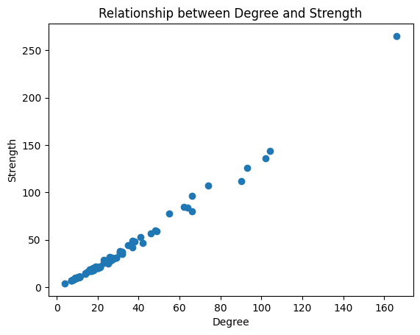
Figure 1: Scatter plot showing relationship between Keyword Degree and Strength.

As per the results obtained, we can conclude that the keyword Organizational Behavior is the most important node in the entire network. The keyword has degree of 166 and strength of 265 meaning that it is the most discussed topic. Also, the most frequent co-occurrence pair is “organizational behavior and “Organizational effectiveness”. This pair has a weight of 11.
As we also can see from the scatter plot (Figure: 1) that the strong positive relationship between Strength and degree is linear with correlation value of approx. 0.99. With this we can conclude that keywords that connect to many other keywords also appear to be more frequent (high strength).
In conclusion, we can say that the keyword network is well-structured and organized.

- Conclusion
The network analysis reveals the structural framework of the provided publication data. The strong connections around organizational behavior indicate that it is a key linking topic that connects various areas of management and data analytics. Overall, this analysis shows how network methods can reveal core research structures, identify influential topics and suggest better academic and strategic decision- makings.

