Information Technology Solutions

MOVIGIL IS A REVOLUTIONARY FLEET SAFETY PLATFORM.

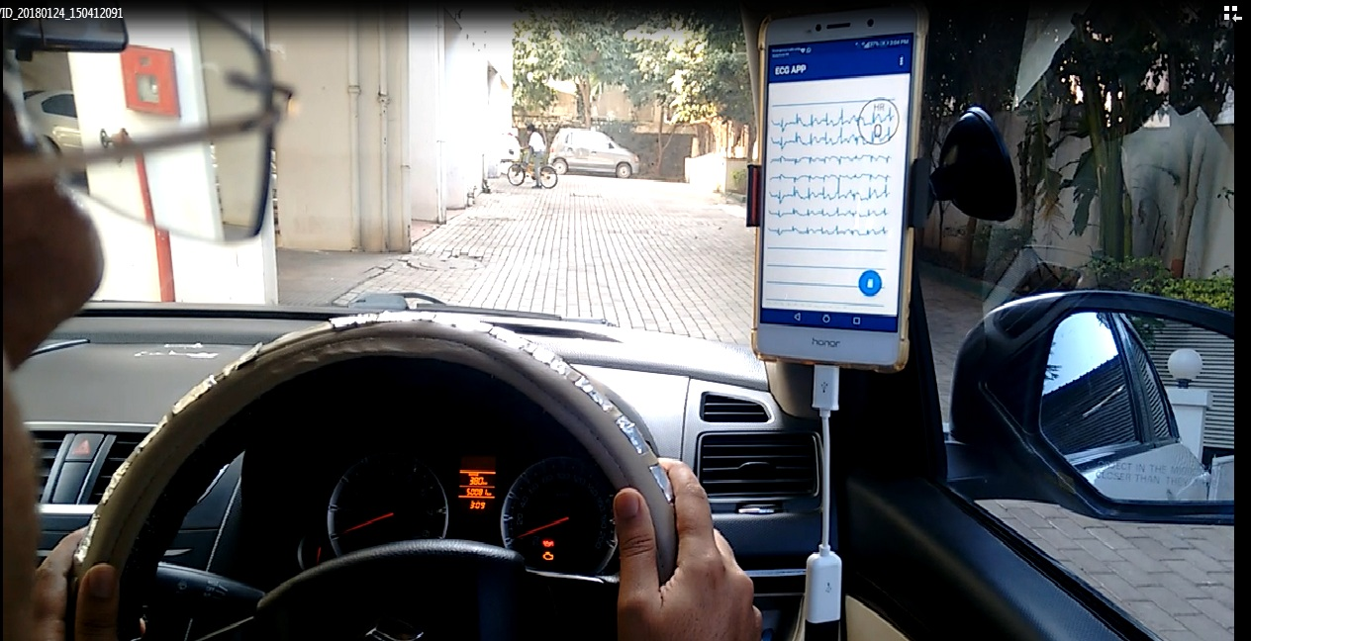

* It monitors the drivers’ well-being by continuously monitoring the body vital signs and combining them with other sensor data captured simultaneously.
* A proprietary sensor fusion algorithm based on machine learning (AI) frameworks provides a comprehensive indication of fatigue experienced by the driver’s body.

REAL ON ROAD TEST DATA

* These tests were carried out in real life driving conditions. (Alpha test) Individuals did 6-8 hours of driving per day, over 2 days covering a total distance of appx 2000 kms.
* Fleet drivers:  (Beta Test) We have completed a controlled test on 5 fleet vehicles. These drivers drove for a minimum of 12 hours/day covering an average distance of over 400 kms/day. Thus we have effectively gathered a dataset spanning approx 10,000 kms clocked over a drive time of approximately 300 hours over 5 business days.

(confidential)

MoVigil

Information for restricted use only. All information and “MoVigil” is proerty of Utsav Systems Inc, Canada. Unauthorised use or transmission of the above information is strictly prohibited.

MoVigil is a specially designed  steering wheel cover with in-built sensors. It can be retrofitted on any vehicle without modifying the internal wiring system. The steering-cover is connected to a small sensor-box hardware which continually captures and processes the driver’s EKG. It also has various other sensors that track vehicle characteristics. The data from multiple sensors is transmitted wirelessly to a mobile App where it is processed by the data fusion algorithm.

Coupled with technologies like artificial intelligence (to process environmental data) and Machine Learning (to make an adaptive model of the prediction algorithm) we provide an indication of upcoming fatigue by calculating a fatigue score.

Should the score reach alarming levels the drivers will receive a haptic feedback on the steering accompanied by audible and visual indication on the mobile device. Fleet Managers will also receive a realtime notification indicating that a certain threshold has been crossed.

**MoVigil**

**Fatigue Management System**

READINESS LEVEL

Product is at TRL 8 as per North America Technology Readiness Level Index. TRL 8 signifies -

*Actual technology completed and qualified through test and demonstration. At this level the*

*technology has been proven to work in its final form and under expected conditions. Activities include developmental testing and evaluation of whether it will meet operational requirements.*



technology

consulting

TECHNICAL SUPPORT

Sit amet, consec tetuer

adipiscing elit, sed diam nonummy nibh euismod

tincidunt ut laoreet dolore

magna aliquam.

ZERO DOWNTIME

Ut wisi enim ad minim veniam, quis nostrud exerci tation

ullamcorper.Et iusto odio

dignissim qui blandit

praeseptatum zzril delenit

augue duis dolore te feugait

nulla adipiscing elit, sed diam nonummy nibh.

TURNKEY SOLUTIONS

Tincidunt ut laoreet dolore magna aliquam erat volut pat.

Ut wisi enim ad minim veniam, quis exerci tation ullamcorper cipit lobortis nisl ut aliquip ex.

For more information on any of our products or services please visit us on the Web at: www.yourwebsitehere.com

Passive

Sed diam nonummy nibh euismod tincidunt ut laoreet dolore magna aliquam erat volutpat.

Ut wisi enim ad minim veniam, quis nostrud exerci tation ullamcorperolor sit amet, consec tetuer.

Et iusto odio dignissim qui blandit praesent luptatum zzril delenit augue duis dolore te feugait nulla facilisi.

Ut wisi enim ad minim veniam, quis exerci tation

ullamcorper suscipit lobortis nisl ut aliquip ex ea

commodo.

Service Features and Benefits

Salient Features

SERVICES AVAILABLE

Technical Support

Installation and Setup

Maintenance

Application Support

Hardware Support

Guaranteed Warranty

5432 Any Street West

Townsville, State 54321

Phone 555.543.5432

Fax 555.543.5433