**ASSIGNMENT A1**

Shantnu Kakkar

CS 5320/6320, Spring 2016

January 27, 2016

**Section 1: Intro:**

This assignment is based on the Perspective Camera Projection Model learnt in the lecture. This model is based the perspective projection equation:

Where,

* p is the image coordinates in Camera’s reference frame. It’s dimension is 3*1
* Z is the z-coordinate of the image in the Camera’s Camera’s reference frame. It’s dimension is 3*1
* M is K(R t), where K is the internal calibration matrix. R and t are the rotation and translation matrices that relate Camera and World Frame
* M is composed of 5 intrinsic factors alpha, beta, theta, x0 and y0.
* alpha and beta are magnifications defined as alpha = k*f and beta = l*f expressed in pixel units, where represent pixel dimensions in pixel/m
* x0 and y0 define the position of the image center in the retinal coordinate system. That means it is the coordinates of co in Figure1 below
* theta is the skew angle in the camera coordinate system that may arise due to manufacturing defect

Figure 1 shows the various parameters described above:

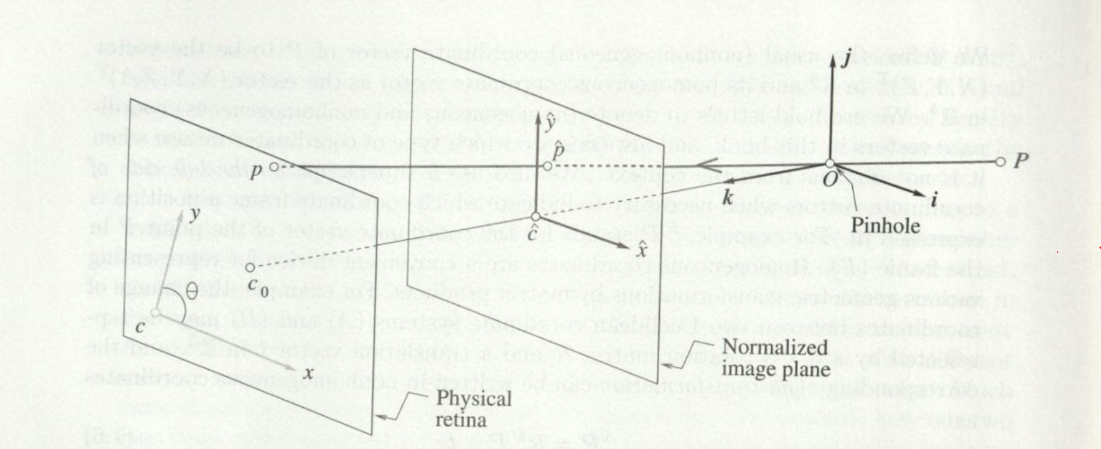

Figure Physical and normalized image coordinate systems

The following question is going to be answered in this report:

1. How does the error in image point location change in terms of change in the various intrinsic parameters?

**Section 2: Method:**

Matlab would be used to carry out the experiments.

We would be doing two experiments by observing the following two plots:

* Trial Number (from 1 to 100) v/s Mean error for each trial
* Variance in the parameter v/s mean error in the point locations in the image

Following functions are made to implement the Perspective projection model:

* CS5320_camera(WorldPoints,alpha,beta,theta,x0,y0,R,t) - produces camera model perspective projection. It takes in input various intrinsic (alpha,beta,theta,x0,y0) and extrinsic parameters and the World points (example world points of a cube or a sphere), and outputs the image points corresponding to those world points.
* CS5320_gen_sphere(C,radius,del_x,del_p) - generate 3D points on the surface of a sphere, with center C, radius radius, del_x step size along major axis to generate points, and del_ p distance between points on the sphere. It outputs a sphere (4xk array): homogeneous coordinates for points on the sphere
* CS5320_gen_cube(C,del_x,S) - generate 3D points on the edges of a cube. C (3x1 vector): center of sphere, del_x (float): step size along edges to generate point, S (float): length of side of cube. It outputs cube (4xk array): homogeneous coordinates for points on the cube
* CS5320_gen_R(u,theta) - generate a rotation matrix about an arbitrary vector. It takes in input as unit vector about which to rotate (u) and theat as amount to rotate (in radians)
* CS5320_question_answer_plot1() - This function is used to plot Trial Number (from 1 to 100) v/s Mean error for each trial, and Variance in the parameter v/s mean error in the point locations in the image. It outputs error vector for number 100 trials, mean of error, variance of error and confidence interval of error. The parameter to be varied is changed inside the function itself. This function also computes mean error , variance or error and confidence interval of error. No inputs are required to give to this function as the value of intrinsic and extrinsic parameter are set inside the function itself.
* CS5320_question_answer_plot1() - This function is used to plot Variance in the parameter v/s mean error in the point locations in the image. The parameter to be varied is changed inside the function itself. This function computes mean error vector, variance vector and confidence interval low and high vectors of error for each variance in index ranging from 0.1 to 1 with increment of 0.1. No inputs are required to give to this function as the value of intrinsic and extrinsic parameter are set inside the function itself.

The following two algorithms are used for getting above two plots respectively:

**PseudoCode to get Trial Number (from 1 to 100) v/s Mean error for each trial**

1. Set a baseline value for all parameters and get the baseline image; e.g.: alpha = 1, beta = 1; theta = pi/2, x0 = 0, y0 = 0, R = eye(3,3), t = [0;0;0]

im = CS5320_camera(WorldPoints,alpha,beta,theta,x0,y0,R,t);

1. pick a noise level based on the Normal distribution (because   
   variance is directly related to noise).  e.g., use the standard normal distribution N(0,1).
2. Pick the parameter to vary and number of trials to run  
         for t = 1:100  
              alphan = alpha + randn;

im_a = CS5320_camera(WorldPoints,alphan,beta,theta,x0,y0,R,t);  
           error(t) = average error in locations of points;  
       end

1. Calculate the mean, variance and confidence interval of the error:
2. Do 3 and 4 for all the intrinsic parameters

**PseudoCode to get Variance in the parameter v/s mean error in the point locations in the image**

1. Set a baseline value for all parameters and get the baseline image; e.g.: alpha = 1, beta = 1; theta = pi/2, x0 = 0, y0 = 0, R = eye(3,3), t = [0;0;0]

im = CS5320_camera(WorldPoints,alpha,beta,theta,x0,y0,R,t);

1. pick a noise level based on the Normal distribution (because   
   variance is directly related to noise).  e.g., use the standard normal distribution N(0,1).
2. Pick the parameter to vary

vs = [0.1:0.1:1];   
num_vs = length(vs);  
for v_index = 1:num_vs  % set variance  
    v = vs(v_index);  
    for t = 1:100   % number of trials  
        alphan = alpha + sqrt(v)*randn;  
        im_a = CS5320_camera(pts,alphan,beta,theta,x0,y0,R,t);  
        % calculate mean error in pt location, etc.  
        errors(t) = ...  
    end  
    means(v_index) = mean(errors);  
    vars(v_index) = var(errors);  
     ci_dn(v_index) = means(v_index) - 1.66*sqrt(vars(v_index)/100);  
     ci_up(v_index) = means(v_index) + 1.66*sqrt(vars(v_index)/100);  
end

1. Do 3 for all the intrinsic parameters

**Section 3: Verification:**

The following figure validates that my code work. Also, the videos A1_trans and A1_rotate validate that my rode is running fine.

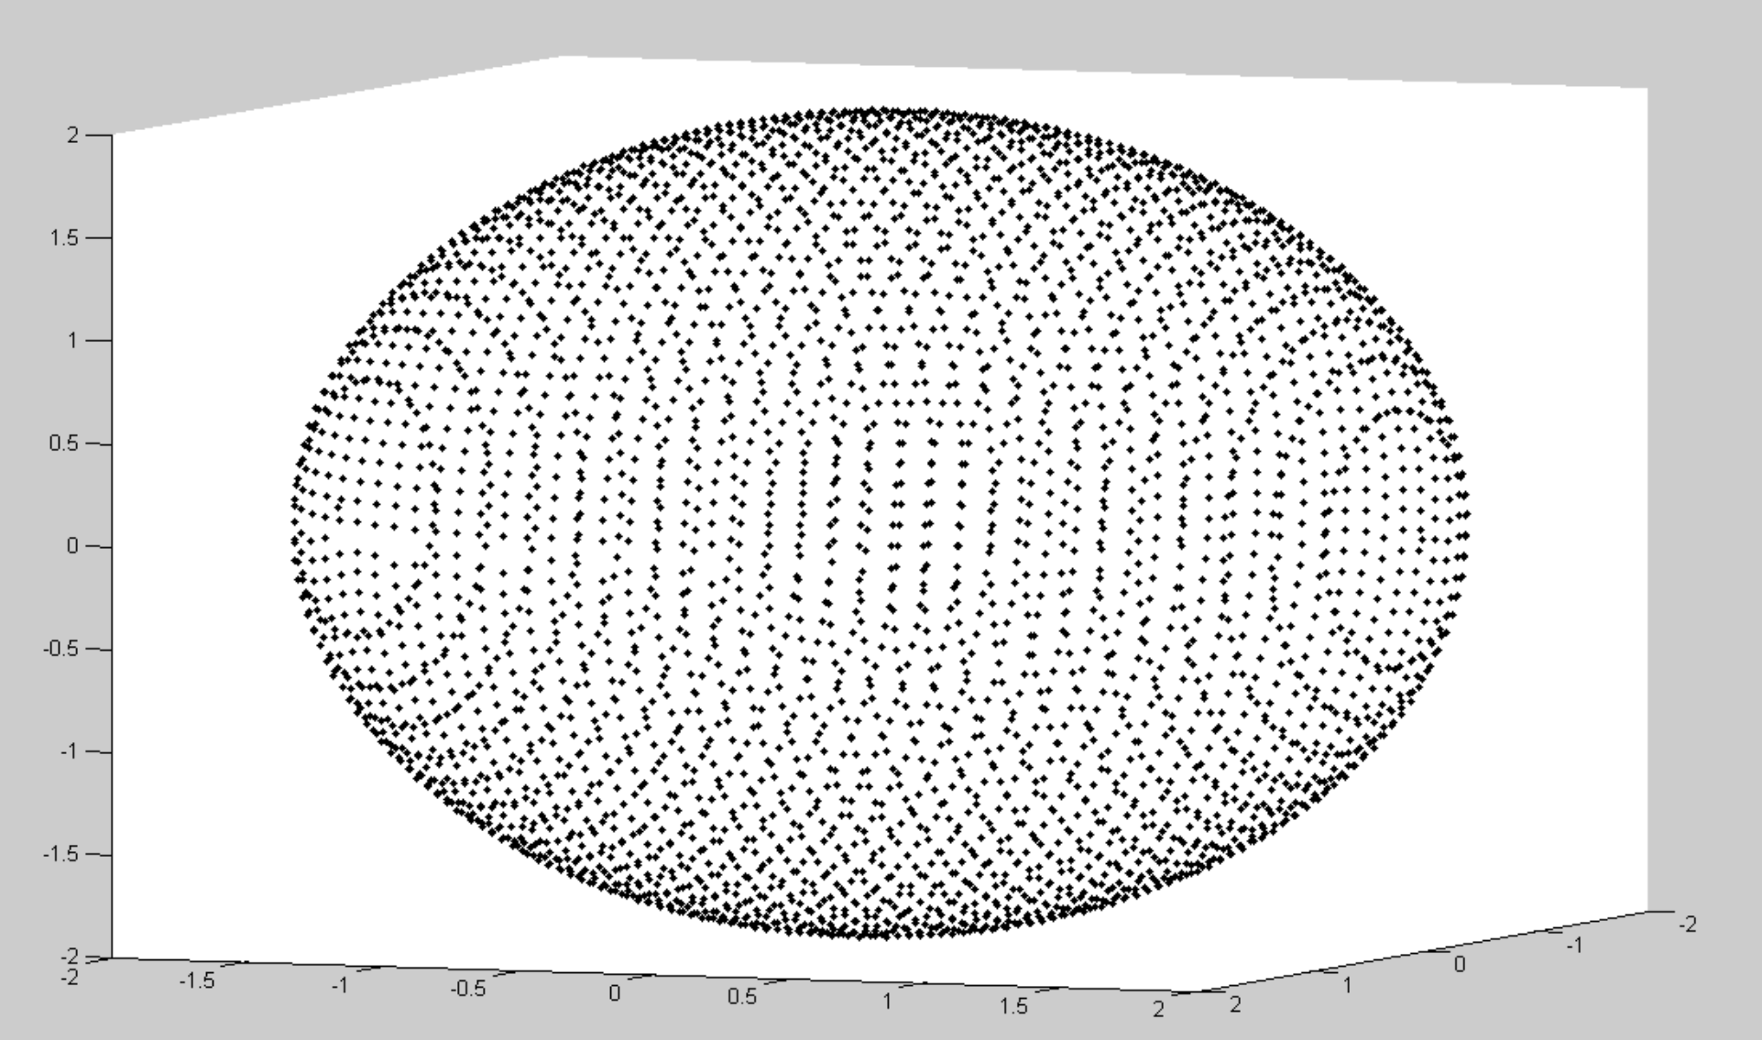

Figure Getting a good sphere on call of CS5320_gen_sphere([0;0;0],2,0.1,0.1);

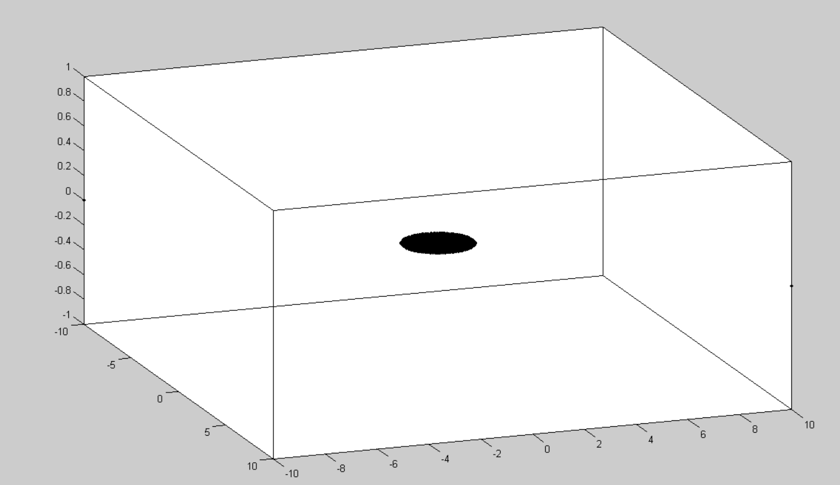

Figure Getting correct 2-d figure (that is a circle) of the sphere generated in Figure 2 using = CS5320_camera function

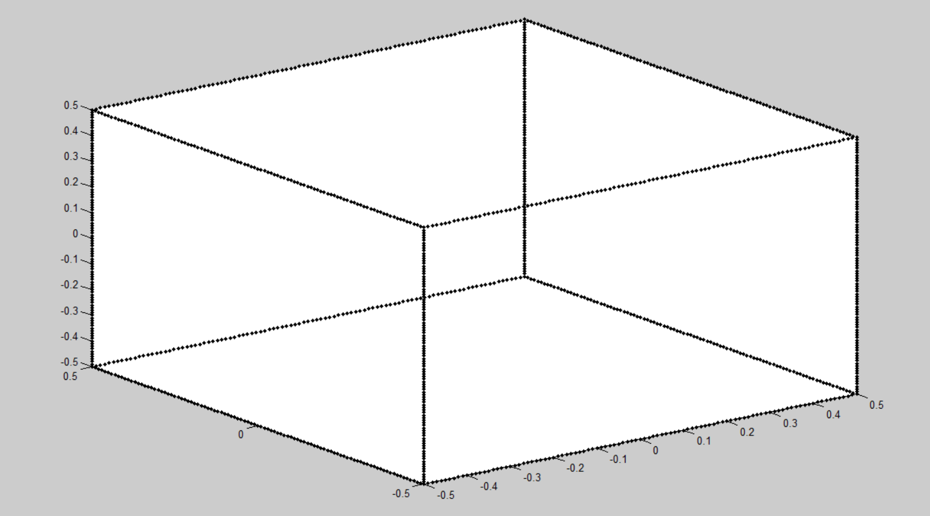

Figure Getting correct cube on call of cube = CS5320_gen_cube([0;0;0],0.01,1);

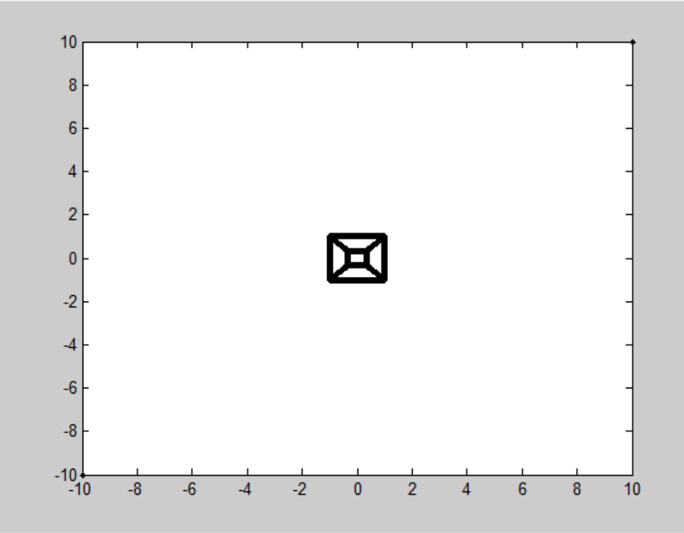

Figure Getting image of cube in figure 4 correctly on call of im = CS5320_camera(cube,1,1,pi/2,0,0,eye(3,3),[0;0;1]);

* a call to CS5320_gen_R with arguments u = [0;0;1] and theta = 0 is giving me the identity matrix.
* I am not able to see my image point If Z is positive, which proves that my CS5320_camera correctly recognies the positive and the negative sides of the camera.

**Section 4: Data:**

Figure 2 and 4 show the world coordinate points of a sphere and a cube respectively, that go into camera function. Figure 3 and 5 show the respective output.

**EXPERIMENT 1:** The following figure show plots for 100 trials with change in various intrinsic parameters. Parameter name is there in the title

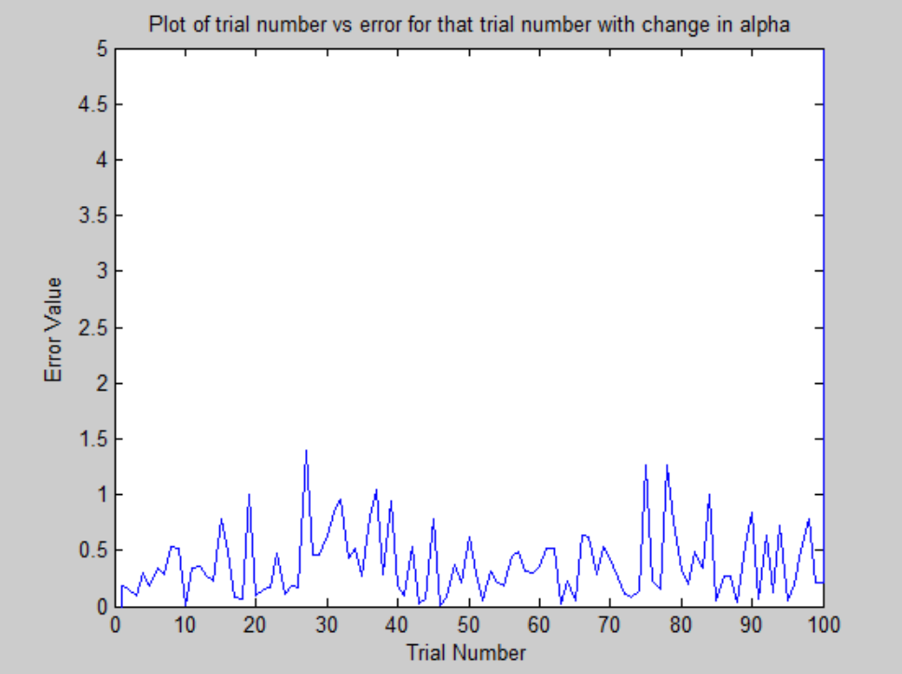

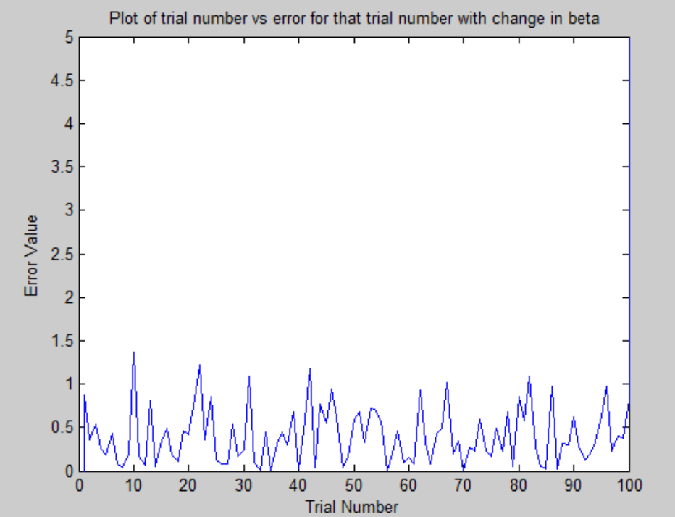

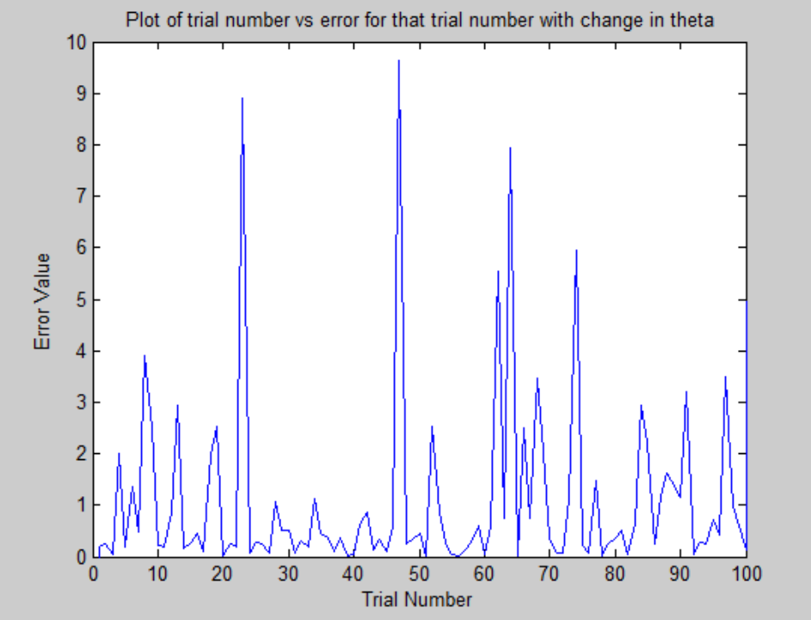

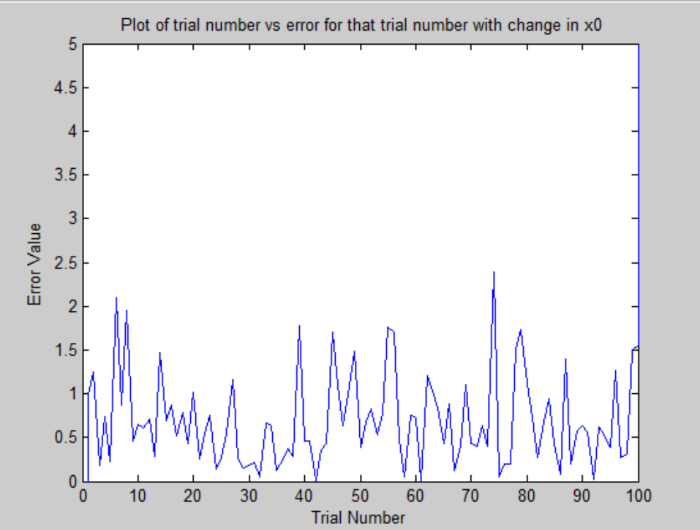

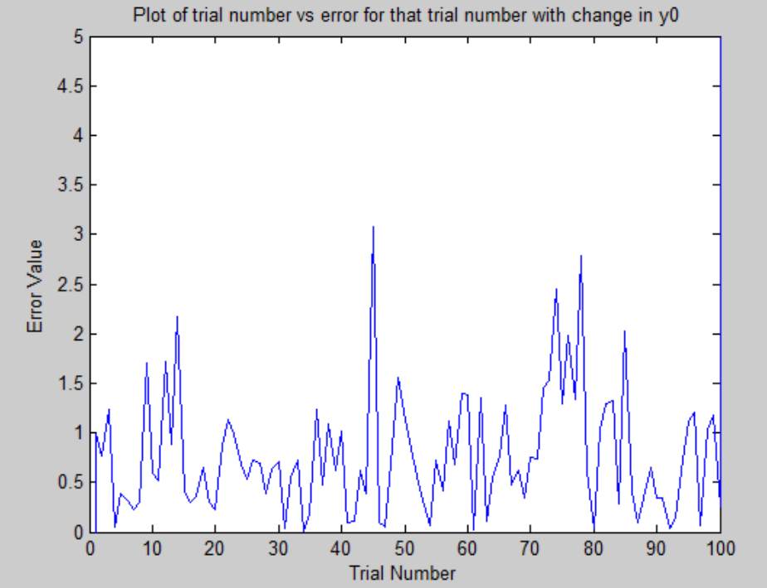

**EXPERIMENT 2:** The following figures show variance in the parameter v/s mean error in the point locations in the image. Parameter name is there in the title

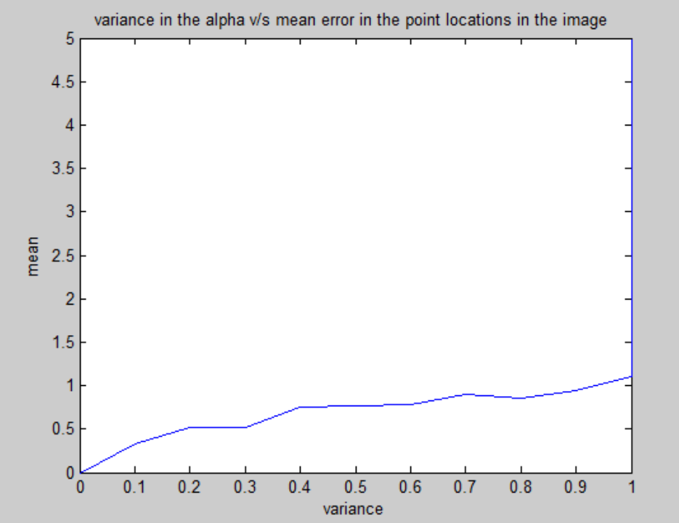

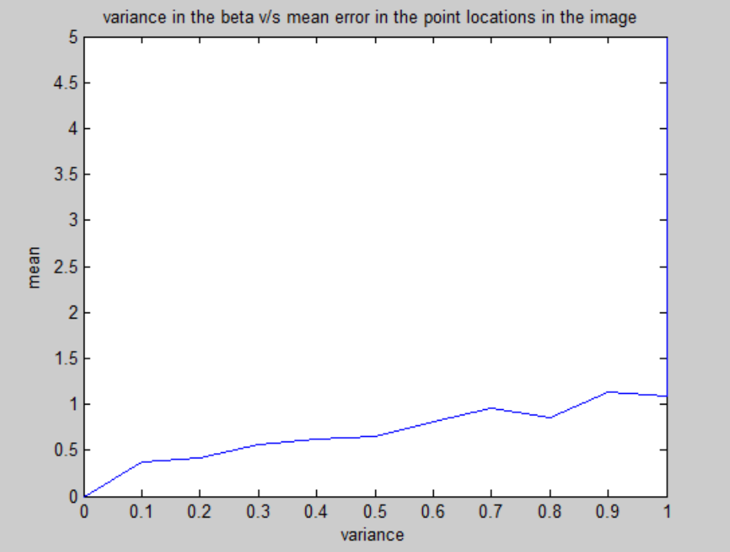

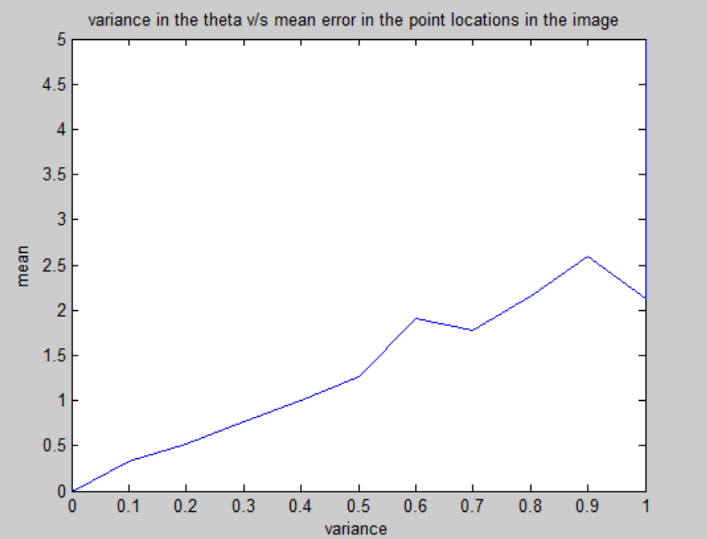

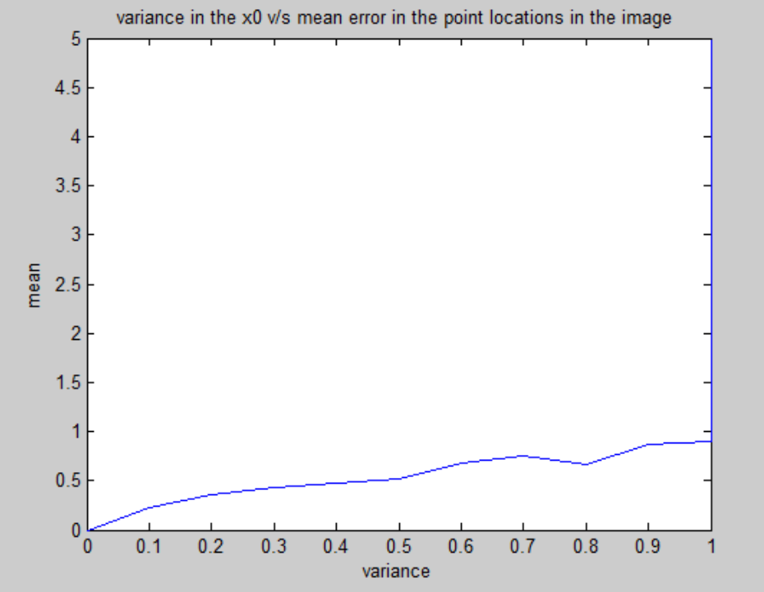

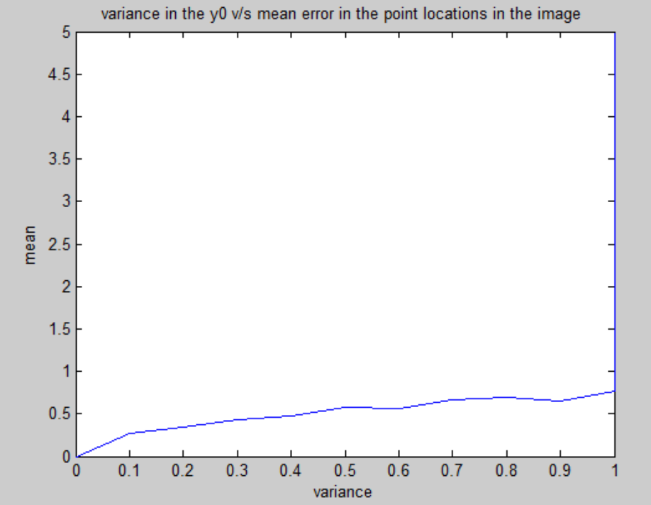

**Section 5: Analysis:**

**Experiment 1: Observing plots for 100 trials with change in various intrinsic parameters.**

Results for change in **alpha**:

**Mean of errors for 100 trials: 0.385577222105104**

**Variance of errors for 100 trials: 0.0943099191691657**

**Confidence interval low for 100 trails: 0.334598754762259**

**Confidence interval high for 100 trails: 0.436555689447949**

Results for change in **beta**:

**Mean of errors for 100 trials: 0.409614792733834**

**Variance of errors for 100 trials: 0.106647033525596**

**Confidence interval low for 100 trails: 0.463825176018140**

**Confidence interval high for 100 trails: 0.355404409449529**

Results for change in **theta**:

**Mean of errors for 100 trials: 1.09415188278690**

**Variance of errors for 100 trials: 3.19702289963163**

**Confidence interval low for 100 trails: 0.797340220242701**

**Confidence interval high for 100 trails: 1.39096354533109**

Results for change in **y0**:

**Mean of errors for 100 trials: 0.698803642702128**

**Variance of errors for 100 trials: 0.271938541882653**

**Confidence interval low for 100 trails: 0.612238416080127**

**Confidence interval high for 100 trails: 0.785368869324129**

Results for change in **y0**:

**Mean of errors for 100 trials: 0.771248446639295**

**Variance of errors for 100 trials: 0.376216407474687**

**Confidence interval low for 100 trails: 0.669429885834437**

**Confidence interval high for 100 trails: 0.873067007444152**

**Experiment 2: Observing plots variance in the parameter v/s mean error in the point locations in the image**

Other than observing variance in the parameter v/s mean error in the point locations in the image (as plotted in figures above), I observed the variance in the parameter v/s variance in error in the point locations, and variance in the parameter vs confidence intervals in error in the point locations. Although I did not draw figures for these for better clarity of the report.

**Section 6: Interpretation:**

The following are my observations:

* Since the noise is Gaussian, the trial number vs error curve is very erratic.
* Changes in x0 and y0 almost double the error in image compared to the error produced by change in alpha and beta
* Change in theta produces the maximum error
* There is almost a linear (not exactly linear but very close to linear as can be seen from Experiment 2 figures above) increase in the mean error for variance in parameters in the range 0.1 to 1 with 0.1 increment. This means that mean error in the point locations in the image is almost linearly directly proportional to variance in the parameter

**Section 7: Critique:**

I better learnt the concept of Perspective Camera Projection Model. The book reading makes more sense now

The experiment could be improved by following ways:

* Drawing variance in the point locations in the image is almost linearly directly proportional to variance in the parameter
* Drawing confidence interval in the point locations in the image is almost linearly directly proportional to variance in the parameter
* Try adding other kind of noises
* Try other world coordinates other than sphere and cube.