**ASSIGNMENT A2**

Shantnu Kakkar

CS 6320, Spring 2016

February 3, 2016

**Section 1: Intro:**

This assignment is based on the Radiometric Stereo surface estimation learnt in the lecture. This estimation is used to reconstruct a patch of surface from a series of pictures of the surface taken under different illuminants. We consider Monge path and orthographic camera. So, the surface is defines a (x,y,f(x,y)) and the point at (x,y,z) in world is mapped to (x,y) in camera. Further we assume a local shading model. The brightness at point (x,y) on surface is:

Where,

* N(x,y) is unit surface normal at point (x,y).
* rho is albedo at point (x,y).
* S1 is the source vector.

The value of Intensity of pixel at (x,y) is:

Where,

* N(x,y) =
* V1 = k*S1, k is constant

A vector V of sources is made and the above equation is called over and over to find the intensities. The following figure 1 shows the algorithm used to retrieve albedo, normal, g and depth. The overall equation comes like this:

Where,

* G(x,y) could be founded by solving system of equations
* V stacks each of n source vectors

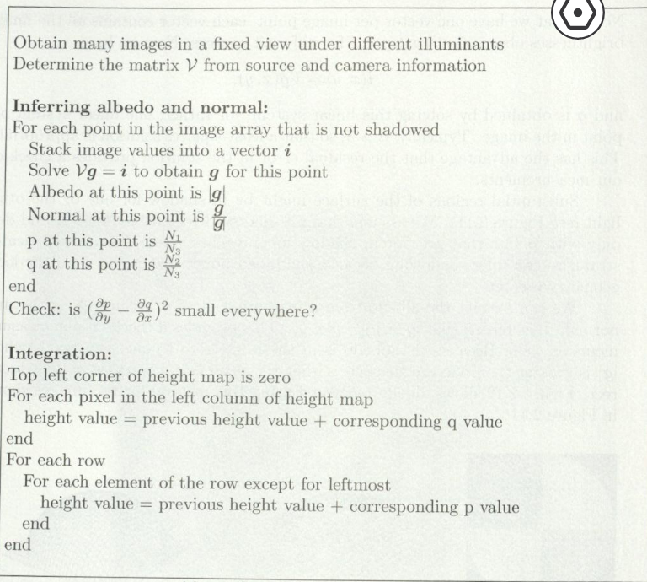

Figure 1 Photometric sterio

The following question is going to be answered in this report:

* What is the relationship between the accuracy of the reconstructed surface properties (rho, N f) and,
* the number of images used

Do statistical analysis for the result of the sequence of steps given in A2 assignement as follows. Based on your results, tell whether number of sources is the only criteria in deciding the mean and variance in error?

% Q = CS5320_ps_sphere(60);

% S1 = [0,0,1];

% I1 = CS5320_ps_render(Q,S1);

% S2 = [0.7,0.7,1];

% S2 = S2/norm(S2);

% I2 = CS5320_ps_render(Q,S2);

% S3 = [-0.7,-0.7,1];

% S3 = S3/norm(S3);

% I3 = CS5320_ps_render(Q,S3);

% S4 = [0.7,-0.7,1];

% S4 = S4/norm(S4);

% I4 = CS5320_ps_render(Q,S4);

% S5 = [-0.7,0.7,1];

% S5 = S5/norm(S5);

% I5 = CS5320_ps_render(Q,S5);

% S = [S1;S2;S3;S4;S5];

% I(:,:,1) = I1;

% I(:,:,2) = I2;

% I(:,:,3) = I3;

% I(:,:,4) = I4;

% I(:,:,5) = I5;

% [rho,N,G,f] = CS5320_pms(I,S);

**Section 2: Method:**

Matlab is used to carry out the experiments.

I do analysis by observing the following plots:

* Number of Sources (from 1 to 20) v/s Mean error in various estimated parameters (rho, N f)

I also compute Mean, Variances and confidence interval in the error in reconstructed surface properties (rho, N f) for the 5 sources given in the A2 assignment that is S1 = [0,0,1]; S2 = [0.7,0.7,1]; S3 = [-0.7,-0.7,1]; S4= [0.7,-0.7,1]; S5 = [-0.7,0.7,1];

Following functions are implemented

* CS5320_ps_sphere – it generates photometric stereo data for checker sphere. The input is size of hieght image (pixels) [sphere radius is size/2]. The outputs: Q (sizexsizex7 array) tells about complete info set for photometric stereo. That is Q(:,:,1): x values for height function, Q(:,:,2): y values for height function, Q(:,:,3): z values for height function, Q(:,:,4): x normal values for surface, Q(:,:,5): y normal values for surface, (:,:,6): z normal values for surface, (:,:,7): albedo value for surface.
* CS5320_ps_render(Q,S) – it renders images from surface model. The input is Q (nxnx7 array): photometric stereo data (from CS5320_ps_sphere), S (3x1 vector): light source direction, and the output is im (nxn array): gray level image of surface with light source S.
* CS5320_pms – it recover surface properties using photometric stereo. The input are I (nxnxk array): k nxn images of surface, S (nx3 array): light source vectors, and the outputs are rho (nxn array): albedo values of surface, N (nxnx3 array): surface normal, g (nxnx3 array): surface description (= rho*N), and f (xnx array): height map.
* CS5320_ps_error - it calculates errors in estimation of depth, rho and N. The input is rho (nxn array): albedo values of surface, N (nxnx3 array): surface normal, g (nxnx3 array): surface description (= rho*N) and f (xnx array): height map, and the output is meanError_Rho (1x1): mean error in row, meanError_N (1x1): mean error in normal meanError_depth(1x1): mean error in f.
* CS5320_runTest - it finds mean error in depth, rho and normal with the change in number of sources. The number of sources are varied from MinNumOfSources to MaxNumOfSources. The plot functions below could be uncommented to see the plots.

The following algorithms are used for getting above plots respectively:

* **PseudoCode to plot Number of Sources (from 1 to 20) v/s Mean error in various estimated parameters (rho, N f)**

1. Generate photometric stereo data for checker sphere that is Q = CS5320_ps_sphere(60);
2. Set MinNumOfSources = 3; MaxNumOfSources = 20;

1. For loop from NumOfSources = MinNumOfSources to MaxNumOfSources
   1. S = [];
   2. For loop from i = 1 to NumOfSources
      1. Stemp = [randn,randn,randn];
      2. Stemp = Stemp/norm(Stemp);
      3. Itemp = CS5320_ps_render(Q,Stemp);
      4. S = [S;Stemp];
      5. I(:,:,i) = Itemp;
2. Recover surface properties using photometric stereo that is [rho,N,G,f] = CS5320_pms(I,S);
3. Find meanError_depth, meanError_rho, meanError_N using CS5320_ps_error(Q,rho,N,G,f);
4. Draw plots

**Section 3: Verification:**

* Testing CS5320_ps_sphere
* Calling sphere of size zero gives an empty array

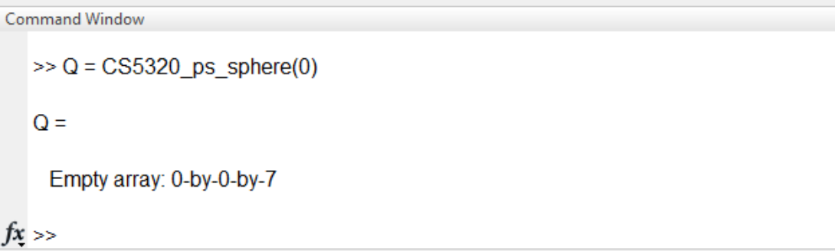

* Testing CS5320_ps_render
* Considering Q(20,20,4:6) that is the normal, let us calculate intensity at (20,20) by hand and by our function

I(20,20) = 1*[ -0.3559 0. 3559 0.8641]. [0,0,1]’ = 0.8641

By matlab,

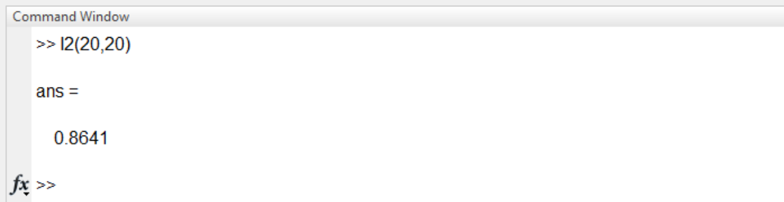

* Testing CS5320_pms by comparing estimated rho and depth with original values. We are getting close values.

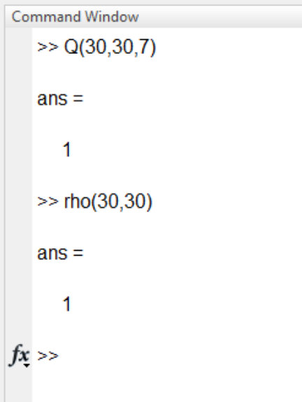

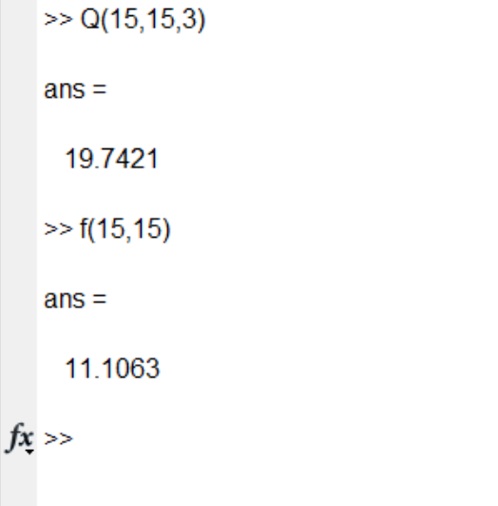

**Section 4: Data:**

Following figure show the world coordinate data of the sphere, that go into the CS5320_ps_render function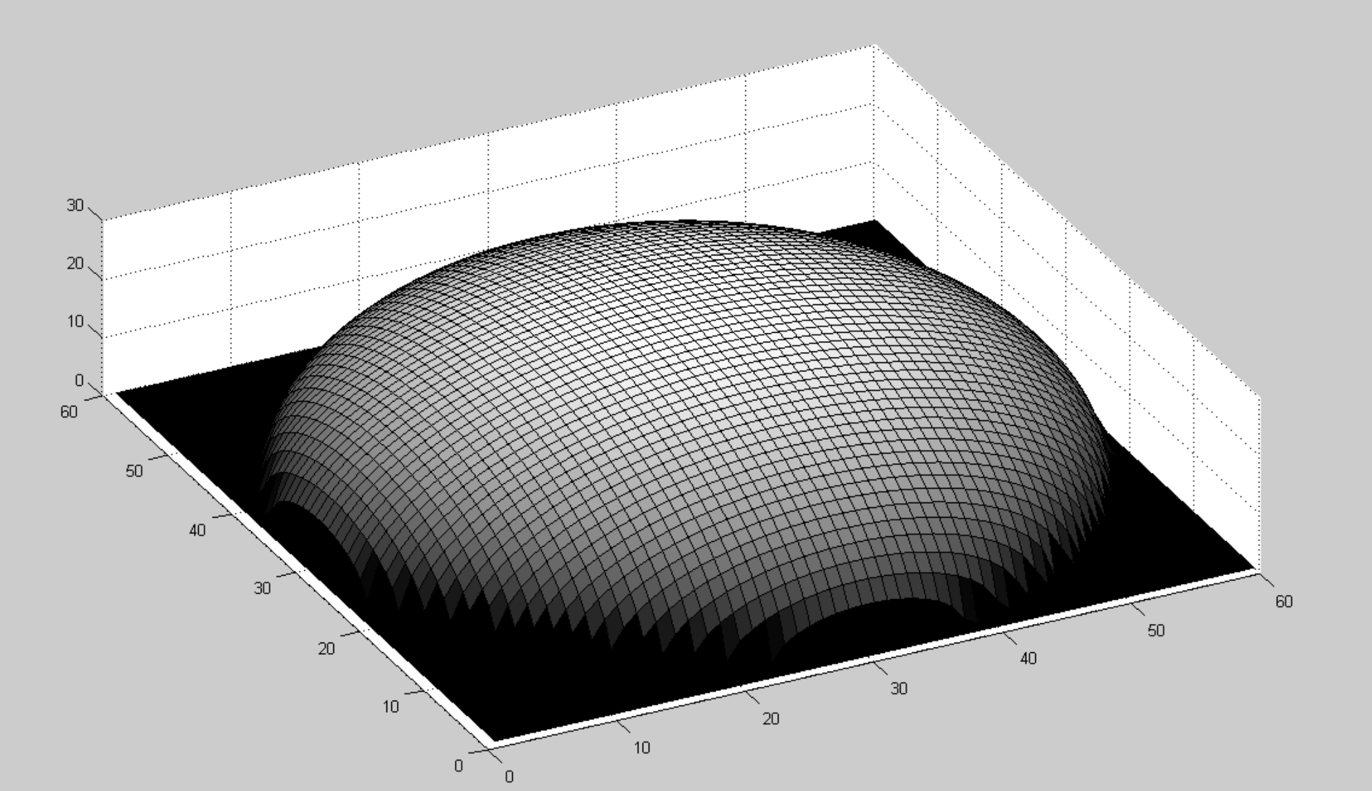

Following figure shows the image data that goes into the CS5320_pms function

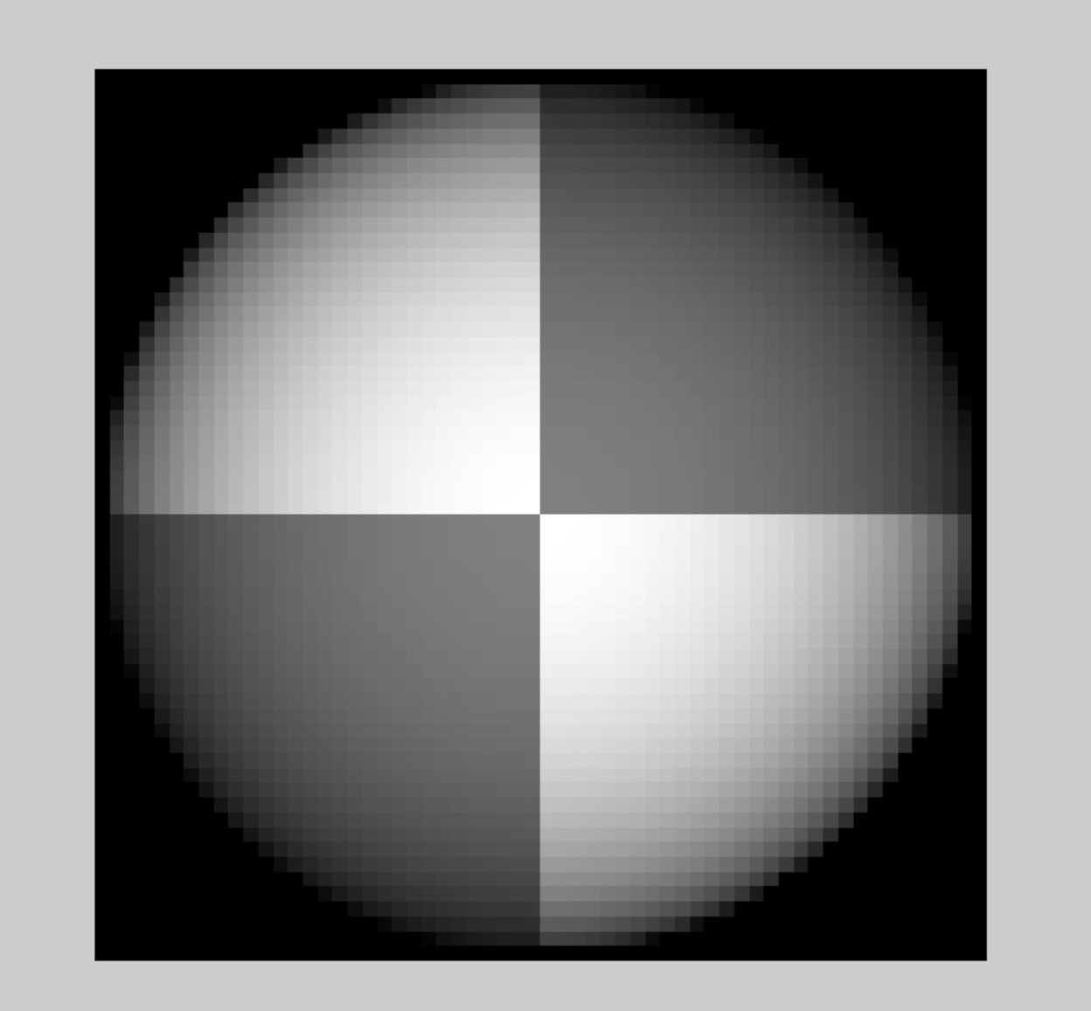

The following is the output data (reconstructed sphere) that I am getting after the CS5320_pms function

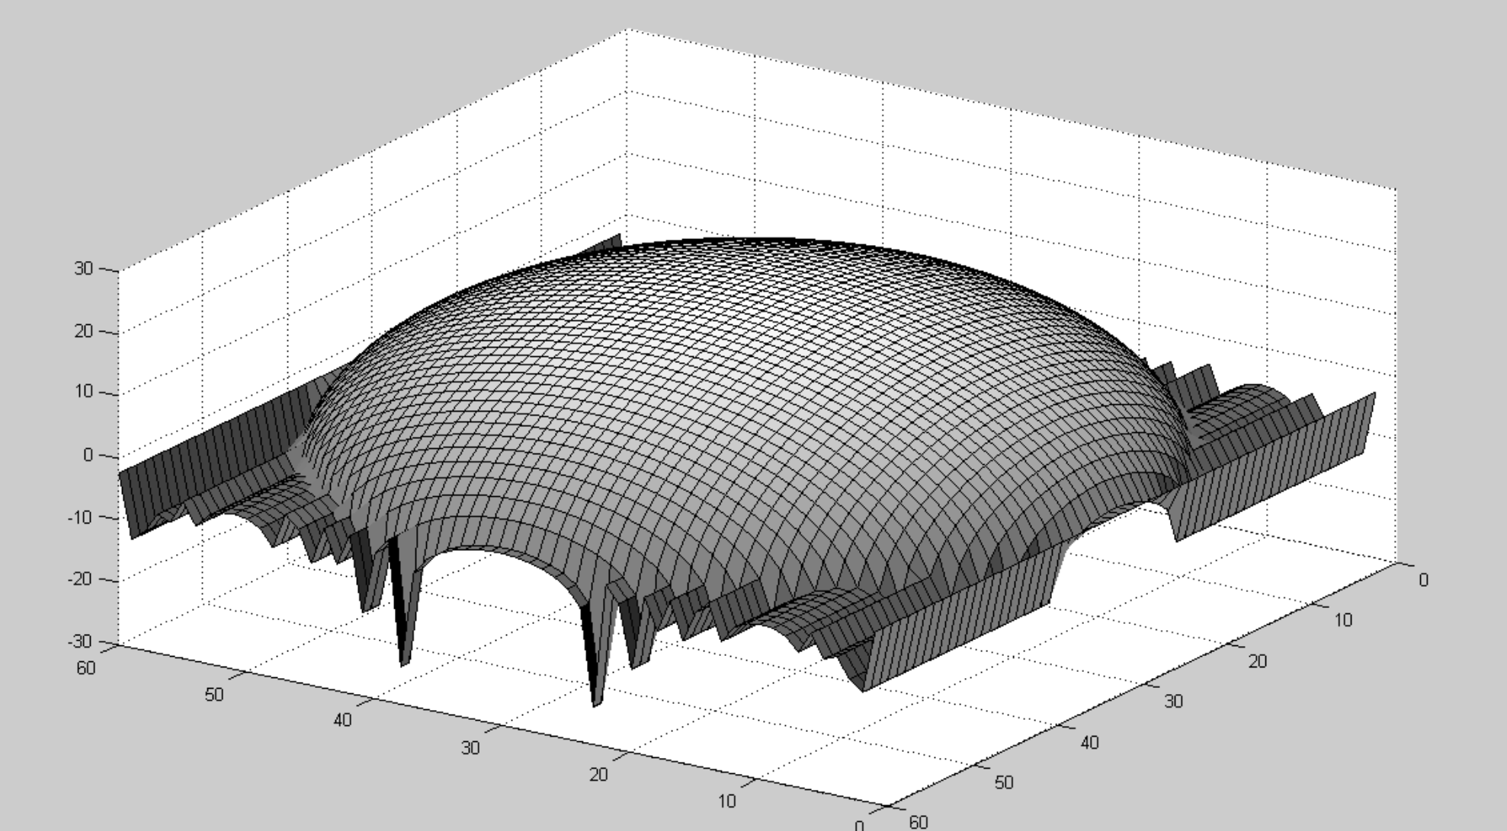

* **EXPERIMENT 1:** The following figure show plots for Number of Sources (from 1 to 20) v/s Mean error and variance in error for various estimated parameters (rho, N f)

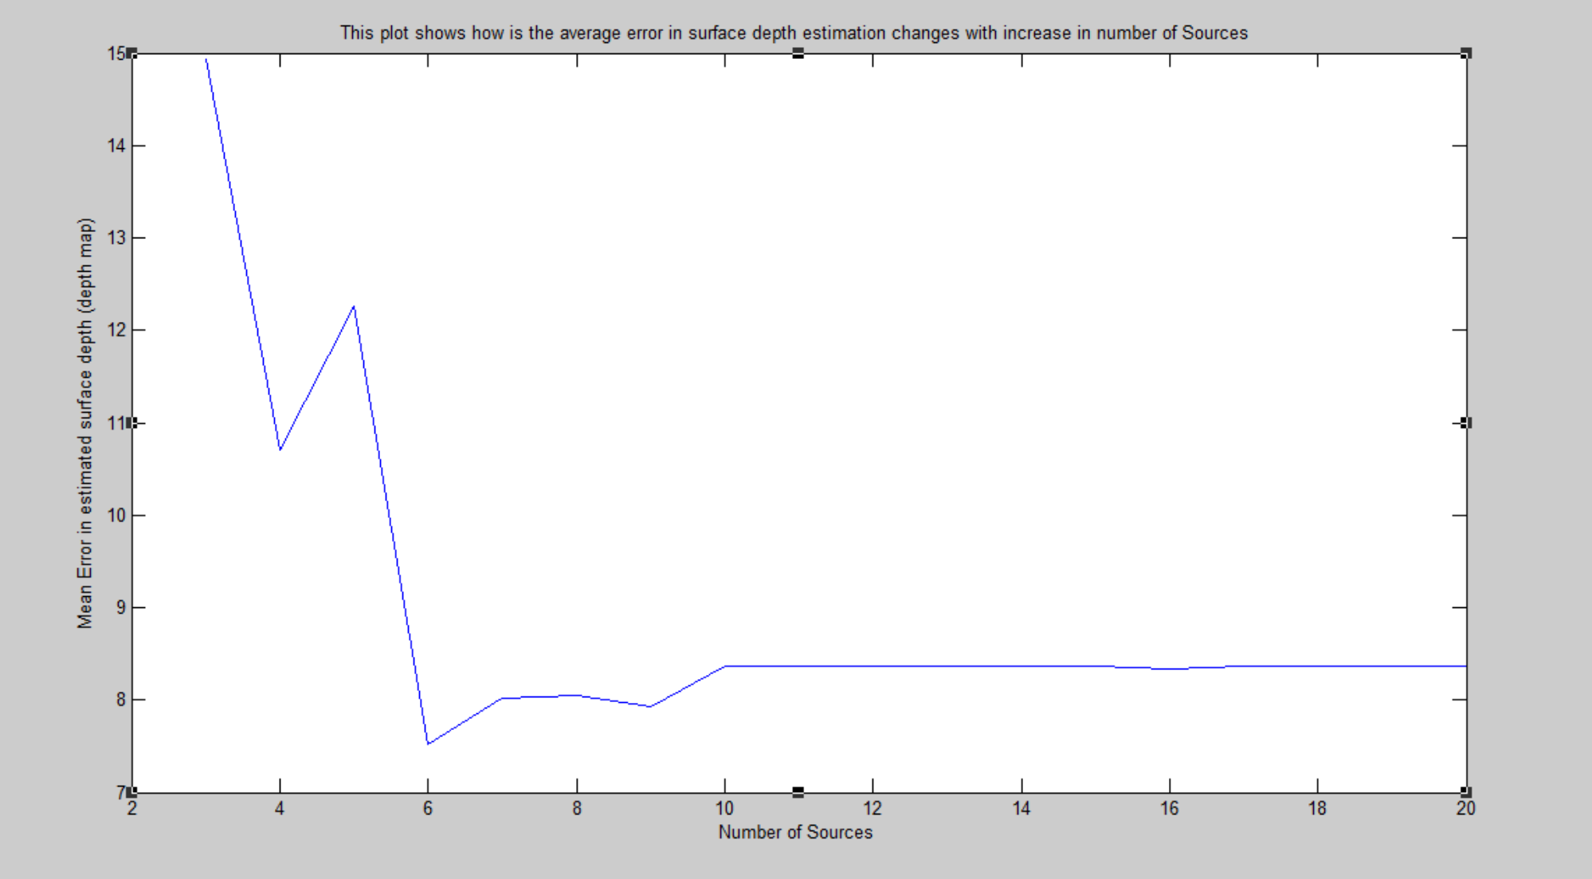

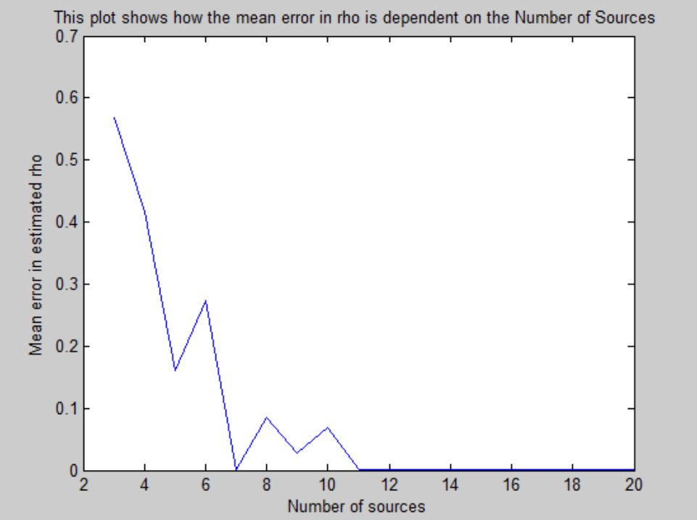

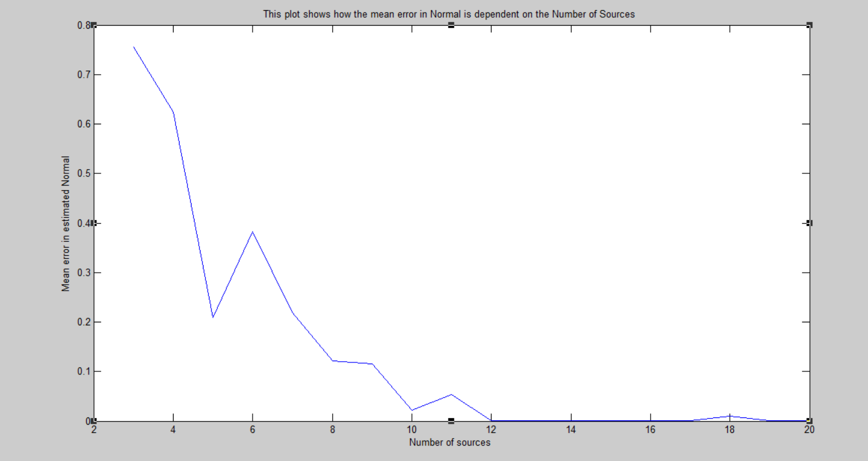

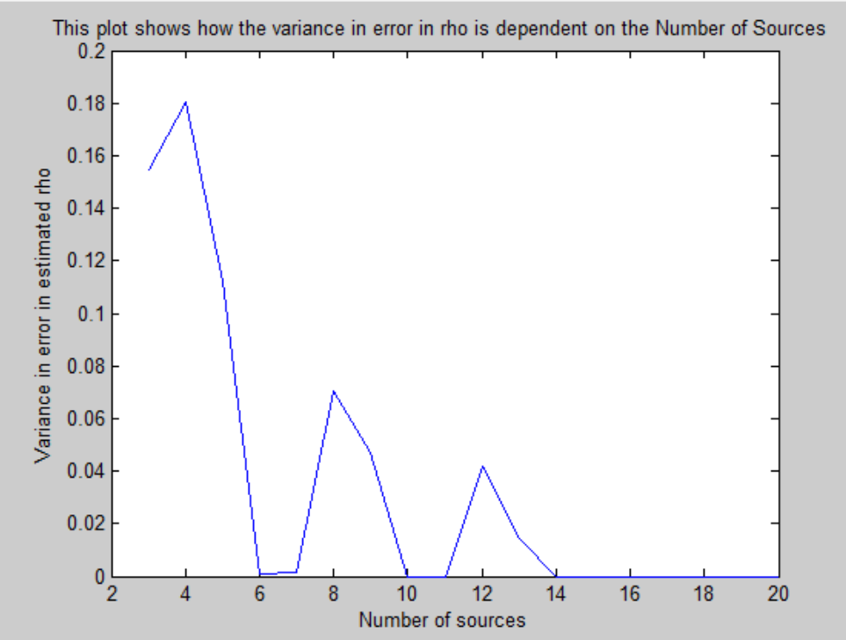

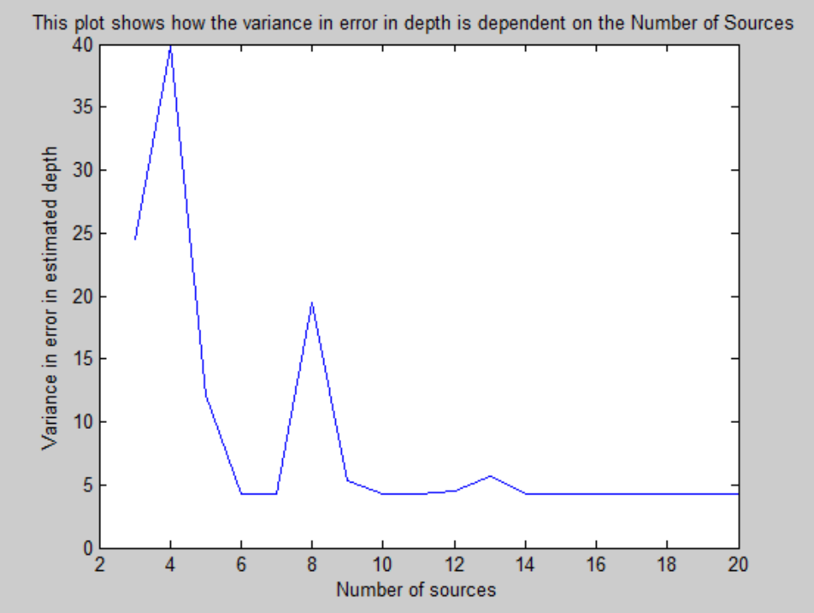

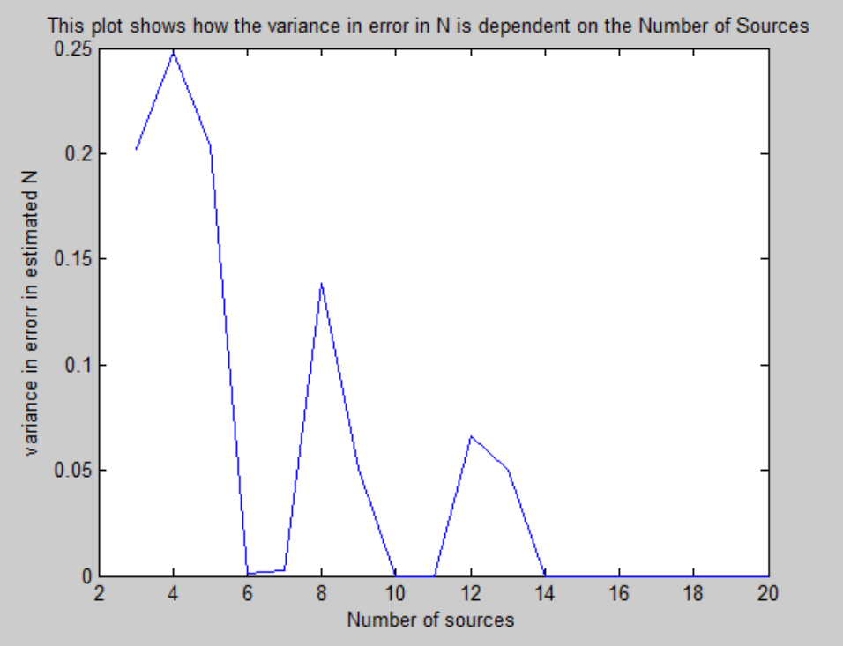

here N is normal

**Section 5: Analysis:**

**Experiment: Performing the sequence of actions given in A2 assignment that is**

% Q = CS5320_ps_sphere(60);

% S1 = [0,0,1];

% I1 = CS5320_ps_render(Q,S1);

% S2 = [0.7,0.7,1];

% S2 = S2/norm(S2);

% I2 = CS5320_ps_render(Q,S2);

% S3 = [-0.7,-0.7,1];

% S3 = S3/norm(S3);

% I3 = CS5320_ps_render(Q,S3);

% S4 = [0.7,-0.7,1];

% S4 = S4/norm(S4);

% I4 = CS5320_ps_render(Q,S4);

% S5 = [-0.7,0.7,1];

% S5 = S5/norm(S5);

% I5 = CS5320_ps_render(Q,S5);

% S = [S1;S2;S3;S4;S5];

% I(:,:,1) = I1;

% I(:,:,2) = I2;

% I(:,:,3) = I3;

% I(:,:,4) = I4;

% I(:,:,5) = I5;

% [rho,N,G,f] = CS5320_pms(I,S);

There are 3600 pixels. Each pixel has an error in estimated depth, rho and normal. So corresponding to the 3600 pixels, there are 3600 errors in depth, 3600 errors in rho and 3600 errors in normal. I am finding mean, variance, and confidence interval of these 3600 errors for depth, row and normal.

Statistical analysis for **depth**

**Mean of error in estimated depth: 8.360062109702902**

**Variance of errors in estimated depth: 4.265085815468075**

**Confidence interval low of errors in estimated depth: 8.020335324715289**

**Confidence interval high of errors in estimated depth: 8.699788894690515**

Statistical analysis for **Normal**

**Mean of errors in estimated Normal: 1.710377649089725e-16**

**Variance of errors in estimated Normal: 2.781858631894219e-32**

**Confidence interval low of errors in estimated Normal: 1.436009666184074e-16**

**Confidence interval high of errors in estimated Normal: 1.984745631995376e-16**

Statistical analysis for **rho**

**Mean of errors in estimated rho: 6.858711129906522e-17**

**Variance of errors in estimated rho: 9.951047360370298e-33**

**Confidence interval low of errors in estimated rho: -1.362345107398230e-09**

**Confidence interval high of errors in estimated rho: 1.362345244572452e-09**

**Section 6: Interpretation:**

The following are my observations:

* As the number of sources increases, the error In the estimation of rho, normal and depth decreases. Infact, if there are more than 10 sources then error decreases to negligible.
* The maximum error (especially for lower values of number of sources) is seen in case of depth. This error in estimation of depth is natural since we are considering delx/delz and dely/delz, which are calculated discretely. We do not have a continuous function.
* Variance is extremely high in case of depth estimation especially for lower number of sources.
* The behaviour of plot of number of sources vs variance (although decreasing), but is still more erratic compared to the number of sources vs mean plot.
* The values of mean and variance are relatively small for the sources given in the A2 assignment (that is 5 sources given which are S1 = [0,0,1]; S2 = [0.7,0.7,1]; S2 = [-0.7,-0.7,1]; S2 = [0.7,-0.7,1]; S2 = [-0.7,0.7,1]. If we see that plot the mean error in depth should be around 12 and the variance in error should be around 10. However, we are getting the mean error and variance errors as only 8 and 4 respectively. This clearly shows that other than number of sources, there are other parameters that play a role in deciding the statistical analysis. The parameter that I could think of is Source Vector Directions or the distribution of the light source locations

**Section 7: Critique:**

The experiment could be improved by following ways:

* Drawing confidence intervals vs number of sources
* Changing distribution of light sources more.
* Changing number of pixel or in other words radius of sphere,
* Currently the estimation is assuming p and q values directly. That needs to be done more mathematically.

**Section 8: log**

20 hours total