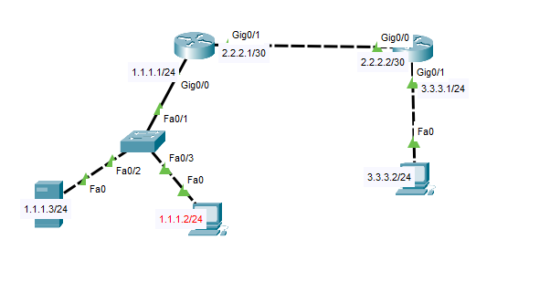

**RouterNo1:**

RouterNo1(config)#int g0/0

RouterNo1(config-if)#ip add 1.1.1.1 255.255.255.0

RouterNo1(config-if)#no sh

RouterNo1(config-if)#exit

RouterNo1(config)#int g0/1

RouterNo1(config-if)#ip add 2.2.2.1 255.255.255.252

RouterNo1(config-if)#no sh

RouterNo1(config-if)#exit

**DHCP settings:**

Router(config)#ip dhcp pool lan1.1

RouterNo1(dhcp-config)#default-router 1.1.1.1

RouterNo1(dhcp-config)#network 1.1.1.0 255.255.255.0

RouterNo1(dhcp-config)#dns-server 9.9.9.9

RouterNo1(dhcp-config)#do wr

RouterNo1(dhcp-config)#exit

**Server connecting commands:**

RouterNo1(config)#aaa new-model

RouterNo1(config)#aaa authentication login default group tacacs+ local

RouterNo1(config)#taca

RouterNo1(config)#tacacs-server host 1.1.1.3

RouterNo1(config)#taca

RouterNo1(config)#tacacs-server key gns

RouterNo1(config)#line vty 0 2

RouterNo1(config-line)#login authentication default

RouterNo1(config-line)#do wr

**Routing:**

ip route to reach RouterNo2:

RouterNo1(config)#ip route 3.3.3.0 255.255.255.0 2.2.2.2

**RouterNo2:**

RouterNo2(config)#int g0/1

RouterNo2(config-if)#ip add 3.3.3.1 255.255.255.0

RouterNo2(config-if)#no sh

RouterNo2(config-if)#exit

RouterNo2(config)#int g0/0

RouterNo2(config-if)#ip add 2.2.2.2 255.255.255.252

RouterNo2(config-if)#no sh

RouterNo2(config-if)#exit

**User creation**:

RouterNo2(config)#username amirul password a

RouterNo2(config)#enable password enable

RouterNo2(config)#do wr

RouterNo2(config)#exit

**DHCP settings:**

Router(config)#ip dhcp pool lan3.1

RouterNo2(dhcp-config)#default-router 3.3.3.1

RouterNo2(dhcp-config)#network 3.3.3.0 255.255.255.0

RouterNo2(dhcp-config)#dns-server 9.9.9.9

RouterNo2(dhcp-config)#do wr

RouterNo2(dhcp-config)#exit

**Server connecting commands:**

RouterNo2(config)#aaa new-model

RouterNo2(config)#aaa authentication login default group tacacs+ local

RouterNo2(config)#tacacs-server host 1.1.1.3

RouterNo2(config)#tacacs-server key gns

RouterNo2(config)#line vty 0 2

RouterNo2(config-line)#login authentication default

RouterNo2(config-line)#do wr

Routing:

ip route to reach RouterNo1:

RouterNo2(config)#ip route 1.1.1.0 255.255.255.0 2.2.2.1

**Server AAA configure:**

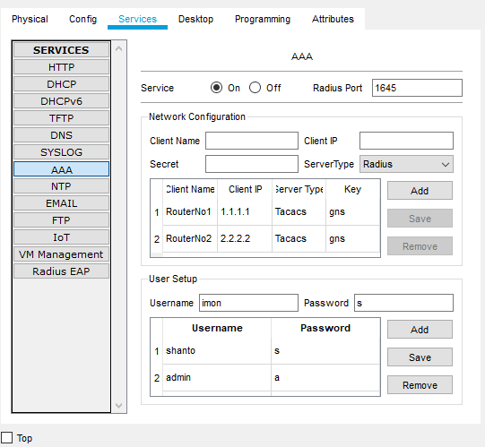

PC cmd prompt: PC1

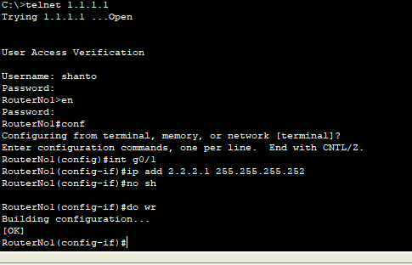

PC2:

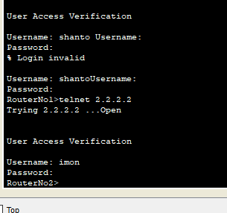

Cut off the server connection and login via local:

