**Name : MD. Amirul Hasan Shanto**

**ID : IT-17027**

**Course Code : ICT-3208**

**Ping information & captured packet: ping 8.8.8.8 in powershell**

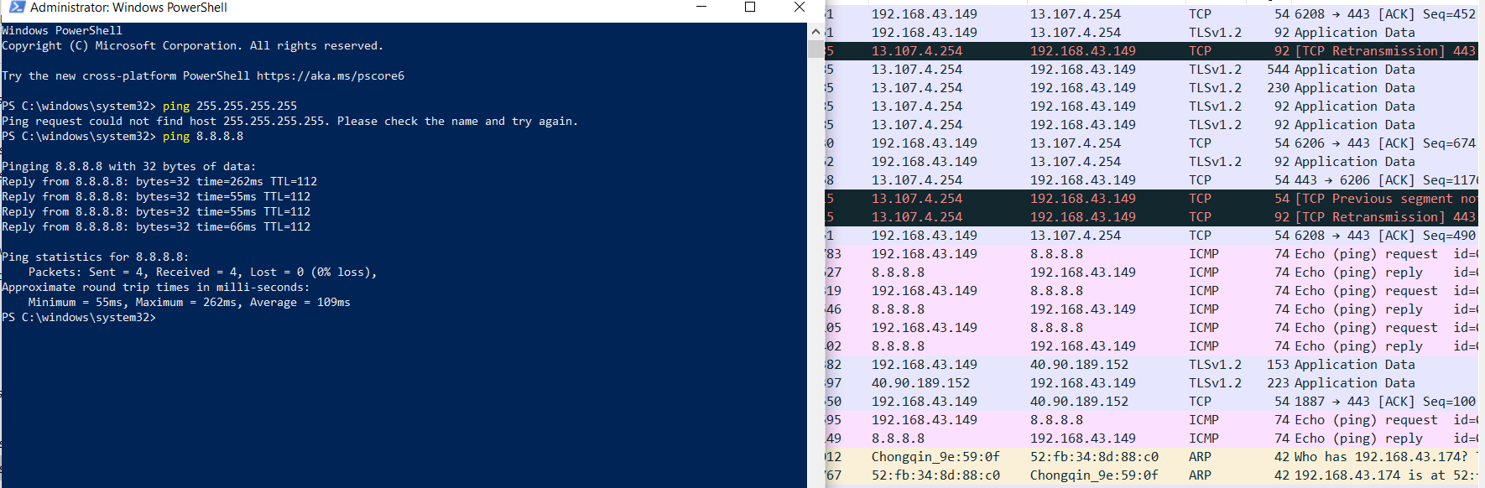

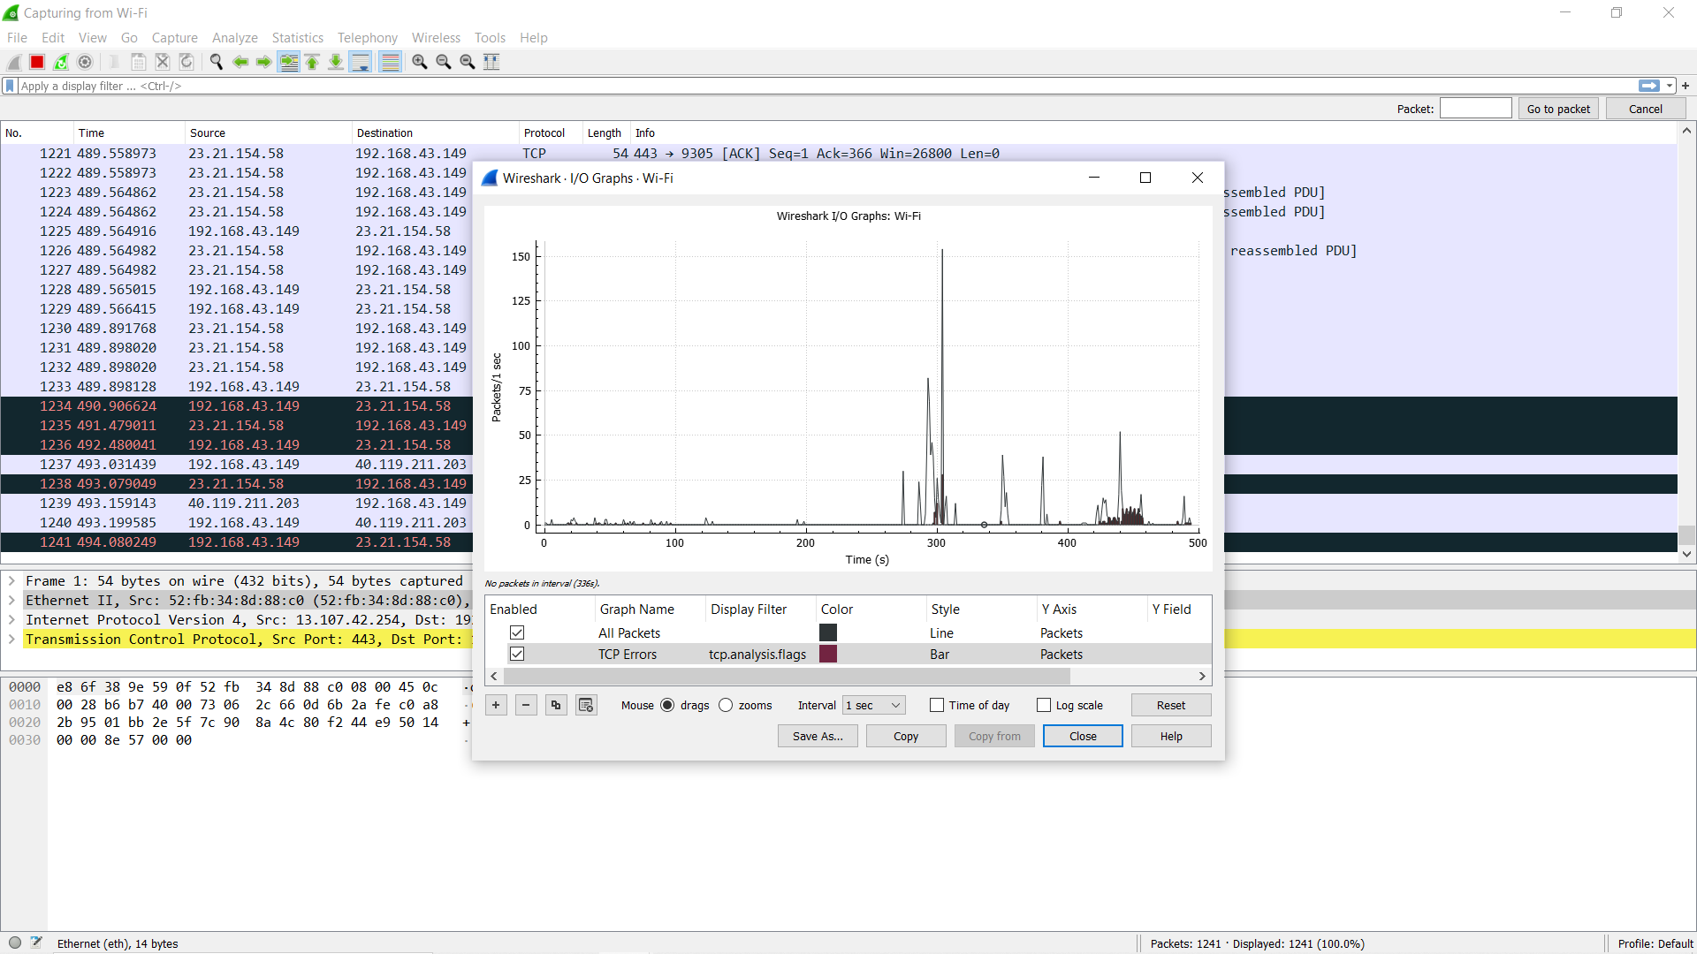

**The protocol information :**

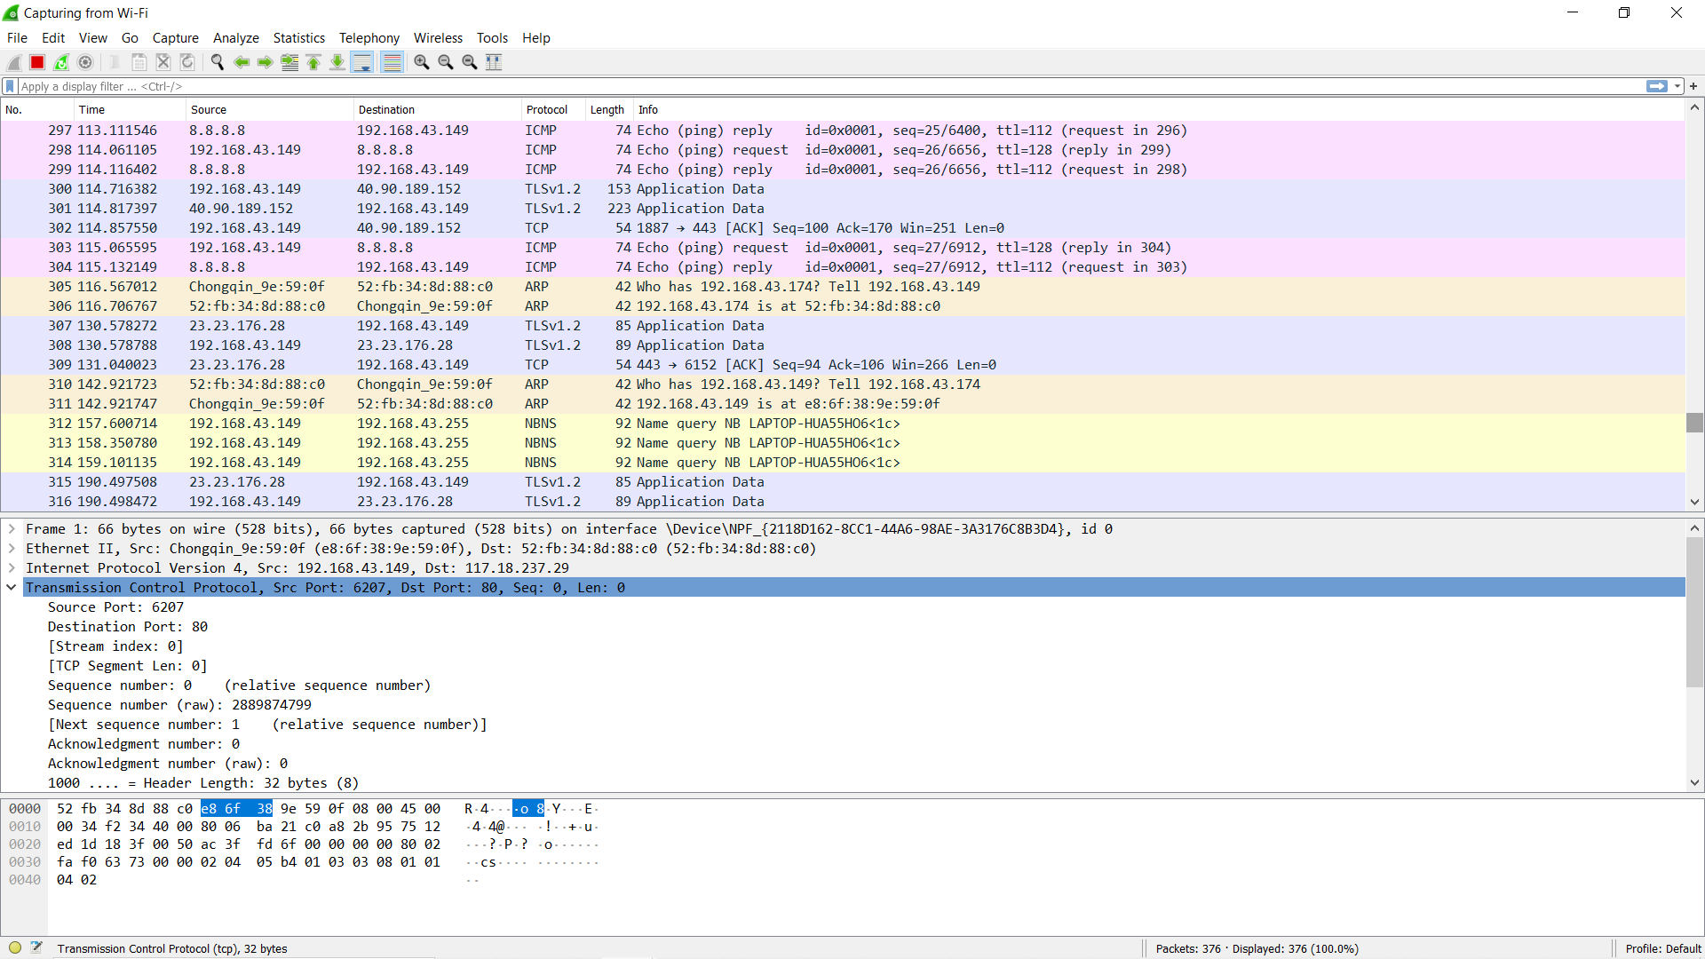

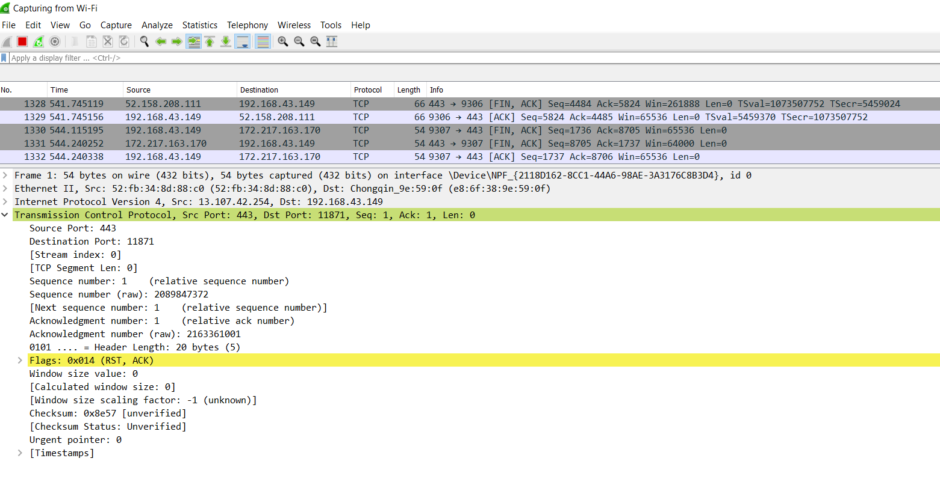

**Port Security Hashing Algorithm:**

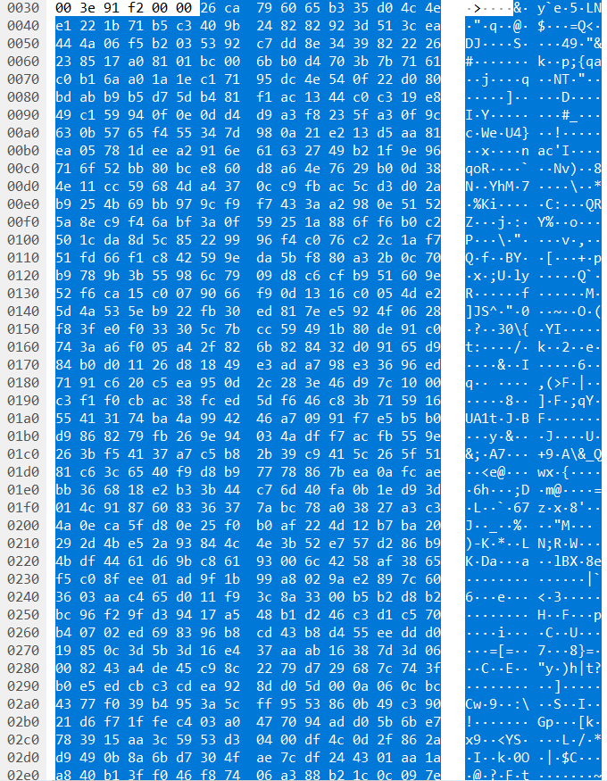

**Different Statistics:**

**Wi_Fi file capture**

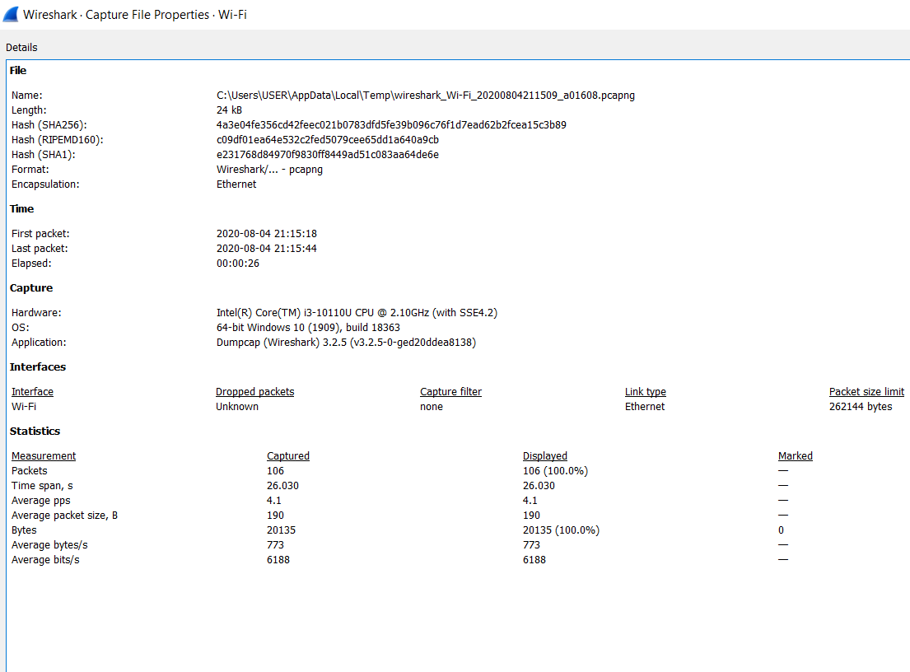

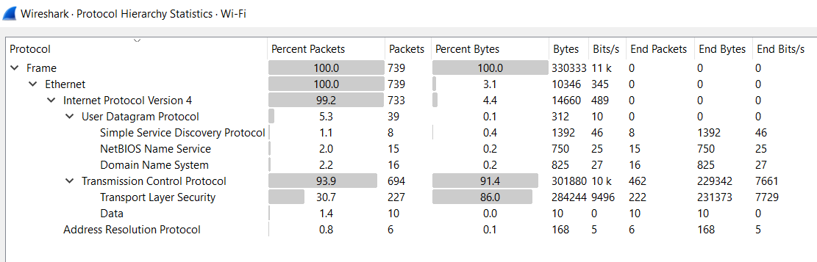

**DNS**

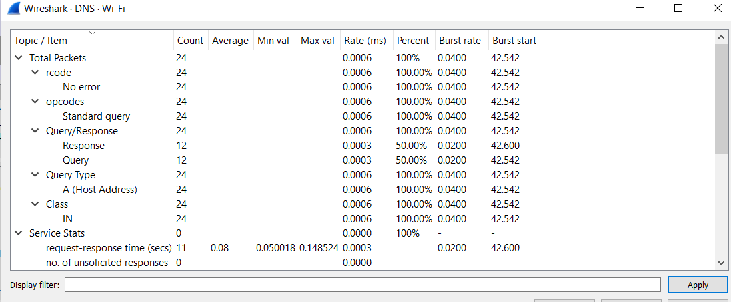

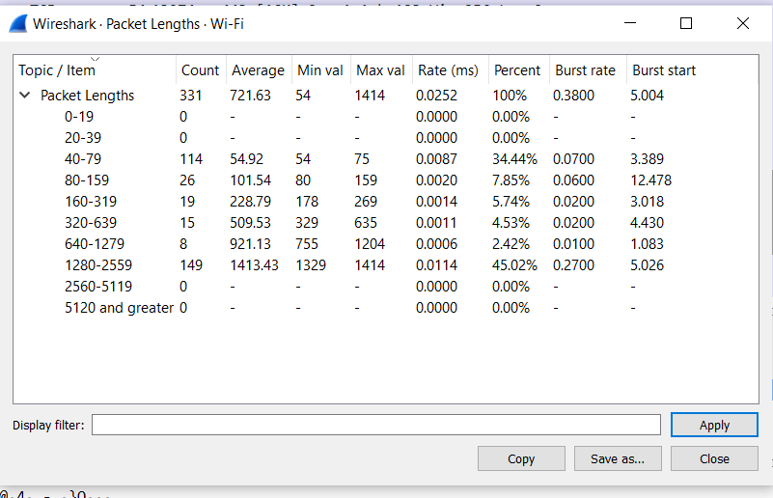

**Protocl have been used:**

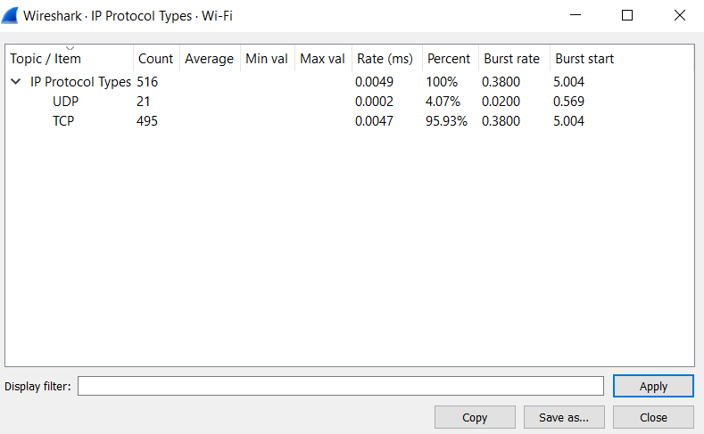

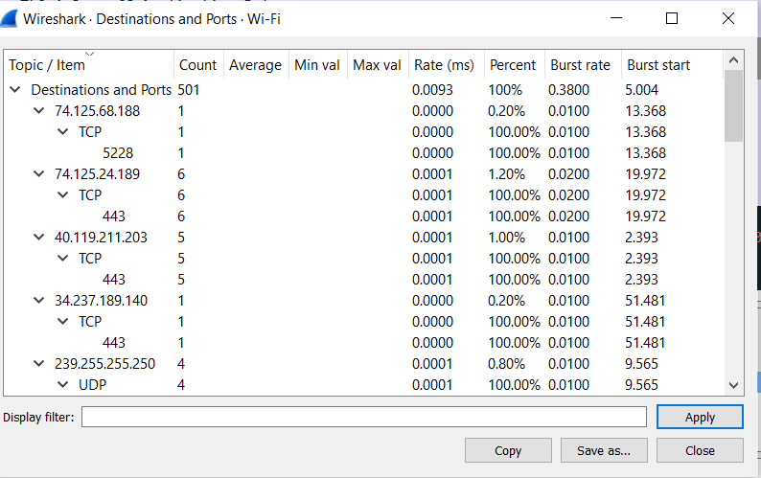

**Error & Success Rates:**

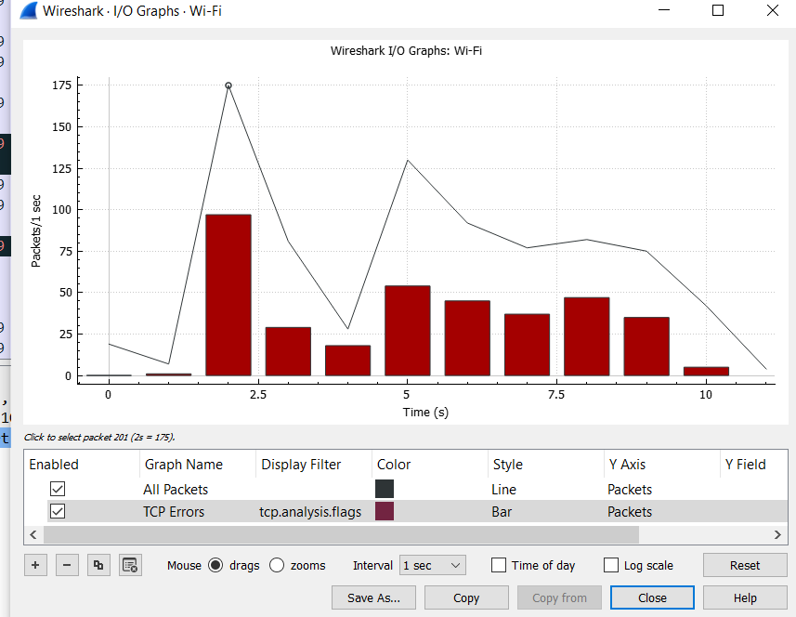

**Real time Response:**

