Lab Report No: 05
Name of the lab report: Connecting a database (MySQL) with Linux
Name: MD. Amirul Hasan Shanto
ID: IT-17027

Objective: In this lab we get introduced with database on ubuntu. Besides we take some sql commands to get executed.

Install MYSQL on ubuntu :
Open the terminal and run those commmands:

sudo apt-get update
sudo apt-get install mysql-server
mysql_secure_installation

Log into mysql by linux ubuntu :
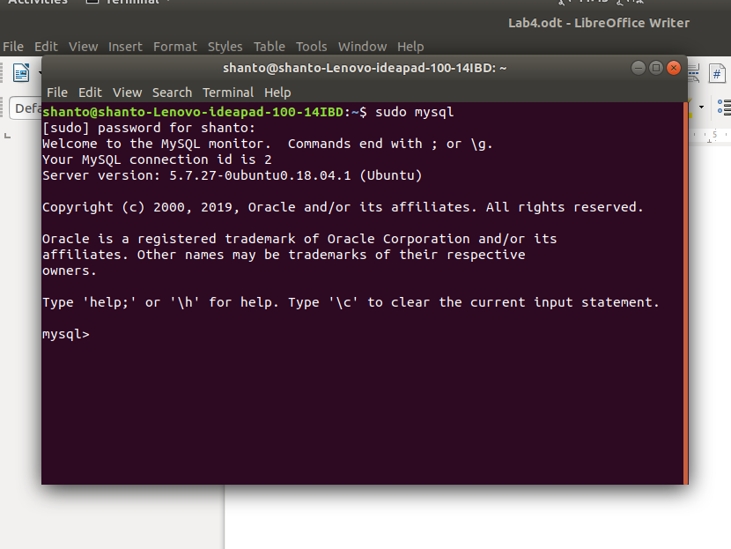

show and create database :
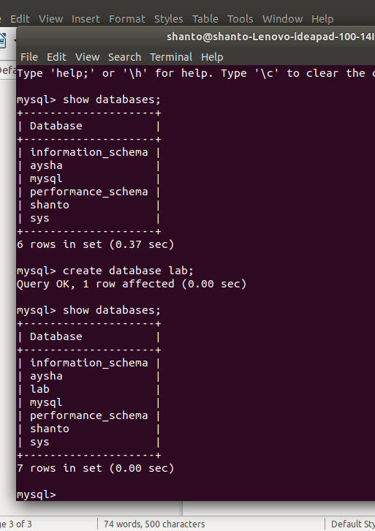

show & create table :
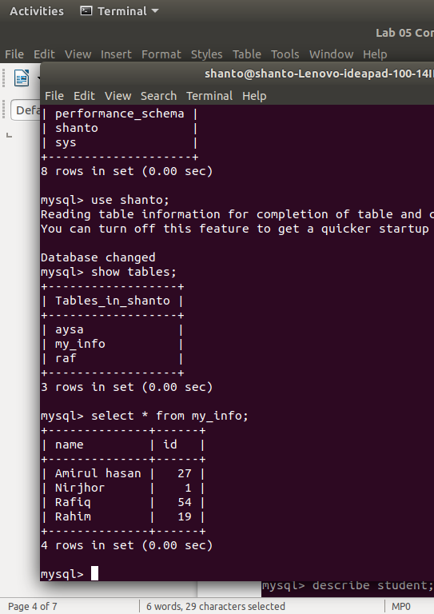

insert into data table :
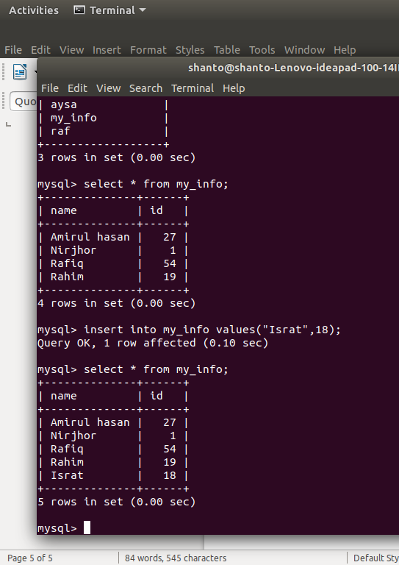

drop table:
