Lab Report No: 02

Name of the lab report: Basic Linux command.
Name: MD. Amirul Hasan Shanto
ID: IT-17027

Objective: On linux operating system Terminal shell command line is preety much helpful.
Through this lab we know some basic commands of linux OS. Let’s what will the commands can do just followed. I take screen shot of my every activities.

Q.1. What is Linux command?
----- Command is an instruction given by a user operating the computer to do something like running a program or multiprogramming .Commands are normally handling by typing in the command line & pressing ENTER which pass them to ‘shell’. The default shell on most Linux system is bash. On Linus the command line is known as ‘Terminal’. We can open it either by pressing “ ctrl+alt+t ” or find from application drawer.
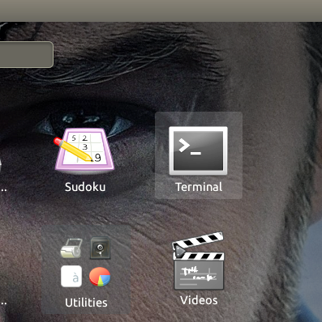
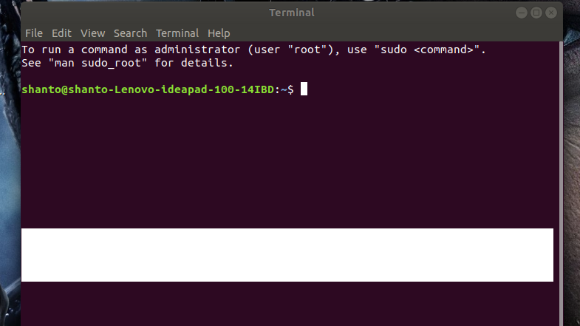

Q.2. Write 15 commands of Linux operating system.
-----
- pwd command.
- ls command.
- cd command.
- uptime command.
- cp commands.
- mv commands.
- rm commands.
- mkdir commands.
- sudu commands.
- hostname commands.
- locate commands.
- echo commands.
- cat commands.
- du commands.
- history commands.

Q.3. Describe the basic operation of Linux commands.
-----
pwd command :

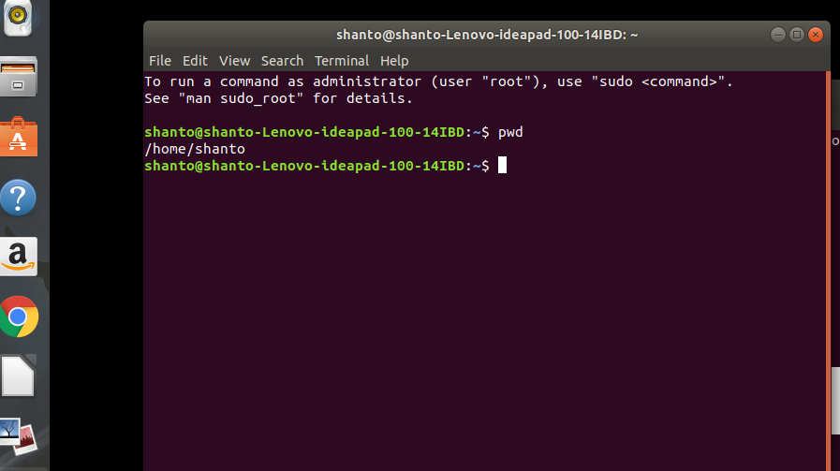
This command showss the location of my current working directory. It's important to know actually where i’m before going to a parent or sub directories.

ls command:
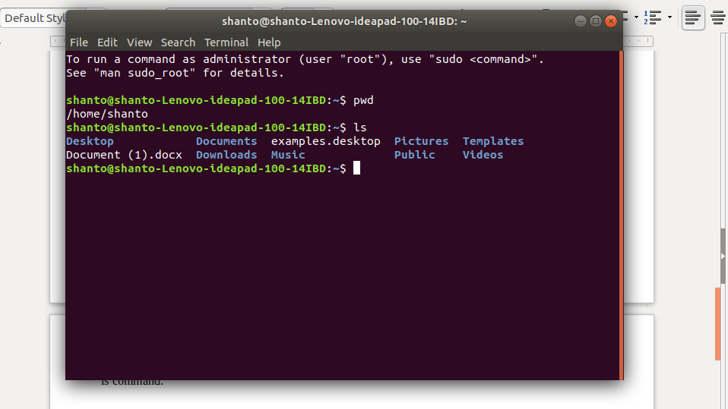

Use the ‘ls’ command to know what files are in the directory I am staying. Besides i can see all the hidden files by using this command.

cd command:
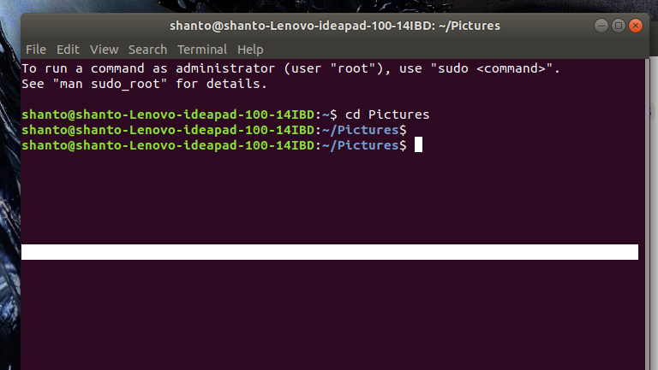

This command is used to go to a directory. For example, if you are in the home folder, and you want to go to the pictures folder, then you can type in“cd Pictures”. Remember, this command is case sensitive, and you have to type in the name of the folder exactly as it is.

uptime command:

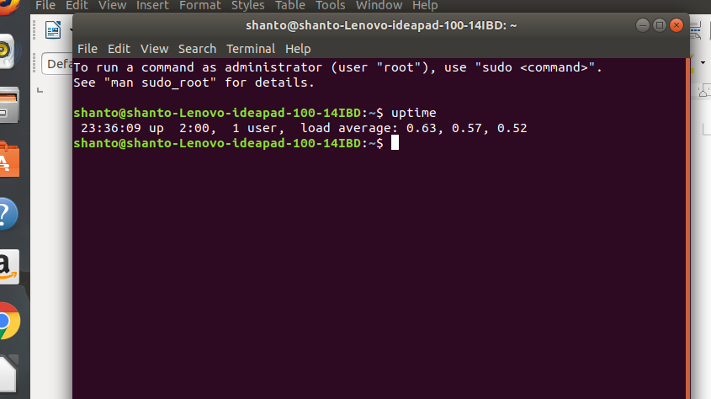

This command can be very interesting. Shows the time when we open our pc, how many times we use it , hour,seconds, minutes.

cp command:

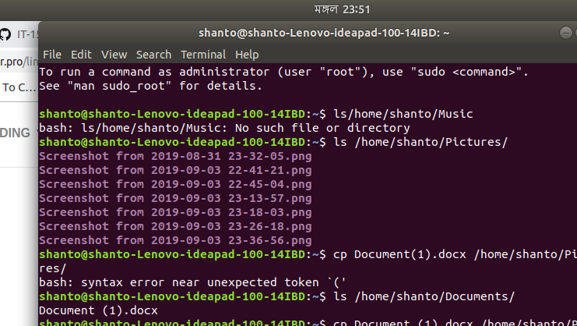
This command to copy files through the command line. It takes two arguments: The first is the location of the file to be copied, the second is where to copy.

mv commands:
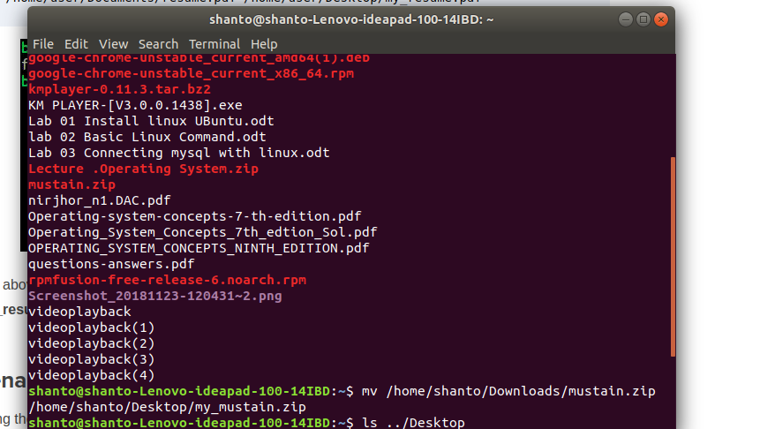

The mv command is used to move or rename directories files.

rm command:
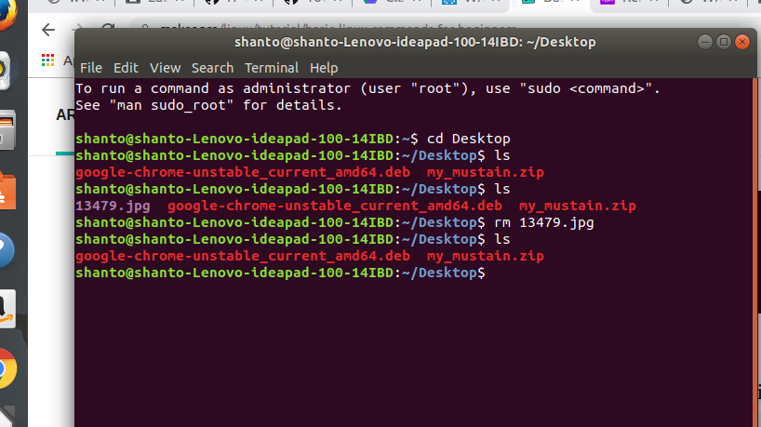

rm is used to delete file directory.

mkdir command:
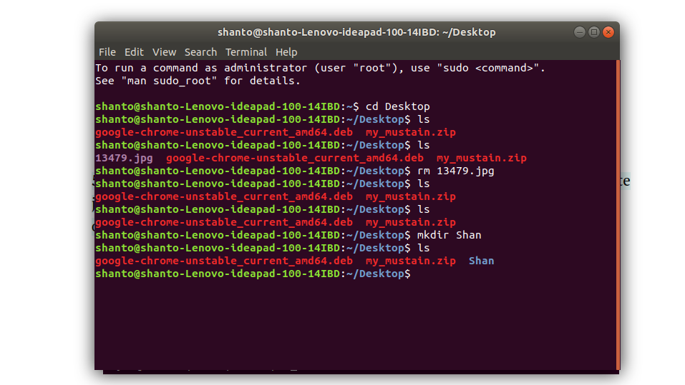

Use to create new file.

Sudu command:
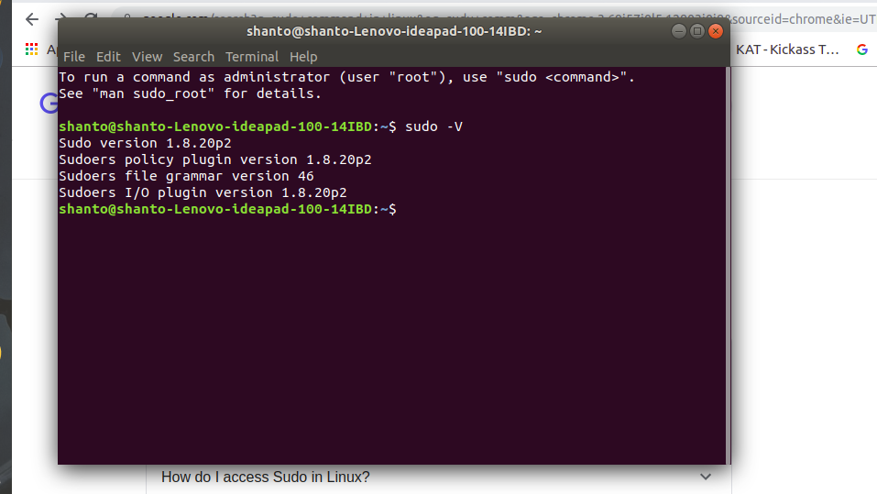
This command provide permission authorization everything.

hostname command:
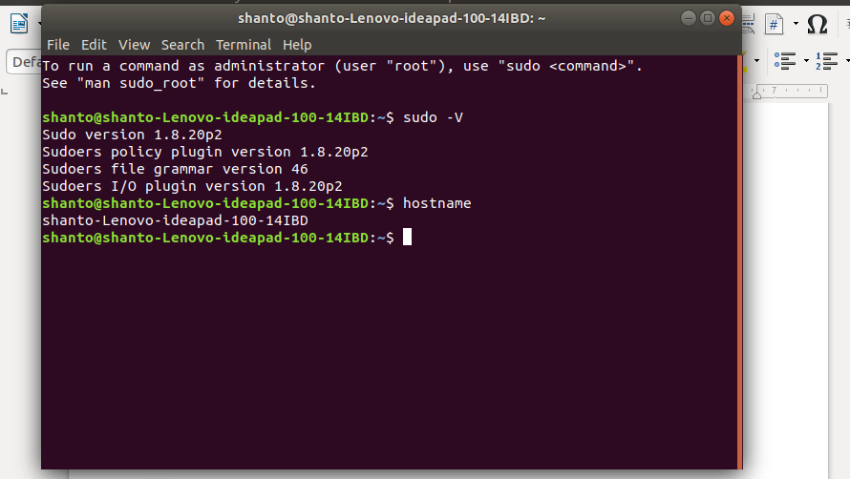

Shows the real Linux user or owner of the pc name.

locate command:
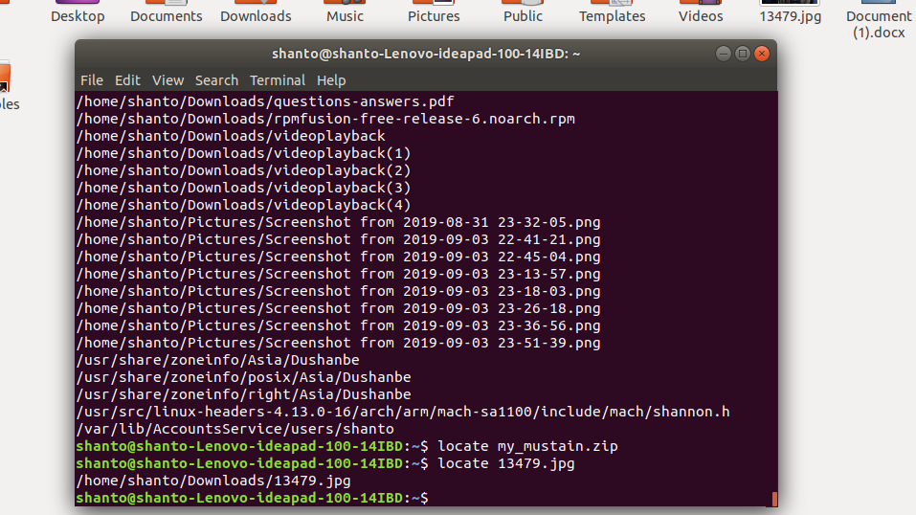
Locate the file directory.

echo Command:
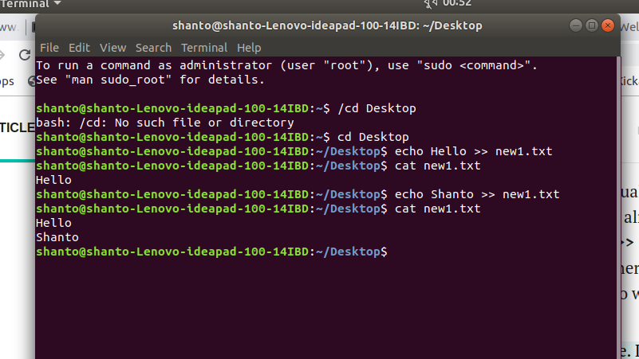

It’s helps us move text into a file.

cat command:

Adding text in file or text add in the previous text file

du command:
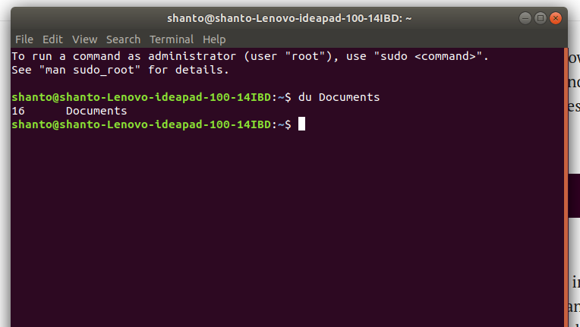
Number of documents file stored in the hard disk.

history command:
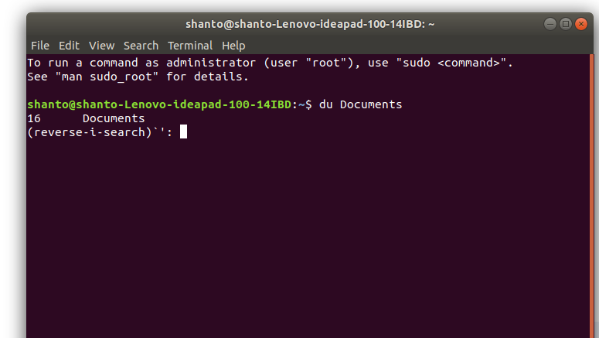

After doing something in the terminal shell , if we are pressing ctrl+R then we have our previous working history.

Conclusion: So as we say earlier this commands shows many interesting scenario of my current OS, like cat,uptime,locate,history is feel ease to me. I think those commands are preety much helpful. I feel different challenge to do this. Yes I take the help from the internet to become more specific.

