Lab Report No: 05
Name of the lab report: Linux command for process .
Name: MD. Amirul Hasan Shanto
ID: IT-17027

Objective: In this lab we get introduced with some new commands that can show how a process running in ubuntu.

Q.1 How to Manage Processes from the Linux Terminal?
Answer: The Linux terminal has a number of useful commands that can display running processes, kill them, and change their priority level. This post lists the classic, traditional commands, as well as some more useful, modern ones.
Many of the commands here perform a single function and can be combined that’s the Unix philosophy of designing programs. Other programs, like htop, provide a friendly interface on top of the commands.

Q.2 Run the following process commands in Linux.
Top, htop, Ps, pstree, kill, pgrep, pkill ,killall, renice, xkill.
Answer:
i) Top:
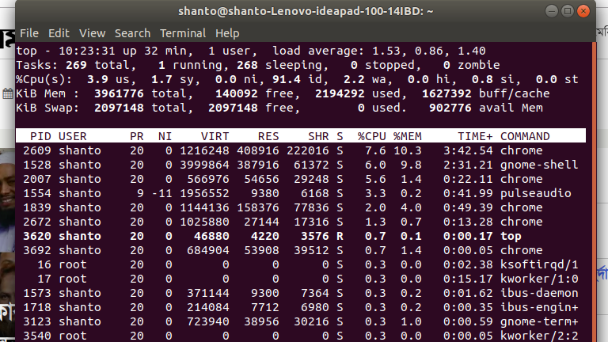
This command is the traditional way to view your system’s resource usage and see the processes that are taking up the most system resources. Top displays a list of processes, with the ones using the most CPU at the top.

ii) htop:
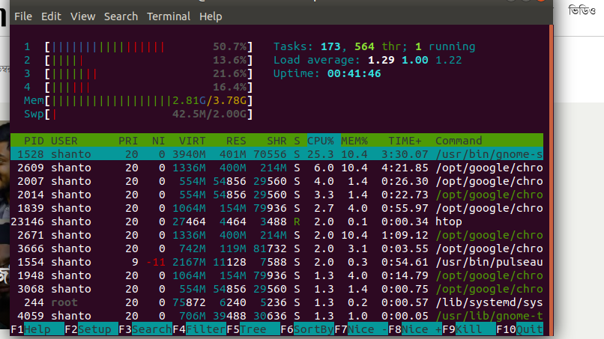

htop displays the same information with an easier-to-understand layout. It also lets you select processes with the arrow keys and perform actions, such as killing them or changing their priority, with the F keys.
iii) ps:
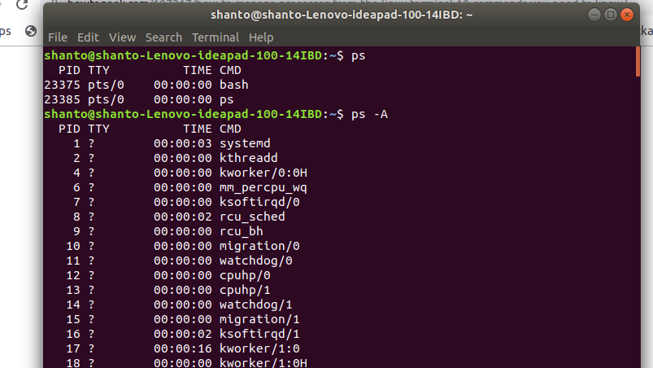
The ps command lists running processes.
iv) pstree :
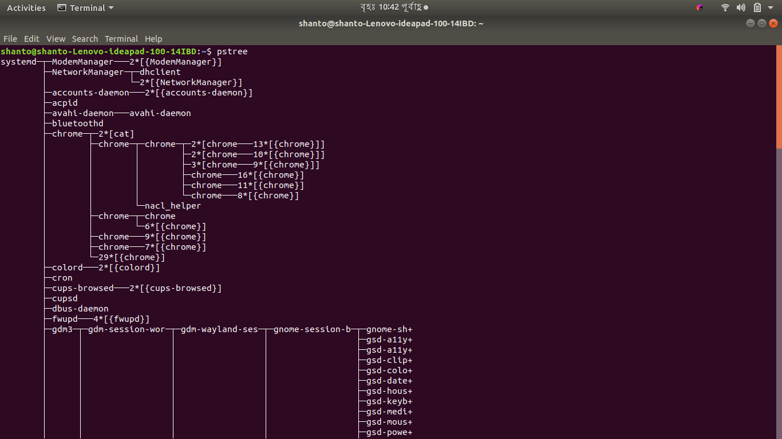
The pstree command is another way of visualizing processes. It displays them in tree format. So, for example, your X server and graphical environment would appear under the display manager that spawned them.

v) kill :
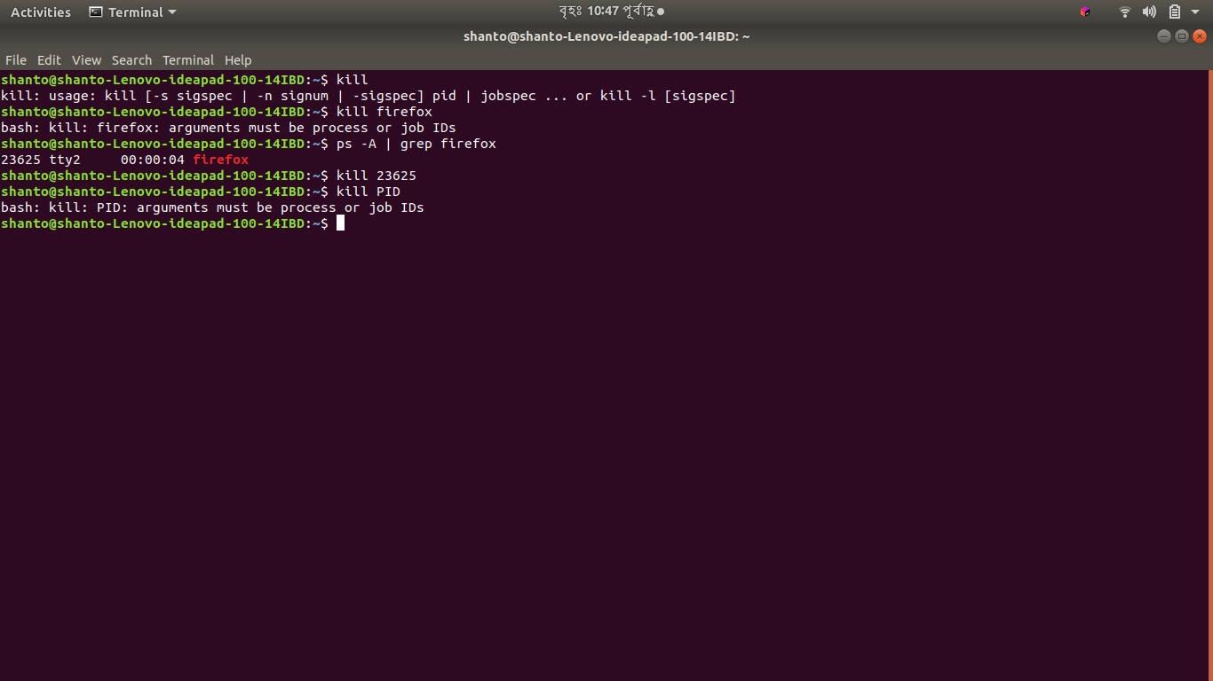
This command can kill a process, given its process ID. You can get this information from the ps -A, top or pgrep commands.
vi) pgrep :
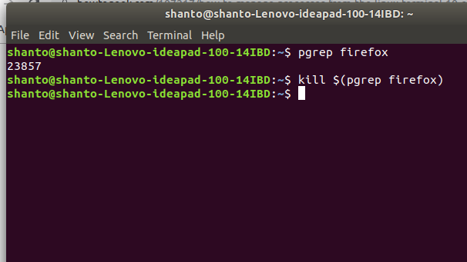
Given a search term,pgrep returns the process IDs that match it.
vii) pkill :
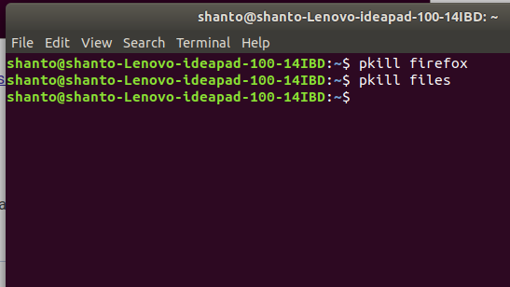
This command can kill a processe.

viii) killall :
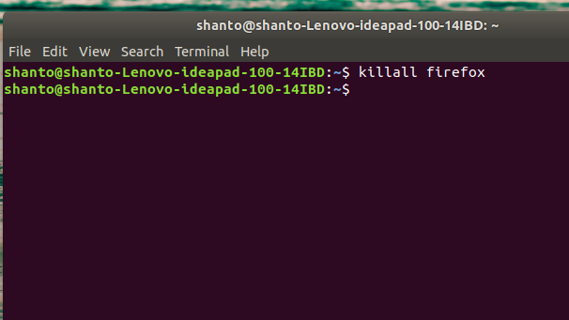
This command can kill a processe.
ix) renice :
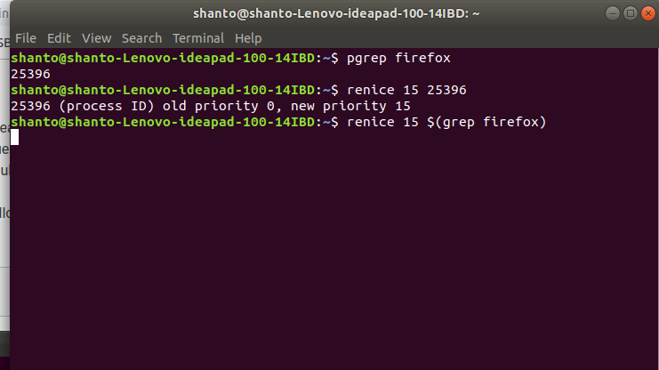

The renice command changes the nice value of an already running process. The nice value determines what priority the process runs with. A value of -15 is very high priority, while a value of 15 is very low priority. A value of 0 is the default priority.

x) xkill :

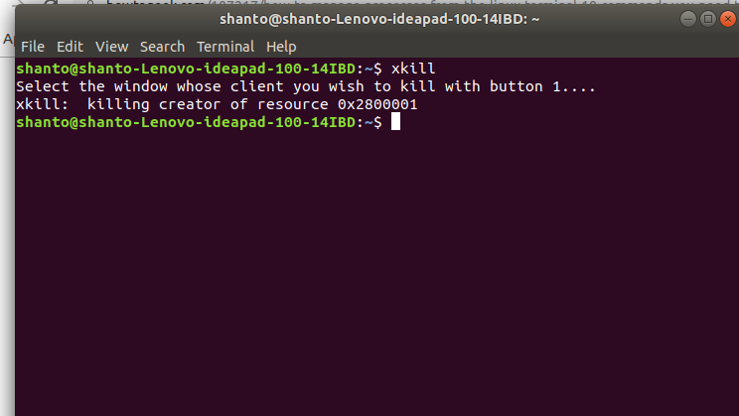
The xkill command is a way of easily killing graphical programs. Run it and your cursor will turn into an x sign. Click a program’s window to kill that program. If you don’t want to kill a program, you can back out of xkill by right-clicking instead.

