Locators in Selenium:

* Before performing any action on a web element its important that first we need to identify the element uniquely
* To identify the webelement we use locators from selenium
* There are 8 different types of locators they are

1. tag
2. id
3. name
4. class
5. linkText
6. partialLinkText
7. cssSelector
8. xpath

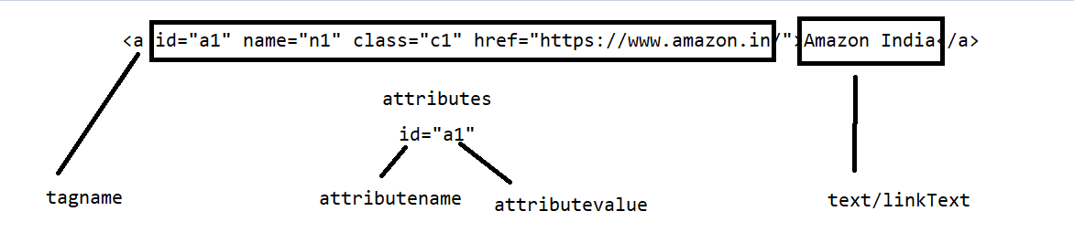

cssSelector:

cssSelector is one of the locators in selenium which can be used if any of the above locators are not available

|  |  |
| --- | --- |
| syntax | tagname[attributename='attributevalue'] |

xpath:

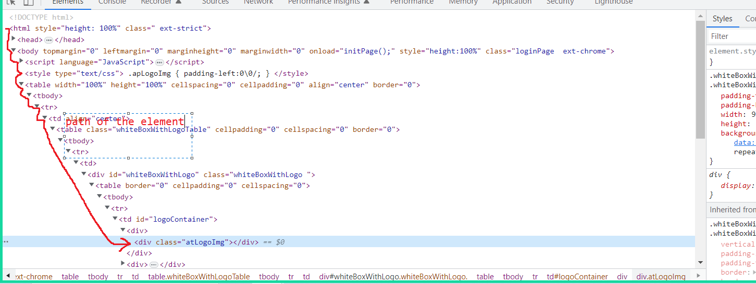

* it is a path of the element from the html tree
* there are 2 types of xpath 1) absolute xpath 2) relative xpath
* absolute xpath -> denoted by /.

it is a complete path from the root element till the element that we want to locate

/ meaning – immediate next element

ex: /html/body/table/tbody/tr/td/table/tbody/tr[1]/td/div/table/tbody/tr/td[1]/div[1]/div

* relative xpath 🡪 denoted by //.

// any element under this tag

different ways of writing xpath

1. using single attribute

|  |  |
| --- | --- |
| syntax | //tagname[@attributename='attributevalue'] |
| examples: | //div[@class='atLogoImg'] |
|  | //input[@placeholder='Username'] |
|  |  |

**Notes from 25/5/2023**

**\*\*\*\*\*\*\*\*\*\*\*\*\*\*\*\*\*\*\*\*\*\*\*\*\*\*\*\*\*\*\*\*\*\*\*\*\*\*\*\*\*\*\*\*\*\*\*\*\*\*\*\*\*\*\*\*\*\*\*\*\*\*\*\*\*\*\*\*\*\*\*\*\*\*\*\*\*\*\*\*\*\*\*\*\*\*\***

Different types of relative XPath

1) Using single attribute

syntax: //tagname[@attributename='attributevalue']

2) Using Text function

syntax: //tagname[text()='textvalue']

<div>Login </div>

//div[text()='Login ']

<a href="register.php" style="color: #0000ee;text-decoration: underline;">REGISTER</a>

//a[text()='REGISTER']

3) Using more than one attribute using AND / OR

syntax: using AND //tagname[@an='av' and @an='av']

syntax: using OR //tagname[@an='av' or @an='av']

<input type="text" name="username" value="" id="username" class="textField" placeholder="Username">

//input[@type='text' and @name='username']

//input[@placeholder='Username' or @name='username']

4) Contains function

How did you handle dynamic elements from your application

syntax: //tagname[contains(@an,'av')] --> attribute

syntax: //tagname[contains(text(),'tv')] --> text value

<b>First

Name: </b>

//b[contains(text(),'First')]

<a>inbox(10)</a>

//a[contains(text(),'inbox')]

5) Starts with

syntax: //tagname[starts-with(@an,'av')] --> attribute

syntax: //tagname[starts-with(text(),'tv')] --> text value

<b>First

Name: </b>

//b[starts-with(text(),'First')]

Example of dynamic elements possibly which you could come accross

<input id="caiosf4726572572Customer842937534cnsdnjd"></input>

<input id="caiosdsadfds6572572Customer842937534cnsdnjd"></input>

<input id="cafsd6572572Customer842fsdfsdnjd"></input>

//input[contains(@id,'Cust')]

<input id="icici84378953nfdjsnfdjsnf"></input>

<input id="icicicxhcudisfh9899797987"></input>

//input[starts-with(@id,'icici')]

other xpaths like following preceding ancestor --- so many ways to write xpath

6) Following and Grouping

sytnax: //tagname[@an='av']/following::tagname

//b[contains(text(),'First')]/following::input[1] --> only in xpath the index will start from 1 not 0

(//input[@type='text' or @name='username'])[2]

**How to handle dropdown in Selenium**

* There are different ways in which the dropdown would have developed in web application and the most commonly used method for developing

a dropdown is by using select tag

* From automation stand point first thing to notice when we are dealing with dropdown is whether this dropdown is developed using select tag

Steps to deal with dropdown which has select tag

1) Identify the dropdown element

2) Create an Object of a select class and pass this webelment as an argument

3) Use one of the following to choose the value from the dropdown

a ) index

b ) visible text

c ) value