

Quantitative Finance

Shanttanu Oberoi (22b1823)

Mentor :Vipin Singh June 2023

# Contents

1. Introduction to quantitative finance 2
   1. Theory of Interest 2
2. Arbitrage theorem 3
   1. What we mean by arbitrage 3
   2. Duality theorem of linear programming 3
   3. Dual Problem 3
3. Random Walks and Brownian Motion 4
   1. Intuitive Idea of Random Walks 4
   2. Absorbing Boundary Condition 4
   3. Stopping time and laplacian equation 5
   4. Intuitive idea of stochastic processes 8
   5. Stock Market Example 9
   6. More Rigorous Stochastic Process 10
   7. Ito’s Lemma 10
4. Options 11
   1. Put Call Parity Formula 12

5. Black Scholes Equation 14

1

1. **Options Greeks 15**
2. **Concluding Words 20**

# Introduction to quantitative finance

For learning financial mathematics you need to have a knowledge of various mathematics concepts like linear algebra, calculus ,probability ,statistics and many more branches related to these topics only like linear programming ,ran- dom walks

# Theory of profit

Lets understand functioning of banks and many mutual funds .Banks give loans to customers at a particular rate , they get this money from investors who invest in fixed deposits of banks and they will get money on withdrawal at a particular rate and this rate is less than the rate of loans ,in this way banks harvest profits for themselves and also sometimes banks and asset managers invest in stock market and earn profits out of this.

These interest rates are of two types : 1.Simple interest

2.Compound interest

underline Simple Profit :for example if this rate is 5 percent per annum then after every year this amount will increase 5 percent of the intial amount invested

.Hence after n years the amount will turn out to be : Let:

P= intial amount invested (principal amount ) r=interest rate

n=duration after which interest is applied A= final amount

for one iteration of interest :



for t iteration by mathematical induction we found that :

**Compound interest:**After every interest period the principal value becomes



the value of principal ’s sum with the simple interest over it .

# Arbitrage theorem What we mean by arbitrage

Whenever there is an opportunity of making profit due to mis price of two

financial commodity such opportunities are known as arbitrage .For example let us see an example where we see that there are two banks such that one produce loan at interest of 5 percent and there exist another bank which give an interest of 6 percent on fixed deposits then in this case the person will take a loan from one bank and deposit it in other bank and after sometime with 6 percent profit will pay for 5 percent profit ,thus resulting in a net profit of 1 percent .

Hence ,according to arbitrage theorem either there is a chance of winning the bet or there is a net positive gain in the bet at the last even after losing . However most of the times financial bodies make sure to avoid such arbitrage

,but if someone still figure this out then (we all know!)

# Duality theorem of linear programming

In linear programming let there be a matrix c which is 1*n and there be matrix which is n*1 hence there product will be c.x=c1*x1+c2*x2+c3*x3. This in-

ner product is often represented as cost function .If we are required to minimize this cost function under constraint say sum of all component of the vector should be equal to say 1 for instance.Now for the solution set we have to assign different grpahs to c.x=k for different k and draw its plane and the minimum value of k for which the plane instersect the plane x1+x2+x3+. =1 then this will be the so-

lution set but obviously we cannot think of higher than 3 dimension.Sometimes we may encounter inequality constraint instead of equality such as x1+x2+x3 1*wecanuseaslackvariableforconvertingthistoequalitysothatnowx*1 + *x*2 + *x*3 +

≤

*x*4 = 1*andinthecostfunctionalsowecanaddanothervariablebutwithacoefficient*0*andthenwecansolvethisprobl*

# Dual Problem

Sometimes optimization for problems given to us may be difficult to compute but what if we figure out a way to make another problem easy to optimize and with same solution set this is what dual problem enable us to do !

In our case the original problem is primal and the helping one is known as dual

.

**Primal:**Minimize c.x subject to constraint to Ax=B.

**Dual:**Maximize y.b subject to yA ≤ *c.*

# Random Walks and Brownian Motion

Whenever we talk about any process in which at every step there is probabilistic approach towards next step however in simpler cases we know all the possible steps hence we can talk about the probability of getting all possible results .Such process are known as stochastic process .

# Intuitive Idea of Random Walks

Lets talk about a simple example in which a person owns a stock whose value can either increase by one or decrease by one, hence let S(n) be the value of the stock after n days hence here each step is probability either 1 or -1 but we know possible ways and also we can calculate all the number of ways of final values after n days (basic combinatorics ) hence number of ways after n days final amount is obtained is 2*n.*

*S*(*n*) = *S*(0) + *X*1 + *X*2 + *X*3 + *X*4 + + *Xn.*

It is also apparent that we can reach a single value by multiple ways .

For example we can have a value i+2n-k be the final value where i is the in- tial value ,hence we can say that value decrease k days and n-k days it will increase.By basic combinatorics we can reach this value by :

*n*

*k*

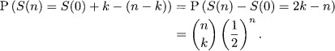

# Absorbing Boundary Condition

In previous case of stock price random walk if we would have applied a restriction such that once a stock price reach there it will remain there only like in the real case we can refer to the stocks whose price have reached 0 .Hence now we have to talk of a conditional probability where we have to compute probability of the stock to reach that price and also maintaining the boundary condition for this we can say that the minimum of the stock price will be the greater than the boundary or maximum can be less than the boundary value for the case of upper boundary .we can mathematically represent this situation as :



Now to compute this we can consider an obviuous statement that the minimum value of the random walk can either be greater than o or less than 0!// hence mathematically it is :



We can see by the spatial homogenity of these random walks that random walk’s probability to a value A from i or probability of the walk to A-i from 0 is coming out be same

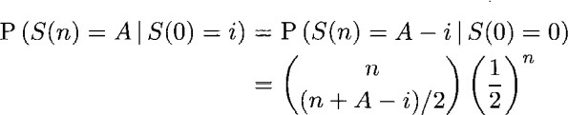

We can also claim that the following random walks will carry same probability and it can easily be thought of :

following graph also illustrating that how can these probabilities be same :

using all the above observations we can reach out to our final conclusion :

# Stopping time and laplacian equation

The first time the random walk reach the value of A such that S(n)=A then the value of n is known as stopping time of the random walk for the value of A and it is denoted by Ω*A.*

Now if we consider a case in which S(0)=i and it has to reach the value

S(n)=A without touching 0 then in this way we can denote this path as p*i−>AandtheP* (*A*)*istheprobabilityofthe*

center

Σ

**P(A)=** *pi−>a Ppi−>A*

now if we consider that before i in our example the value of i can either be i-1 or i+1 and after reaching i it will go to all of its possible paths hence this summation can be expressed in the following way :



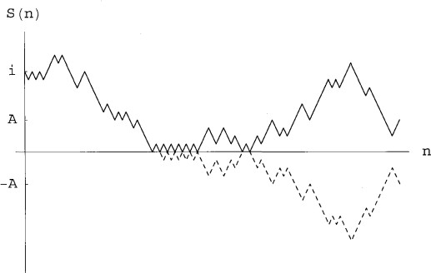

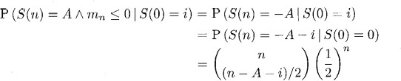

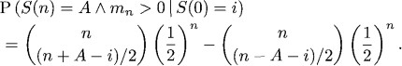

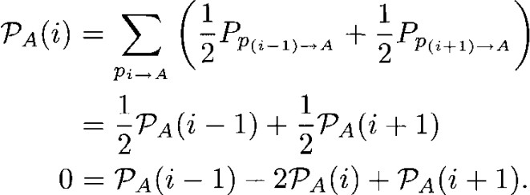

hence we have reached a final equation after solving as above ,this equa- tion written above is also known as laplacian equation .We know a priori that P*A*(*A*) = 1*andPA*(0) = 0*,*

*hencewecanreachouttoasystemoflinearequationsthatis* :

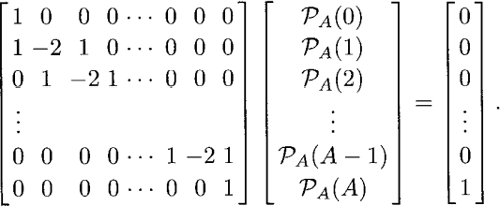

after solving the above set of equations by conventional approach like that of pivots we can reach to a conclusion which is as follows:

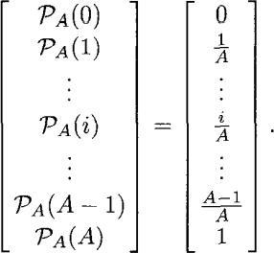

By the symmetry of the random walks we can reach out to a another set of solutions:

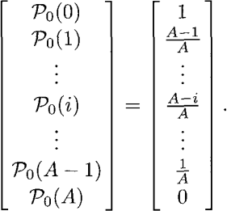

Here P0(*i*)*representtheprobabilitythattherandomwalkwillreachto*0*valuefromiavoidingthevalueAinthewa*

P0(*i*) = 1 *PA*(*i*) From statistics we all know that the expected value of any quantity can be represented in the following manner:

−

expected value = sum of product of all quantity with their expected value

Now to show the expectation value of the expectation value of the stopping value :

in this we can consider the probability that a day before either the value can be i+1 or i-1 hence we can see the expectation value calculation to be :

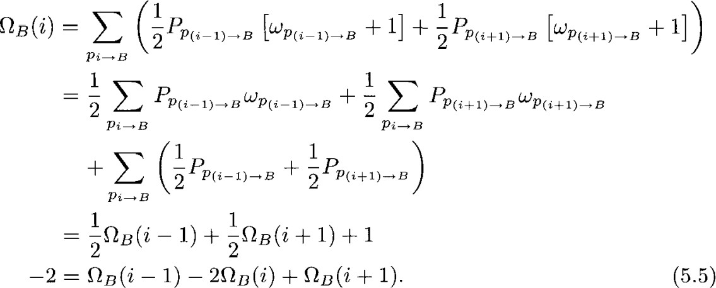

If we have a look at the above equation we can see we have considered the same procedure as for laplacian equation considering equal probability for the a day before and since we are considering the stopping time to be [*ω*] + 1

since we are considering a day more.

The result that we got at the end is known as poisson equation.Matrix formed by this :

After solving the augmented matrix for the set of equations formed above by conventional mehtod of pivot we get the following result: *ωb*(*i*) = *i*(*A* − *i*)

# Intuitive idea of stochastic processes

Now we are approaching towards a more realistic seeming situations .Till now conditions which we were discussing seemed to be a more idealistic in which stocks prices were changing in only two way either +1 or -1 and that also once a day but if we see a real life example we know that there is no bound on prices

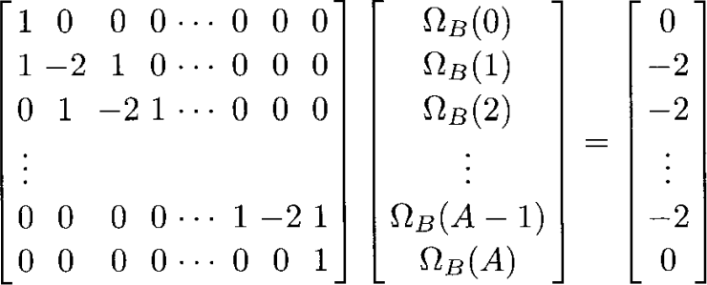

to rise and fall and fluctuations are also simultaneous .

Now if we consider a decay we can see that in that also we see that the fluctu- ations are simultaneous .In these the decay law that is followed is given by the following rule:

dp/dt=*µP*

However we know that the amount of substance left after t time is given by (t)=P0*e*(*µ*)*t*

However we all know that in this way the process will become deterministic but that is not the case for stock price (what if it would have been !).For stock price cases we take the noise also in consideration .What is noise ?

Noise is the error or deviation from the deterministic path. let X =ln(P) then

*dP*

= *dX*]˙

*P*

In case of deterministic process dX=*µdt.*

For the case of stochastic process dX=*µdt* + *σdz*(*t*)√*dt*

The underlined part of the equation represent the time dependent noise/deviation from the deterministic model .*σrepresentthevolatilityofthefinancialcommodity.*

# Stock Market Example

In the previous section we tried to mimic the stock market prices fluctuations.We found various terms in that stochastic equation like *µ, σ,* ∆*t*]

now we are going to look the assignment of each of these terms with the real life example .Following is the graph of the price of the sony’s stock price for 248 days , data in the graph is the closing price:

Since we are talking of the data on each price ,means we are talking of the vari-

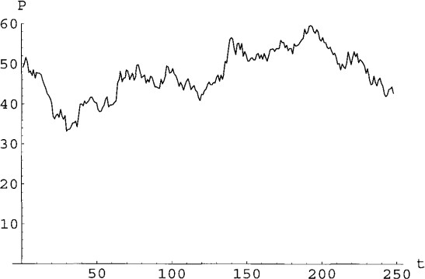

ation after each day hence we are considering the ∆*t* = 1*.WeallknowthatX* =

*ln*(*P* )*.HenceToformthequantity*∆*Xbysubtractingconsecutivedayprice, meanofthisquantityisknownasµands*

# More Rigorous Stochastic Process

Equations we were talking about till now was: dX=adt+bdW(t)

To add more randomness what if we claim coefficient also as time and current X dependent.

dX=a(X,t)dt+b(X,t)dW(t)

In the above equation we cannot simply integrate both the sides because of the constants a and b .ALso We were previously given a relation X=lnP and in normal case what we did was we subsituted dx=dP/P and then we were getting result by integrating both sides but here we cannot perform this operation as well and hence we need to derive some method by which we can perform these calculation .

The major problem we are facing is that the constants a and b are also following random walks and are x dependent hence we need to dx will also have stochastic elements ,hence Ito lemma enable us to solve for these cases.

# Ito’s Lemma

Let Y be a function of X and t then the random walks of the process Y can be shown as:

given dX=a(X,t)dt+b(X,t)dW(t)

**Y=f(X,t) is the random walk of Y that we have to compute . dY=(a(X,t)F***X* + *Ft* + 1*/*2 ∗ (*b*(*X, t*))2*FXX* )*dt* + +*b*(*X, t*)*FxdW* (*t*)

Proof involves familiarisation with taylor expansions and multi variable calculus.

# Options

Before diving into the topics of options it is very important for us to learn the basic meaning of options.As the name suggest options provide us with an options whether we want to buy an entity or not in the later course of time in exchange with a cost for the deal also known as premium.

# Types of Options

There are two types of options :

1.Call Options 2.Put Options

# Call Options

Suppose there exist a stock A whose current price is 100 rupees and your speculate that the price of that stock may increase in near future say within 3 months and hence you made a deal with a person who that you will purchase that stock from him in rupees 120 in exchange of 20 rupees as an advance that you will later pay the remaining 100 rupees.After 3 months you see that the price of the stock become 130 but since you have made that deal hence now the stock is only costing you rupees 120 and you end up making rupees 100 as a profit

.However you find that the stock price now become only rupees 80 hence instead of buying it for rupees 120 you decide to exit the option and now the stock cost you 100 rupees ( 80 for current stock price and 20 rupees for advance).In a way by call options you are betting that the stock price will go up .

# Put Options

It is just the opposite of call options , here you are betting that the stock price will go down .Here you have a stock and you get an option of selling that in a price that you want.

# CLassification of Options on the basis of nature of exercising

There are two types of options :

1. **American options : These type of options can even be exercise before the maturity period .Obviously since these type of options provide you with a flexibility of exercise therefore these are expected to be of more cost then the european counterpart.**
2. **European options : These type of options can only be exercised on the maturity period end before these however you can sell your options to other individual .**

# Put Call Parity Formula

Let us consider a story of two friends say Ram and shyam . Ram purchased a put option with the current scenerio being :

current stock price:560 rupees maturity period: 1 year Exercise price: 575 rupees

Consider 2 scenerios:

1. **Price after 1 year : 800 rupees**
2. **Price after 1 year : 300 rupees**

Price =800 rupees

Ram will see that he is profiting more with the normal selling there- fore he will let the option to expire .

Sell stock =800 Option Lapse=0

money Ram have = 800

Price = 300 rupees

Ram will now definitely exercise the option

Sell stock = 300 Option Exercise = 275 (575-300) money Ram have = 575

Shyam decide to exercise a call option

for the same Shyam invest in a risk free bond with annual interest rate of 10 percent, also the exercise price for the stock is 575 rupees hence Ram need to invest in the bond an amount of 522.72 so that e he can afford a price of 575 rupees after an year .

Price =800 rupees He will possess a stock of price 800 rupees and will prefer to exercise the stock .

Price = 300 rupees He will possess a stock of rupees 300 and will prefer not to exercise the option as mentioned .

As clear from the above situation that the outcomes in final for both the cases will come out to be same however as a rule the intial invest- ment also in both the cases should be same ,which is what the put call parity formula states .

Put Call Parity Formula:

Stock Price(which he need to but to practice the put option) + Value of the put option= value of the call option + the money you invested in bond so that you can pay the exercise price.

In case there is an inequality in the equation then we can claim that there is an arbitrage opportunity waiting for us !

How can we use arbitrage when there is an inequality ?

Suppose in our example of Ram and Shyam the premium for put op- tion if 20 rupees and the premium for the call option is 40 rupees and the current stock price be 560 rupees hence in this example : 522.72+40 is less than 560 + 20 (side of put is more than the Call’s side)

Hence how can the arbitrage be exploited ?

For making profit but the call option portfolio and sell the put option portfolio .

How?

buy the call option at an exercising price of 575 rupees on a premium of 40 rupees

Now also invest 522.72 rupees in a zero coupon bond

Now short sell the stock to Ram who wanted to exercise the put op- tion by borrowing it from some lender .

Also write a Put option for Ram who is eager to have one at a pre- mium price of 20 rupees.

Now in the very beginning only we have made a profit of rupees 17.28 rupees .

How ?

since we have an income flow of :

560 for short sell price and 20 for premium of the put option .

and we have spent rupees 40 for premium of the call option and 522.72 rupees for the zero coupon bond investment .

Now many of you might be interested to know how will this intial profit be affected by the maturity time can’t it turn into a loss who knows?

The answer is no ! We have fixed our profit by doing this and this will remain the same even by the time of the maturity time .Let us see how?

Lets assume that the price of the stock becomes 800 rupees : Then we will surely exercise the call option adn hence the call options in a way came up with rupees 225 for us we also will get rupees 575 as a return of the zero coupon bond we invested in hence in a net there is a net cash inflow is 800 rupees however since we short sell the stock to Ram and now ram will not exercise the option and hence will sell it to us in 800 rupees hence the cash gone out is 800 rupees hence we will have a net zero cash flow and the final profit will remain same at rupees 17.28 rupees.

If the stock price drop to rupees 300 then in that case :

we will get zero rupees gain from the call option since we have let it expired and from bond we will get rupees 575 inward flow and now since the stock price have fallen hence Ram will like to exercise the put option and hence the option exercise will cost us rupees 275 ru- pees and since we will need the stock to return in the exercise price it will cost us extra rupees 300 hence 575 in total therefore the net cash flow in this case also comes out to be zero .

Now If the cost of the put portfolio is less than the cost of the call portfolio then in that case we need to buy the put portfolio and sell the call portfolio and for the same :

Buy the share

Buy the put option

Sell the bond at a risk free interest which the call option person want in an order to buy the stock at maturity .

Sell the call option at the premium price.

In an arbitrage opportunity you will be able to ensure a profit of the intialization price difference .

# Black Scholes Equation

Let the value of the security assume a stochastic value of:



It is very obvious that the value of the option is somewhat dependent on the value of the stock’s price and time hence it is F(S,t) hence if we go in accordance with the Ito’s Lemma then we will find out that the value of the option follow:

Now suppose that there exist a portfolio in which we have purchased selling the option and buying ∆*unitsofstocksthen* :



*P* = *F* − ∆*S.*

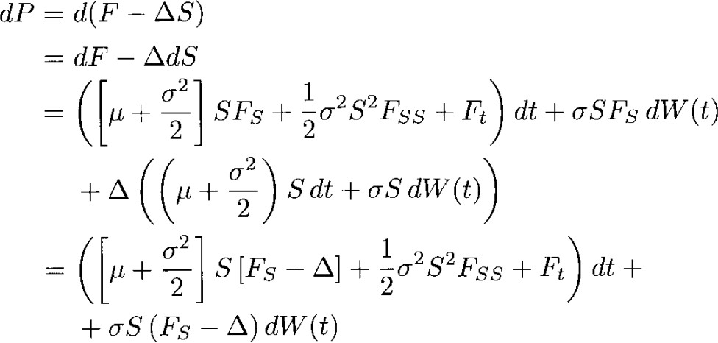

**here we can assume that** ∆*istherateofchangeofoptionswithchangeinthevalueofthesecurityhencethe*∆

*FS*

*Henceonfollowingtheaboverelationwegetthefollowing* :



In an arbitrage free setting we can find that the return from the above portfolio and return from a risk free bond will be same where the interest rate is r . Hence we can find that :

After using many mathematical manipulations to solve this partial differential equation ranging from setting up an analogy between heat equation and using fourier transform we reach to final Black Scholes formula for call option pricing that is :

Similarly by using the put call parity formula we reach to a final con- clusion for the put option pricing model equation that is :

Graph for the call option price on the (S,t) plane :

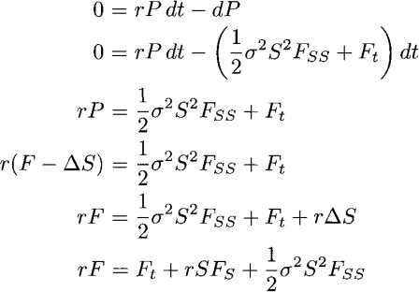





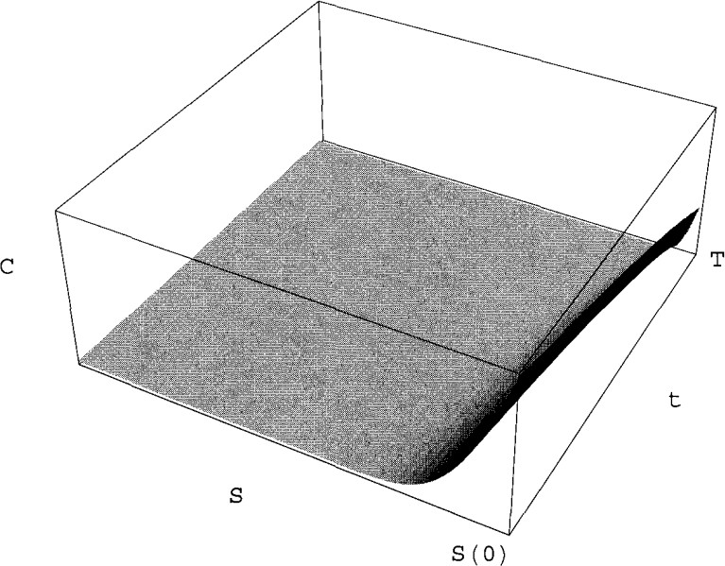

# Options Greeks

In the Quant world the derivative or rate of change of the option price with respect to different independent variable is known as options greek as due to different signs us to represent .There exist majorly : Delta : rate of change of the value of the options price with respect to value of the stock price

Rho:rate of the value of the value of the options price with respect to the value of the interest rate

Theta : rate of change of the value of the options price with respect to the time

Gamma :rate of the change of value of the value of the rate of change in the price of the options value with respect to the stock price .

Vega :measure the option’s senstivity with respect to the volatility of the stock price.

# Theta

By following different rules of derivatives we reach to the final rela- tion:

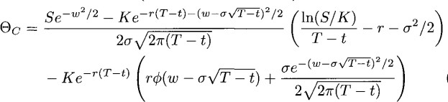

Similar calculation can be carried off for the put option price :

# Delta

By applying the derivative with respect to the price of the stock to the put call parity formula we can finally reach to the following rela- tion:

Now after applying the derivative on the call option price with re- spect to the stock price we finally reach to the following relation that

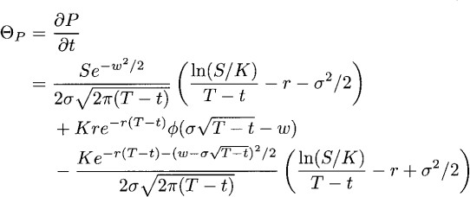

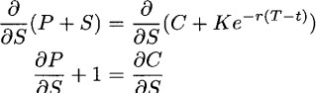

:



by following the above relation as we saw we get that the delta of the put option is : delta*P* = *deltaC* − 1

# Gamma

As we know gamma is the double derivative of the price of the option with respect to the price of the stock hence when we differentiate the relation of put and call delta with respect to the stock price we reach to the conclusion that the gamma for put and call comes out to be



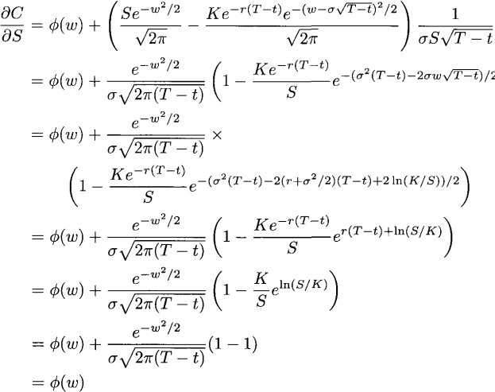

equal . hence:



Similarly we can compute the relations for vega and rho by partially differentiating the option price with respect to corresponding inde- pendent variables .

# Relation between Gamma Delta and Theta

We know that the Black Scholes relation came out to be :



Hence if put corresponding values of the greeks in the above equation we reach out to the following conclusion:



hence putting them will give us:

We can also show the black scholes equation as a linear operator giving zero whenever applied on the solution of the black scholes equation .

# Concluding Words

I was planning to learn financial mathematics but was lacking the motivation to start in a way a reason to start but then summer of sci- ence came .For this in the beginning i started to learn basics of finance



with which i was already familiar however when the topic of duality theorem came things took a turn and then i got a feeling that the path ahead of me ain’t going to be that easy .However with patience i moved forward and got to learn about stochastic process and a very important term in stochastic calculus which is ”Ito’s Lemma” ,which was a foundation stone for the very famous Black Scholes Pricing Model (Sometimes people see financial mathematics as completely associated by this ).After that i also learned about another famous term in the quant finance world which is put call parity formula and the arbitrage opportunity associated with these .After that i learned about ”option greeks”.Although summer of science for this year has come to an end but it has ended upn giving me a direction for learning it further !