Task 4: Design and Modelling Deliverable
Name: Shanty Lakapua
Course: CMN224 / CMP224 Software Engineering
Client: Waghi Valley Produce Cooperative, Intake and Payments System
Date: 11/10/2026
- Outline Architecture
1.1 Package Diagram
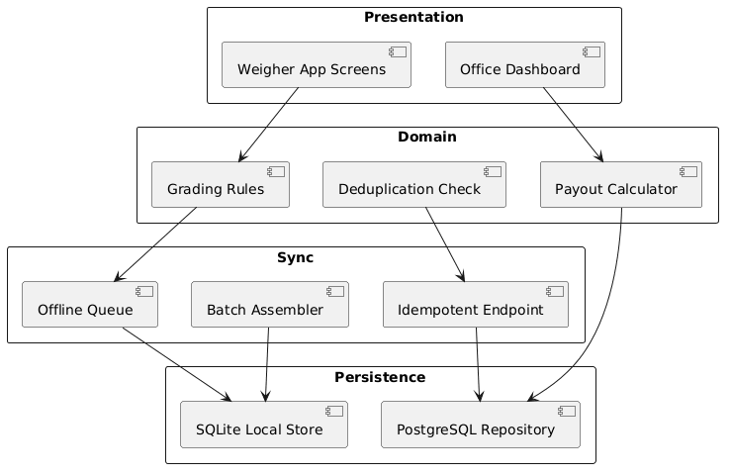
This shows how the system is split into packages. The UI package (PyQt5 forms) depends on the Business Logic package (intake recording, payment calculation, approval workflow). The Business Logic package depends on the Data Access package (SQLite at the depot, PostgreSQL at the town office, sync logic). Arrows point downward only. No package depends on a package above it.
The decision for these records: I chose a strict top-down dependency so that the two people maintaining this system can fix a bug in the business logic without touching the forms or the database code.
1.2 Deployment Diagram

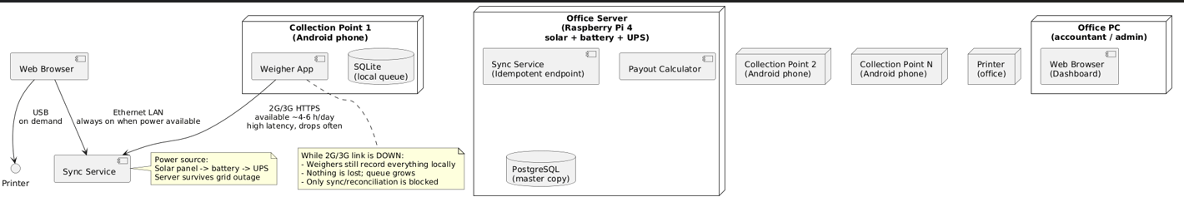
This shows the physical layout. The Depot Laptop holds the local SQLite file and runs the desktop app. The Town Office holds the central PostgreSQL database and the sync server. Data moves between them over 4G when available, or on a USB stick when it is not. There is no peer-to-peer link between any two depots. The town office is the only consolidation point.
The decision these records: I placed the server only at the town office because it is the only site with reliable power and 4G. The depot has solar and a generator, which is not enough to run a server process reliably.
- Use Case Model
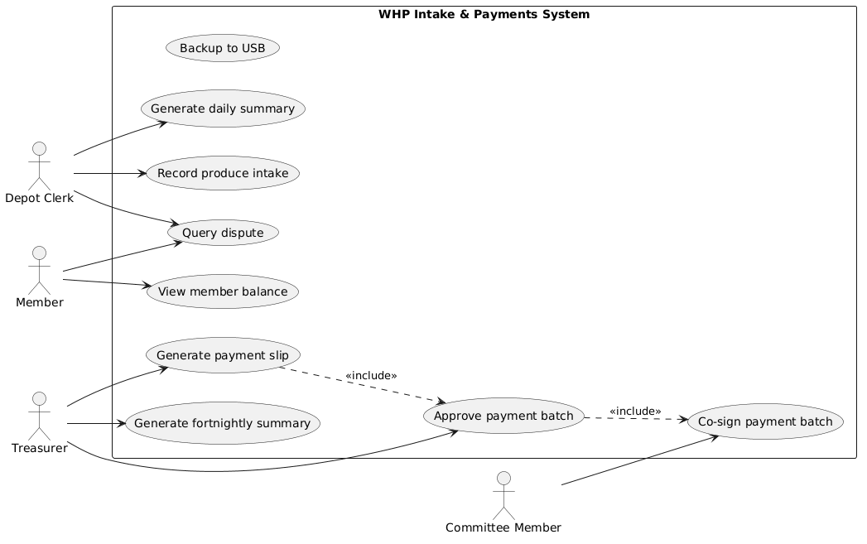
This shows four actors (Depot Clerk, Treasurer, Committee Member, Member) and nine use cases inside the system boundary. The two most important relationships are the include arrows: "Generate payment slip" includes "Approve payment batch," and "Approve payment batch" includes "Co sign payment batch." This encodes the two-person approval rule from the SRS.
The decision these records: I made "Co sign payment batch" a separate use case rather than a step inside "Approve payment batch" because the committee member is a different actor with a different role. Merging them would hide the separation of duties.
- Class Diagram
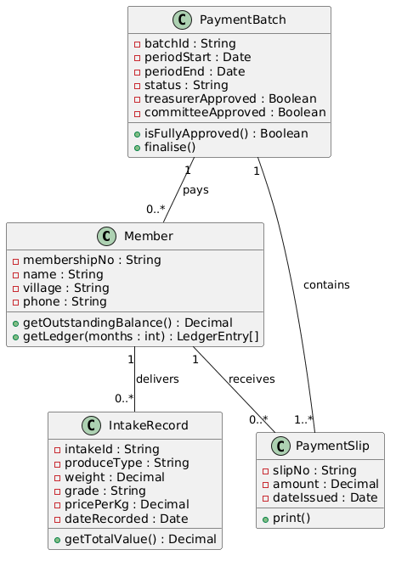
This shows four classes: Member, IntakeRecord, PaymentSlip, and PaymentBatch. Every attribute appears in the SRS in scope list. The multiplicity on "PaymentBatch contains PaymentSlip" is 1 to many, which encodes the business rule that a batch cannot be approved if it is empty. The multiplicity on "Member delivers IntakeRecord" is 1 to many, which encodes the rule that one member can deliver many times.
The decision for these records: I kept PaymentBatch as its own class rather than a collection inside Member because it has its own lifecycle (Draft, PendingApproval, TreasurerApproved, Finalised, Paid) and its own approval state. If I had made it a list inside Member, the state diagram would not have worked.
- State Diagram
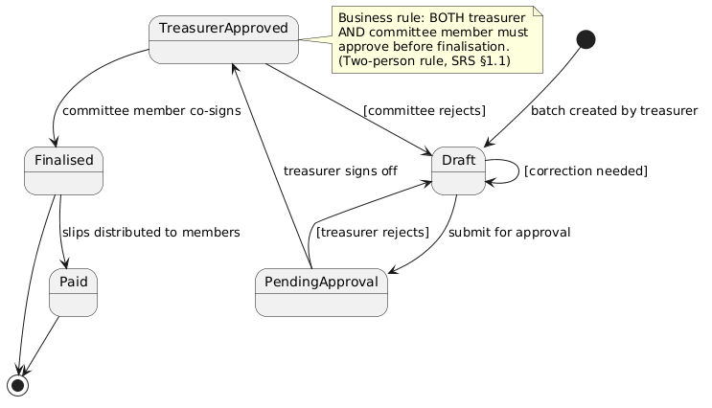
This shows the lifecycle of a PaymentBatch. It starts in Draft, moves to PendingApproval when the treasurer submits it, then to TreasurerApproved when the treasurer signs off, then to Finalised when the committee member co-signs. Guards appear on the rejection paths: [treasurer rejects] sends it back to Draft, and [committee rejects] also sends it back to Draft. The final state is Paid, after slips are distributed to members.
The decision for these records: I put the two-person approval rule as a guard on the transition to Finalised rather than as a separate state. This means the system cannot reach Finalised unless both approvals exist. It is a hard constraint, not a soft one.
- Activity Diagram
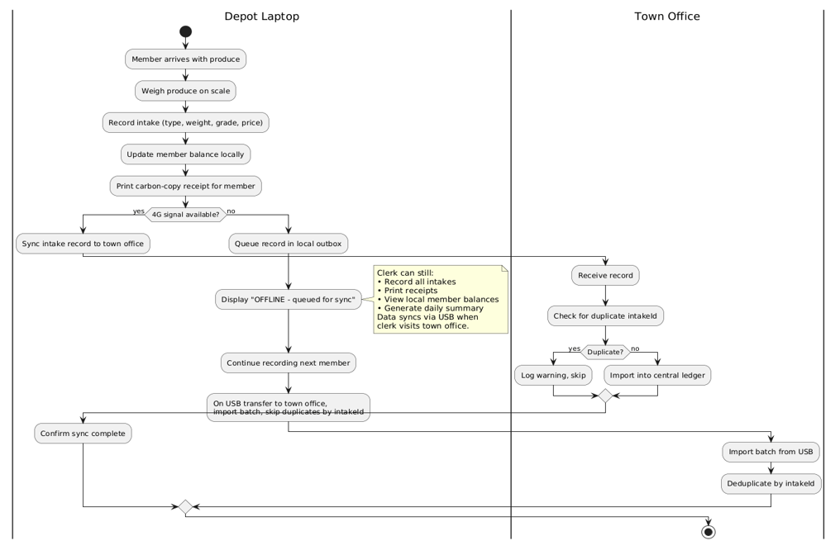
This shows the daily intake recording workflow across two swimlanes: Depot Laptop and Town Office. The clerk weighs the produce, records the intake, updates the member balance locally, and prints a receipt. Then a decision node checks if 4G is available. If yes, the record syncs to the town office, which checks for duplicates by intakes before importing. If no, the record queues in a local outbox, the clerk keeps working, and the data transfers via USB on the next visit to the town office.
The decision is this: I put the duplicate check on the town office side, not the depot side. The depot does not need to know what the town office already has. The town office is the single source of truth for the consolidated ledger, so it is the right place to deduplicate.
- Design Pattern Applied
The pattern I used is the Layered Architecture pattern. It appears in my package diagram, where the system is split into three layers: Presentation (PyQt5 forms), Business Logic (intake recording, payment calculation, approval workflow), and Data Access (SQLite at the depot, PostgreSQL at the town office, sync logic). Each layer depends only on the layer below it.
What this buys me: if the sync mechanism changes from 4G to USB only, only the Data Access layer changes. The forms and the business rules are untouched. If a new field is added to the intake form, only the Presentation layer and the Business Logic layer change. The database and sync code are untouched. For two people who are not professional developers, that separation means a bug in one layer does not force them to understand the other two.
- Consistency Checks
# | Check | Status
1 | Every use case traces to a user requirement in the SRS | Done. All nine use cases map to in-scope items in section 1.1 of the SRS
2 | Every class attribute appears in the requirements | Done. membershipNo, village, phone, produceType, weight, grade, pricePerKg, slipNo all appear in the SRS
3 | At least one multiplicity encodes a real business rule | Done. PaymentBatch 1 to many PaymentSlip encodes "a batch cannot be approved if empty"
4 | At least one state transition carries a guard from a business rule | Done. [treasurer rejects] and [committee rejects] encode the two-person approval rule
5 | Activity diagram has a branch for the offline case | Done. The "4G signal available?" decision node branches to USB sync
6 | Swimlanes match the devices in the deployment diagram | Done. Depot Laptop and Town Office appear in both
7 | Every class is placed on a machine in the deployment view | Done. See table below
8 | No package has an upward dependency arrow | Done. Arrows point down only in the package diagram
9 | One scenario traces cleanly through all five views | Done. See paragraph below
10 | The design pattern is named, located, and justified | Done. Layered Architecture, section 6 above

Class | Lives on
Member, IntakeRecord, PaymentSlip, PaymentBatch | Depot Laptop (local SQLite file)
Sync server, consolidated ledger | Town Office (PostgreSQL)
Scenario trace: A member delivers 2 kg of grade A coffee to the depot. The clerk records the intake on the Depot Laptop (use case: Record produce intake). An IntakeRecord object is created with weight 2.0, grade A, and the current price per kg (class diagram). The PaymentBatch for the current fortnight moves from Draft toward PendingApproval once all intakes for the period are recorded (state diagram). The activity diagram shows the clerk weighing, recording, printing the receipt, then the sync branch: 4G is up, so the record sends to the Town Office, which checks for a duplicate intake and imports it into PostgreSQL. The deployment diagram confirms the Depot Laptop holds the local SQLite file, and the Town Office holds the central database. The package diagram confirms the intake module in Business Logic depends on the sync module in Data Access, not the other way around.
- AI Declaration
I used an AI assistant to help me draft the PlantUML syntax for the four behavioural diagrams in Lab 6 and to structure this assembly document. The choice of client, the SRS content, the architecture decisions from Lab 4, the consistency checks, and the final judgement are my own. I verified every diagram against my SRS before committing. The AI had no access to my lecture notes, my class discussions, or my understanding of the Waghi Valley produce (WHP) context.

