**Assignment-3**

**Q3. Host a Jenkins image on azure container instance?**

**Output screens:**

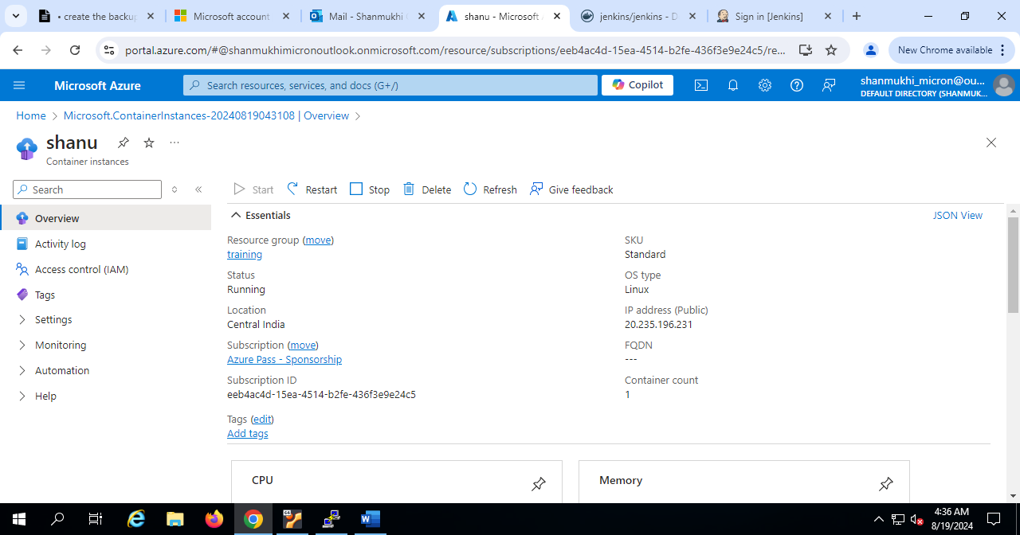

**Q5. Create an alert for the high c.p.u usage with email notification on windows server?**

**Output screens:**

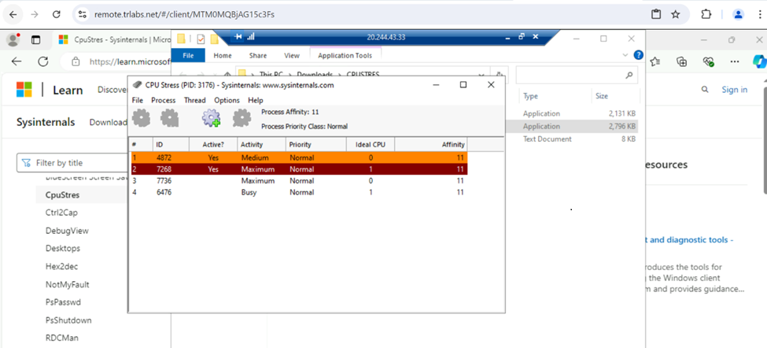

**Q4. Create and configure a cosmos database and demonstrate crud operations?**

**Output screens:**

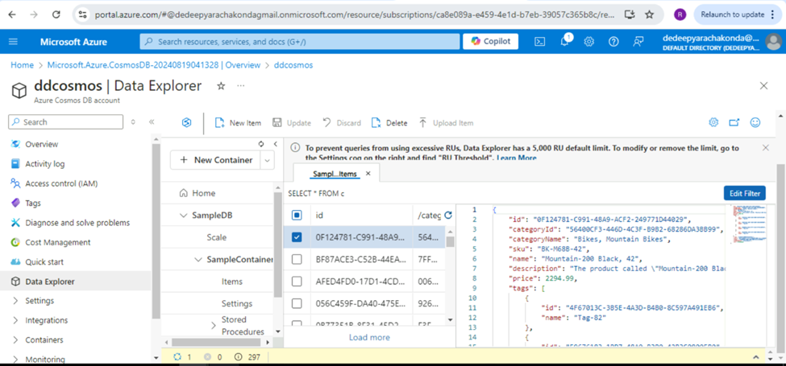

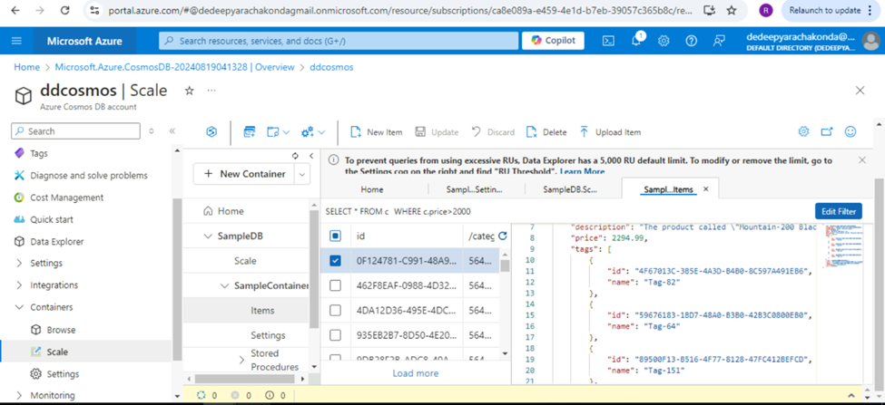

**Q1. Create and Configure an Azure SQL Database:**

* + **Create a new Azure SQL Database.**
  + **Configure firewall rules to allow access to your database from specific IP addresses.**
  + **Create tables, insert sample data, and run basic SQL queries**
  + **Create Employees and Departments tables and demonstrate INNER JOIN, LEFT OUTER JOIN and RIGHT OUTER JOIN**
  + **Configure automated backups and test restoring a database from a backup**
  + **Set up and configure geo-replication to create readable secondary replicas in different regions.**

**Output screens:**

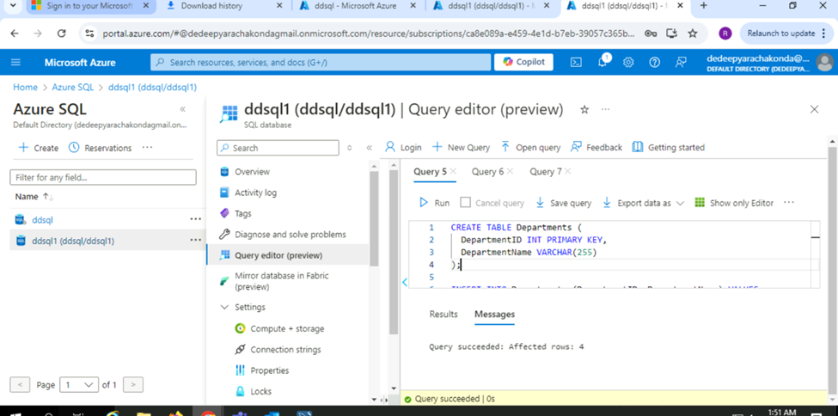

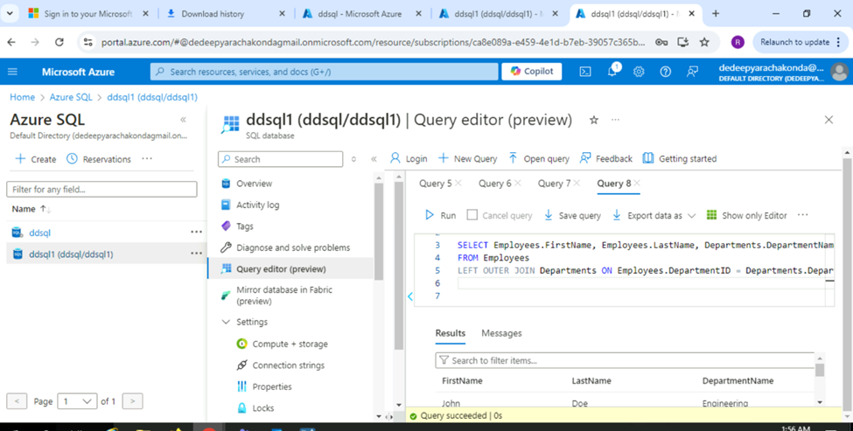

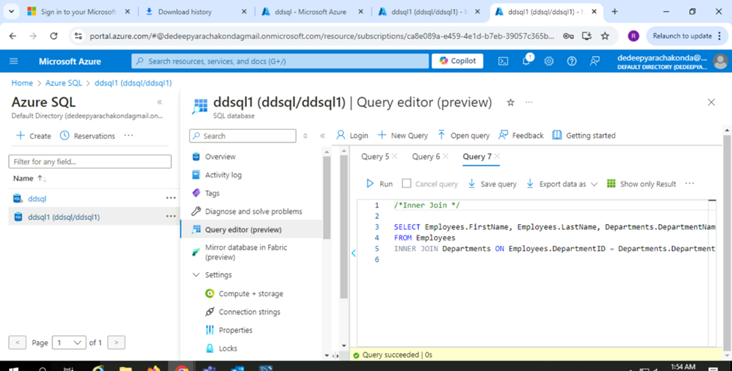

**Q2 . Create and Configure an Azure MYSQL Database:**

* + **Create a new Azure SQL Database.**
  + **Configure firewall rules to allow access to your database from specific IP addresses.**
  + **Create tables, insert sample data, and run basic SQL queries**
  + **Create Employees and Departments tables and demonstrate INNER JOIN, LEFT OUTER JOIN and RIGHT OUTER JOIN**
  + **Configure automated backups and test restoring a database from a backup**
  + **Set up and configure geo-replication to create readable secondary replicas in different regions.**

**Output screens:**



