**Assignment-4**

**4. Create jenkins freestyle pipeline- spring pet clinic jar creation?**

**Output screens:**

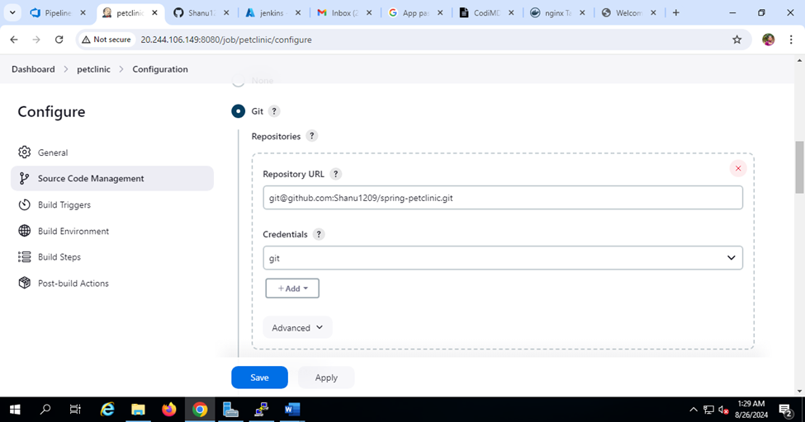

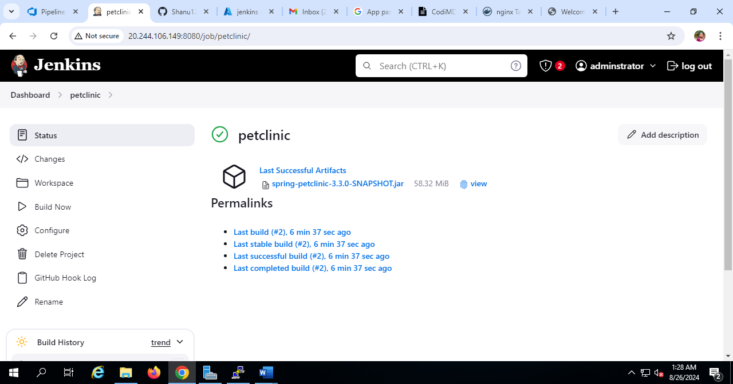

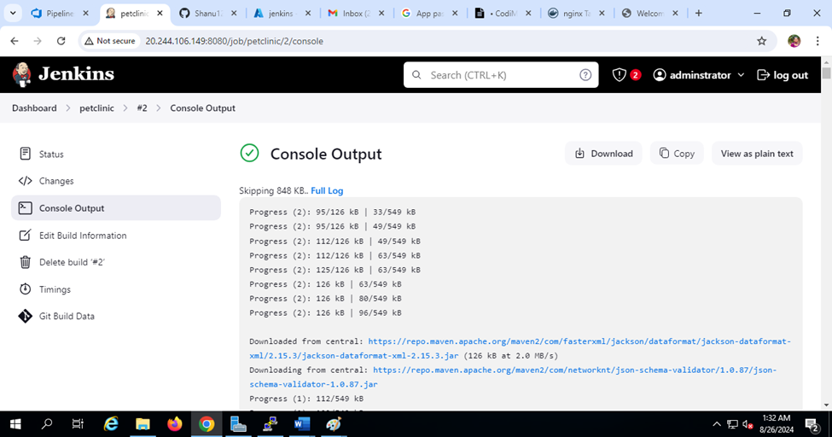

**5. Create a pipeline in Jenkins using spring pet clinic jar creation?**

**Output screens:**

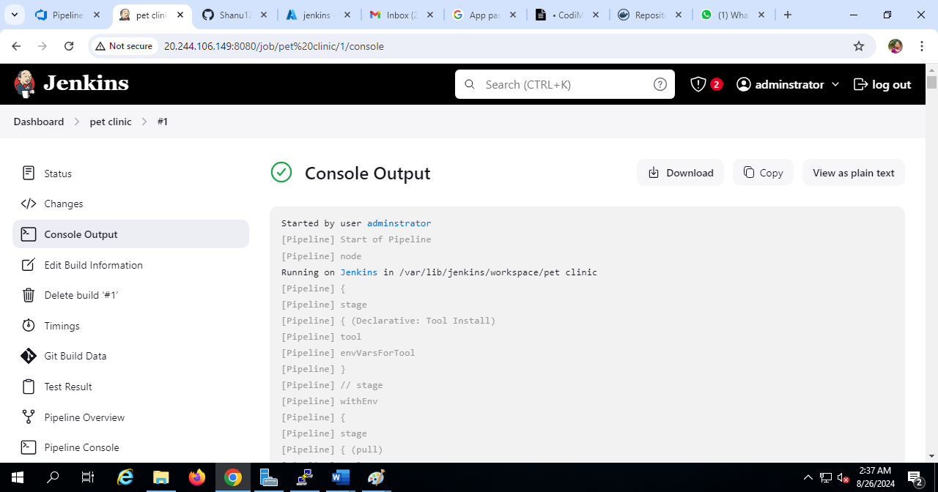

**2. Deploy the pet clinic in azure devops?**

**Output screens:**

**1.deploy .net app in azure dev ops from azure demo generator?**

**Output screens:**

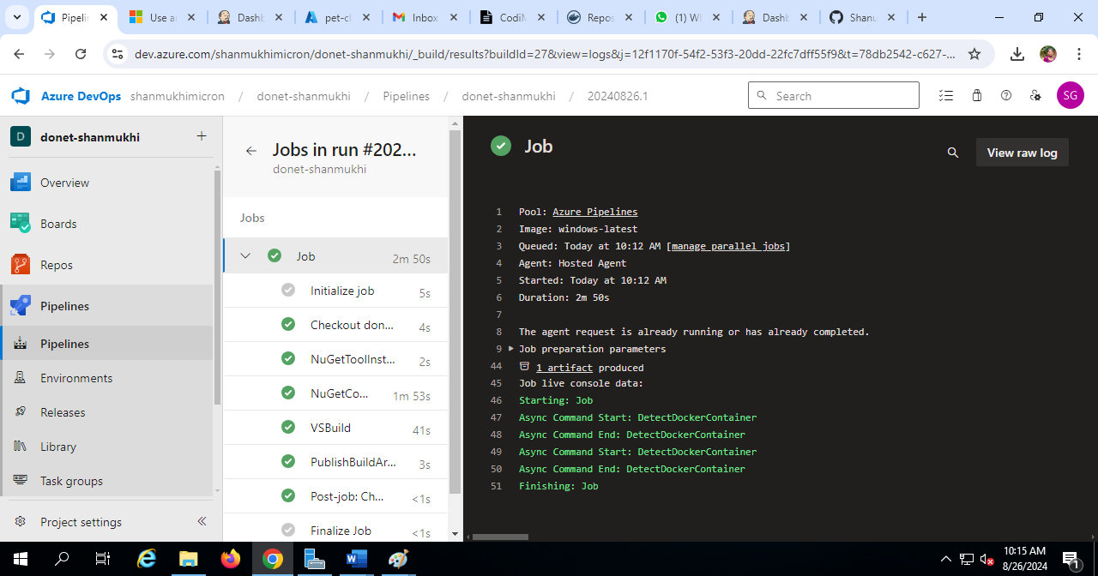

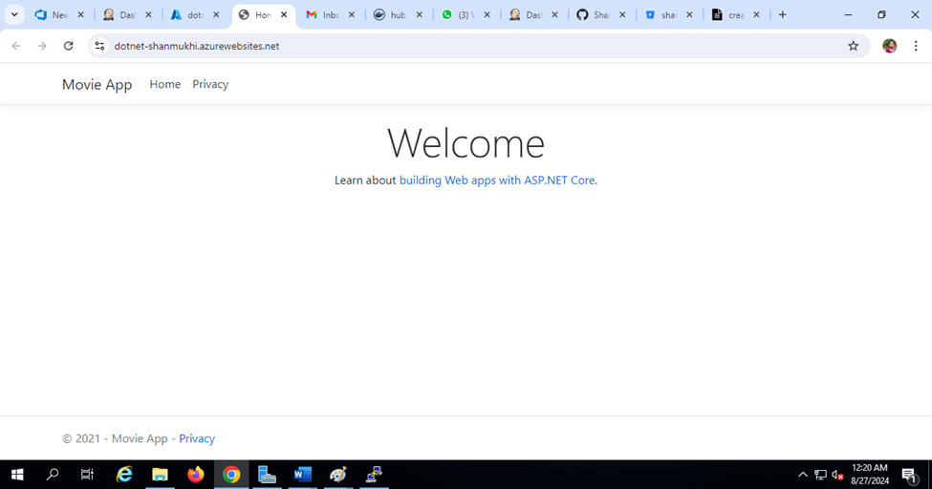

**3.bitbucket - create a project , create a repo, push existing code , create a branch , demonstrate pull request?**



