**Assignment-5**

**Q1. create a docker for spring pet clinic?**

**Output screens:**

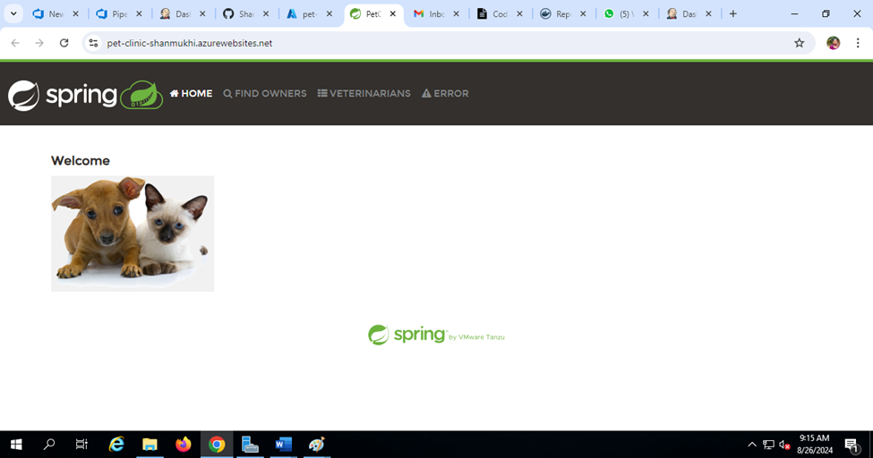

**Q2. Host spring pet clinic in k8s?**

**Output screens:**

