1. Limit Service

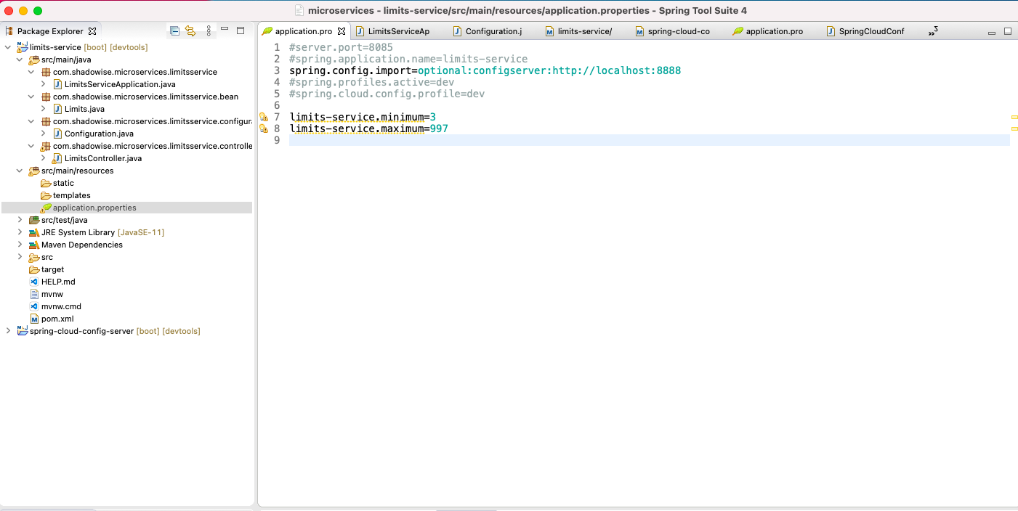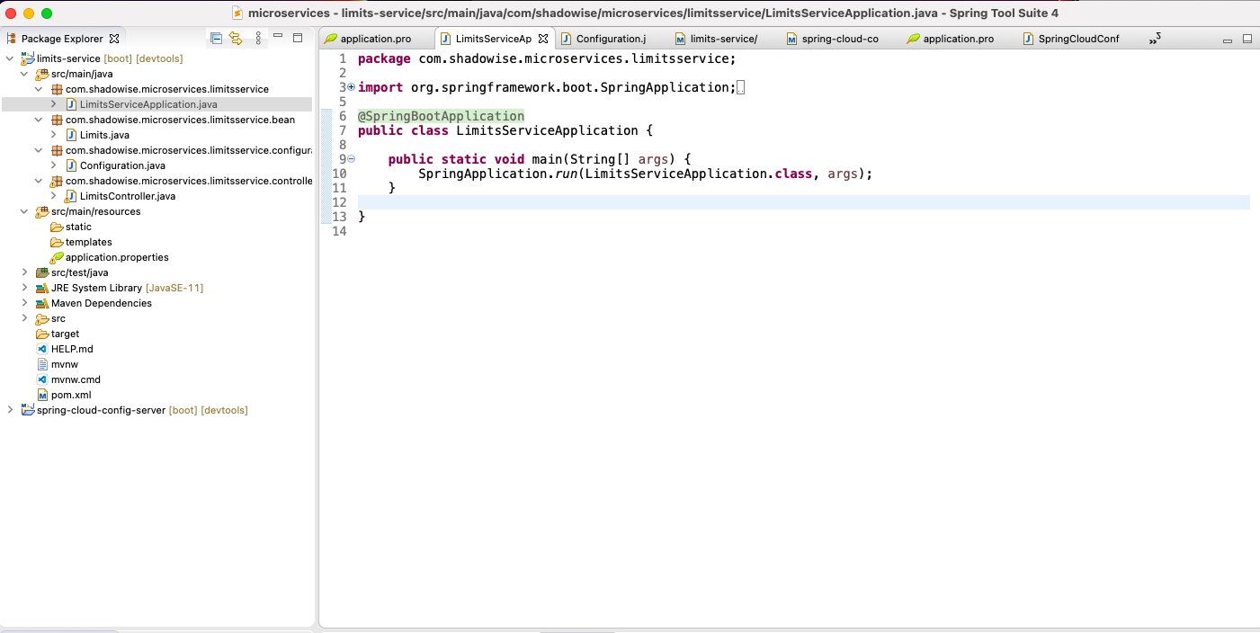

Pick properties from Appl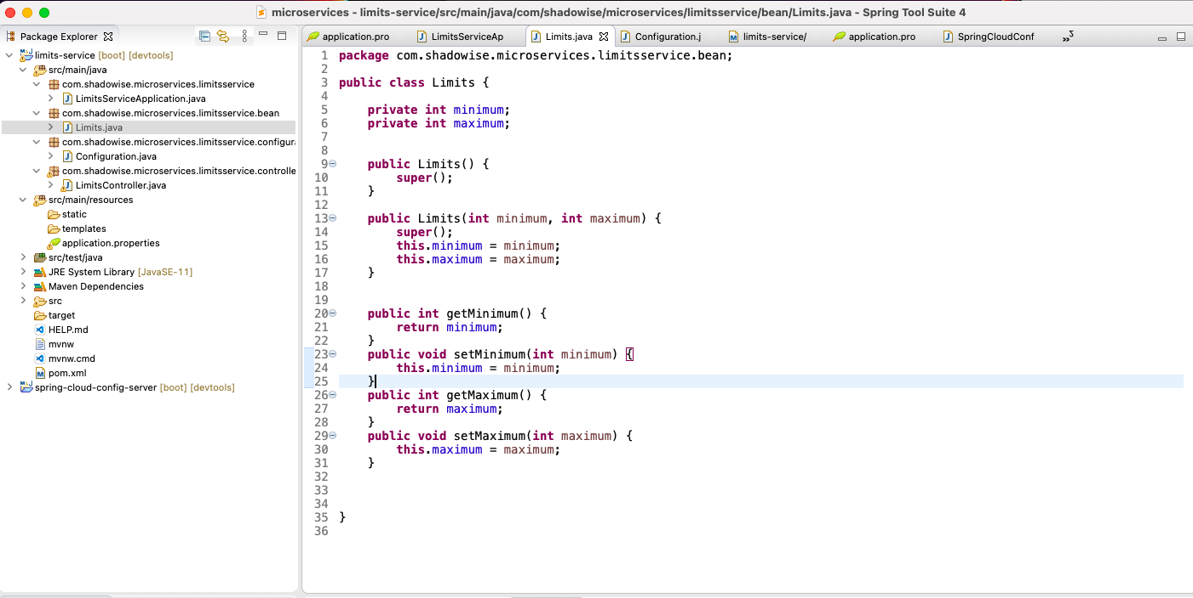ication.properties file

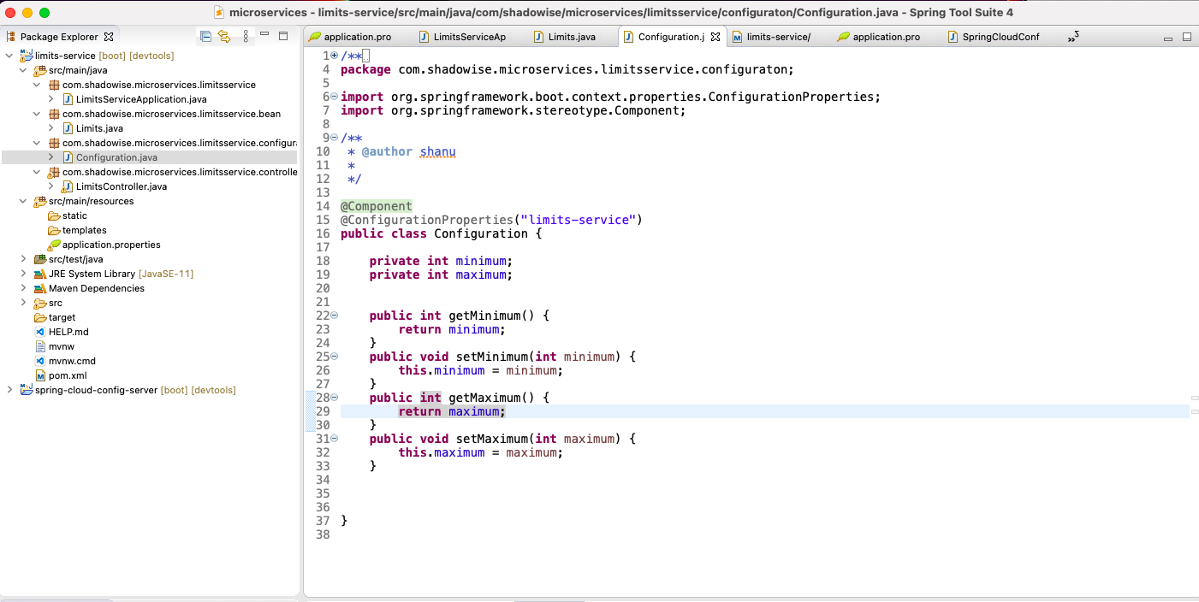

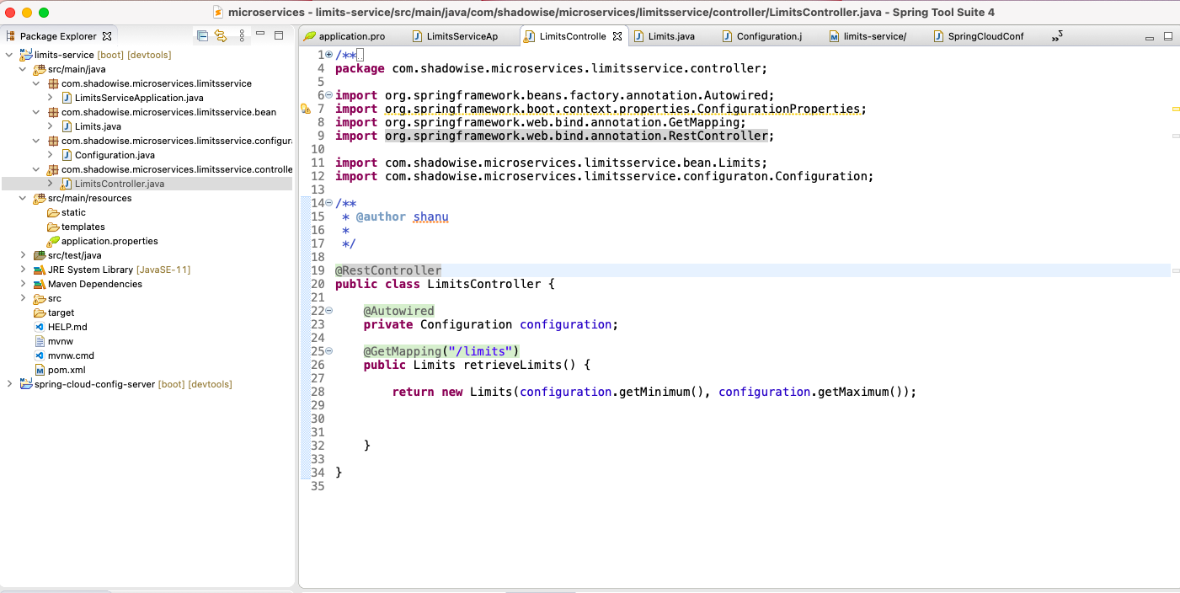

2.Spring Cloud config Server

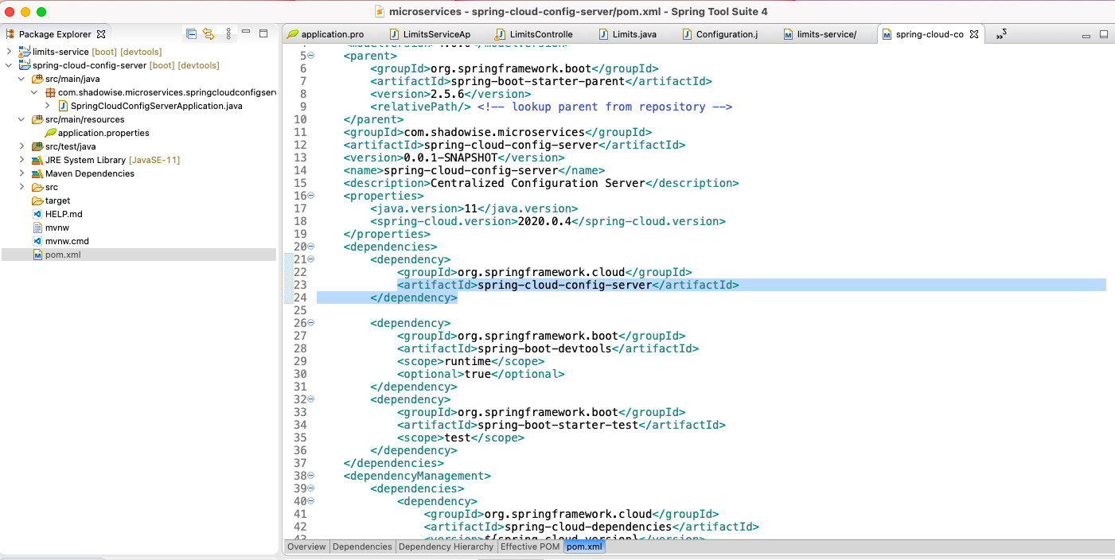

Read configuration from GIT repo(Local git now)

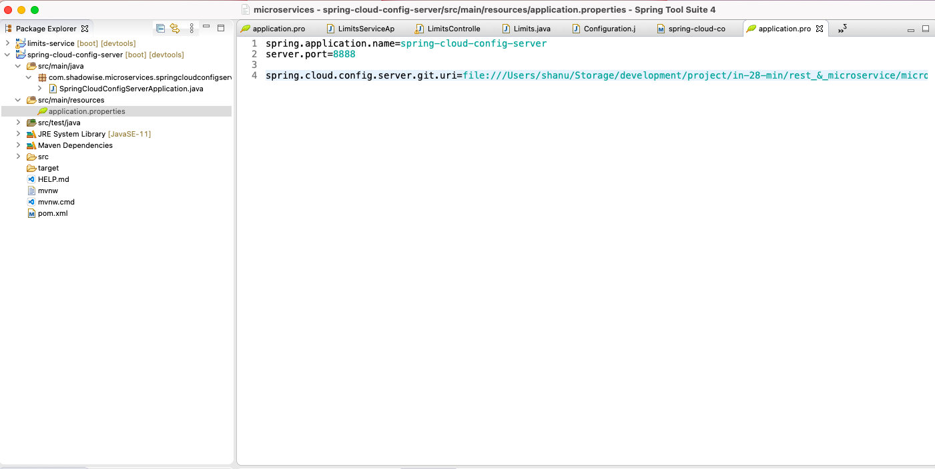

@EnableConfigServer. For get data from Git repo file

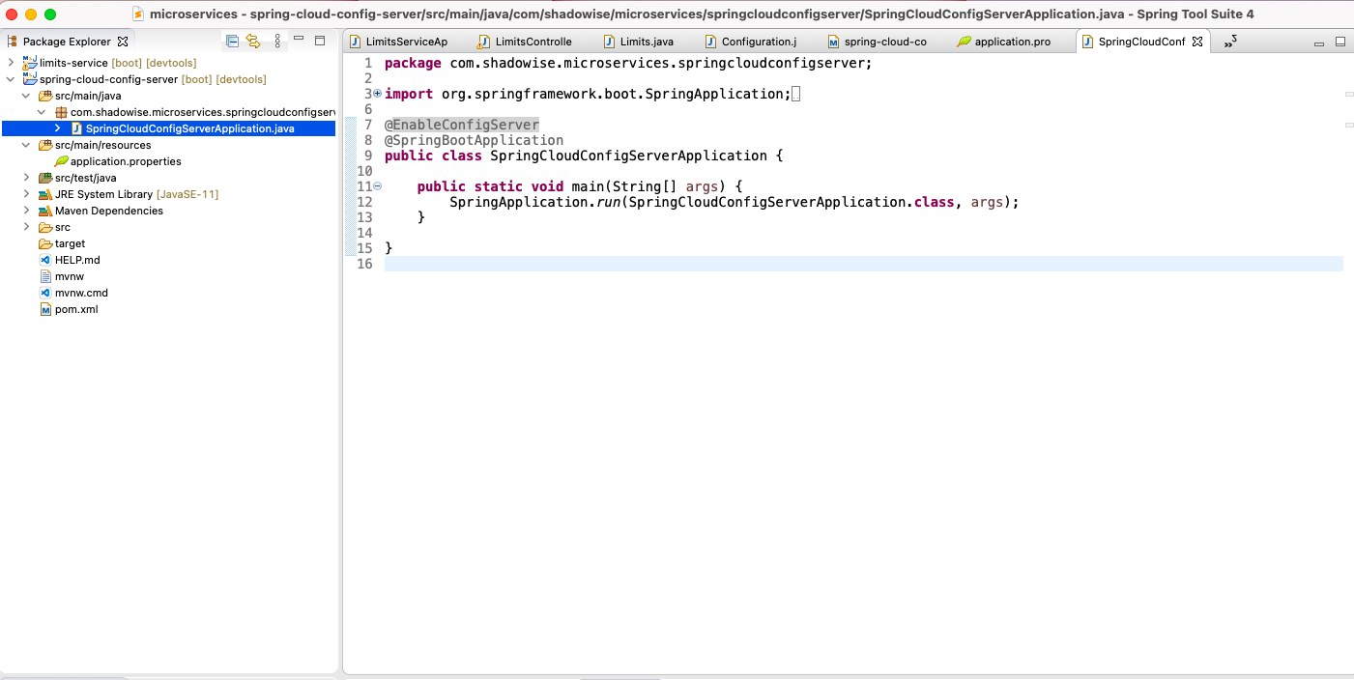

3. Connect limit service to Spring cloud Config server

Limits-service : Pom.xml

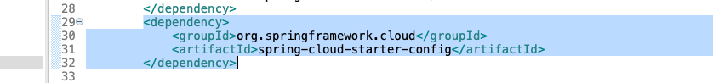

Above dependency already added .so this is required to connect with cloud config server.

Limits-service :Application.properties file

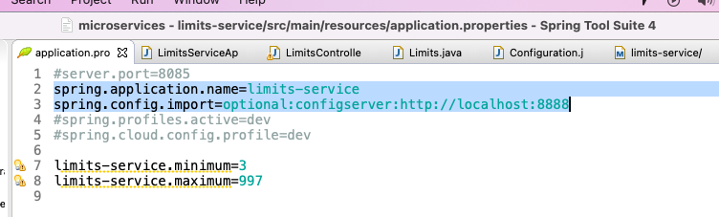

After done this.

Run App and see result.

O/P:

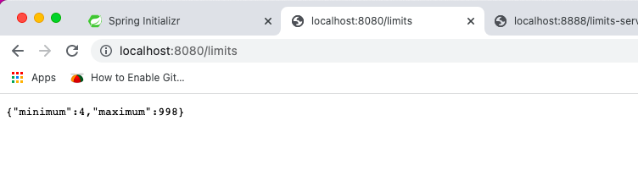

Value is fetching, after connecting spring cloud config server and read from get repo file limits-service.properties.

Logs for reference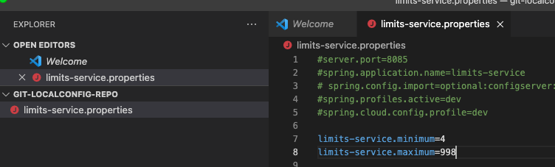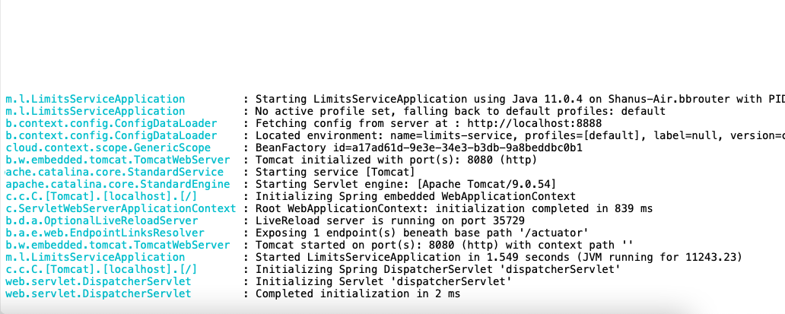

Environment based limit values.

Fetch Limit from spring cloud config server as per environment.

-created two file in git repo for dev and qa

limits-service-dev.properties

O/P:

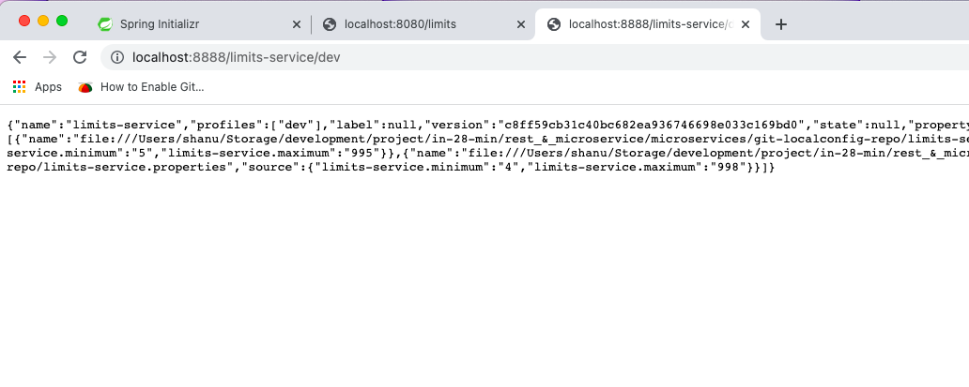

limits-service-qa-properties

O/P:

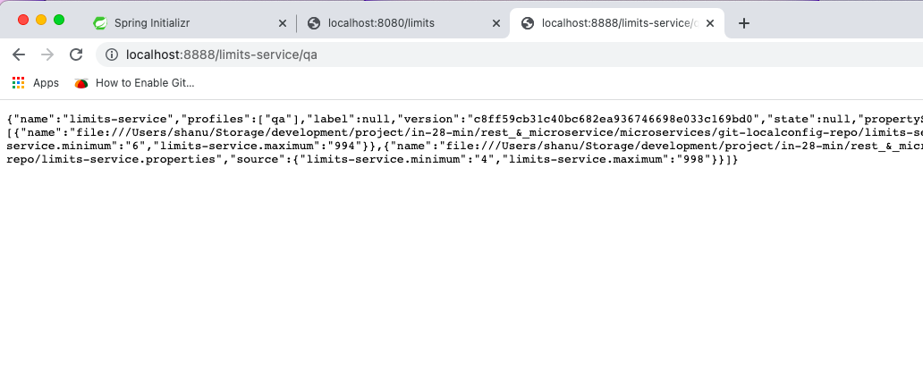

Now make default profile to pck value always.

Add below properties in application.properties file

spring.profiles.active=dev

spring.cloud.config.profile=dev

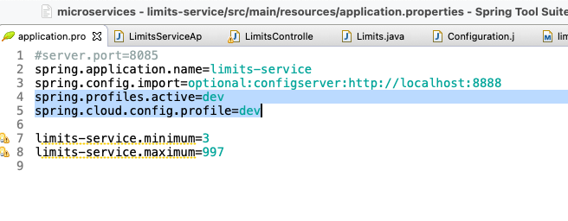

O/p:

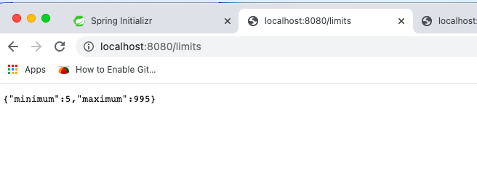

Value is picking from dev git repo file.

\*\*\*\*\*\*\*\*\*\*\*\*\*\*\*\* DONE \*\*\*\*\*\*\*\*\*\*\*\*\*\*\*\*\*\*\*\*\*\*\*\*\*\*

Check currency-exchange and Currency Conversion Microservices for more implementation example.