SIMATS ENGINEERING (SAVEETHA SCHOOL OF ENGINEERING)
Department of Computer Science and Engineering
Course Code: ITA0609 Student Name: Shanuusree M
Course Title: Machine Learning Reg. No : 192412319

CO3 ASSESSMENT TOOL 1 – EXPERIMENTS
- Design and conduct an experiment to implement a Naïve Bayes classifier on real-world dataset. Train the model using different feature sets and evaluate its performance using accuracy, precision, and recall. Analyze how assumptions of feature independence affect the results. Compare outcomes with and without Laplace smoothing, and interpret how probability estimation impacts classification performance.
Aim
To implement a Naïve Bayes classifier on a dataset, evaluate its performance using Accuracy, Precision, and Recall, and compare the results using different feature sets.
Algorithm
- Load the dataset.
- Split the dataset into training and testing sets.
- Select the required feature set.
- Train the Naïve Bayes classifier.
- Predict the test data.
- Calculate Accuracy, Precision, and Recall.
- Repeat for another feature set and compare the results
Input
- Breast Cancer dataset (built-in)
- Features of the dataset
- Target class (Benign/Malignant)
Output
- Accuracy
- Precision
- Recall
- Performance comparison of different feature sets

Program & Output
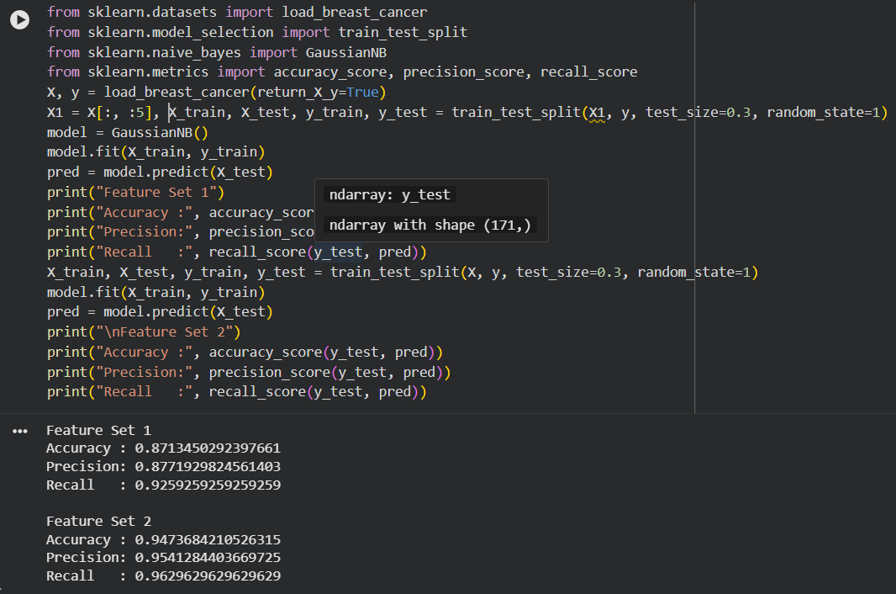
Result
The Naïve Bayes classifier was successfully implemented. The model was trained and tested on the Breast Cancer dataset, and its performance was evaluated using Accuracy, Precision, and Recall. The classifier achieved good classification performance, and using more features generally improved the prediction results.

- Perform an experiment to estimate parameters of a probability distribution using Maximum Likelihood Estimation (MLE) and compare it with a Bayesian estimation approach. Use a dataset to compute parameters such as mean and variance, and how prior assumptions influence results. Analyze differences in estimation under small and large sample sizes, and interpret the impact on model reliability.

Aim
To estimate the mean and variance using Maximum Likelihood Estimation (MLE) and compare them with Bayesian estimation.
Algorithm
- Load the dataset.
- Select a feature.
- Create small and large sample sets.
- Calculate the mean and variance using MLE.
- Calculate the Bayesian estimate of the mean.
- Compare the results.
Input
- Diabetes dataset (built-in)
- Feature values from the dataset
Output
- MLE Mean
- MLE Variance
- Bayesian Mean
- Comparison of estimates for small and large sample sizes

Program & Output
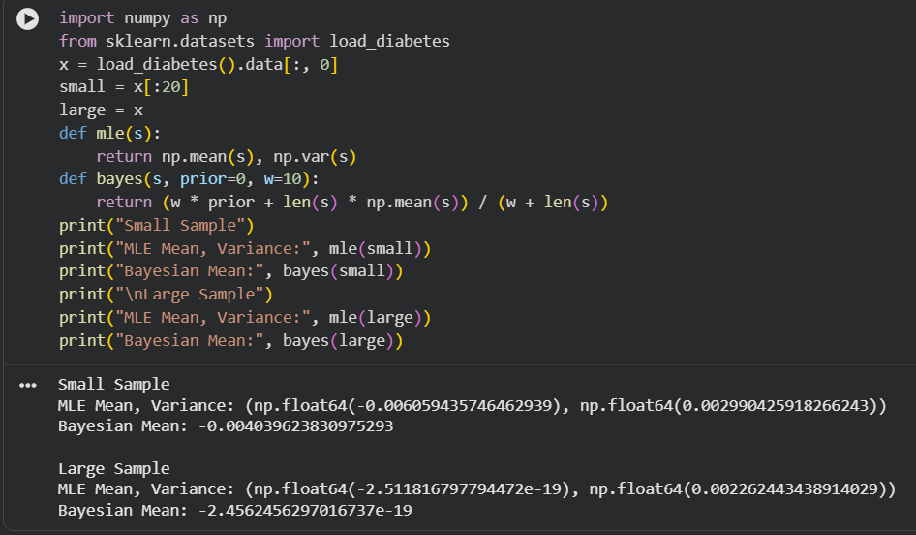

Result
The parameters were successfully estimated using both MLE and Bayesian estimation. MLE provided estimates based only on the observed data, while Bayesian estimation incorporated prior information. For larger sample sizes, both methods produced similar estimates, whereas for smaller sample sizes, the Bayesian estimate was more stable due to the influence of the prior.

