STUDENT PERFORMANCE PREDICTION
(Using Machine Learning)
A PROJECT REPORT
SUBMITTED BY
Roll Number | Registration Number | Student Code | Student Name
24103460107 | 24103002889 | BWU/BCA/24/112 | Shanwi Ansari

In partial fulfillment for the award of the degree
BACHELOR OF COMPUTER APPLICATION
IN
DEPARTMENT OF COMPUTATIONAL SCIENCE
BRAINWARE UNIVERSITY
398, Ramkrishnapur Road, Barasat, North 24 Parganas, Kolkata - 700 125

ABSTRACT
The Student Performance Prediction System is a machine learning project built using Python that predicts the final marks a student is likely to score, based on academic and behavioural factors. The system learns from data of past students and then estimates the expected performance of a new student from only seven simple answers. The main objective of this project is to show the practical use of the complete machine learning workflow: data collection, cleaning, exploratory analysis, model training, evaluation and deployment in a simple user interface.
The seven inputs used by the system are the marks of Class Test 1 (CT-1) and Class Test 2 (CT-2), average assignment score, daily study hours, class participation, sleep hours and daily phone or social media hours. The target value to be predicted is the final marks out of 100. The dataset was created for this project with 1010 records, including a few missing values and duplicate rows so that the data-cleaning step could be demonstrated properly.
After cleaning, the data is divided into a training set (80%) and a testing set (20%). Three regression algorithms, Linear Regression, Random Forest and Gradient Boosting, are trained and compared using three metrics: Mean Absolute Error (MAE), Root Mean Squared Error (RMSE) and the R-squared (R²) score. Linear Regression gave the best result with an MAE of 3.09 marks and an R² of 0.90, which means the model explains about 90% of the variation in final marks. The best model is saved to a file so that it can be used again without training.
The project also identifies which factors have the strongest relationship with performance. The feature-importance analysis shows that CT-2 marks and CT-1 marks are the most important factors, followed by study hours and assignment score, while too many hours on the phone or social media lowers the predicted marks.
A web interface built with Streamlit allows any student or teacher to enter the seven answers and instantly receive the predicted marks, a performance category (Excellent, Good, Average or At Risk), simple suggestions for improvement and a chart of the most important factors. Overall, the project gives a simple, working machine learning system that can help identify weak students early and guide them before the final examination.

INDEX
❖ ABSTRACT
❖ LIST OF FIGURE
❖ LIST OF TABLE
❖ LIST OF SCREENSHOTS
1. INTRODUCTION
2. LITERATURE SURVEY
3. SYSTEM ANALYSIS AND DESIGN
4. IMPLEMENTATION
5. OUTPUT SCREENSHOT
6. TESTING AND DEBUGGING
7. CONCLUSION AND FUTURE ENHANCEMENT
8. REFERENCES

LIST OF FIGURE, TABLE AND SCREENSHOTS

List of Figures
Fig. 3.1 :- Layered Architecture of the Student Performance Prediction System
Fig. 3.2 :- System Flow Chart (Training and Prediction)
Fig. 3.3 :- DFD Level 0 (Context Diagram)
Fig. 3.4 :- DFD Level 1

List of Tables
Table 3.1 :- Layers and Their Responsibilities
Table 3.2 :- Features of the Dataset
Table 3.3 :- Core Concepts Used
Table 3.4 :- Performance Categories
Table 3.5 :- Steps of the System Flow
Table 3.6 :- Processes and Data Stores in the DFD
Table 6.1 :- Model Comparison Results
Table 6.2 :- Feature Importance
Table 6.3 :- Test Cases

List of Screenshots
5.1 :- Input Form (7 Questions)
5.2 :- Predicted Marks and Performance Category
5.3 :- Suggestions Section
5.4 :- Feature Importance Chart in the Application
5.5 :- Distribution of Final Marks
5.6 :- Correlation Heatmap
5.7 :- Relationship of Key Factors with Final Marks
5.8 :- Model Comparison Chart
5.9 :- Actual vs Predicted Marks
5.10 :- Feature Importance (Random Forest)

1. INTRODUCTION
Every educational institution wants its students to perform well in examinations. A student's final result depends on many things, such as how well the student did in class tests, how regular the student is with assignments, how many hours the student studies, how active the student is in class, how much the student sleeps and how much time is lost on the phone or social media. Teachers can usually notice a weak student only after the final results are declared, and by then it is too late to help.
Machine learning gives a way to solve this problem. In machine learning, a computer program learns patterns from old data instead of being told fixed rules. If we give the program the details of many past students along with their final marks, it can learn how each factor affects the result. It can then predict the likely marks of a new student before the examination is held. This is called supervised learning, and because the answer to be predicted is a number (marks), the problem is a regression problem.
The Student Performance Prediction System developed in this project does exactly this. A user answers seven simple questions: CT-1 marks, CT-2 marks, average assignment score, study hours per day, class participation, sleep hours and phone or social media hours. The system then predicts the expected final marks out of 100 and places the student in one of four categories: Excellent, Good, Average or At Risk. It also gives short suggestions to improve and shows a chart of the factors that matter most.
The project follows the complete machine learning workflow. First, a student-performance dataset is created. Next, the data is cleaned by removing duplicate rows and filling missing values. Exploratory data analysis (EDA) is then done with charts to understand the data. The data is split into training and testing sets, three algorithms are trained and compared, and the best one is saved. Finally, the saved model is connected to a web interface so that anyone can use it without knowing programming.
The system is developed in Python using pandas and NumPy for data handling, matplotlib and seaborn for charts, scikit-learn for machine learning, joblib for saving the model and Streamlit for the web interface. All of these tools are free and widely used, which makes the project easy to run, understand and extend.
In conclusion, the Student Performance Prediction System is a simple but complete machine learning application. It not only predicts marks but also explains which factors are most strongly related to performance, so that students and teachers can take early and useful action.

2. LITERATURE SURVEY
This project is based on the research area called Educational Data Mining (EDM) and Learning Analytics. These fields use data collected from students, such as marks, attendance and study behaviour, to understand how students learn and to predict how they will perform. Many studies in this area show that early prediction helps institutions to support weak students before the final examination.
Earlier methods of checking student performance were mostly manual. Teachers compared marks in spreadsheets, applied fixed pass-mark or attendance rules, and prepared result reports after the examination. These methods are reactive: they tell us what has already happened, but they do not tell us what is likely to happen.
Researchers have used many machine learning algorithms for predicting student performance. Linear Regression is the simplest and is often used as a baseline because it is fast and easy to explain. Decision Trees and Random Forests can capture more complex relationships by combining the decisions of many trees. Gradient Boosting builds trees one after another so that each new tree corrects the mistakes of the earlier ones. Studies generally report that previous academic results, such as earlier test marks, are the strongest predictors of future performance, and that study habits and class participation also play an important role.
Public datasets such as the Student Performance dataset of the UCI Machine Learning Repository and the Student Performance Factors dataset on Kaggle are widely used for such work. They contain factors such as hours studied, attendance, previous scores and exam scores. The idea of using these kinds of factors is followed in this project, with class-test marks (CT-1 and CT-2) used as the main academic inputs because they are available to every student during the semester.
Many existing tools show only reports or charts and are not easy for a student to use. Based on these findings, this project combines a regression model, a feature-importance analysis and a very simple web interface, so that a student can get a prediction and clear suggestions in a few seconds.

3. SYSTEM ANALYSIS AND DESIGN
System analysis and design is the stage in which the problem is studied, the requirements are decided and the structure of the solution is planned. It explains what the system must do and how its parts work together.

3.1 System Analysis
Existing System: In most colleges, student performance is checked through marks registers, spreadsheets and semester result sheets. A teacher sees the result only after the examination is over. A student has no simple way to know in advance what marks to expect or which habit needs to be improved.
Problems in the Existing System:
- Performance is known only after the final results, so early help is not possible.
- No automatic prediction of final marks from the marks of class tests and other factors.
- No clear information about which factors (study hours, phone use, sleep, etc.) affect the result most.
- Reports are manual, take time to prepare and are not interactive.
- Students do not receive personal suggestions to improve.
Proposed System: The proposed system is a machine learning application that takes seven simple answers from the user, predicts the final marks using a trained regression model, shows a performance category and gives suggestions. It also shows which factors have the strongest relationship with performance.
Advantages of the Proposed System:
- Predicts the final marks in advance, so weak students can be helped early.
- Compares three machine learning algorithms and automatically uses the best one.
- Shows the most important factors affecting performance with a clear chart.
- Very easy to use: only seven questions with sliders, no technical knowledge needed.
- Free tools only; works on any normal computer with Python.

3.2 System Design
The system is divided into small modules. Each module has one clear job, which makes the project easy to understand, test and improve.
Modules of the System:
- Dataset Module (generate_dataset.py) – Creates the student-performance dataset with 8 columns (7 inputs and 1 target). It is not needed if a Kaggle dataset is used.
- Data Cleaning Module (train.py) – Removes duplicate rows and fills missing values with the column median.
- EDA Module (eda.py) – Draws charts such as the distribution of marks, correlation heatmap and scatter plots.
- Model Training and Evaluation Module (train.py) – Splits the data, trains three models, calculates MAE, RMSE and R², selects the best model and saves it.
- Prediction Module (predict.py) – Loads the saved model, arranges the user's answers in the correct order, predicts the marks and finds the performance category.
- User Interface Module (app.py) – A Streamlit web page with seven sliders, a Predict button, result display, suggestions and the feature-importance chart.
System Architecture: The system follows a simple layered structure. The user interface collects the answers and sends them to the application layer. The application layer passes them to the saved machine learning model, which returns the predicted marks. The result is then shown on the screen with a category and suggestions.
Technologies Used:
- Programming Language: Python 3
- Data Handling: pandas, NumPy
- Machine Learning: scikit-learn (Linear Regression, Random Forest, Gradient Boosting, metrics, train-test split)
- Visualization: matplotlib, seaborn
- Model Saving: joblib
- User Interface: Streamlit
- Data Storage: CSV file (student_performance.csv)
- Tools: VS Code, Jupyter Notebook / Google Colab, GitHub

3.3 Theory Architecture
The system is built in four layers. Each layer has one job and talks only to the layer next to it. The web page never reads the dataset directly; it always goes through the application code, which uses the saved model.
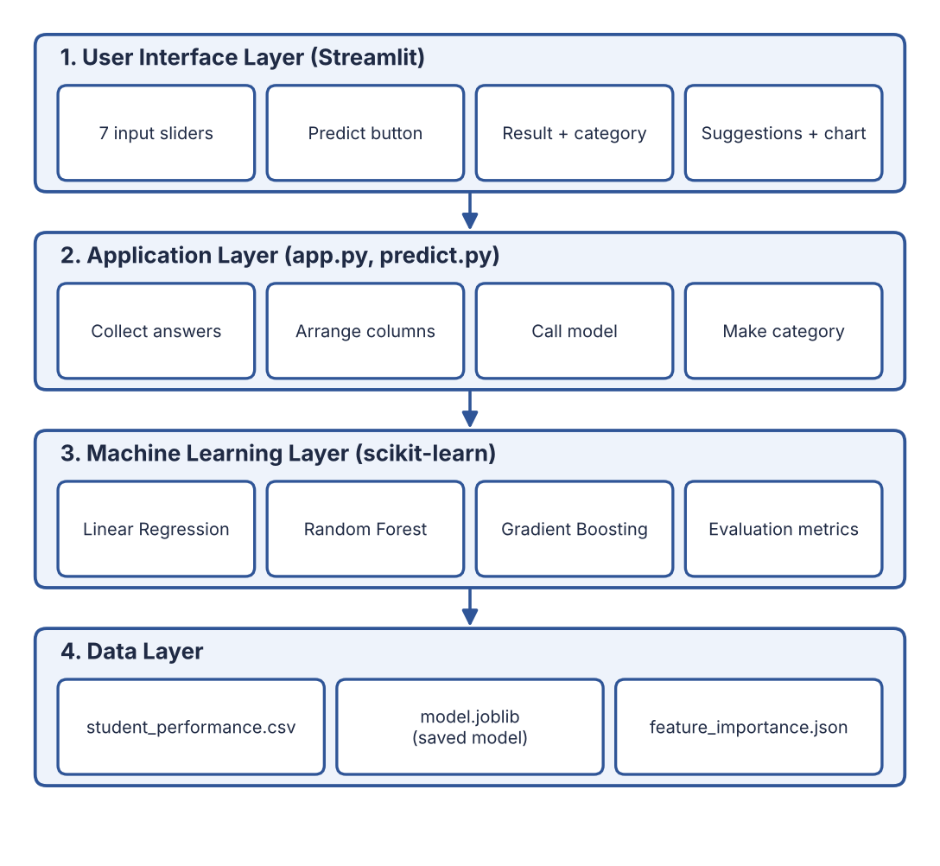
Fig. 3.1 :- Layered Architecture of the Student Performance Prediction System
Table 3.1 :- Layers and Their Responsibilities
Layer | Main parts | Responsibility
User Interface | Streamlit page, sliders, buttons | Collects the seven answers, shows the predicted marks, category, suggestions and chart.
Application | app.py, predict.py | Receives the answers, arranges them in the correct column order, calls the model and finds the category.
Machine Learning | scikit-learn models, train.py | Cleans the data, splits it, trains three models, evaluates them and saves the best one.
Data | student_performance.csv, model.joblib, feature_importance.json | Stores the dataset, the trained model and the feature-importance values.

Dataset Used
The dataset has 1010 records before cleaning (1000 after removing 10 duplicate rows). It was created for this project using Python so that it follows realistic patterns: students with good class-test marks tend to score well, more study hours increase marks, and long phone or social media time reduces marks. Some missing values (45 in total) and duplicate rows were added on purpose so that the cleaning step is demonstrated with real work. The code also works with a real Kaggle dataset once the column names are matched.
Table 3.2 :- Features of the Dataset
Column | Meaning | Role
CT1_Marks | Class Test 1 marks (out of 30) | Input feature
CT2_Marks | Class Test 2 marks (out of 30) | Input feature
Assignment_Score | Average assignment score (in %) | Input feature
Study_Hours | Study hours per day (0 to 10) | Input feature
Participation | Class participation, 1 (low) to 5 (high) | Input feature
Sleep_Hours | Sleep hours per night (3 to 10) | Input feature
Distraction_Hours | Phone / social media hours per day (0 to 10) | Input feature
Final_Marks | Final marks out of 100 | Target (predicted value)

Core Concepts Used
Table 3.3 :- Core Concepts Used
Concept | Simple meaning | Where it is used
Supervised learning | The model learns from examples whose correct answers are already known. | Training on past students' marks.
Regression | Predicting a number (here, final marks). | All three models.
Features and target | Features are the inputs; the target is the output to predict. | 7 inputs and Final_Marks.
Train-test split | Part of the data is used to learn (80%) and part is kept hidden to test (20%). | train_test_split in train.py.
Linear Regression | Finds the best straight-line relationship between inputs and marks. | Best model of the project.
Random Forest | Builds many decision trees and averages their answers. | Comparison and feature importance.
Gradient Boosting | Builds trees one by one, each fixing the mistakes of the previous. | Comparison model.
Feature importance | A score showing how much each input helps the prediction. | Importance chart.
MAE, RMSE, R² | Measures of prediction error and of how well the model fits. | Model evaluation.

Evaluation Metrics
- MAE (Mean Absolute Error): the average difference between the predicted and the actual marks. A smaller value is better. For example, an MAE of 3 means the prediction is about 3 marks away on average.
- RMSE (Root Mean Squared Error): similar to MAE but gives a bigger penalty to large mistakes. A smaller value is better.
- R² score: shows how much of the variation in marks is explained by the model. It lies between 0 and 1, and a value close to 1 is better. An R² of 0.90 means about 90% is explained.

Performance Categories
After the marks are predicted, the system converts them into a simple category using fixed limits:
Table 3.4 :- Performance Categories
Predicted marks | Category | Meaning
80 and above | Excellent | Very strong performance expected.
65 to 79.9 | Good | Good performance expected.
50 to 64.9 | Average | Pass level, but there is room to improve.
Below 50 | At Risk | The student needs extra help and attention.

3.4 System Flow
The flow chart shows what happens in the system. The left side is the training part, which is done once by the developer. The right side is the prediction part, which runs every time a user opens the web page. The saved model joins the two parts.
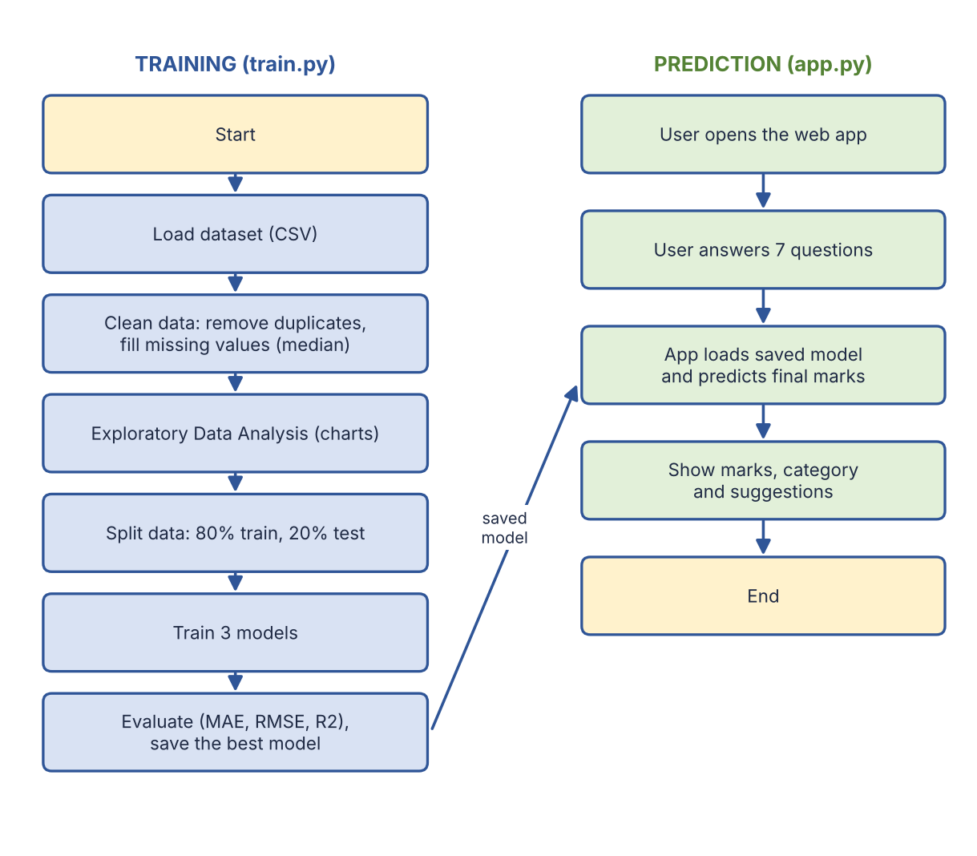
Fig. 3.2 :- System Flow Chart (Training and Prediction)
Table 3.5 :- Steps of the System Flow
Step | Name | What happens
1 | Load dataset | The CSV file is read into a pandas DataFrame (1010 rows, 8 columns).
2 | Clean data | 10 duplicate rows are removed and 45 missing values are filled with the column median. 1000 clean rows remain.
3 | EDA | Charts show the spread of marks, the correlation of each factor with marks and key scatter plots.
4 | Split data | 800 rows (80%) are used for training and 200 rows (20%) for testing.
5 | Train models | Linear Regression, Random Forest and Gradient Boosting learn from the training data.
6 | Evaluate and save | MAE, RMSE and R² are calculated on the test data. The best model is saved as model.joblib.
7 | User input | The user answers the seven questions in the web page.
8 | Predict | The saved model predicts final marks, which are limited to the range 0 to 100.
9 | Show result | The marks, the category, the suggestions and the importance chart are displayed.

3.5 Data Flow Diagrams
A Data Flow Diagram (DFD) shows how data moves through the system. Level 0 shows the system as one process, and Level 1 shows the main processes inside it.

DFD Level 0 (Context Diagram)
The user gives the seven answers to the system and receives the predicted marks and suggestions. The system uses the dataset to learn.
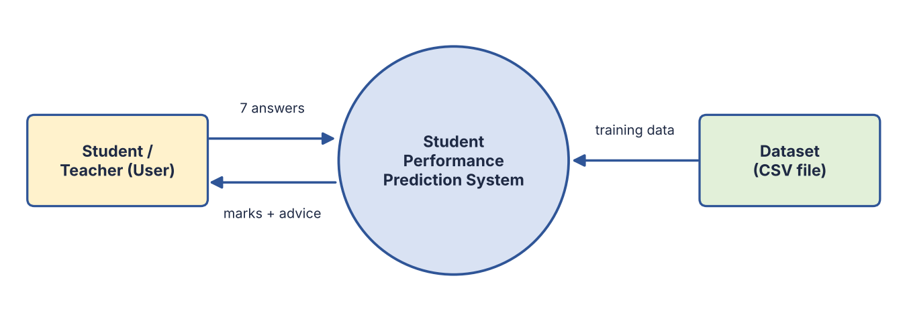
Fig. 3.3 :- DFD Level 0 of the System

DFD Level 1
Level 1 shows that the dataset is used by the training process, which creates the saved model. The prediction process reads this saved model to predict the marks.
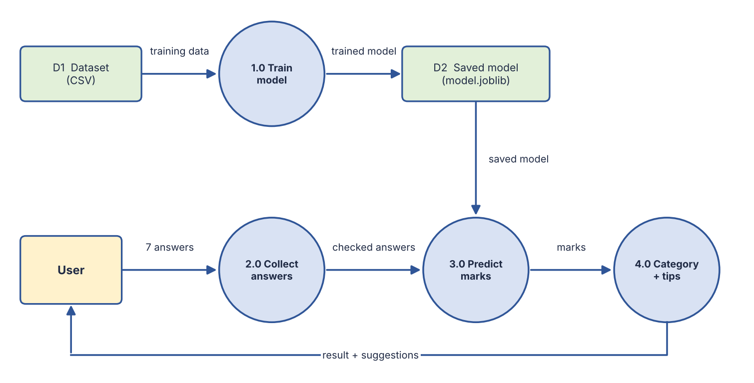
Fig. 3.4 :- DFD Level 1 of the System
Table 3.6 :- Processes and Data Stores in the DFD
No. | Name | Description
1.0 | Train model | Reads the dataset (D1), cleans it, trains and evaluates the models and writes the best one to D2.
2.0 | Collect answers | Takes the seven answers from the user and arranges them in the correct order.
3.0 | Predict marks | Reads the saved model (D2) and predicts the final marks.
4.0 | Category and tips | Finds the category, creates suggestions and shows everything to the user.
D1 | Dataset | data/student_performance.csv
D2 | Saved model | models/model.joblib

4. IMPLEMENTATION
The implementation phase turns the design into working code. The project is kept in a single folder, and each file has one purpose.

4.1 Project Folder Structure
student-performance-predictor/
|-- Student_Performance_Prediction.ipynb (full notebook with explanations)
|-- app.py (Streamlit web interface)
|-- requirements.txt (list of libraries)
|-- README.md
|-- data/
| |-- student_performance.csv (dataset)
|-- src/
| |-- generate_dataset.py (creates the dataset)
| |-- eda.py (exploratory data analysis)
| |-- train.py (clean, split, train, evaluate, save)
| |-- predict.py (loads model and predicts)
|-- models/
| |-- model.joblib (saved trained model)
|-- outputs/ (charts and metrics.json)
|-- docs/ (documentation and PPT)

4.2 Data Cleaning and Splitting
The dataset is loaded with pandas. Duplicate rows are removed and missing values are filled with the median of each column. The median is used because it is not affected by very high or very low values. The cleaned data is then split into 80% training and 20% testing data.
df = pd.read_csv("data/student_performance.csv")
df = df.drop_duplicates() # remove duplicate rows
df = df.fillna(df.median(numeric_only=True)) # fill missing values

X = df.drop(columns=["Final_Marks"]) # 7 input features
y = df["Final_Marks"] # target
X_train, X_test, y_train, y_test = train_test_split(
X, y, test_size=0.2, random_state=42)

4.3 Model Training and Evaluation
Three models are trained on the training data. Each model then predicts the marks of the test students, and the predictions are compared with the real marks using MAE, RMSE and R². The model with the highest R² score is selected and saved with joblib.
models = {
"Linear Regression": LinearRegression(),
"Random Forest": RandomForestRegressor(n_estimators=200, random_state=42),
"Gradient Boosting": GradientBoostingRegressor(random_state=42),
}
for name, model in models.items():
model.fit(X_train, y_train) # learning step
pred = model.predict(X_test)
mae = mean_absolute_error(y_test, pred)
rmse = np.sqrt(mean_squared_error(y_test, pred))
r2 = r2_score(y_test, pred)

joblib.dump({"model": best_model, "features": feature_names}, "models/model.joblib")

4.4 Prediction Module
The prediction module (predict.py) loads the saved model. It puts the user's answers in the same column order that was used in training, predicts the marks, limits them between 0 and 100 and finds the category.
def predict_student(answers: dict) -> dict:
model, features = load_model()
row = pd.DataFrame([answers])[features] # keep correct column order
marks = float(model.predict(row)[0])
marks = max(0.0, min(100.0, marks)) # keep marks between 0 and 100
return {"marks": round(marks, 1), "category": grade_category(marks)}

4.5 User Interface
The user interface (app.py) is built with Streamlit. It shows a form with seven sliders: CT-1 marks (0 to 30), CT-2 marks (0 to 30), assignment score (0 to 100), study hours per day, class participation (1 to 5), sleep hours and phone or social media hours. When the user presses the Predict my performance button, the answers are sent to the prediction module and the result is shown with the predicted marks, a progress bar, the performance category and a list of suggestions. At the bottom, a bar chart shows the importance of every factor.
The suggestions are created by simple rules. For example, if CT-2 marks are lower than CT-1 marks, the student is advised to revise weak topics; if study hours are below 2.5, the student is advised to study more; and if phone or social media time is above 4 hours, the student is advised to reduce it.

4.6 How to Run the Project
pip install -r requirements.txt
python src/generate_dataset.py # optional: create the dataset
python src/eda.py # save EDA charts in outputs/
python src/train.py # train, evaluate and save the model
python -m streamlit run app.py # open the web application

5. OUTPUT SCREENSHOT
This chapter shows the output of the project. Screenshots 5.1 to 5.4 are the pages of the web application, and 5.5 to 5.10 are the charts produced during analysis and evaluation.
5.1 :- Input Form (7 Questions)
5.2 :- Predicted Marks and Performance Category
5.3 :- Suggestions Section
5.4 :- Feature Importance Chart in the Application
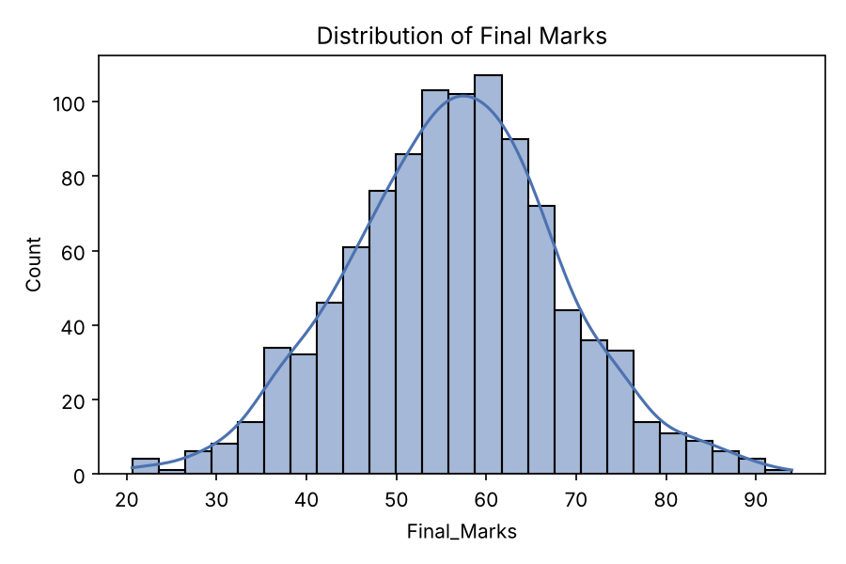
5.5 :- Distribution of Final Marks
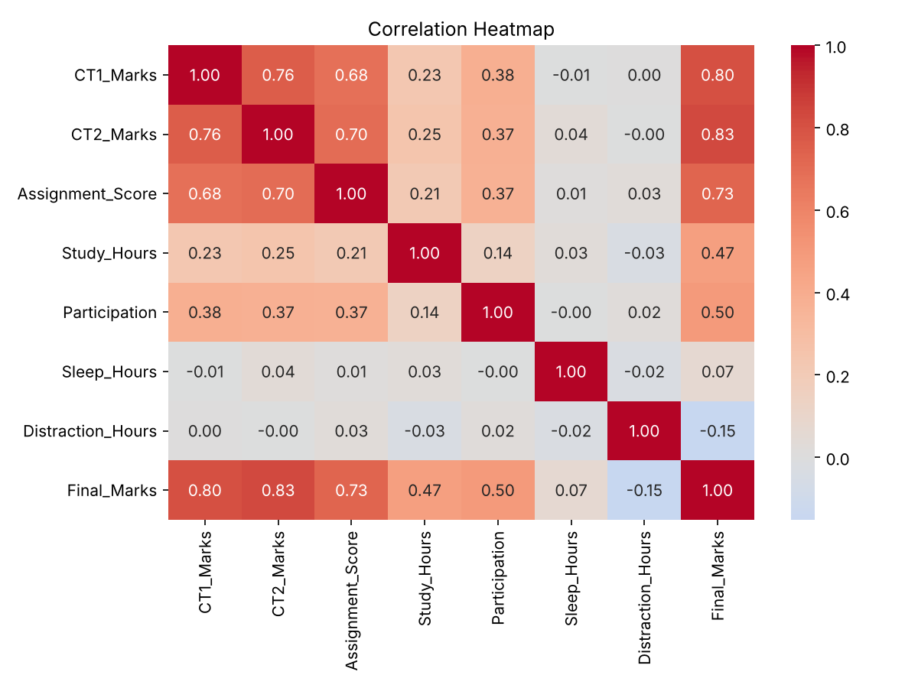
5.6 :- Correlation Heatmap
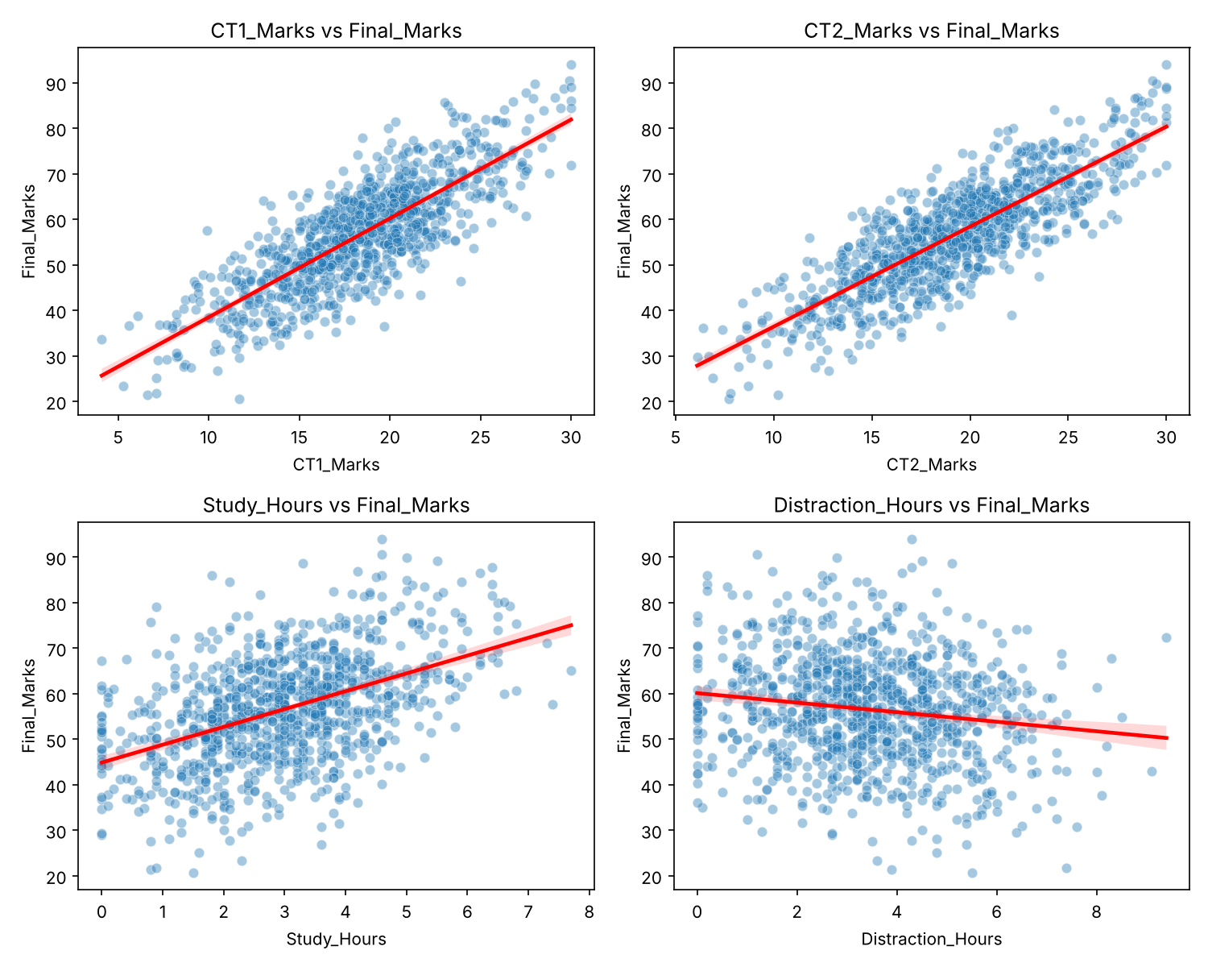
5.7 :- Relationship of Key Factors with Final Marks
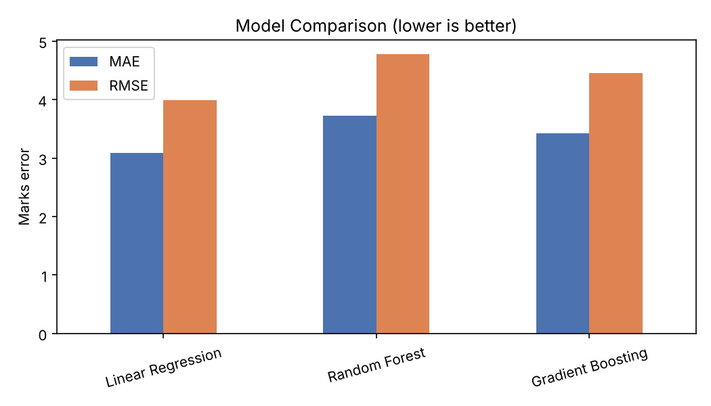
5.8 :- Model Comparison Chart
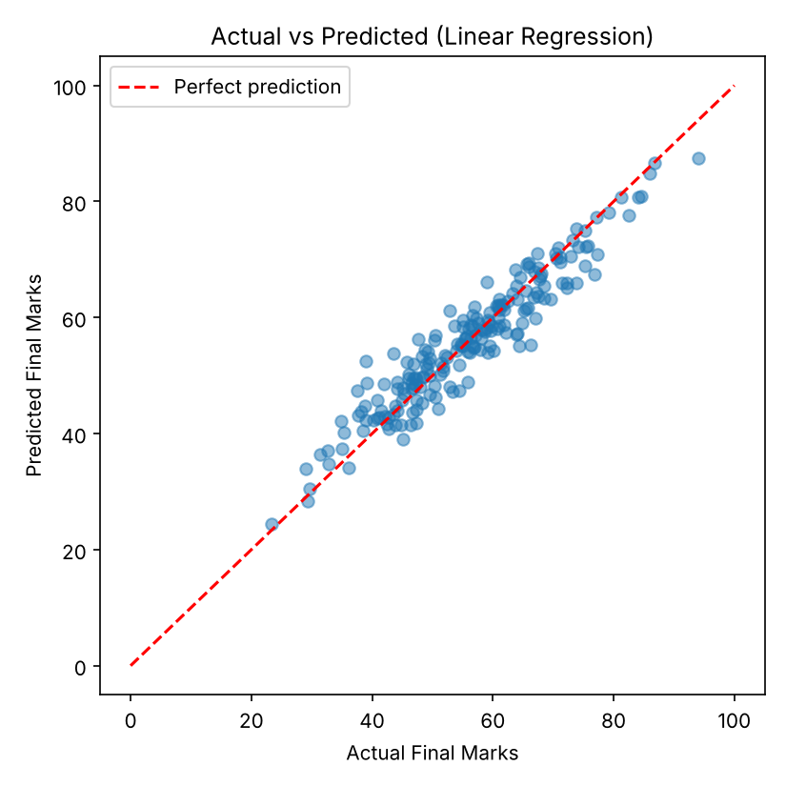
5.9 :- Actual vs Predicted Marks (Linear Regression)
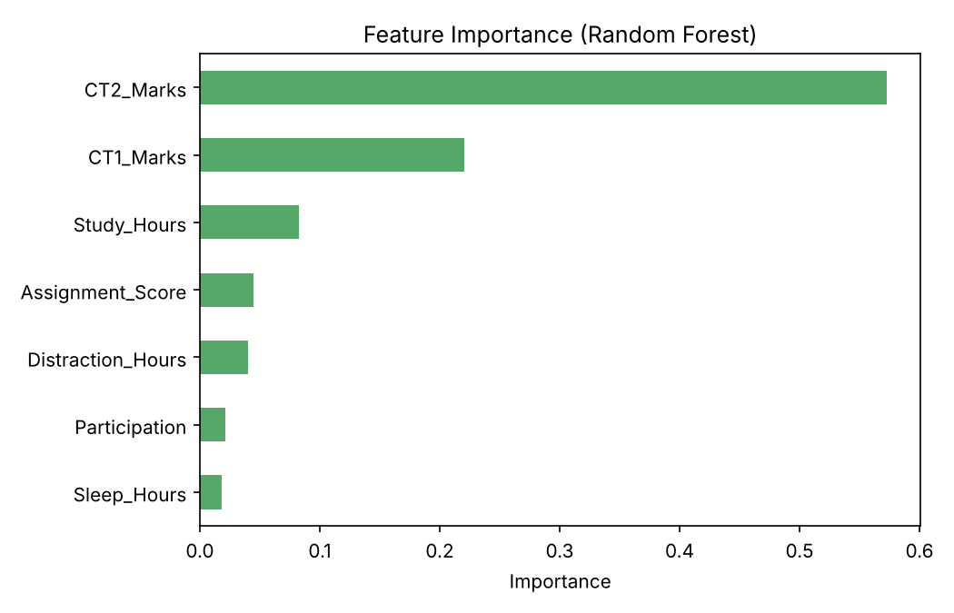
5.10 :- Feature Importance (Random Forest)

6. TESTING AND DEBUGGING

Introduction
Testing and debugging are important steps to make sure the system gives correct results and does not fail. For a machine learning project, testing has two parts: checking that the program (code and interface) works properly, and checking that the model predicts well on data it has not seen before.

Types of Testing
1. Unit Testing
Individual functions were tested alone. For example, the grade_category function was checked at the boundary values 49.9, 50, 64.9, 65, 79.9 and 80 to confirm that each score falls in the correct category. The prediction function was also checked to confirm that the output is always between 0 and 100.
2. Integration Testing
This checks that the modules work together: the data goes from the CSV file to the cleaning step, then to training, then to the saved model, and finally to the prediction function called by the web interface. The column order of the user's answers was checked to match the order used in training.
3. System Testing
The whole application was tested from start to end: opening the page, moving the sliders, pressing the Predict button and reading the marks, category, suggestions and chart.
4. Model Validation Testing
The model was tested on 200 students (20% of the data) that were not used for training. The predictions were compared with the real marks using MAE, RMSE and R², as shown below.
Table 6.1 :- Model Comparison Results
Model | MAE | RMSE | R² score
Linear Regression (best) | 3.09 | 3.99 | 0.900
Gradient Boosting | 3.42 | 4.46 | 0.875
Random Forest | 3.72 | 4.78 | 0.857

Observation: Linear Regression gave the lowest error and the highest R² score. This is because final marks depend almost in a straight-line way on the inputs, so a simple model fits well. On average, the prediction is about 3 marks away from the real marks, and the model explains about 90% of the variation in marks.
Table 6.2 :- Feature Importance (Random Forest)
Rank | Factor | Importance score
1 | CT-2 marks | 0.572
2 | CT-1 marks | 0.220
3 | Study hours | 0.083
4 | Assignment score | 0.045
5 | Phone / social media hours | 0.040
6 | Class participation | 0.021
7 | Sleep hours | 0.018

Observation: The two class-test marks together account for about 79% of the total importance. Study hours and assignment score come next. Phone or social media time has a small negative effect on marks, and sleep hours have the least effect in this dataset.

Overall Conclusion
The testing shows that the system works correctly, gives sensible predictions for strong, average and weak students, and keeps all outputs within the valid range.
TEST CASES :- (Table 6.3)
Test Id | Description | Input | Expected Result | Actual Output | Status
TC-1 | Load the dataset | Run train.py with the CSV file | 1010 rows and 8 columns are read | As expected | Pass
TC-2 | Data cleaning | 10 duplicates, 45 missing values | 1000 rows and 0 missing values remain | As expected | Pass
TC-3 | Train-test split | 1000 clean rows | 800 training and 200 testing rows | As expected | Pass
TC-4 | Train and select model | 3 algorithms | All train; best model saved | Linear Regression, R² 0.900 | Pass
TC-5 | Strong student | CT-1 26, CT-2 27, assignments 88, study 5 h, participation 5, sleep 7.5 h, phone 1.5 h | High marks, category Excellent | 83.0, Excellent | Pass
TC-6 | Average student | CT-1 20, CT-2 21, assignments 75, study 3.5 h, participation 4, sleep 7 h, phone 3 h | Middle marks, category Average | 64.0, Average | Pass
TC-7 | Weak student | CT-1 10, CT-2 9, assignments 45, study 1 h, participation 1, sleep 4.5 h, phone 7 h | Low marks, category At Risk | 24.7, At Risk | Pass
TC-8 | Effect of phone use | Average student with phone 0.5 h and then 9 h | Marks fall when phone use rises | 66.7 and 57.6 | Pass
TC-9 | Boundary values | All maximum inputs and all minimum inputs | Marks stay between 0 and 100 | 100.0 and 0.0 | Pass
TC-10 | Slider limits | Try to set CT-1 above 30 | Slider does not go above 30 | As expected | Pass
TC-11 | Suggestions | Study 1 h, phone 10 h | Study more and reduce phone use tips shown | As expected | Pass

7. CONCLUSION AND FUTURE ENHANCEMENT
The Student Performance Prediction System successfully predicts the final marks of a student from seven simple inputs: CT-1 marks, CT-2 marks, assignment score, study hours, class participation, sleep hours and phone or social media hours. The project covers the complete machine learning process: dataset creation, data cleaning, exploratory analysis, splitting the data, training three algorithms, evaluating them with MAE, RMSE and R², saving the best model and connecting it to a web interface.
Among the three algorithms, Linear Regression gave the best result with an MAE of 3.09, an RMSE of 3.99 and an R² score of 0.90. The feature-importance analysis shows that class-test marks (especially CT-2 and CT-1) have the strongest relationship with the final marks, followed by study hours and assignment score. Too much phone or social media time lowers the marks. All the objectives of the project, which were to build a prediction model, to find the important factors and to provide a simple user interface, have been achieved.
The system can help students to understand where they stand and what to improve before the final examination, and it can help teachers to find students who are At Risk early. The project also gave practical experience with Python, pandas, scikit-learn, data visualization and Streamlit.

Limitations
- The dataset used is a created (generated) dataset, so the exact results may differ with real college data.
- Only seven factors are used; family background, health and teaching quality are not included.
- The model gives an estimate and not a guaranteed result.

Future Enhancement
- Train the model on real data collected from the college or on a real Kaggle dataset with more students.
- Add more factors such as attendance, internal marks of other subjects, family support and health.
- Try other algorithms such as XGBoost or neural networks and tune their settings.
- Add a teacher dashboard to view the whole class and find At Risk students at once.
- Store the history of each student in a database and show progress over time.
- Deploy the application online (for example on Streamlit Community Cloud) and create a mobile-friendly version.

8. REFERENCES
1. Scikit-learn Documentation – Machine Learning in Python. https://scikit-learn.org
2. Streamlit Documentation. https://docs.streamlit.io
3. pandas Documentation. https://pandas.pydata.org/docs
4. NumPy Documentation. https://numpy.org/doc
5. Matplotlib Documentation. https://matplotlib.org/stable/index.html
6. Seaborn Documentation. https://seaborn.pydata.org
7. Kaggle – Student Performance Factors dataset (example dataset for this type of project). https://www.kaggle.com
8. UCI Machine Learning Repository – Student Performance Data Set. https://archive.ics.uci.edu
9. Géron, A. Hands-On Machine Learning with Scikit-Learn, Keras and TensorFlow. O'Reilly Media.
10. Romero, C. and Ventura, S. Educational Data Mining: A Review of the State of the Art. IEEE Transactions on Systems, Man, and Cybernetics, Part C, 2010.

