Hospital Network Project – Full Documentation with All Screenshots
This document contains the full visual record of the Cisco Packet Tracer hospital campus network project. All screenshots captured during configuration, troubleshooting, and validation are included.

Screenshots and Configuration Evidence
Figure 1: Screenshot 2026-02-03 161408.png
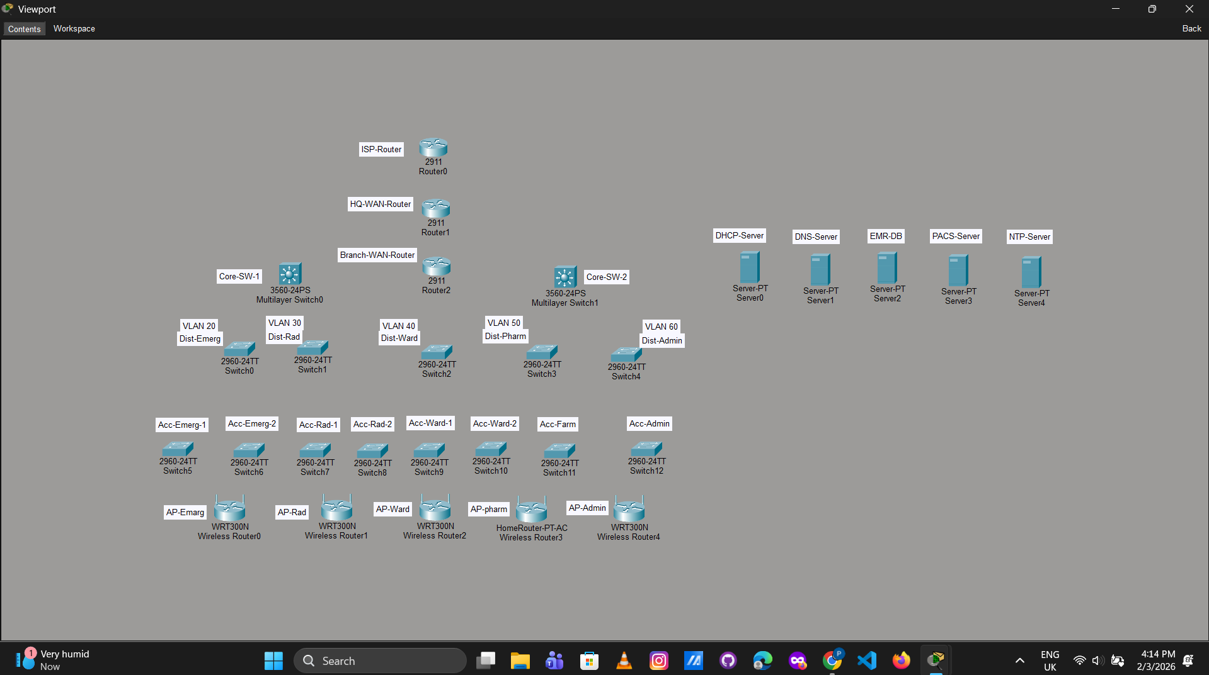
Figure 2: Screenshot 2026-02-03 161820.png
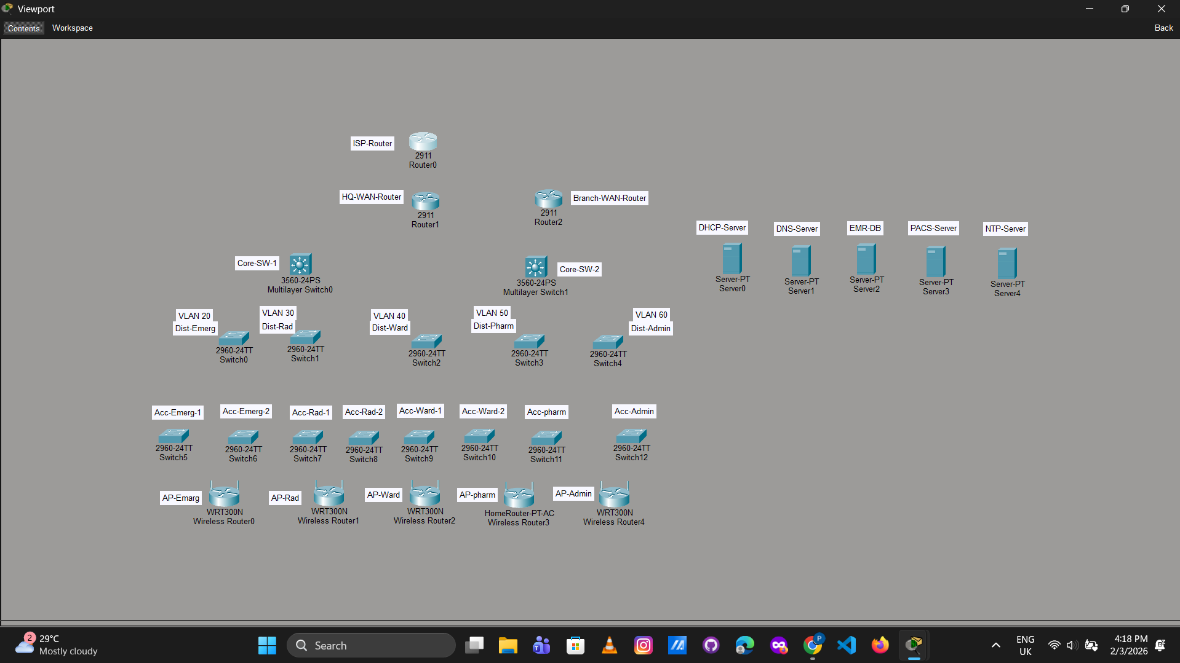
Figure 3: Screenshot 2026-02-03 162135.png
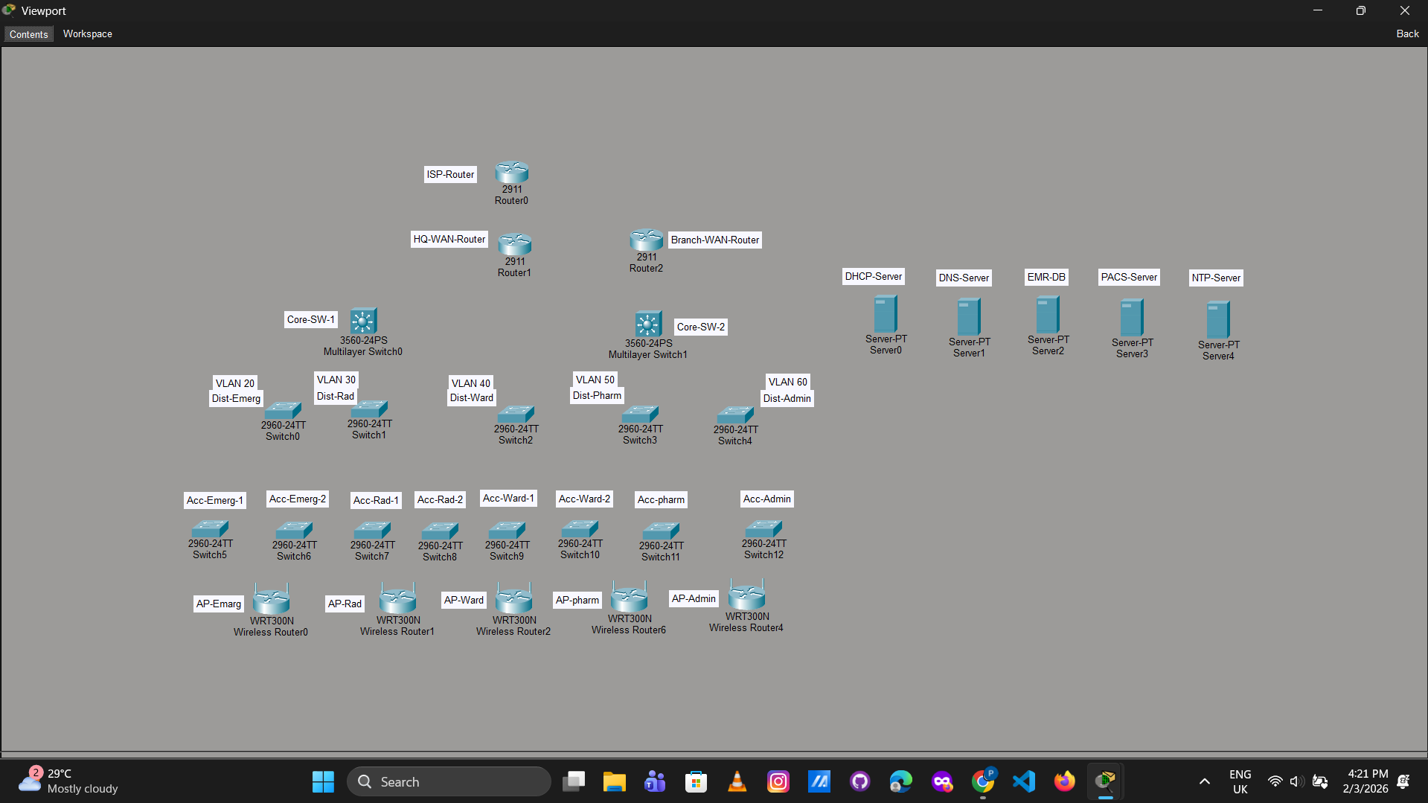
Figure 4: Screenshot 2026-02-03 171452.png
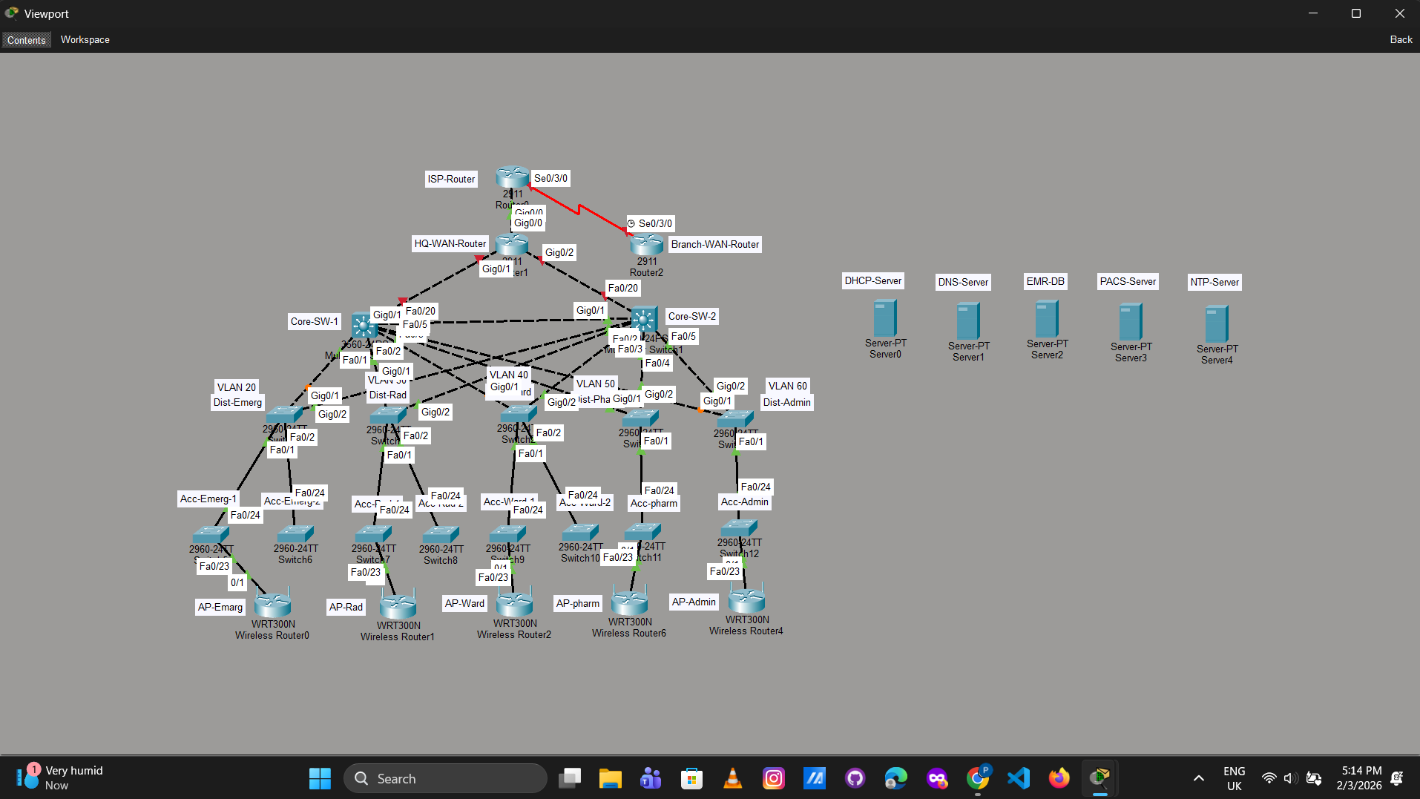
Figure 5: Screenshot 2026-02-03 171850.png
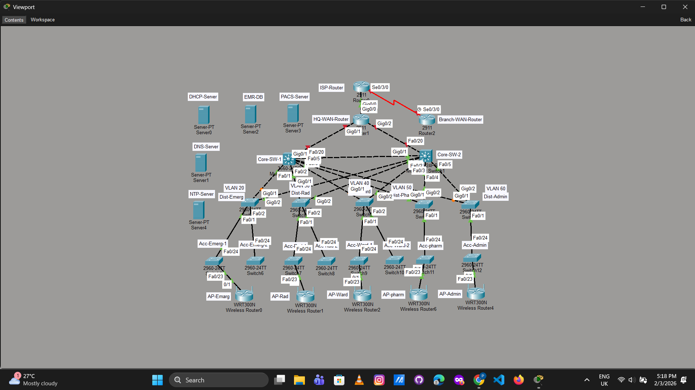
Figure 6: Screenshot 2026-02-03 234743.png
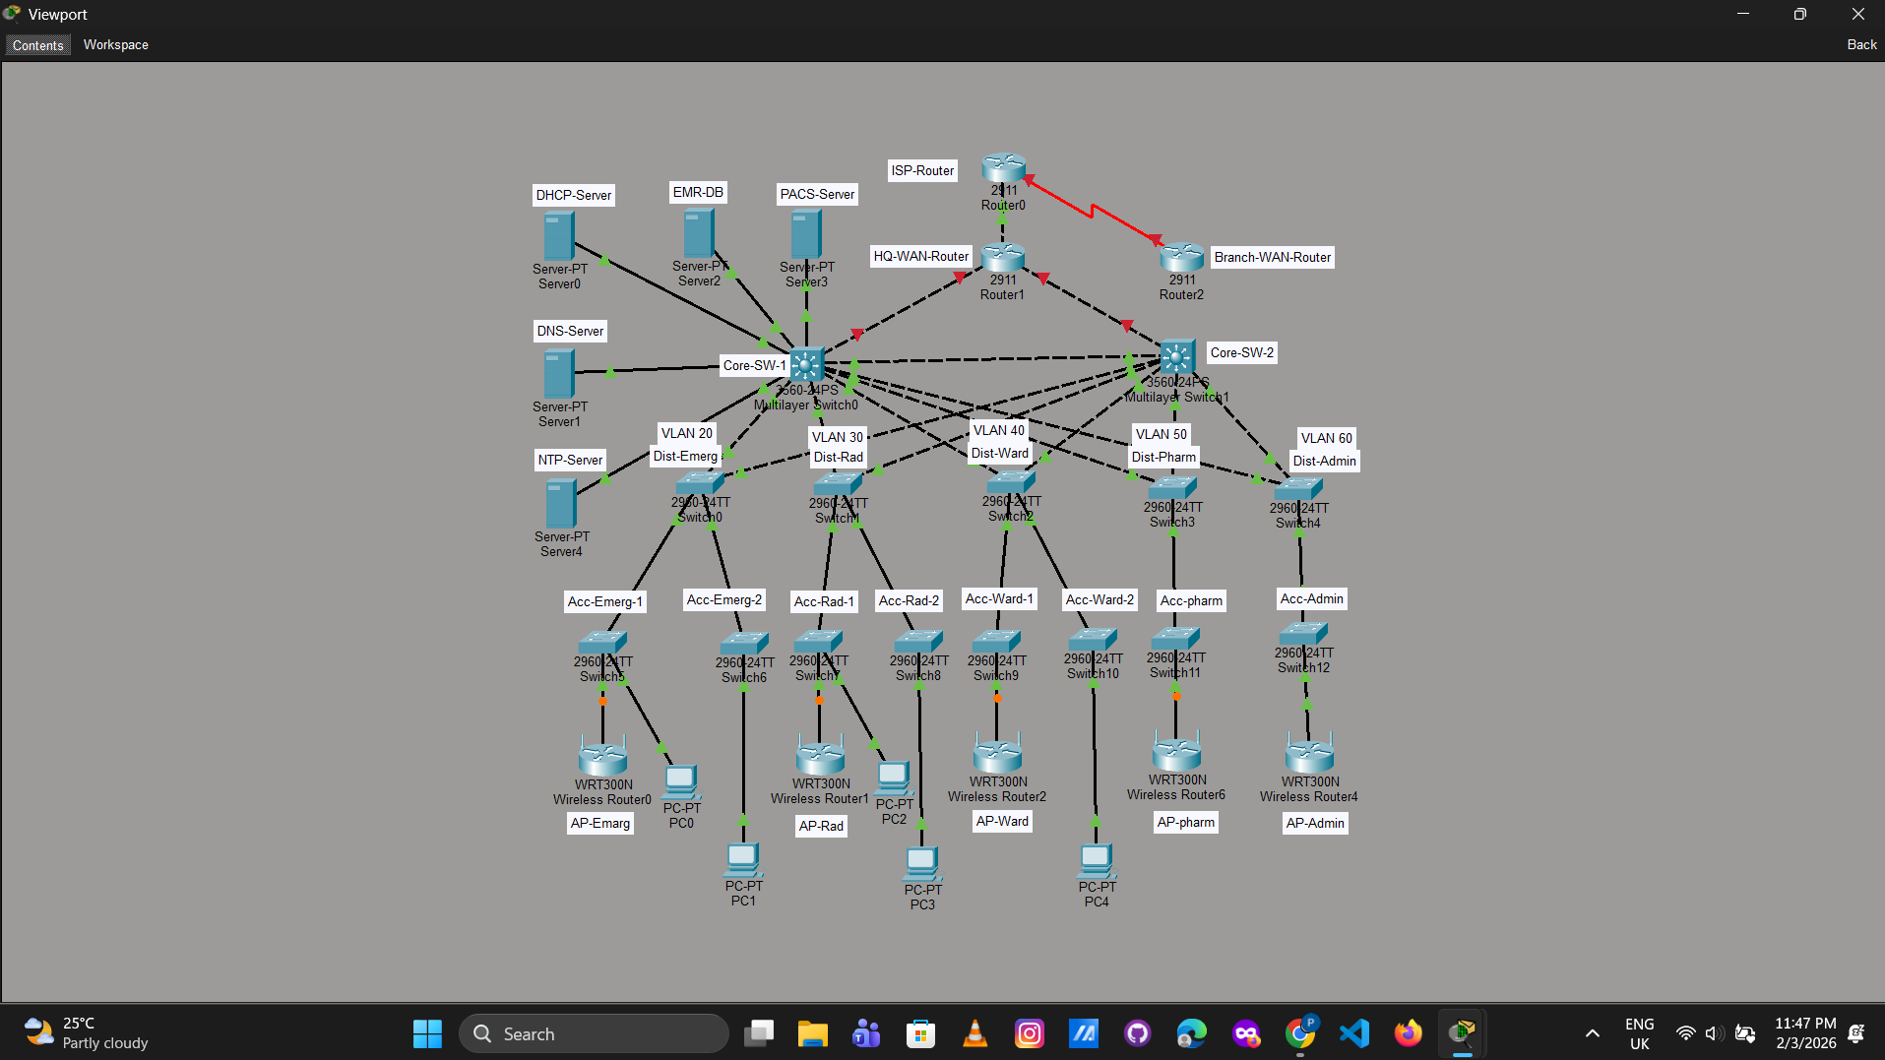
Figure 7: Screenshot 2026-02-03 235843.png
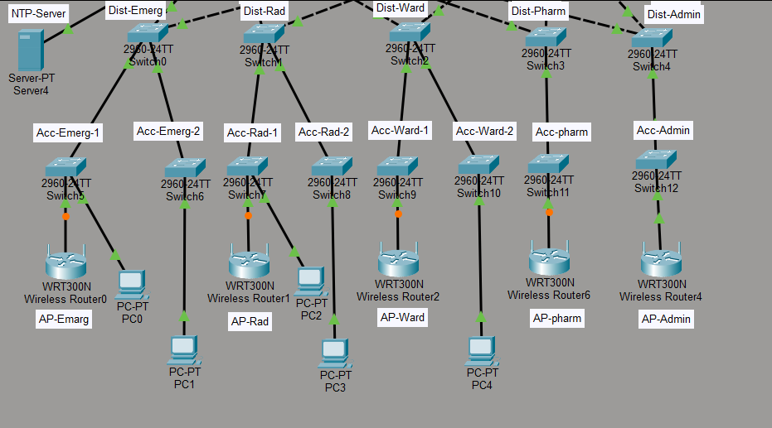
Figure 8: Screenshot 2026-02-04 011951.png
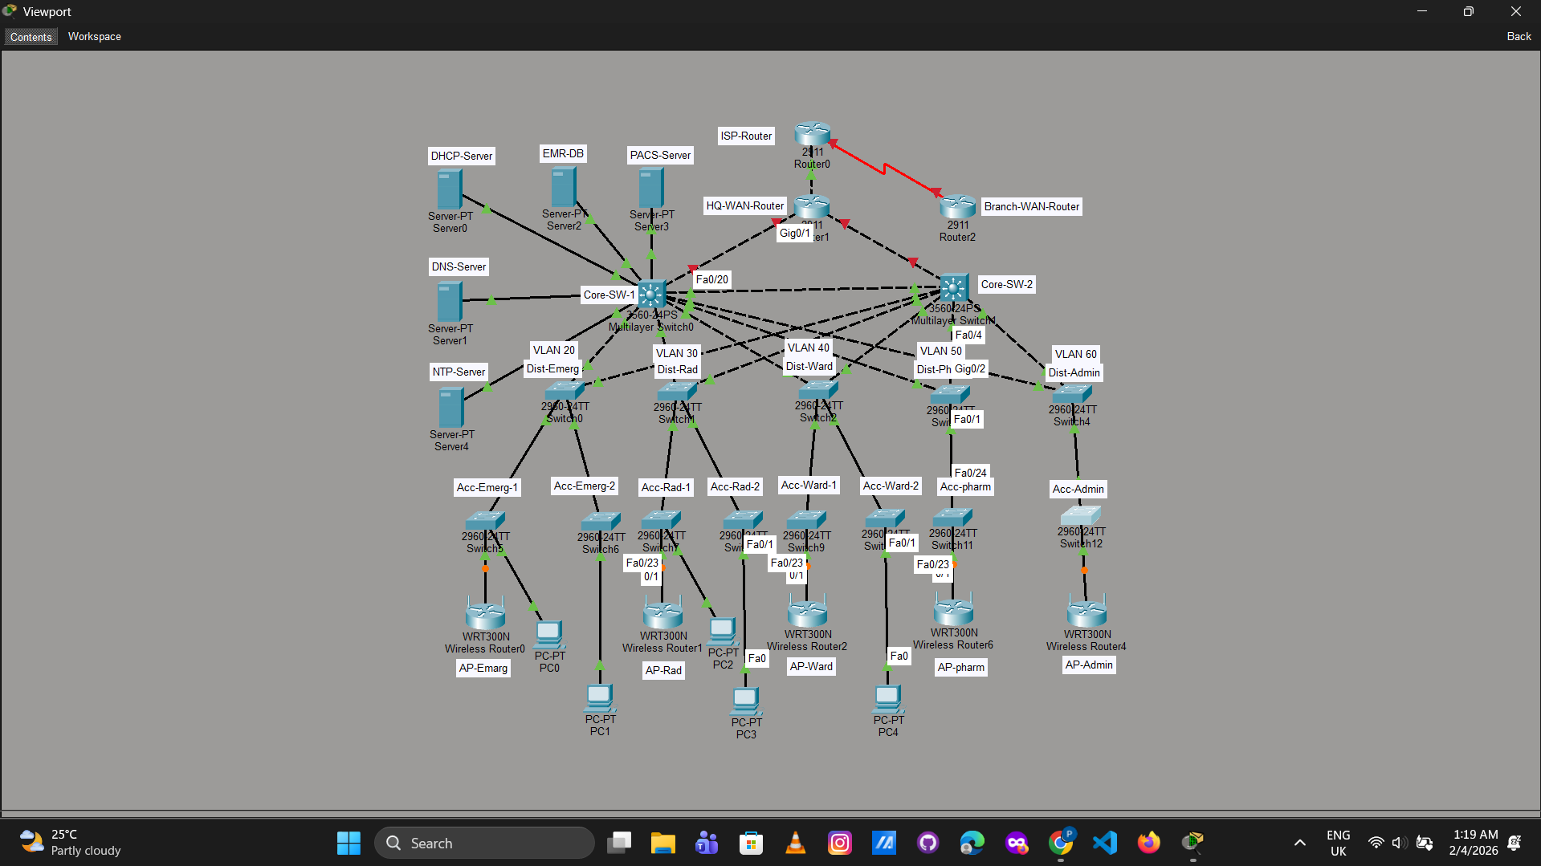
Figure 9: Screenshot 2026-02-04 085718.png
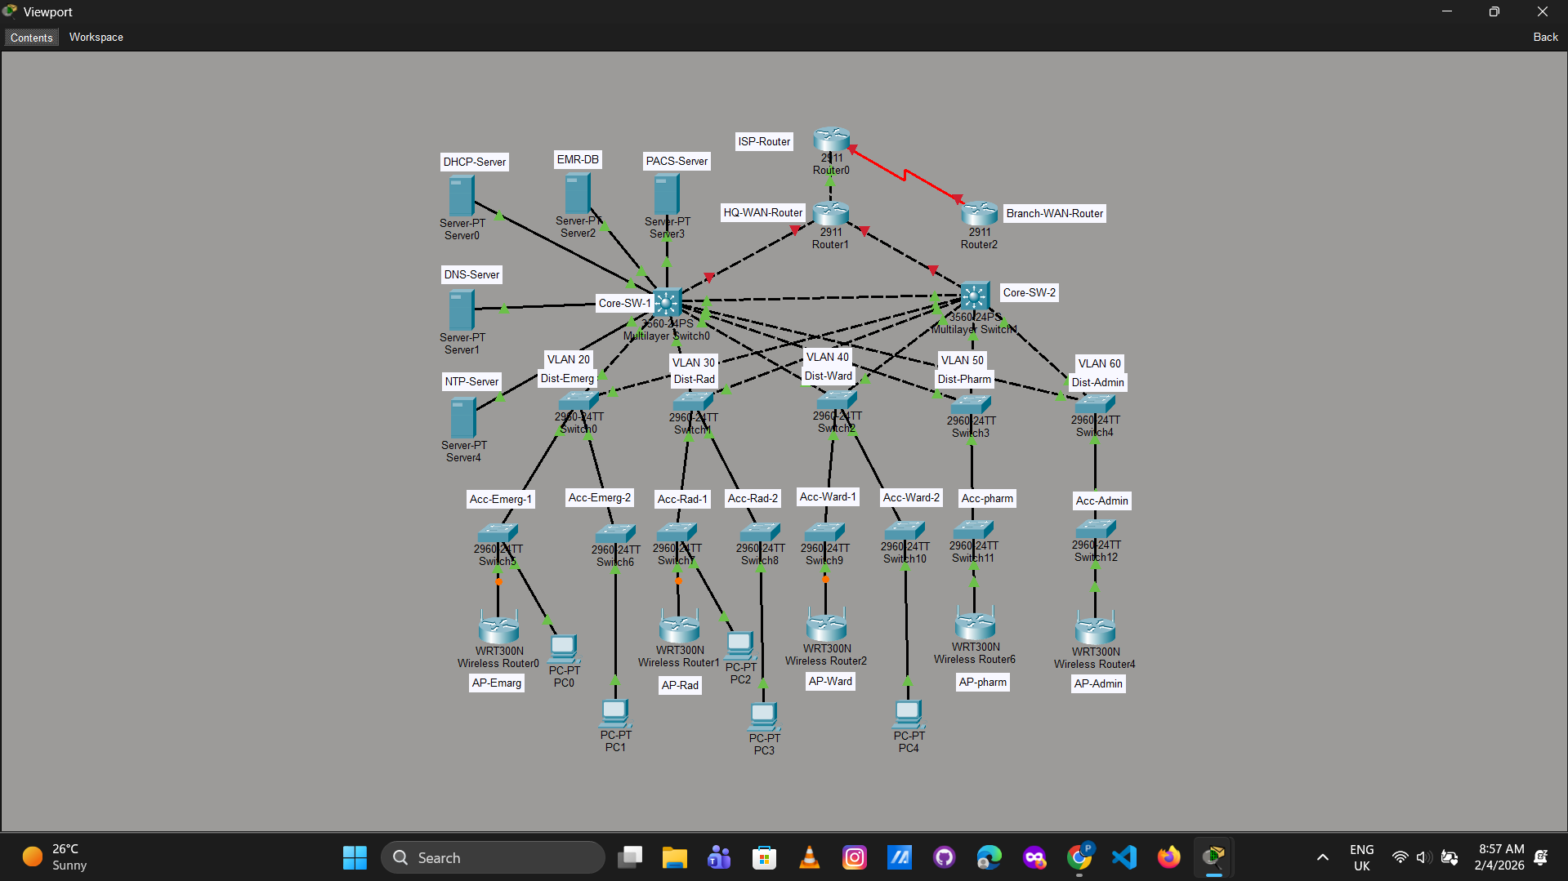
Figure 10: Screenshot 2026-02-04 113525.png
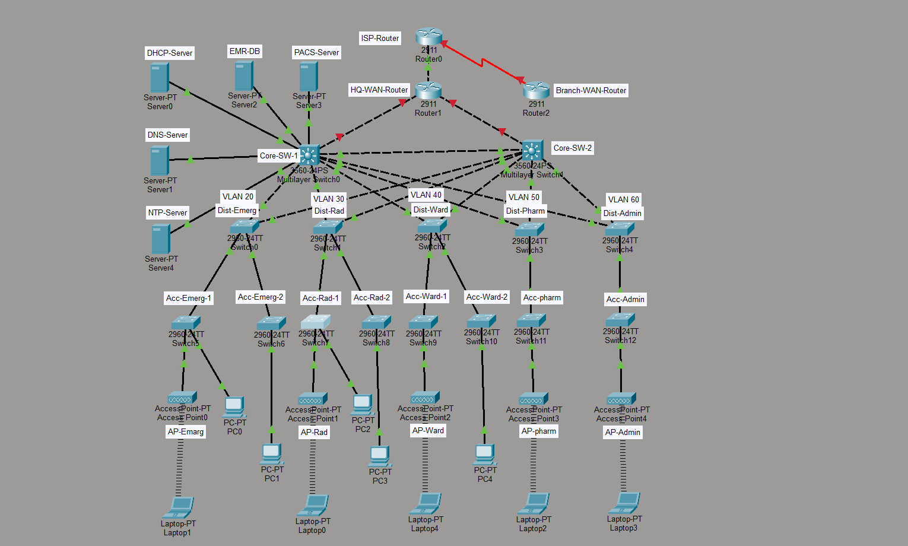
Figure 11: Screenshot 2026-02-04 121051.png
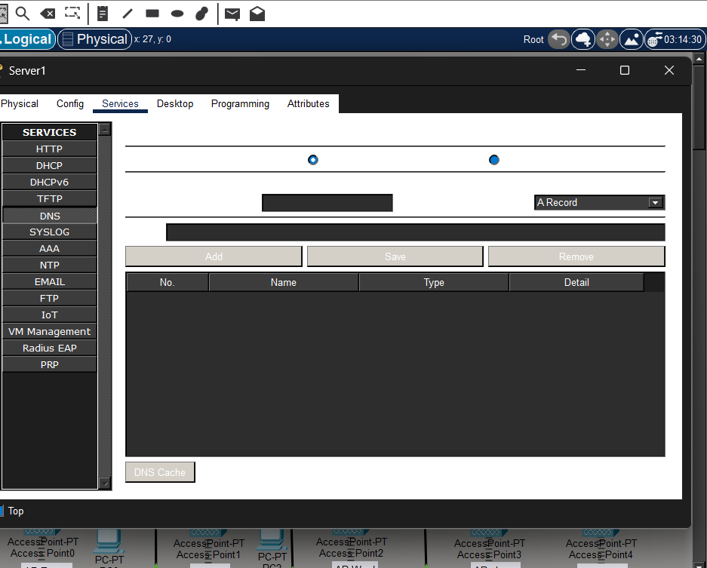
Figure 12: Screenshot 2026-02-04 122330.png
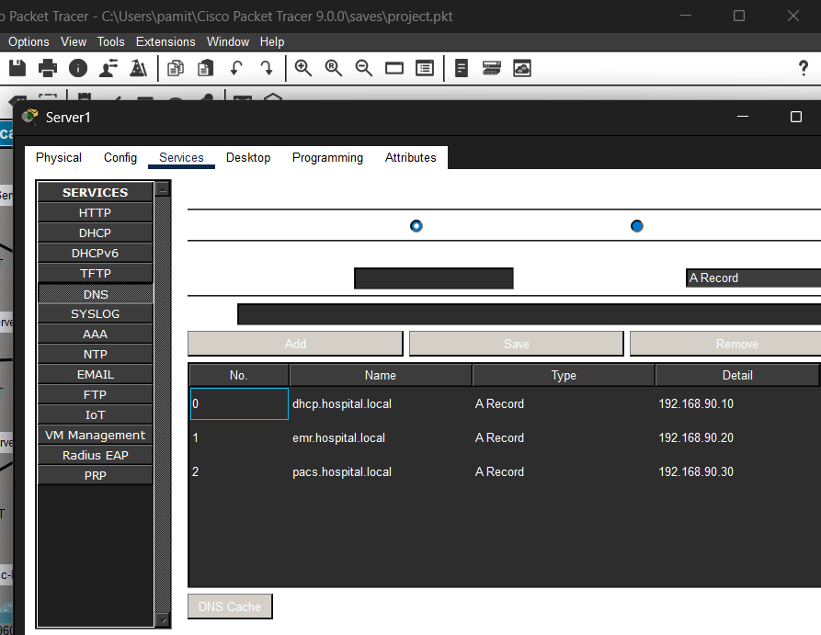
Figure 13: Screenshot 2026-02-04 122758.png
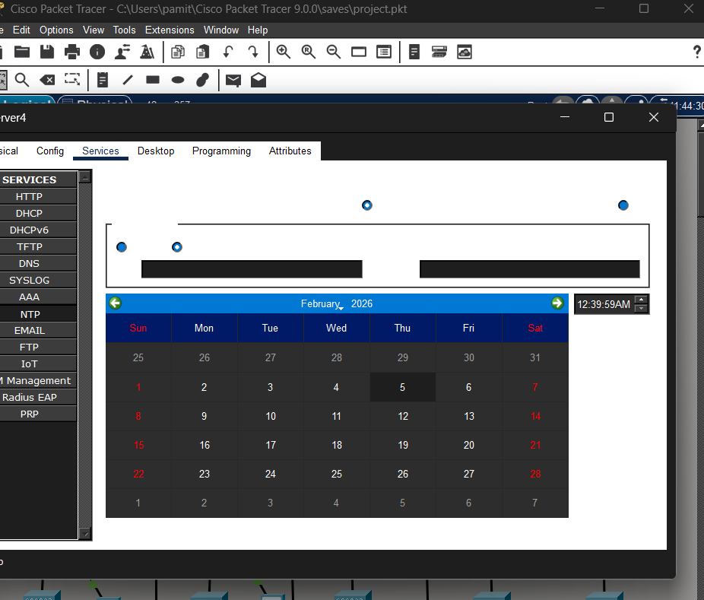
Figure 14: Screenshot 2026-02-04 122916.png
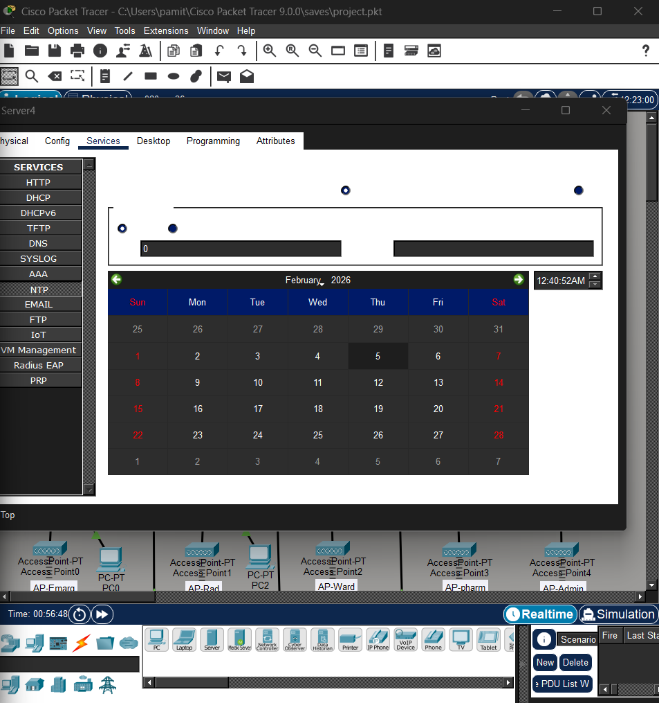
Figure 15: Screenshot 2026-02-04 131215.png
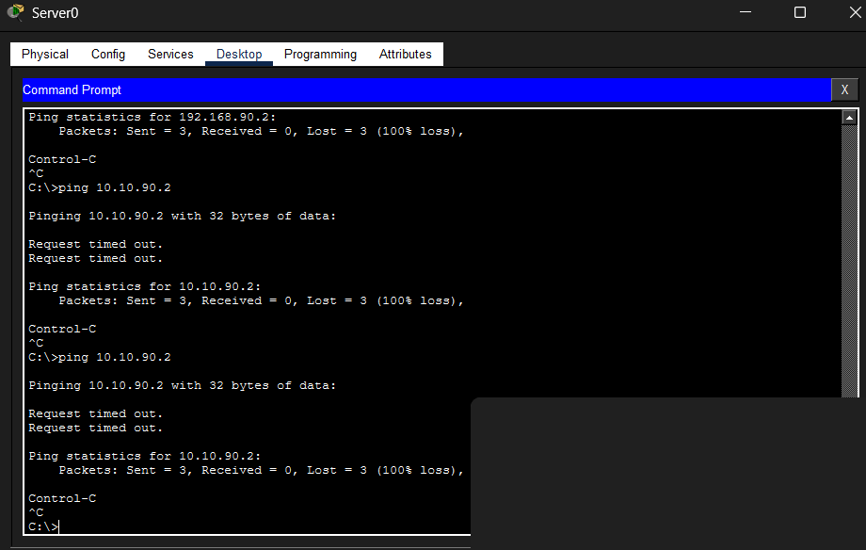
Figure 16: Screenshot 2026-02-04 131240.png
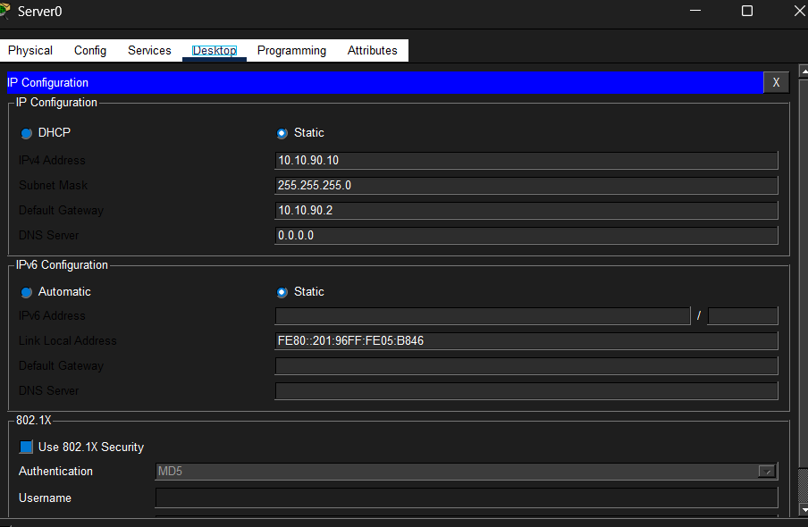
Figure 17: Screenshot 2026-02-04 132334.png
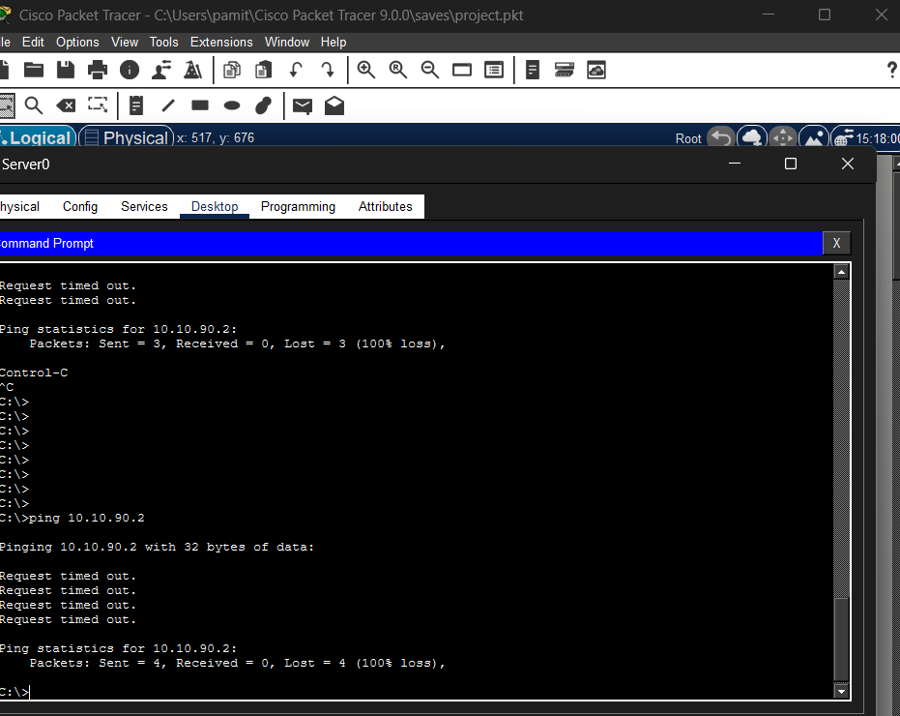
Figure 18: Screenshot 2026-02-04 143553.png
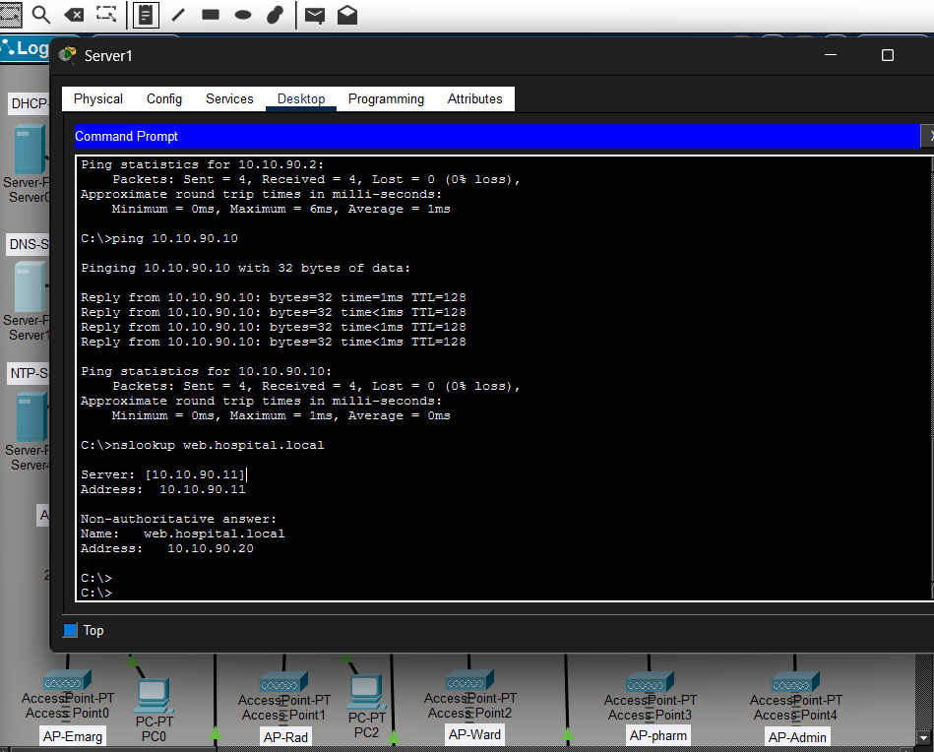
Figure 19: Screenshot 2026-02-04 150904.png
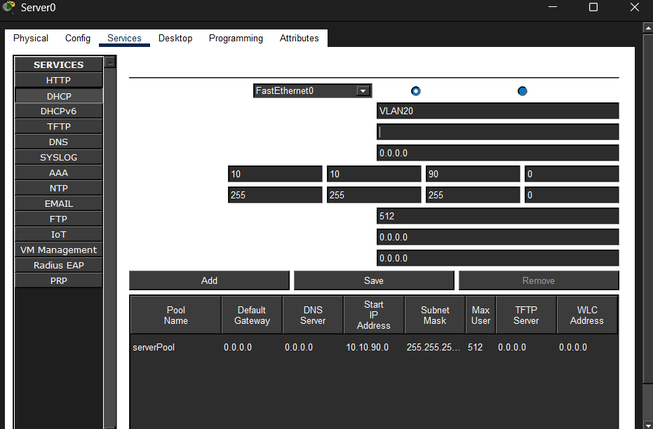
Figure 20: Screenshot 2026-02-04 151857.png
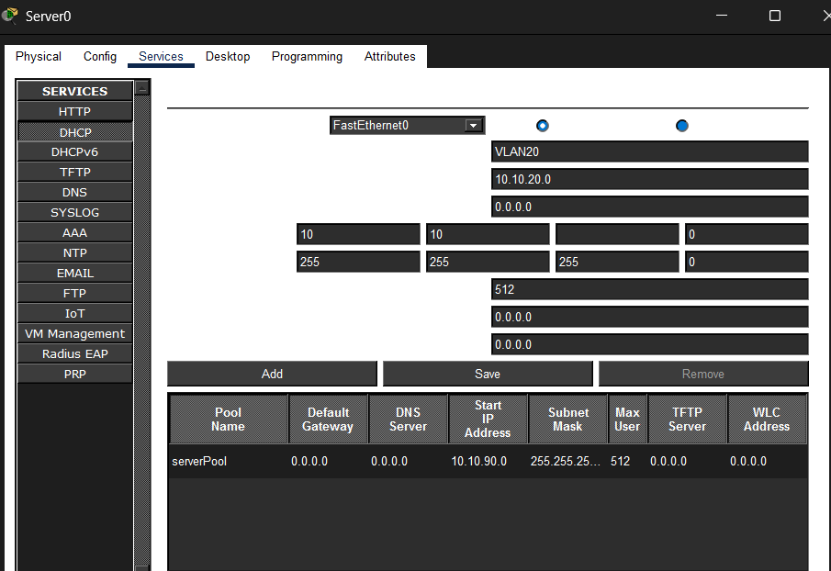
Figure 21: Screenshot 2026-02-04 152557.png
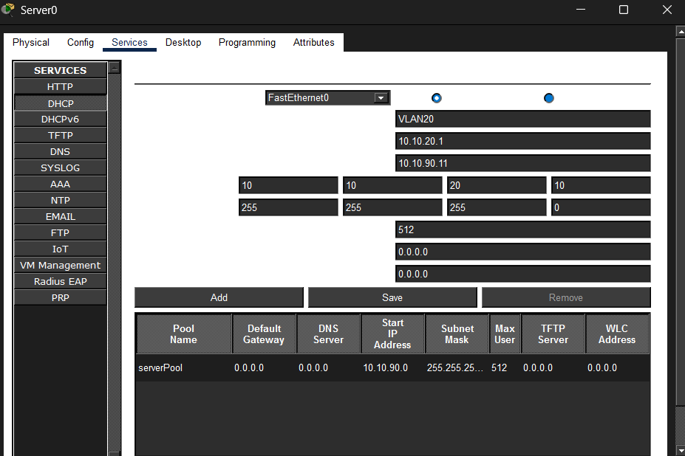
Figure 22: Screenshot 2026-02-04 152602.png
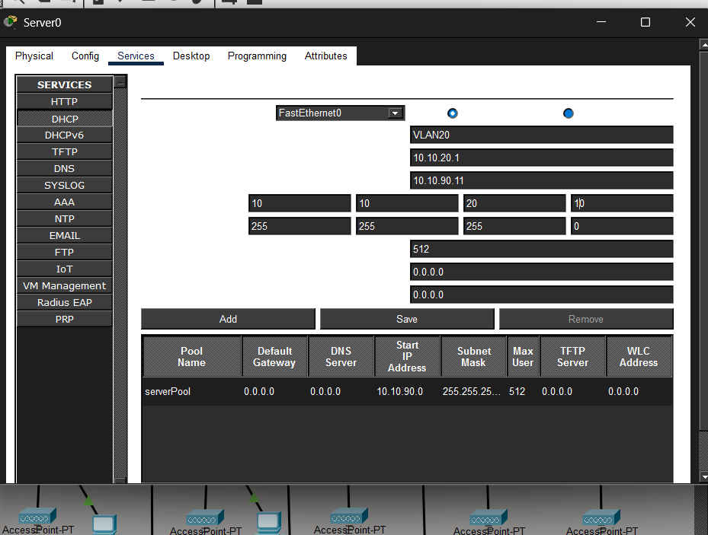
Figure 23: Screenshot 2026-02-04 154209.png
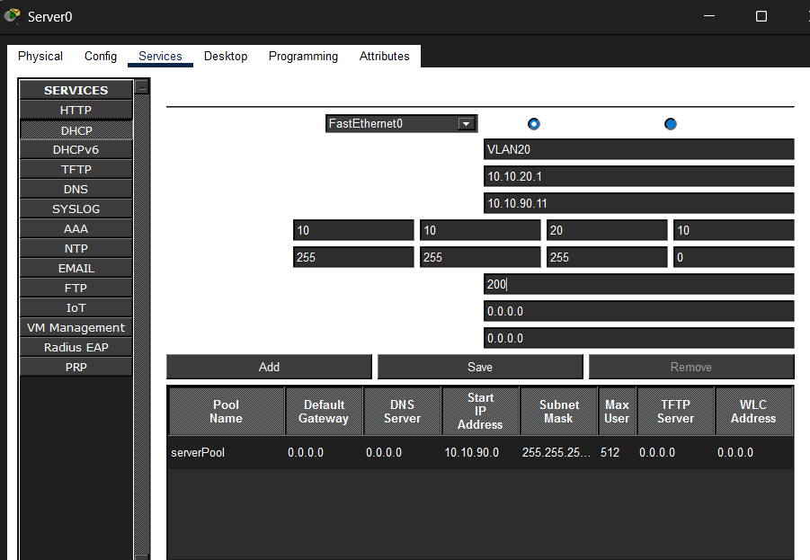
Figure 24: Screenshot 2026-02-04 154215.png
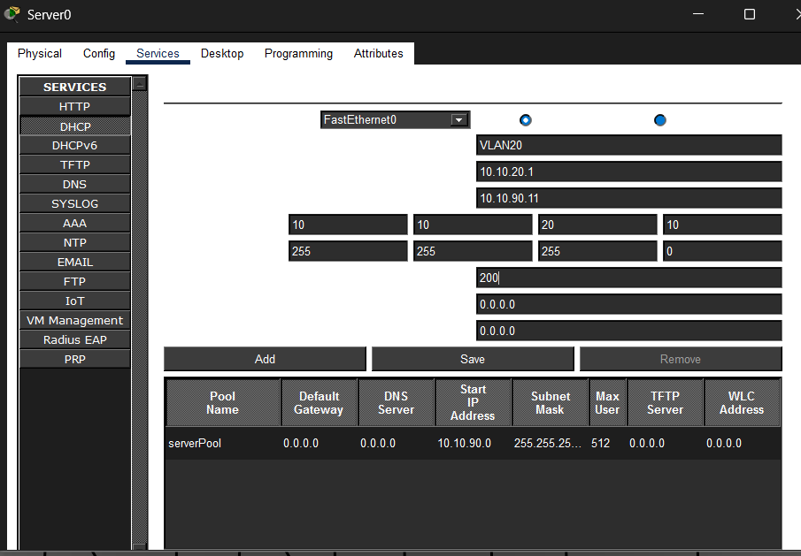
Figure 25: Screenshot 2026-02-04 155945.png
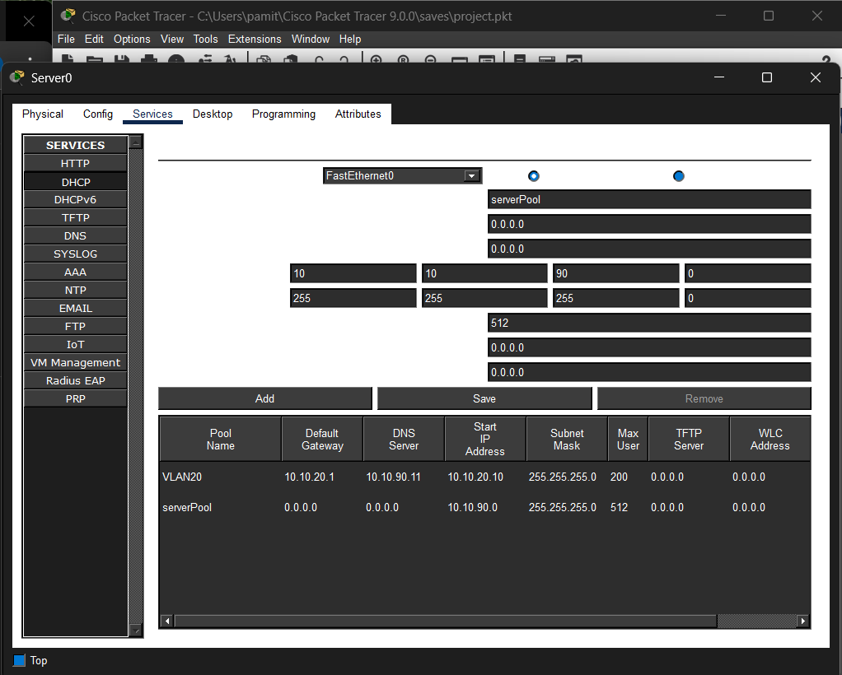
Figure 26: Screenshot 2026-02-04 163405.png
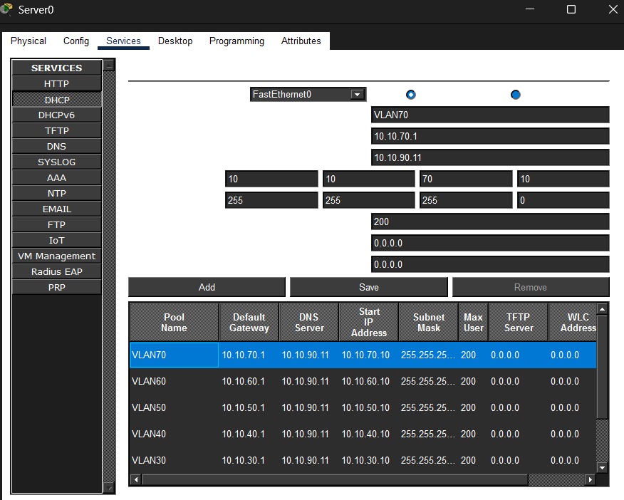
Figure 27: Screenshot 2026-02-04 170914.png
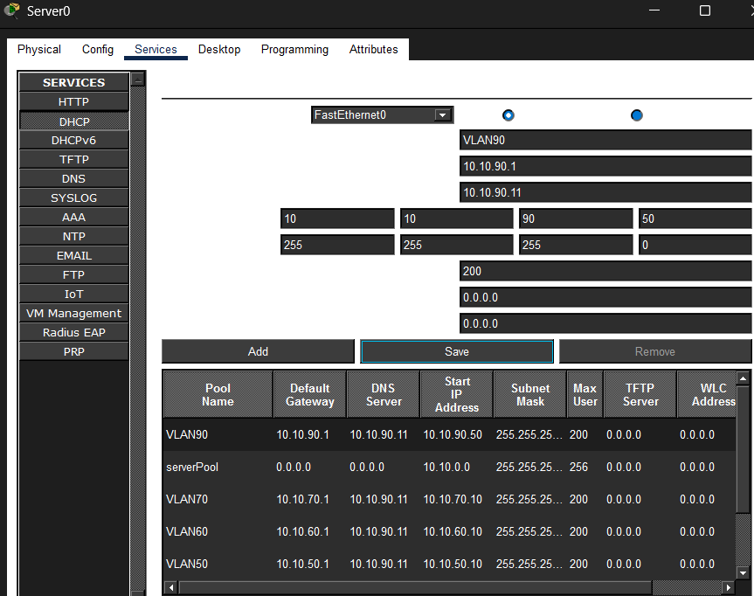
Figure 28: Screenshot 2026-02-04 175332.png
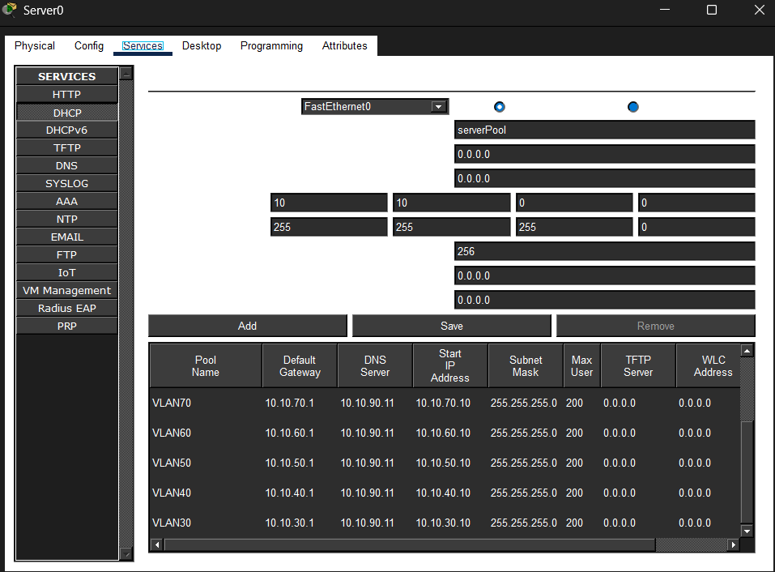
Figure 29: Screenshot 2026-02-04 203301.png
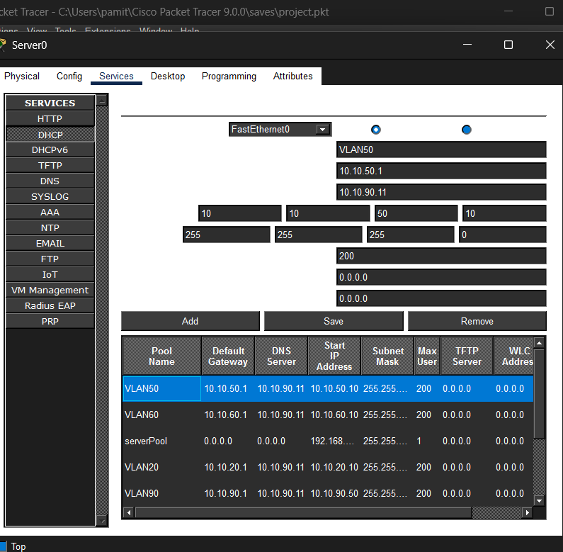
Figure 30: Screenshot 2026-02-04 205420.png
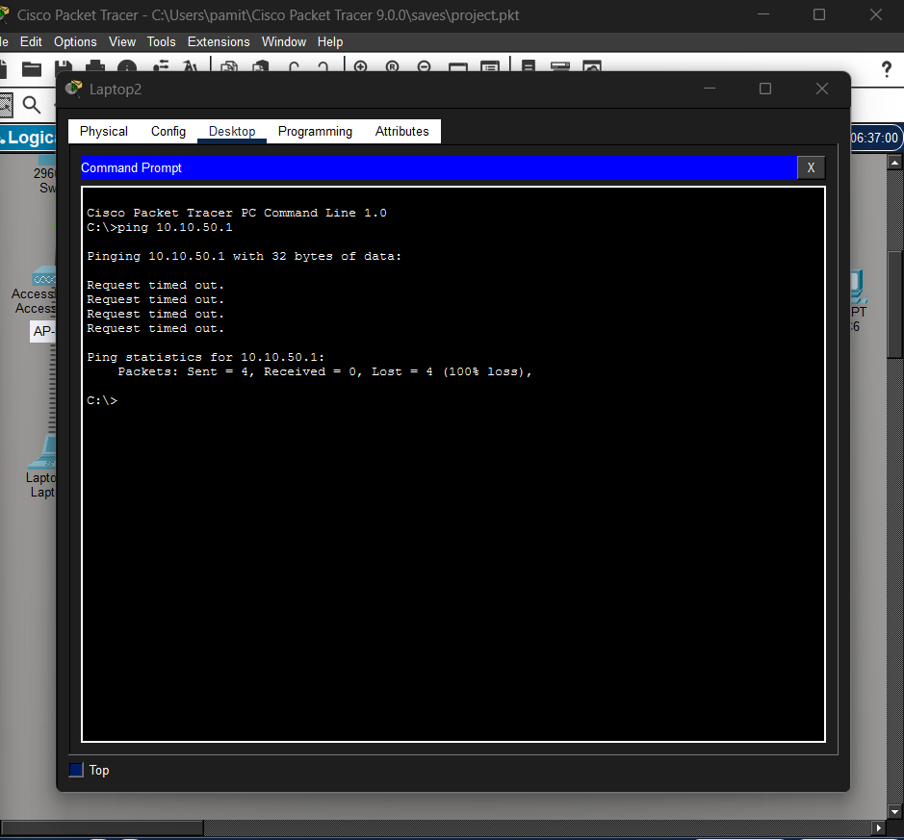
Figure 31: Screenshot 2026-02-04 205618.png
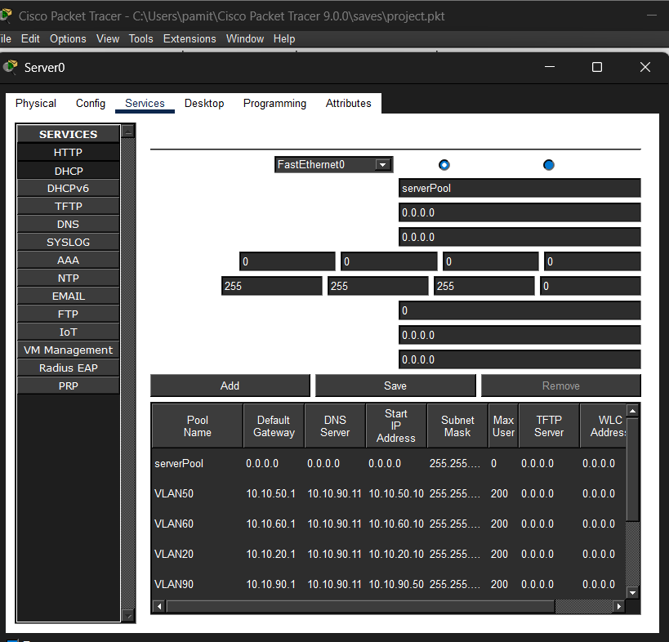
Figure 32: Screenshot 2026-02-04 210239.png
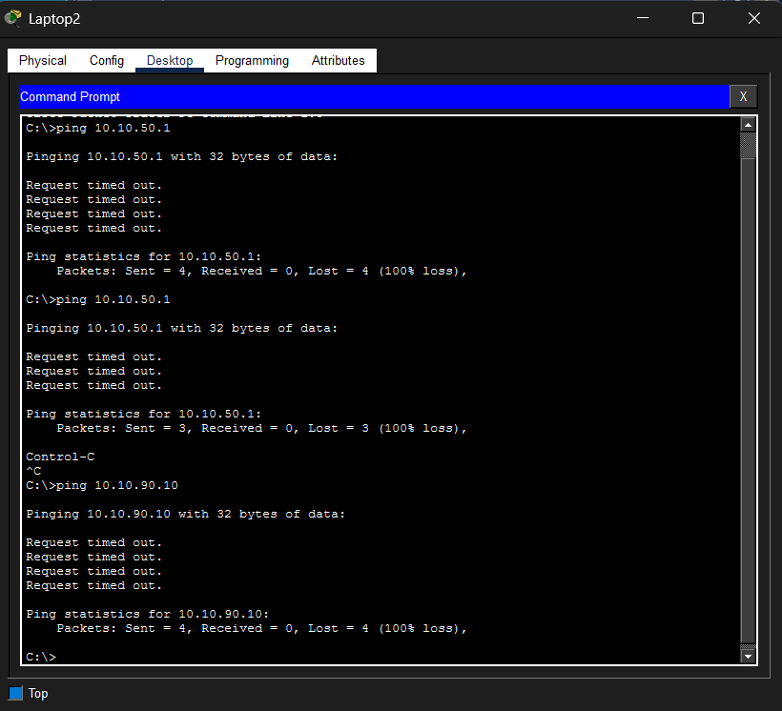
Figure 33: Screenshot 2026-02-04 212528.png
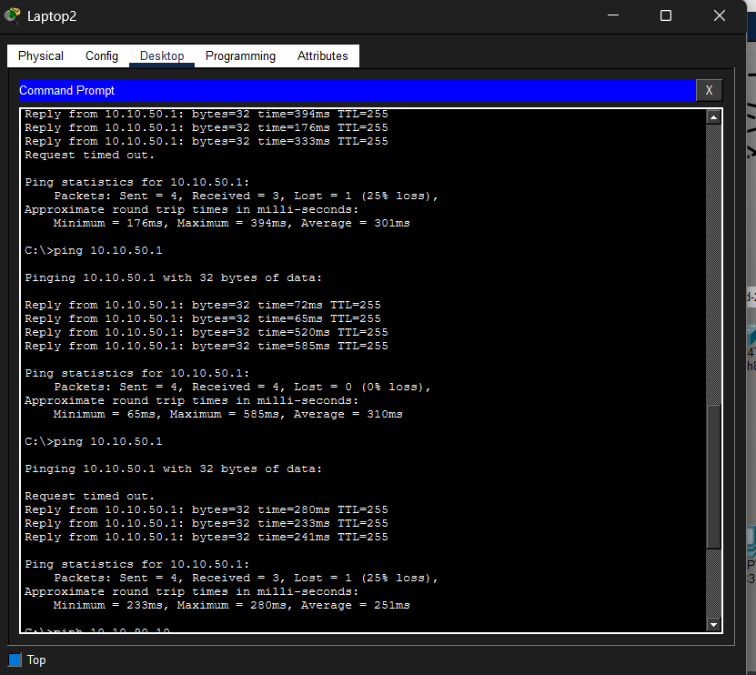
Figure 34: Screenshot 2026-02-04 212723.png
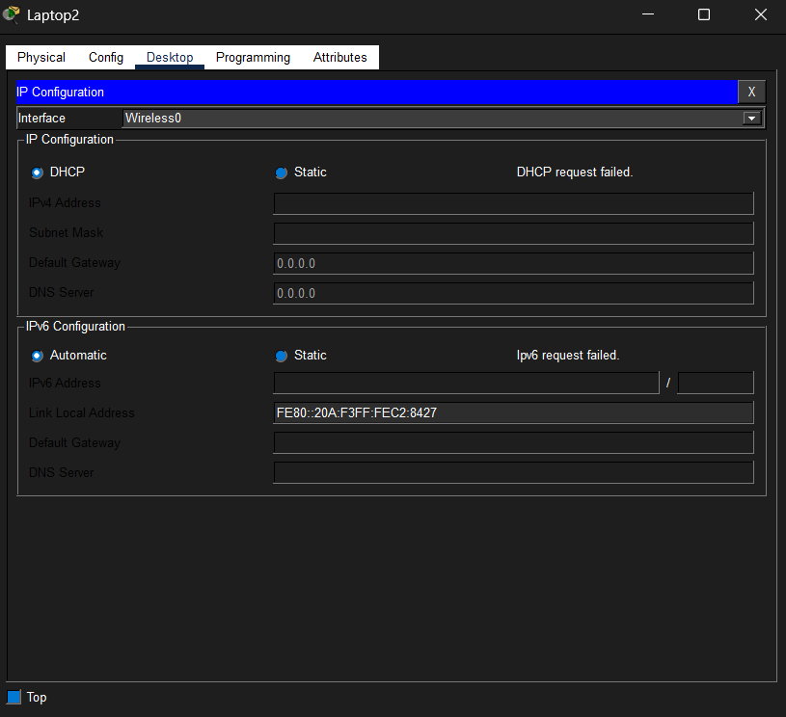
Figure 35: Screenshot 2026-02-04 212916.png
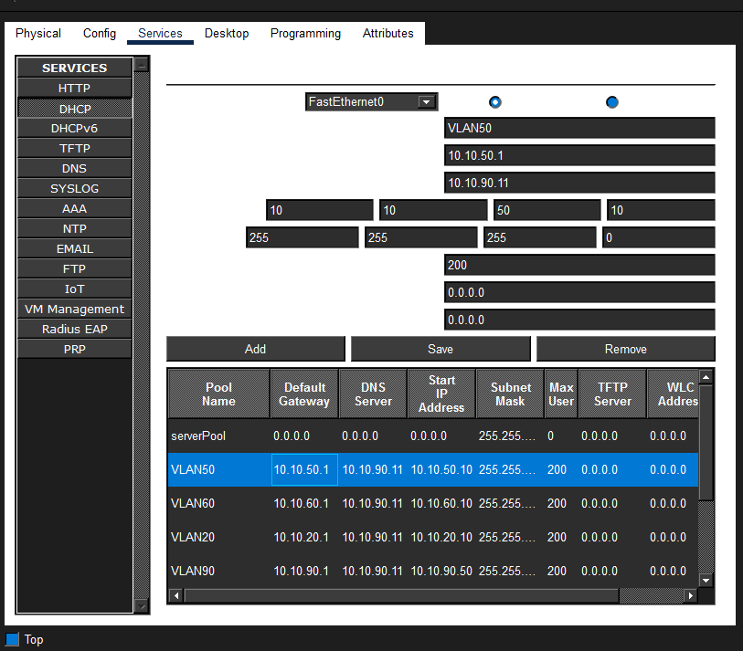
Figure 36: Screenshot 2026-02-04 221703.png
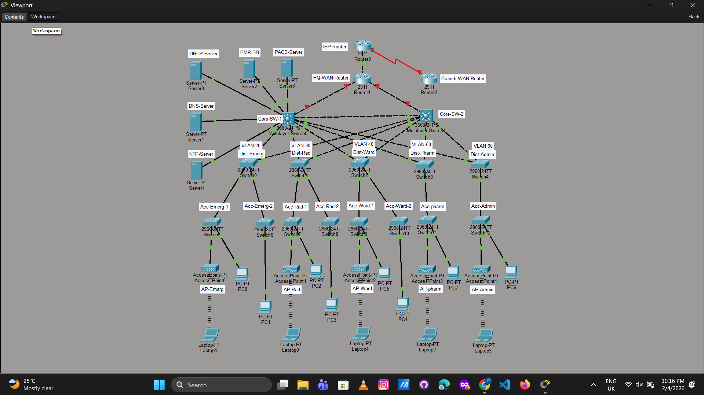
Figure 37: Screenshot 2026-02-04 231933.png
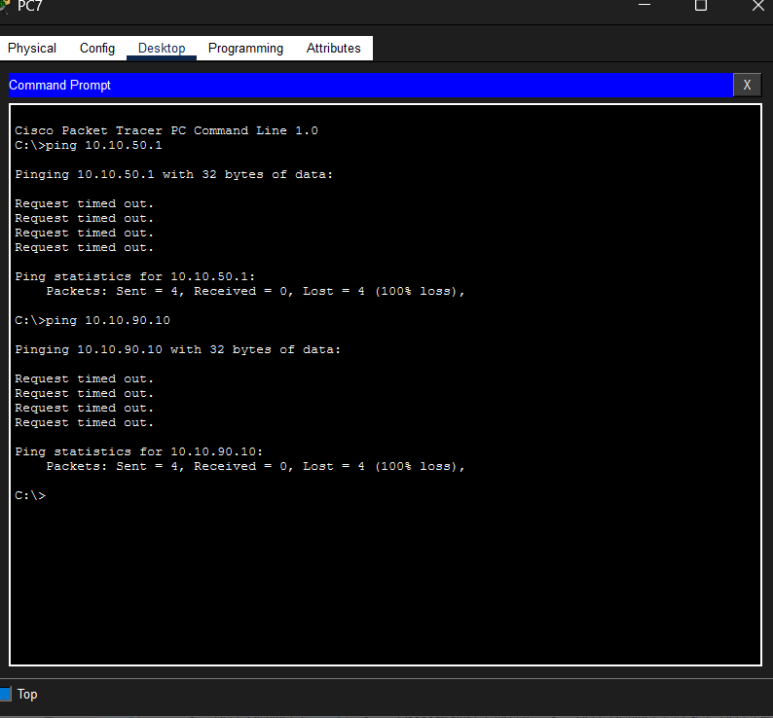
Figure 38: Screenshot 2026-02-05 053019.png
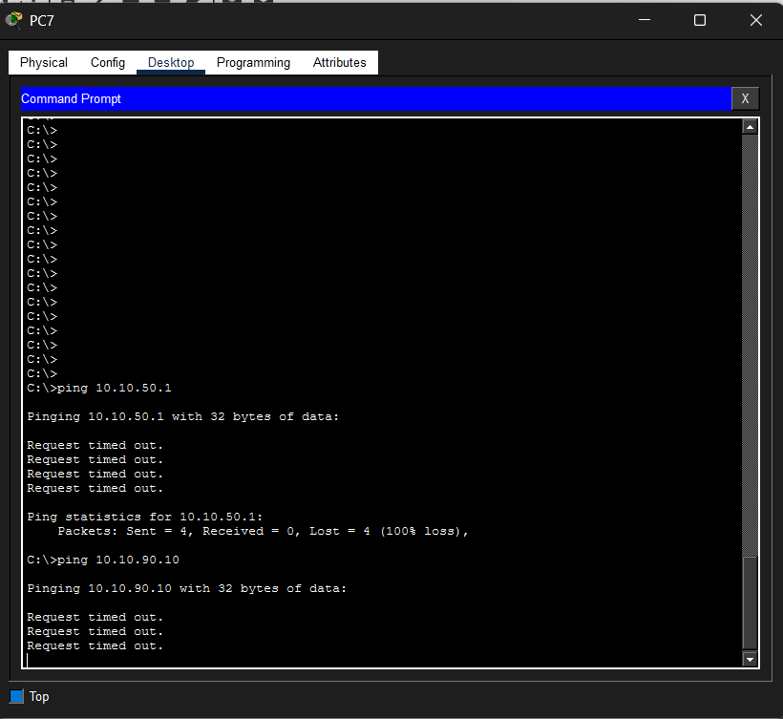
Figure 39: Screenshot 2026-02-05 053227.png
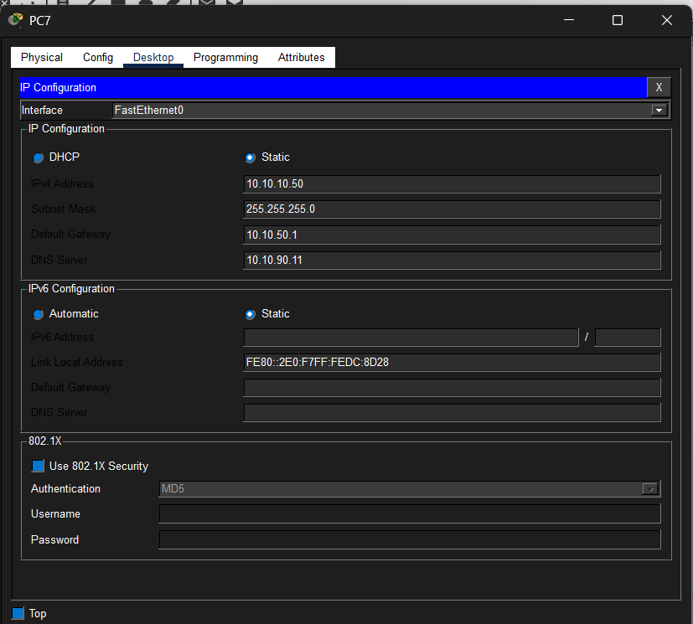
Figure 40: Screenshot 2026-02-05 063840.png
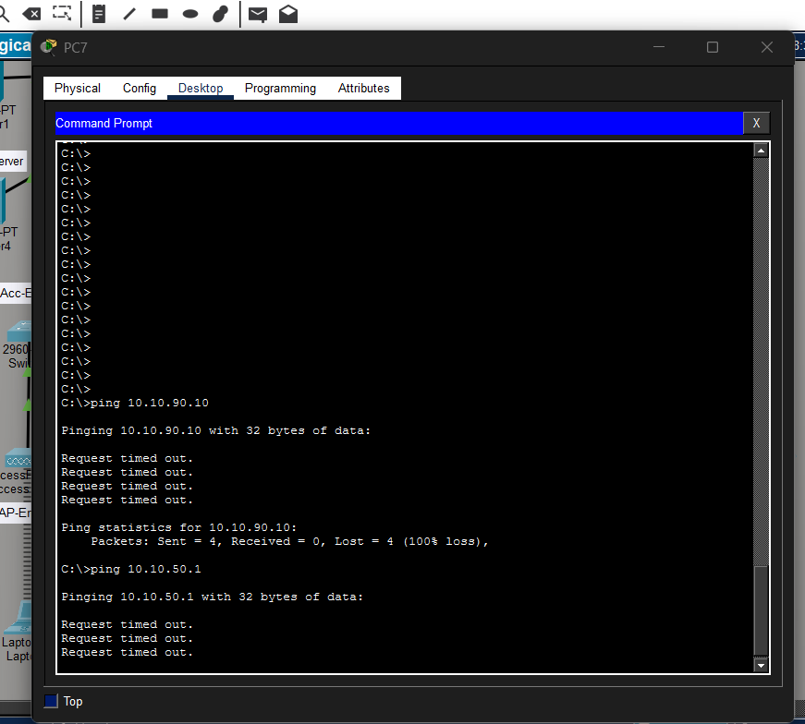
Figure 41: Screenshot 2026-02-05 080834.png
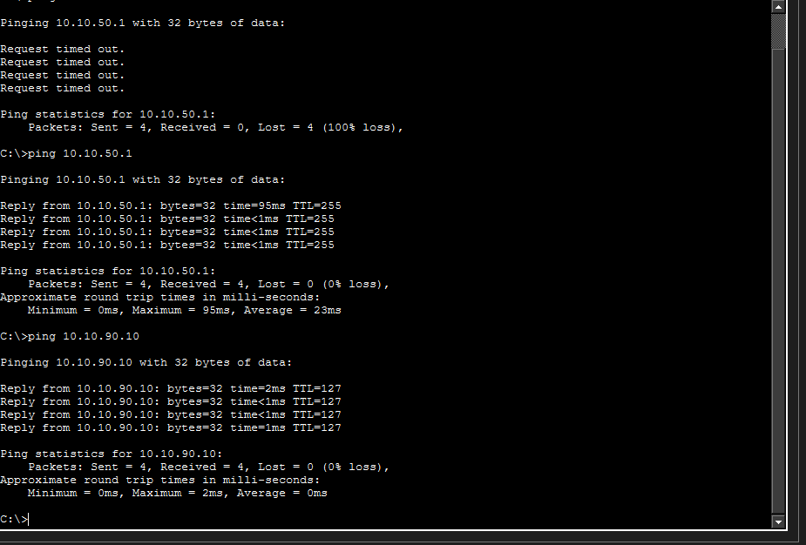
Figure 42: Screenshot 2026-02-05 081221.png
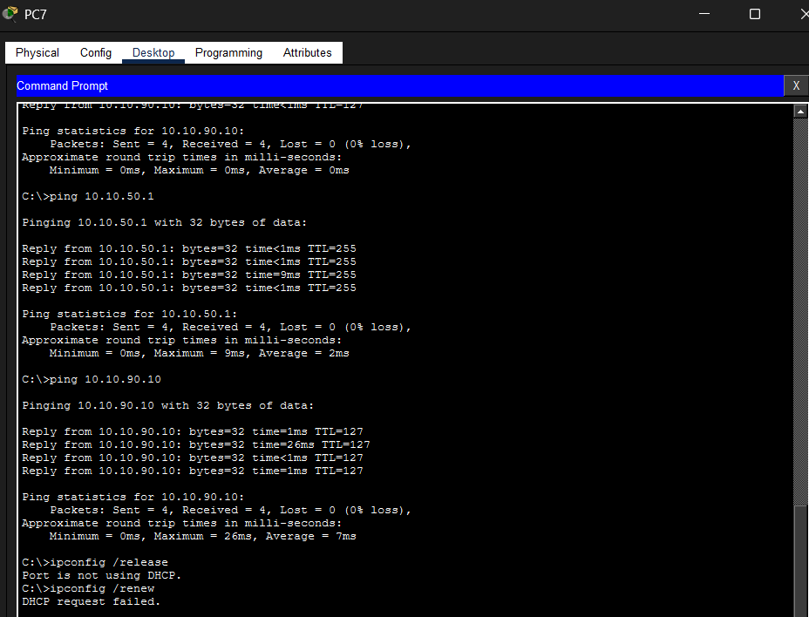
Figure 43: Screenshot 2026-02-05 081333.png
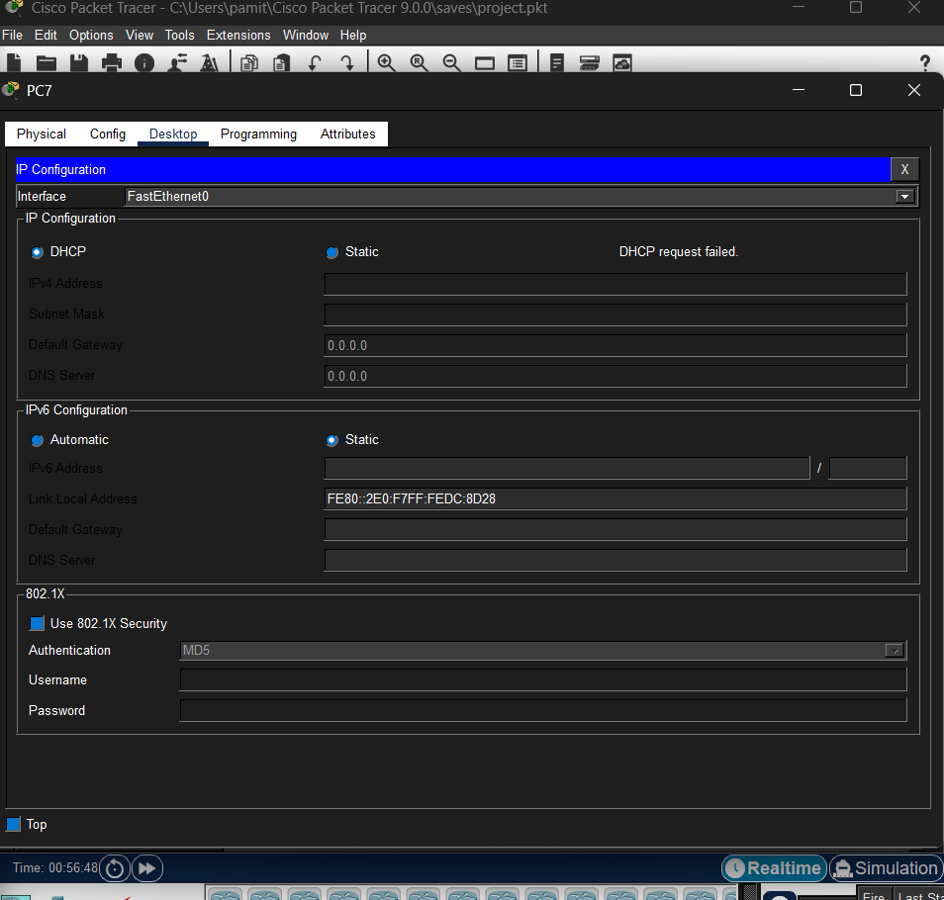
Figure 44: Screenshot 2026-02-05 081340.png
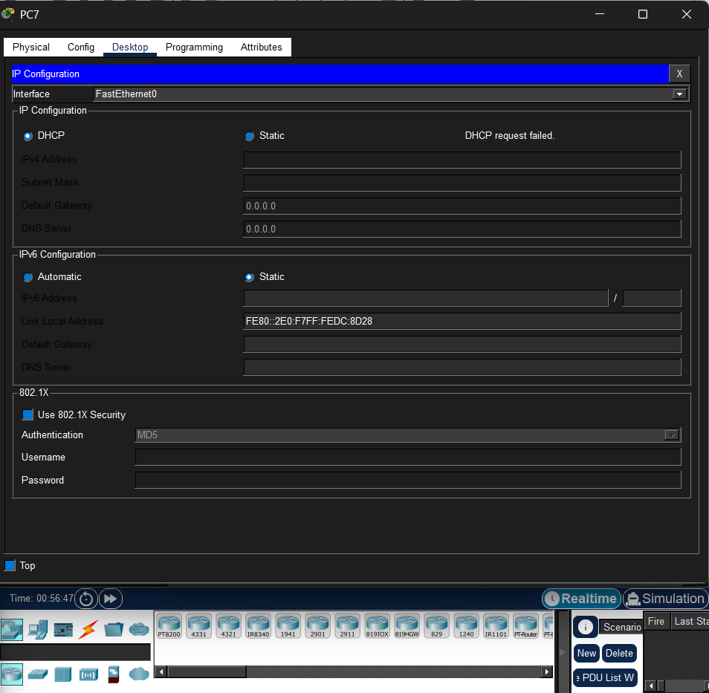
Figure 45: Screenshot 2026-02-05 084813.png
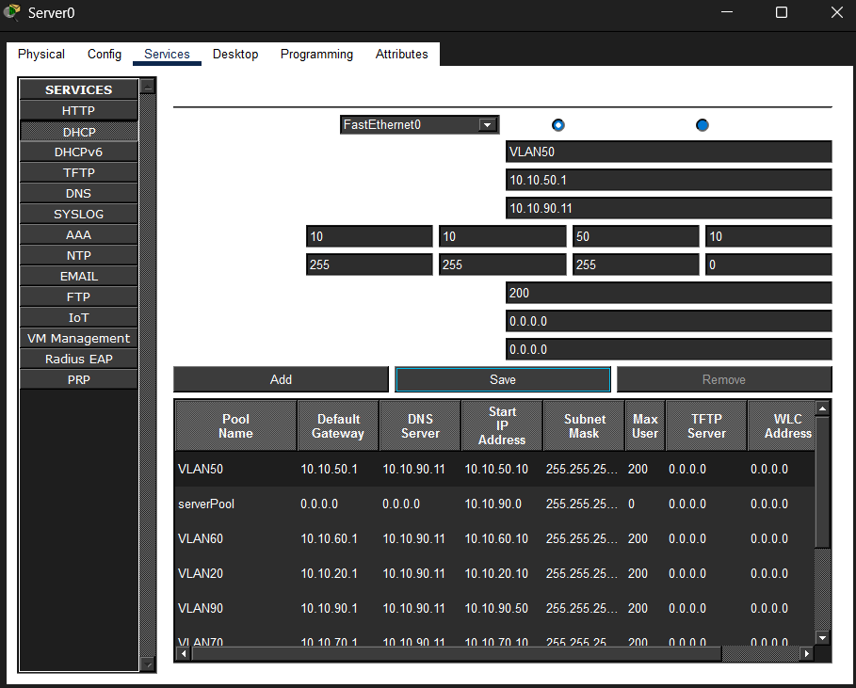
Figure 46: Screenshot 2026-02-05 085128.png
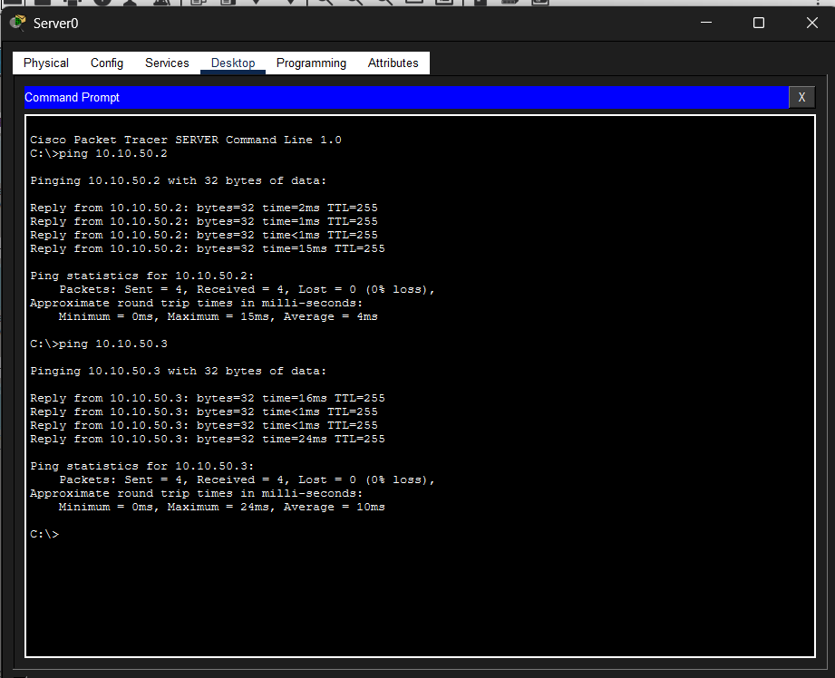
Figure 47: Screenshot 2026-02-05 085433.png
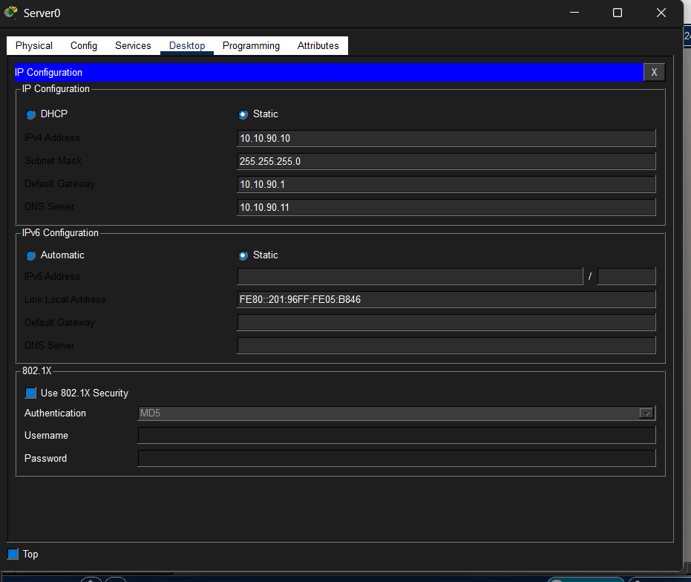
Figure 48: Screenshot 2026-02-05 142121.png
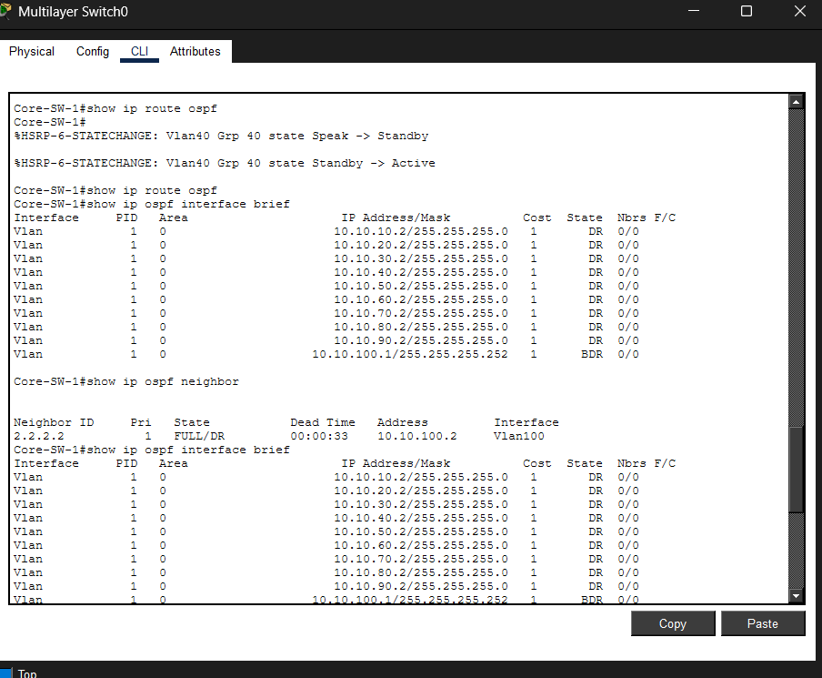
Figure 49: Screenshot 2026-02-05 142214.png
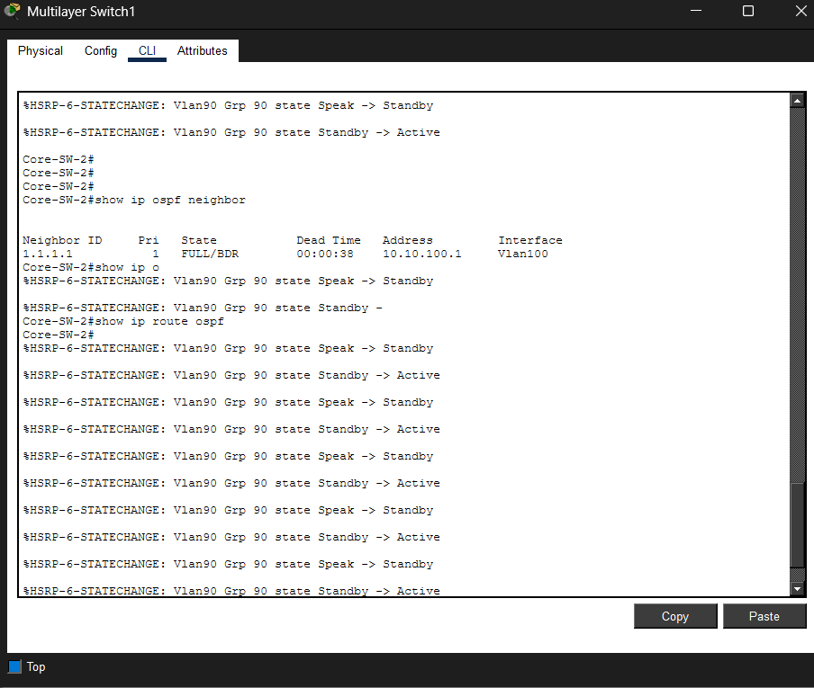
Figure 50: Screenshot 2026-02-05 145013.png
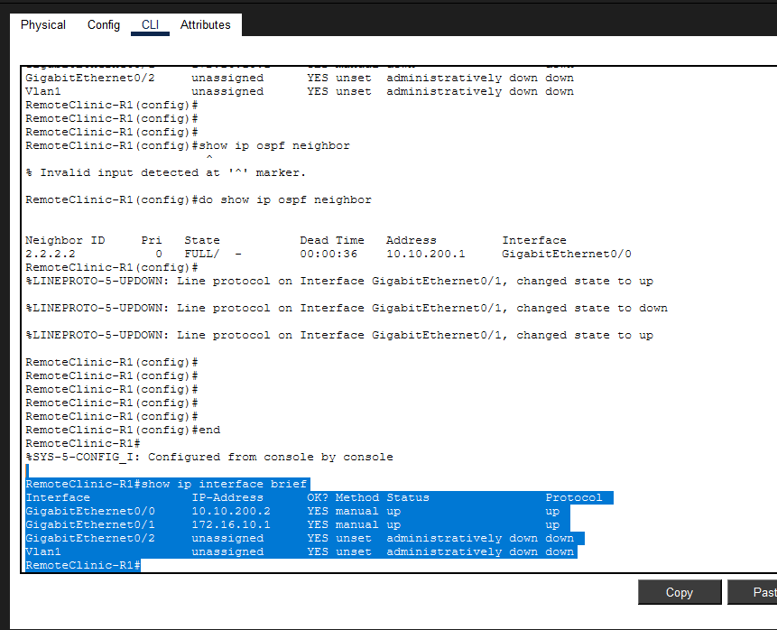
Figure 51: Screenshot 2026-02-05 145607.png
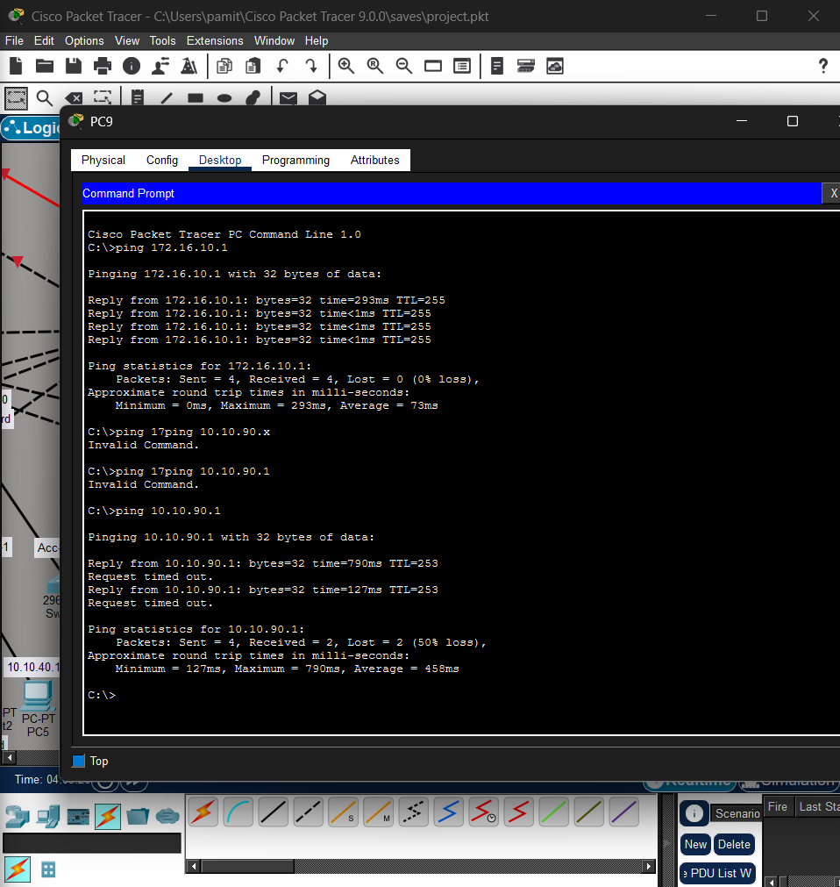
Figure 52: Screenshot 2026-02-05 163340.png
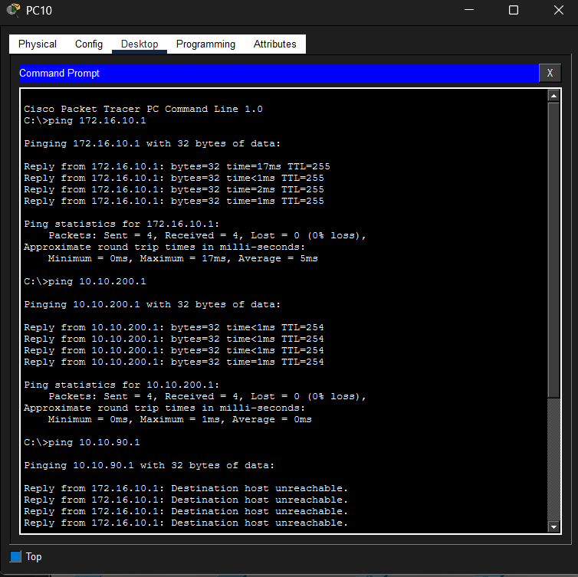
Figure 53: Screenshot 2026-02-05 163453.png
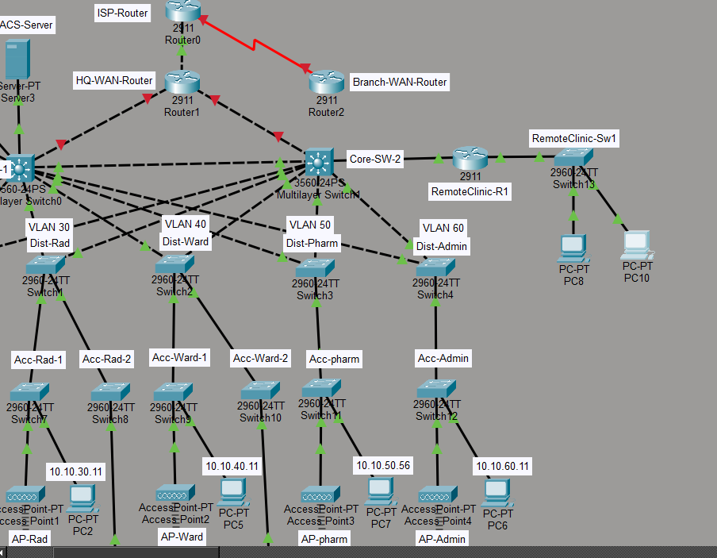
Figure 54: Screenshot 2026-02-05 170156.png
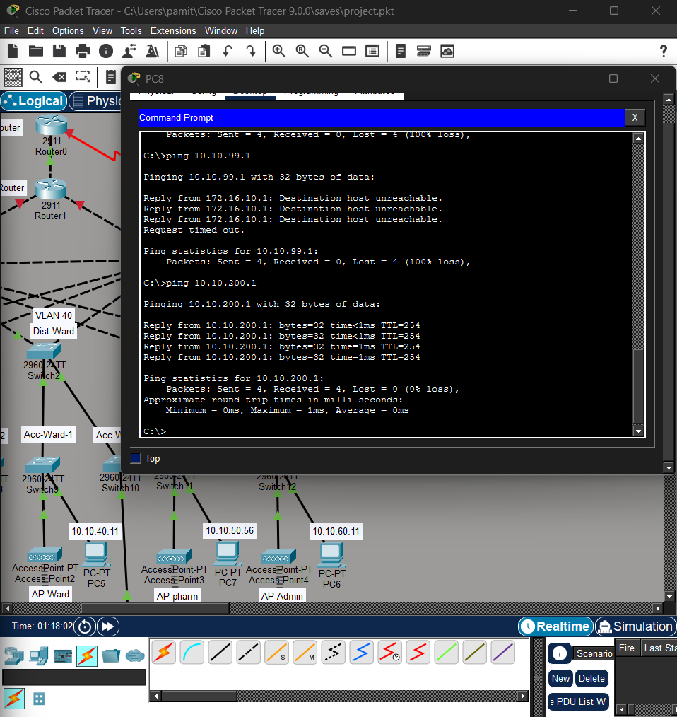
Figure 55: Screenshot 2026-02-05 180955.png
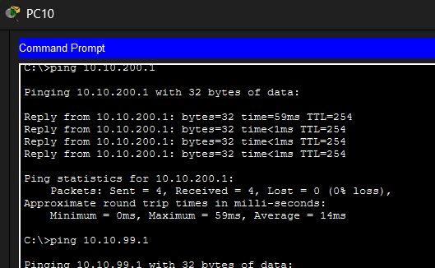
Figure 56: Screenshot 2026-02-05 180957.png
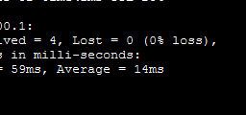
Figure 57: Screenshot 2026-02-05 181019.png
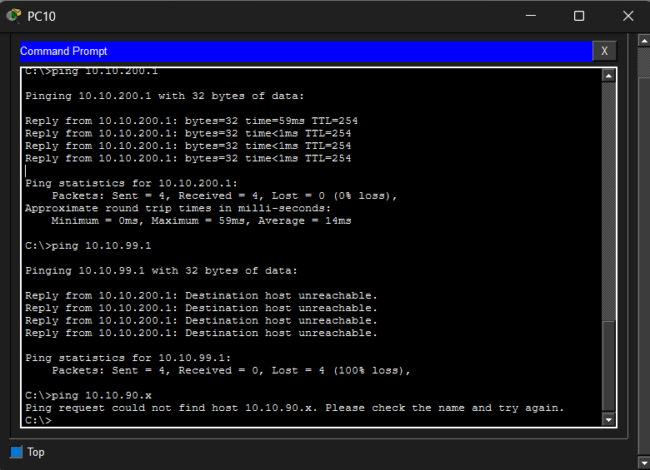
Figure 58: Screenshot 2026-02-05 183930.png
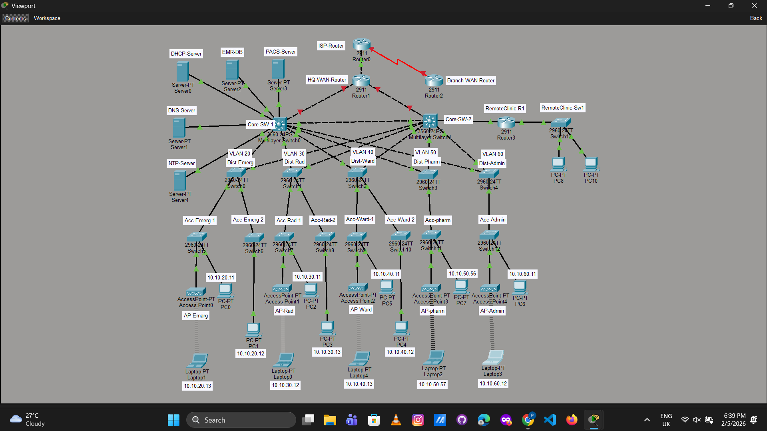
Figure 59: Screenshot 2026-02-05 194025.png
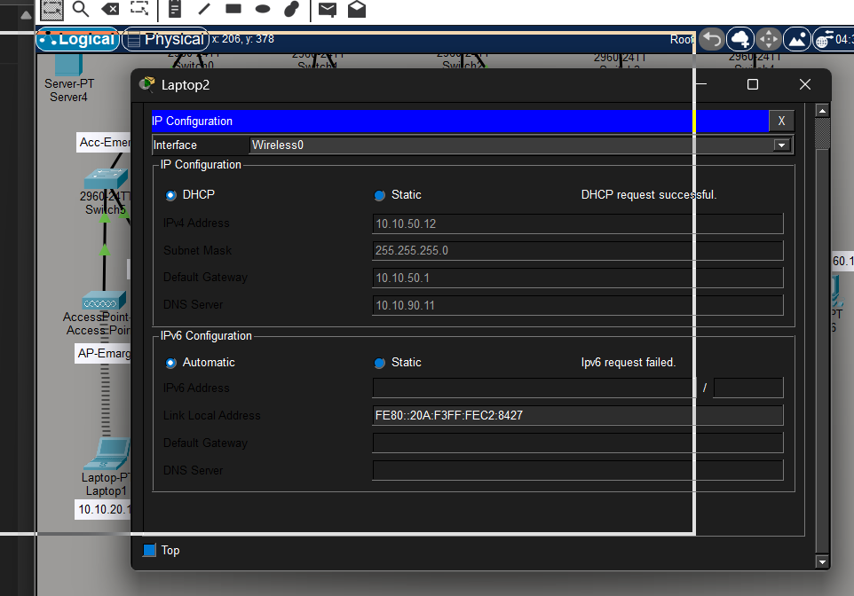
Figure 60: Screenshot 2026-02-05 195028.png
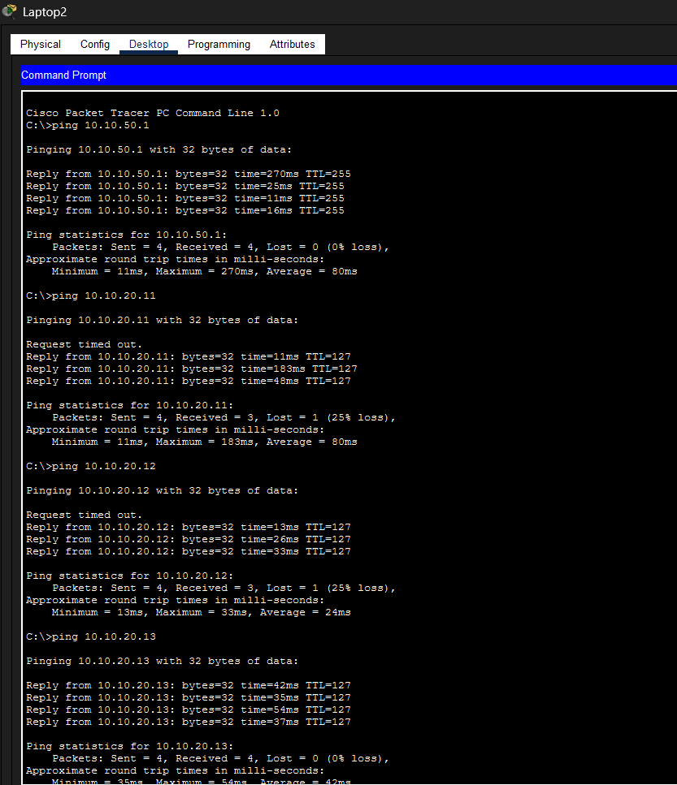
Figure 61: Screenshot 2026-02-05 195115.png
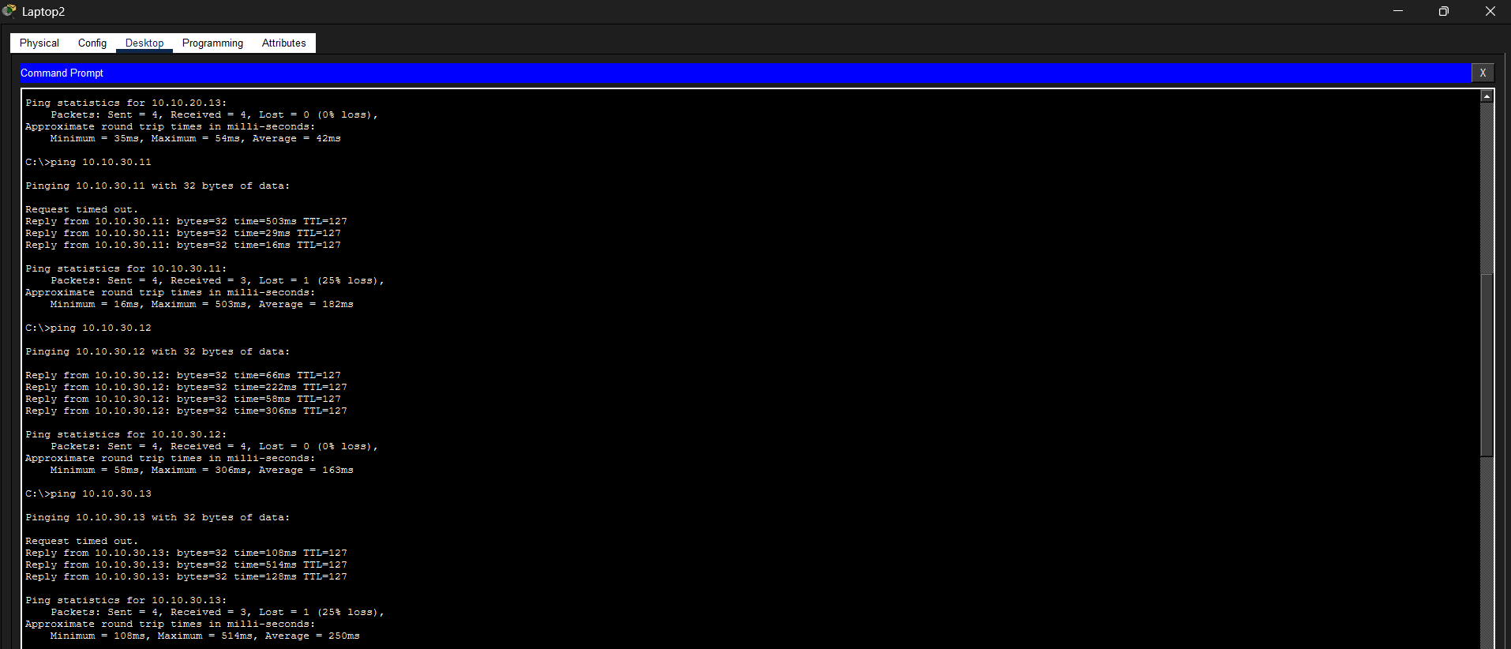
Figure 62: Screenshot 2026-02-05 195146.png
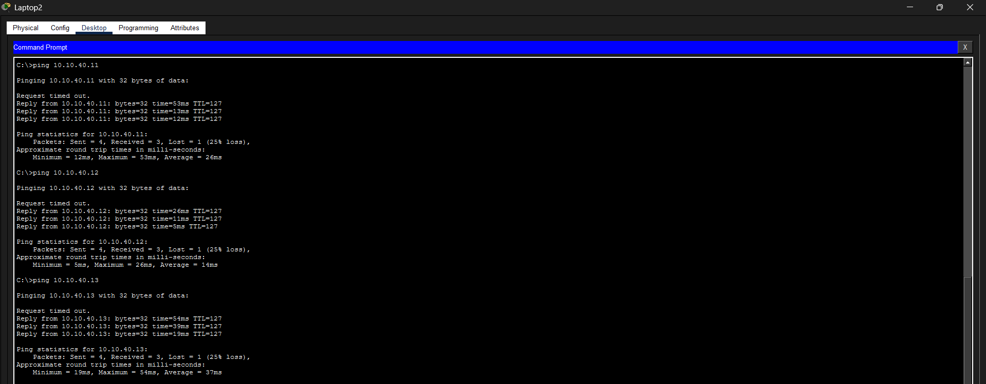
Figure 63: Screenshot 2026-02-05 195219.png
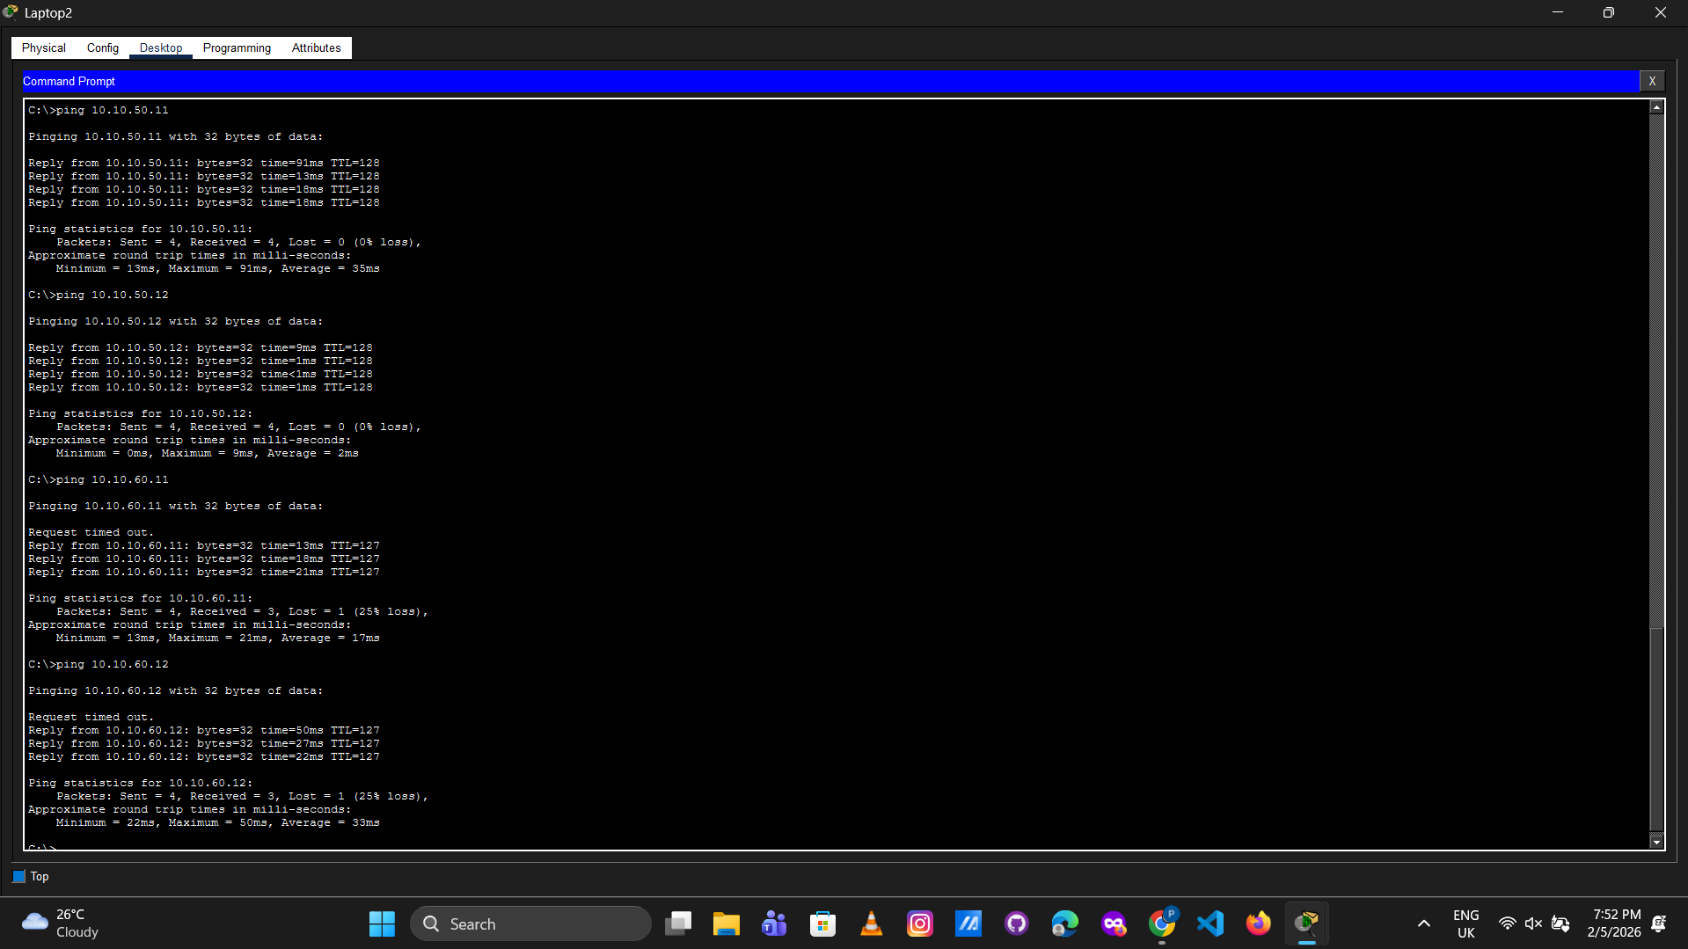
Figure 64: Screenshot 2026-02-05 205017.png
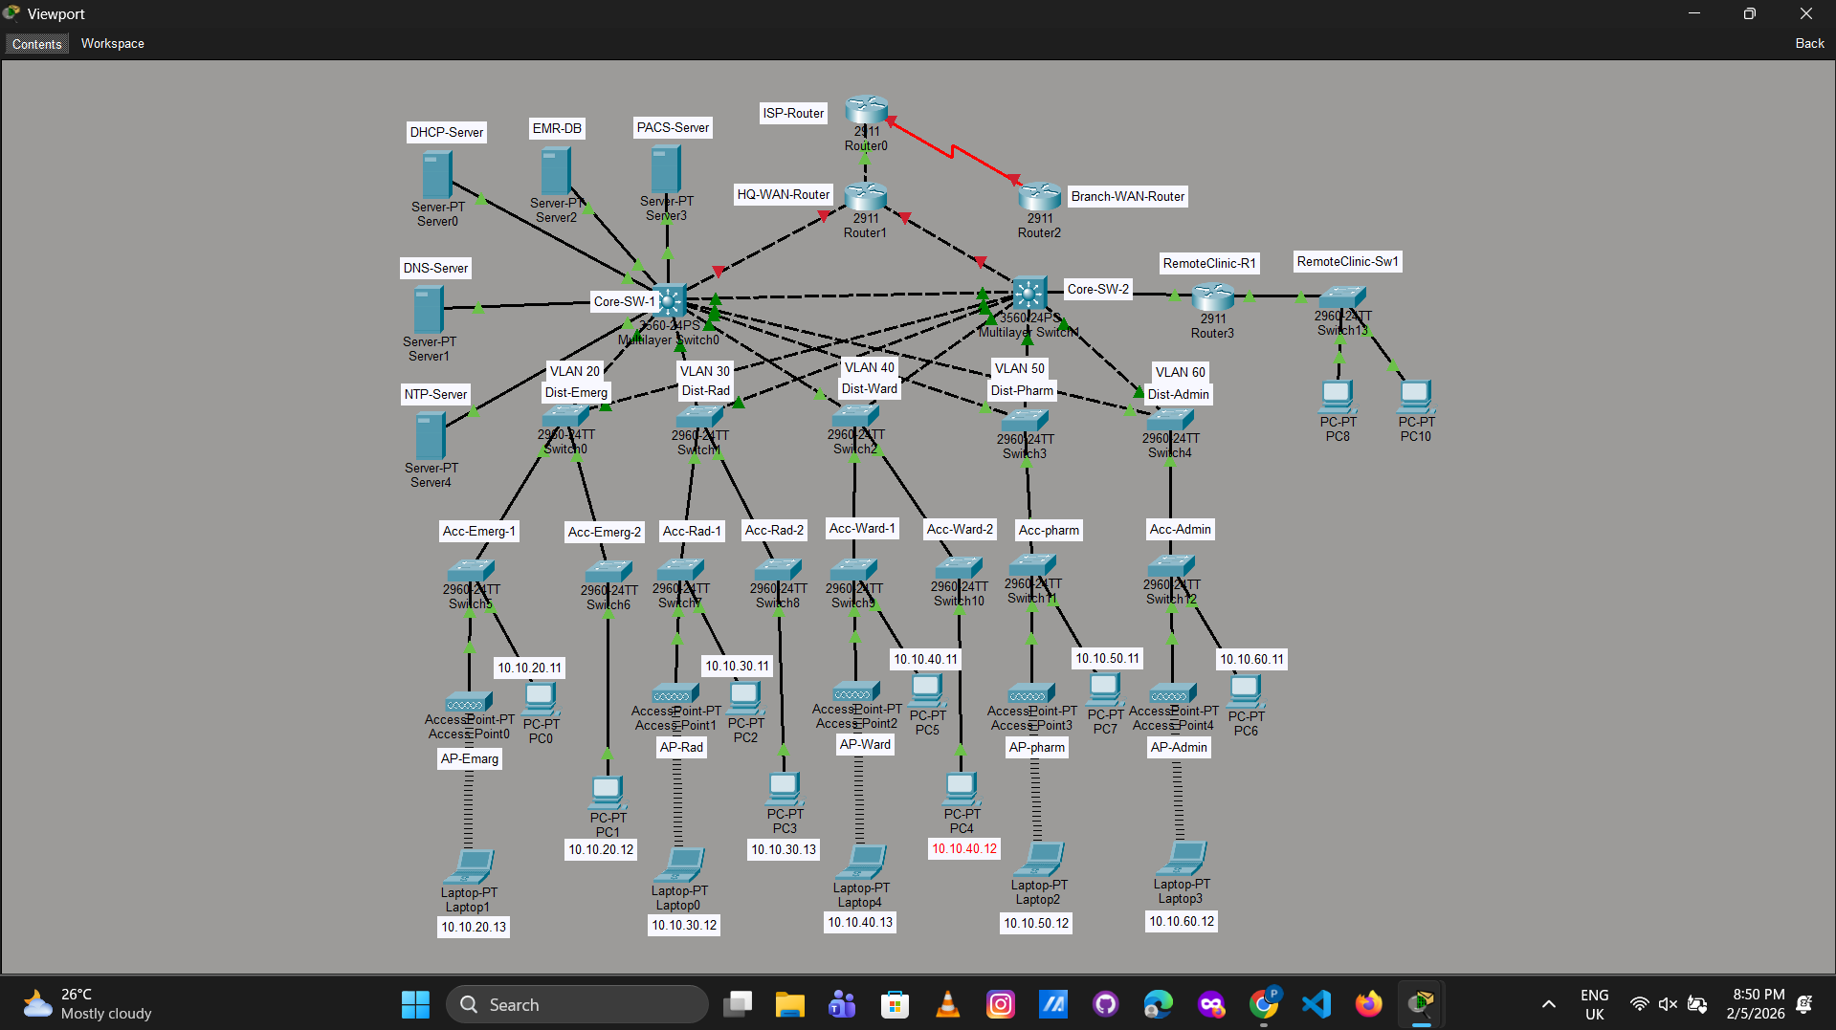
Figure 65: Screenshot 2026-02-05 205021.png
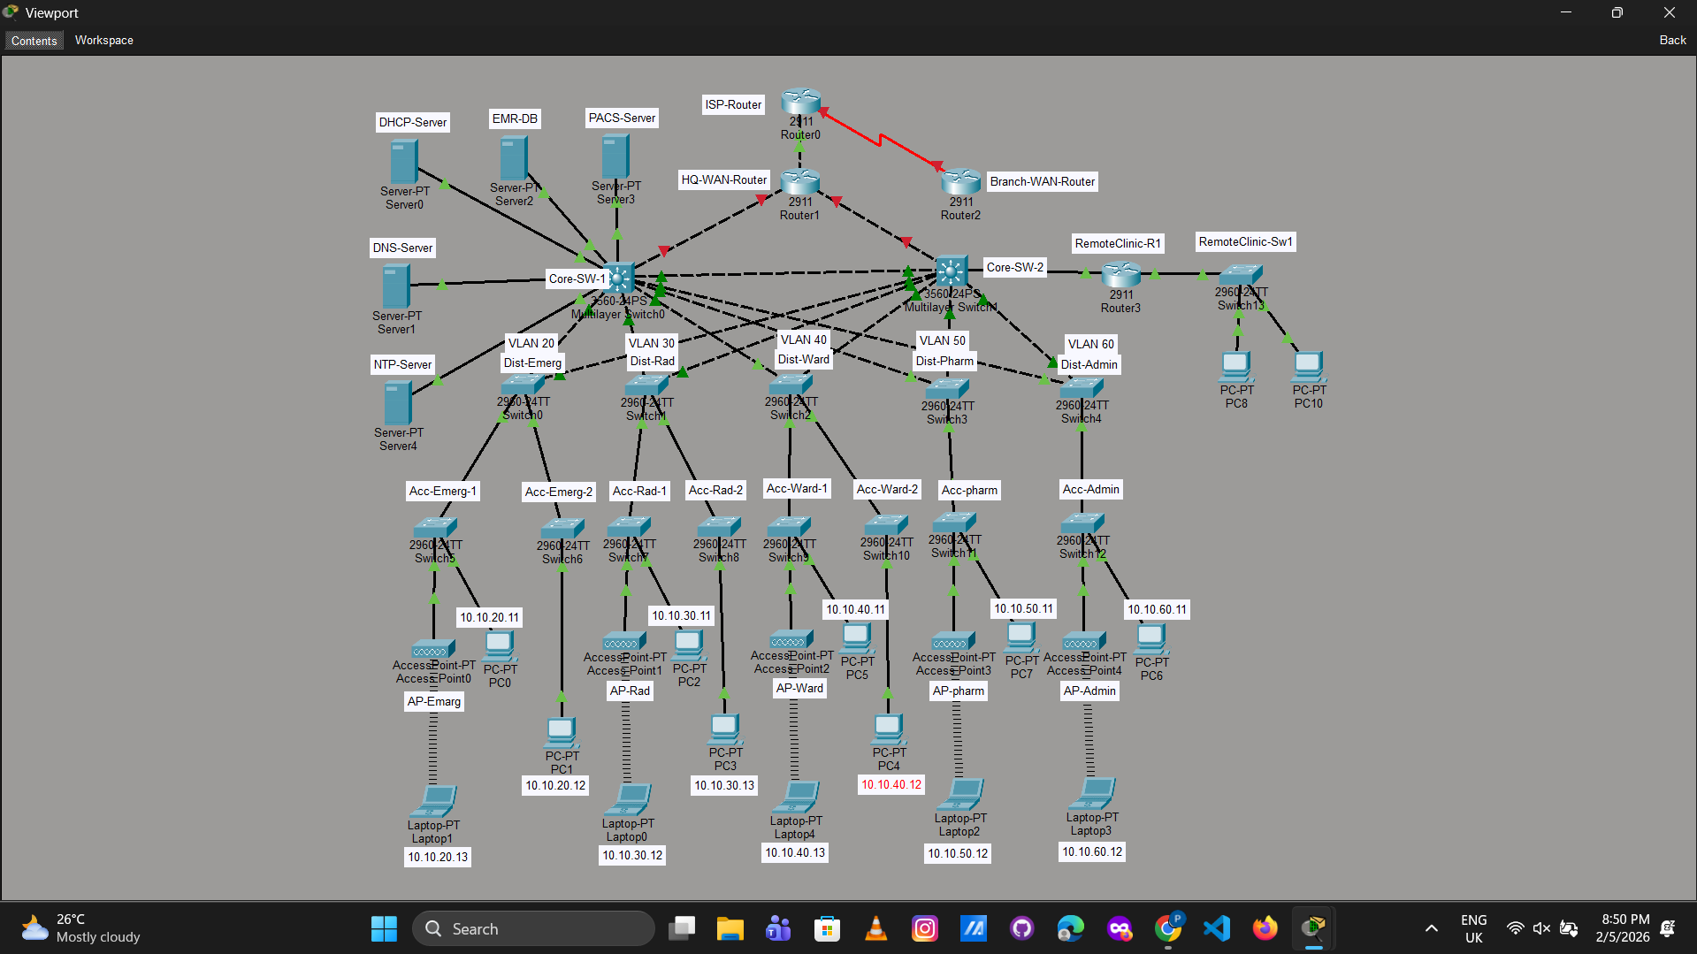
Figure 66: Screenshot 2026-02-05 212252.png
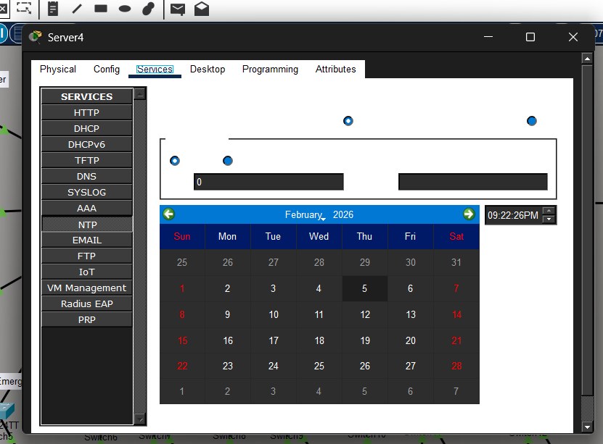
Figure 67: Screenshot 2026-02-05 214609.png
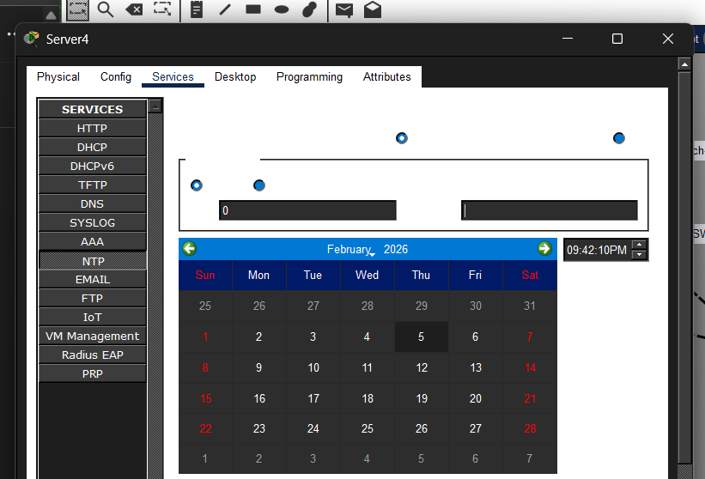
Figure 68: Screenshot 2026-02-05 221540.png
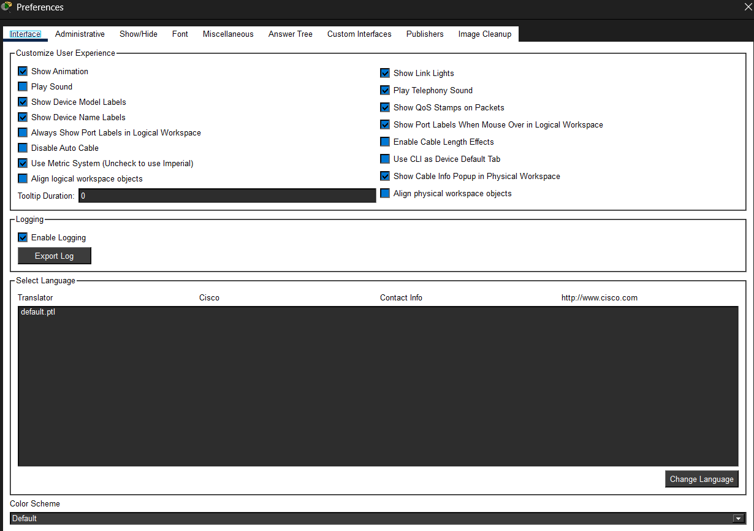
Figure 69: Screenshot 2026-02-05 231954.png
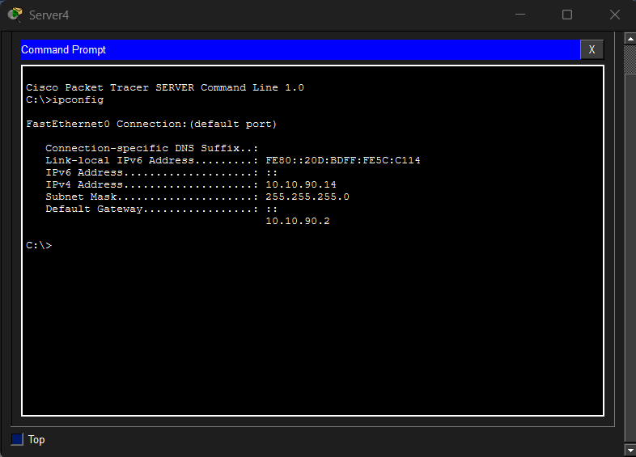
Figure 70: Screenshot 2026-02-06 092726.png
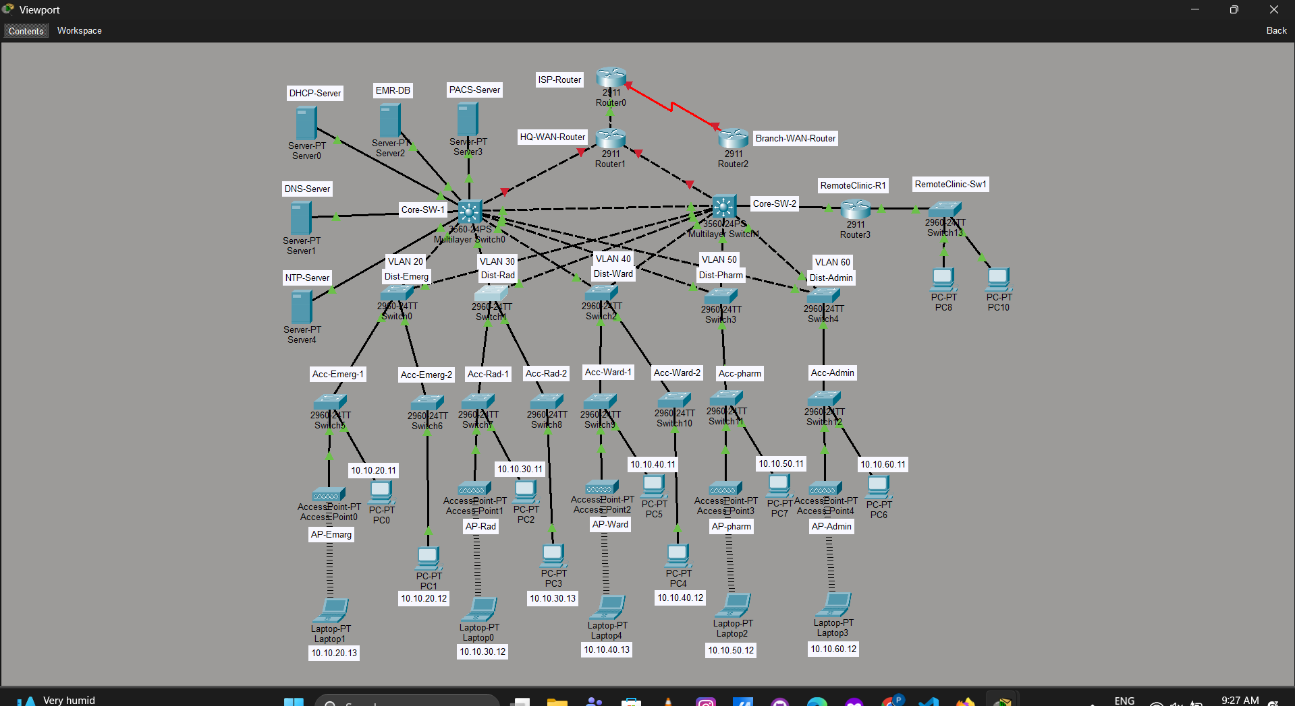
Figure 71: Screenshot 2026-02-06 110630.png
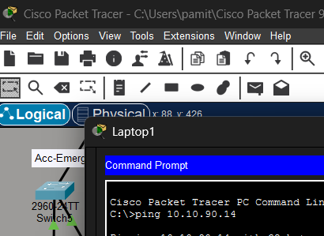
Figure 72: Screenshot 2026-02-06 110711.png
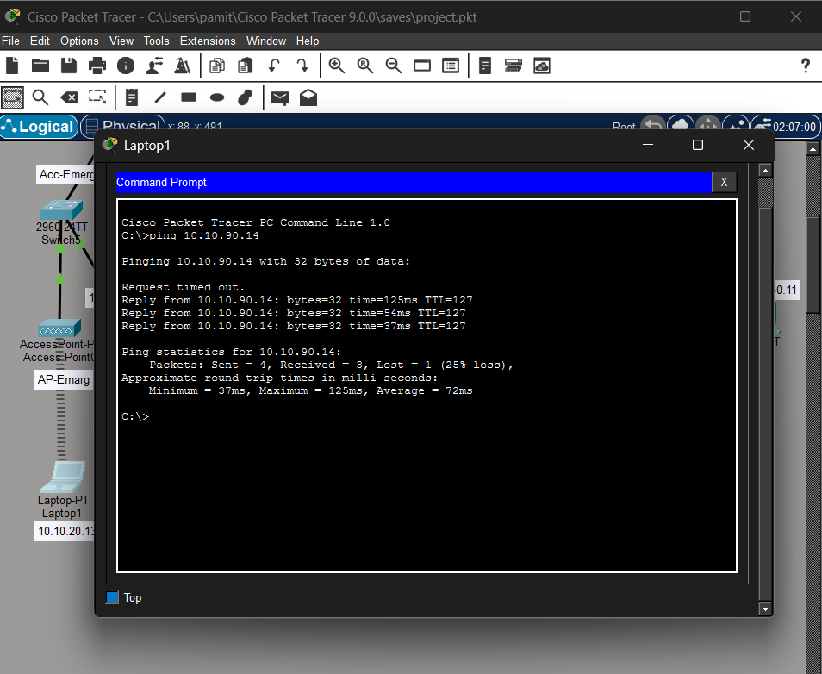
Figure 73: Screenshot 2026-02-06 123929.png
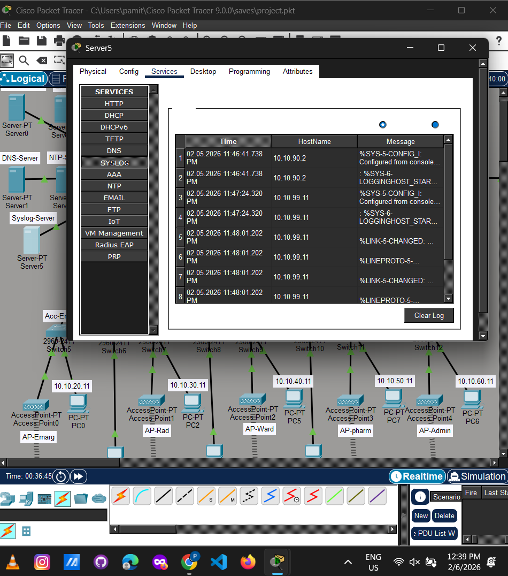
Figure 74: Screenshot 2026-02-06 124302.png
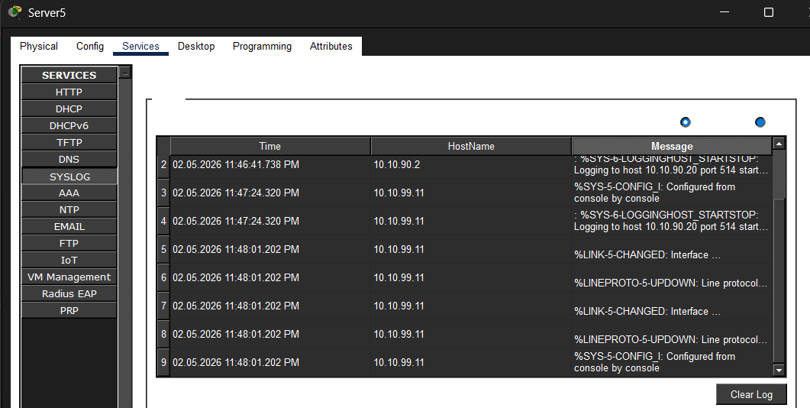
Figure 75: Screenshot 2026-02-06 130802.png
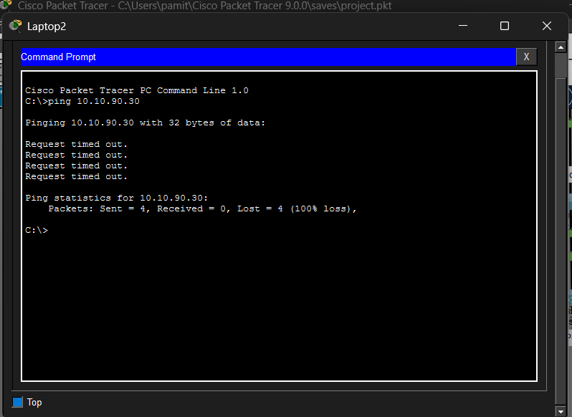
Figure 76: Screenshot 2026-02-06 131716.png
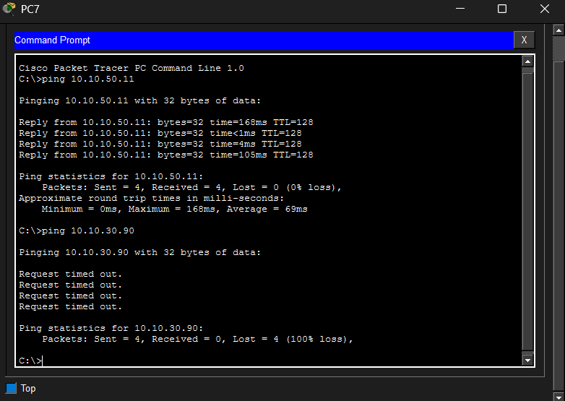
Figure 77: Screenshot 2026-02-06 145956.png
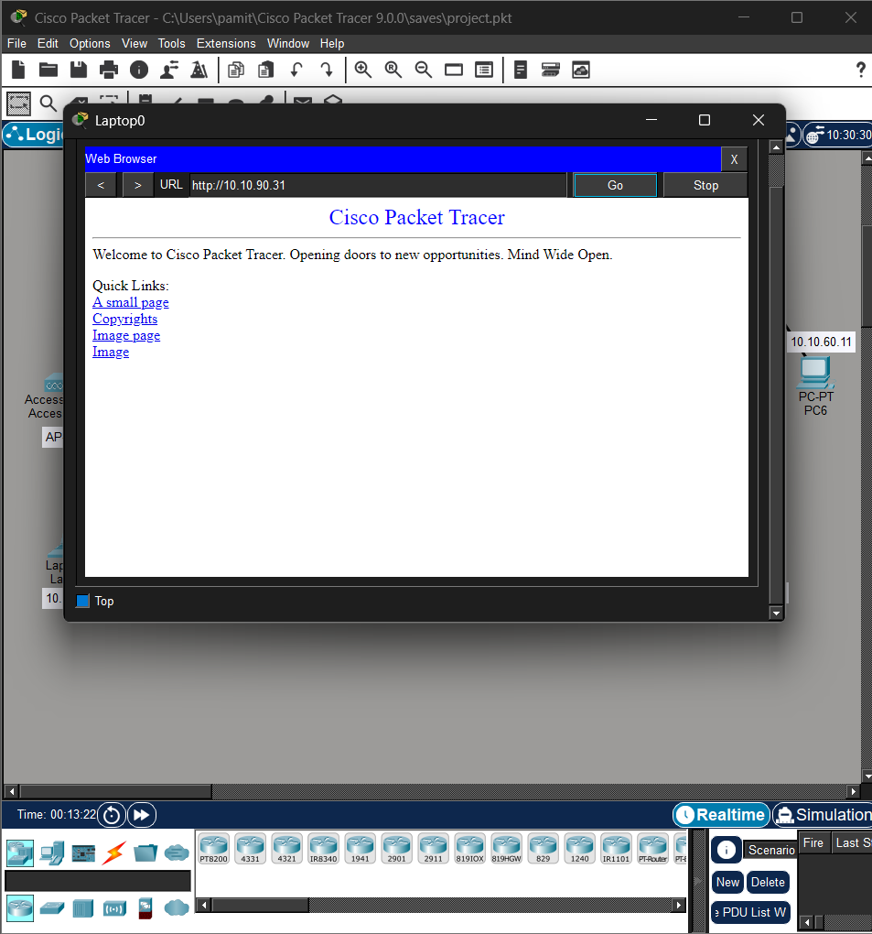
Figure 78: Screenshot 2026-02-06 154831.png
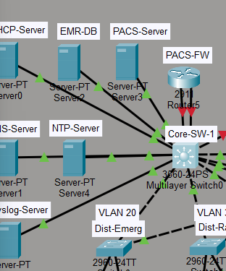
Figure 79: Screenshot 2026-02-06 162620.png
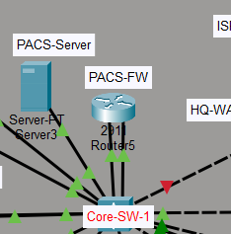
Figure 80: Screenshot 2026-02-06 165317.png
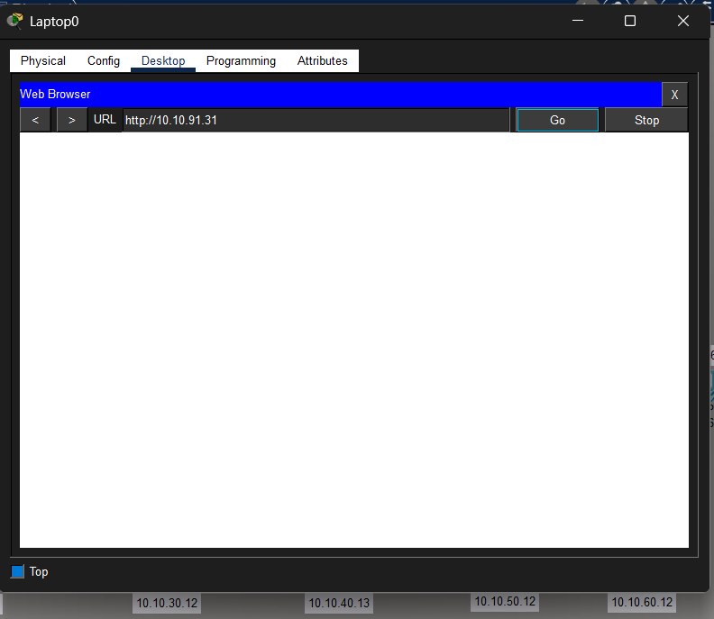
Figure 81: Screenshot 2026-02-06 165529 - Copy.png
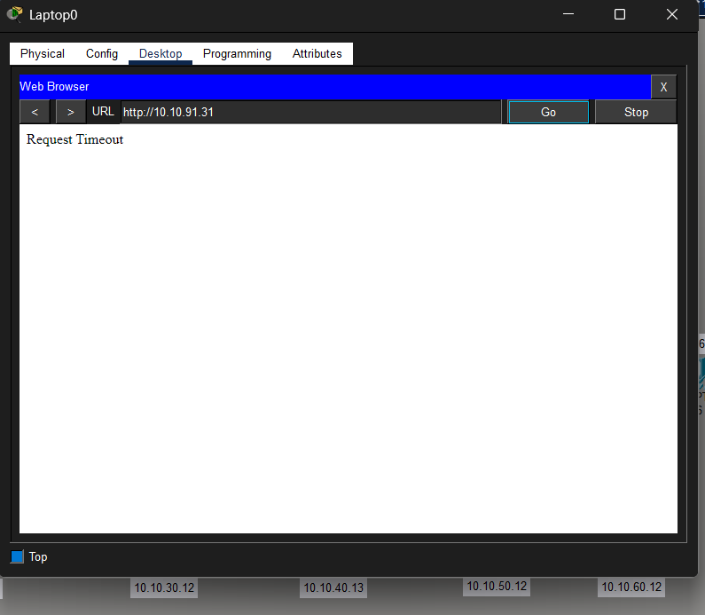
Figure 82: Screenshot 2026-02-06 165529.png

Figure 83: Screenshot 2026-02-06 170307.png
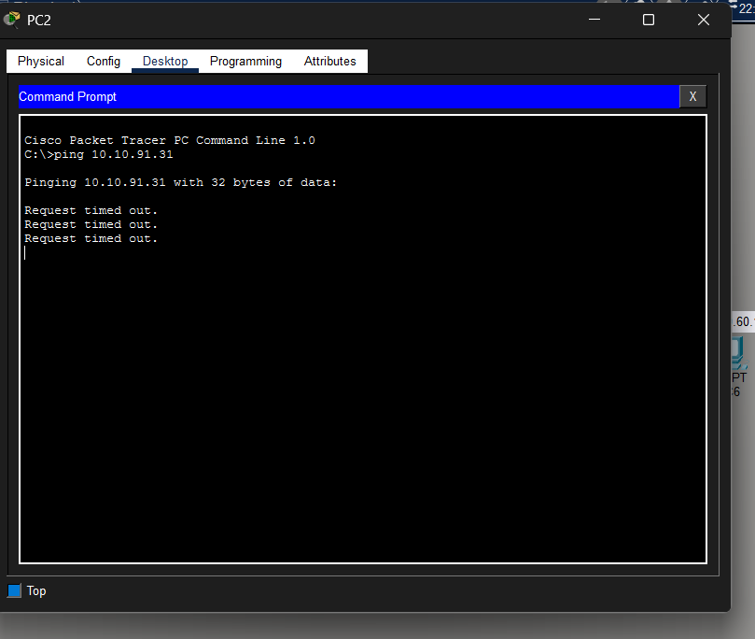
Figure 84: Screenshot 2026-02-06 170311.png
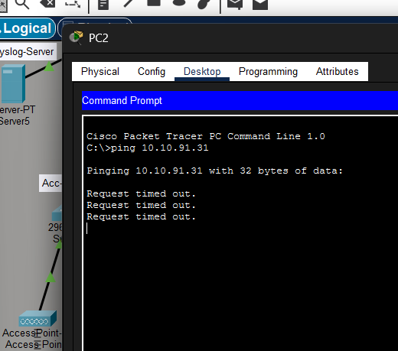
Figure 85: Screenshot 2026-02-06 170330.png
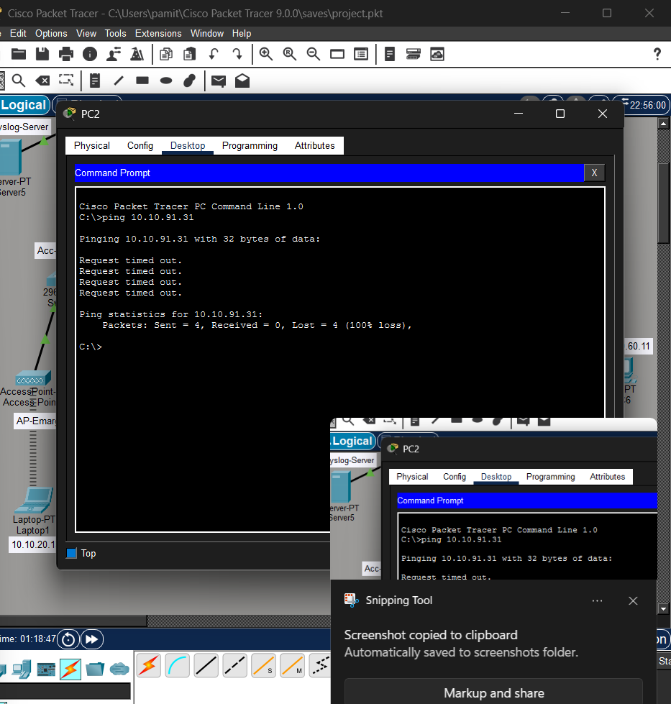
Figure 86: Screenshot 2026-02-06 170853.png
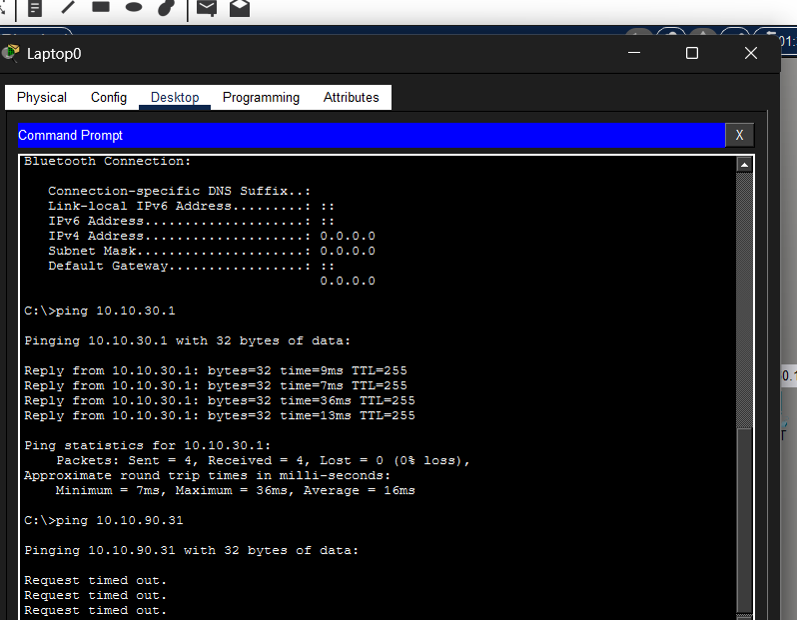
Figure 87: Screenshot 2026-02-06 171634.png
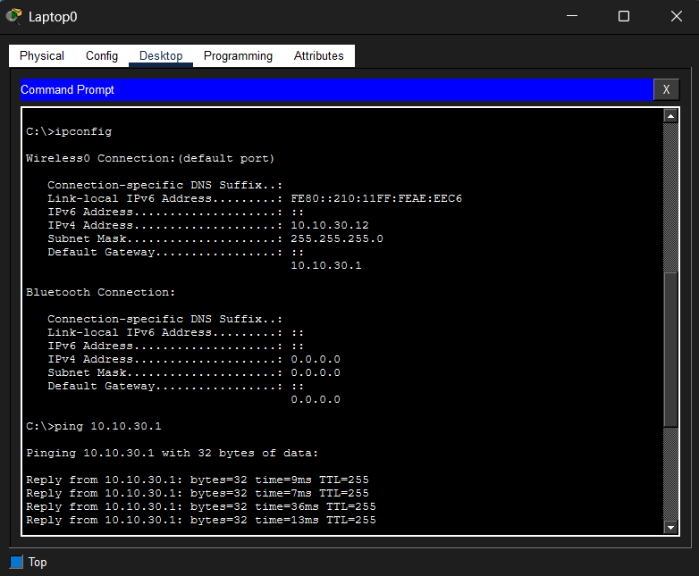
Figure 88: Screenshot 2026-02-06 180416 - Copy.png
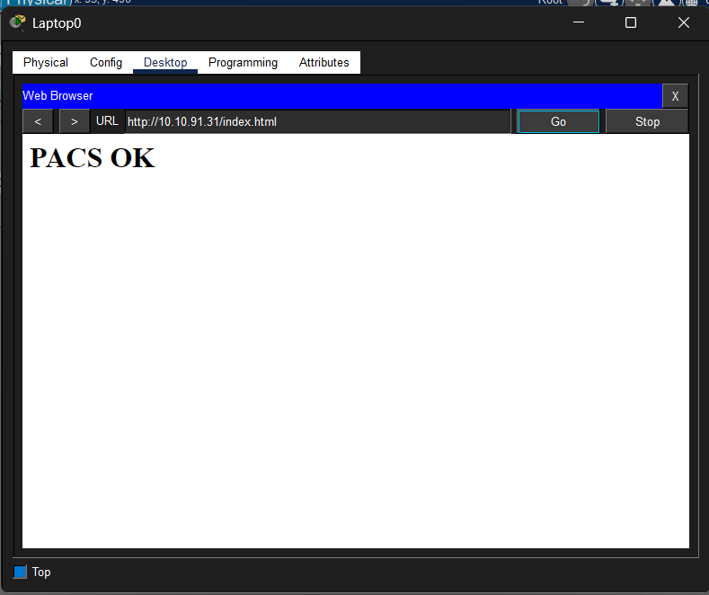
Figure 89: Screenshot 2026-02-06 180416.png

Figure 90: Screenshot 2026-02-06 180730 - Copy.png
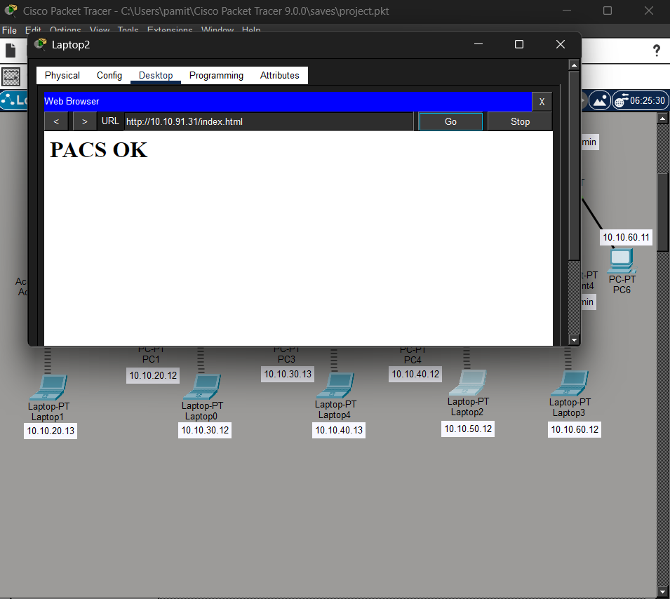
Figure 91: Screenshot 2026-02-06 180730.png

Figure 92: Screenshot 2026-02-06 190042.png
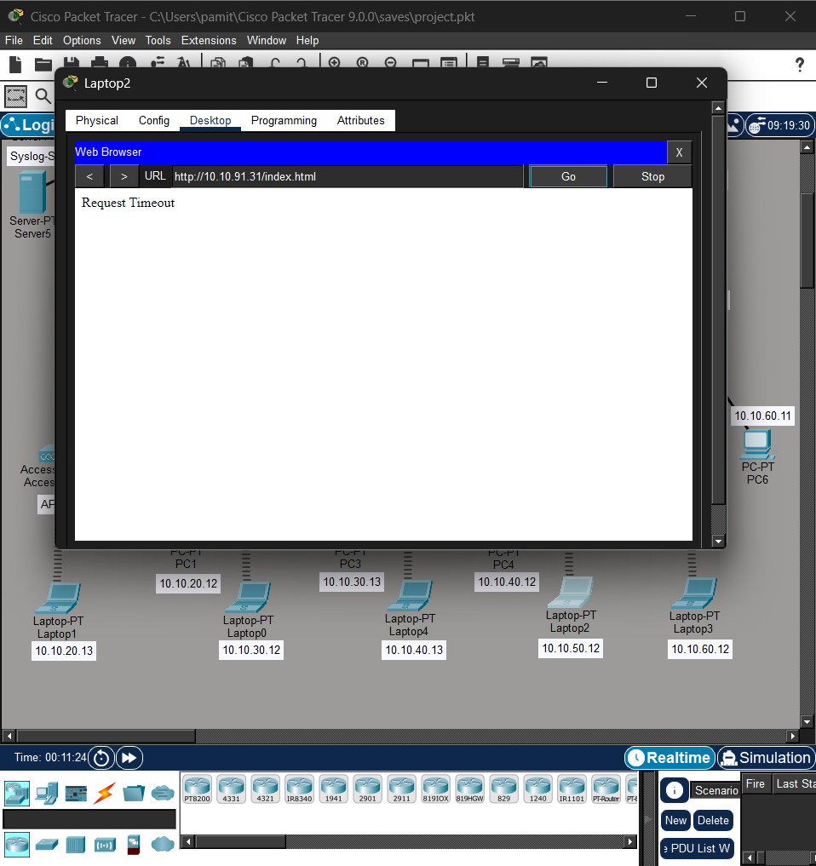
Figure 93: Screenshot 2026-02-06 200441.png
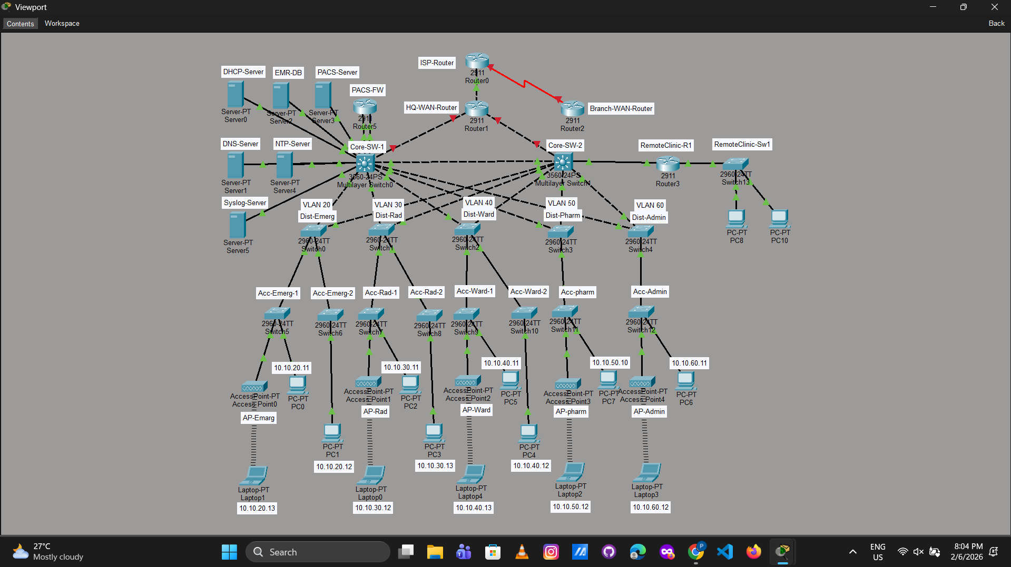
Figure 94: Screenshot 2026-02-06 203605.png
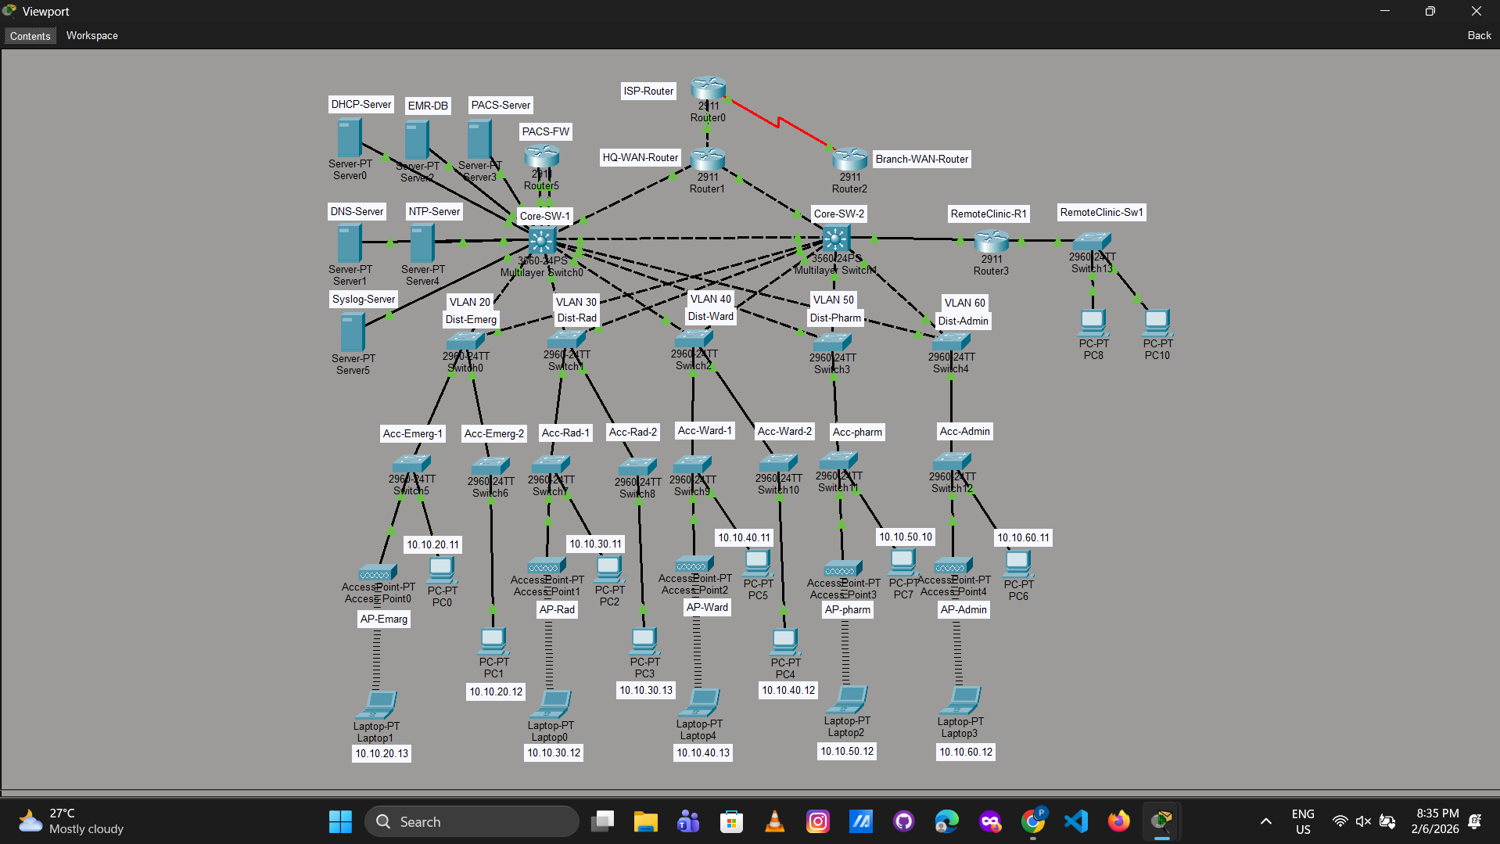
Figure 95: Screenshot 2026-02-06 203611.png
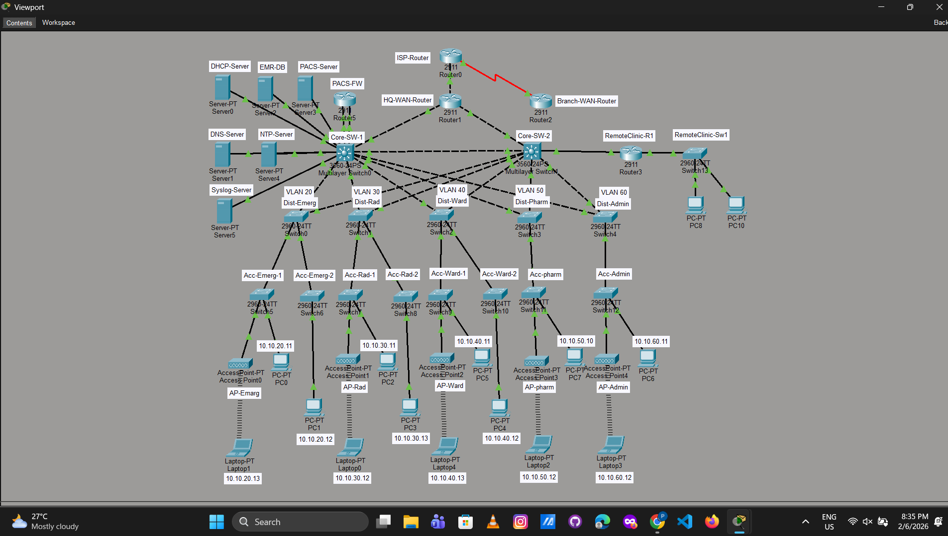
Figure 96: Screenshot 2026-02-08 173837.png
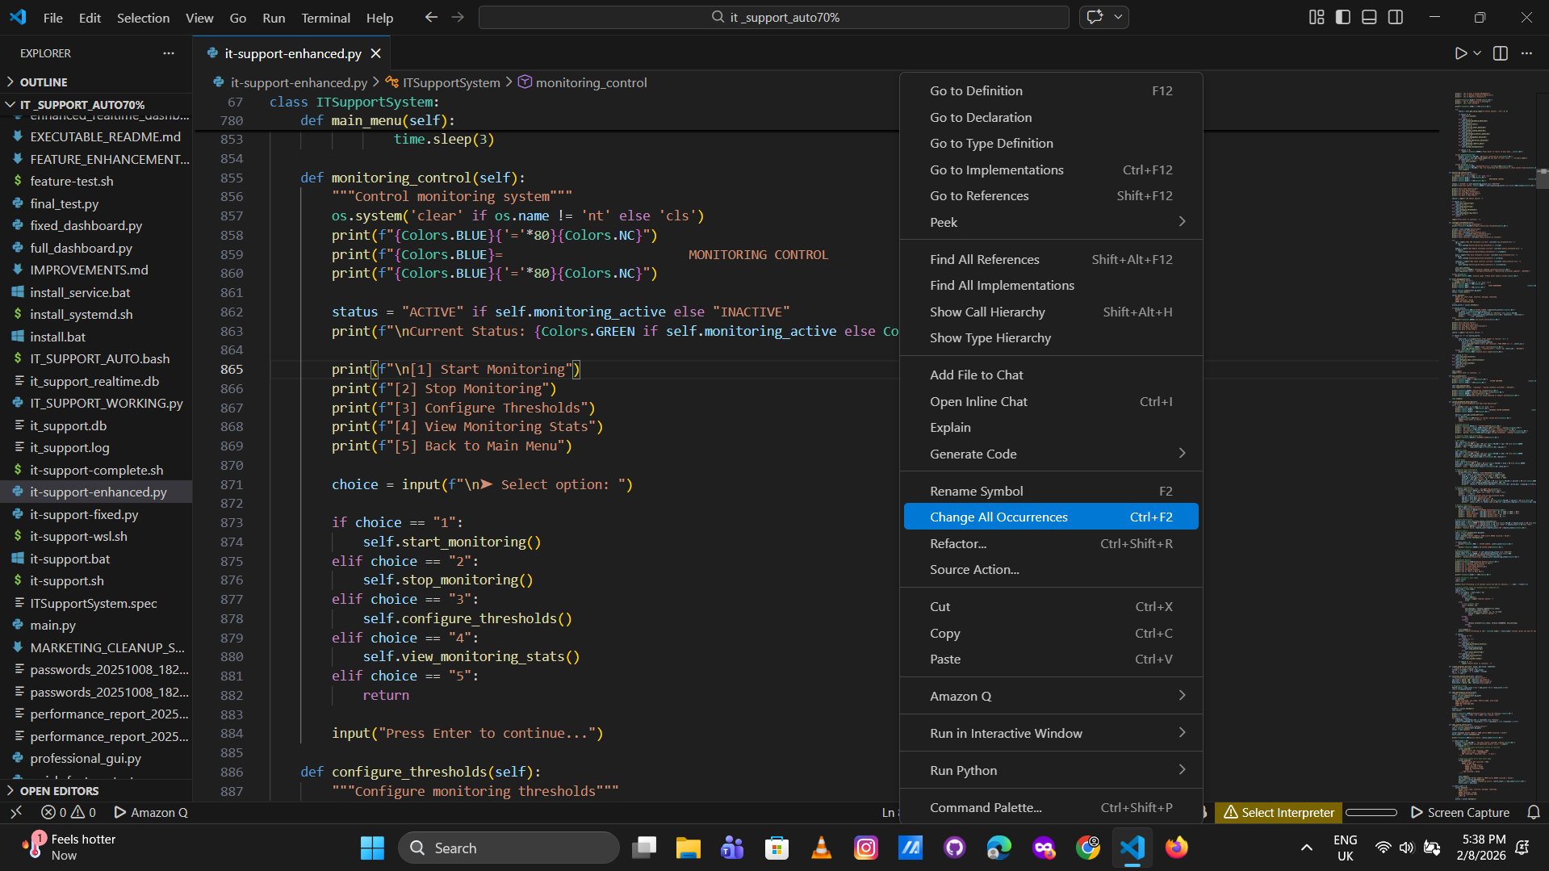
Figure 97: Screenshot 2026-02-08 175655.png
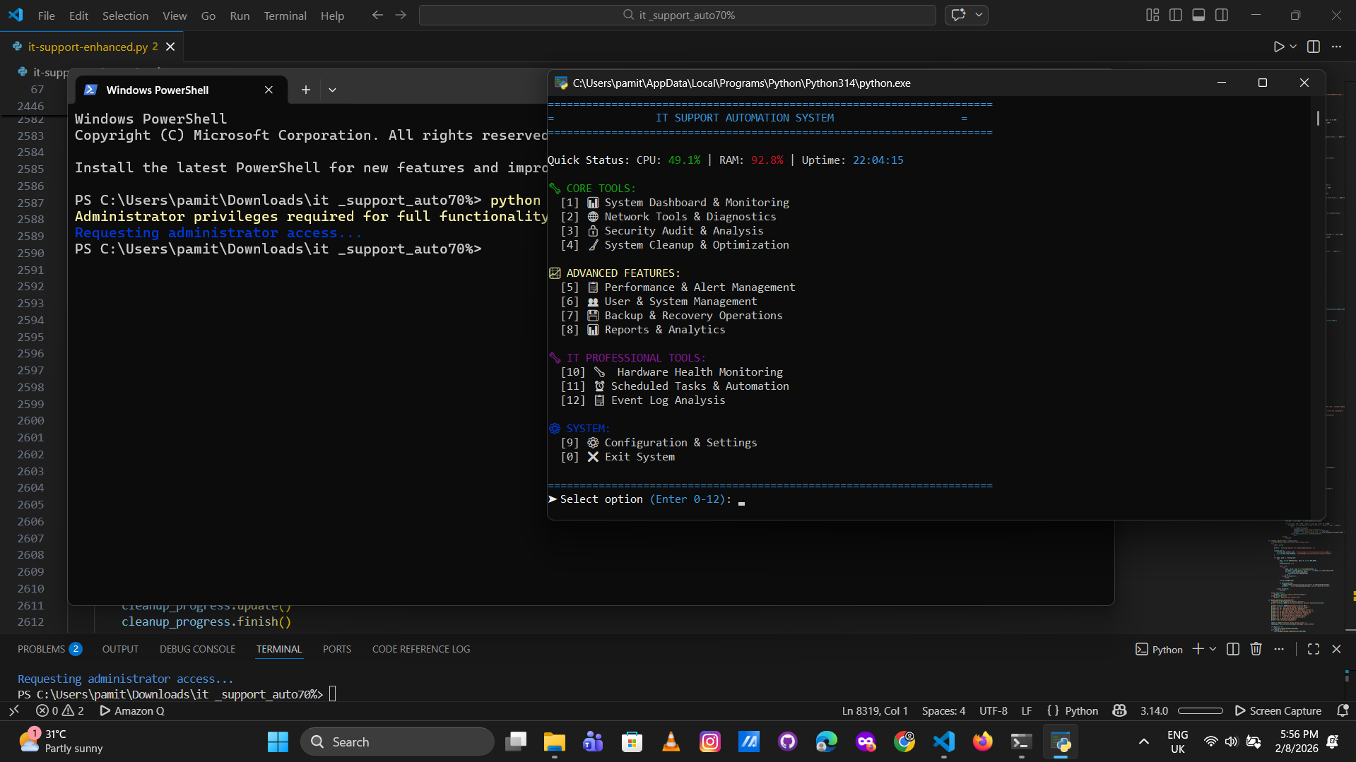
Figure 98: Screenshot 2026-02-08 210418.png
Figure 99: Screenshot 2026-02-09 131003.png
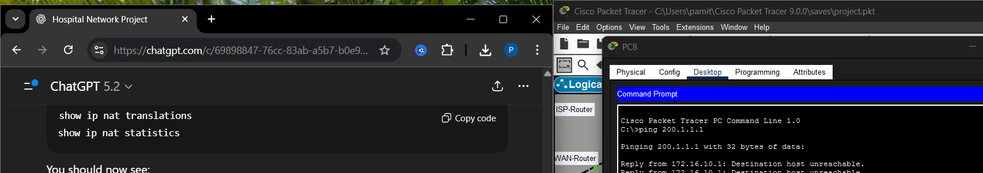
Figure 100: Screenshot 2026-02-09 131022.png
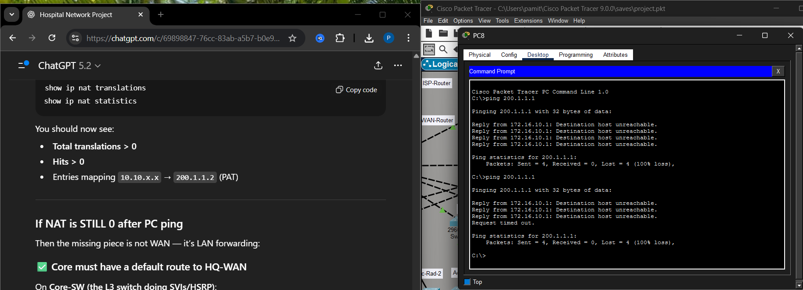
Figure 101: Screenshot 2026-02-09 154931.png
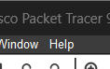
Figure 102: Screenshot 2026-02-09 160306.png
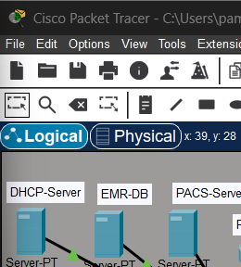
Figure 103: Screenshot 2026-02-09 160324.png
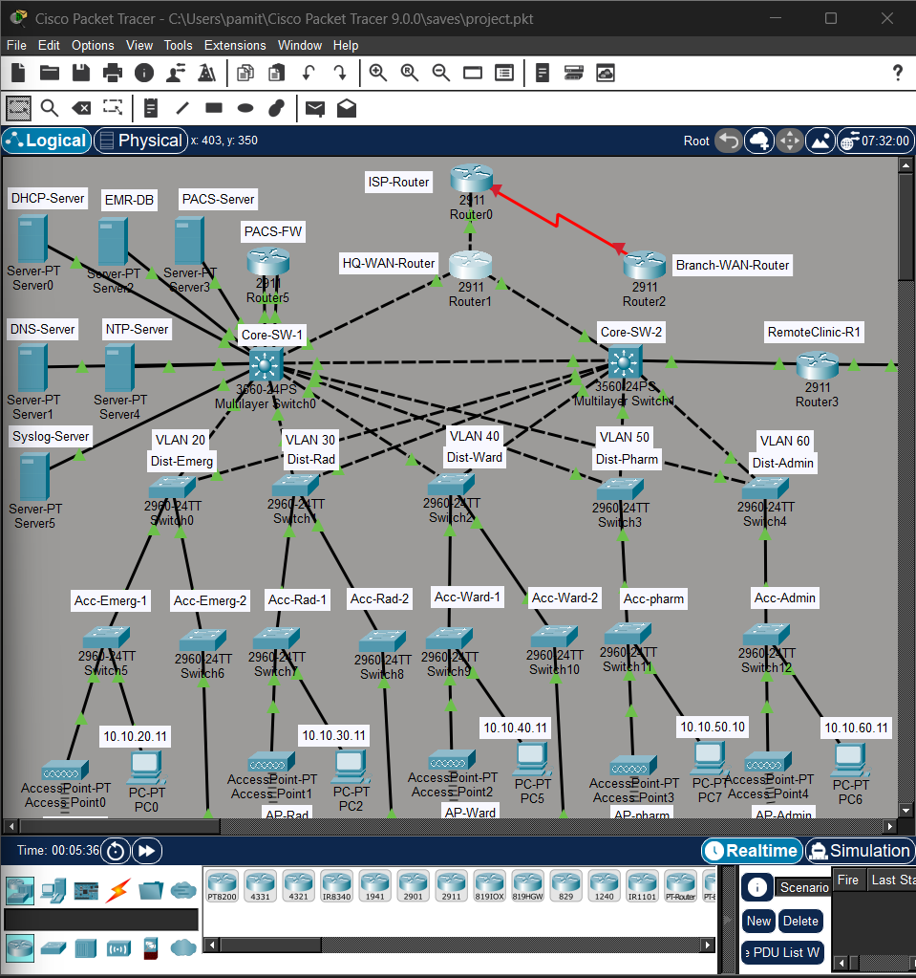
Figure 104: Screenshot 2026-02-09 162003.png
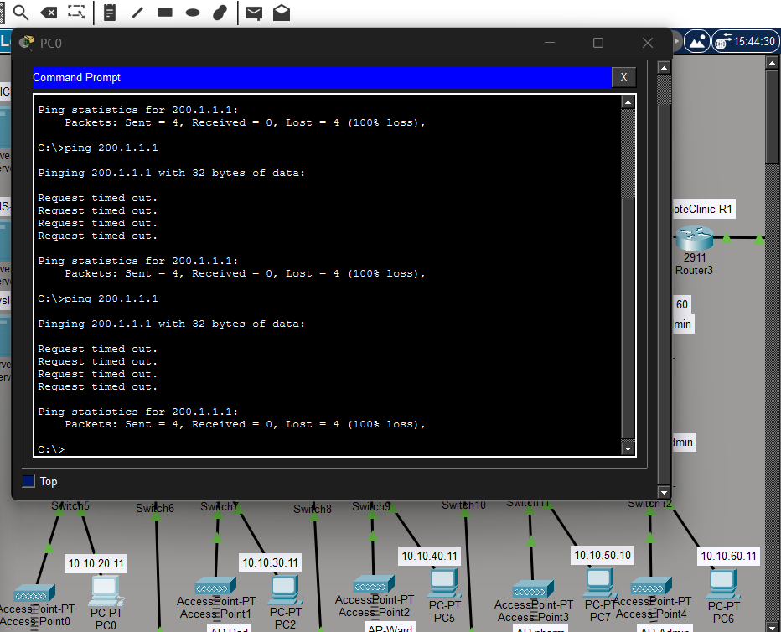
Figure 105: Screenshot 2026-02-09 162453.png
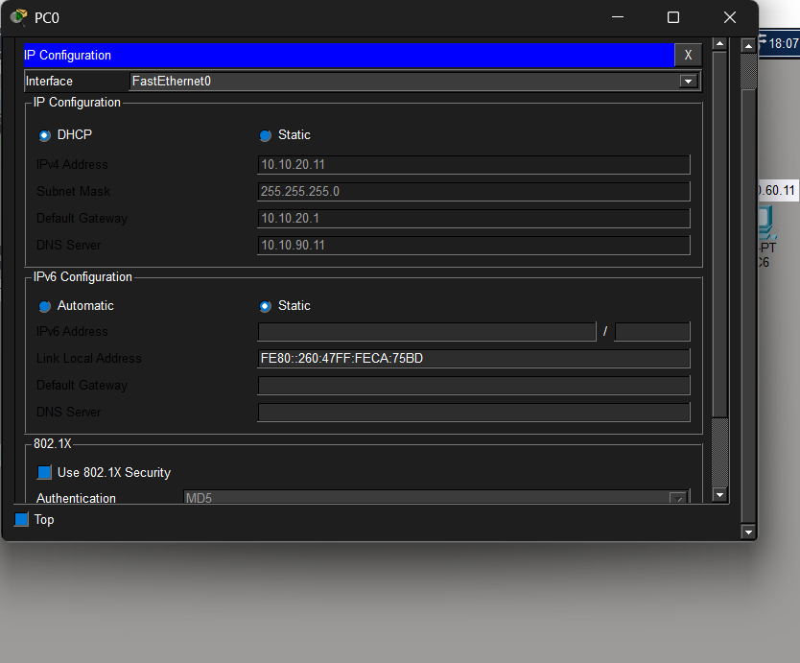
Figure 106: Screenshot 2026-02-09 163635.png
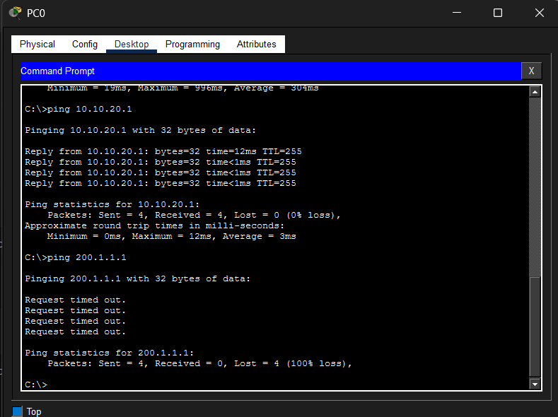
Figure 107: Screenshot 2026-02-09 164129.png
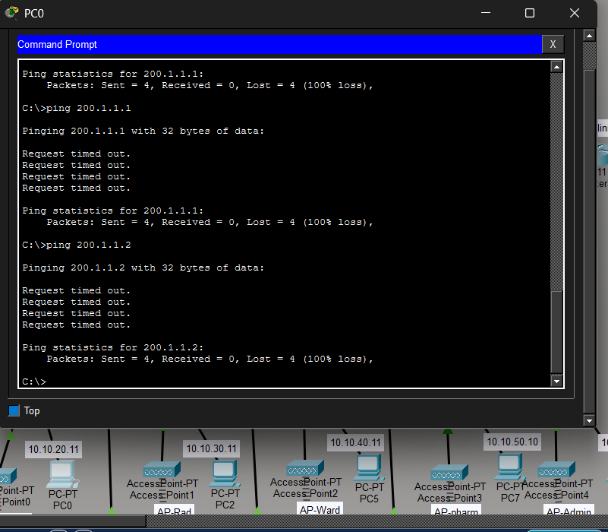
Figure 108: Screenshot 2026-02-09 170844.png
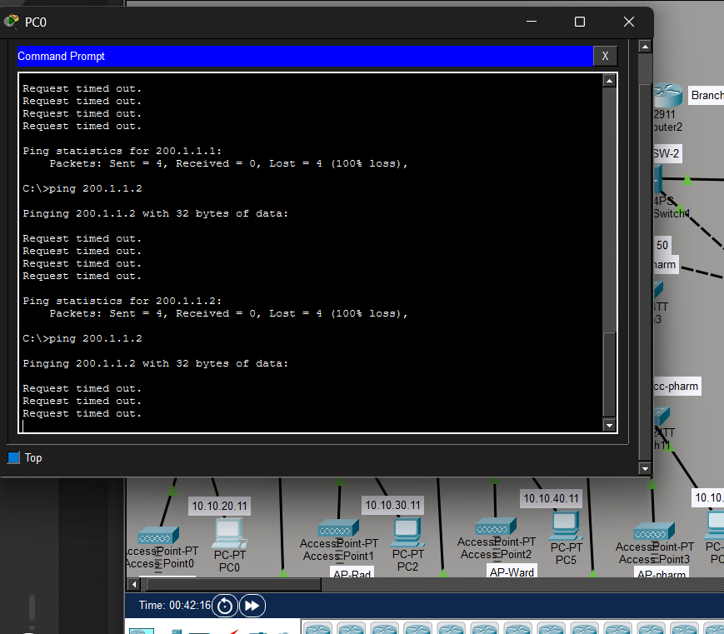
Figure 109: Screenshot 2026-02-09 173546.png
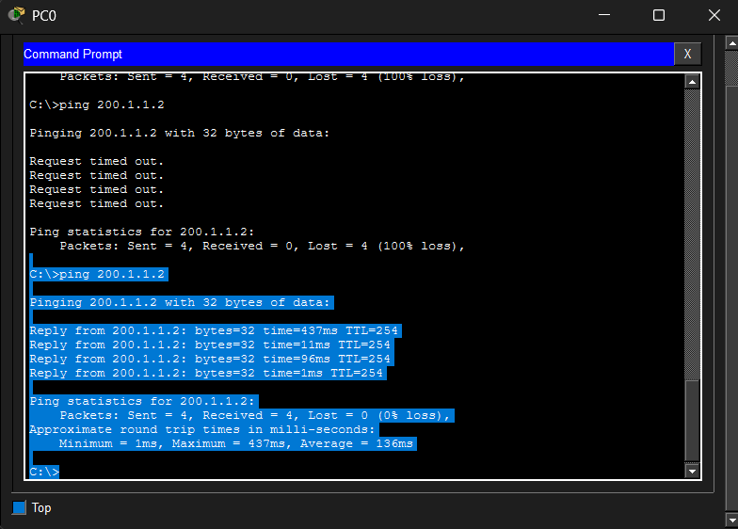
Figure 110: Screenshot 2026-02-09 173853 - Copy.png
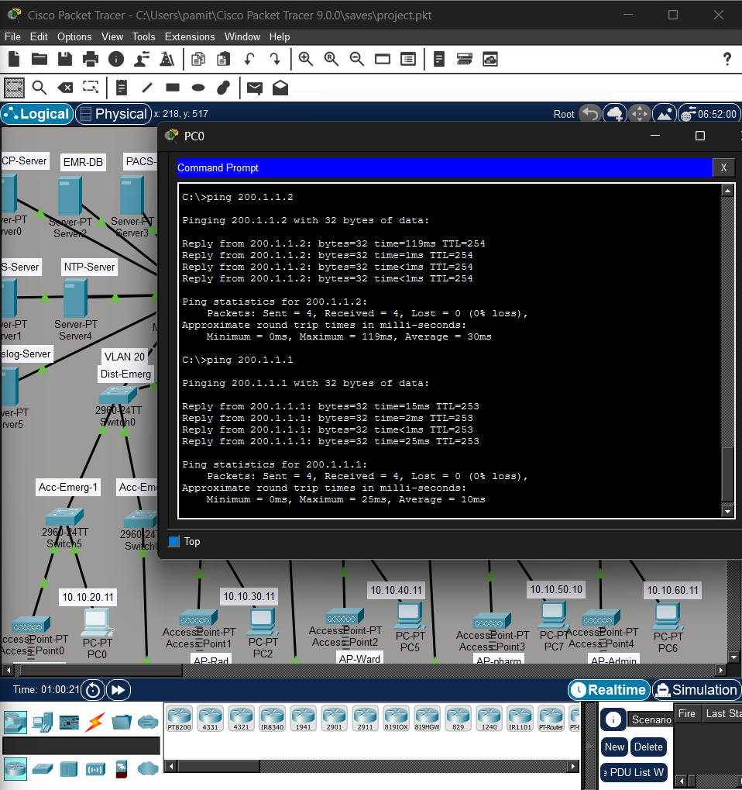
Figure 111: Screenshot 2026-02-09 173853.png

Figure 112: Screenshot 2026-02-09 175433 - Copy.png
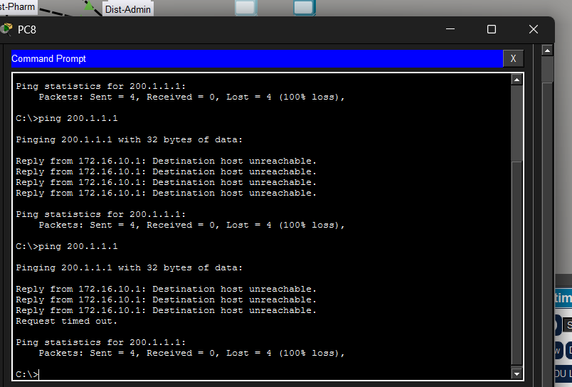
Figure 113: Screenshot 2026-02-09 175433.png

Figure 114: Screenshot 2026-02-09 180304 - Copy.png
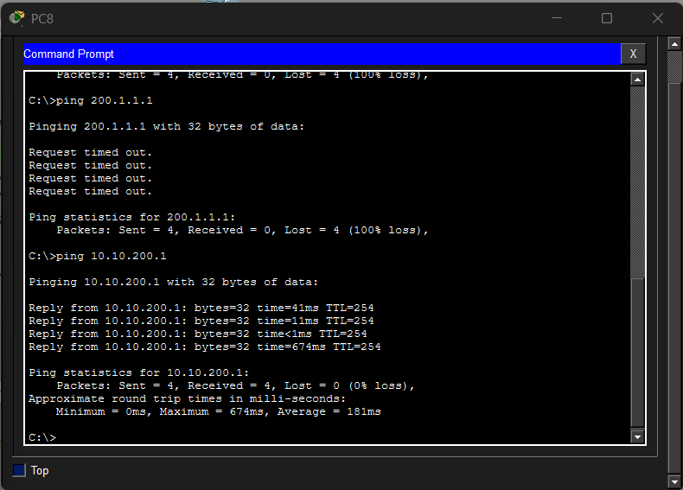
Figure 115: Screenshot 2026-02-09 180304.png

Figure 116: Screenshot 2026-02-09 181305.png
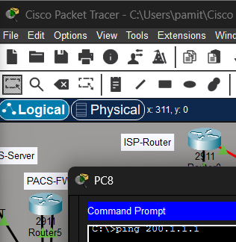
Figure 117: Screenshot 2026-02-09 181324.png
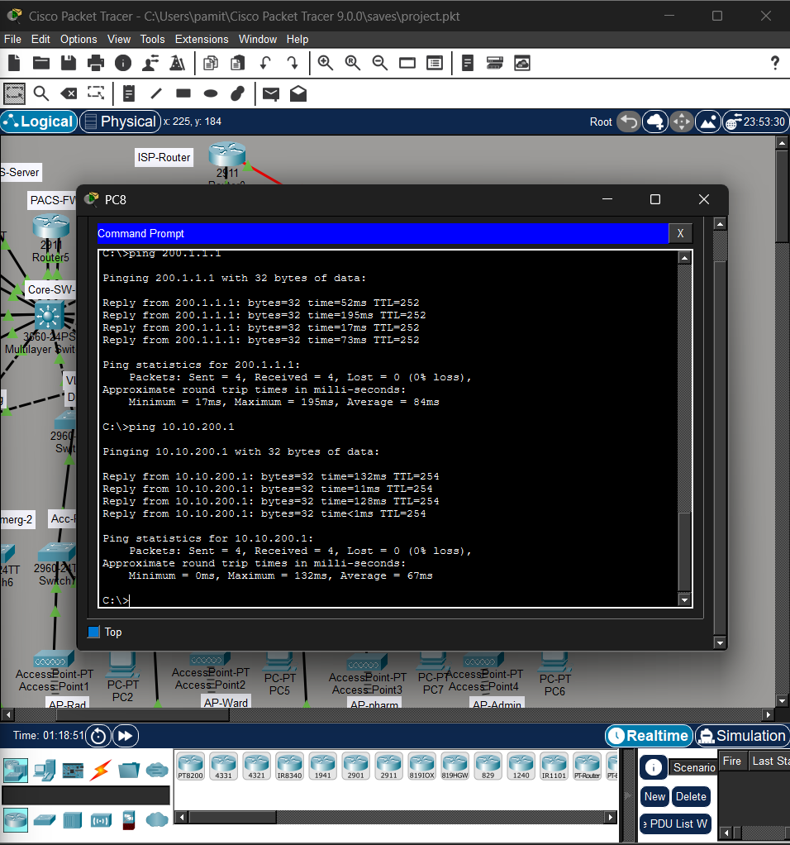
Figure 118: Screenshot 2026-02-09 200111 - Copy.png
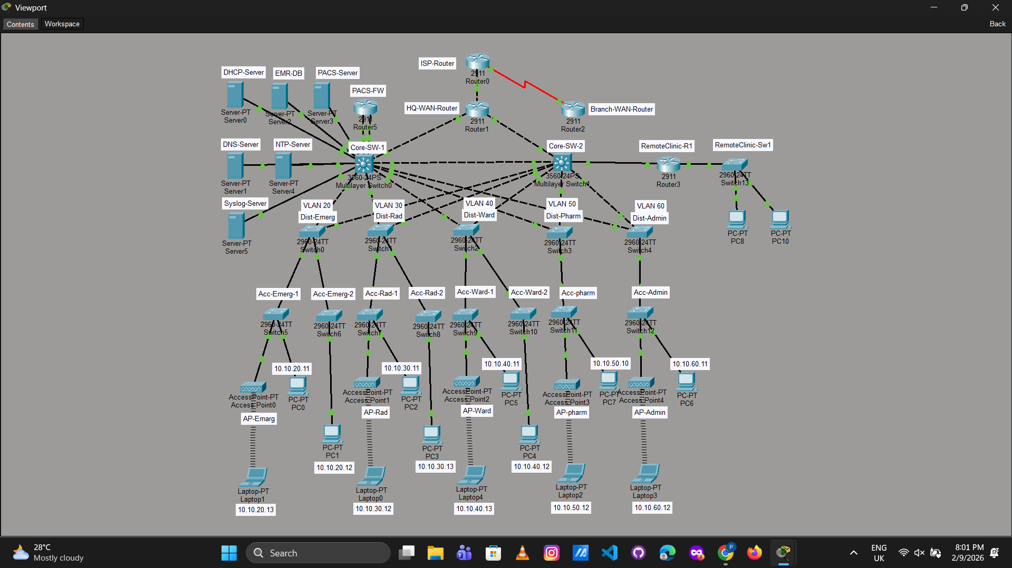
Figure 119: Screenshot 2026-02-09 200111.png


