**Air University**



**Department of Computer Science**

**Subject: ICT**

**Semester Project:**

**Building a website**

**Website Name:**

**AdventuresInPakistan**

**Group Members:**

**Shanza Ashraf (232489)**

**Rabbia Jamil (232399)**

**Topic of Website:**

**Tours and information of northern areas of Pakistan**

**Task 1:**

**Purpose of Tourism website:**

The purpose of this website is to promote and facilitate travel to a particular destination or region. Tourism websites serve as digital platforms that provide information, inspiration, and practical resources for individuals attracted in visiting a specific location. tourism website aims to attract, inform, and assist potential travelers in exploring and experiencing a destination. It plays a crucial role in promoting tourism, supporting local economies, and promotion a positive travel environment.

The purpose of a tourism website for the northern areas of Pakistan is to effectively market the region, provide valuable information to tourists, promote sustainable practices, engage with local communities, and contribute to the overall growth of tourism in the area.

People all over the world are fond of travel and tourism. People often find it difficult to search for the best places. To address the issue, we adopt the travelling website which will offer best places among others

This website contains highlights of some important places along with high quality photography and allow people to book their dream destination with in their budgets. It also includes full customer support, book as per your time choice, full virtual tour of place through different videos and images.

This project is based on how an effective travel website will make us feel. It is based on a travelling website with fully featured functions that will activate the travelling bug with exciting imagery.

The website aims to promote and showcase the beauty, uniqueness, and attractions of the northern areas to attract tourists. It serves as a promotional tool for the region as a whole.

**Portfolio for tourist:**

The primary purpose of portfolio is to provide to tourists visiting the northern areas of Pakistan. The portfolio serves as a comprehensive online guide and resource hub for individuals planning to explore the beauty, culture, and adventure that the northern regions have to offer.

With a focus on user-friendly design and comprehensive information, the portfolio aims to engage tourists effectively and convert their interest into actual visits. It provides the necessary details for trip planning, encouraging tourists to explore the northern areas.

The primary purpose is to serve as a comprehensive information hub for tourists interested in exploring the northern areas. This includes details on attractions, accommodations, activities, local culture, and travel tips.

The portfolio actively promotes the northern areas of Pakistan as a must-visit destination, contributing to the broader efforts of showcasing the region's unique offerings and development positive tourism experiences.

Supporting the local tourism industry by providing exposure to businesses such as hotels, tour operators, restaurants, and other services. This, in turn, contributes to the economic growth of the region.

The purpose of my tourism portfolio is not only to serve tourists but also to strategically position the business for growth, collaboration, and success in the competitive tourism industry.

**Target Audience:**

The target audience of tourism website is tourists, primary goal is to provide to individuals who are seeking information and assistance in planning their trips. Those who might be exploring options for their next vacation and seeking inspiration or detailed information about a specific location. Individuals who have a general interest in travel and search, even if they haven't finalized their travel plans. They visit the website for inspiration, travel tips, and to discover new destinations. Travelers who are specifically interested in adventure tourism, seeking information on trekking, mountaineering, water sports, or other adventurous activities in the destination. Tourists with an interest in cultural experiences, historical sites, local traditions, and events. They visit website to gain insights into the cultural richness of the destination. Individuals who have a general interest in travel and exploration, even if they haven't finalized their travel plans. They visit the website for inspiration, travel tips, and to discover new destinations.

**Task 2:**

Sketch Your Website Layout on Figma

* Create wireframes and prototypes for your website.
* Design the layout, color scheme, and overall aesthetic of your website.
* Include sections such as Home, About Me, Projects, Skills, and Contact.

**Simple Website design without pictures and aesthetic on Figma:**

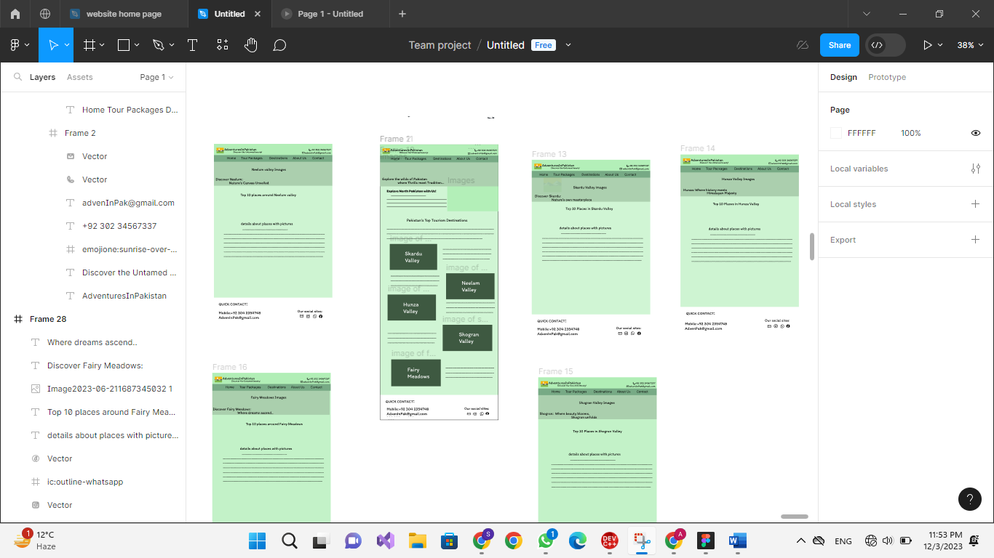

**Website Design with color scheme, layout and pictures:**

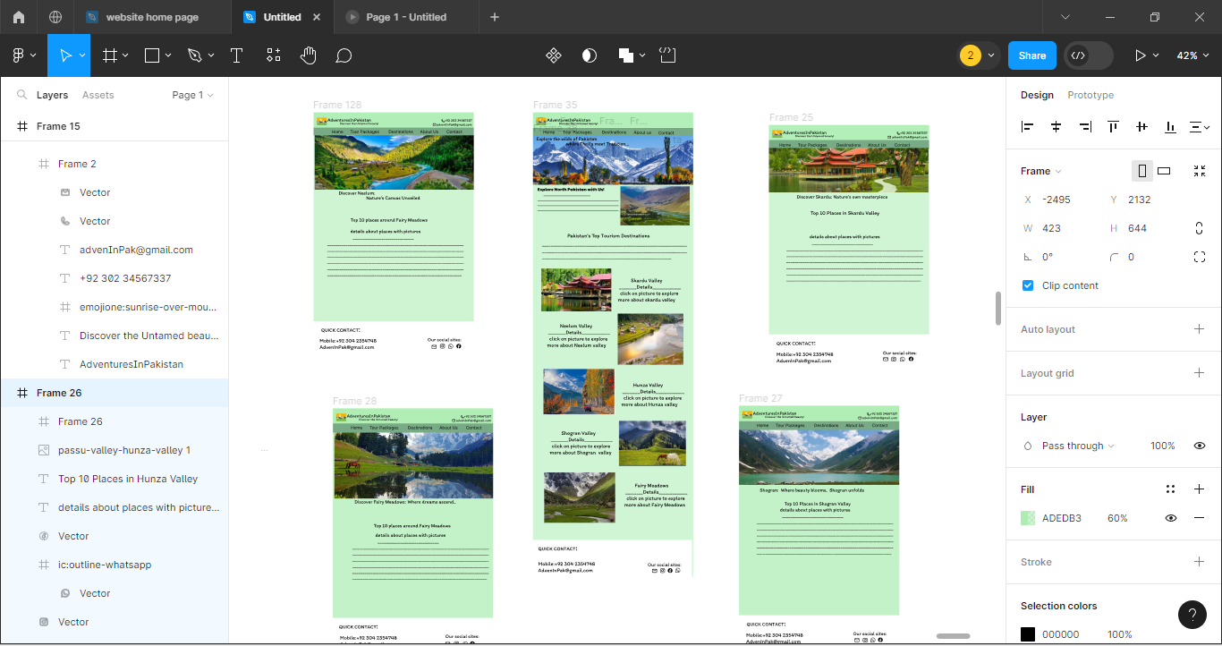

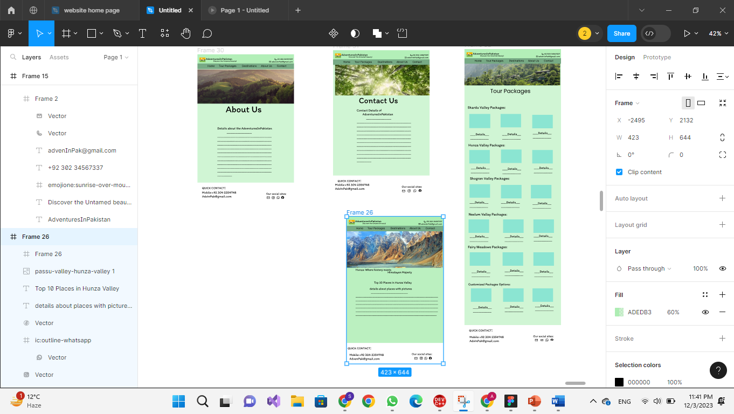

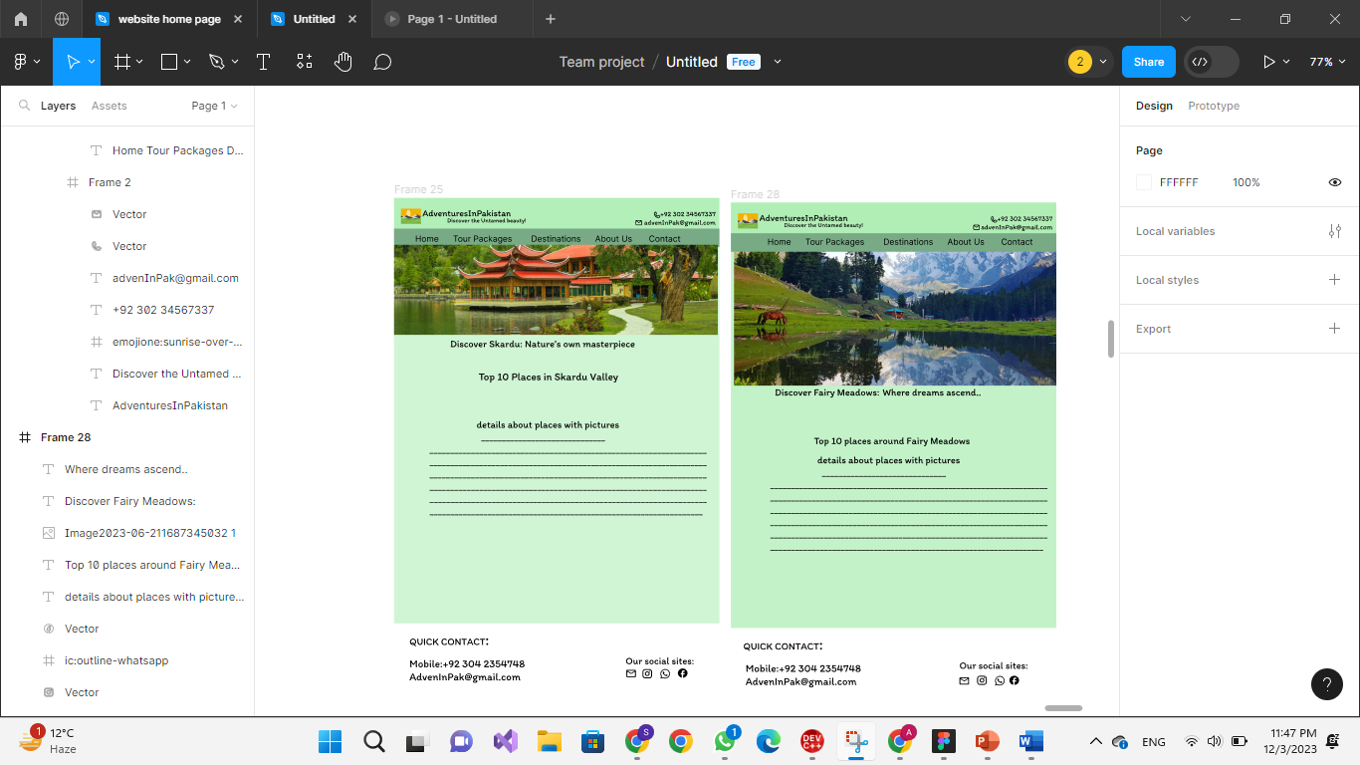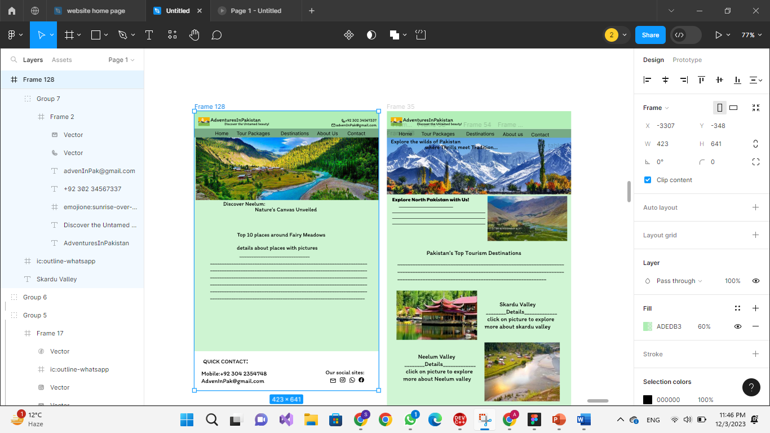

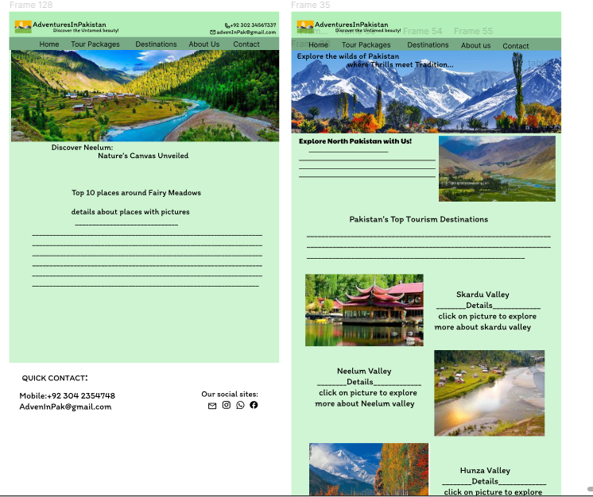

**Phase 2: Software Engineering Basics**

**Task 3:**

**Features:**

***User-Friendly Interface*:**

Intuitive navigation for users to easily explore the website.

Clear and attractive layout with visually appealing design.

**Destination Information:**

Detailed information about various tourist destinations.

High-quality images, videos, and descriptions for each location.

**Travel Guides and Tips:**

Comprehensive travel guides for different destinations.

Tips on local customs, best times to visit, and safety information.

**Booking and Arranging trips:**

After exploring the information of different places of northern Pakistan on website, you can book the package or customize the package according to your interests by contacting us.

**Events and Activities:**

Calendar of events, festivals, and activities at each destination.

Integration with external event calendars or platforms.

**Responsive Design:**

Ensure the website is accessible and functional on various devices (desktop, tablet, mobile).

**Social Media Integration:**

Sharing features for users to share their travel experiences.

Integration with social media platforms for marketing.

**Mobile Responsiveness:**

Prioritize mobile responsiveness for users accessing the website on different devices.

**Testing and Quality Assurance:**

Regular updates and maintenance to fix any issues.

**User-Friendly Homepage with Clear Navigation for “AdventuresInPakistan”**

**Attractive Visuals:**

Engaging hero image or video showcasing a stunning travel destination. High-quality, captivating images rotating in a slideshow format.

**Intuitive Navigation Bar:**

Clear and concise navigation menu with easily recognizable icons or labels.

Sections include “Home”, "Destinations," About Us" "Travel Guides," and “Tour Packages"

**Featured Destinations:**

Highlight a few featured destinations with beautiful images, brief descriptions, and "Explore" buttons.

**Reviews:**

Feature a section with user reviews for social proof.

Carousel of quotes with images of users and their travel experiences.

**Responsive Design:**

Ensure that the homepage layout adjusts seamlessly across various devices (desktop, tablet, mobile).

Prioritize mobile responsiveness for users on the go.

**Clear Navigation:**

The navigation bar guides users to key sections, ensuring they can easily find destinations, accommodations, guides, events, and their profiles.

**Engaging Content:**

Featured destinations and upcoming events capture attention, encouraging users to explore further.

**Mobile-Friendly Interaction:**

The responsive design ensures a seamless transition to smaller screens, allowing users to explore on the go.

**Social Connection:**

Social media integration encourages users to share their favorite destinations and engage with the community.

**Mobile Responsiveness for a Whole Experience:**

Ensure that the website is raised for mobile devices, providing a seamless and enjoyable user experience across various screen sizes. Use responsive design techniques to adapt the layout and content for smaller screens. This includes optimizing images, adjusting navigation menus, and ensuring that all interactive elements are easily accessible on mobile devices.

**Task 4:**

**User Stories for "Adventures In Pakistan" Website:**

As a user, I want to see a captivating hero image or video showcasing a stunning travel destination on the homepage so that I am immediately drawn into the website experience.

As a user, I want to easily navigate through the website sections using a clear and concise navigation menu with recognizable icons or labels. This includes sections like "Home," "Destinations," "About Us," "Travel Guides," "Events," and "Tour Packages."

As a user, I want to explore featured destinations by clicking on images with brief descriptions and "Explore" buttons to discover more about these places.

As a user, I want to read reviews from other travelers to gain insights and build trust in the website. The reviews should be presented in a carousel format with quotes and images of users sharing their travel experiences.

As a user, I want a responsive homepage layout that seamlessly adjusts across various devices (desktop, tablet, mobile) for a consistent and enjoyable browsing experience.

As a user, I want the navigation bar to guide me to key sections, ensuring I can easily find destinations, accommodations, guides, events, and my profile.

As a user, I want to view engaging content on the homepage, featuring featured destinations and upcoming events that capture my attention and encourage further exploration.

As a user, I want to read testimonials from other travelers to build trust in the community aspect and real travel experiences.

As a user, I want the website to be mobile-friendly, allowing for a seamless transition to smaller screens and enabling me to explore the content on the go.

As a user, I want to share my favorite destinations on social media and engage with the community. The website should integrate social media platforms for easy sharing and interaction.

As a user, I want the entire website to be responsive on mobile devices, ensuring a seamless and enjoyable user experience across various screen sizes. This includes optimized images, adjusted navigation menus, and easily accessible interactive elements on mobile devices.