

The UNIVERSITY OF AZAD JAMMU & KASHMIR
DEPARTMENT OF SOFTWARE ENGINEERING
Course Title:
Software Design and Architecture
COURSE CODE:
SEC-532
Semester:
3rd
Lab 03:
Student Case Study
SUBMITTED BY:
STUDENT NAME:
SHAHNZA MUNIR
ROLL NO:
2025-SE-02
INSTRUCTOR NAME:
Engr. Ghulam Rubani Butt
SUBMISSION DATE:
7 November 2026
LAB 03 : STUDENT CASE STUDY
Student Course Registration System

1. Identified Classes and Justification
The model contains three classes: Student, Course, and Enrollment. Student stores the identity and name of a student. Course stores the identifying code, title, credit hours, and seat capacity of a course. Enrollment is an essential registration-record class because every registration has its own date and status, and it connects exactly one student with exactly one course.

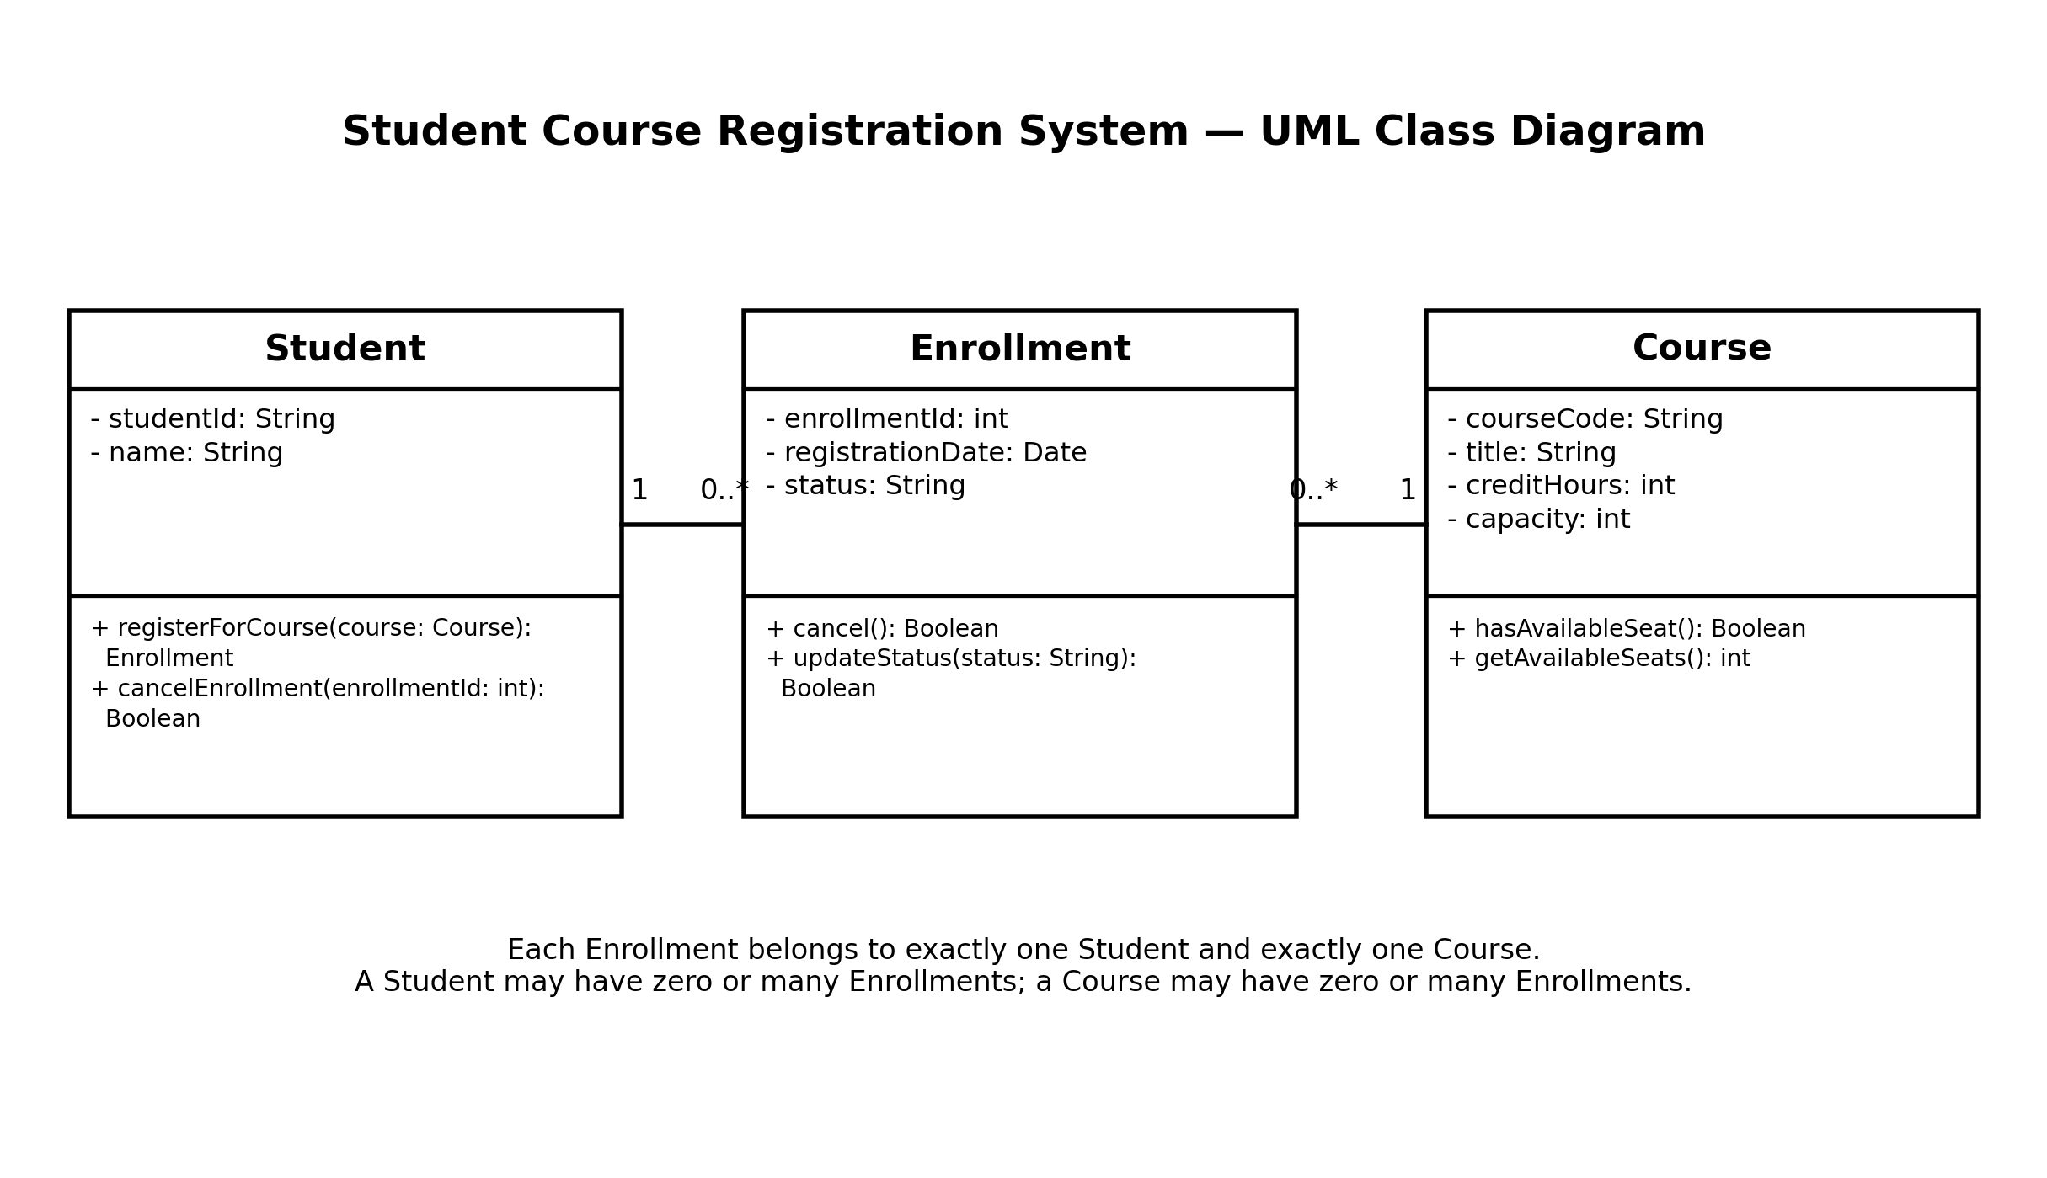
2. UML Class Diagram

Figure 1. UML class diagram for the Student Course Registration System.

3. Class Specifications

1. Student
Attributes:
studentId: String
name: String
Operations:
registerForCourse(course: Course): Enrollment
cancelEnrollment(enrollmentId: int): Boolean
Represents a student who can register for several courses and cancel an existing registration.

2. Course
Attributes:
courseCode: String
title: String
creditHours: int
capacity: int
Operations:
hasAvailableSeat(): Boolean
getAvailableSeats(): int
Represents a course and its maximum enrollment capacity. The availability operation checks whether another student can register.

3. Enrollment
Attributes:
enrollmentId: int
registrationDate: Date
status: String
Operations:
cancel(): Boolean
updateStatus(status: String): Boolean
Represents one registration record. It stores when the student registered and the current status, such as Pending, Approved, Rejected, or Cancelled.

4. Relationships and Multiplicities
Relationship | Multiplicity | Meaning
Student — Enrollment | Student 1; Enrollment 0..* | One student may have zero or many enrollment records. Every enrollment belongs to exactly one student.
Course — Enrollment | Course 1; Enrollment 0..* | One course may have zero or many enrollment records. Every enrollment refers to exactly one course.
Student — Course | Many-to-many through Enrollment | A student can register for many courses, and a course can have many students. Enrollment resolves this relationship and stores registration-specific data.

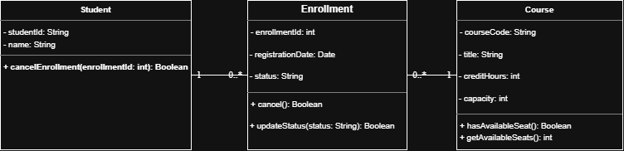
5.Exported diagram (PNG)

Figure 2. Exported diagram (PNG) for the Student Course Registration System

6. Lab Questions 10–15
10. Why use a registration record instead of linking Student directly to Course?
Because each registration has its own enrollment ID, registration date, and status. A separate Enrollment class stores these details and resolves the many-to-many relationship between students and courses.
11. Can a student exist without being registered in a course? Show the multiplicity.
Ans: Yes. A student can exist before registering. Therefore, one Student may be associated with zero or many Enrollment records (0..*).
12. Can a course exist even if no student has registered for it? Show the multiplicity.
Ans: Yes. A course can be offered before any student registers. Therefore, one Course may be associated with zero or many Enrollment records (0..*).
13. Which class should store the date and status of an individual registration? Why?
Ans: Enrollment should store registrationDate and status because both values describe one particular registration, not the student or the course as a whole.
14. Which operation could represent cancellation? Which could represent checking seat availability?
Ans: Enrollment.cancel(): Boolean can represent cancellation. Course.hasAvailableSeat(): Boolean can check whether at least one seat is available. Student.cancelEnrollment(enrollmentId: int): Boolean can also initiate cancellation for a selected registration.
15. Does the class diagram show the order in which messages are sent? Explain why or why not.
Ans: No. A class diagram shows the static structure of a system: classes, attributes, operations, and relationships. The order of messages over time is shown in a sequence diagram.

7. Short Explanation:
The Student Course Registration System is represented by three classes: Student, Course, and Enrollment. Student stores a unique student ID and the student's name. Course stores its course code, title, credit hours, and maximum capacity. Enrollment is the registration record that connects one student to one course and stores the registration date and current status. A student may have zero or many enrollment records, while each enrollment belongs to exactly one student. Similarly, a course may have zero or many enrollment records, while each enrollment refers to exactly one course. This design supports the many-to-many relationship between students and courses through Enrollment. The Course class includes operations to check seat availability, and Enrollment includes an operation to cancel a registration.

